Lesson 6
Objective: Multiply two-digit multiples of 10 by two-digit multiples of 10 with the area model.

Suggested Lesson Structure
 Fluency Practice (12 minutes)
 Application Problem (5 minutes)
 Concept Development (33 minutes)
 Student Debrief (10 minutes)
Total Time (60 minutes)
Fluency Practice (12 minutes)
- Multiply by Different Units 4.NBT.1 (4 minutes)
- Take Out the 10, 100, or 1,000 4.NBT.1 (2 minutes)
- Multiply by Multiples of 10, 100, and 1,000 4.NBT.1 (6 minutes)
Multiply by Different Units (4 minutes)
Note: This activity reviews concepts practiced in Lesson 5.
T: (Write 3 × 2 = .) Say the multiplication sentence in unit form.
S: 3 ones × 2 = 6 ones.
Repeat for the following possible sequence: 30 × 2, 300 × 2, 3,000 × 2, 3,000 × 3, 30 × 3, 300 × 5, 70 × 5,
400 × 8, 40 × 5, and 800 × 5.
Take Out the 10, 100, or 1,000 (2 minutes)
Note: This activity helps prepare students to multiply by multiples of 10, 100, or 1,000.
T: I’ll say a number. I want you to restate the number as a multiplication sentence, taking out the 10, 100, or 1,000. Ready. 20.
S: 2 × 10.
T: 200.
S: 2 × 100.
T: 2,000.
S: 2 × 1,000.
Repeat the process for the following possible sequence: 5,000, 30, 700, 8,000, and 90.
Multiply by Multiples of 10, 100, and 1,000 (6 minutes)
Materials: (S) Personal white board
Note: This activity reviews concepts practiced in Lesson 5.
T: (Write 5 × 300.) Say the multiplication expression.
S: 5 × 300.
T: Rewrite the multiplication sentence, taking out the 100, and solve.
S: (Write 5 × 3 × 100 = 1,500.)
Repeat process for the following possible sequence: 70 × 3, 8 × 4,000, 6 × 200, and 50 × 8.
Application Problem (5 minutes)
There are 400 children at Park Elementary School. Park High School has 4 times as many students.
a. How many students in all attend both schools?
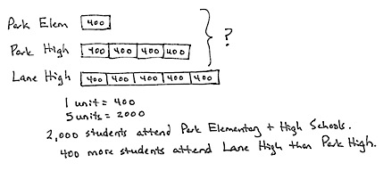
b. Lane High School has 5 times as many students as Park Elementary. How many more students attend Lane High School than Park High School?

NOTES ON
MULTIPLE MEANS
OF ENGAGEMENT:
Differentiate the difficulty of the Application Problem by adjusting the numbers. Extend for students working above grade level with these open-ended questions:
- How many students would you predict attend the middle school? Explain your reasoning.
- If these were estimates of the number of students, what might be the actual numbers?

Note: These problems are a review of work from Lesson 5.

Concept Development (33 minutes)
Materials: (T) Thousands place value chart (Lesson 4 Template) (S) Personal white board, thousands place value chart (Lesson 4 Template)
Problem 1: Use the place value chart to multiply a two-digit multiple of 10 by a two-digit multiple of 10.
Display 30 × 20 on the board.

NOTES ON
MULTIPLE MEANS
OF REPRESENTATION:
For students developing oral language skills, alternate between choral response and written response. Encourage students to explain their math thinking in the language of their choice. Allow added response time for English language learners to gather their thoughts.

T: Here we are multiplying a two-digit number by another two-digit number. What are some other ways we could express 30 × 20?
S: 3 tens × 2 tens.
10 × 20 × 3.
10 × 30 × 2.
2 × 30 × 10.
3 × 20 × 10.
T: Let’s use 10 × 20 × 3 in a place value chart to help us solve 30 × 20. (Project place value chart as shown to the right.)
T: What is 2 tens times 10?
S: 2 tens times 10 is 2 hundreds.
T: So, the value of 10 × 20 is…?
S: 200.
T: And, then 200 × 3?
S: Triple that group. 200 times 3. 3 times 2 hundreds. 3 groups of 2 hundred.
T: 10 × 20 × 3 is…?
S: 600.
T: With your partner, represent one of the following on your place value chart:
10 × 30 × 2 as 10 groups of 30 times 2.
2 × 30 × 10 as 2 groups of 30 times 10.
3 × 20 × 10 as 3 groups of 20 times 10.
Allow students two minutes to work.
T: Did you get the same answer?
S: Yes, we got 6 hundreds again.
T: When we multiply a two-digit number by another two-digit number, there are many equivalent ways to express it as a product. Decomposing our multiplication problem into more units can help us solve.
Problem 2: Create an area model to represent the multiplication of a two-digit multiple of 10 by a two-digit multiple of 10.
T: (Display 40 × 20.) Let’s model 40 × 20 as an area. Tell your partner what 40 × 20 is.
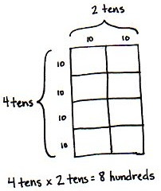
S: 4 tens times 20. That’s 80 tens, or 800.
T: (Record student statement.) What is 20 in unit form?
S: 2 tens.
T: So, then, what is 4 tens times 2 tens?
S: I know 4 times 2 is 8. I don’t know what to do with the units. I know 4 times 2 is 8. That leaves both tens. 10 tens. It’s like saying 4 times 2 times 10 tens!
T: Let’s prove how we can multiply the units. Draw a 40 by 20 rectangle on your personal white board. Partition the horizontal side into 2 tens and the vertical side into 4 tens. Label each side. What is the area of one square? (Point to a 10 by 10 square.)
S: 10 × 10 = 100.
T: Say a multiplication sentence for how many of the squares there are.
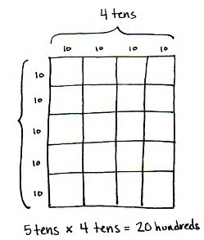
S: 4 × 2 = 8.
T: Tell your partner how this rectangle shows 4 tens times 2 tens equals 8 hundreds.
S: Each square is 10 by 10. That makes 100. There are 8 hundreds.
Problem 3: Use an area model to represent the multiplication of a two-digit multiple of 10 by a two-digit multiple of 10.
Display 50 × 40 horizontally on the board.
T: Name 50 × 40 in unit form.
S: 5 tens × 4 tens.
T: With your partner, draw a rectangle to represent 5 tens times 4 tens.
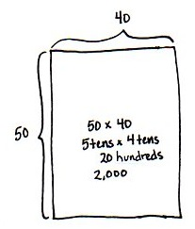
S: I can draw the vertical side as 5 tens and the horizontal side as 4 tens. 10 times 10 is 100. 5 times 4 is 20. 20 is the same as 2 tens. 2 tens times 100 is 2,000.
T: Use a place value chart to prove 2 tens times 100 is 2,000.
Students draw a place value chart.
T: What is 50 × 40?
S: 2,000.
T: What conclusion can be made about multiplying a unit of 10 times a unit of 10?
S: 10 times 10 is always 100. So, I can decompose any unit of 10, multiply how many units of 10 there are, and it will be that many hundreds. 7 tens times 8 tens is 56 of some unit. I just have to find the unit. Ten times ten is 100. So, it’s 56 hundreds or 5,600.
Repeat with 60 × 30.
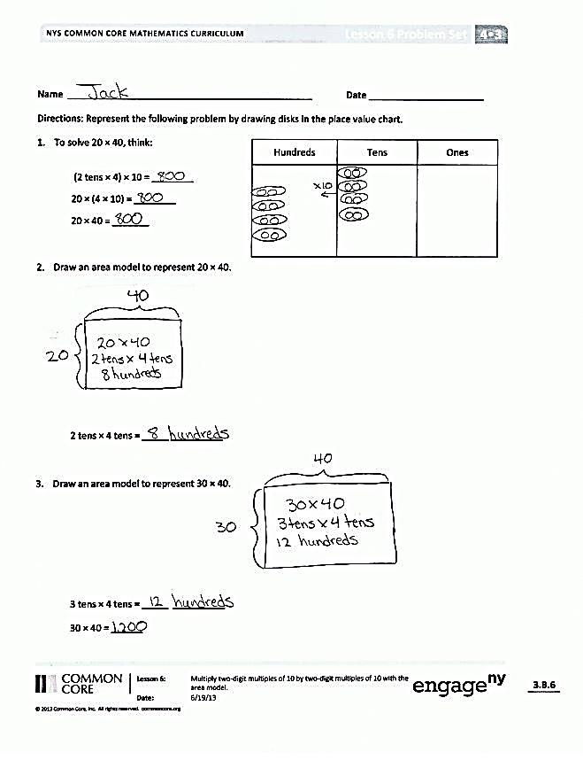
Problem Set (10 minutes)
Students should do their personal best to complete the Problem Set within the allotted 10 minutes. For some classes, it may be appropriate to modify the assignment by specifying which problems they work on first. Some problems do not specify a method for solving. Students should solve these problems using the RDW approach used for Application Problems.
Student Debrief (10 minutes)
Lesson Objective: Multiply two-digit multiples of 10 by two-digit multiples of 10 with the area model.
The Student Debrief is intended to invite reflection and active processing of the total lesson experience.
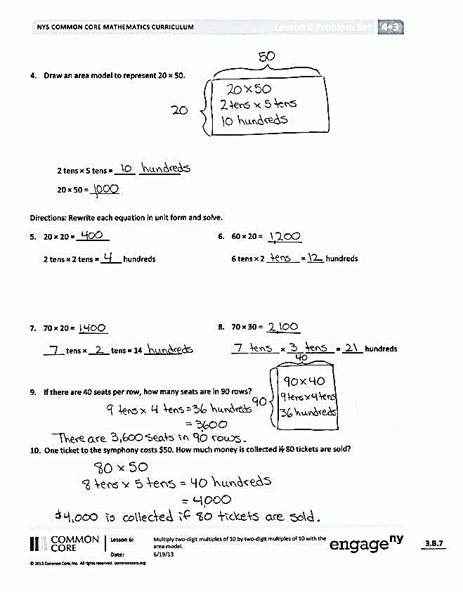
Invite students to review their solutions for the Problem Set. They should check work by comparing answers with a partner before going over answers as a class. Look for misconceptions or misunderstandings that can be addressed in the Debrief. Guide students in a conversation to debrief the Problem Set and process the lesson.
You may choose to use any combination of the questions below to lead the discussion.
- What patterns did you notice while solving Problem 1?
- Explain to your partner how to solve the problem 80 × 50 from Problem 10. What does the answer have to do with thousands when the units in 80 and 50 are 8 tens and 5 tens?
- To solve 4 × 10 × 2 × 10, you can multiply 4 × 2 to get 8, then multiply 10 × 10 to get 100, then multiply the 8 times 100. Is it always possible to rearrange numbers like this when multiplying?
- Talk to your partner about how you solved Problem 2. Can you come up with a different way to solve this problem?

Exit Ticket (3 minutes)
After the Student Debrief, instruct students to complete the Exit Ticket. A review of their work will help you assess the students’ understanding of the concepts that were presented in the lesson today and plan more effectively for future lessons. You may read the questions aloud to the students.

Name Date
Represent the following problem by drawing disks in the place value chart.

hundreds | tens | ones
- To solve 20 × 40, think:
(2 tens × 4) × 10 = ________
20 × (4 × 10) = ________
20 × 40 = _______

- Draw an area model to represent 20 × 40.

2 tens × 4 tens = _____ ____________

- Draw an area model to represent 30 × 40.

3 tens × 4 tens = _____ _____________
30 × 40 = ______
- Draw an area model to represent 20 × 50.

2 tens × 5 tens = _____ _____________
20 × 50 = _______
Rewrite each equation in unit form and solve.
- 20 × 20 = ________
2 tens × 2 tens = _____ hundreds

- 60 × 20 = _______
6 tens × 2 ________ = ____ hundreds

- 70 × 20 = _______
_____ tens × _____ tens = 14 _________

- 70 × 30 = _______
____ _______ × ____ _______ = _____ hundreds

- If there are 40 seats per row, how many seats are in 90 rows?

- One ticket to the symphony costs $50. How much money is collected if 80 tickets are sold?

Name Date
Represent the following problem by drawing disks in the place value chart.

hundreds | tens | ones
- To solve 20 × 30, think:
(2 tens × 3) × 10 = ________
20 × (3 × 10) = ________
20 × 30 = _______

- Draw an area model to represent 20 × 30.

2 tens × 3 tens = _____ ____________

- Every night, Eloise reads 40 pages. How many total pages does she read at night during the 30 days of November?

Name Date
Represent the following problem by drawing disks in the place value chart.

hundreds | tens | ones
- To solve 30 × 60, think:
(3 tens × 6) × 10 = ________
30 × (6 × 10) = ________
30 × 60 = _______

- Draw an area model to represent 30 × 60.

3 tens × 6 tens = _____ _____________

- Draw an area model to represent 20 × 20.

2 tens × 2 tens = _____ _____________
20 × 20 = ______
- Draw an area model to represent 40 × 60.

4 tens × 6 tens = _____ _____________
40 × 60 = _______
Rewrite each equation in unit form and solve.
- 50 × 20 = ________
5 tens × 2 tens = _____ hundreds
- 30 × 50 =
3 tens × 5 ________ = ____ hundreds

- 60 × 20 =
_____ tens × _____ tens = 12 _________
- 40 × 70 =
____ _______ × ____ _______ = _____ hundreds

- There are 60 seconds in a minute and 60 minutes in an hour. How many seconds are in one hour?

- To print a comic book, 50 pieces of paper are needed. How many pieces of paper are needed to print 40 comic books?

