Lesson 5
Objective: Multiply multiples of 10, 100, and 1,000 by single digits, recognizing patterns.

Suggested Lesson Structure
 Fluency Practice (8 minutes)
 Concept Development (42 minutes)
 Student Debrief (10 minutes)
Total Time (60 minutes)
Fluency Practice (8 minutes)
- Group Count by Multiples of 10 and 100 4.NBT.1 (4 minutes)
- Multiply Units 4.NBT.1 (4 minutes)
Group Count by Multiples of 10 and 100 (4 minutes)
Note: Changing units helps to prepare students to recognize patterns of place value in multiplication.
Repeat the process from Lesson 4 using the following suggested sequence:
- Sevens, stopping to convert at 14 tens, 35 tens, 63 tens, and 70 tens.
- Eights, stopping to convert at 24 hundreds, 40 hundreds, 64 hundreds, and 80 hundreds.
- Nines, stopping to convert at 27 hundreds, 45 hundreds, 63 hundreds, and 90 hundreds.
Multiply Units (4 minutes)
Materials: (S) Personal white board
Note: This fluency activity gives students practice reviewing content from Lesson 4.
T: (Write 3 × 2 = .) Say the multiplication sentence in unit form.
S: 3 ones × 2 = 6 ones.
T: Write the answer in standard form.
S: (Write 6.)
T: (Write 30 × 2 = .) Say the multiplication sentence in unit form.
S: 3 tens × 2 = 6 tens.
T: Write the answer in standard form.
S: (Write 60.)
Repeat for the following possible sequence: 3 hundreds × 2, 3 thousands × 2, 5 ones × 3, 5 tens × 3, 5 thousands × 3, 5 thousands × 4, 5 tens × 4, 5 ones × 8, 5 hundreds × 8, and 9 tens × 7.
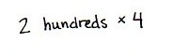
Concept Development (42 minutes)
Materials: (T) Thousands place value chart (Lesson 4 Template) (S) Personal white board, thousands place value chart (Lesson 4 Template)
Problem 1: Use place value disks to represent multiplication patterns.
Write the following on the board:
2 ones × 4 2 tens × 4 2 hundreds × 4 2 thousands × 4
T: Show 2 ones × 4 on your place value chart. Circle each group of 2 ones.
T: Show 2 tens × 4 on your place value chart. Circle each group of
2 tens.
T: 2 ones × 4 is…?
S: 8 ones.
T: 2 tens × 4 is…?
S: 8 tens. 80.

NOTES ON
MULTIPLE MEANS
OF ACTION AND EXPRESSION:
Learners differ in their physical abilities. Provide alternatives to drawing place value disks, such as placing cubes or concrete disks or indicating their selection. In addition, use color to highlight the movement of the array from the ones, to the tens, to the hundreds place.
T: With your partner, represent 2 hundreds × 4. Circle each group of 2 hundreds.
T: (Allow about one minute.) What did you notice about multiplying 2 hundreds × 4 compared to 2 tens × 4?
S: There was the same number of place value disks. It was almost the same, except I used disks that represented 1 hundred instead of 10. The value of the disks is in the hundreds, so my answer is larger.
T: 2 hundreds × 4 is…?
S: 8 hundreds. 800.
T: What do you think would happen if we multiplied
2 thousands × 4?
S: It would look the same again! But, instead of disks representing 100, we would use disks representing 1,000. The answer would be 8 thousands because we multiplied 2 times 4 in the thousands column.
Repeat with 30 × 3, 300 × 3, and 3,000 × 3.
Problem 2: Numerically represent single-digit numbers times a multiple of 10.
Display 8 × 2, 8 × 20, 8 × 200, and 8 × 2,000 horizontally on the board.
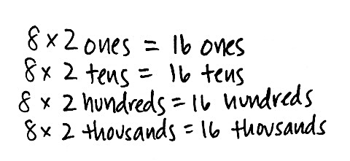
T: With your partner, solve these multiplication problems in unit form.
Allow students two minutes to work in pairs.
T: What patterns do you notice?
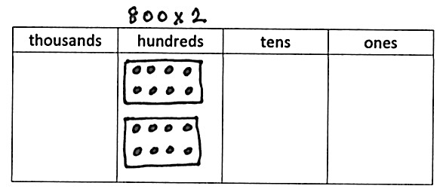
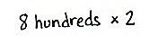
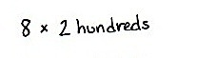
S: All of the problems have 8 as a factor. The units are in order of the place value chart, smallest to largest. The unit we multiply is the same unit we get in our answer, like 8 × 2 tens equals 16 tens and 8 × 2 hundreds is 16 hundreds.
T: What happens if we change the unit from 8 × 2 hundreds to 8 hundreds × 2? Does the answer change?
S: Nothing happens. The answer stays the same even though the unit changed. 8 × 2 hundreds can be written as
8 × (2 × 100), and 8 hundreds × 2 can be written as (8 × 100) × 2. Both statements are equivalent.
Repeat with 5 × 2, 5 × 20, 5 × 200, and 5 × 2,000 horizontally on the board. As students begin to recognize the pattern of zeros as they multiply by multiples of 10, note the complexity in the additional zero when multiplying 5 times 2.
Problem 3: Solve a word problem by finding the sum of two different products of a single-digit number by a two- and three-digit multiple of 10.

NOTES ON
MULTIPLE MEANS
OF ACTION AND EXPRESSION:
Teach English language learners and others to track information from the word problem as notes or as a model as they read sentence by sentence.
- Francisco played a video game and earned 60 points for every coin he collects. He collected 7 coins. How many points did he earn for the coins that he collected?
- Francisco also earned 200 points for every level he completed in the game. He completed 7 levels. How many points did he earn for the levels that he completed?
- What was the total number of points that Francisco earned?
Introduce each step of the problem separately, instructing students to follow the RDW process. Students should ask themselves what they know and draw a tape diagram as needed before solving. Encourage students to show how they decompose each multiplication problem and promote simplifying strategies for the addition.

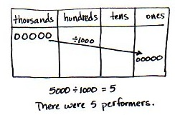
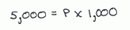
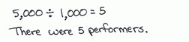
Problem 4: Solve a word problem involving 1,000 times as many.
At a concert, there were 5,000 people in the audience. That was 1,000 times the number of performers. How many performers were at the concert?
MP.4
T: Write an equation to solve for how many performers were at the concert. Solve using a method of your choice.
S: I know 1,000 times the number of performers is 5,000, so to solve the equation of p × 1,000 = 5,000, I know that there were 5 performers. There are 1,000 times as many people in the audience, so I can divide 5,000 by 1,000 to find 5 performers.
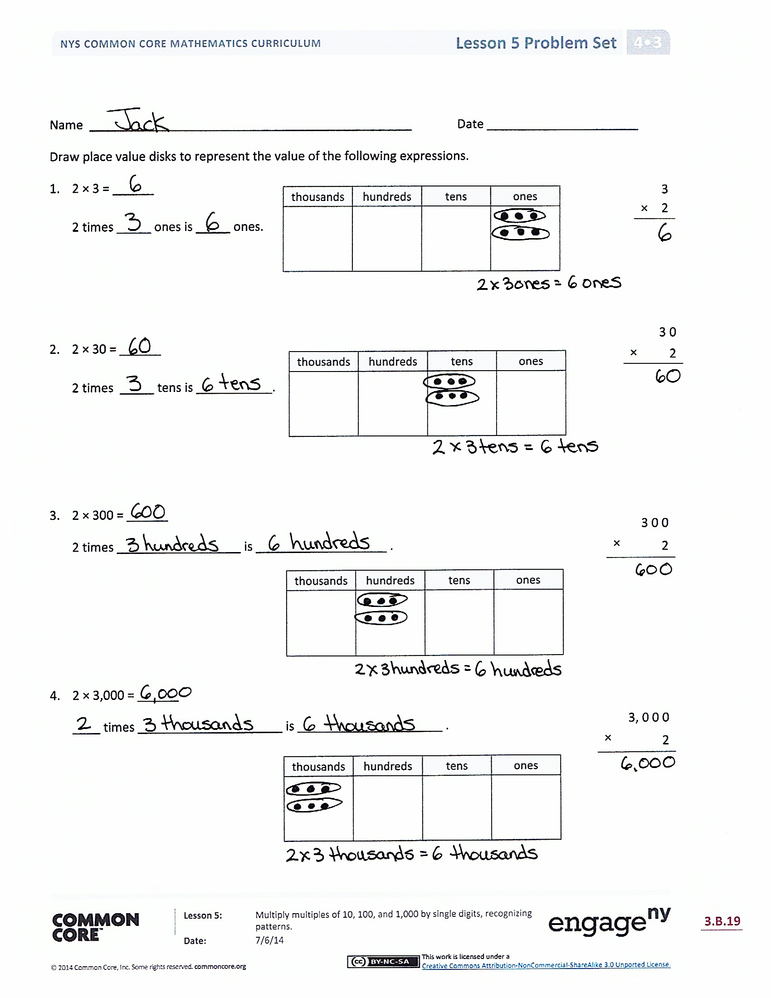
Problem Set (10 minutes)
Students should do their personal best to complete the Problem Set within the allotted 10 minutes. For some classes, it may be appropriate to modify the assignment by specifying which problems they work on first. Some problems do not specify a method for solving. Students should solve these problems using the RDW approach used for Application Problems.
Student Debrief (10 minutes)
Lesson Objective: Multiply multiples of 10, 100, and 1,000 by single digits, recognizing patterns.
The Student Debrief is intended to invite reflection and active processing of the total lesson experience.
Invite students to review their solutions for the Problem Set. They should check work by comparing answers with a partner before going over answers as a class. Look for misconceptions or misunderstandings that can be addressed in the Debrief. Guide students in a conversation to debrief the Problem Set and process the lesson.
You may choose to use any combination of the questions below to lead the discussion.
- What pattern did you notice while solving Problems 1, 2, and 3?
- Sometimes, we decompose using addition, such as saying 30 = 10 + 10 + 10, and sometimes we decompose using multiplication, such as saying 30 = 3 × 10. What are some possible decompositions of 24 using addition? Multiplication?
- What did you notice about 5 × 2, 5 × 20, 5 × 200, and 5 × 2,000? (Note: Try to elicit that there is a “hidden” or “extra” zero because 5 × 2 ones is 1 ten, 5 × 2 tens is 10 tens, etc.)
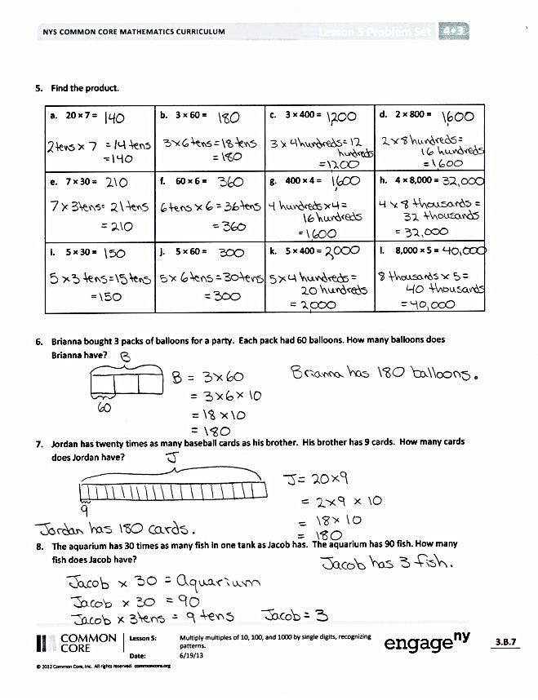
- Explain to your partner how you solved for the Problems 5(i–l). Explain to your partner the value and importance of the number zero in the factor and the product.
- What significant math vocabulary did we use today to communicate precisely?
- How did the last lesson prepare you for this lesson?
Exit Ticket (3 minutes)
After the Student Debrief, instruct students to complete the Exit Ticket. A review of their work will help you assess the students’ understanding of the concepts that were presented in the lesson today and plan more effectively for future lessons. You may read the questions aloud to the students.
Name Date
Draw place value disks to represent the value of the following expressions.
 | 3
× | 2
thousands | hundreds | tens | ones
- 2 × 3 = ______

2 times _____ ones is _____ ones.

 | 3 0
× | 2
thousands | hundreds | tens | ones
- 2 × 30 = ______

2 times _____ tens is _____ ___________.

- 2 × 300 = ______
thousands | hundreds | tens | ones
2 times _______ _____________ is _______ ________________ .
 | 3 0 0
× | 2

- 2 × 3,000 = ______
____ times _____________________ is _____________________ .
thousands | hundreds | tens | ones
 | 3, 0 0 0
× | 2

- 20 × 7 | - 3 × 60 | - 3 × 400 | - 2 × 800
- 7 × 30 | - 60 × 6 | - 400 × 4 | - 4 × 8,000
- 5 × 30 | - 5 × 60 | - 5 × 400 | - 8,000 × 5
- Find the product.
- Brianna buys 3 packs of balloons for a party. Each pack has 60 balloons. How many balloons does Brianna have?

- Jordan has twenty times as many baseball cards as his brother. His brother has 9 cards. How many cards does Jordan have?

- The aquarium has 30 times as many fish in one tank as Jacob has. The aquarium has 90 fish. How many fish does Jacob have?

Name Date
 | 2 0 0
× | 4
Draw place value disks to represent the value of the following expressions.
- 4 × 200 = ______
4 times _______ _______________ is _______ ________________ .
thousands | hundreds | tens | ones

 | 2, 0 0 0
× | 4
- 4 × 2,000 = ______
____ times _______ _______________ is _______ ________________ .
thousands | hundreds | tens | ones

- Find the product.
- 30 × 3 | - 8 × 20 | - 6 × 400 | - 2 × 900
- 8 × 80 | - 30 × 4 | - 500 × 6 | - 8 × 5,000

- Bonnie worked for 7 hours each day for 30 days. How many hours did she work altogether?

Name Date
Draw place value disks to represent the value of the following expressions.
 | 2
× | 5
thousands | hundreds | tens | ones
- 5 × 2 = ______

5 times _____ ones is _____ ones.

thousands | hundreds | tens | ones
 | 2 0
× | 5
- 5 × 20 = ______

5 times _____ tens is _________________.

- 5 × 200 = ______
5 times _______ _____________ is ______ _______________ .
thousands | hundreds | tens | ones
 | 2 0 0
× | 5

- 5 × 2,000 = ______
____ times _______ _______________ is _______ ________________ .
thousands | hundreds | tens | ones
 | 2, 0 0 0
× | 5

- 20 × 9 | - 6 × 70 | - 7 × 700 | - 3 × 900
- 9 × 90 | - 40 × 7 | - 600 × 6 | - 8 × 6,000
- 5 × 70 | - 5 × 80 | - 5 × 200 | - 6,000 × 5
- Find the product.

- At the school cafeteria, each student who ordered lunch gets 6 chicken nuggets. The cafeteria staff prepares enough for 300 kids. How many chicken nuggets does the cafeteria staff prepare altogether?

- Jaelynn has 30 times as many stickers as her brother. Her brother has 8 stickers. How many stickers does Jaelynn have?

- The flower shop has 40 times as many flowers in one cooler as Julia has in her bouquet. The cooler has 120 flowers. How many flowers are in Julia’s bouquet?

