Lesson 1
Objective: Investigate and use the formulas for area and perimeter of rectangles.

Suggested Lesson Structure
 Fluency Practice (15 minutes)
 Concept Development (35 minutes)
 Student Debrief (10 minutes)
Total Time (60 minutes)

Fluency Practice (15 minutes)
- Perimeter and Area 4.MD.3 (3 minutes)
- Multiply a Number by Itself 4.MD.3 (5 minutes)
- Group Counting 4.OA.4 (3 minutes)
- Find the Unknown Factor 4.OA.4 (4 minutes)

Perimeter and Area (3 minutes)
Materials: (T) Grid paper (with ability to project or enlarge grid paper)
Note: This fluency activity prepares students for this lesson’s Concept Development.
T: (Project grid paper with a rectangle of 5 units by 2 units shaded.) What’s the length of the longest side?
S: 5 units.
T: (Write 5 units. Point to the opposite side.) What’s the length of the opposite side?
S: 5 units.
T: (Write 5 units.) What’s the sum of the rectangle’s two longest sides?
S: 10 units.
T: What’s the length of the shortest side?
S: 2 units.
T: (Write 2 units. Point to the unknown side.) What’s the length of the unknown side?
S: 2 units.
T: (Write 2 units.) What’s the sum of the rectangle’s two shortest sides?
S: 4 units.
T: What’s the perimeter?
S: 14 units.
T: How many square units are in one row?
S: 5 square units.
T: How many rows of 5 square units are there?
S: 2 rows.
T: Let’s find how many square units there are in the rectangle, counting by fives.
S: 5, 10.
T: What’s the area?
S: 10 square units.

Repeat process for 3 × 4 and 7 × 3 rectangles.

Multiply a Number by Itself (5 minutes)
Note: Multiplying a number by itself helps students quickly compute the area of squares.
T: (Project 1 × 1 = .) Say the complete multiplication equation.
S: 1 × 1 = 1.
Repeat the process for 2, 3, 4, 5, 6, 7, 8, 9, and 10.
T: I’m going to call out a number. You say the answer when it’s multiplied by itself. 2.
S: 4.
Repeat the process for possible sequence: 1, 10, 5, 3, 6, 8, 4, 7, and 9.
Group Counting (3 minutes)
Note: Group counting helps review multiples and factors that students need to recall during the lesson.
Direct students to count forward and backward, occasionally changing the direction of the count, using the following sequence: threes to 24, fours to 24, and sixes to 24.
T: Count by threes. Ready? (Use a familiar signal to indicate counting up or counting down.)
S: 3, 6, 9, 12, 9, 12, 9, 12, 15, 18, 21, 18, 21, 18, 21, 24, 21, 18, 21, 18, 15, 12, 9, 12, 9, 6, 3.

Find the Unknown Factor (4 minutes)

Materials: (S) Personal white board
Note: Finding the unknown factor in isolation prepares students to solve unknown side problems when given the area.
T: (Project 3 × = 12.) On your personal white boards, write the unknown factor.
S: (Write 4.)
T: Say the multiplication sentence.
S: 3 × 4 = 12.
Repeat the process with the following possible sequence: 4 × = 12, 4 × = 24, 3 × = 24,
6 × = 12, 6 × = 24, and 3 × = 18.

Concept Development (35 minutes)
Materials: (T) Grid paper (with ability to project or enlarge grid paper), chart paper (S) Grid paper, personal white board

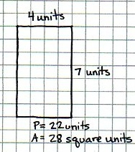
Problem 1: Review and compare perimeter and area of a rectangle.
T: Draw a rectangle on your grid paper that is four units wide and seven units long.
S: (Draw rectangle on grid paper.)
T: (Monitor to see that the students have drawn the rectangle correctly.) Tell your partner what you notice about your rectangle.
S: The opposite sides are the same length. It has four right angles. The area of the rectangle is 28 square units.
The perimeter of the rectangle is 22 units.

T: Place the point of your pencil on one of the corners of the rectangle. Now, trace around the outside of the rectangle until you get back to where you started. What do we call the measurement of the distance around a rectangle?
S: The perimeter.
T: Trace the perimeter again. This time, count the units as you trace them. What is the perimeter of the rectangle?
S: 22 units.
T: When we know the measurements of the length and width of a rectangle, is there a quicker way to determine the perimeter than to count the units while tracing?
S: We could add the measurements of all four sides of the rectangle.
T: Take your pencil and count all of the squares within your rectangle. These squares represent the area of the rectangle. How do I find the area of the rectangle?
S: You count the squares. You can multiply the length times the width of the rectangle. Four units times 7 units is 28 square units.

Problem 2: Use the formula 2 × (l + w) to solve for perimeter and to find an unknown side length of a rectangle.
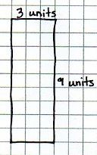
T: Draw a rectangle on your graph paper that is 3 units wide and 9 units long. (Draw and display the rectangle.) Watch as I label the length and width of the rectangle. Now, label the length and width of your rectangle. How can I find the perimeter?
S: Add up the lengths of all of the sides. 3 + 9 + 3 + 9 = 24. The perimeter is 24 units. You could also add 3 + 3 + 9 + 9. The answer is still 24 units. The order doesn’t matter when you are adding.
T: Use your pencil to trace along one width and one length. Along how many units did you trace?
S: 12 units.
T: How does 12 relate to the length and width of the rectangle?
S: It’s the sum of the length and width.
T: How does the sum of the length and width relate to finding the perimeter of the rectangle?
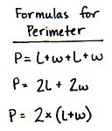
S: It’s halfway around. I can double the length and double the width to find the perimeter instead of adding all the sides (2l + 2w). I could also add the length and the width and double that sum,
2 × (l + w). Both of those work since the opposite sides are equal.
T: You have just mentioned many formulas, like counting along the sides of the rectangle or adding sides or doubling, to find the perimeter. Let’s create a chart to keep track of the formulas for finding the perimeter of a rectangle. Talk to your partner about the most efficient way to find the perimeter.
S: If I draw the shape on grid paper, I can just count along the edge. I am good at adding, so I will add all four sides. It is faster to double the sum of the length and width. It’s only two steps.
T: We can write the formula as P = 2 × (l + w) on our chart, meaning we add the length and width first and then multiply that sum by 2. What is the length plus width of this rectangle?
S: 3 plus 9 equals 12. 12 units.
T: 12 units doubled, or 12 units times 2, equals?
S: 24 units.
T: Now, draw a rectangle that is 2 units wide and 4 units long. Find the perimeter by using the formula I just mentioned. Then, solve for the perimeter using a different formula to check your work.
S: 2 + 4 = 6 and 6 × 2 = 12. The perimeter is 12 units. Another way is to double 2, double 4, and then add the doubles together. 4 plus 8 is 12 units. Both formulas give us the same answer.
Repeat with a rectangle that is 5 units wide and 6 units long.
Instruct students to sketch a rectangle with a width of 5 units and a perimeter of 26 units on their personal white boards, not using graph paper.
T: Label the width as 5 units. Label the length as an unknown of x units. How can we determine the length? Discuss your ideas with a partner.
S: If I know that the width is 5, I can label the opposite side as 5 units since they are the same. If the perimeter is 26, I can take away the widths to find the sum of the other two sides. 26 – 10 = 16. If the sum of the remaining two sides is 16, I know that each side must be 8 since I know that they are equal and that 8 + 8 = 16, so x = 8 (shows sketch to demonstrate her thinking).
S: We could also find the length another way. I know that if I add the length and the width of the rectangle together that I will get half of the perimeter. In this rectangle, because the perimeter is 26 units, the length plus the width equals 13 units. If the width is 5, that means that the length has to be 8 units because 5 + 8 = 13. 26 ÷ 2 = 13, x + 5 = 13 or 13 – 5 = x, so x = 8.
Repeat for P = 28 cm, l = 8 cm.

Problem 3: Use the area formula (l × w) to solve for area and to solve for the unknown side length of a rectangle.
T: Look back at the rectangle with the width of 3 units and the length of 9 units. How can we find the area of the rectangle?
S: We can count all of the squares. We could also count the number of squares in one row and then skip-count that number for all of the rows. That’s just multiplying the number of rows by the number in each row. A quicker way is to multiply the length times the width. Nine rows of 3 units each is like an array. We can just multiply 9 × 3.
T: Talk to your partner about the most efficient way to find the area of a rectangle.

Discuss how to find the area for the 2 × 4 rectangle and the 5 × 6 rectangle drawn earlier in the lesson. Encourage students to multiply length times width to solve. Ask students to tell how the area of each rectangle needs to be labeled and why.
T: We discussed a formula for finding the perimeter of a rectangle. We just discovered a formula for finding the area of a rectangle. If we use A for area, l for length, and w for width, how could we write the formula?
S: A = l × w.
T: (Sketch a rectangle on the board, and label the area as 50 square centimeters.) If we know that the area of a rectangle is 50 square centimeters and that the length of the rectangle is 10 centimeters, how can we determine the measurement of the width of the rectangle?
S: I can use the area formula. 50 square centimeters is equal to 10 centimeters times the width. 10 times 5 equals 50, so the width is 5 centimeters. The area formula says 50 = 10 × . I can solve that with division! So, 50 square centimeters divided by 10 centimeters is 5 centimeters.
Repeat for A = 32 square m, l = 8 m and for A = 63 square cm, w = 7 cm.

Problem 4: Given the area of a rectangle, find all possible whole number combinations of the length and width, and then calculate the perimeter.
T: If a rectangle has an area of 24 square units, what whole numbers could be the length and width of the rectangle? Discuss with your partner.
S: The length is 3 units, and the width is 8 units. Yes, but the length could also be 4 units and the width 6 units. Or, the other way around: length of 6 units and width of 4 units. There are many combinations of length and width to make a rectangle with an area of 24 square units.
T: With your partner, draw and complete a table similar to mine until you have found all possible whole number combinations for the length and width.
Circulate, checking to see that students are using the length times width formula to find the dimensions. Complete the table with all combinations as a class.
T: Now, sketch each rectangle, and solve for the perimeter using the perimeter formula.
Circulate, checking to see that students draw rectangles to scale and solve for perimeter using the formula. Check answers as a class.
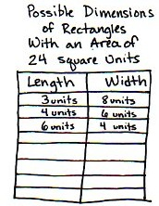
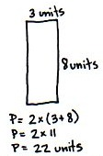
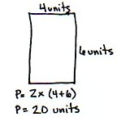

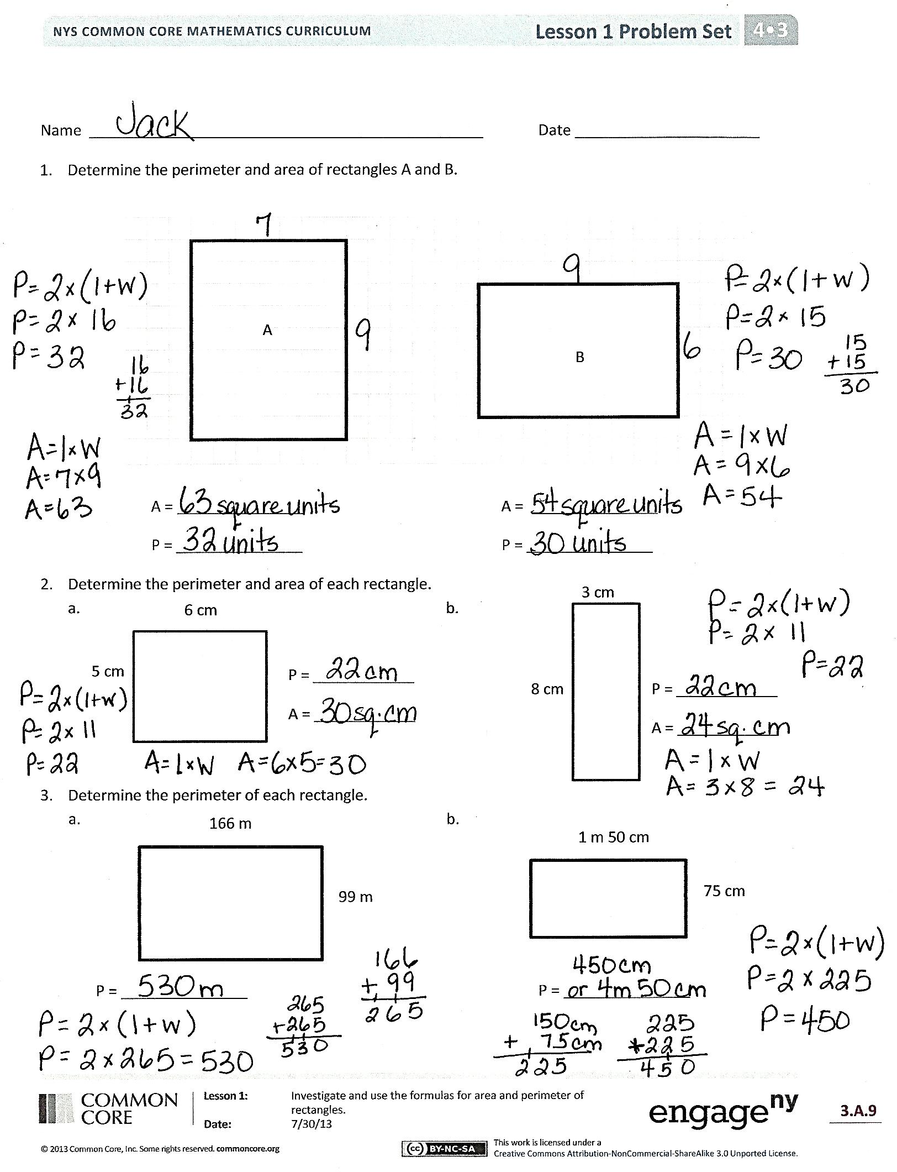
Problem Set (10 minutes)
Students should do their personal best to complete the Problem Set within the allotted 10 minutes. Some problems do not specify a method for solving. This is an intentional reduction of scaffolding that invokes MP.5, Use Appropriate Tools Strategically. Students should solve these problems using the RDW approach used for Application Problems.
For some classes, it may be appropriate to modify the assignment by specifying which problems students should work on first. With this option, let the purposeful sequencing of the Problem Set guide your selections so that problems continue to be scaffolded. Balance word problems with other problem types to ensure a range of practice. Consider assigning incomplete problems for homework or at another time during the day.
Student Debrief (10 minutes)
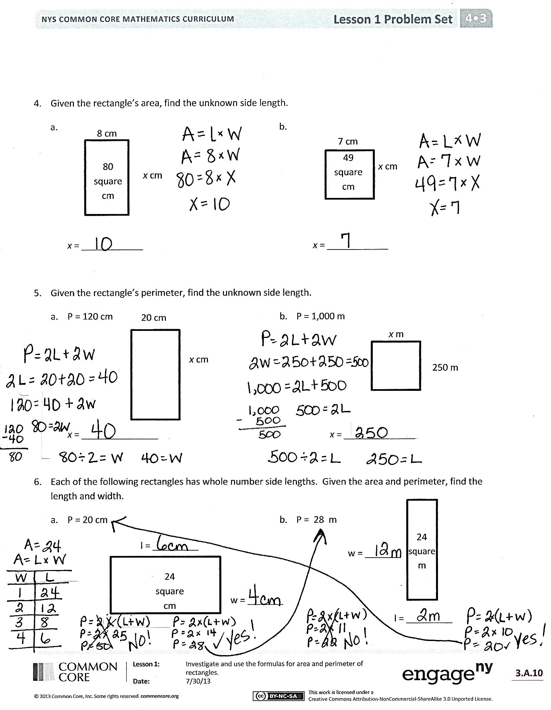
Lesson Objective: Investigate and use the formulas for area and perimeter of rectangles.
The Student Debrief is intended to invite reflection and active processing of the total lesson experience.
Invite students to review their solutions for the Problem Set. They should check work by comparing answers with a partner before going over answers as a class. Look for misconceptions or misunderstandings that can be addressed in the Debrief. Guide students in a conversation to debrief the Problem Set and process the lesson.
You may choose to use any combination of the questions below to lead the discussion.
- What is a formula for solving for perimeter? What formula is most efficient?
- Compare the units used to measure perimeter and the units used to measure area (length units and square units).
- What was challenging about solving Problems 6(a) and 6(b)? How did the process of solving Problems 4 and 5 help you to figure out how to solve Problems 6(a) and 6(b)?
- The perimeters of the rectangles in Problems 2(a) and 2(b) are the same. Why are the areas different?
- The areas of the rectangles in Problems 6(a) and 6(b) are the same. Why are the perimeters different?
- How did you find the answer for the length of the unknown side, x, in Problems 4(a) and 4(b)?
- What was your strategy for finding the length of the unknown side, x, in Problems 5(a) and 5(b)? Discuss with your partner.
- What significant math vocabulary did we use today to communicate precisely?

Exit Ticket (3 minutes)
After the Student Debrief, instruct students to complete the Exit Ticket. A review of their work will help you assess the students’ understanding of the concepts that were presented in the lesson today and plan more effectively for future lessons. You may read the questions aloud to the students.

Name Date
- Determine the perimeter and area of rectangles A and B.

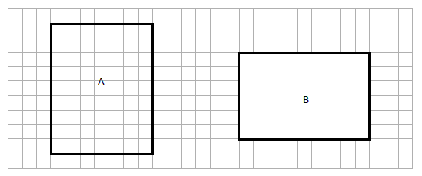

A = _______________

P = _______________

A = _______________
P = _______________

- Determine the perimeter and area of each rectangle.
3 cm
6 cm

P = ____________
A = ____________
5 cm

8 cm
P = ____________
A = ____________

- Determine the perimeter of each rectangle.
166 m

75 cm
1 m 50 cm

99 m

P = _______________ P = _______________

- Given the rectangle’s area, find the unknown side length.

8 cm
x cm
b.
7 cm
49 square cm

x cm
80 square cm

x = ____________

x = ____________

- Given the rectangle’s perimeter, find the unknown side length.
20 cm

- P = 120 cm
x cm
- P = 1,000 m
x m

250 m

x = _______________

x = ______________
- Each of the following rectangles has whole number side lengths. Given the area and perimeter, find the length and width.

  - P = 20 cm
l = _________

24 square cm
- P = 28 m

24 square m
w = _______

w = _______

l = _________
Name Date
- Determine the area and perimeter of the rectangle.
2 cm
8 cm

- Determine the perimeter of the rectangle.
347 m
99 m

Name Date
- Determine the perimeter and area of rectangles A and B.
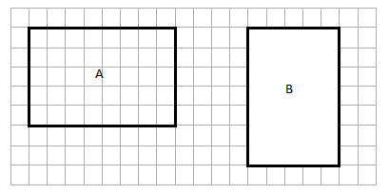

A = _______________

P = _______________

A = _______________
P = _______________

- Determine the perimeter and area of each rectangle.
4 cm
8 cm

3 cm
7 cm

P = _____________

A = ____________
P = ____________

A = ____________
9 cm

- Determine the perimeter of each rectangle.
149 m
76 m

45 cm
2 m 10 cm

P = _______________ P = _______________
- Given the rectangle’s area, find the unknown side length.

6 cm
x cm
60 square cm
25 square m
5 m
x m

x = ____________

x = ____________

- Given the rectangle’s perimeter, find the unknown side length.
40 cm
x cm

- P = 180 cm

- P = 1,000 m
x m
150 m

x = _______________

x = ______________
- Each of the following rectangles has whole number side lengths. Given the area and perimeter, find the length and width.

- A = 32 square cm
P = 24 cm
l = _________
w = _______
36 square m
- A = 36 square m
w = _______
P = 30 m

l = _________
32 square cm

