Lesson 2
Objective: Express metric mass measurements in terms of a smaller unit; model and solve addition and subtraction word problems involving metric mass.

Suggested Lesson Structure

A NOTE ON
STANDARDS ALIGNMENT:
In Module 2, students convert metric mass units to add and subtract mixed units. This lesson builds on the content of 2.MD.5 and 3.MD.2.
Occasionally, students work beyond the 4.MD.1 and 4.MD.2 standards by converting from a smaller unit to a larger unit. They do this by creating a connection between metric units and place value units.
Develop students’ basic number sense to make these conversions, and always accept answers in the smaller unit.
 Fluency Practice (12 minutes)
 Application Problem (8 minutes)
 Concept Development (30 minutes)
 Student Debrief (10 minutes)
Total Time (60 minutes)
Fluency Practice (12 minutes)
- Convert Units 4.MD.1 (4 minutes)
- Unit Counting 4.MD.1 (4 minutes)
- Add and Subtract Meters and Centimeters 4.MD.2 (4 minutes)
Convert Units (4 minutes)
Materials: (S) Personal white board
Note: Isolated review builds fluency with conversion so that students can use this skill as a tool for solving word problems.

NOTES ON
MULTIPLE MEANS
OF REPRESENTATION:
Use color to customize the presentation of the Convert Units activity. Enhance learners’ perception of the information by consistently displaying meters in one color (e.g., red), while displaying centimeters in a different color (e.g., green). In addition, use color to distinguish the two parts of the number bond.

T: (Write 1 m = ___ cm.) 1 meter is how many centimeters?
S: 100 centimeters.
Repeat the process with the following possible sequence: 2 m,
3 m, 9 m, and 6 m.
T: (Write 1,000 g = ____ kg.) 1,000 grams is the same as how many kilograms?
S: 1 kilogram.
Repeat the process with the following possible sequence: 2,000 g, 3,000 g, 7,000 g, and 5,000 g.

T: (Project a number bond with 2 kg written as the whole, 1 kg as one of the parts, and ____ g as the other part.) Fill in the unknown part.
S: (Write a number bond with 2 kg as the whole, 1 kg as one of the parts, and 1,000 g as the other part.)
T: Write the whole as an addition sentence with mixed units.
S: (Write 1 kg + 1,000 g = 1 kg + 1 kg = 2 kg.)
Repeat the process with the following possible sequence: 3 kg = 2 kg + 1,000 g and 5 kg = 4 kg + 1,000 g.
Unit Counting (4 minutes)
Note: This fluency activity deepens student understanding of the composition and decomposition of unit conversions, laying a foundation for adding and subtracting meters and centimeters. The numbers in bold type indicate the point at which the direction of the counting changes.
Direct students to count by 50 cm in the following sequence, letting them know with gestures when to change direction in counting:
- 50 cm, 100 cm, 150 cm, 200 cm, 250 cm, 300 cm, 250 cm, 200 cm, 150 cm, 100 cm, 50 cm.
- 50 cm, 1 m, 150 cm, 2 m, 250 cm, 3 m, 250 cm, 2 m, 150 cm, 1 m, 50 cm.
- 50 cm, 1 m, 1 m 50 cm, 2 m, 2 m 50 cm, 3 m, 2 m 50 cm, 2 m, 1 m 50 cm, 1 m, 50 cm.
Add and Subtract Meters and Centimeters (4 minutes)
Materials: (S) Personal white board
Note: Reviewing this concept from Lesson 1 helps students work towards mastery of adding and subtracting meters and centimeters.
T: (Write 540 cm + 320 cm = ____.) Say 540 centimeters in meters and centimeters.
S: 5 meters 40 centimeters.
T: (Write 5 m 40 cm below 540 cm.) Say 320 centimeters in meters and centimeters.
S: 3 meters 20 centimeters.
T: (Write 3 m 20 cm below 320 cm.) Add the meters.
S: 5 meters + 3 meters = 8 meters.
T: (Write 5 m 40 cm + 3 m 20 cm = ___.) Add the centimeters.
S: 40 centimeters + 20 centimeters = 60 centimeters.
T: (Write 8 m 60 cm as the sum on the line.) Say the addition sentence in centimeters.
S: 540 centimeters + 320 centimeters = 860 centimeters.
T: (Write 420 cm + 350 cm = ____.) On your personal white boards, write 420 cm + 350 cm by representing each number of centimeters as meters and centimeters, and then combining meters and centimeters.
S: (Write 4 m 20 cm + 3 m 50 cm = 7 m 70 cm.)
Repeat the process with the following possible sequence: 650 cm – 140 cm and 780 cm – 210 cm.
Application Problem (8 minutes)
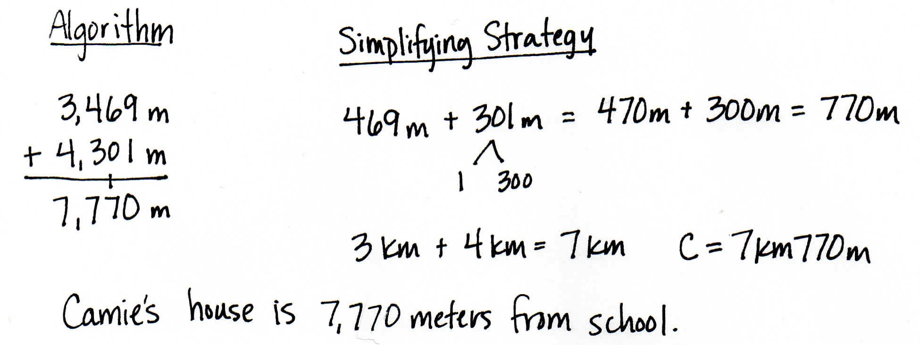
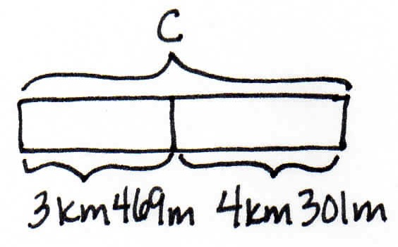
The distance from school to Zoie’s house is 3 kilometers 469 meters. Camie’s house is 4 kilometers 301 meters farther away from Zoie’s. How far is it from Camie’s house to school? Solve using an algorithm or a simplifying strategy.

Note: This Application Problem reviews Lesson 1. Students express a metric measurement in a larger unit in terms of a smaller unit and model and solve an addition word problem involving kilometers and meters. Be sure to discuss why 7,770 m and 7 km 770 m are the same.
Concept Development (30 minutes)
Materials: (T) 1-liter water bottle, 1,000 small paper clips, dollar bill, dictionary, balance scale, weights (1 kg and 1 g) (S) Personal white board
Problem 1: Convert kilograms to grams.
Display the words weight and mass.

NOTES ON TERMINOLOGY:
Mass is a fundamental measure of the amount of matter in an object. While weight is a measurement that depends upon the force of gravity (one would weigh less on the Moon than one does on Earth), mass does not depend upon the force of gravity. We use both words here, but it is not important for students to recognize the distinction at this time.

T: (Hold up a 1-liter bottle of water.) This bottle of water weighs 1 kilogram. We can also say that it has a mass of 1 kilogram. This is what a scientist would say.
T: (Hold up the dictionary.) This dictionary weighs about 1 kilogram.
T: (Hold up the paperclip.) The mass of this small paperclip is about 1 gram. A dollar bill weighs about 1 gram, too.
T: (Write on the board: 1 kilogram = 1,000 grams.) If the mass of this dictionary is about 1 kilogram, about how many small paperclips will be as heavy as this dictionary?
S: 1,000 paper clips.
Take one minute to balance 1 dictionary and 1,000 small paperclips on a scale. Alternatively, use a 1-kilogram mass weight. Also balance 1 small paperclip and a 1-gram weight.
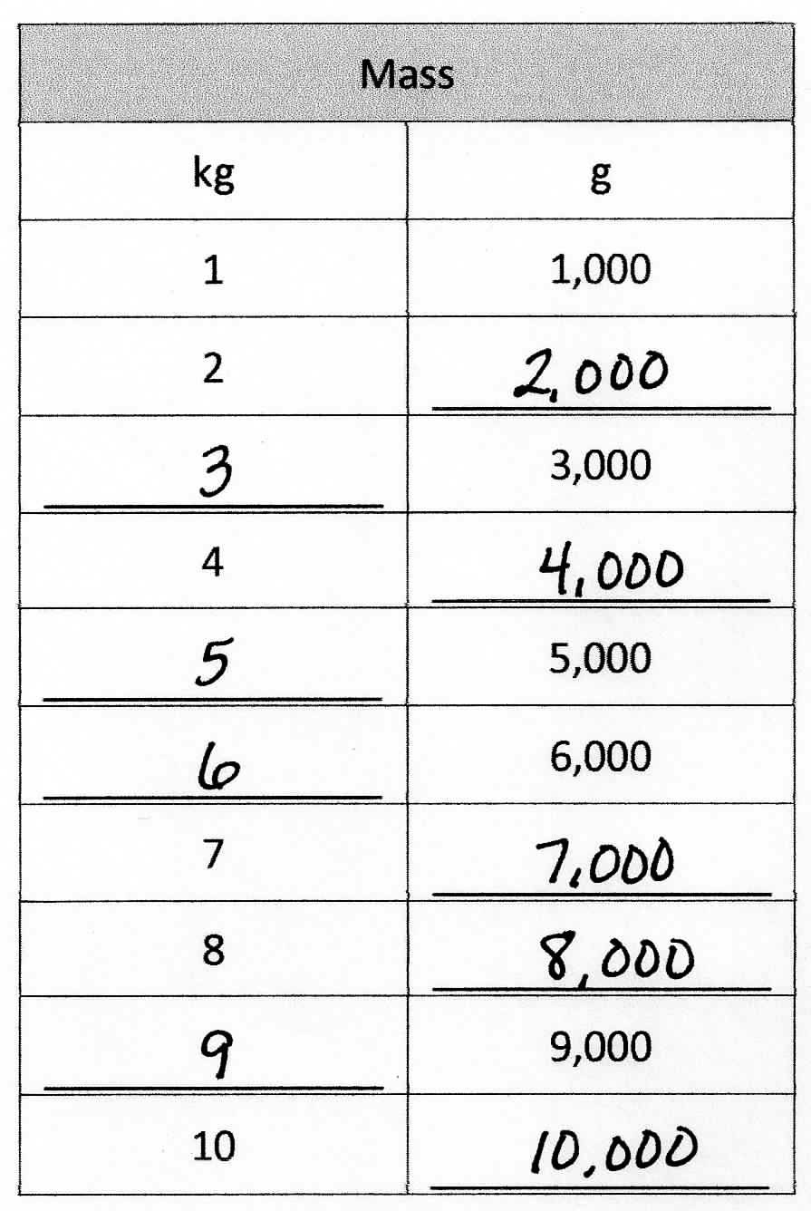
T: Let’s use a chart to show the relationship between kilograms and grams.
T: (Display a two-column chart, and fill it in together.) We know that 1 kilogram equals 1,000 grams.
T: How many grams is 2 kilograms?
S: 2,000 g.
MP.8
T: How many kilograms is 3,000 grams?
S: 3 kg.
Continue up to 10 kilograms.
T: Compare kilograms and grams.
S: A kilogram is heavier because we need 1,000 grams to equal 1 kilogram. 1 kilogram is 1,000 times as much as 1 gram.
T: (Display 1 kg 500 g = ______ g.) Let’s convert 1 kg 500 g to grams. 1 kilogram is equal to how many grams?
S: 1,000 grams.
T: 1,000 grams plus 500 grams is 1,500 grams. (Fill in the blank.)
T: (Display 1 kg 300 g = ___ g.) 1 kg 300 g is equal to how many grams?
S: 1,300 grams.
Repeat with 5 kg 30 g. (Anticipate the incorrect answer of 530 g.)
T: 2,500 grams is equal to how many kilograms?
S: 2 kg 500 g. We made two groups of 1,000 grams, so we have 2 kilograms and 500 grams.
Repeat with 5,005 g.
Problem 2: Add mixed units of mass using the algorithm or a simplifying strategy.
T: (Display horizontally: 8 kg + 8,200 g.) Talk for one minute with your partner about how to solve this problem.
S: We can’t add different units together. We can convert the kilograms to grams before adding.
We can rename 8 kg to 8,000 g. 8,000 g + 8,200 g = 16,200 g. We can rename 8,200 g to
8 kg 200 g.
T: Are you going to use the algorithm or a simplifying strategy?
S: A simplifying strategy!
T: Why?
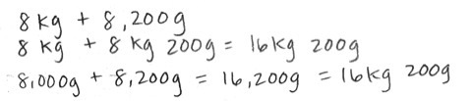
S: There is no regrouping. I can add the numbers easily in my head. 8,200 g = 8 kg 200 g. 8 kg 200 g + 8 kg = 16 kg 200 g.
T: (Display horizontally: 25 kg 537 g + 5 kg 723 g.) A simplifying strategy or the algorithm? Discuss with your partner.
S: I think the algorithm because the numbers are too big. There is regrouping and the numbers are not easy to combine. I think I can use a simplifying strategy.
T: Choose the way you want to do it. You will have two minutes. If you finish before the two minutes are up, try solving it a different way. Let’s have two pairs of students work at the board, one pair using the algorithm, one pair recording a simplifying strategy.

NOTES ON
MULTIPLE MEANS
OF ENGAGEMENT:
Vary your demands and provide supportive tools (e.g., calculators) to students as they meet the challenge of regrouping, conversions, and two methods of solving. Students working below grade level may benefit from mastering one method of solving first. Or, consider altering the degree of difficulty of the computations.

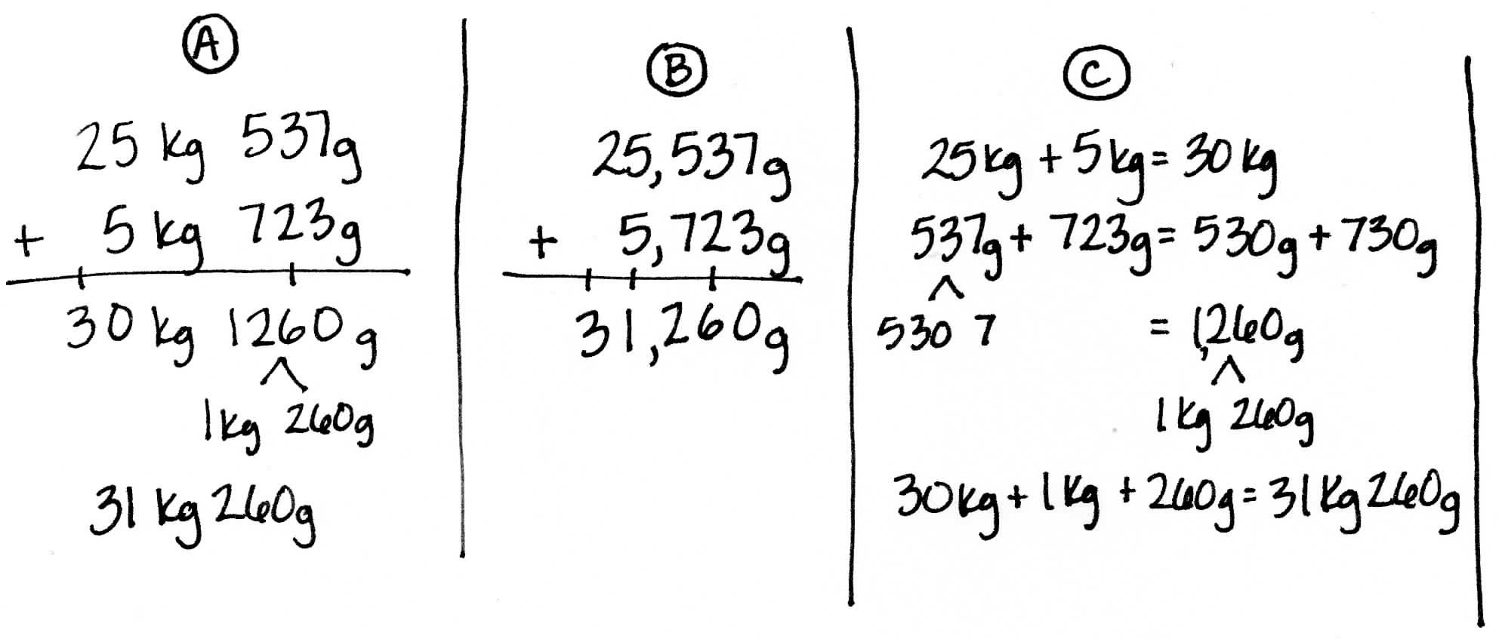
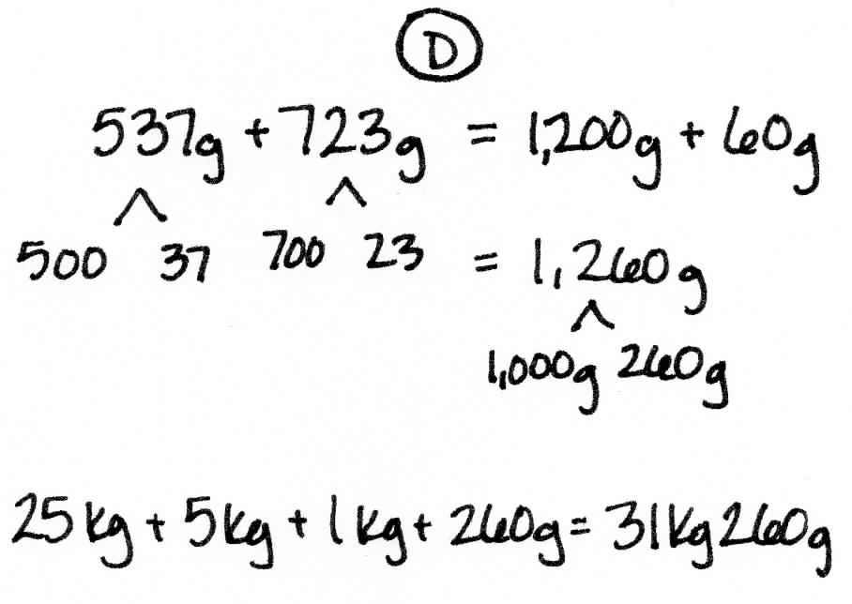
After two minutes, review the student work on the board, which hopefully includes strategies such as those below. If not, gently supplement or provide alternative solutions such as the ones below. Solutions A and B use an algorithm. Solutions C and D are simplifying strategies.

Note: Students have been learning numerous simplifying strategies since Grade 1. These are only two of the strategies they may have learned. Encourage students to compare their strategies as they work through each problem they solve mentally.
Problem 3: Subtract mixed units of mass using the algorithm or a simplifying strategy.
T: (Display horizontally: 10 kg – 2 kg 250 g.) A simplifying strategy or the algorithm? Discuss with a partner.
S: There are no grams in the number I’m subtracting from, so I’m going to use the algorithm. This is like 10 thousand minus 2 thousand 250. I’m going to use the algorithm, because there is a lot of regrouping. I think I can do this with a simplifying strategy, because we are subtracting from
10 kg.
T: Choose the way you want to do it. You will have two minutes. If you finish before two minutes is up, try solving the other way. Let’s have two pairs of students work at the board, one pair using the algorithm, one pair recording a simplifying strategy.
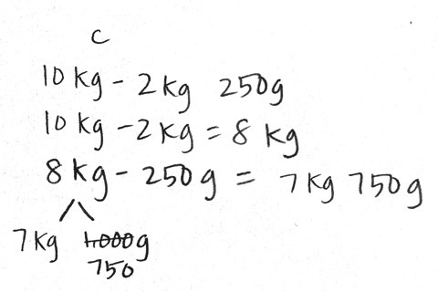
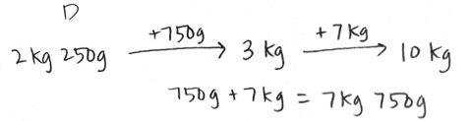
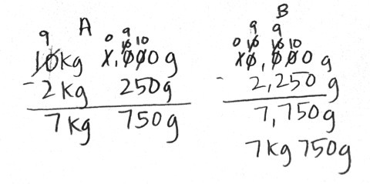
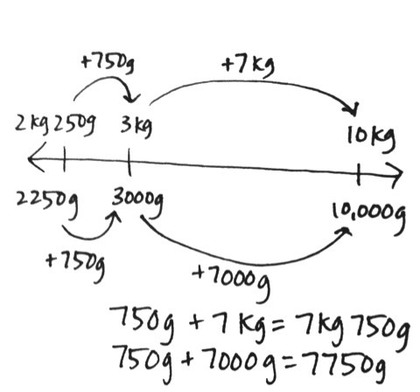

After two minutes, review the student work on the board, which hopefully includes strategies such as those above. If not, gently supplement or provide alternative solutions such as the ones shown above. Solutions A and B use an algorithm. Solutions C, D, and E are simplifying strategies.
T: Look at the first algorithm used by your peers. How did they prepare the problem for subtraction?
S: They renamed 10 kilograms as 9 kilograms and 1,000 grams first.
T: What did they do in their second solution?
S: Converted kilograms to grams.
T: How did our first simplifying strategy pair solve the problem?
S: They subtracted the 2 kilograms first.
T: And then?
S: Subtracted the 250 grams from 1 kilogram.
T: Does anyone have a question for the simplifying strategy math team?
S: How did you know 1 thousand minus 250 was 750?
S: We just subtracted 2 hundred from 1 thousand and then thought of 50 less than 800.
T: How did the next simplifying strategies team solve the problem?
S: They added up from 2 kilograms 250 grams to 3 kilograms first, and then added 7 more kilograms to get to 10 kilograms.
T: What does the number line show?
S: It shows how we can count up from 2 kilograms 250 grams to 10 kilograms to find our answer. It also shows that 7 kilograms 750 grams is equivalent to 7,750 grams.
T: With your partner, take a moment to review the solution strategies on the board.
T: (Display horizontally: 32 kg 205 g – 5 kg 316 g.) A simplifying strategy or the algorithm? Discuss with a partner.
S: Those numbers are not easy to subtract. I’m going to use the algorithm. Definitely the algorithm. There are not enough grams in the first number so I know we will have to regroup.
T: Choose the way you want to do it and solve.
Note: Not all problems are easily solved using a simplifying strategy. Encourage students to evaluate the problem carefully to determine the most efficient course for solving problems.
Problem 4: Solve a word problem involving mixed units of mass, modeled with a tape diagram.
A suitcase cannot weigh more than 23 kilograms for a flight. Robert packed his suitcase for his flight, and it weighs 18 kilograms 705 grams. How many more grams can he add to his suitcase without going over the weight limit?
T: Read with me. Take one minute to draw and label a tape diagram. (Allow students time to work.)
T: Tell your partner the known and unknown information.
S: We know how much Robert’s suitcase is allowed to weigh and how much it already weighs. We don’t know how many more grams it can hold to reach the maximum allowed weight of 23 kilograms.
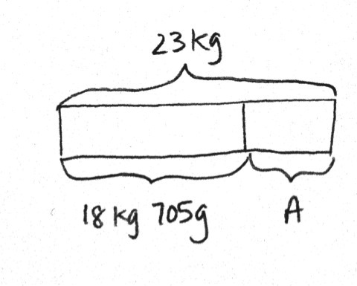
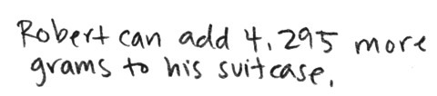
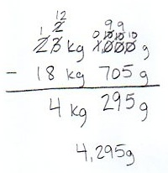
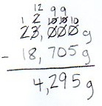
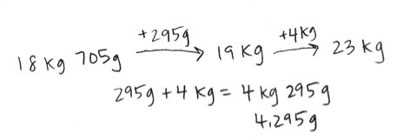
T: Will you use the algorithm or a simplifying strategy? Label the missing part on your diagram and make a statement of the solution.

Circulate, reviewing the students’ work, which hopefully includes strategies such as those above. If not, gently supplement. Solutions A and B use the algorithm. Solution C is a simplifying strategy.
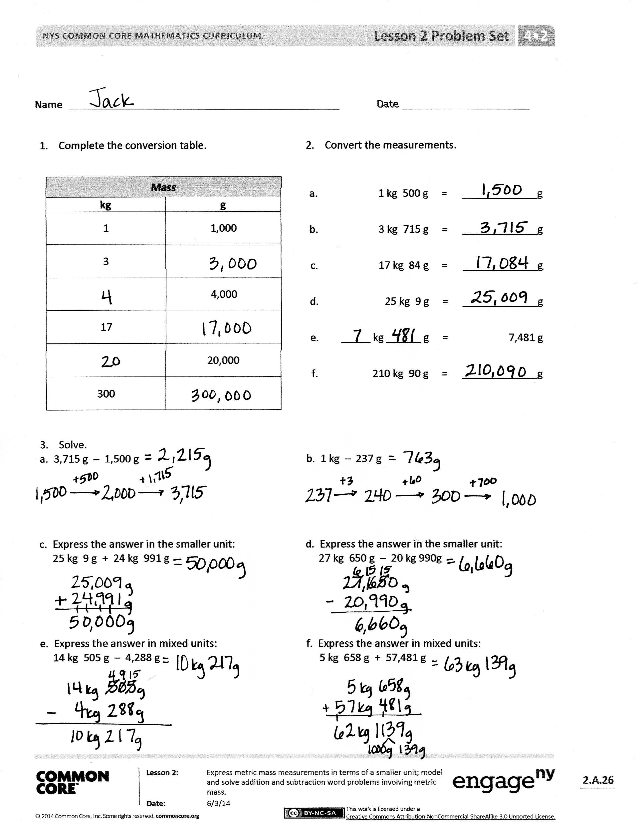
Problem Set (10 minutes)
Students should do their personal best to complete the Problem Set within the allotted 10 minutes. For some classes, it may be appropriate to modify the assignment by specifying which problems they work on first. Some problems do not specify a method for solving. Students should solve these problems using the RDW approach used for Application Problems.
Student Debrief (10 minutes)
Lesson Objective: Express metric mass measurements in terms of a smaller unit; model and solve addition and subtraction word problems involving metric mass.
The Student Debrief is intended to invite reflection and active processing of the total lesson experience.
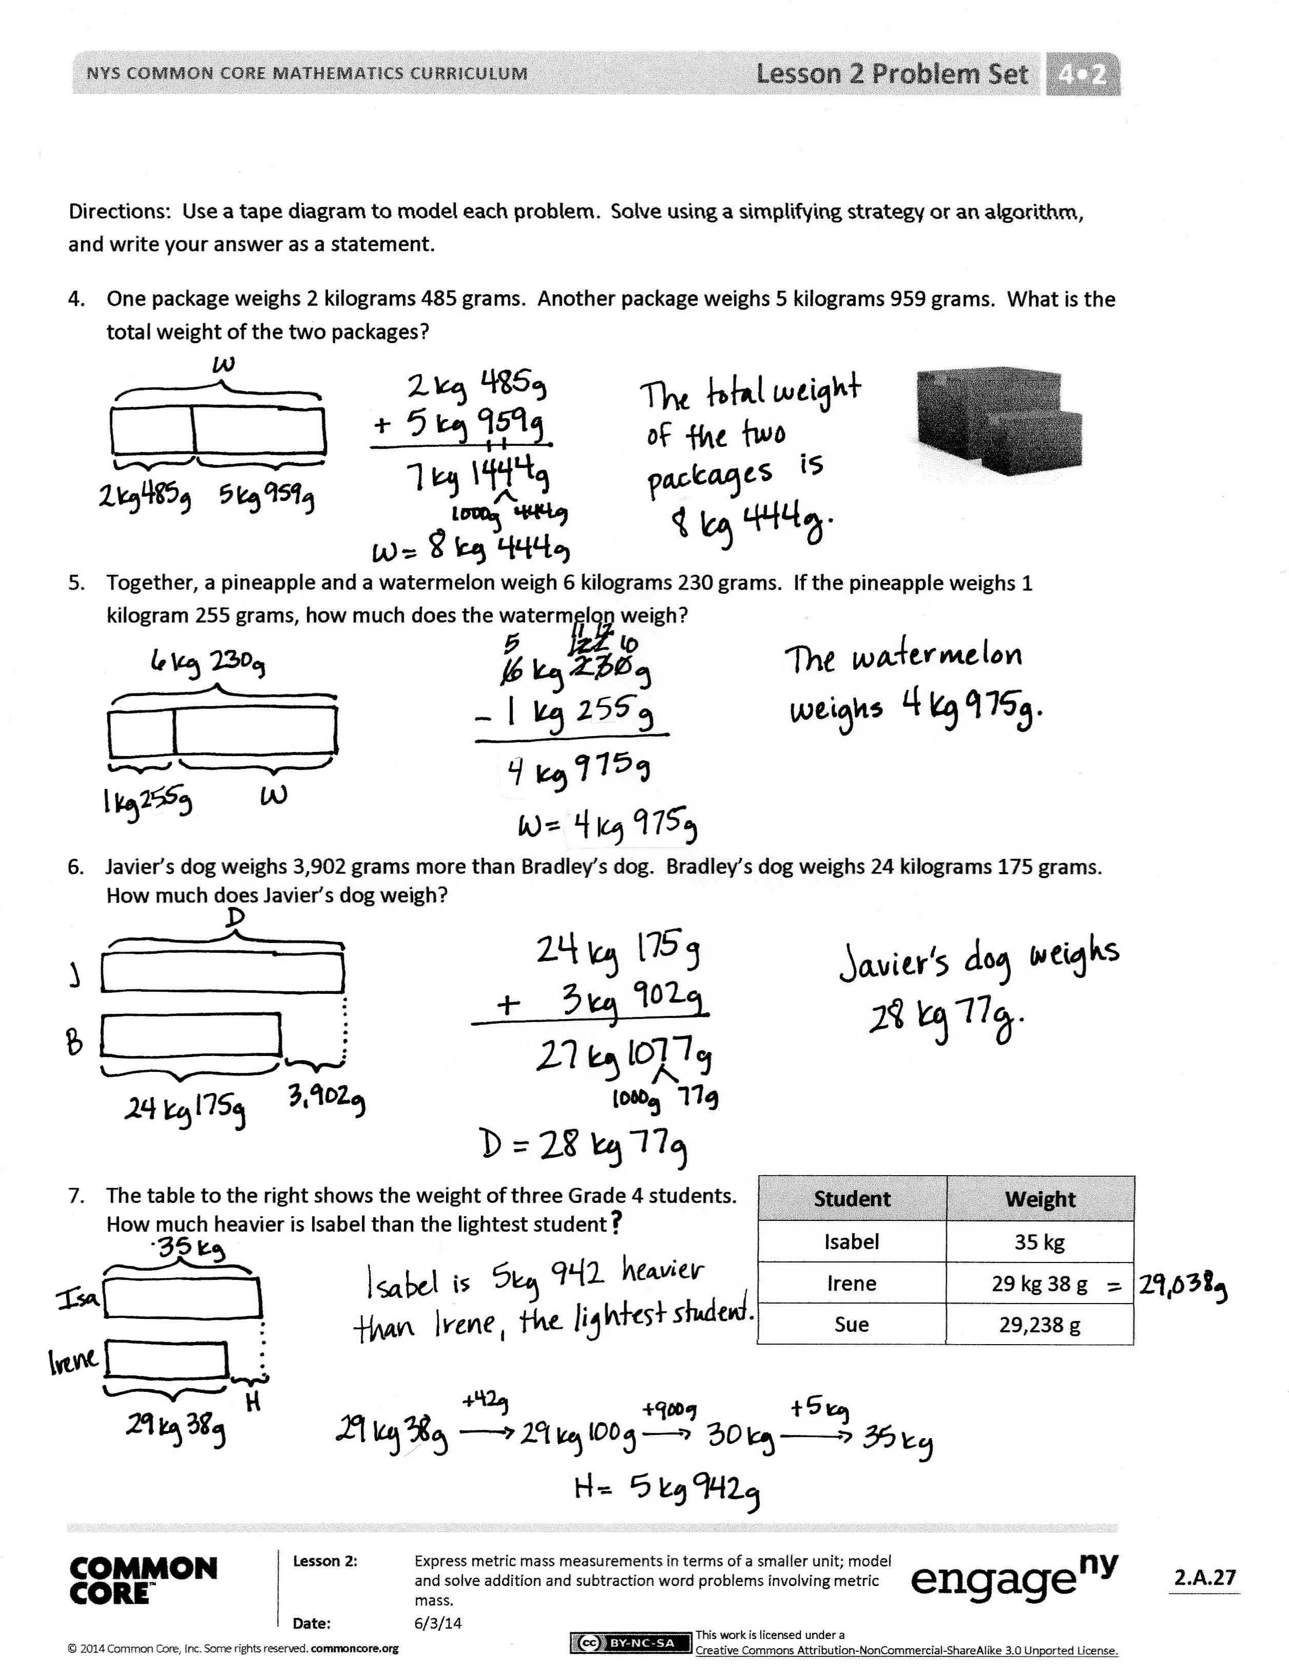
Invite students to review their solutions for the Problem Set. They should check work by comparing answers with a partner before going over answers as a class. Look for misconceptions or misunderstandings that can be addressed in the Debrief. Guide students in a conversation to debrief the Problem Set and process the lesson.
You may choose to use any combination of the questions below to lead the discussion.
- In our lesson, we solved addition and subtraction problems two different ways but got equivalent answers. Is one answer better than the other? Why or why not?
- What did you do differently in Problem 3 when it asked you to express the answer in the smaller unit versus in mixed units?
- In Problem 6, did it make sense to answer in the smallest unit or mixed units? Why? When might it be better to answer in the smallest unit?
- Explain to your partner how you solved Problem 7. Was there more than one way to solve it?
- How did the Application Problem connect to today’s lesson?
- How did today’s lesson of weight conversions build on yesterday’s lesson of length conversions?
- What is mass?
- When might we use grams rather than kilograms?
Exit Ticket (3 minutes)
After the Student Debrief, instruct students to complete the Exit Ticket. A review of their work will help you assess the students’ understanding of the concepts that were presented in the lesson today and plan more effectively for future lessons. You may read the questions aloud to the students.
Name Date

- Complete the conversion table.
Mass
kg | g
1 | 1,000
3
 | 4,000
17
 | 20,000
300

- Convert the measurements.
Mass
kg | g
1 | 1,000
3
 | 4,000
17
 | 20,000
300

a. | 1 kg 500 g | = | _____________ g
b. | 3 kg 715 g | = | _____________ g
c. | 17 kg 84 g | = | _____________ g
d. | 25 kg 9 g | = | _____________ g
e. | _____ kg ______ g | = | 7,481 g
f. | 210 kg 90 g | = | _____________ g

- Solve.
- 3,715 g – 1,500 g b. 1 kg – 237 g

- Express the answer in the smaller unit: d. Express the answer in the smaller unit:
25 kg 9 g + 24 kg 991 g 27 kg 650 g – 20 kg 990 g

- Express the answer in mixed units: f. Express the answer in mixed units:
14 kg 505 g – 4,288 g 5 kg 658 g + 57,481 g

Use a tape diagram to model each problem. Solve using a simplifying strategy or an algorithm, and write your answer as a statement.
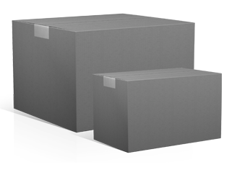
- One package weighs 2 kilograms 485 grams. Another package weighs 5 kilograms 959 grams. What is the total weight of the two packages?

- Together, a pineapple and a watermelon weigh 6 kilograms 230 grams. If the pineapple weighs 1 kilogram 255 grams, how much does the watermelon weigh?

- Javier’s dog weighs 3,902 grams more than Bradley’s dog. Bradley’s dog weighs 24 kilograms 175 grams. How much does Javier’s dog weigh?

Student | Weight
Isabel | 35 kg
Irene | 29 kg 38 g
Sue | 29,238 g
- The table to the right shows the weight of three Grade 4 students. How much heavier is Isabel than the lightest student?

Name Date
- Convert the measurements.

- 21 g 415 g = __________ g
- 2 kg 91 g = __________ g
- 87 kg 17 g = __________ g
- ____ kg _____ g = 96,020 g

Use a tape diagram to model the following problem. Solve using a simplifying strategy or an algorithm, and write your answer as a statement.
Dog | Weight
Great Dane | 59 kg
Golden Retriever | 32 kg 48 g
Chihuahua | 1,329 g
- The table to the right shows the weight of three dogs. How much more does the Great Dane weigh than the Chihuahua?

Name Date

- Complete the conversion table.
- Convert the measurements.
Mass
kg | g
1 | 1,000
6
 | 8,000
15
 | 24,000
550
a. | 2 kg 700 g | = | _____________ g
b. | 5 kg 945 g | = | _____________ g
c. | 29 kg 58 g | = | _____________ g
d. | 31 kg 3 g | = | _____________ g
e. | 66,597 g | = | _____ kg _______ g
f. | 270 kg 41 g | = | _____________ g

- Solve.

  - 370 g + 80 g

  - 5 kg – 730 g

  - Express the answer in the smaller unit:
27 kg 547 g + 694 g

  - Express the answer in the smaller unit:
16 kg + 2,800 g

  - Express the answer in mixed units:
4 kg 229 g – 355 g

  - Express the answer in mixed units:
70 kg 101 g – 17 kg 862 g
Use a tape diagram to model each problem. Solve using a simplifying strategy or an algorithm, and write your answer as a statement.
- One suitcase weighs 23 kilograms 696 grams. Another suitcase weighs 25 kilograms 528 grams. What is the total weight of the two suitcases?

- A bag of potatoes and a bag of onions combined weigh 11 kilograms 15 grams. If the bag of potatoes weighs 7 kilograms 300 grams, how much does the bag of onions weigh?

- The table below shows the weight of three dogs. What is the difference in weight between the heaviest and lightest dog?

Dog | Weight
Lassie | 21 kg 249 g
Riley | 23 kg 128 g
Fido | 21,268 g

