Lesson 1
Objective: Express metric length measurements in terms of a smaller unit; model and solve addition and subtraction word problems involving metric length.

Suggested Lesson Structure

A NOTE ON
STANDARDS ALIGNMENT:
In this lesson and the entire module, students convert metric length units in the context of addition and subtraction problems involving mixed units. This lesson builds on the content of 2.MD.5 and 3.MD.2.
On some occasions, students work beyond the 4.MD.1 and 4.MD.2 standards by converting from a smaller unit to a larger unit. They do this by creating a connection between units of measures related to place value.
If students are not ready for the conversions up, have them work in small groups to further develop the number sense necessary for understanding these conversions, and always accept answers in the smaller unit.

 Fluency Practice (10 minutes)
 Application Problem (8 minutes)
 Concept Development (32 minutes)
 Student Debrief (10 minutes)
Total Time (60 minutes)
Fluency Practice (10 minutes)
- Convert Units 4.MD.1 (2 minutes)
- Meter and Centimeter Number Bonds 4.MD.1 (8 minutes)
Convert Units (2 minutes)
Note: Isolated review builds fluency with conversion so that students can use this skill as a tool for solving word problems.
T: (Write 100 cm = ____ m.) 100 centimeters is the same as how many meters?
S: 1 meter.
Repeat the process with the following possible sequence: 200 cm, 300 cm, 800 cm, and 500 cm.
T: (Write 1 m = ____ cm.) How many centimeters are in 1 meter?
S: 100 centimeters.
Repeat the process with the following possible sequence: 2 m, 3 m, 7 m, 4 m, and 9 m.

Meter and Centimeter Number Bonds (8 minutes)
Materials: (S) Personal white board
Note: This fluency activity prepares students to add and subtract meters and centimeters later in the lesson.
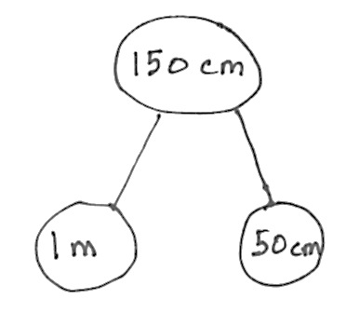
T: (Project a number bond with 150 cm written as the whole and 1 m as one of the parts.) How many centimeters are in 1 meter?
S: 100 centimeters.
T: (Beneath 1 m, write 100 cm.) On your personal white boards, write a number bond filling in the unknown part.
S: (Write a number bond with a whole of 150 cm and parts of 1 m and 50 cm.)
Repeat the process with wholes of 180 cm, 120 cm, 125 cm, 105 cm, and 107 cm.
T: (Project a number bond with 2 m written as the whole, 1 m as one of the parts, and ____ cm as the other part.) Fill in the unknown part.
S: (Write a number bond with 2 m as the whole, 1 m as one of the parts, and 100 cm as the other part.)
T: Show a number bond with a whole of 3 meters and pull out 100 centimeters. Name the other part in meters.
S: (Draw a number bond with 3 m as the whole, 100 cm as one of the parts, and 2 m as the other part.)
Repeat the process with the following possible sequence: 5 meters, 8 meters, 9 meters, and 10 meters.
Application Problem (8 minutes)
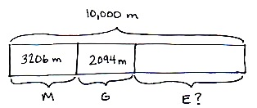
Martha, George, and Elizabeth sprint a combined distance of 10,000 meters. Martha sprints 3,206 meters. George sprints 2,094 meters. How far does Elizabeth sprint? Solve using an algorithm or a simplifying strategy.

Note: This Application Problem builds on G4–M1–Lesson 19. Note that Solution A models the standard algorithm whereas Solution B records a simplifying strategy using number bonds. A number bond demonstrates part–whole relationships and is a way to record completing a whole or taking part from a whole. This Application Problem leads to the Concept Development of this lesson because the problem involves the metric unit of a meter.
Concept Development (32 minutes)
Materials: (T) Staples, ruler, meter stick, teacher-made poster with metric units (shown below) (S) Personal white board
Problem 1: Understand 1 centimeter, 1 meter, and 1 kilometer in terms of concrete objects.
Begin with a five-minute discussion about the length of a centimeter, meter, and kilometer.
- Use familiar, concrete examples such as a staple, the height of a countertop, and the distance to a local landmark that you know to be about 1 kilometer.

NOTES ON
MULTIPLE MEANS
OF REPRESENTATION:
English language learners may benefit from further discussion of concrete items that are about the same length as a centimeter, meter, or kilometer. Write examples on index cards of items that are a centimeter, a meter, or a kilometer in length. Have students place them in the appropriate columns of a chart. Provide students with blank index cards so they can create their own cards to add to the chart.

- Have students measure the size of concrete examples that are given using centimeters and/or meters.
- Display a chart such as the one shown below.
- Add other examples to the chart, such as the width of a fingernail, the width of a door, the distance of two and a half laps around a running track, the length of a base ten cube, the height of a stack of five pennies, the outstretched arms of a child, and the distance around a soccer field four times. Show a meter stick to reference the exact size of a centimeter and a meter.

NOTES ON
MULTIPLE MEANS
OF ENGAGEMENT:
Ask students where they have heard the prefix kilo- before. As they learned in Grade 3, 1 kilogram equals 1,000 grams, so 1 kilometer equals 1,000 meters. Ask how many bytes are in 1 kilobyte.

Problem 2: Compare the sizes and note relationships between meters and kilometers as conversion equivalencies.
Use a two-column table, as pictured to the right, to support the following sequence.
T: 1 km = 1,000 m. How many meters are in 2 km? 3 km? 7 km? 70 km?
MP.7
S: 2,000 m, 3,000 m, 7,000 m, 70,000 m.
T: Write 2,000 m = ____ km on your board. If 1,000 m equals 1 km, 2,000 m equals how many kilometers?
S: 2 kilometers.
Repeat for 8,000 m, 10,000 m, and 9,000 m.
T: Compare kilometers and meters.
S: A kilometer is a longer distance because we need 1,000 meters to equal 1 kilometer. 1 kilometer is 1,000 times as much as 1 meter.
T: (Display 1 km 500 m = ______ m.) Let’s convert, or rename, 1 km 500 m to meters. 1 kilometer is equal to how many meters?
S: 1,000 meters.
T: 1,000 meters plus 500 meters is 1,500 meters. (Fill in the blank.)
T: (Display 1 km 300 m = ___ m.) 1 kilometer 300 meters is equal to how many meters?
S: 1,300 meters.
Repeat with 5 km 30 m. (Anticipate the incorrect answer of 530 m.)
T: 2,500 meters is equal to how many kilometers? How do you know?
S: 2 km 500 m. We made two groups of 1,000 meters, so we have 2 kilometers and 500 meters.
Repeat with 5,005 m.
Problem 3: Add mixed units of length using the algorithm or simplifying strategies.
Display horizontally: 5 km + 2,500 m.
T: Talk for one minute with your partner about how to solve this problem.
S: We can’t add different units together. We can convert the kilometers to meters before adding. 5 kilometers equals 5,000 meters, so 5,000 m + 2,500 m = 7,500 m. I’m going to rename 7,500 m to 7 km 500 m.
T: Renaming 7,500 m to 7 km 500 m created a mixed unit. Mixed units can be helpful when using a simplifying strategy.
T: Are you going to use the algorithm or a simplifying strategy to solve?
S: Simplifying strategy.
T: Why?
S: There is no regrouping. The units are easy to combine. It’s just like adding place value units.
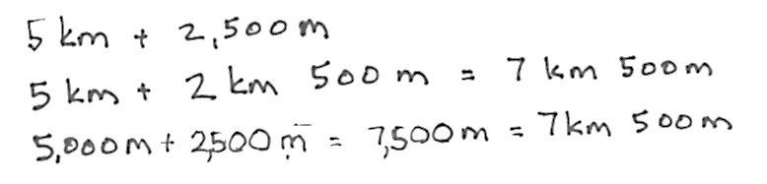

NOTES ON
MULTIPLE MEANS
OF REPRESENTATION:
Students performing below grade level may struggle with the concept of regrouping in order to add or subtract mixed units. Be sure to relate regrouping back to the work done in the fluency activity and in Problem 1. Explicitly show them the connection between the conversions that they learned to make and how that applies to adding and subtracting with mixed units. Consider the following:
We can’t add different units together. If I need to convert 5 kilometers to meters, and I know 1 kilometer is equal to 1,000 meters, then 5 kilometers equals 5,000 meters. Now, I can add 5,000 meters and 2,500 meters.

T: When we added meters, the answer was 7,500 m. When we added mixed units, the answer was 7 km 500 m. Are these answers equal? Why or why not?
S: It is the same amount because 7 km = 7,000 m and 7,000 m + 500 m = 7,500 m.
T: (Display horizontally: 1 km 734 m + 4 km 396 m.) Simplifying strategy or the algorithm? Discuss with a partner.
S: Simplifying strategy, because 7 hundred plus 3 hundred is 1 thousand. 1 thousand meters equals 1 kilometer. 96 + 34 is easy, since the 4 gets 96 to 100. 6 kilometers, 130 meters. But there are three renamings, and the sum of the meters is more than a thousand. My head is spinning. I’m going to try it mentally and then check with the algorithm.
T: Choose the way you want to do it. You will have two minutes. If you finish before the two minutes are up, try solving it a different way. Let’s have two pairs of students work at the board, one pair using the algorithm and one pair recording a simplifying strategy.
After two minutes, review the student work on the board, which hopefully includes strategies such as those below. If not, gently supplement or provide alternative solutions as shown below. Solutions A and B use the algorithm. Solutions C and D are simplifying strategies.
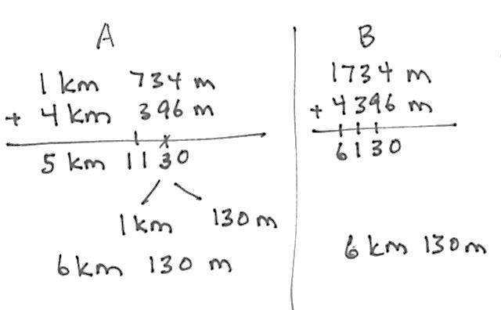
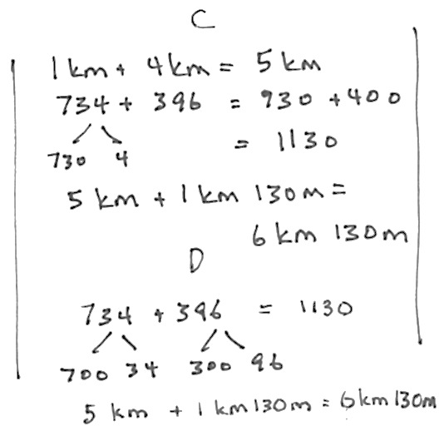

Problem 4: Subtract mixed units of length using the algorithm or simplifying strategies.
T: (Display horizontally: 10 km – 3 km 140 m.) Simplifying strategy or the algorithm? Discuss with a partner.
S: Oh, for sure, I’m using the algorithm. There are no meters in the number I’m subtracting from. That’s like 10 thousand minus 3 thousand 140. Algorithm for me. I can do mental math. I’ll show you when we solve.
T: Choose the way you want to do it. You will have two minutes. If you finish before the two minutes are up, try solving it a different way. Let’s have two pairs of students work at the board, one pair using the algorithm and one pair recording a simplifying strategy.
After two minutes, review the student work on the board, which hopefully includes strategies such as those below. If not, gently supplement or provide alternative solutions as shown below. Solutions A and B use the algorithms. Solutions C and D are simplifying strategies.
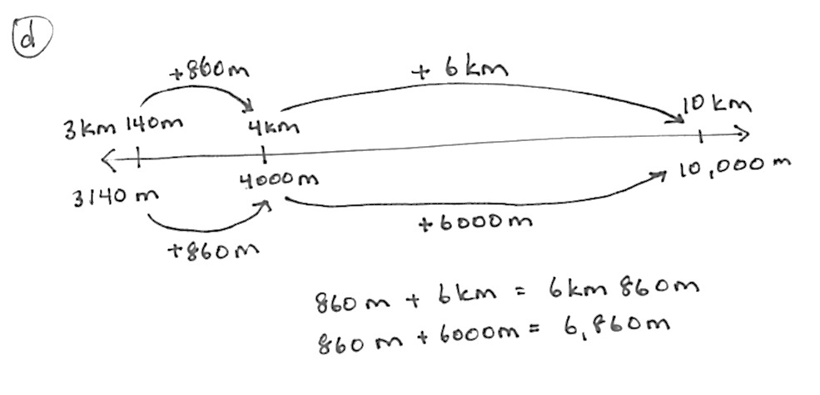
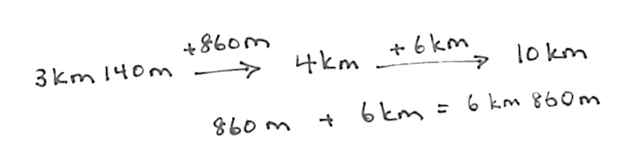
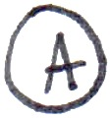

T: Look at Solution A. How did they set up to solve using the algorithm?

A NOTE ON
STANDARDS ALIGNMENT:
The concept of converting the answer into mixed units reaches beyond the fourth-grade standard. For those students working above grade level, acknowledge the conversion. Students working at or below grade level are not expected to convert their answers.

S: They converted everything to meters.
T: What did they do in Solution B?
S: They renamed 1 kilometer for 1,000 meters right away.
T: What happened in Solution C?
S: They subtracted the 3 kilometers first.
T: And then?
S: Subtracted the meters from 1 kilometer after renaming 1 kilometer as 1,000 meters.
T: Does anyone have a question for the mental math team?
S: How did you know 1 thousand minus 140 was 860?
S: We just subtracted 1 hundred and then thought of 40 less than 900. We know 6 tens and 4 tens is 1 hundred, so it wasn’t too hard.
T: What about Solution D?
S: They used a number line to show a counting up strategy. It’s like Solution E. They just represented it in a different way.
T: And Solution E?
S: They counted up from 3 km 140 m to 4 km first and then added 6 more km to get to 10 km.
T: With your partner, take a moment to review the solution strategies on the board. Tell your partner why 6 km 860 m is equal to 6,860 m.
S: The number line team showed 6 km 860 m is equal to 6,860 m by matching kilometers to meters. You can regroup 6 kilometers as 6,000 meters. You can regroup 6,000 meters as 6 kilometers. Both are the same amounts, but they are represented using different units, either mixed or a single unit.
Problem 5: Solve a word problem involving mixed units of length using the algorithm or simplifying strategies.
Sam practiced his long jump in P.E. On his first attempt, he jumped 1 meter 47 centimeters. On his second attempt, he jumped 98 centimeters. How much farther did Sam jump on his first attempt than his second?
T: Take two minutes with your partner to draw a tape diagram to model this problem. (Circulate as students work.)
T: Your diagrams show a comparison between two values. How can you solve for the unknown?
S: Subtract 98 cm from 1 m 47 cm.
T: Will you use the algorithm or a simplifying strategy?
As before, invite two pairs to the board to solve as others work at their desks. Solution A shows the algorithm. Solutions B, C, and D show simplifying strategies.

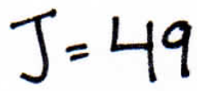
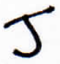
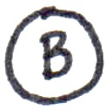
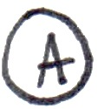

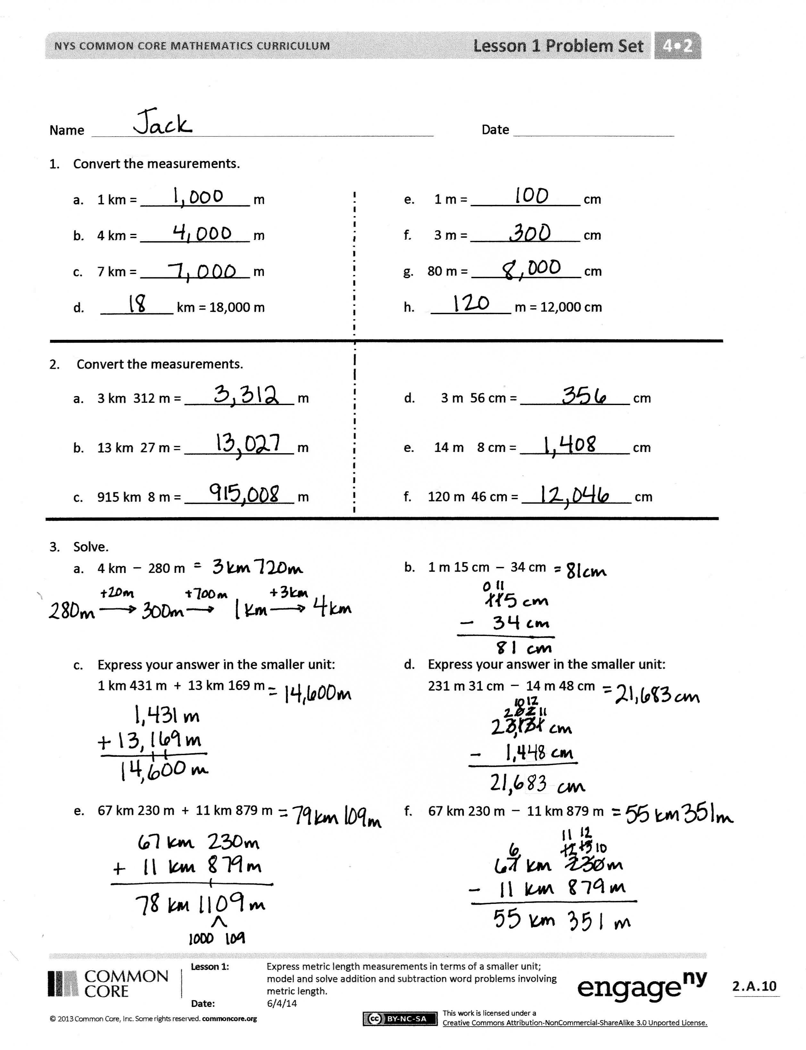
Problem Set (10 minutes)
Students should do their personal best to complete the Problem Set within the allotted 10 minutes. Some problems do not specify a method for solving. This is an intentional reduction of scaffolding that invokes MP.5, Use Appropriate Tools Strategically. Students should solve these problems using the RDW approach used for Application Problems.
For some classes, it may be appropriate to modify the assignment by specifying which problems students should work on first. With this option, let the purposeful sequencing of the Problem Set guide your selections so that problems continue to be scaffolded. Balance word problems with other problem types to ensure a range of practice. Consider assigning incomplete problems for homework or at another time during the day.
Student Debrief (10 minutes)
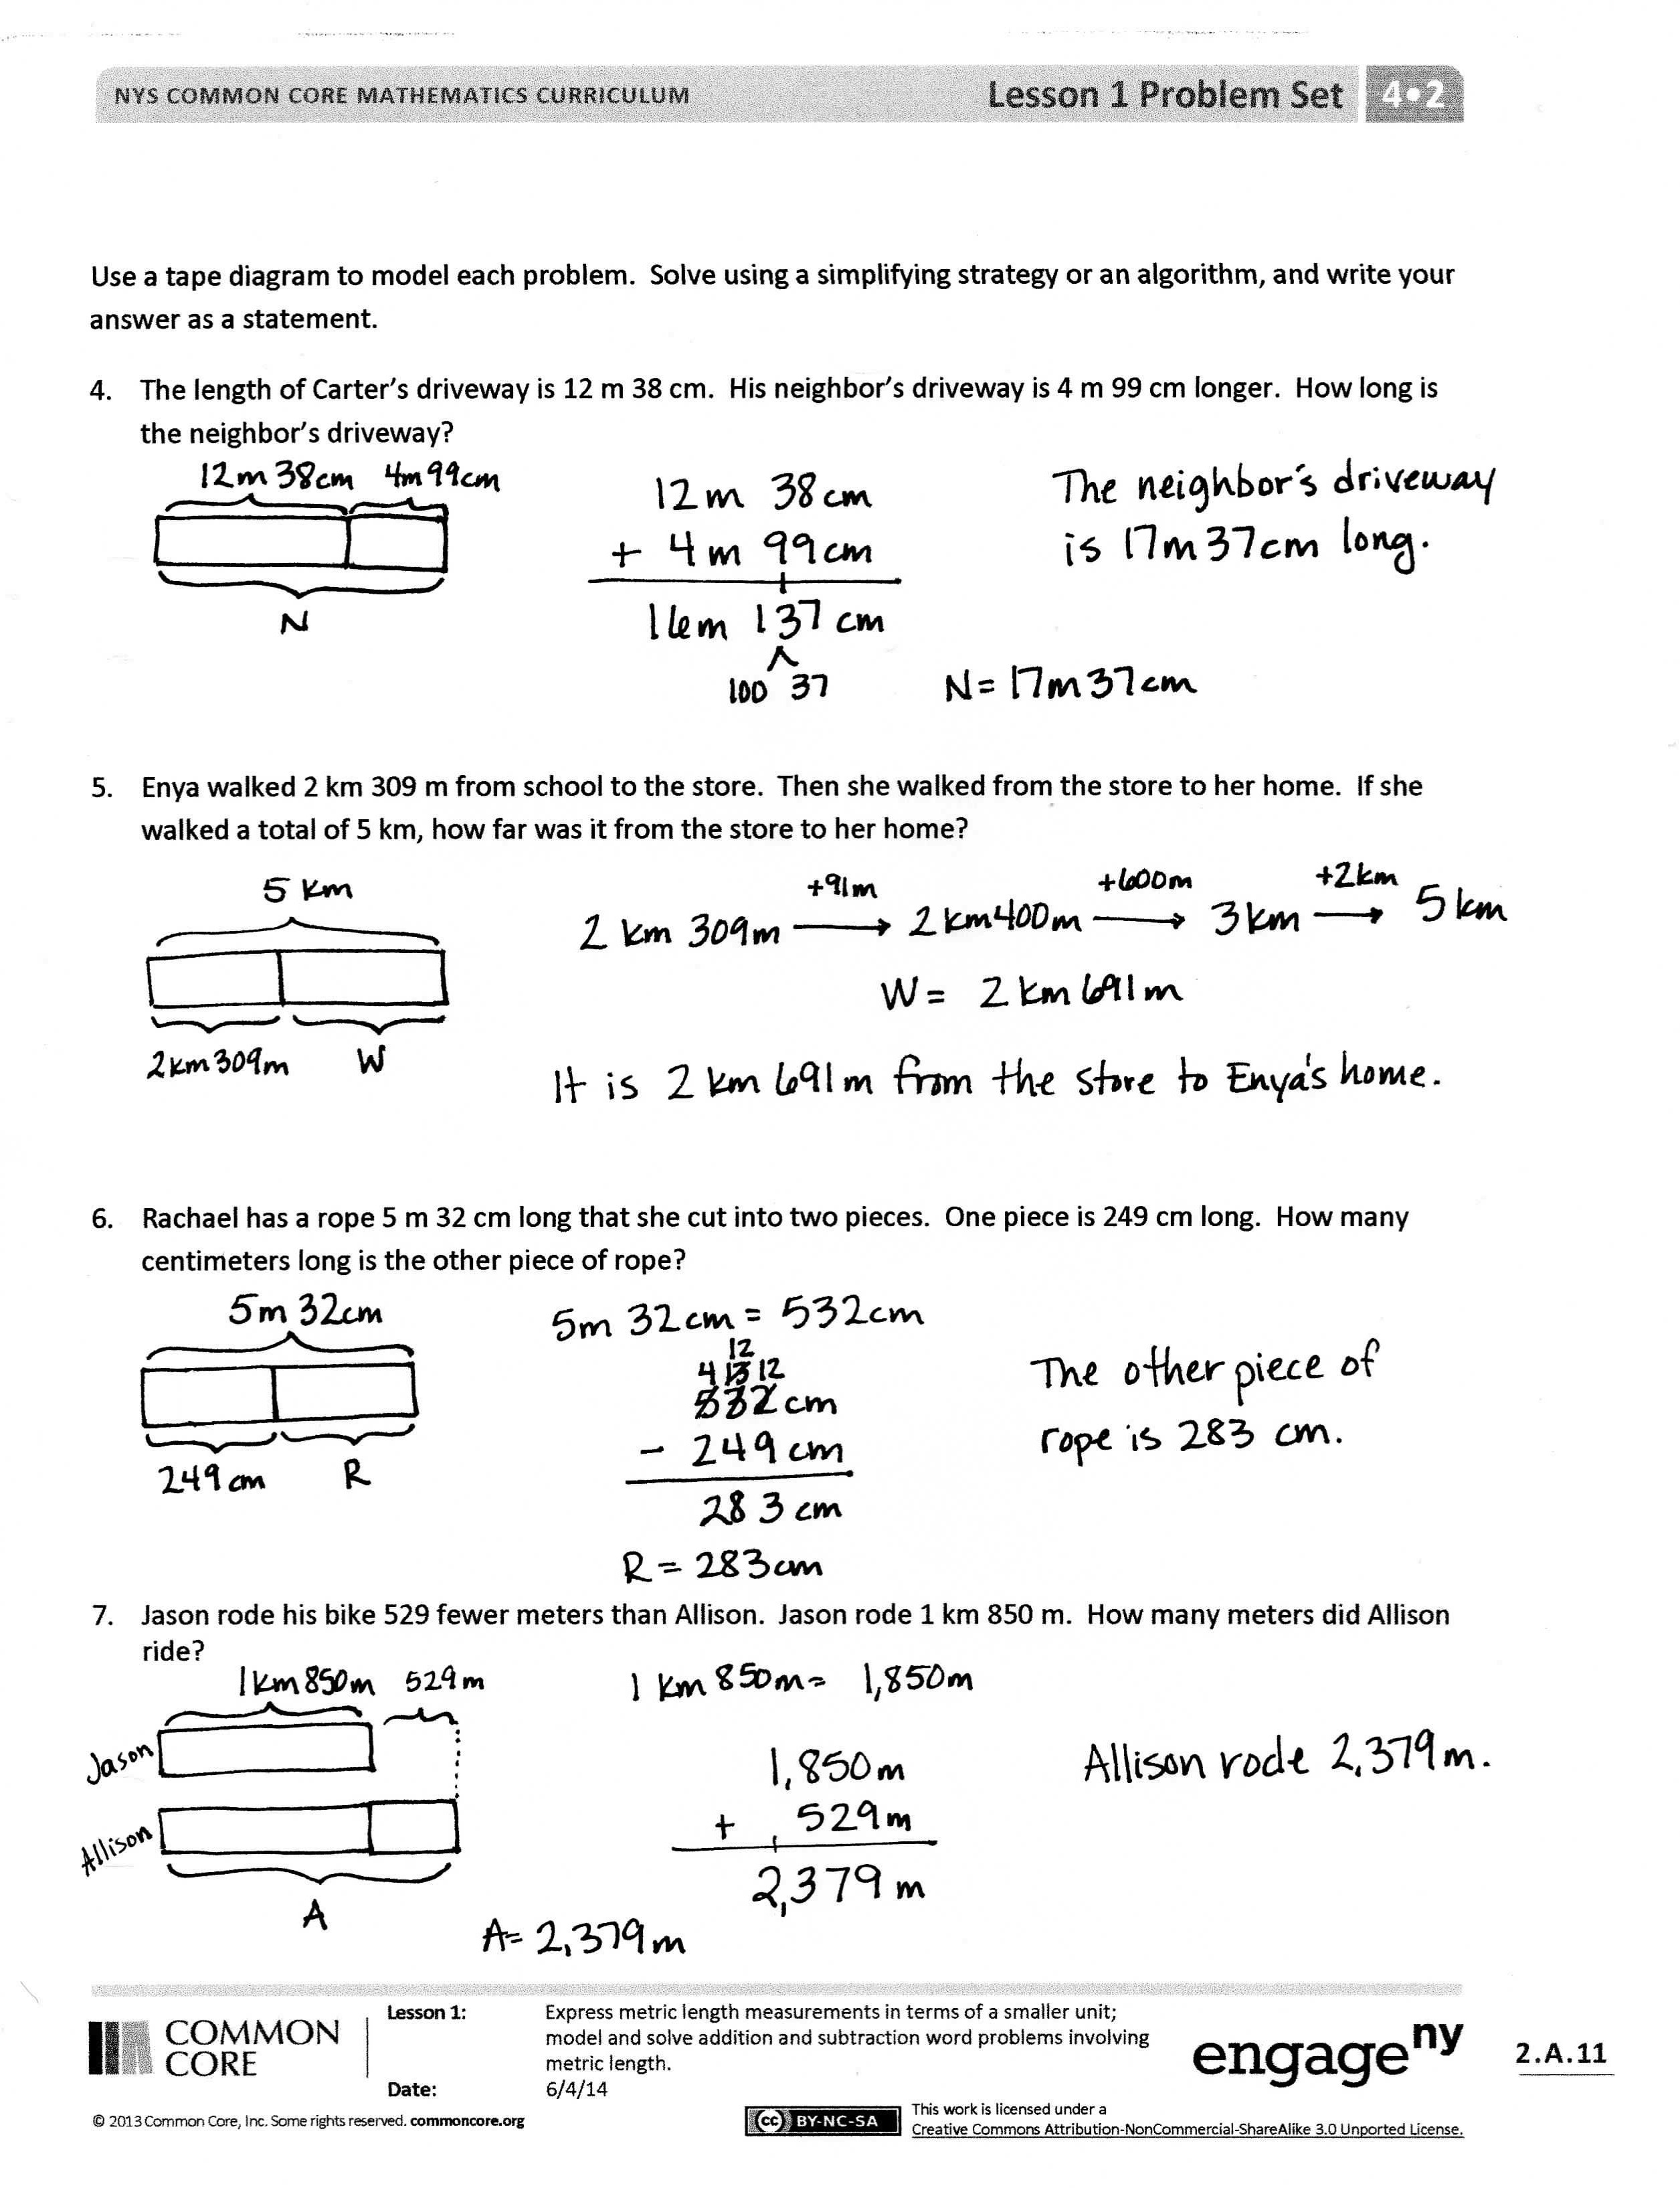
Lesson Objective: Express metric length measurements in terms of a smaller unit; model and solve addition and subtraction word problems involving metric length.
The Student Debrief is intended to invite reflection and active processing of the total lesson experience.
Invite students to review their solutions for the Problem Set. They should check work by comparing answers with a partner before going over answers as a class. Look for misconceptions or misunderstandings that can be addressed in the Debrief. Guide students in a conversation to debrief the Problem Set and process the lesson.
You may choose to use any combination of the questions below to lead the discussion.
- What pattern did you notice in the equivalences for Problems 1 and 2 of the Problem Set? How did converting 1 kilometer to 1,000 meters in Problem 1(a) help you to solve Problem 2(a)?
- How did solving Problem 2 prepare you to solve Problem 3?
- For Problem 3, Parts (c) and (d), explain how you found your answer in terms of the smaller of the two units. What challenges did you face?
- When adding and subtracting mixed units of length, what are two ways that you can solve the problem? Explain to your partner.
- How did solving Problems 1, 2, and 3 help you to solve the rest of the problems on the Problem Set?
- Look at Problem 5 in the Concept Development. How did you draw your tape diagram? Explain to your partner how you solved this problem.
- What new math vocabulary did we use today to communicate precisely?
- How did the Application Problem connect to today’s lesson?
Exit Ticket (3 minutes)
After the Student Debrief, instruct students to complete the Exit Ticket. A review of their work will help you assess the students’ understanding of the concepts that were presented in the lesson today and plan more effectively for future lessons. You may read the questions aloud to the students.

Name Date
- Convert the measurements.

- 1 km = _______________ m
- 4 km = _______________ m
- 7 km = _______________ m
- __________ km = 18,000 m
- 1 m = _______________ cm
- 3 m = _______________ cm
- 80 m = _______________ cm
- ___________ m = 12,000 cm

- Convert the measurements.

a. 3 km 312 m = _______________ m
b. 13 km 27 m = _______________ m
c. 915 km 8 m = _______________ m
d. 3 m 56 cm = _______________ cm
e. 14 m 8 cm = _______________ cm
f. 120 m 46 cm = _______________ cm

- Solve.

- 4 km − 280 m

- 1 m 15 cm – 34 cm

- Express your answer in the smaller unit:
1 km 431 m + 13 km 169 m
- Express your answer in the smaller unit:
231 m 31 cm − 14 m 48 cm

- 67 km 230 m + 11 km 879 m
- 67 km 230 m − 11 km 879 m

Use a tape diagram to model each problem. Solve using a simplifying strategy or an algorithm, and write your answer as a statement.
- The length of Carter’s driveway is 12 m 38 cm. His neighbor’s driveway is 4 m 99 cm longer. How long is his neighbor’s driveway?

- Enya walked 2 km 309 m from school to the store. Then, she walked from the store to her home. If she walked a total of 5 km, how far was it from the store to her home?

- Rachael has a rope 5 m 32 cm long that she cut into two pieces. One piece is 249 cm long. How many centimeters long is the other piece of rope?

- Jason rode his bike 529 fewer meters than Allison. Jason rode 1 km 850 m. How many meters did Allison ride?

Name Date
- Complete the conversion table.
 | Distance
 | 71 km | __________ m
 | __________ km | 30,000 m
 | 81 m | __________ cm
 | __________ m | 400 cm

- 13 km 20 m = __________ m

- 401 km 101 m – 34 km 153 m = ____________

- Gabe built a toy tower that measured 1 m 78 cm. After building some more, he measured it, and it was 82 cm taller. How tall is his tower now? Draw a tape diagram to model this problem. Use a simplifying strategy or an algorithm to solve, and write your answer as a statement.

Name Date
- Find the equivalent measures.

a. 5 km = _______________ m
b. 13 km = _______________ m
c. _______________ km = 17,000 m
d. 60 km = _______________ m
e. 7 m = _______________ cm
f. 19 m = _______________ cm
g. _______________ m = 2,400 cm
h. 90 m = _______________ cm

- Find the equivalent measures.

a. 7 km 123 m = _______________ m
b. 22 km 22 m = _______________ m
c. 875 km 4 m = _______________ m
d. 7 m 45 cm = _______________ cm
e. 67 m 7 cm = _______________ cm
f. 204 m 89 cm = ______________ cm

- Solve.

- 2 km 303 m – 556 m

- 2 m – 54 cm

- Express your answer in the smaller unit:
338 km 853 m + 62 km 71 m

- Express your answer in the smaller unit: 800 m 35 cm – 154 m 49 cm

- 701 km – 523 km 445 m
- 231 km 811 m + 485 km 829 m

Use a tape diagram to model each problem. Solve using a simplifying strategy or an algorithm, and write your answer as a statement.
- The length of Celia’s garden is 15 m 24 cm. The length of her friend’s garden is 2 m 98 cm more than Celia’s. What is the length of her friend’s garden?

- Sylvia ran 3 km 290 m in the morning. Then, she ran some more in the evening. If she ran a total of
10 km, how far did Sylvia run in the evening?

- Jenny’s sprinting distance was 356 meters shorter than Tyler’s. Tyler sprinted a distance of 1 km 3 m. How many meters did Jenny sprint?

- The electrician had 7 m 23 cm of electrical wire. He used 551 cm for one wiring project. How many centimeters of wire does he have left?

