Lesson 19
Objective: Create and solve multi-step word problems from given tape diagrams and equations.

Suggested Lesson Structure
 Fluency Practice (12 minutes)
 Application Problem (5 minutes)
 Concept Development (30 minutes)
 Student Debrief (13 minutes)
Total Time (60 minutes)
Fluency Practice (12 minutes)
- Rename Units to Subtract 4.NBT.4 (5 minutes)
- Add Up to the Next Unit 4.NBT.4 (3 minutes)
- Convert Units 4.MD.1 (4 minutes)
Rename Units to Subtract (5 minutes)
Note: This fluency activity supports further practice of decomposing a larger unit to make smaller units in order to subtract.
T: (Write: 1 ten – 6 ones.) Am I ready to subtract?
S: No.
T: Rename 1 ten as 10 ones. Say the entire number sentence.
S: 10 ones minus 6 ones is 4 ones.
Repeat with 2 tens – 6 ones, 2 tens – 1 ten 6 ones, 1 hundred – 6 tens, 2 hundreds – 4 tens, 3 hundreds – 1 hundred 4 tens, 5 thousands – 3 hundreds, 5 thousands – 3 thousands 3 hundreds, 2 ten thousands – 3 hundreds.
Add Up to the Next Unit (3 minutes)
Note: This fluency activity strengthens students’ ability to make the next unit, a skill used when using the arrow way to add or subtract. This activity also anticipates students’ use of the arrow way to solve mixed measurement unit addition and subtraction in Module 2.
T: (Write 8.) How many more to make 10?
S: 2.
T: (Write 80.) How many more to make 100?
S: 20.
T: (Write 84.) How many more to make 100?
S: 16.
Repeat with the following numbers to make 1000: 200, 250, 450, 475, 600, 680, 700, 720, 800, 805, 855, and 945.
Convert Units (4 minutes)
Note: Reviewing unit conversions that were learned in third grade helps prepare the students to solve problems with centimeters and meters in Topic A of Module 2.
Materials: (S) Personal white board
T: (Write 1 m = ___ cm.) How many centimeters are in a meter?
S: 1 m = 100 cm.
Repeat process for 2 m, 3 m, 8 m, 8 m 50 cm, 7 m 50 cm, and 4 m 25 cm.
T: (Write 100 cm = ___ m.) Say the answer.
S: 100 cm = 1 m.
T: (Write 150 cm = ___ m ___ cm.) Say the answer.
S: 150 cm = 1 m 50 cm. Repeat process for 250 cm, 350 cm, 950 cm, and 725 cm.
Application Problem (5 minutes)
For Jordan to get to his grandparents’ house, he has to travel through Albany and Plattsburgh. From Jordan’s house to Albany is 189 miles. From Albany to Plattsburgh is 161 miles. If the total distance of the trip is 508 miles, how far from Plattsburgh do Jordan’s grandparents live?
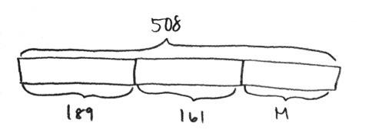
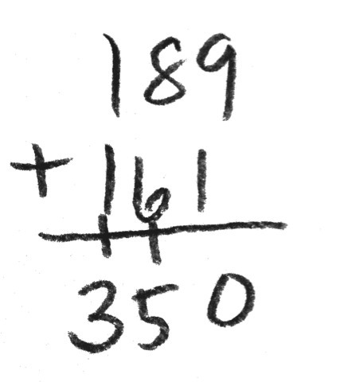
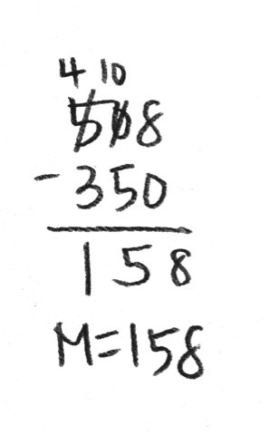
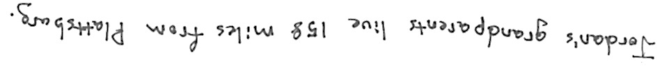

Note: This problem reviews two-step problems from the previous lessons.

Concept Development (30 minutes)
Materials: (S) Problem Set
Suggested Delivery of Instruction for Lesson 19’s Word Problems.
1. Draw the labeled tape diagram on the board, and give the students the context. Have them write a story problem based on the tape diagram.
Have two pairs of students, who you think can be successful with writing a problem, work at the board while the others work independently or in pairs at their seats. Review the following questions before beginning the first problem.
- What story makes sense with the diagram?
- What question will I ask in my word problem?
As students work, circulate. Reiterate the questions above.
After 2 minutes, have the two pairs of students share their stories.
For about 1 minute, have the demonstrating students receive and respond to feedback and questions from their peers.
2. Calculate to solve and write a statement.
Give everyone 2 minutes to exchange stories, calculate, and make a statement of the answer.
3. Assess the solution for reasonableness.
Give students 1–2 minutes to assess and explain the reasonableness of their solutions.
Note: In Lessons 17–19, the Problem Set will be comprised of the word problems from the lesson and is, therefore, to be used during the lesson itself.
Problem 1: Create and solve a simple two-step word problem from the tape diagram below.
Suggested context: People at a football game.

NOTES ON
MULTIPLE MEANS
OF REPRESENTATION:
Students who are English language learners may find it difficult to create their own problem. Work together with a small group of students to explain what the tape diagram is showing. Work with the students to write information into the tape diagram. Discuss what is known and unknown. Together, build a question based on the discussion.

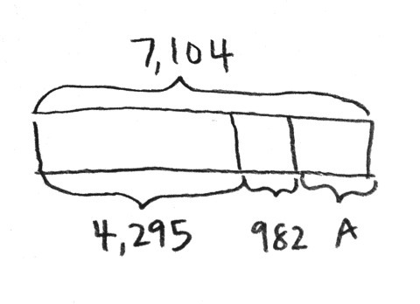

Problem 2: Create and solve a two-step addition word problem from the tape diagram below.
Suggested context: Cost of two houses.

NOTES ON
MULTIPLE MEANS
OF ACTION
AND REPRESENTATION:
Students working below grade level may struggle with the task of creating their own problems. These students may benefit from working together in a partnership with another student. First, encourage them to design a tape diagram showing the known parts, the unknown part, and the whole. Second, encourage them to create a word problem based on the diagram.

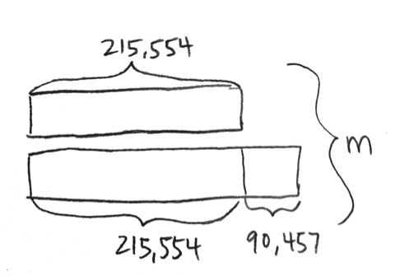

Problem 3: Create and solve a three-step word problem involving addition and subtraction from the tape diagram below.
Suggested context: Weight in kilograms of three different whales.
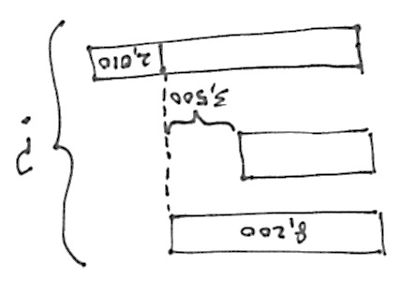
MP.2

Problem 4: Students use equations to model and solve multi-step word problems.
Display the equation 5,233 + 3,094 + k = 12,946.
T: Draw a tape diagram that models this equation.
T: Compare with your partner. Then create a word problem that uses the numbers from the equation. Remember to first create a context. Then write a statement about the total and a question about the unknown. Finally, tell the rest of the information.
Students work independently. Students can share problems in partners to solve or select word problems to solve as a class.

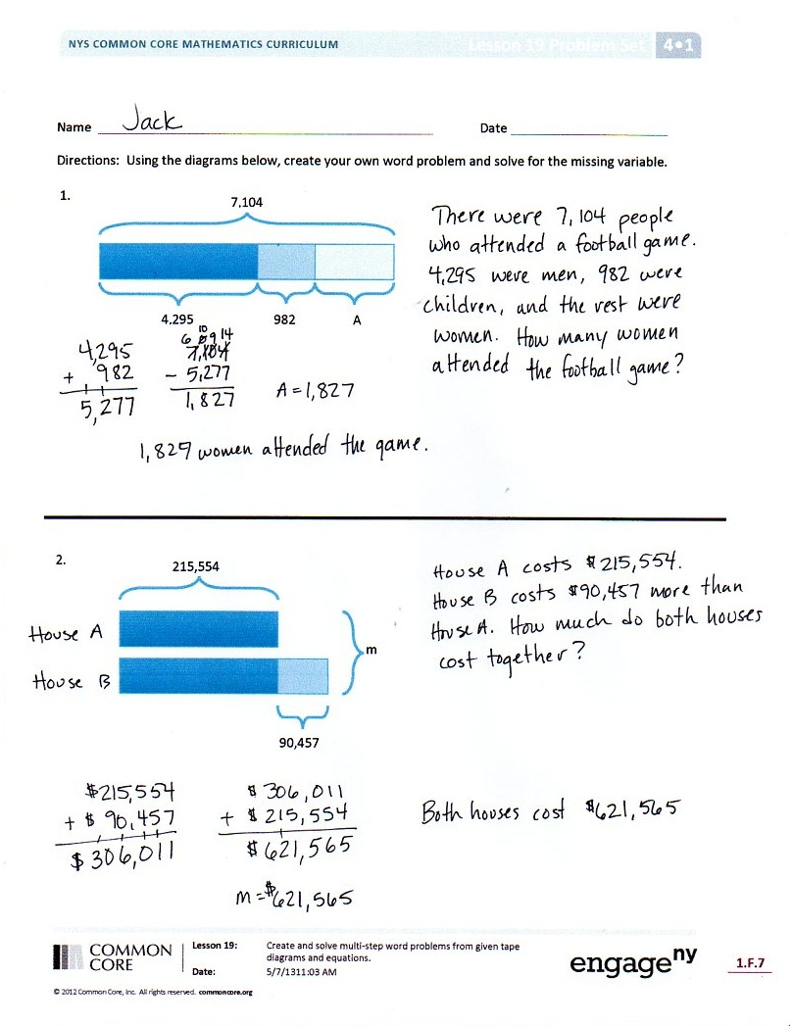
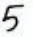
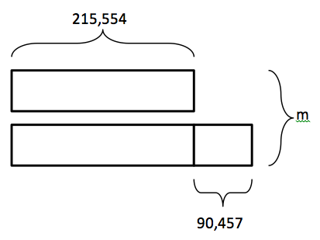
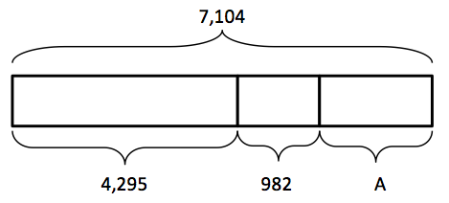
Problem Set
Please note that the Problem Set in Topic F is comprised of the lesson’s problems as stated at the introduction of the lesson.
For some classes, it may be appropriate to modify the assignment by specifying which problems they work on first. Some problems do not specify a method for solving. Students should solve these problems using the RDW approach used for Application Problems.
Student Debrief (13 minutes)
Lesson Objective: Create and solve multi-step word problems from given tape diagrams and equations.
The Student Debrief is intended to invite reflection and active processing of the total lesson experience.
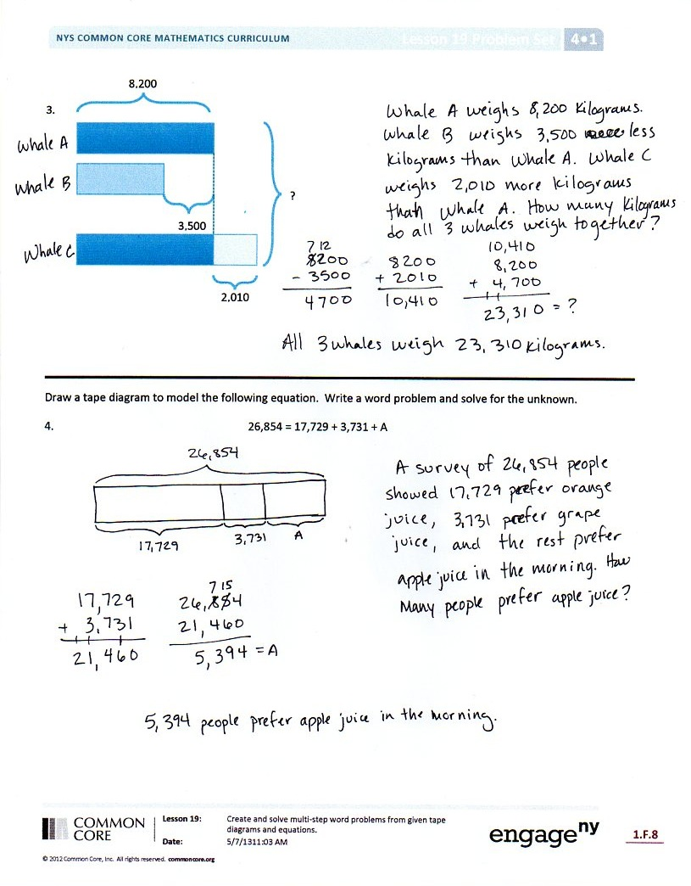
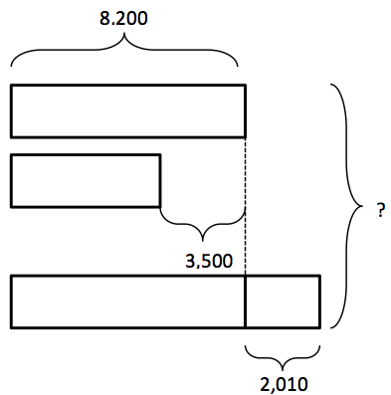
Invite students to review their solutions for the Problem Set. They should check work by comparing answers with a partner before going over answers as a class. Look for misconceptions or misunderstandings that can be addressed in the Debrief. Guide students in a conversation to debrief the Problem Set and process the lesson.
You may choose to use any combination of the questions below to lead the discussion.
- How does a tape diagram help when solving a problem?
- What is the hardest part about creating a context for a word problem?
- To write a word problem, what must you know?
- There are many different contexts for Problem 2, but everyone found the same answer. How is that possible?
- What have you learned about yourself as a mathematician over the past module?
- How can you use this new understanding of addition, subtraction, and solving word problems in the future?

Exit Ticket (3 minutes)
After the Student Debrief, instruct students to complete the Exit Ticket. A review of their work will help you assess the students’ understanding of the concepts that were presented in the lesson today and plan more effectively for future lessons. You may read the questions aloud to the students.
Name Date
Using the diagrams below, create your own word problem. Solve for the value of the variable.

1.
7,104
4,295
982

A

2.
215,554
90,457
m

3.
8,200
2,010
?

3,500

- Draw a tape diagram to model the following equation. Create a word problem. Solve for the value of the variable.
$\text{26,854} \text{=} \text{17,729} \text{+} \text{3,731} \text{+} \text{A}$

Name Date
Using the diagram below, create your own word problem. Solve for the value of the variable.

15,387
29,435
A

- Using the equation below, draw a tape diagram and create your own word problem. Solve for the value of the variable.
$$\text{248,798 = 113,205 + A + 99,937}$$

Name Date
Using the diagrams below, create your own word problem. Solve for the value of the variable.
12,115
Redwood
Cypress
A
6,294
3,849
Dogwood
At the local botanical gardens, there are ________________ Redwoods and ________________ Cypress trees.
There are a total of _________________ Redwood,
Cypress, and Dogwood trees.
How many ____________________________________
_____________________________________________
_____________________________________________?

There are 65,302 ______________________
_____________________________________.
There are 37,436 fewer _________________
_____________________________________.
How many ____________________________
____________________________________?
2.
65,302
T
37,436

3. Use the following tape diagram to create a word problem. Solve for the value of the variable.
A
42,086
215,561
36,538

- Draw a tape diagram to model the following equation. Create a word problem. Solve for the value of the variable.
27,894 + A + 6,892 = 40,392

