Lesson 18
Objective: Solve multi-step word problems modeled with tape diagrams, and assess the reasonableness of answers using rounding.

Suggested Lesson Structure
 Fluency Practice (10 minutes)
 Application Problem (5 minutes)
 Concept Development (33 minutes)
 Student Debrief (12 minutes)
Total Time (60 minutes)
Fluency Practice (10 minutes)
- Number Patterns 4.OA.5 (5 minutes)
- Convert Units 4.MD.1 (5 minutes)
Number Patterns (5 minutes)
Materials: (S) Personal white board
Note: This fluency activity bolsters students’ place value understanding and helps them apply these skills to a variety of concepts.
T: (Project 40,100, 50,100, 60,100, ____.) What is the place value of the digit that’s changing?
S: Ten thousand.
T: Count with me saying the value of the digit I’m pointing to.
S: (Point at the ten thousand digit as students count.) 40,000, 50,000, 60,000.
T: On your personal white boards, write what number would come after 60,100.
S: (Write 70,100.)
Repeat with the following possible sequence: 82,030, 72,030, 62,030, ___ ; 215,003, 216,003, 217,003, ___ ; 943,612, 943,512, 943,412, ___ ; and 372,435, 382,435, 392,435, ___.
Convert Units (5 minutes)
Materials: (S) Personal white board
Note: This fluency activity strengthens understanding of the relationship between kilograms and grams learned in Grade 3, preparing students to use this relationship to solve problems in G4–M2–Topic A. Use a number bond to support understanding of the relationship between of grams and kilograms.
T: Count by 200 grams starting at 0 grams and counting up to 2,000 grams. When you get to 1,000 grams, say 1 kilogram. When you get to 2,000 grams, say 2 kilograms.
S: 0 g, 200 g, 400 g, 600 g, 800 g, 1 kg, 1,200 g, 1,400 g, 1,600 g, 1,800 g, 2 kg.
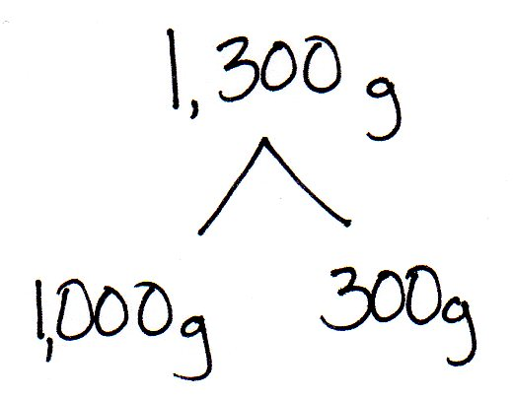
Repeat the process, this time pulling out the kilogram (e.g., 1 kg 200 g, 1 kg 400 g).
T: (Write 1,300 g = ___ kg ___ g.) On your boards, fill in the blanks to make a true number sentence.
S: (Write 1,300 g = 1 kg 300 g.)
Repeat process for 1,003 g, 1,750 g, 3,450 g, and 7,030 g.
Application Problem (5 minutes)
In all, 30,436 people went skiing in February and January. 16,009 went skiing in February. How many fewer people went skiing in January than in February?

Note: This comparison subtraction problem reviews content from Lesson 17.
Concept Development (33 minutes)
Materials: (S) Problem Set
Suggested Delivery of Instruction for Solving Topic F’s Word Problems
1. Model the problem.
Have two pairs of students, who you think can be successful with modeling the problem, work at the board while the others work independently or in pairs at their seats. Review the following questions before beginning the first problem.
- Can you draw something?
- What can you draw?
- What conclusions can you make from your drawing?
As students work, circulate. Reiterate the questions above.
After 2 minutes, have the two pairs of students share only their labeled diagrams.
For about 1 minute, have the demonstrating students receive and respond to feedback and questions from their peers.
2. Calculate to solve and write a statement.
Give everyone 2 minutes to finish work on the problem, sharing his or her work and thinking with a peer.
All should then write their equations and statements for the answer.
3. Assess the solution for reasonableness.
Give students 1–2 minutes to assess and explain the reasonableness of their solutions.
Note: In Lessons 17–19, the Problem Set is comprised of the word problems from the lesson and is, therefore, to be used during the lesson itself.
Problem 1: Solve a multi-step word problem requiring addition and subtraction, modeled with a tape diagram, and check the reasonableness of the answer using estimation.
In one year, a factory used 11,650 meters of cotton, 4,950 fewer meters of silk than cotton, and 3,500 fewer meters of wool than silk. How many meters in all were used of the three fabrics?
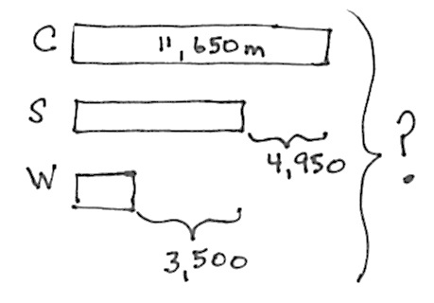
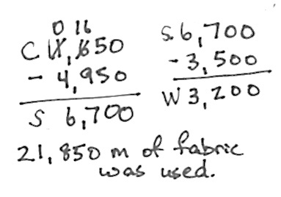
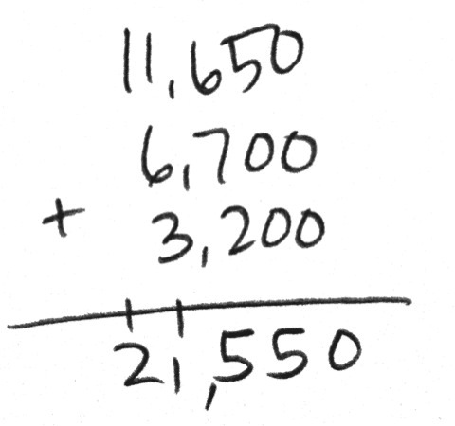
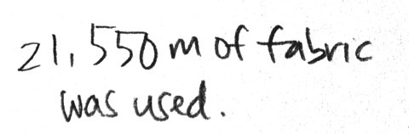

This problem is a step forward for students as they subtract to find the amount of wool from the amount of silk. Students also might subtract the sum of 4,950 and 3,500 from 11,650 to find the meters of wool and add that to the amount of silk. It’s a longer method but makes sense. As you circulate, look for other alternate strategies which can be quickly mentioned or explored more deeply as per your professional judgment.
Be advised, however, not to emphasize creativity but rather analysis and efficiency. Ingenious short cuts might be highlighted.
After the students have solved the problem, ask them to check their answers for reasonableness:
T: How can you know if 21,550 is a reasonable answer? Discuss with your partner.
S: Well, I can see by looking at the diagram that the amount of wool fits in the part where the amount of silk is unknown, so the answer is a little less than double 12,000. Our answer makes sense.
S: Another way to think about it is that 11,650 can be rounded to 12 thousands. 12 thousands plus 7 thousands for the silk, since 12 thousands minus 5 thousands is 7 thousands, plus about 4 thousands for the wool. That’s 23 thousands.

Problem 2: Solve an additive multi-step word problem using a tape diagram, modeled with a tape diagram, and check the reasonableness of the answer using estimation.
The shop sold 12,789 chocolate and 9,324 cookie dough cones. It sold 1,078 more peanut butter cones than cookie dough cones and 999 more vanilla cones than chocolate cones. What was the total number of ice cream cones sold?
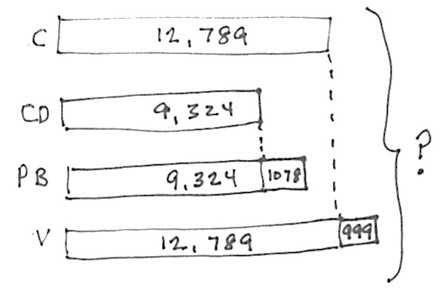
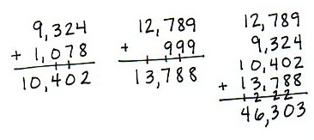

The solution above shows calculating the total number of cones of each flavor and then adding. Students may also add like units before adding the extra parts.
After the students have solved the problem, ask them to check their answers for reasonableness:
T: How can you know if 46,303 is a reasonable answer? Discuss with your partner.
S: By looking at the tape diagram, I can see we have 2 thirteen thousands units. That’s 26 thousands.
We have 2 nine thousands units. So 26 thousands and 18 thousands is 44 thousands. Plus about 2 thousands more. That’s 46 thousands. That’s close.
MP.3
S: Another way to see it is that I can kind of see 2 thirteen thousands and the little extra pieces with the peanut butter make 11 thousands. That is 37 thousands plus 9 thousands from cookie dough is 46 thousands. That’s close.
Problem 3: Solve a multi-step word problem requiring addition and subtraction, modeled with a tape diagram, and check the reasonableness of the answer using estimation.
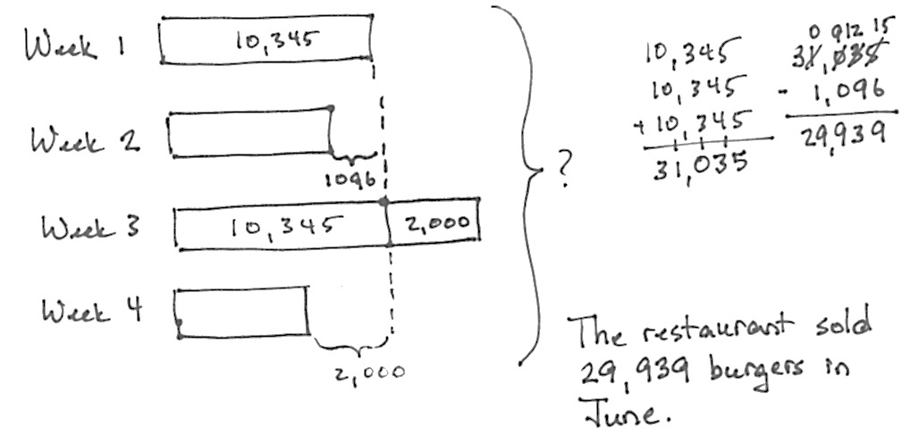
In the first week of June, a restaurant sold 10,345 omelets. In the second week, 1,096 fewer omelets were sold than in the first week. In the third week, 2 thousand more omelets were sold than in the first week. In the fourth week, 2 thousand fewer omelets were sold than in the first week. How many omelets were sold in all in June?

This problem is interesting because 2 thousand more and 2 thousand less mean that there is one more unit of 10,345. We, therefore, simply add in the omelets from the second week to three units of 10,345.
T: How can you know if 40,284 is a reasonable answer? Discuss with your partner.
S: By looking at the tape diagram, it’s easy to see it is like 3 ten thousands plus 9 thousands, that’s 39 thousands. That is close to our answer.
S: Another way to see it is just rounding one week at a time starting at the first week; 10 thousands plus 9 thousands plus 12 thousands plus 8 thousands. That’s 39 thousands.
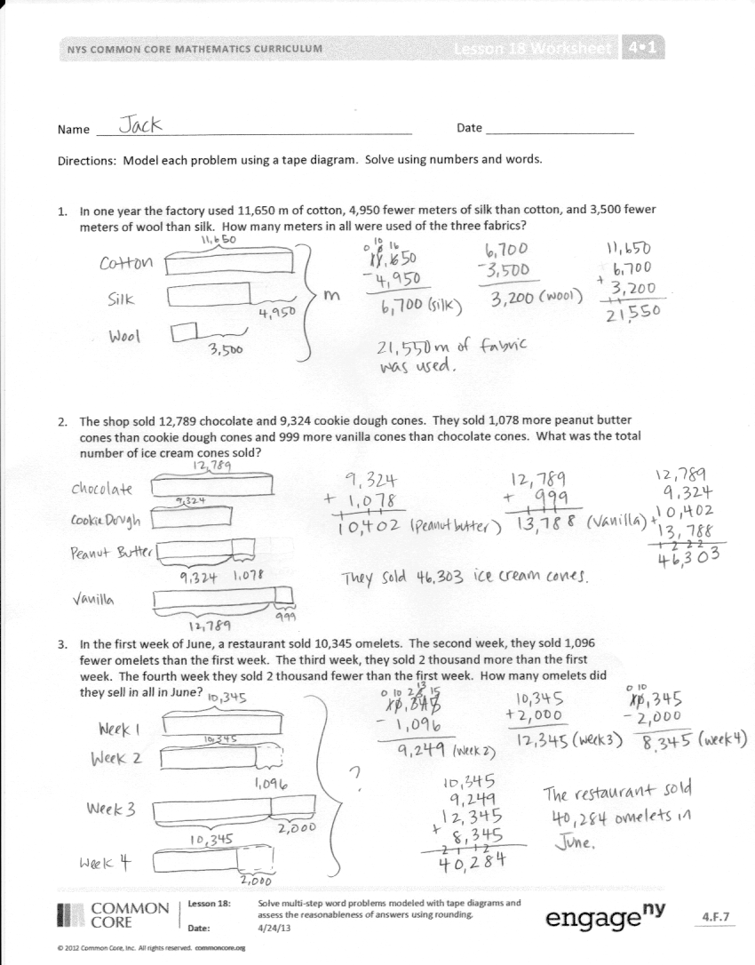
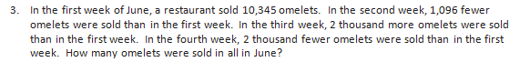
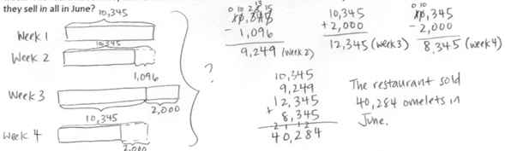
Problem Set

Please note that in Topic F, the Problem Sets are used in the Concept Developments. As a result, the 10 minutes usually allotted for the completion of the Problem Set are not needed.
Student Debrief (12 minutes)
Lesson Objective: Solve multi-step word problems modeled with tape diagrams and assess the reasonableness of answers using rounding.
The Student Debrief is intended to invite reflection and active processing of the total lesson experience.
Invite students to review their solutions for the Problem Set. They should check work by comparing answers with a partner before going over answers as a class. Look for misconceptions or misunderstandings that can be addressed in the Debrief. Guide students in a conversation to debrief the Problem Set and process the lesson.
You may choose to use any combination of the questions below to lead the discussion.
- How are the problems alike? How are they different?
- How was your solution the same and different from those that were demonstrated by your peers?
- Why is there more than one right way to solve, for example, Problem 3?
- Did you see other solutions that surprised you or made you see the problem differently?
- In Problem 1, was the part unknown or the total unknown? What about in Problems 2 and 3?
- Why is it helpful to assess for reasonableness after solving?
- How were the tape diagrams helpful in estimating to test for reasonableness? Why is that?
Exit Ticket (3 minutes)
After the Student Debrief, instruct students to complete the Exit Ticket. A review of their work will help you assess the students’ understanding of the concepts that were presented in the lesson today and plan more effectively for future lessons. You may read the questions aloud to the students.

Name Date
Draw a tape diagram to represent each problem. Use numbers to solve, and write your answer as a statement.
1. In one year the factory used 11,650 meters of cotton, 4,950 fewer meters of silk than cotton, and 3,500 fewer meters of wool than silk. How many meters in all were used of the three fabrics?

2. The shop sold 12,789 chocolate and 9,324 cookie dough cones. It sold 1,078 more peanut butter cones than cookie dough cones and 999 more vanilla cones than chocolate cones. What was the total number of ice cream cones sold?

3. In the first week of June, a restaurant sold 10,345 omelets. In the second week, 1,096 fewer omelets were sold than in the first week. In the third week, 2 thousand more omelets were sold than in the first week. In the fourth week, 2 thousand fewer omelets were sold than in the first week. How many omelets were sold in all in June?

Name Date
Draw a tape diagram to represent the problem. Use numbers to solve, and write your answer as a statement.
Park A covers an area of 4,926 square kilometers. It is 1,845 square kilometers larger than Park B.
Park C is 4,006 square kilometers larger than Park A.
  - What is the area of all three parks?

  - Assess the reasonableness of your answer.

Name Date
Draw a tape diagram to represent each problem. Use numbers to solve, and write your answer as a statement.

1. There were 22,869 children, 49,563 men, and 2,872 more women than men at the fair. How many people were at the fair?

- Number A is 4,676. Number B is 10,043 greater than A. Number C is 2,610 less than B. What is the total value of numbers A, B, and C?

3. A store sold a total of 21,650 balls. It sold 11,795 baseballs. It sold 4,150 fewer basketballs than baseballs. The rest of the balls sold were footballs. How many footballs did the store sell?

