Lesson 17
Objective: Solve additive compare word problems modeled with tape diagrams.

Suggested Lesson Structure
 Fluency Practice (10 minutes)
 Application Problem (8 minutes)
 Concept Development (35 minutes)
 Student Debrief (7 minutes)
Total Time (60 minutes)
Fluency Practice (10 minutes)
- Change Place Value 4.NBT.2 (5 minutes)
- Convert Units 4.MD.1 (5 minutes)
Change Place Value (5 minutes)
Materials: (S) Personal white board, labeled millions place value chart (Lesson 11 Template)
Note: This fluency activity helps students work toward mastery of using place value skills to add and subtract different units.
T: (Project place value chart to the millions place. Write 4 hundred thousands, 6 ten thousands,
3 thousands, 2 hundreds, 6 tens, 5 ones.) On your personal white boards, write the number.
S: (Write 463,265.)
T: Show 100 more.
S: (Write 463,365.)
Possible further sequence: 10,000 less, 100,000 more, 1 less, and 10 more.
T: (Write 400 + 90 + 3 =____.) On your place value chart, write the number.
Possible further sequence: 7,000 + 300 + 80 + 5; 20,000 + 700,000 + 5 + 80; 30,000 + 600,000 + 3 + 20.
Convert Units (5 minutes)
Note: This fluency activity strengthens understanding of the relationship between kilograms and grams learned in Grade 3 and prepares students to use this relationship to solve problems in G4–M2–Topic A. Use a number bond to support understanding the relationship of grams and kilograms.
T: (Write 1 kg = ___ g.) How many grams are in 1 kilogram?
S: 1 kg = 1,000 g.
Repeat the process for 2 kg, 3 kg, 8 kg, 8 kg 500 g, 7 kg 500 g, and 4 kg 250 g.
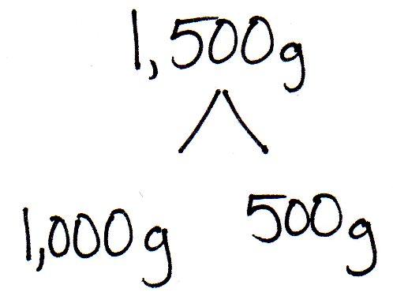
T: (Write 1,000 g = ___ kg.) Say the answer.
S: 1,000 grams equals 1 kilogram.
T: (Write 1,500 g = ___ kg ___ g.) Say the answer.
S: 1,500 grams equals 1 kilogram 500 grams.
Repeat the process for 2,500 g, 3,500 g, 9,500 g, and 7,250 g.
Application Problem (8 minutes)
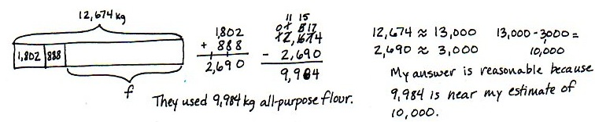
A bakery used 12,674 kg of flour. Of that, 1,802 kg was whole wheat and 888 kg was rice flour. The rest was all-purpose flour. How much all-purpose flour did they use? Solve and check the reasonableness of your answer.
Note: This problem leads into today’s lesson and bridges as it goes back into the work from Lesson 16.
Concept Development (35 minutes)
Materials: (S) Problem Set
Suggested Delivery of Instruction for Solving Topic F’s Word Problems
1. Model the problem.
Have two pairs of students, who you think can be successful with modeling the problem, work at the board while the others work independently or in pairs at their seats. Review the following questions before solving the first problem.
- Can you draw something?
- What can you draw?
- What conclusions can you make from your drawing?
As students work, circulate. Reiterate the questions above.
After 2 minutes, have the two pairs of students share only their labeled diagrams.
For about 1 minute, have the demonstrating students receive and respond to feedback and questions from their peers.
2. Calculate to solve and write a statement.
Give everyone 2 minutes to finish work on the problem, sharing his or her work and thinking with a peer.
All should then write their equations and statements for the answer.
3. Assess the solution for reasonableness.
Give students 1–2 minutes to assess and explain the reasonableness of their solutions.
Note: In Lessons 17–19, the Problem Set is comprised of word problems from the lesson and is therefore to be used during the lesson itself.
Problem 1: Solve a single-step word problem using how much more.
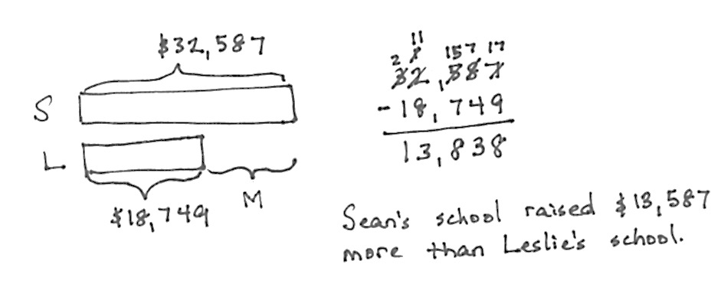
Sean’s school raised $32,587. Leslie’s school raised $18,749.
How much more money did Sean’s school raise?

NOTES ON
MULTIPLE MEANS
OF ACTION
AND EXPRESSION:
Students working below grade level
may continue to need additional
support in subtracting numbers
using place value charts or disks.

Support students in realizing that though the question is asking, “How much more?” we can see from the tape diagram that the unknown is a missing part, and, therefore, we subtract to find the answer.

NOTES ON
MULTIPLE MEANS
OF ENGAGEMENT:
Challenge students to think about how reasonableness can be associated with rounding. If the actual answer does
not round to the estimate, does it
mean that the answer is not reasonable?
Ask students to explain their thinking.
(For example, 376 – 134 = 242. Rounding to the nearest hundred would result with an estimate of
400 – 100 = 300. The actual answer
of 242 rounds to 200, not 300.)

Problem 2: Solve a single-step word problem using how many fewer.
At a parade, 97,853 people sat in bleachers. 388,547 people stood along the street. How many fewer people were in the bleachers than standing along the street?
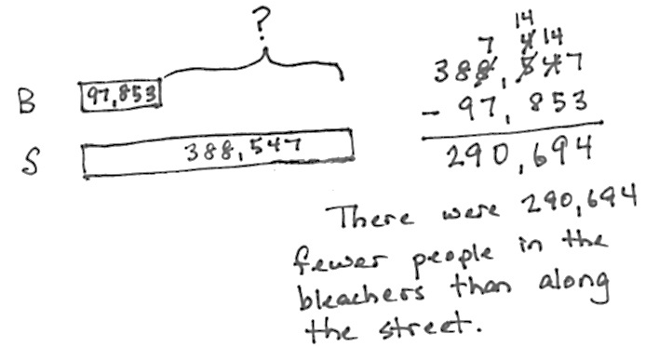

Circulate and support students to realize that the unknown number of how many fewer people is the difference between the two tape diagrams. Encourage them to write a statement using the word fewer when talking about separate things. For example, I have fewer apples than you do and less juice.
Problem 3: Solve a two-step problem using how much more.
A pair of hippos weighed 5,201 kilograms together. The female weighed 2,038 kilograms. How much more did the male weigh than the female?
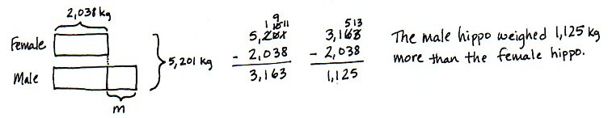
Many students may want to draw this as a single tape showing the combined weight to start. That works. However, the second step most likely requires a new double tape to compare the weights of the male and female. If no one comes up with the model pictured, you can show it quickly. Students generally do not choose to draw a bracket with the known total to the side until they are very familiar with two-step comparison models. However, be aware that students have modeled this problem type since Grade 2.
MP.2
Problem 4: Solve a three-step problem using how much longer.
A copper wire was 240 meters long. After 60 meters was cut off, it was double the length of a steel wire. How much longer was the copper wire than the steel wire at first?

NOTES ON
MULTIPLE MEANS
OF ACTION
AND EXPRESSION:
For students who may find Problem 4 challenging, remind them of the work done earlier in this module with multiples of 10. For example, 180 is ten times as much as 18. If 18 divided by 2 is 9, then 180 divided by 2 is 90.

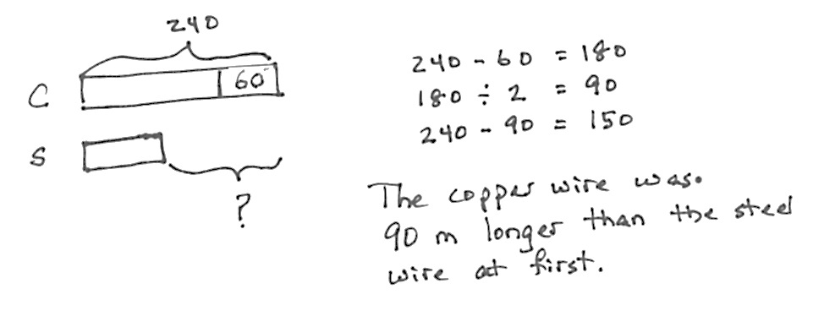

T: Read the problem, draw a model, write equations both to estimate and calculate precisely, and write a statement. I’ll give you 5 minutes.
Circulate, using the bulleted questions to guide students. When students get stuck, encourage them to focus on what they can learn from their drawings.
- Show me the copper wire at first.
- In your model, show me what happened to the copper wire.
- In your model, show me what you know about the steel wire.
- What are you comparing? Where is that difference in your model?
Notice the number size is quite small here. The calculations are not the issue but rather the relationships. Students will eventually solve similar problems with larger numbers, but they will begin here at a simple level numerically.
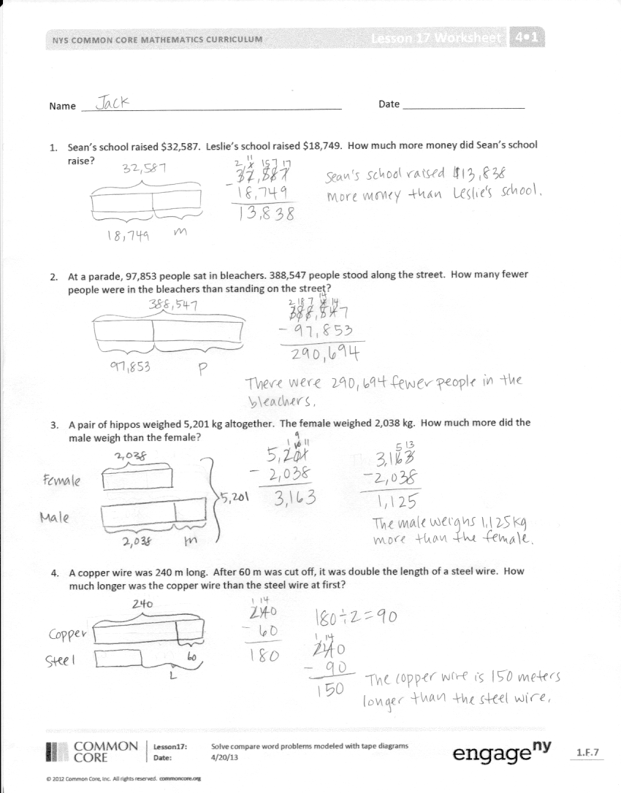
Problem Set
Please note that in Topic F, the Problem Sets are used in the Concept Developments. As a result, the 10 minutes usually allotted for the completion of the Problem Set are not needed.
Student Debrief (7 minutes)
Lesson Objective: Solve additive compare word problems modeled with tape diagrams.
The Student Debrief is intended to invite reflection and active processing of the total lesson experience.
Invite students to review their solutions for the Problem Set. They should check work by comparing answers with a partner before going over answers as a class. Look for misconceptions or misunderstandings that can be addressed in the Debrief. Guide students in a conversation to debrief the Problem Set and process the lesson.
You may choose to use any combination of the questions below to lead the discussion.
- How are your tape diagrams for Problem 1 and Problem 2 similar?
- How did your tape diagrams vary across all problems?
- In Problem 3, how did drawing a double tape diagram help you to visualize the problem?
- What was most challenging about drawing the tape diagram for Problem 4? What helped you find the best diagram to solve the problem?
- What different ways are there to draw a tape diagram to solve comparative problems?
- What does the word compare mean?
- What phrases do you notice repeated through many of today’s problems that help you to see the problem as a comparative problem?
Exit Ticket (3 minutes)
After the Student Debrief, instruct students to complete the Exit Ticket. A review of their work will help you assess the students’ understanding of the concepts that were presented in the lesson today and plan more effectively for future lessons. You may read the questions aloud to the students.

Name Date
Draw a tape diagram to represent each problem. Use numbers to solve, and write your answer as a statement.
- Sean’s school raised $32,587. Leslie’s school raised $18,749. How much more money did Sean’s school raise?

- At a parade, 97,853 people sat in bleachers and 388,547 people stood along the street. How many fewer people were in the bleachers than standing on the street?

- A pair of hippos weighed 5,201 kilogram together. The female weighed 2,038 kilogram. How much more did the male weigh than the female?

- A copper wire was 240 meters long. After 60 meters was cut off, it was double the length of a steel wire. How much longer was the copper wire than the steel wire at first?

Name Date
Draw a tape diagram to represent each problem. Use numbers to solve, and write your answer as a statement.

A mixture of 2 chemicals measures 1,034 milliliters. It contains some of Chemical A and 755 milliliters of Chemical B. How much less of Chemical A than Chemical B is in the mixture?

Name Date
Draw a tape diagram to represent each problem. Use numbers to solve, and write your answer as a statement.
- Gavin has 1,094 toy building blocks. Avery only has 816 toy building blocks. How many more building blocks does Gavin have?

- Container B holds 2,391 liters of water. Together, Container A and Container B hold 11,875 liters of water. How many more liters of water does Container A hold than Container B?

- A piece of yellow yarn was 230 inches long. After 90 inches had been cut from it, the piece of yellow yarn was twice as long as a piece of blue yarn. At first, how much longer was the yellow yarn than the blue yarn?

