Lesson 7
Objective: Round multi-digit numbers to the thousands place using the vertical number line.

Suggested Lesson Structure
 Fluency Practice (15 minutes)
 Application Problem (6 minutes)
 Concept Development (27 minutes)
 Student Debrief (12 minutes)
Total Time (60 minutes)
Fluency Practice (15 minutes)
- Change Place Value 4.NBT.1 (5 minutes)
- Number Patterns 4.NBT.1 (5 minutes)
- Find the Midpoint 4.NBT.3 (5 minutes)
Change Place Value (5 minutes)
Materials: (S) Personal white board, unlabeled hundred thousands place value chart (Lesson 5 Template)
Note: This fluency activity reviews Lesson 6’s content.
T: (Project place value chart. Write 3 hundred thousands, 5 ten thousands, 2 thousands, 1 hundred, 5 tens, and 4 ones.) On your personal white board, draw place value disks and write the numbers beneath it.
S: (Draw disks and write 352,154.)
T: Show 100 more.
S: (Draw 1 more 100 disk, erase the number 1 in the hundreds place, and replace it with a 2 so that their boards now read 352,254.)
Possible further sequence: 10,000 less, 100,000 more, 1 less, and 10 more.
Repeat with the following: 7,385; 297,084; and 306,032.
Number Patterns (5 minutes)
Materials: (S) Personal white board
Note: This activity synthesizes skip-counting fluency with Lesson 6’s content and applies it in a context that lays a foundation for rounding multi-digit numbers to the thousands place.
T: (Project 50,300; 60,300; 70,300; ____.) What is the place value of the digit that’s changing?
S: Ten thousand.
T: Count with me saying the value of the digit I’m pointing to. (Point at the ten thousand digit as students count.)
S: 50,000; 60,000; 70,000.
T: On your personal board, write what number would come after 70,300.
S: (Write 80,300.)
Repeat for the following possible sequence, using place value disks if students are struggling:
92,010 82,010 72,010 ______
135,004 136,004 137,004 ______
832,743 832,643 832,543 ______
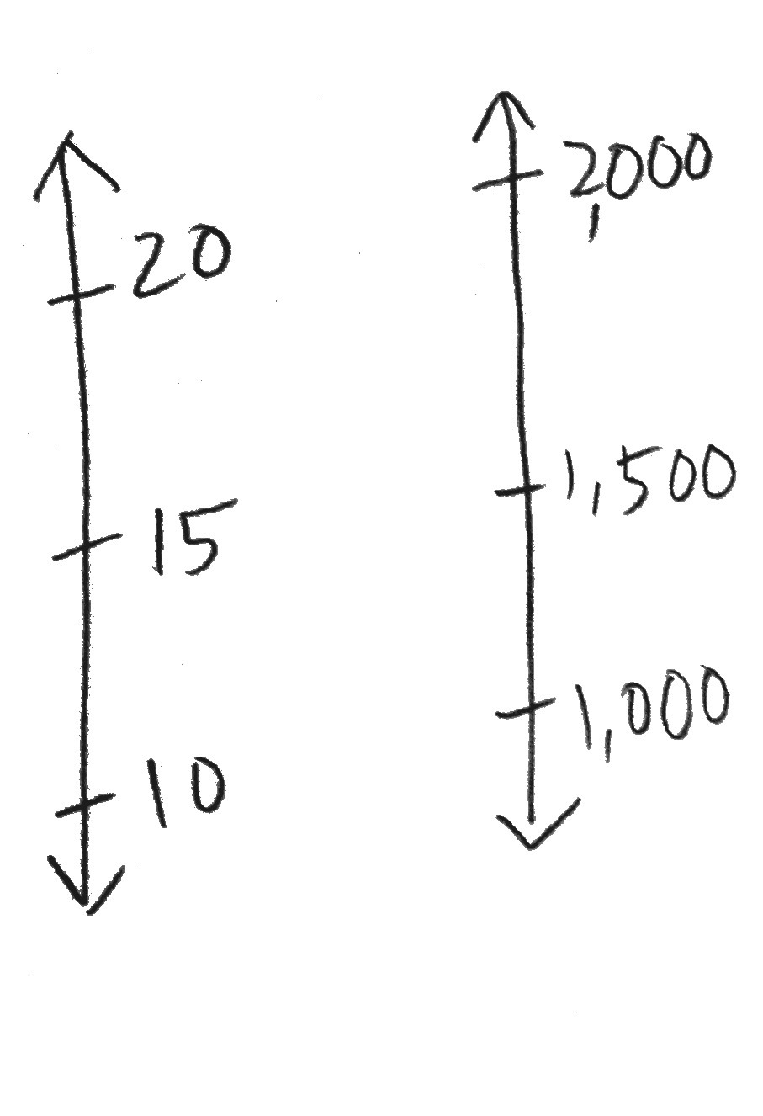
271,543 281,543 291,543 ______
number line
Find the Midpoint (5 minutes)
Materials: (S) Personal white board
Note: Practicing this skill in isolation lays a foundation to conceptually understand rounding on a vertical number line and reviews Grade 3 skills in anticipation of this lesson.
Project a vertical number line with endpoints 10 and 20.
T: What’s halfway between 10 and 20?
S: 15.
T: (Write 15 halfway between 10 and 20. Draw a second line with 1,000 and 2,000 as the endpoints.) How many hundreds are in 1,000?
S: 10 hundreds.
T: (Below 1,000, write 10 hundreds.) How many hundreds are in 2,000?
S: 20 hundreds.
MP.2
T: (Write 20 hundreds below 2,000.) What’s halfway between 10 hundreds and 20 hundreds?
S: 15 hundreds.
T: (Write 1,500 halfway between 1,000 and 2,000. Below 1,500, write 15 hundreds.) On your personal board, draw a vertical number line with two endpoints and a midpoint.
S: (Draw number line with two endpoints and a midpoint.)
T: Label 31,000 and 32,000 as endpoints.
S: (Label 31,000 and 32,000 as endpoints.)
MP.2
T: How many hundreds are in 31,000?
S: 310 hundreds.
T: How many hundreds are in 32,000?
S: 320 hundreds.
T: Identify the midpoint.
S: (Write 31,500.)
Repeat process and procedure to find the midpoint of 831,000 and 832,000; 63,000 and 64,000;
264,000 and 265,000; and 99,000 and 100,000.
Application Problem (6 minutes)
According to their pedometers, Mrs. Alsup's class took a total of 42,619 steps on Tuesday. On Wednesday, they took ten thousand more steps than they did on Tuesday. On Thursday, they took one thousand fewer steps than they did on Wednesday. How many steps did Mrs. Alsup's class take on Thursday?

Note: This Application Problem builds on the concept of the previous lesson requiring students to find
1 thousand, 10 thousand, or 100 thousand more or less than a given number.
Concept Development (27 minutes)
Materials: (S) Personal white board
Problem 1: Use a vertical number line to round four-digit numbers to the nearest thousand.
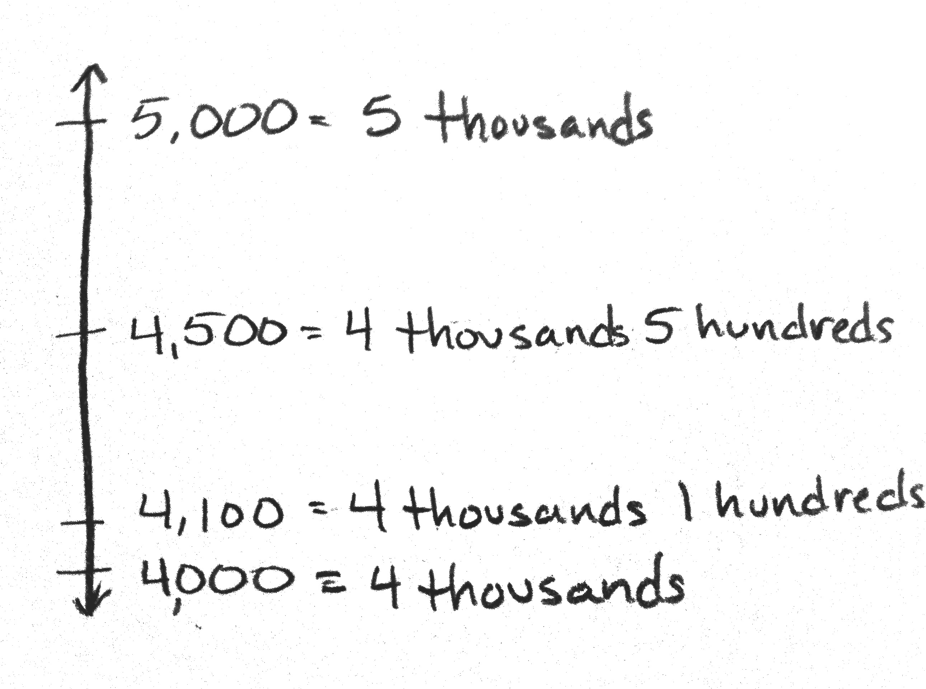
T: (Draw a vertical number line with 2 endpoints.) We are going to round 4,100 to the nearest thousand. How many thousands are in 4,100?
S: 4 thousands.
T: (Mark the lower endpoint with 4 thousands.) And 1 more thousand would be?
S: 5 thousands.
T: (Mark the upper endpoint with 5 thousands.) What’s halfway between 4 thousands and 5 thousands?
S: 4,500.
T: (Label 4,500 on the number line.) Where should I label 4,100? Tell me where to stop. (Move your marker up the line.)
S: Stop!
T: (Label 4,100 on the number line.) Is 4,100 nearer to 4 thousands or 5 thousands?
S: 4,100 is nearer to 4 thousands.
T: True. We say 4,100 rounded to the nearest thousand is 4,000.

NOTES ON
MULTIPLE MEANS
OF REPRESENTATION:
For those students who have trouble conceptualizing halfway, demonstrate halfway using students as models. Two students represent the thousands.
A third student represents halfway.
A fourth student represents the number being rounded.
Discuss: Where do they belong? To whom are they nearer? To which number would they round?

T: (Label 4,700 on the number line.) What about 4,700?
S: 4,700 is nearer to 5 thousands.
T: Therefore, we say 4,700 rounded to the nearest thousand is 5,000.
Problem 2: Use a vertical number line to round five- and six-digit numbers to the nearest thousand.
T: Let’s round 14,500 to the nearest thousand. How many thousands are there in 14,500?
S: 14 thousands.
T: What’s 1 more thousand?
S: 15 thousands.
T: Designate the endpoints on your number line. What is halfway between 14,000 and 15,000?
S: 14,500. Hey, that’s the number that we are trying to round to the nearest thousand.
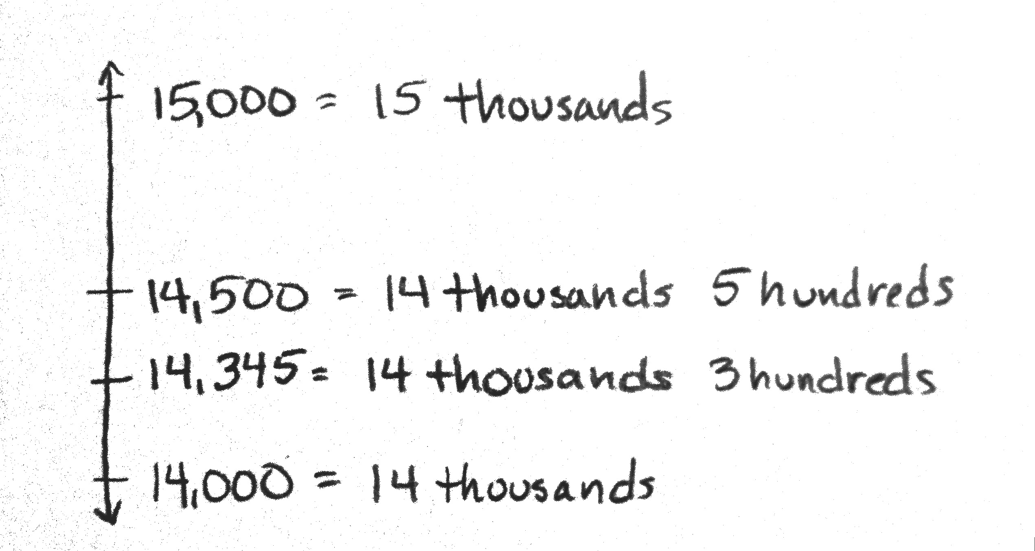
T: True. 14,500 is right in the middle. It is the halfway point. It is not closer to either number. The rule is that we round up. 14,500 rounded to the nearest thousand is 15,000.
T: With your partner, mark 14,990 on your number line and round it to the nearest thousand.
S: 14,990 is nearer to 15 thousands or 15,000.
T: Mark 14,345 on your number line. Talk with your partner about how to round it to the nearest thousand.
S: 14,345 is nearer to 14 thousands. 14,345 is nearer to 14,000. 14,345 rounded to the nearest thousand is 14,000.
T: Is 14,345 more than or less than the halfway point?
S: Less than.
T: We can look to see if 14,345 is closer to 14,000 or 15,000, and we can also look to see if it is greater than or less than the halfway point. If it is less than the halfway point, it is closer to 14,000.
Repeat using the numbers 215,711 and 214,569 rounding to the nearest thousand, naming how many thousands are in each number.
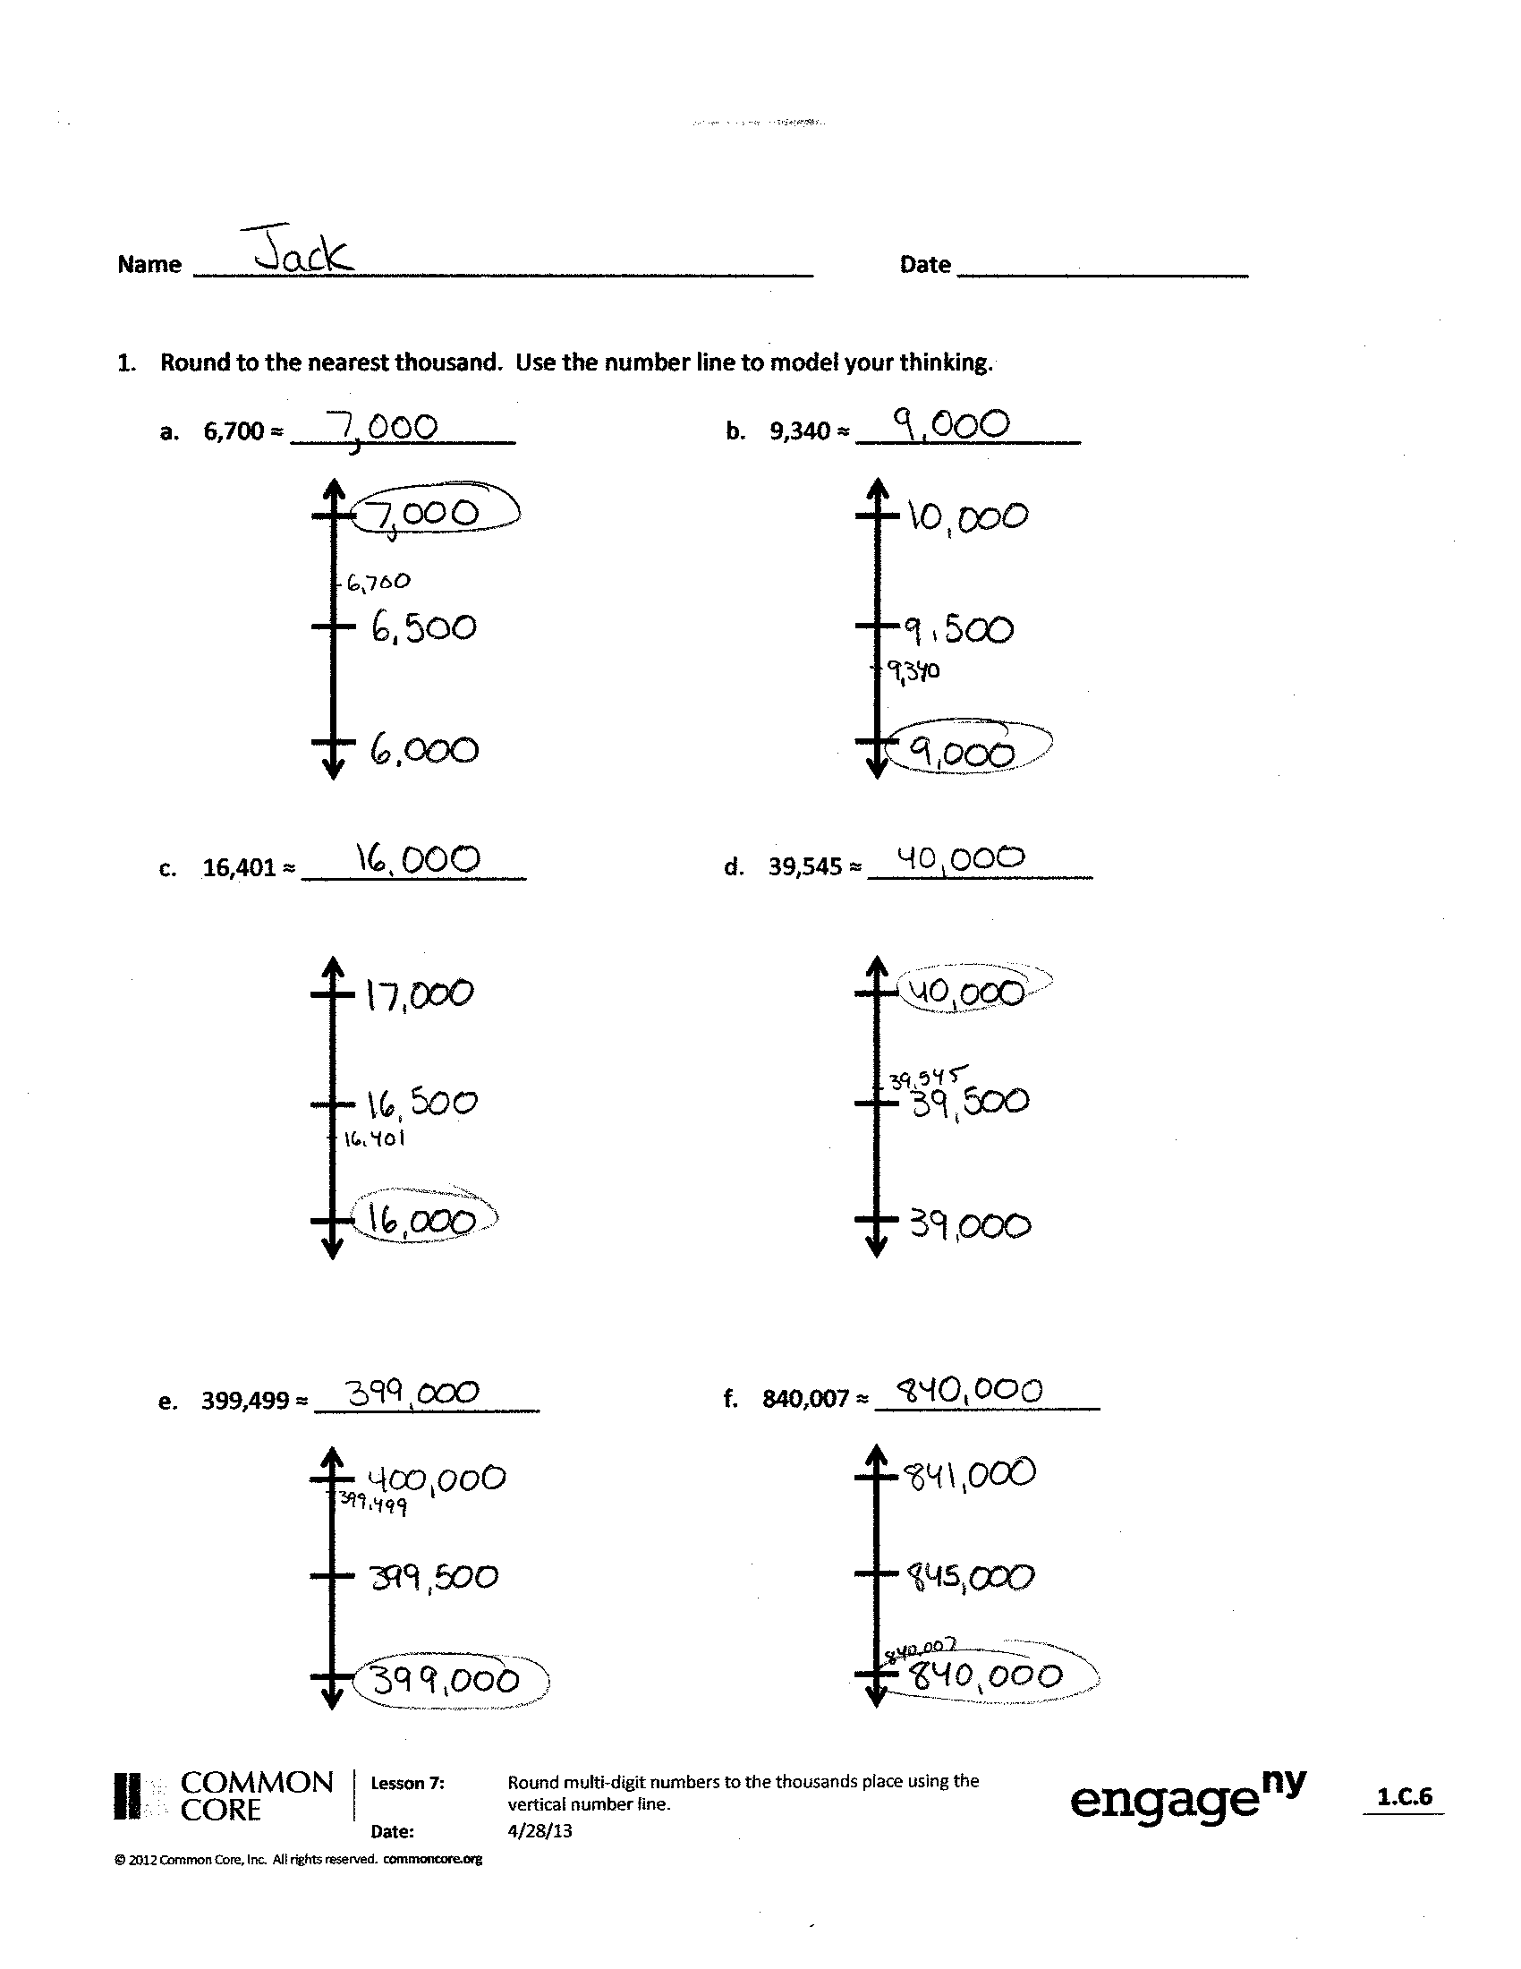
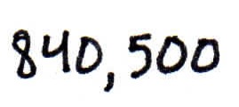
Problem Set (10 minutes)

Students should do their personal best to complete the Problem Set within the allotted 10 minutes. For some classes, it may be appropriate to modify the assignment by specifying which problems they work on first. Some problems do not specify a method for solving. Students should solve these problems using the RDW approach used for Application Problems.
Student Debrief (12 minutes)
Lesson Objective: Round multi-digit numbers to the thousands place using the vertical number line.
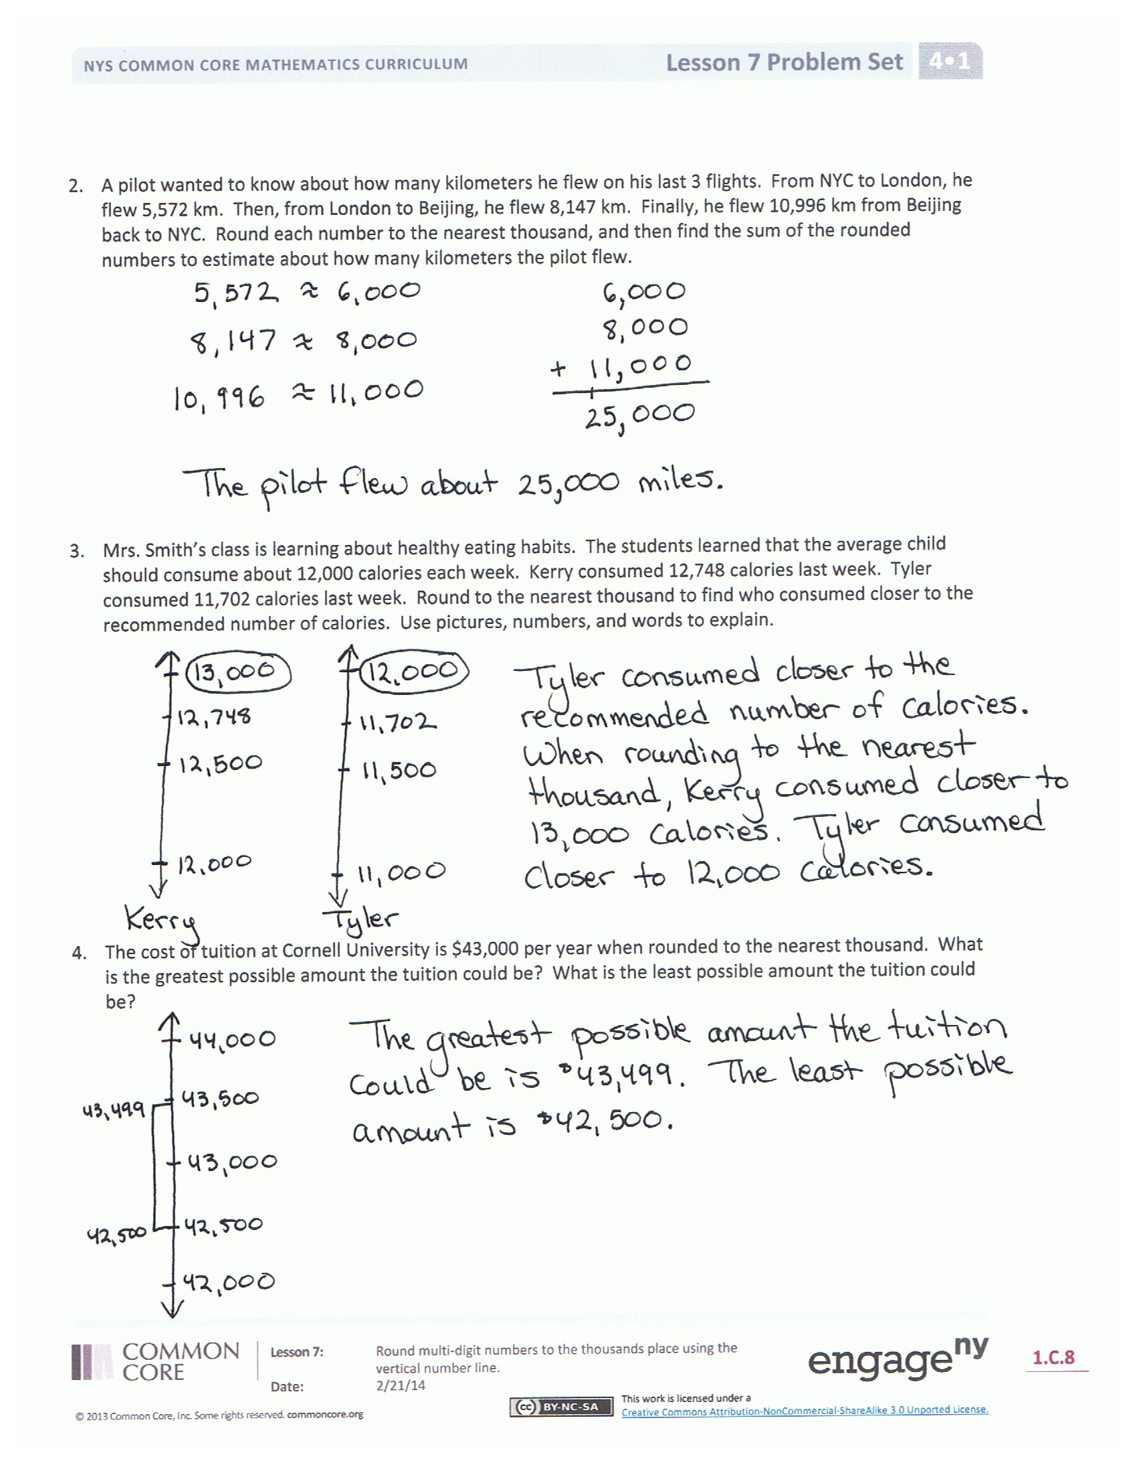
Invite students to review their solutions for the Problem Set and the totality of the lesson experience. They should check work by comparing answers with a partner before going over answers as a class. Look for misconceptions or misunderstandings that can be addressed in the Debrief. Guide students in a conversation to debrief the Problem Set.
You may choose to use any combination of the questions below to lead the discussion.
- Look at Problem 1 in the Problem Set.
Compare how you rounded 6,700 and 16,401. Explain how your rounding to the nearest thousand differed even though both numbers have a 6 in the thousands place.
- What was your strategy for solving Problem 4?
How did the vertical number line support your thinking?
- What makes 5 special in rounding?
- How does the number line help you round numbers? Is there another way you prefer? Why?
- What is the purpose of rounding?
- When might we use rounding or estimation?
Exit Ticket (3 minutes)
After the Student Debrief, instruct students to complete the Exit Ticket. A review of their work will help you assess the students’ understanding of the concepts that were presented in the lesson today and plan more effectively for future lessons. You may read the questions aloud to the students.
Name Date
- Round to the nearest thousand. Use the number line to model your thinking.

  - 6,700 ≈ _________________ b. 9,340 ≈ _________________

c. 16,401 ≈ _________________ d. 39,545 ≈ _________________

e. 399,499 ≈ _________________ f. 840,007 ≈ _________________

- A pilot wanted to know about how many kilometers he flew on his last 3 flights. From NYC to London, he flew 5,572 km. Then, from London to Beijing, he flew 8,147 km. Finally, he flew 10,996 km from Beijing back to NYC. Round each number to the nearest thousand, and then find the sum of the rounded numbers to estimate about how many kilometers the pilot flew.

- Mrs. Smith’s class is learning about healthy eating habits. The students learned that the average child should consume about 12,000 calories each week. Kerry consumed 12,748 calories last week. Tyler consumed 11,702 calories last week. Round to the nearest thousand to find who consumed closer to the recommended number of calories. Use pictures, numbers, or words to explain.

- For the 2013-2014 school year, the cost of tuition at Cornell University was $43,000 when rounded to the nearest thousand. What is the greatest possible amount the tuition could be? What is the least possible amount the tuition could be?

Name Date
- Round to the nearest thousand. Use the number line to model your thinking.

a. 7,621 ≈ ___________ b. 12,502 ≈ ___________ c. 324,087 ≈ ___________

- It takes 39,090 gallons of water to manufacture a new car. Sammy thinks that rounds up to about 40,000 gallons. Susie thinks it is about 39,000 gallons. Who rounded to the nearest thousand, Sammy or Susie?
Use pictures, numbers, or words to explain.

Name Date
- Round to the nearest thousand. Use the number line to model your thinking.

- 5,900 ≈ _________________ b. 4,180 ≈ _________________

c. 32,879 ≈ _________________ d. 78,600 ≈ _________________

e. 251,031 ≈ _________________ f. 699,900 ≈ _________________

- Steven put together 981 pieces of a puzzle. About how many pieces did they put together? Round to the nearest thousand. Use what you know about place value to explain your answer.

- Louise’s family went on vacation to Disney World. Their vacation cost $5,990. Sophia’s family went on vacation to Niagara Falls. Their vacation cost $4,720. Both families budgeted about $5,000 for their vacation. Whose family stayed closer to the budget? Round to the nearest thousand. Use what you know about place value to explain your answer.

- Marsha’s brother wanted help with the first question on his homework. The question asked the students to round 128,902 to the nearest thousand and then to explain the answer. Marsha’s brother thought that the answer was 128,000. Was his answer correct? How do you know? Use pictures, numbers, or words to explain.

