Lesson 6
Objective: Find 1, 10, and 100 thousand more and less than a given number.

Suggested Lesson Structure
 Fluency Practice (12 minutes)
 Application Problem (4 minutes)
 Concept Development (33 minutes)
 Student Debrief (11 minutes)
Total Time (60 minutes)
Fluency Practice (12 minutes)
- Unit Skip-Counting 4.NBT.1 (3 minutes)
- Rename the Units 4.NBT.2 (5 minutes)
- Compare Numbers 4.NBT.2 (4 minutes)
Unit Skip-Counting (3 minutes)
Note: This activity applies skip-counting fluency to the multiplying by ten lessons.

NOTES ON
MULTIPLE MEANS
OF ACTION AND EXPRESSION:
Before directing the students to count by 3 ten thousands, direct them first to count by 3 cats. Then, direct them to count by 3 hundreds. Finally, bridge the directions to counting by 3 ten thousands.

T: Count by threes to 30.
S: 3, 6, 9, 12, 15, 18, 21, 24, 27, 30.
T: Now count by 3 ten thousands to 30 ten thousands. Stop counting and raise your hand when you see me raise my hand.
S: 3 ten thousands, 6 ten thousands, 9 ten thousands.
T/S: (Raise hand.)
T: Say the number in standard form.
S: 90,000.
Continue, stopping the students at 15 ten thousands, 21 ten thousands, and 30 ten thousands.
Repeat the process. This time, count by fours to 40 and by 4 hundred thousands to 40 hundred thousands.
Rename the Units (5 minutes)
Note: This fluency activity applies students’ place value skills in a new context that helps them better access the lesson’s content.
Materials: (S) Personal white board
T: (Write 54,783.) Say the number.
S: 54,783.
T: How many thousands are in 54,783?
S: 54 thousands.
T: (Write 54,783 = _____ thousands ____ ones.) On your personal white boards, fill in the equation.
S: (Write 54,783 = 54 thousands 783 ones.)
T: How many ten thousands are in 54,783?
S: 5 ten thousands.
T: (Write 54,783 = _____ ten thousands ____ hundreds ____ ones.) On your boards, fill in the equation.
S: (Write 54,783 = 5 ten thousands 47 hundreds 83 ones.)
Follow the same process and sequence for 234,673.
Compare Numbers (4 minutes)
Materials: (S) Personal white board
Note: This fluency activity reviews comparing number concepts learned in Lesson 5.
T: (Write 231,005 _____ 83,872.) On your personal white boards, compare the numbers by writing the greater than, less than, or equal to symbol.
S: (Write 231,005 > 83,872.)
Repeat using the following sequence: 6 thousands 4 hundreds 9 tens _______5 ten thousands 4 hundreds 9 ones and 8 hundred thousands 7 thousands 8 hundreds 2 tens ______ 807,820.
Application Problem (4 minutes)
Use the digits 5, 6, 8, 2, 4, and 1 to create two six-digit numbers. Be sure to use each of the digits within both numbers. Express the numbers in word form and use a comparison symbol to show their relationship.
Note: This Application Problem builds on the content of the previous two lessons.
Concept Development (33 minutes)
Materials: (T) Unlabeled hundred thousands place value chart (Lesson 5 Template) (S) Personal white board, unlabeled hundred thousands place value chart (Lesson 5 Template)
Problem 1: Find 1 thousand more and 1 thousand less.
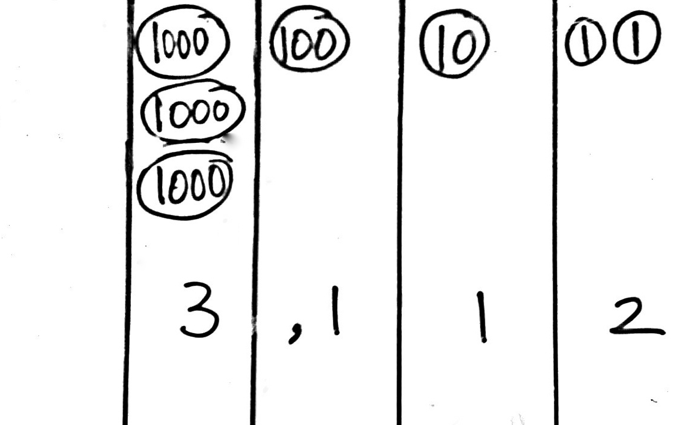
T: (Draw 2 thousand disks in the place value chart.) How many thousands do you count?
S: Two thousands.
T: What number is one thousand more? (Draw 1 more thousand.)
S: Three thousands.
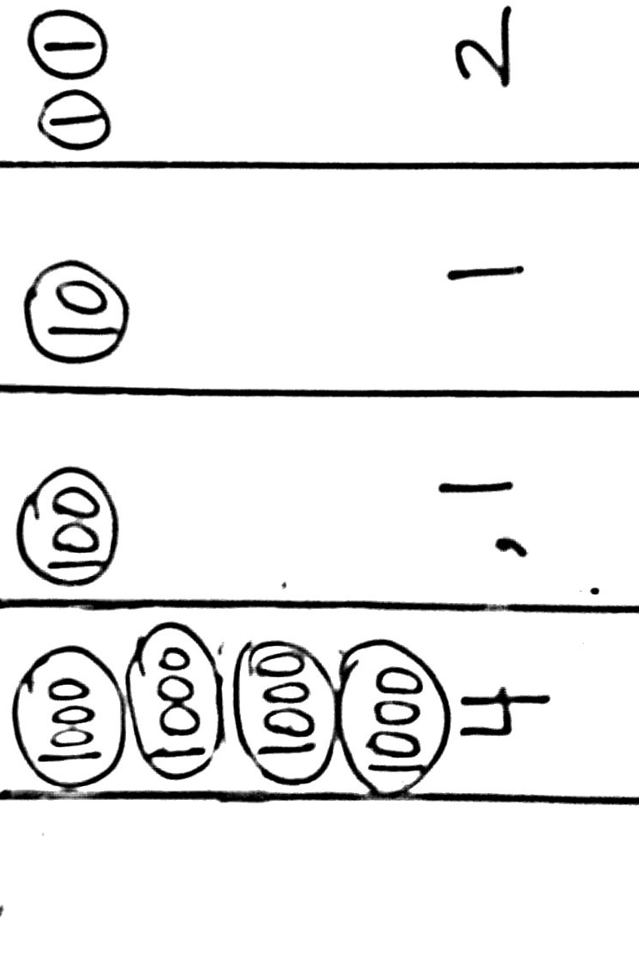
T: (Write 3 thousands 112 ones.) Model this number with disks and write its expanded and standard form.
S: (Write 3,000 + 100 + 10 + 2. 3,112.)
T: Draw 1 more unit of one thousand. What number is 1 thousand more than 3,112?
S: 4,112 is 1 thousand more than 3,112.
T: 1 thousand less than 3,112?
S: 2,112.
T: Draw 1 ten thousand disk. What number do you have now?
MP.5
S: 14,112.
T: Show 1 less unit of 1 thousand. What number is 1 thousand less than 14,112?
S: 13,112.
T: 1 thousand more than 14,112?
S: 15,112.
T: Did the largest unit change? Discuss with your partner.
S: (Discuss.)
T: Show 19,112. (Pause as students draw.) What is 1 thousand less? 1 thousand more than 19,112?
S: 18,112. 20,112.
T: Did the largest unit change? Discuss with your partner.
S: (Discuss.)
T: Show 199,465. (Pause as they do so.) What is 1 thousand less? 1 thousand more than 199,465?
S: 198,465. 200,465.
T: Did the largest unit change? Discuss with your partner.
S: (Discuss.)

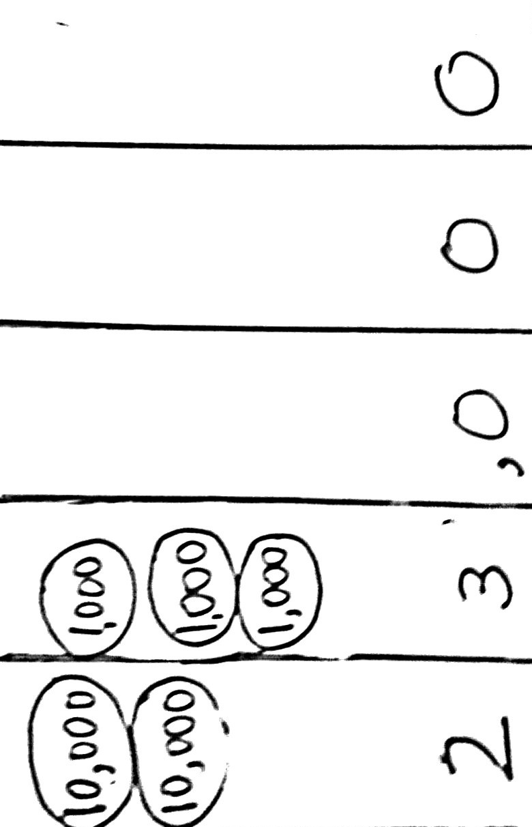
Problem 2: Find 10 thousand more and 10 thousand less.
T: Use numbers and disks to model 2 ten thousands 3 thousands. Read and write the expanded form.
S: (Model, read and write 20,000 + 3,000 = 23,000.)
T: What number is 10 thousand more than 2 ten thousands 3 thousands? Draw, read, and write the expanded form.
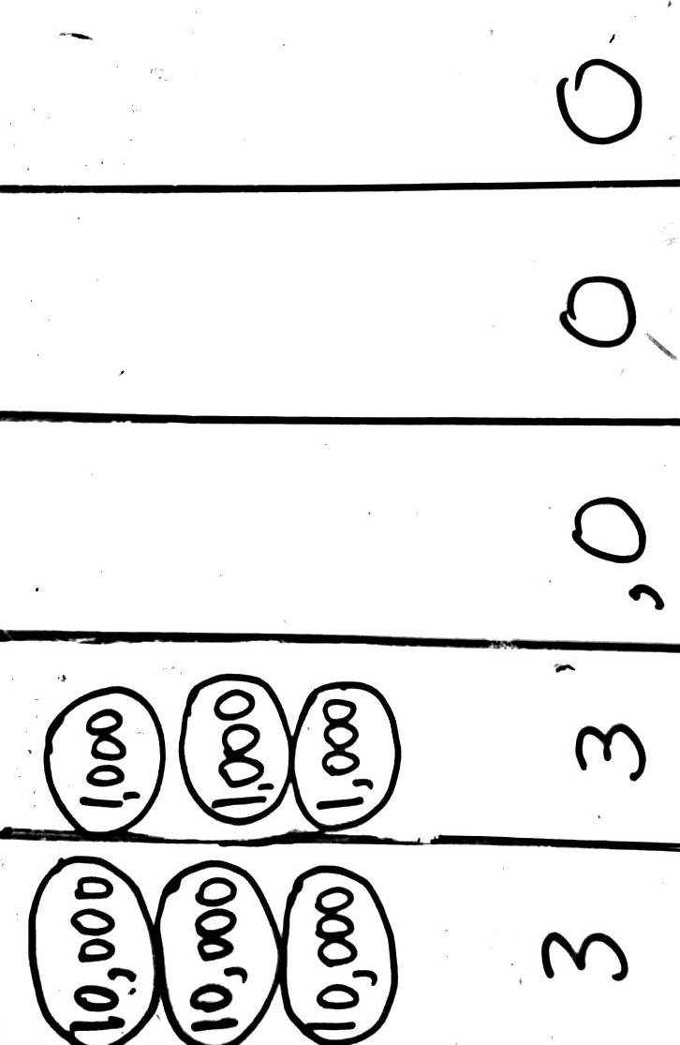
S: (Model, read and write 20,000 + 10,000 + 3,000 = 33,000.)
T: (Display 100,000 + 30,000 + 4,000.) Use disks and numbers to model the sum. What number is 10 thousand more than 134,000? Say your answer as an addition sentence.
S: 10,000 plus 134,000 is 144,000.
T: (Display 25,130 – 10,000.) What number is 10 thousand less than 25,130? Work with your partner to use numbers and disks to model the difference. Write and whisper to your partner an equation in unit form to verify your answer.
S: (Model, read, and write 2 ten thousands 5 thousands 1 hundred 3 tens minus 1 ten thousand is 1 ten thousand 5 thousands 1 hundred 3 tens.)
Problem 3: Find 100 thousand more and 100 thousand less.
T: (Display 200,352.) Work with your partner to find the number that is 100 thousand more than 200,352.
Write an equation to verify your answer.

NOTES ON
MULTIPLE MEANS
OF ENGAGEMENT:
After students predict the next number in the pattern, ask students to create their own pattern using the strategy of one thousand more or less, ten thousand more or less, or one hundred thousand more or less. Then, ask students to challenge their classmates to predict the next number in the pattern.
S: (Write 200,352 + 100,000 = 300,352.)
T: (Display 545,000 and 445,000 and 345,000.) Read these three numbers to your partner. Predict the next number in my pattern and explain your reasoning.
S: I predict the next number will be 245,000. I notice the numbers decrease by 100,000. 345,000 minus 100,000 is 245,000. I notice the hundred thousand units decreasing: 5 hundred thousands, 4 hundred thousands, 3 hundred thousands. I predict the next number will have 2 hundred thousands. I notice the other units do not change, so the next number will be 2 hundred thousands 4 ten thousands 5 thousands.

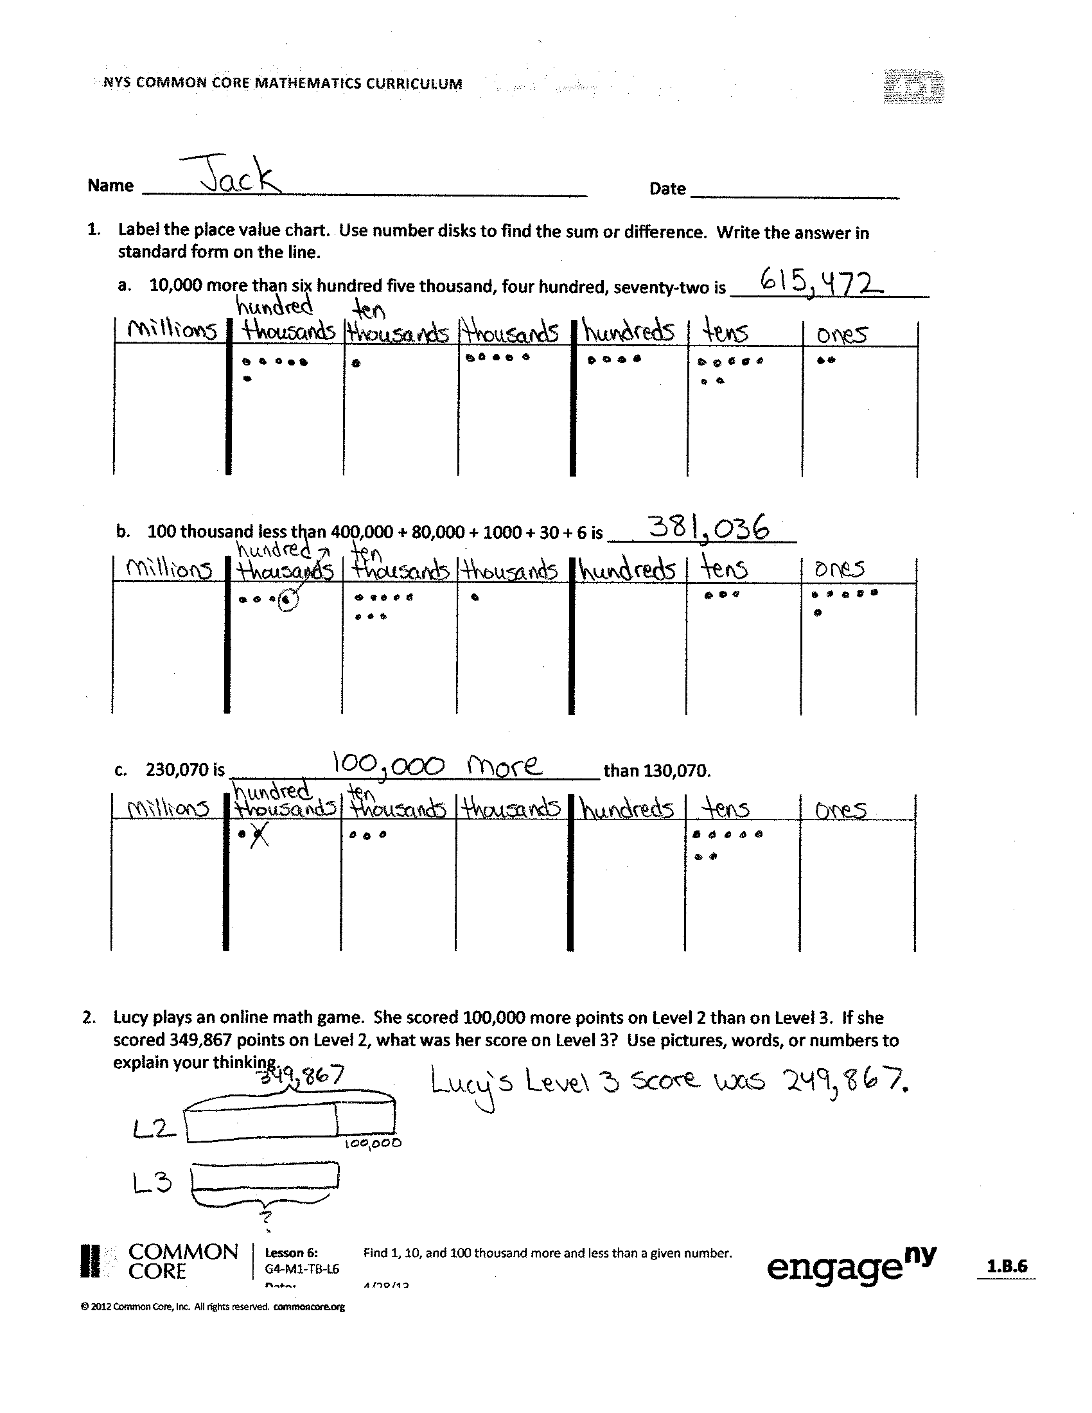
Problem Set (10 minutes)
Students should do their personal best to complete the Problem Set within the allotted 10 minutes. For some classes, it may be appropriate to modify the assignment by specifying which problems they work on first. Some problems do not specify a method for solving. Students should solve these problems using the RDW approach used for Application Problems.
Student Debrief (11 minutes)
Lesson Objective: Find 1, 10, and 100 thousand more and less than a given number.
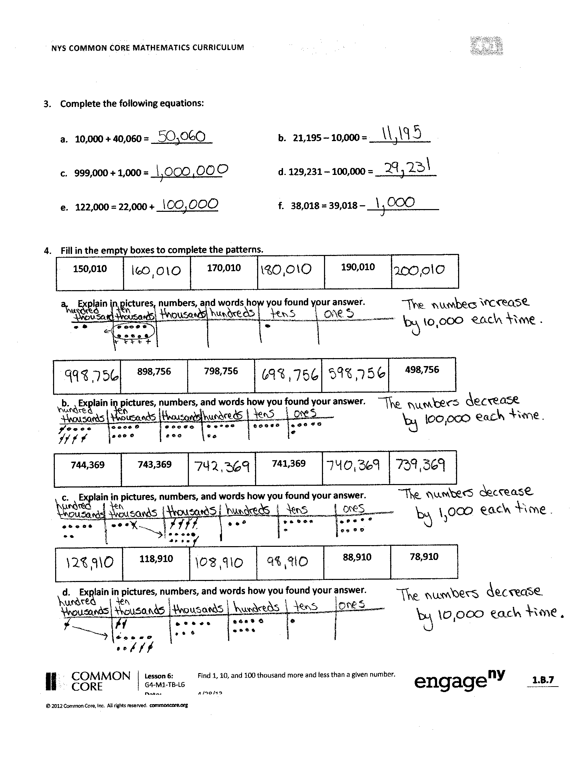
Invite students to review their solutions for the Problem Set and the totality of the lesson experience. They should check work by comparing answers with a partner before going over answers as a class. Look for misconceptions or misunderstandings that can be addressed in the Debrief. Guide students in a conversation to debrief the Problem Set.
a.
b.
c.
d.
You may choose to use any combination of the questions below to lead the discussion.
- When drawing place value disks in the Problem Set, how did you show that a number was added or that a number was taken away? If you used symbols, which symbols did you use?
- Look at Problem 2 in the Problem Set. How did you solve? Compare your method to your partner’s. How else could you model?
- Why were Problem 3(e) and (f) more challenging than the rest? How did you use your place value knowledge to solve?
- Look at Problem 4. What strategy did you use to complete the pattern? How many ways can we model to solve? Which way is best? Why do you think so?
- Compare Problem 3 and Problem 4. Which was easier to solve? Why?
- How does your understanding of place value help you add or subtract 1,000, 10,000, and 100,000?
- What place value patterns have we discovered?
Exit Ticket (3 minutes)
After the Student Debrief, instruct students to complete the Exit Ticket. A review of their work will help you assess the students’ understanding of the concepts that were presented in the lesson today and plan more effectively for future lessons. You may read the questions aloud to the students.

Name Date
- Label the place value chart. Use place value disks to find the sum or difference. Write the answer in standard form on the line.
- 10,000 more than six hundred five thousand, four hundred seventy-two is ___________________.

- 100 thousand less than 400,000 + 80,000 + 1,000 + 30 + 6 is ____________________.

- 230,070 is _______________________________________ than 130,070.

- Lucy plays an online math game. She scored 100,000 more points on Level 2 than on Level 3. If she scored 349,867 points on Level 2, what was her score on Level 3? Use pictures, words, or numbers to explain your thinking.
- Fill in the blank for each equation.

a. 10,000 + 40,060 = ____________ b. 21,195 – 10,000 = ____________
c. 999,000 + 1,000 = ______________ d. 129,231 – 100,000 = ____________
e. 122,000 = 22,000 + ____________ f. 38,018 = 39,018 – ______________

- Fill in the empty boxes to complete the patterns.
150,010

__________
170,010

__________
190,010

__________
a.

Explain in pictures, numbers, or words how you found your answers.
b.

__________
898,756
798,756

__________

__________
498,756

Explain in pictures, numbers, or words how you found your answers.

c.
744,369
743,369

__________
741,369

__________

__________

Explain in pictures, numbers, or words how you found your answers.

d.
78,910
118,910

__________
88,910

__________

__________

Explain in pictures, numbers, or words how you found your answers.

Name Date
- Fill in the empty boxes to complete the pattern.
468,235

__________

471,235

__________
472,235

__________

Explain in pictures, numbers, or words how you found your answers.

- Fill in the blank for each equation.
a. 1,000 + 56,879 = ____________ b. 324,560 – 100,000 = ____________
c. 456,080 – 10,000 = ______________ d. 10,000 + 786,233 = ____________

- The population of Rochester, NY in the 2000 Census was 219,782. The 2010 Census found that the population decreased by about 10,000. About how many people lived in Rochester in 2010?
Explain in pictures, numbers, or words how you found your answer.

Name Date
- Label the place value chart. Use place value disks to find the sum or difference. Write the answer in standard form on the line.

  - 100,000 less than five hundred sixty thousand, three hundred thirteen is ______________.

  - Ten thousand more than 300,000 + 90,000 + 5,000 + 40 is ____________________.

  - 447,077 is _______________________________________ than 347,077.

- Fill in the blank for each equation:

a. 100,000 + 76,960 = ____________ b. 13,097 – 1,000 = ____________

c. 849,000 – 10,000 = ______________ d. 442,210 + 10,000 = ____________

e. 172,090 = 171,090 + ____________ f. 854,121 = 954,121 – ____________
- Fill in the empty boxes to complete the patterns.
145,555

__________
147,555

__________
149,555

__________
a.

Explain in pictures, numbers, or words how you found your answers.

b.

__________
764,321
774,321

__________

__________
804,321

Explain in pictures, numbers, or words how you found your answers.

125,876
225,876

__________
425,876

__________

__________
c.

Explain in pictures, numbers, or words how you found your answers.

214,445
254,445

__________
224,445

__________

__________
d.

Explain in pictures, numbers, or words how you found your answers.

- In 2012, Charlie earned an annual salary of $54,098. At the beginning of 2013, Charlie’s annual salary was raised by $10,000. How much money will Charlie earn in 2013? Use pictures, words, or numbers to explain your thinking.

