Lesson 5
Objective: Compare numbers based on meanings of the digits using
>, <, or = to record the comparison.

Suggested Lesson Structure
 Fluency Practice (14 minutes)
 Application Problem (6 minutes)
 Concept Development (30 minutes)
 Student Debrief (10 minutes)
Total Time (60 minutes)
Fluency Practice (14 minutes)
- Sprint: Multiply by 4 3.OA.7 (10 minutes)
- Unit Skip-Counting 4.NBT.1 (2 minutes)
- Place Value 4.NBT.2 (2 minutes)
Sprint: Multiply by 4 (10 minutes)
Materials: (S) Multiply by 4 Sprint
Note: This fluency reviews a foundational Grade 3 standard that helps students learn standard 4.NBT.5.
Unit Skip-Counting (2 minutes)
Note: This activity applies skip-counting fluency that was built during the first four lessons and applies to concepts from the multiplying by ten lessons.
T: Count by twos to 20.
S: 2, 4, 6, 8, 10, 12, 14, 16, 18, 20.
T: Now count by 2 tens to 20 tens. Stop counting and raise your hand when you see me raise my hand.
S: 2 tens, 4 tens, 6 tens.
T/S: (Raise hand.)
T: Say the number in standard form.
S: 60.
Continue, stopping the students at 12 tens, 16 tens, and 20 tens.
Repeat the process. This time, count by threes to 30 and by 3 ten thousands to 30 ten thousands.
Place Value (2 minutes)
Note: Reviewing and practicing place value skills in isolation prepares students for success in comparing
numbers during the lesson.
T: (Write 3,487.) Say the number.
S: 3,487.
T: What digit is in the tens place?
S: 8.
T: (Underline 8.) What’s the value of the 8?
S: 80.
T: State the value of the 3.
S: 3,000.
T: 4?
S: 400.
Repeat for the following possible sequence: 59,607; 287,493; and 742,952.
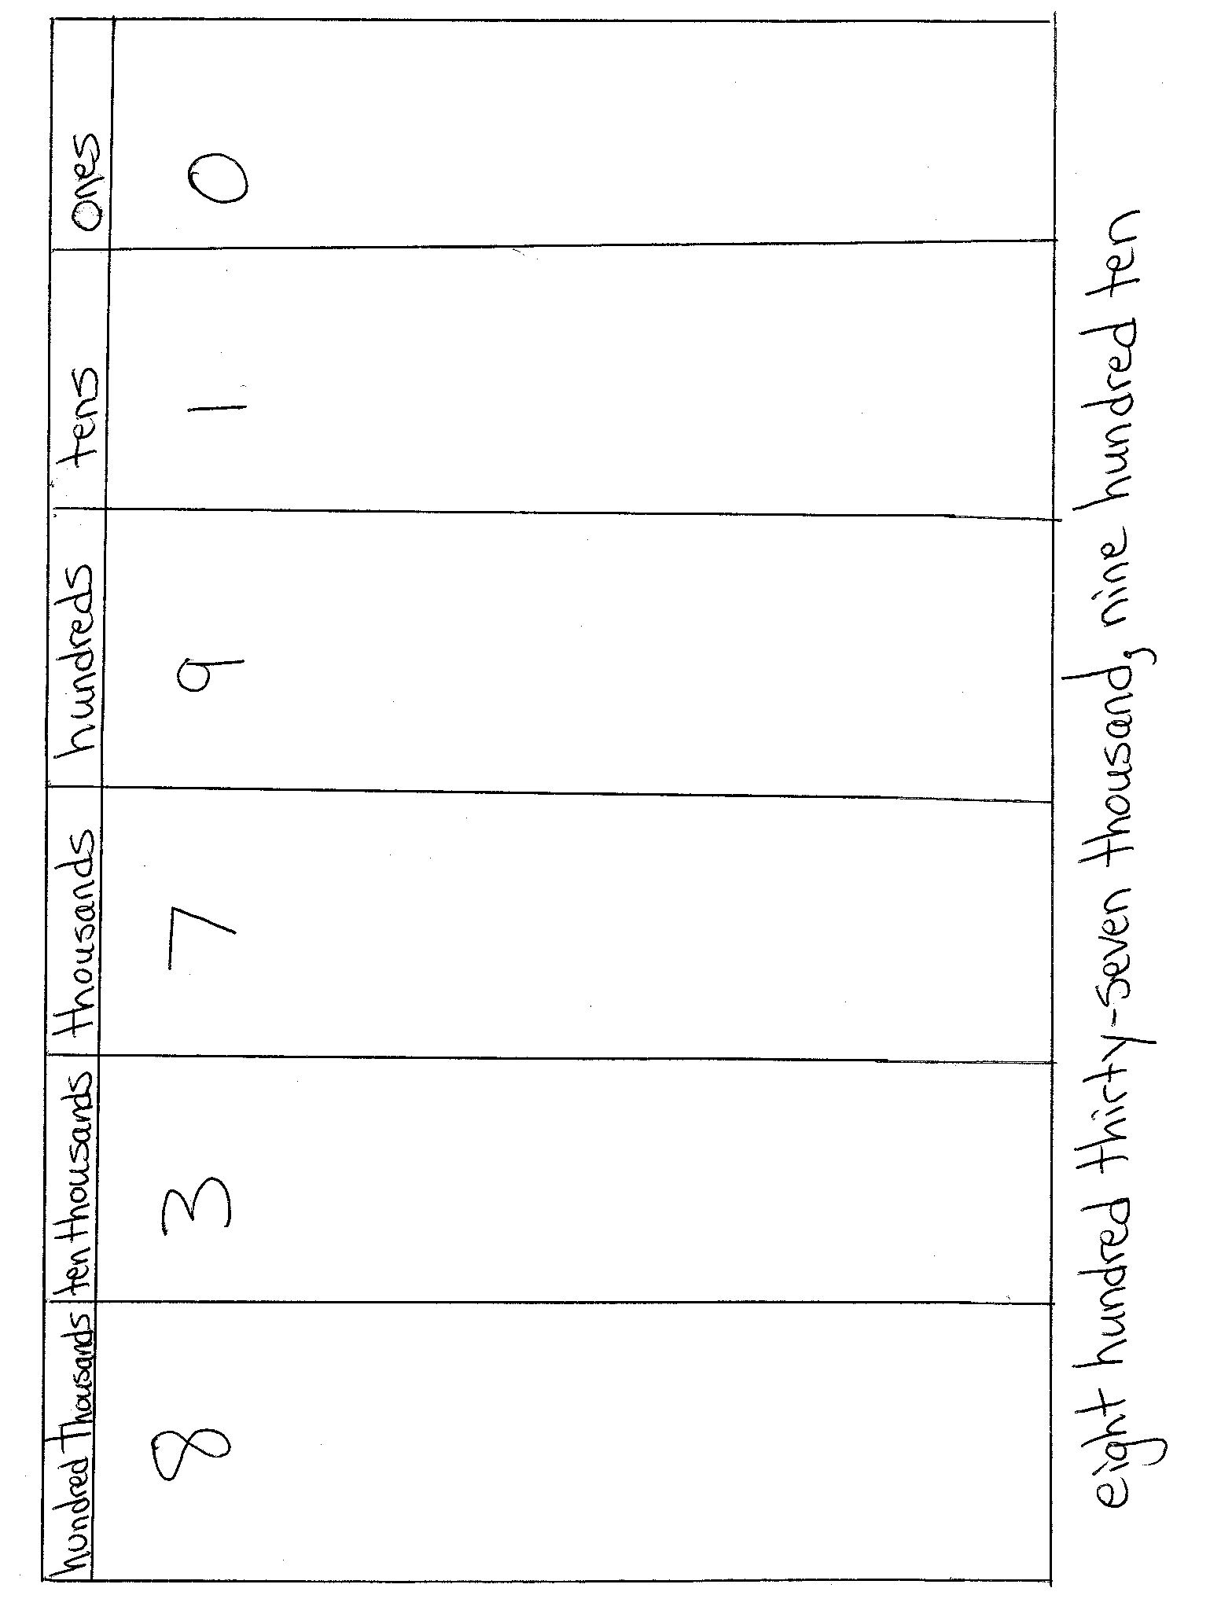
Application Problem (6 minutes)
Draw and label the units on the place value chart to hundred thousands. Use each of the following digits (9, 8, 7, 3, 1, 0) once to create a number that is between 7 hundred thousands and 9 hundred thousands. In word form, write the number you created.
Extension: Create 2 more numbers following the same directions as above.
Note: This Application Problem builds on the content of the previous lesson, requiring students to read and write
multi-digit numbers in expanded, word, and unit forms.
Concept Development (30 minutes)
Materials: (S) Personal white board, unlabeled hundred thousands place value chart (Template)
Problem 1: Comparing two numbers with the same largest unit.
Display: 3,010 2,040
T: Let’s compare two numbers. Say the standard form to your partner and model each number on your place value chart.
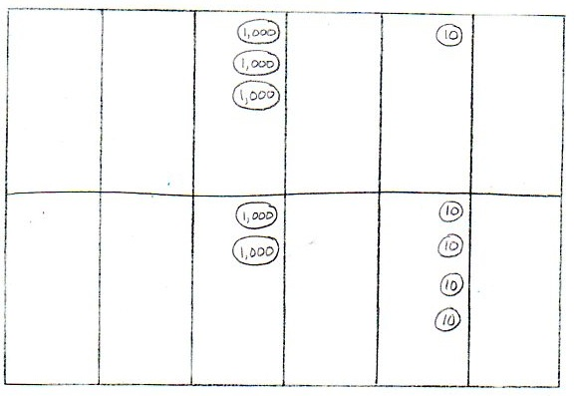
S: Three thousand, ten. Two thousand, forty.
T: What is the name of the unit with the greatest value?
S: Thousands.
T: Compare the value of the thousands.
S: 3 thousands is greater than 2 thousands. 2 thousands is less than 3 thousands.
T: Tell your partner what would happen if we only compared tens rather than the unit with the greatest value.
S: We would say that 2,040 is greater than 3,010, but that isn’t right. The number with more of the largest unit being compared is greater. We don’t need to compare the tens because the thousands are different.

NOTES ON
MULTIPLE MEANS
OF REPRESENTATION:
Provide sentence frames for students to refer to when using comparative statements.

T: Thousands is our largest unit. 3 thousands is greater than 2 thousands so 3,010 is greater than 2,040. (Write the comparison symbol “>" in the circle.) Write this comparison statement on your board and say it to your partner in two different ways.
S: (Write 3,010 > 2,040.) 3,010 is greater than 2,040. 2,040 is less than 3,010.
Problem 2: Comparing two numbers with an equal amount of the largest units.
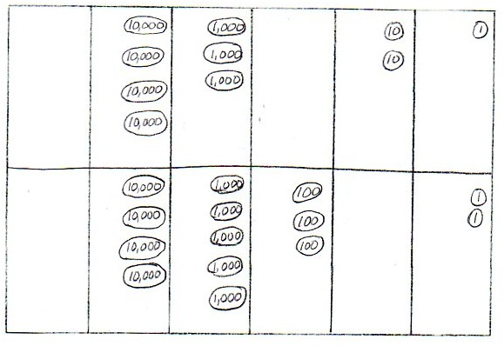
Display: 43,021 45,302
T: Model and read each number. How is this comparison different from our first comparison?
S: Before, our largest unit was thousands. Now, our largest unit is ten thousands. In this comparison, both numbers have the same number of ten thousands.
T: If the digits of the largest unit are equal, how do we compare?
S: We compare the thousands. We compare the next largest unit. We compare the digit one place to the right.
T: Write your comparison statement on your board. Say the comparison statement in two ways.
S: (Write 43,021 < 45,302 and 45,302 > 43,021.) 43,021 is less than 45,302. 45,302 is greater than 43,021.
Repeat the comparison process using 2,305 and 2,530 and then 970,461 and 907,641.
T: Write your own comparison problem for your partner to solve. Create a two number comparison problem in which the largest unit in both numbers is the same.

Problem 3: Comparing values of multiple numbers using a place value chart.
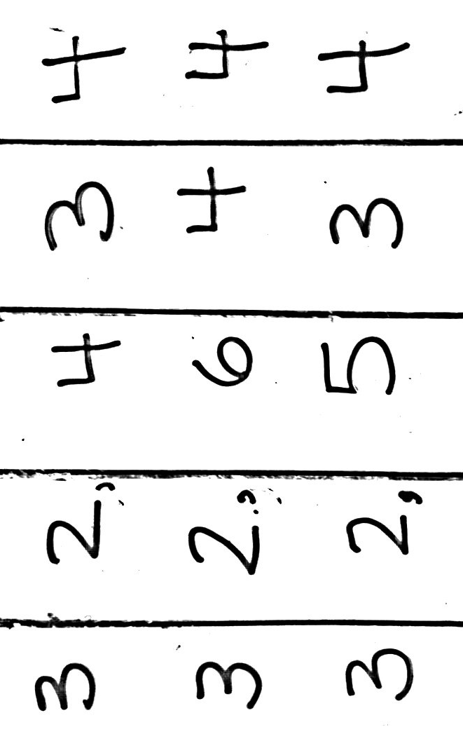
Display: 32,434, 32,644, and 32,534.
MP.1
T: Write these numbers in your place value chart. Whisper the value of each digit as you do so.
T: When you compare the value of these three numbers, what do you notice?
S: All three numbers have 3 ten thousands. All three numbers have 2 thousands. We can compare the hundreds because they are different.
T: Which number has the greatest value?
S: 32,644.

NOTES ON
MULTIPLE MEANS
OF ACTION AND EXPRESSION:
For students who have difficulty converting numbers from expanded form into standard form, demonstrate, using a place value chart to show how each number can be represented and then how the numbers can be added together. Alternatively, use place value cards (known as Hide Zero cards in the primary grades) to allow students to see the value of each digit that composes a number. The cards help students manipulate and visually display both the expanded form and the standard form of any number.

T: Tell your partner which number has the least value and how you know.
S: 32,434 is the smallest of the three numbers because it has the least number of hundreds.
T: Write the numbers from greatest to least. Use comparison symbols to express the relationships of the numbers.
S: (Write 32,644 > 32,534 > 32,434.)
Problem 4: Comparing numbers in different number forms.
Display: Compare 700,000 + 30,000 + 20 + 8 and 735,008.
T: Discuss with your partner how to solve and write your comparison.
S: I will write the numerals in my place value chart to compare. Draw disks for each number. I’ll write the first number in standard form, then compare.
S: (Write 730,028 < 735,008.)
T: Tell your partner which units you compared and why.
S: I compared thousands because the larger units were the same. 5 thousands are greater than 0 thousands, so 735,008 is greater than 730,028.
Repeat with 4 hundred thousands 8 thousands 9 tens and 40,000 + 8,000 + 90.

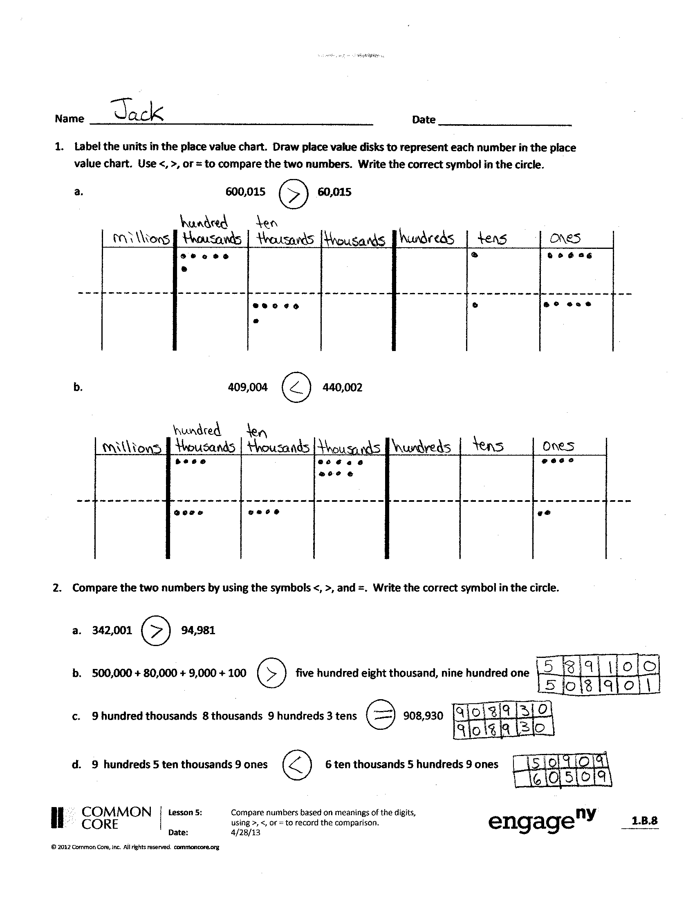
Problem Set (10 minutes)
Students should do their personal best to complete the Problem Set within the allotted 10 minutes. For some classes, it may be appropriate to modify the assignment by specifying which problems they work on first. Some problems do not specify a method for solving. Students should solve these problems using the RDW approach used for Application Problems.
Student Debrief (10 minutes)
Lesson Objective: Compare numbers based on meanings of the digits using >, <, or = to record the comparison.
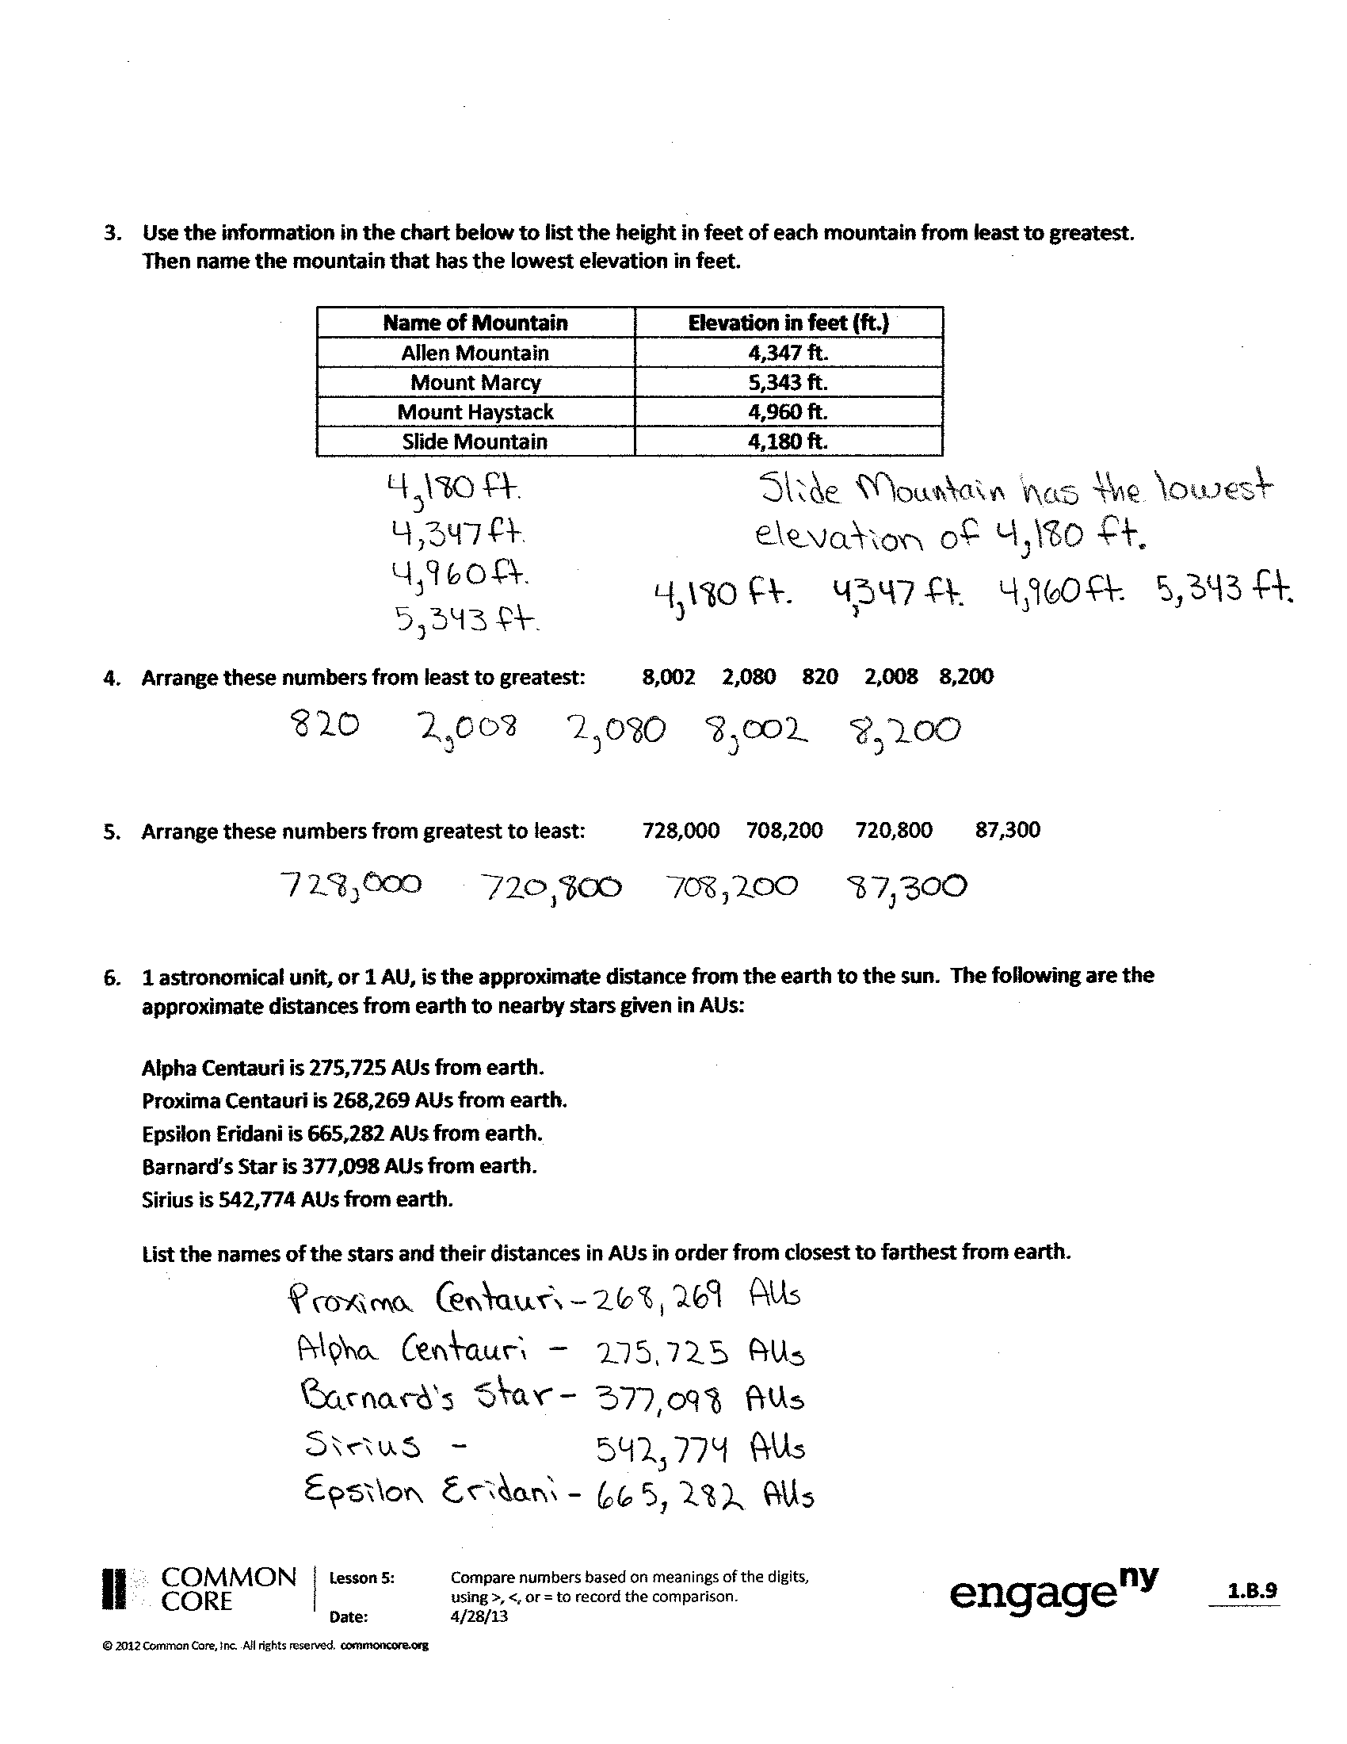
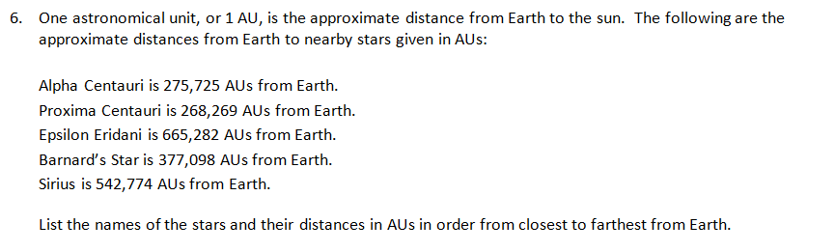
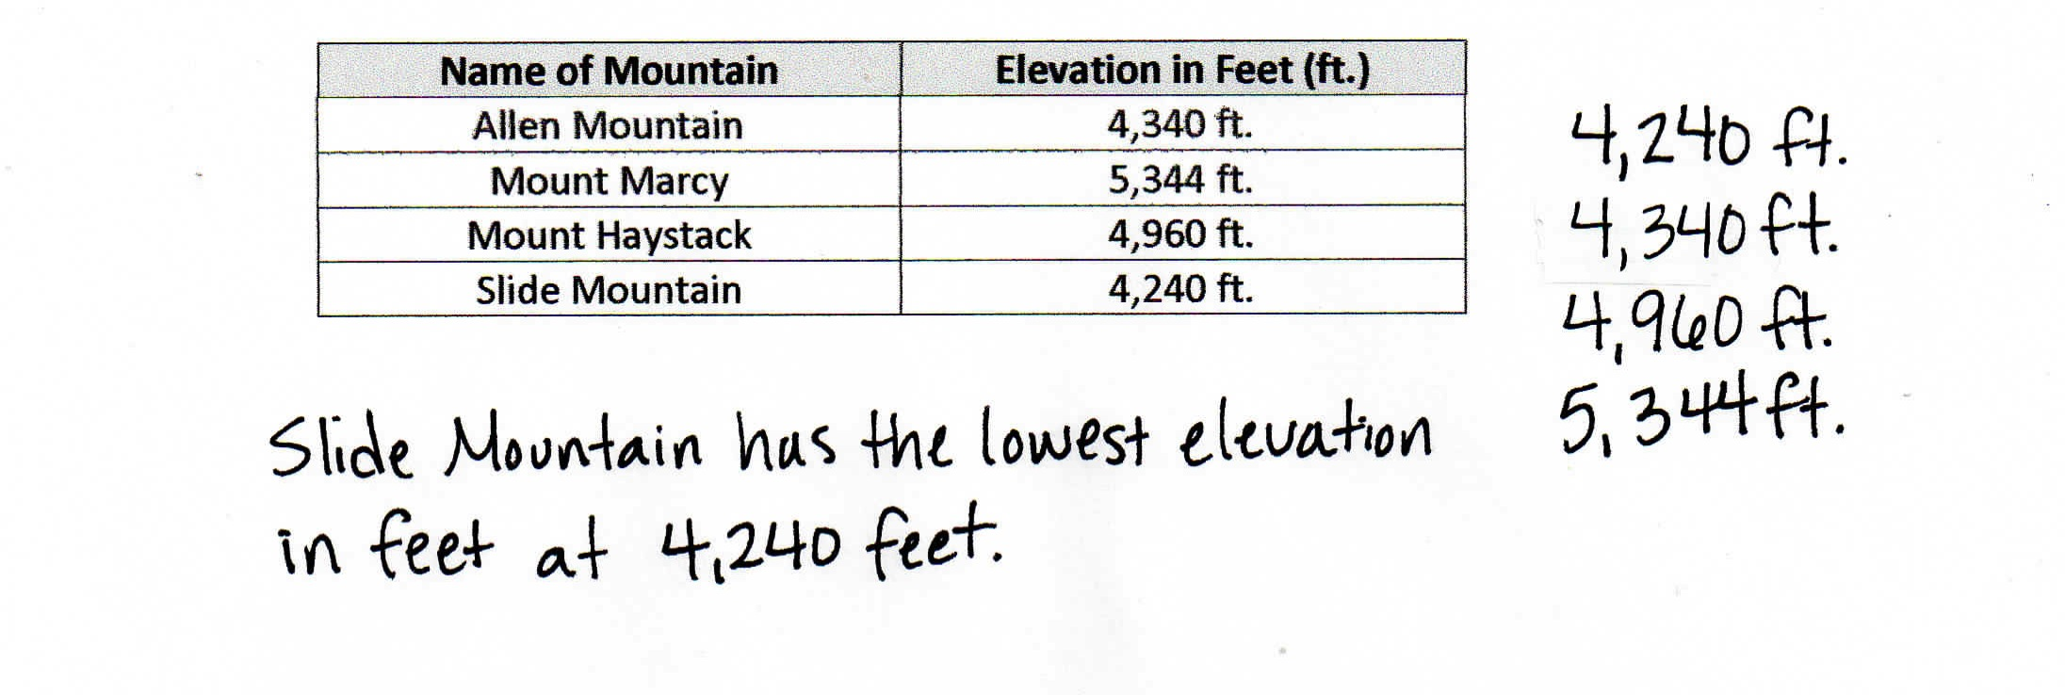
Invite students to review their solutions for the Problem Set and the totality of the lesson experience. They should check work by comparing answers with a partner before going over answers as a class. Look for misconceptions or misunderstandings that can be addressed in the Debrief. Guide students in a conversation to debrief the Problem Set.
You may choose to use any combination of the questions below to lead the discussion.
- When comparing numbers, which is more helpful to you: lining up digits or lining up place value disks in a place value chart? Explain.
- How is comparing numbers in Problem 1(a) different from Problem 1(b)?
- How does your understanding of place value help to compare and order numbers?
- How can ordering numbers apply to real life?
- What challenges arise in comparing numbers when the numbers are written in different forms, such as in Problem 2?
Exit Ticket (3 minutes)
After the Student Debrief, instruct students to complete the Exit Ticket. A review of their work will help you assess the students’ understanding of the concepts that were presented in the lesson today and plan more effectively for future lessons. You may read the questions aloud to the students.

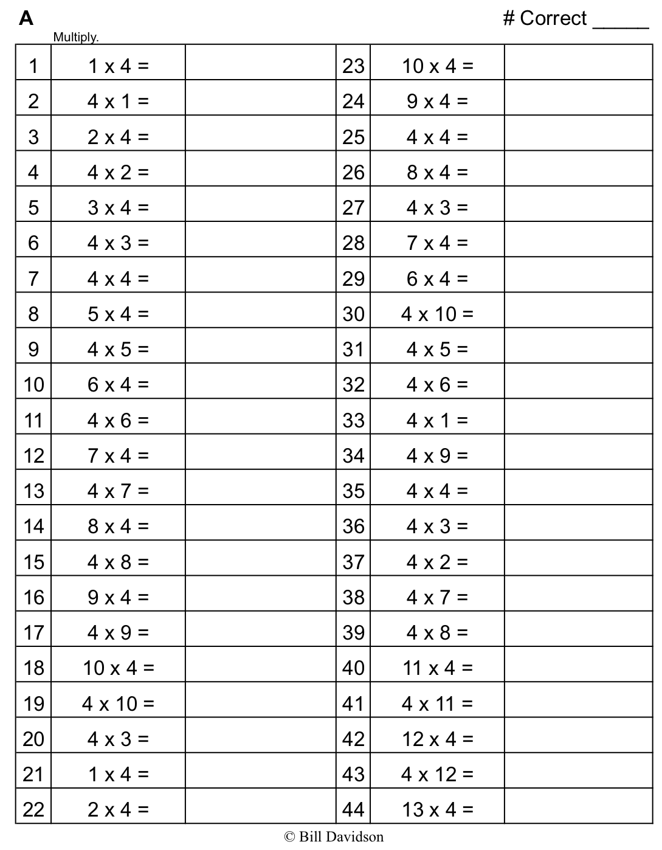
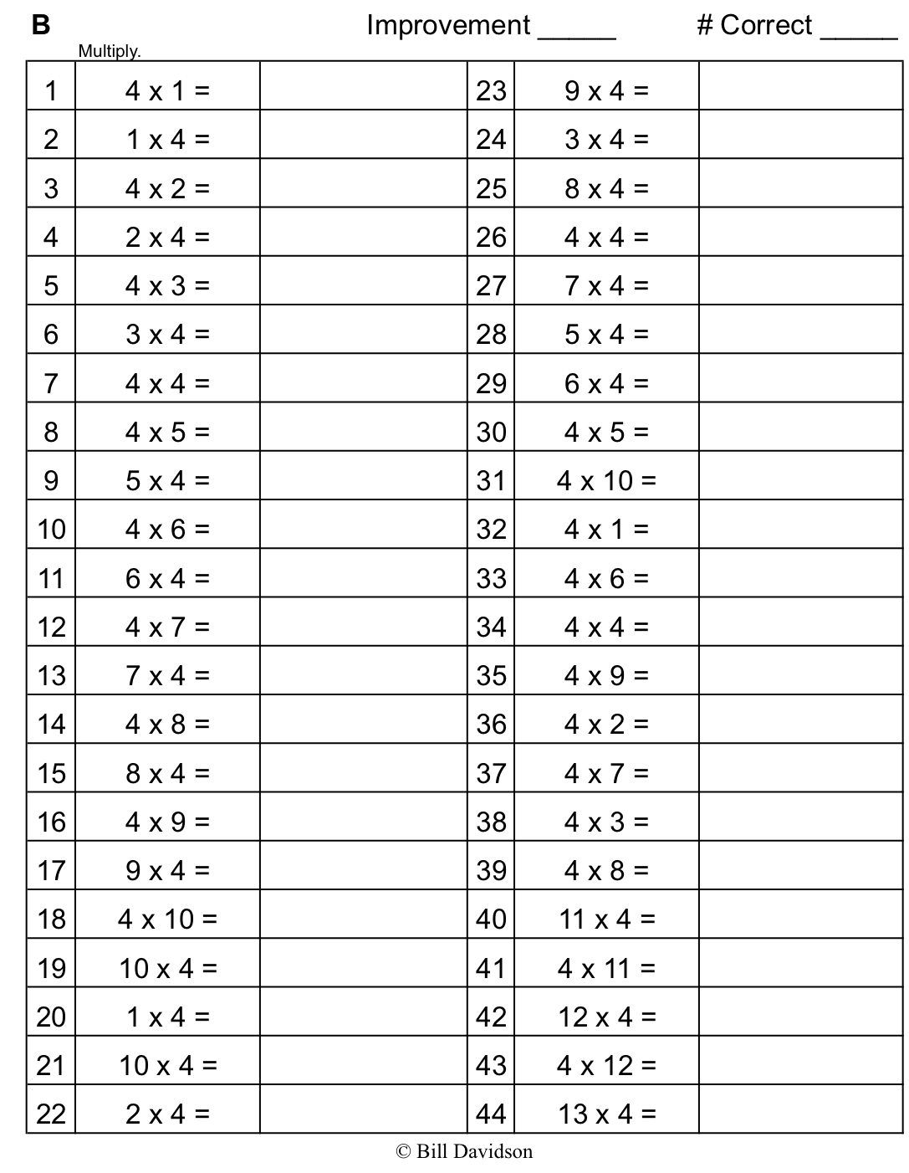
Name Date
- Label the units in the place value chart. Draw place value disks to represent each number in the place value chart. Use <, >, or = to compare the two numbers. Write the correct symbol in the circle.
a. 600,015 60,015

b. 409,004 440,002

- Compare the two numbers by using the symbols <, >, and =. Write the correct symbol in the circle.

- 342,001 94,981

- 500,000 + 80,000 + 9,000 + 100 five hundred eight thousand, nine hundred one

- 9 hundred thousands 8 thousands 9 hundreds 3 tens 908,930

- 9 hundreds 5 ten thousands 9 ones 6 ten thousands 5 hundreds 9 ones
- Use the information in the chart below to list the height in feet of each mountain from least to greatest. Then, name the mountain that has the lowest elevation in feet.
Name of Mountain | Elevation in Feet (ft.)
Allen Mountain | 4,340 ft.
Mount Marcy | 5,344 ft.
Mount Haystack | 4,960 ft.
Slide Mountain | 4,240 ft.

- Arrange these numbers from least to greatest: 8,002 2,080 820 2,008 8,200

- Arrange these numbers from greatest to least: 728,000 708,200 720,800 87,300

- One astronomical unit, or 1 AU, is the approximate distance from Earth to the sun. The following are the approximate distances from Earth to nearby stars given in AUs:

Alpha Centauri is 275,725 AUs from Earth.
Proxima Centauri is 268,269 AUs from Earth.
Epsilon Eridani is 665,282 AUs from Earth.
Barnard’s Star is 377,098 AUs from Earth.
Sirius is 542,774 AUs from Earth.
List the names of the stars and their distances in AUs in order from closest to farthest from Earth.

Name Date
- Four friends played a game. The player with the most points wins. Use the information in the table below to order the number of points each player earned from least to greatest. Then, name the person who won the game.

Player Name | Points Earned
Amy | 2,398 points
Bonnie | 2,976 points
Jeff | 2,709 points
Rick | 2,699 points

- Use each of the digits 5, 4, 3, 2, 1 exactly once to create two different five-digit numbers.

  - Write each number on the line and compare the two numbers by using the symbols < or >.
Write the correct symbol in the circle.

__________________ __________________

  - Use words to write a comparison statement for the problem above.

Name Date
- Label the units in the place value chart. Draw place value disks to represent each number in the place value chart. Use <, >, or = to compare the two numbers. Write the correct symbol in the circle.
a. 909,013 90,013

b. 210,005 220,005

- Compare the two numbers by using the symbols <, >, and =. Write the correct symbol in the circle.

- 501,107 89,171

- 300,000 + 50,000 + 1,000 + 800 six hundred five thousand, nine hundred eight

- 3 hundred thousands 3 thousands 8 hundreds 4 tens 303,840

- 5 hundreds 6 ten thousands 2 ones 3 ten thousands 5 hundreds 1 one
- Use the information in the chart below to list the height, in feet, of each skyscraper from shortest to tallest. Then, name the tallest skyscraper.

Name of Skyscraper | Height of Skyscraper (ft.)
Willis Tower | 1,450
One World Trade Center | 1,776
Taipei 101 | 1,670
Petronas Towers | 1,483

- Arrange these numbers from least to greatest: 7,550 5,070 750 5,007 7,505

- Arrange these numbers from greatest to least: 426,000 406,200 640,020 46,600

- The areas of the 50 states can be measured in square miles (sq. miles).

California is 158,648 sq. miles. Nevada is 110,567 sq. miles. Arizona is 114,007 sq. miles.
Texas is 266,874 sq. miles. Montana is 147,047 sq. miles, and Alaska is 587,878 sq. miles.
Arrange the states in order from least area to greatest area.

unlabeled hundred thousand place value chart

