Lesson 4
Objective: Read and write multi-digit numbers using base ten numerals, number names, and expanded form.

Suggested Lesson Structure
 Fluency Practice (13 minutes)
 Application Problem (6 minutes)
 Concept Development (26 minutes)
 Student Debrief (15 minutes)
Total Time (60 minutes)
Fluency Practice (13 minutes)
- Skip-Counting 3.OA.4–7 (3 minutes)
- Place Value 4.NBT.2 (2 minutes)
- Numbers Expressed in Different Base Units 4.NBT.1 (8 minutes)
Skip-Counting (3 minutes)
Note: Practicing skip-counting on the number line builds a foundation for accessing higher order concepts throughout the year.
Direct students to skip-count by fours forward and backward to 48 focusing on transitions crossing the ten.
Place Value (2 minutes)

NOTES ON
MULTIPLE MEANS
OF REPRESENTATION:
Place value fluency supports language acquisition as it couples meaningful visuals with valuable practice speaking the standard and unit form of numbers to 1 million.

Materials: (S) Personal white board, unlabeled millions place value chart (Lesson 2 Template)
Note: Reviewing and practicing place value skills in isolation prepares students for success in writing multi-digit numbers in expanded form.
T: Show 5 hundred thousands as place value disks and write the number below it on the place value chart.
S: (Draw 5 hundred thousands disks and write 500,000 below the chart.)
T: Say the number in unit form.
S: 5 hundred thousands.
T: Say it in standard form.
S: 500,000.
Continue for the following possible sequence: 5 hundred thousands 3 ten thousands, 5 hundred thousands 3 hundreds, 5 ten thousands 3 hundreds, 1 hundred thousand 3 hundreds 5 tens, and 4 hundred thousands 2 ten thousands 5 tens 3 ones.
Numbers Expressed in Different Base Units (8 minutes)
Materials: (S) Personal white board
Note: This fluency activity prepares students for success in writing multi-digit numbers in expanded form.
Base Hundred Units
T: (Project 3 hundreds = ____.) Say the number in standard form.
S: 300.
Continue with a suggested sequence of 9 hundreds, 10 hundreds, 19 hundreds, 21 hundreds, 33 hundreds, 30 hundreds, 100 hundreds, 200 hundreds, 500 hundreds, 530 hundreds, 537 hundreds, and 864 hundreds.
Base Thousand Units
T: (Project 5 thousands = _____.) Say the number in standard form.
S: 5,000.
Continue with a suggested sequence of 9 thousands, 10 thousands, 20 thousands, 100 thousands, 220 thousands, and 347 thousands.
Base Ten Thousand Units
T: (Project 7 ten thousands = _____.) Say the number in standard form.
S: 70,000.
Continue with a suggested sequence of 9 ten thousands, 10 ten thousands, 12 ten thousands, 19 ten thousands, 20 ten thousands, 30 ten thousands, 80 ten thousands, 81 ten thousands, 87 ten thousands, and 99 ten thousands.
Base Hundred Thousand Units
T: (Project 3 hundred thousands = _____.) Say the number in standard form.
S: 300,000.
Continue with a suggested sequence of 2 hundred thousands, 4 hundred thousands, 5 hundred thousands, 7 hundred thousands, 8 hundred thousands, and 10 hundred thousands.
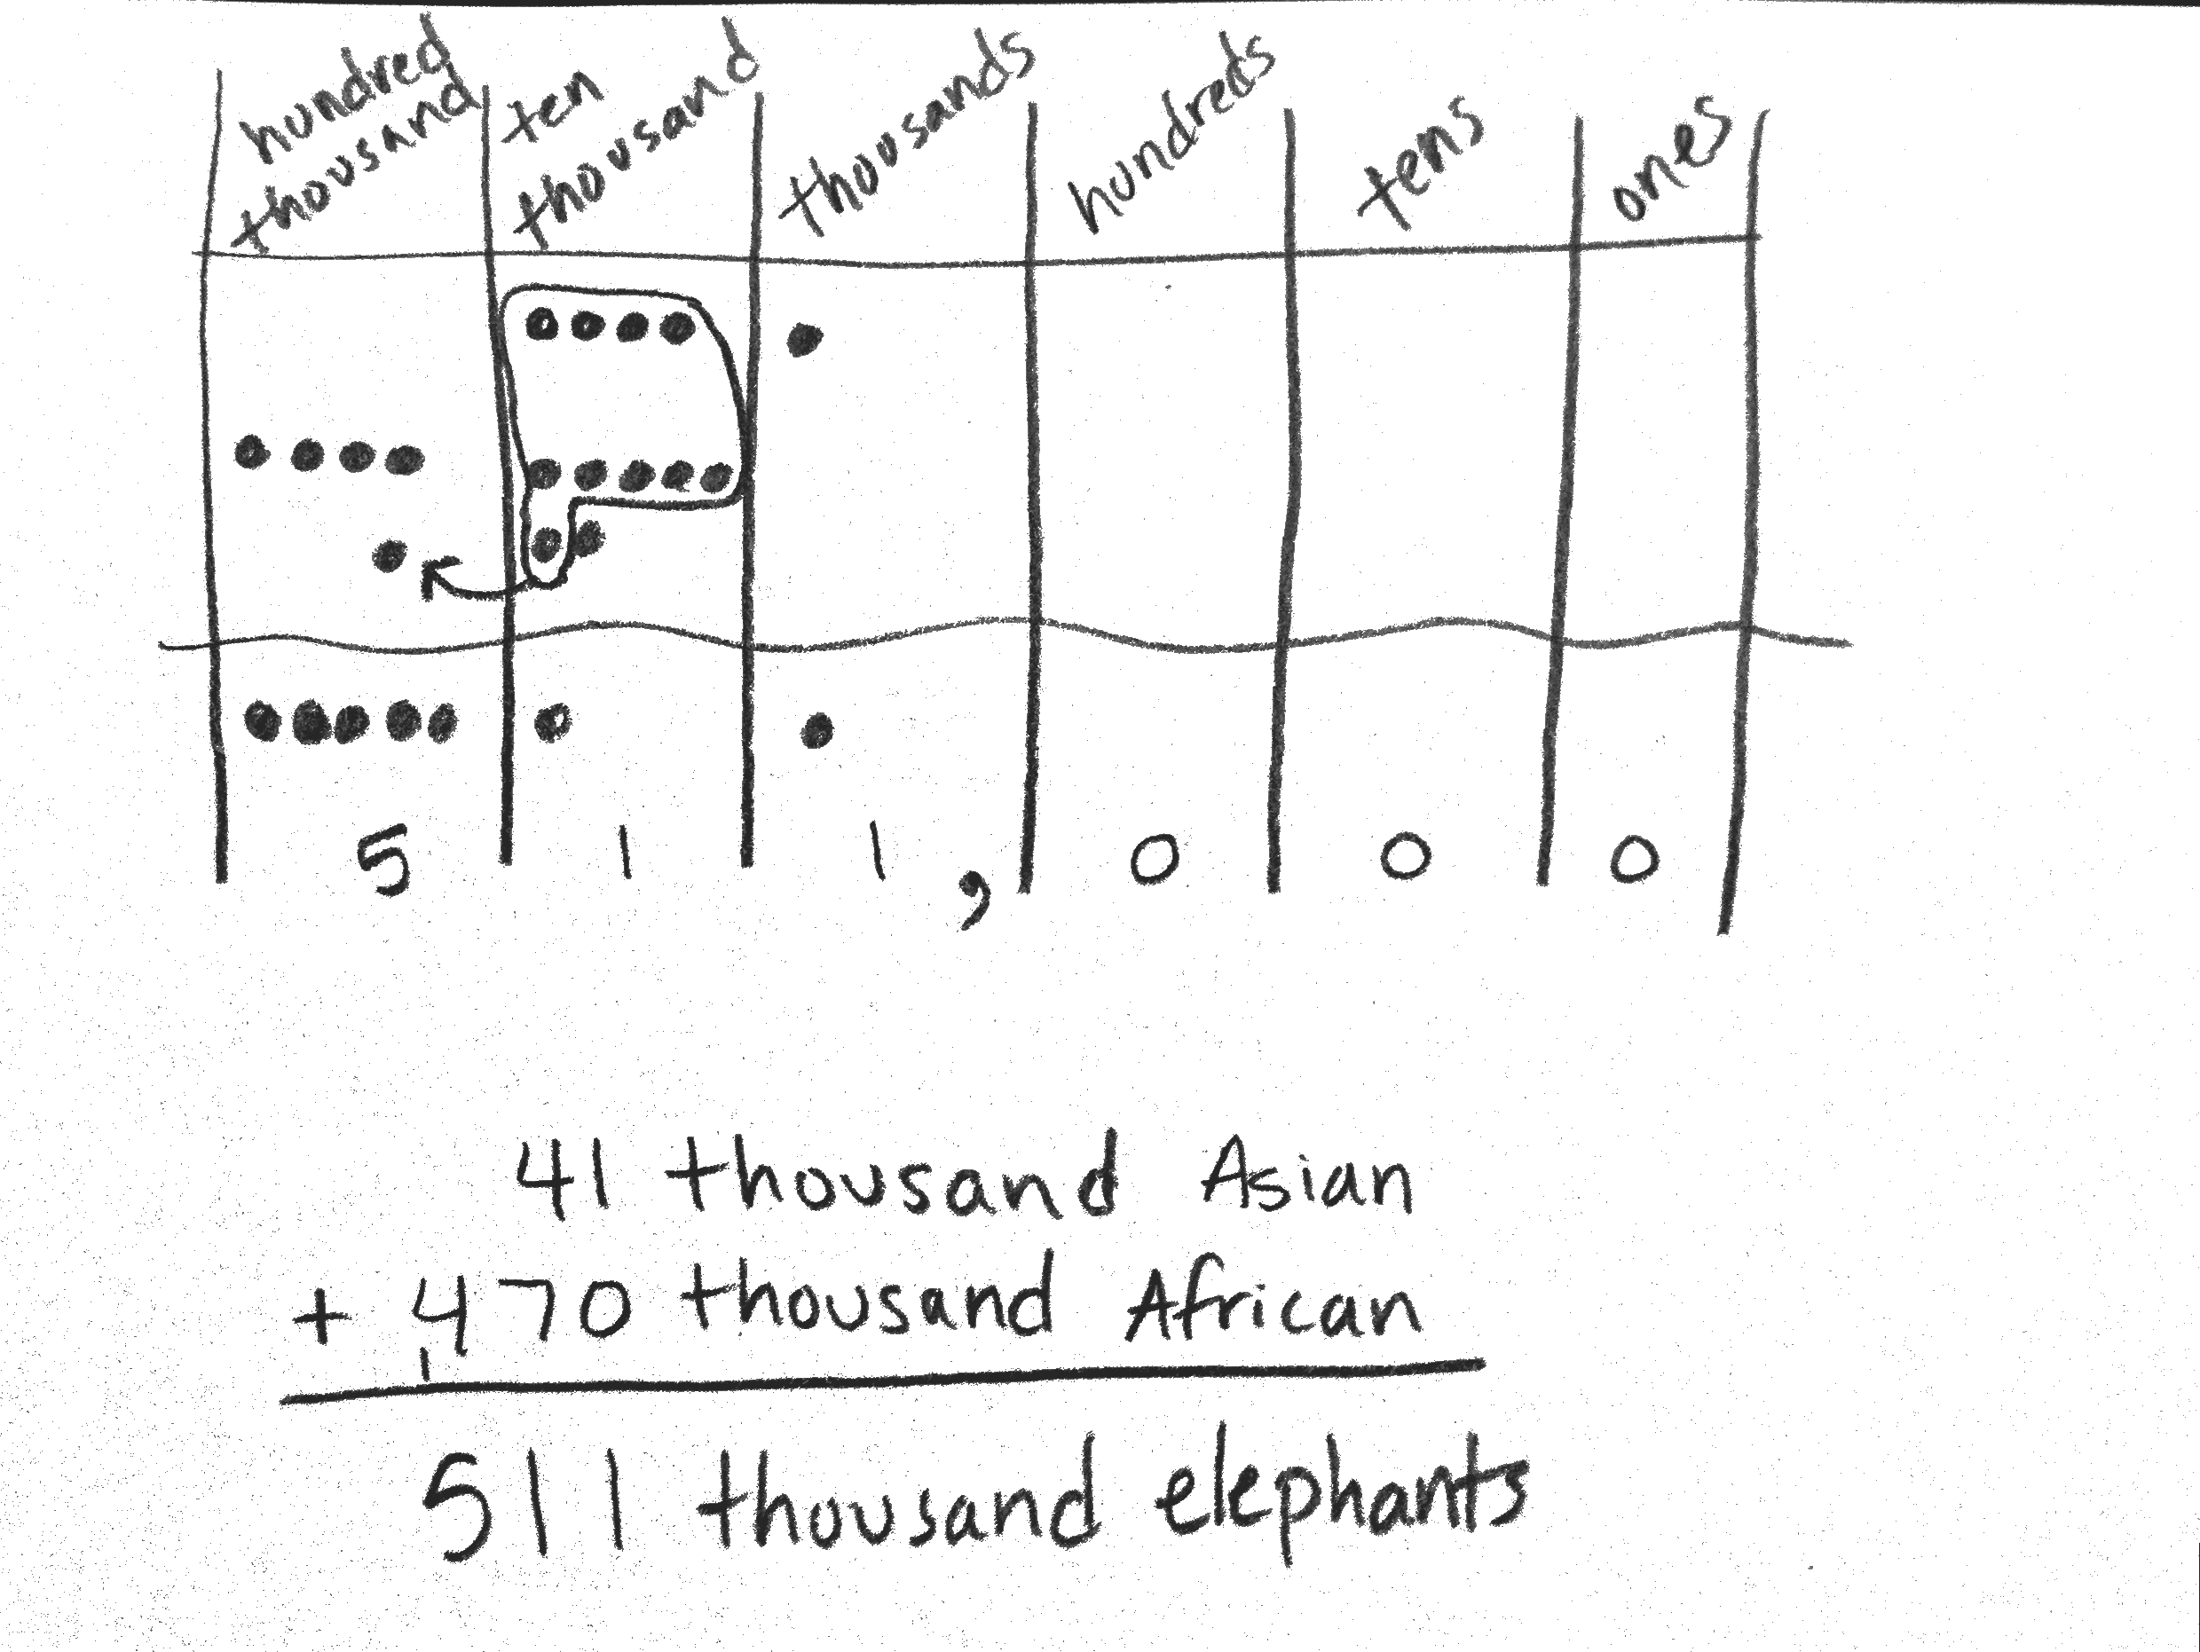
Application Problem (6 minutes)
About 511,000 elephants are left.
There are about forty-one thousand Asian elephants and about four hundred seventy thousand African elephants left in the world.
About how many Asian and African elephants are left in total?
Note: This Application Problem builds on the content of the previous lesson, requiring students to name base thousand units. It also builds from 3.NBT.2 (fluently add and subtract within 1000). Assist students
by asking them to add using unit names (similar to the example), not
the entire numbers as digits.
Concept Development (26 minutes)

NOTES ON
MULTIPLE MEANS
OF ACTION AND EXPRESSION:
Scaffold student composition of number words with the following options:
- Provide individual cards with number words that can be easily copied.
- Allow students to abbreviate number words.
- Set individual goals for writing number words.
- Allow English language learners their language of choice for expressing number words.

Materials: (S) Personal white board, unlabeled millions place value chart (Lesson 2 Template)
Problem 1: Write a four-digit number in expanded form.
T: On your place value chart write 1,708.
T: What is the value of the 1?
S: 1 thousand.
T: (Record 1,000 under the thousands column.)
What is the value of the 7?
S: 7 hundred.
T: (Record 700 under the hundreds column.) What value does the zero have?
S: Zero. Zero tens.
T: What is the value of the 8?
S: 8 ones.
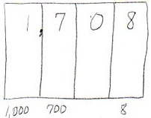
T: (Record 8 under the ones column.) What is the value of 1,000 and 700 and 8?
S: 1,708.
T: So 1,708 is the same as 1,000 plus 700 plus 8.
T: Record that as a number sentence.
S: (Write 1,000 + 700 + 8 = 1,708.)
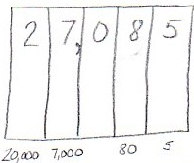
Problem 2: Write a five-digit number in word form and expanded form.
T: Now erase your values and write this number: 27,085.
T: Show the value of each digit at the bottom of your place value chart.
S: (Write 20,000, 7,000, 80, and 5.)
T: Why is there no term representing the hundreds?
S: Zero stands for nothing. Zero added to a number doesn’t change the value.
T: With your partner write an addition sentence to represent 27,085.
S: 20,000 + 7,000 + 80 + 5 = 27,085.
T: Now, read the number sentence with me.
S: Twenty thousand plus seven thousand plus eighty plus five equals twenty-seven thousand, eighty-five.
T: (Write the number as you speak.) You said “twenty-seven thousand, eighty-five.”
T: What do you notice about where I placed a comma in both the standard form and word form?
S: It is placed after 27 to separate the thousands in both the standard form and word form.
Problem 3: Transcribe a number in word form to standard and expanded form.
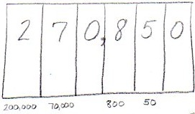
Display two hundred seventy thousand, eight hundred fifty.
T: Read this number. (Students read.) Tell your partner how
you can match the word form to the standard form.
S: Everything you say, you should write in words.
The comma helps to separate the numbers in the thousands
from the numbers in the hundreds, tens, and ones.
T: Write this number in your place value chart. Now, write this number in expanded form. Tell your partner the number sentence.
S: 200,000 plus 70,000 plus 800 plus 50 equals 270,850.
Repeat with sixty-four thousand, three.
Problem 4: Convert a number in expanded form to word and standard form.
Display 700,000 + 8,000 + 500 + 70 + 3.
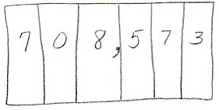
T: Read this expression. (Students read.) Use digits to write this number in your place value chart.
T: My sum is 78,573. Compare your sum with mine.
S: Your 7 is in the wrong place. The value of the 7 is 700,000. Your 7 has a value of 70,000.
MP.3
T: Read this number in standard form with me.
S: Seven hundred eight thousand, five hundred seventy-three.
T: Write this number in words. Remember to check for correct use of commas and hyphens.
Repeat with 500,000 + 30,000 + 10 + 3.
Problem Set (10 minutes)
Students should do their personal best to complete the Problem Set within the allotted 10 minutes. For some classes, it may be appropriate to modify the assignment by specifying which problems they work on first. Some problems do not specify a method for solving. Students should solve these problems using the RDW approach used for Application Problems.
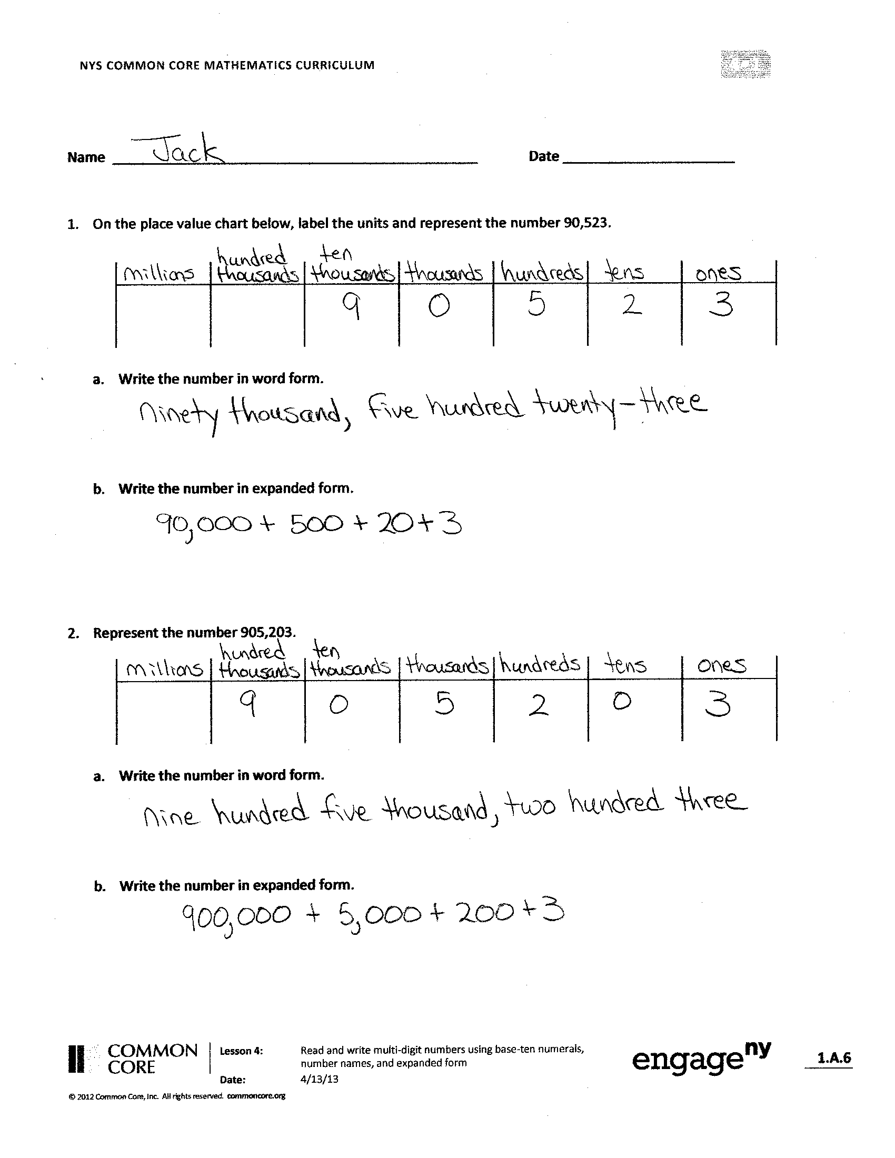
Student Debrief (15 minutes)
1a.
b.
c.
2a.
b.
c.
Lesson Objective: Read and write multi-digit numbers using base ten numerals, number names, and expanded form.
Invite students to review their solutions for the Problem Set and the totality of the lesson experience. They should check work by comparing answers with a partner before going over answers as a class. Look for misconceptions or misunderstandings that can be addressed in the Debrief. Guide students in a conversation to debrief the Problem Set.
You may choose to use any combination of the questions below to lead the discussion.
- Compare the numbers in Problems 1 and 2.
What do you notice?
- As you completed the chart on Page 2, what number words were tricky to write? Which number words can be confused with other number words? Why? What strategies did you use to spell number words?
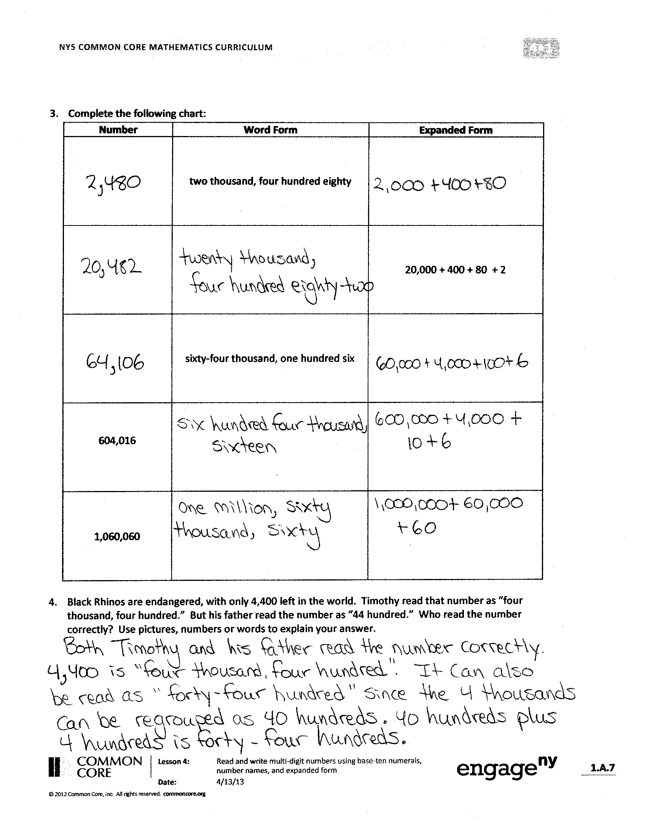
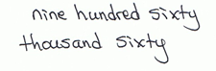
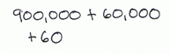
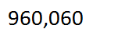
- In Problem 4, Timothy and his dad read a number word in two ways. What other numbers can be read more than one way? Which way of reading a number best helps you solve? When?
- Two students discussed the importance of zero. Nate said that zero is not important while Jill said that zero is extremely important. Who is right? Why do you think so?
- What role can zero play in a number?
- How is expanded form related to the standard form of a number?
- When might you use expanded form to solve a calculation?
Exit Ticket (3 minutes)
After the Student Debrief, instruct students to complete the Exit Ticket. A review of their work will help you assess the students’ understanding of the concepts that were presented in the lesson today and plan more effectively for future lessons. You may read the questions aloud to the students.

Name Date
- On the place value chart below, label the units and represent the number 90,523.

- Write the number in word form.

- Write the number in expanded form.

- On the place value chart below, label the units and represent the number 905,203.

- Write the number in word form.

- Write the number in expanded form.

3. Complete the following chart:
Standard Form | Word Form | Expanded Form
 | two thousand, four hundred eighty
 |  | 20,000 + 400 + 80 + 2
 | sixty-four thousand, one hundred six
604,016

960,060

- Black Rhinos are endangered, with only 4,400 left in the world. Timothy read that number as “four thousand, four hundred.” His father read the number as “44 hundred.” Who read the number correctly? Use pictures, numbers, or words to explain your answer.

Name Date
- Use the place value chart below to complete the following:

- Label the units on the chart.

- Write the number 800,000 + 6,000 + 300 + 2 in the place value chart.

- Write the number in word form.

- Write one hundred sixty thousand, five hundred eighty-two in expanded form.

Name Date
- On the place value chart below, label the units and represent the number 50,679.

- Write the number in word form.

- Write the number in expanded form.

- On the place value chart below, label the units and represent the number 506,709.

- Write the number in word form.

- Write the number in expanded form.

- Complete the following chart:
Standard Form | Word Form | Expanded Form
 | five thousand, three hundred seventy
 |  | 50,000 + 300 + 70 + 2
 | thirty-nine thousand, seven hundred one
309,017

770,070

- Use pictures, numbers, and words to explain another way to say sixty-five hundred.

