Lesson 3
Objective: Name numbers within 1 million by building understanding of the place value chart and placement of commas for naming base thousand units.

Suggested Lesson Structure
 Fluency Practice (15 minutes)
 Application Problem (6 minutes)
 Concept Development (32 minutes)
 Student Debrief (7 minutes)
Total Time (60 minutes)
Fluency Practice (15 minutes)

A NOTE
ON STANDARDS ALIGNMENT:
In this lesson, students extend pass 1 million (4.NBT standards limit to whole numbers less than or equal to 1 million) to establish a pattern of ones, tens, and hundreds within each base ten unit (thousands, millions, billions, trillions).
Calculations in following lessons are limited to less than or equal to 1 million. If students are not ready for this step, omit establishing the pattern and internalize the units of the thousands period.

- Sprint: Multiply by 3 3.OA.7 (10 minutes)
- Place Value and Value 4.NBT.2 (3 minutes)
- Base Ten Units 4.NBT.1 (2 minutes)
Sprint: Multiply by 3 (10 minutes)
Materials: (S) Multiply by 3 Sprint
Note: This fluency activity reviews a foundational third grade standard that helps students learn standard 4.NBT.5.
Place Value and Value (3 minutes)
Materials: (T) Unlabeled millions place value chart (Lesson 2 Template)
Note: Reviewing and practicing place value skills in isolation prepares students for success in multiplying different place value units during the lesson.
T: (Project the number 1,468,357 on a place value chart. Underline the 5.) Say the digit.
S: 5.
T: Say the place value of the 5.
S: Tens.
T: Say the value of 5 tens.
S: 50.
Repeat process, underlining 8, 4, 1, and 6.
Base Ten Units (2 minutes)
Note: This fluency activity bolsters students’ place value proficiency while reviewing multiplication concepts
learned in Lessons 1 and 2.
T: (Project 2 tens =____.) Say the number in standard form.
S: 2 tens = 20.
Repeat for possible sequence: 3 tens, 9 tens, 10 tens, 11 tens, 12 tens, 19 tens, 20 tens, 30 tens, 40 tens, 80 tens, 84 tens, and 65 tens.
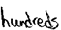
Application Problem (6 minutes)
The school library has 10,600 books.
The town library has 10 times as many books. How many books does the town library have?
Note: This Application Problem builds on the concept from the previous lesson of determining 10 times as much as a number.
Concept Development (32 minutes)
Materials: (S) Personal white board, unlabeled millions place value chart (Lesson 2 Template)
Note: Students will go beyond the 4.NBT standard of using numbers less than or equal to 1 million to establish a pattern within the base ten units.

NOTES ON
MULTIPLE MEANS
FOR ACTION AND EXPRESSION:
Scaffold partner talk with sentence frames such as:
- “I notice _____.”
- “The place value headings are alike because _____.”
- “The place value headings are not alike because _____.”
- “The pattern I notice is _____.”
- “I notice the units _______.”

Introduction: Patterns of the base ten system.
T: In the last lesson, we extended the place value chart to 1 million. Take a minute to label the place value headings on your place value chart. (Circulate and check all headings.)
T: Excellent. Now talk with your partner about similarities and differences you see in those heading names.
S: I notice some words repeat, like ten, hundred, and thousand, but ones appears once. I notice the thousand unit repeats 3 times—thousands, ten thousands, hundred thousands.
T: That’s right! Beginning with thousands, we start naming new place value units by how many one thousands, ten thousands, and hundred thousands we have. What do you think the next unit might be called after 1 million?
S: Ten millions.
T: (Extend chart to the ten millions.) And the next?
S: Hundred millions.
T: (Extend chart again.) That’s right! Just like with thousands, we name new units here in terms of how many one millions, ten millions, and hundred millions we have. 10 hundred millions gets renamed as 1 billion. Talk with your partner about what the next two place value units should be.
S: Ten billions and hundred billions. It works just like it does for thousands and millions.
Problem 1: Placing commas in and naming numbers.
T: You’ve noticed a pattern: ones, tens, and hundreds; one thousands, ten thousands, and hundred thousands; one millions, ten millions, and hundred millions; and so on. We use commas to indicate this grouping of units, taken 3 at a time. For example, ten billion would be written: 10,000,000,000.
T: (Write 3608430325.) Record this number and place the commas to show our groupings of units.

NOTES ON
MULTIPLE MEANS
FOR ACTION AND EXPRESSION:
Scaffold reading numbers into the hundred thousands with questioning such as:
T: What’s the value of the 3?
S: 30 thousand.
T: How many thousands altogether? S: 36 thousands.
T: What’s the value of the 8?
S: 80.
T: Add the remaining ones.
S: 89.
T: Read the whole number.
S: Thirty-six thousand, eighty-nine.
Continue with similar numbers until students reach fluency. Alternate the student recording numbers, modeling, and reading.
S: (Record the number and place the commas.)
T: (Show 430,325 on a place value chart.) How many thousands are in this number?
S: 430.
T: 430 what?
S: 430 thousands.
T: Correct, we read this number as “four hundred thirty thousand, three hundred twenty-five.”
T: (Extend chart and show 608,430,325.) How many millions are there in this number?
S: 608 millions.
T: Using what you know about our pattern in naming units, talk with your partner about how to name this number.
S: Six hundred eight million, four hundred thirty thousand, three hundred twenty-five.

Problem 2: Add to make 10 of a unit and bundling up to 1 million.
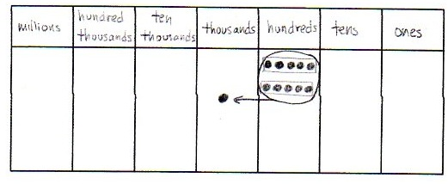
T: What would happen if we combined 2 groups of 5 hundreds? With your partner, draw place value disks to solve. Use the largest unit possible to express your answer.
S: 2 groups of 5 hundreds equals 10 hundreds.
It would make 10 hundreds which can be bundled to make 1 thousand.
T: Now, solve for 5 thousands plus 5 thousands. Bundle in order to express your answer using the largest unit possible.
MP.2
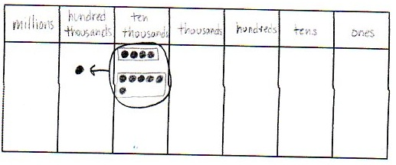
S: 5 thousands plus 5 thousands equals 10 thousands. We can bundle 10 thousands to make 1 ten thousand.
T: Solve for 4 ten thousands plus 6 ten thousands. Express your answer using the largest unit possible.
S: 4 ten thousands plus 6 ten thousands equals 10 ten thousands. We can bundle 10 ten thousands to make 1 hundred thousand.
Continue renaming problems, showing regrouping as necessary.
- 3 hundred thousands + 7 hundred thousands
- 23 thousands + 4 ten thousands
- 43 ten thousands + 11 thousands
Problem 3: 10 times as many with multiple units.
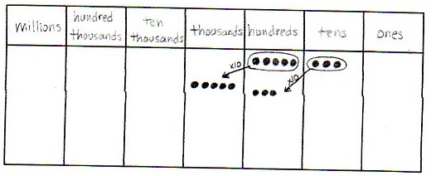
T: On your place value chart, model 5 hundreds and 3 tens with place value disks. What is 10 times 5 hundreds 3 tens?
S: (Show charts.) 5 thousands 3 hundreds.
T: Model 10 times 5 hundreds 3 tens with digits on the place value chart. Record your answer in standard form.
S: (Students show 10 times 5 hundreds is 5 thousands and 10 times 3 tens is 3 hundreds as digits.) 5,300.
T: Check your partner’s work and remind him/her of the comma’s role in this number.
T: (Write 10 × 1 ten thousand 5 thousands 3 hundreds 9 ones = ______.) With your partner, solve this problem and write your answer in standard form.
S: 10 × 15,309 = 153,090.
Problem Set (10 minutes)

NOTES ON
COMMAS:
Commas are optional for 4-digit numbers, as omitting them supports visualization of the total amount of each unit. For example, in the number 3247, 32 hundreds or 324 tens is easier to visualize when 3247 is written without a comma. In Grade 3, students understand 324 as 324 ones, 32 tens 4 ones, or 3 hundreds 2 tens 4 ones. This flexible thinking allows for seeing simplifying strategies (e.g., to solve 3247 – 623, rather than decompose 3 thousands, students might subtract 6 hundreds from 32 hundreds: 32 hundreds – 6 hundreds + 47 ones – 23 ones is 26 hundreds and 24 ones or 2624).
Students should do their personal best to complete the Problem Set within the allotted 10 minutes. For some classes, it may be appropriate to modify the assignment by specifying which problems they work on first. Some problems do not specify a method for solving. Students should solve these problems using the RDW approach used for Application Problems.
Student Debrief (7 minutes)
Lesson Objective: Name numbers within 1 million by building understanding of the place value chart and placement of commas for naming base thousand units.
Invite students to review their solutions for the Problem Set and the totality of the lesson experience. They should check work by comparing answers with a partner before going over answers as a class. Look for misconceptions or misunderstandings that can be addressed in the Debrief. Guide students in a conversation to debrief the Problem Set.
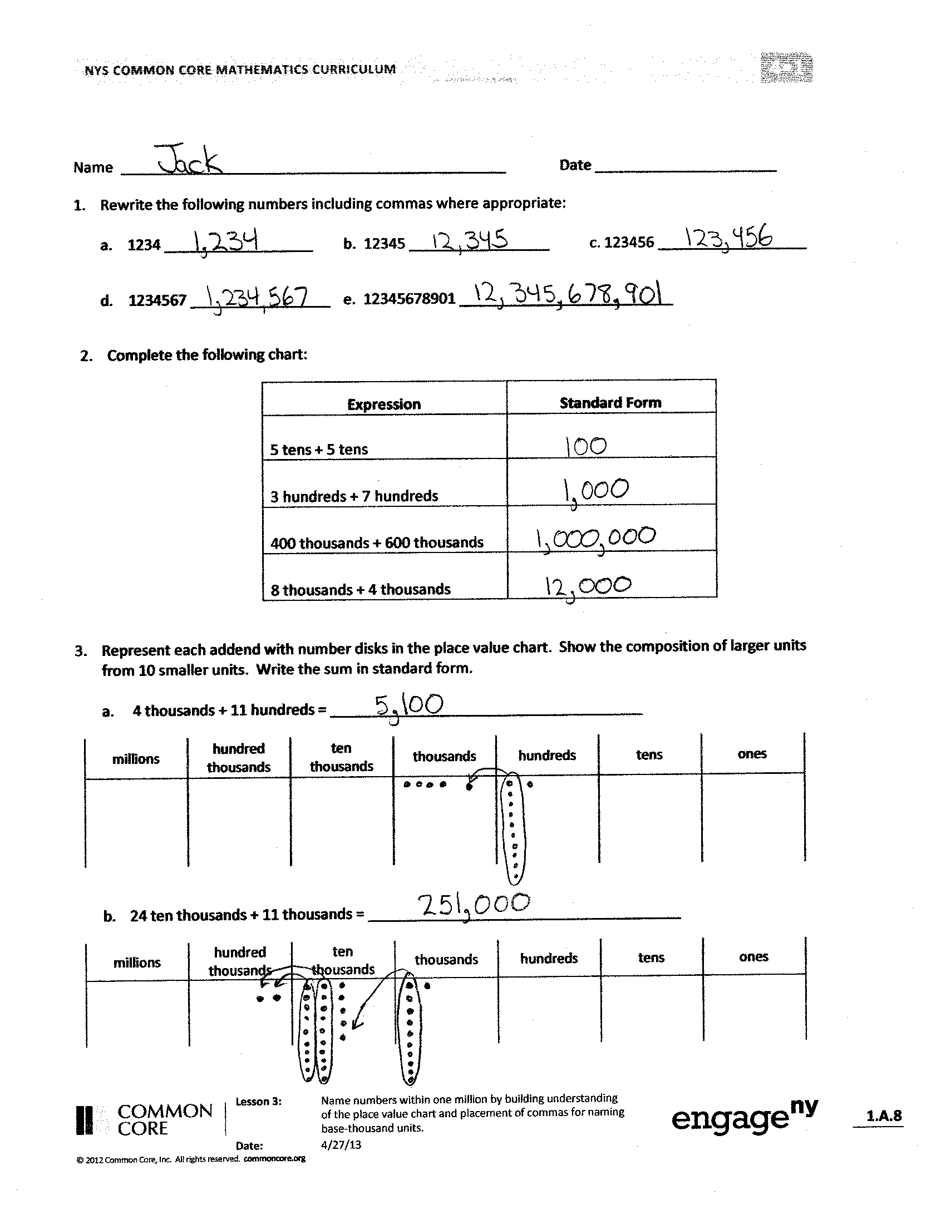
You may choose to use any combination of the questions below to lead the discussion.
- In Problem 1, how did you know where to place commas within a number?
- Read aloud the numbers in Problem 1(d) and (e) with your partner. What role do the commas have as you read the numbers?
- How do place value understanding and the role of commas help you to read the value in the millions period that is represented by the number of millions, ten millions, and hundred millions?
- What did you discover as you solved Problem 3? How did 3(a) help you to solve 3(b)?
- How did you use the place value chart to help you compare unlike units in Problem 5?
- When might it be useful to omit commas?
(Please refer to the UDL box for commas to guide your discussion.)

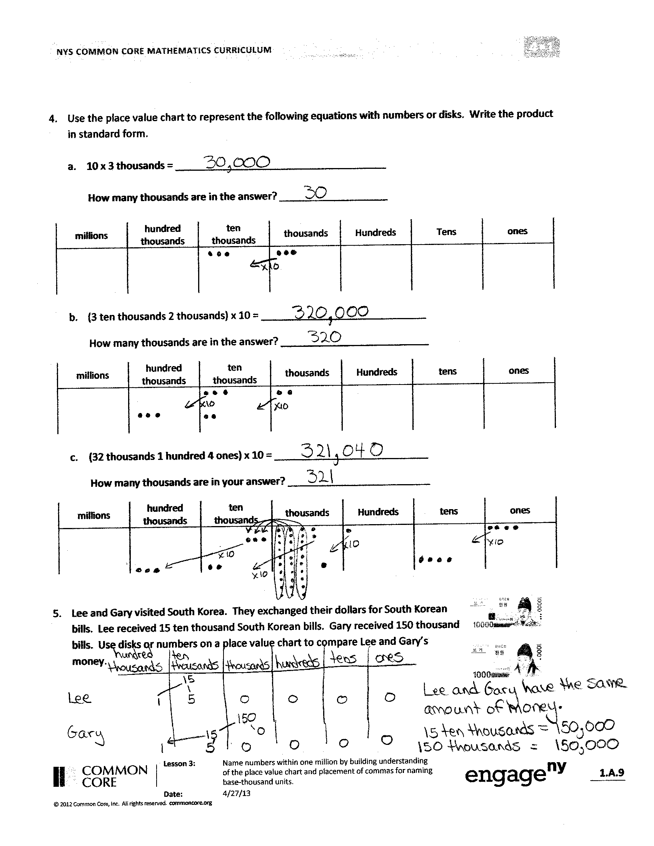
Exit Ticket (3 minutes)
After the Student Debrief, instruct students to complete the Exit Ticket. A review of their work will help you assess the students’ understanding of the concepts that were presented in the lesson today and plan more effectively for future lessons. You may read the questions aloud to the students.
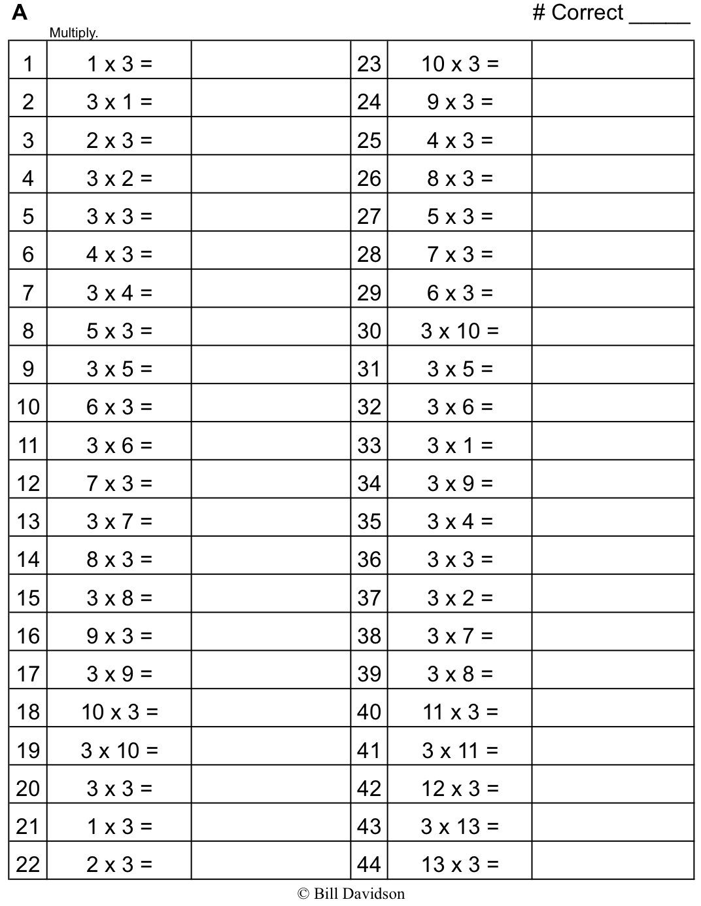
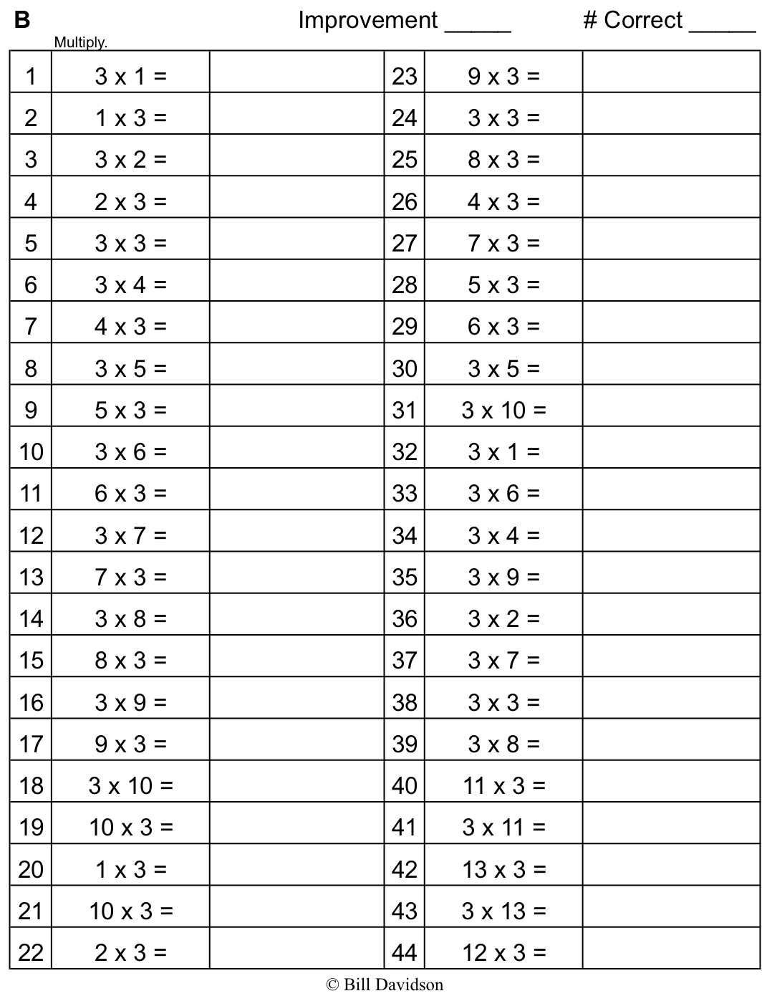
Name Date
- Rewrite the following numbers including commas where appropriate:

- 1234 _________________
- 12345 ________________
- 123456 _______________

- 1234567 _____________________
- 12345678901 _____________________

- Solve each expression. Record your answer in standard form.
Expression | Standard Form
5 tens + 5 tens
3 hundreds + 7 hundreds
400 thousands + 600 thousands
8 thousands + 4 thousands

- Represent each addend with place value disks in the place value chart. Show the composition of larger units from 10 smaller units. Write the sum in standard form.

  - 4 thousands + 11 hundreds = ______________________________________
millions | hundred thousands | ten thousands | thousands | hundreds | tens | ones

b. 24 ten thousands + 11 thousands = ______________________________________
millions | hundred thousands | ten thousands | thousands | hundreds | tens | ones
- Use digits or disks on the place value chart to represent the following equations. Write the product in standard form.

- 10 × 3 thousands = _____________________________________

How many thousands are in the answer? ___________________
millions | hundred thousands | ten thousands | thousands | hundreds | tens | ones

- (3 ten thousands 2 thousands) × 10 = _____________________________
How many thousands are in the answer? __________________________
millions | hundred thousands | ten thousands | thousands | hundreds | tens | ones

- (32 thousands 1 hundred 4 ones) × 10 = ___________________________
How many thousands are in your answer? _________________________
millions | hundred thousands | ten thousands | thousands | hundreds | tens | ones

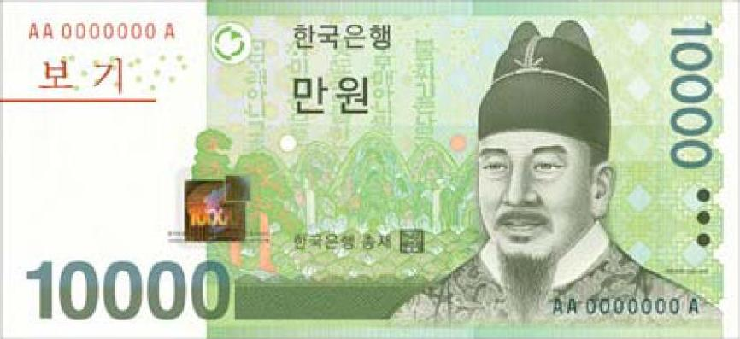
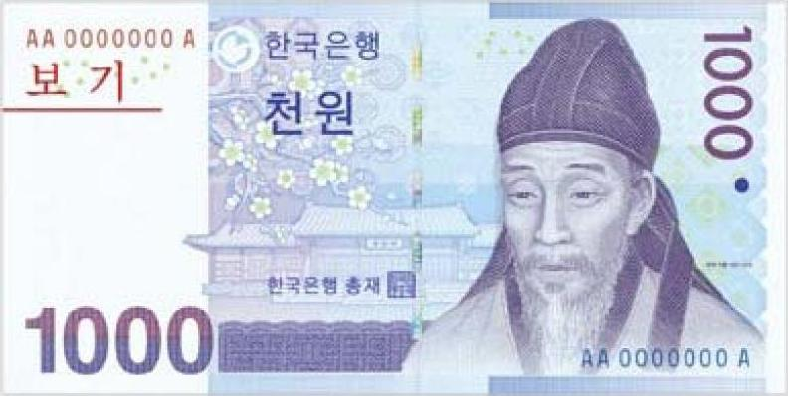
- Lee and Gary visited South Korea. They exchanged their dollars for South Korean bills. Lee received 15 ten thousand South Korean bills. Gary received 150 thousand bills. Use disks or numbers on a place value chart to compare Lee and Gary’s money.

Name Date
- In the spaces provided write the following units in standard form. Be sure to place commas where appropriate.

- 9 thousands 3 hundreds 4 ones _______________________________________________________

- 6 ten thousands 2 thousands 7 hundreds 8 tens 9 ones ____________________________________

- 1 hundred thousand 8 thousands 9 hundreds 5 tens 3 ones ________________________________

- Use digits or disks on the place value chart to write 26 thousands 13 hundreds.

millions | hundred thousands | ten thousands | thousands | hundreds | tens | ones

How many thousands are in the number you have written? ____________________

Name Date
- Rewrite the following numbers including commas where appropriate:
- 4321 ________________________ b. 54321 _______________________
- 224466 ________________________ d. 2224466 _______________________
- 10010011001 __________________________
- Solve each expression. Record your answer in standard form.
Expression | Standard Form
4 tens + 6 tens
8 hundreds + 2 hundreds
5 thousands + 7 thousands

- Represent each addend with place value disks in the place value chart. Show the composition of larger units from 10 smaller units. Write the sum in standard form.

  - 2 thousands + 12 hundreds = ______________________________________

millions | hundred thousands | ten thousands | thousands | hundreds | tens | ones

  - 14 ten thousands + 12 thousands = ______________________________________

millions | hundred thousands | ten thousands | thousands | hundreds | tens | ones
- Use digits or disks on the place value chart to represent the following equations. Write the product in standard form.

- 10 × 5 thousands = _____________________________________

How many thousands are in the answer? ___________________

millions | hundred thousands | ten thousands | thousands | hundreds | tens | ones

- (4 ten thousands 4 thousands) × 10 = _____________________________
How many thousands are in the answer? __________________________
millions | hundred thousands | ten thousands | thousands | hundreds | tens | ones

- (27 thousands 3 hundreds 5 ones) × 10 = __________________________

How many thousands are in your answer? _________________________

millions | hundred thousands | ten thousands | thousands | hundreds | tens | ones

- A large grocery store received an order of 2 thousand apples. A neighboring school received an order of 20 boxes of apples with 100 apples in each. Use disks or disks on a place value chart to compare the number of apples received by the school and the number of apples received by the grocery store.

