Lesson 1
Objective: Interpret a multiplication equation as a comparison.

Suggested Lesson Structure
 Fluency Practice (13 minutes)

NOTES ON
FLUENCY PRACTICE:
Think of fluency as having three goals:
- Maintenance (staying sharp on previously learned skills).
- Preparation (targeted practice for the current lesson).
- Anticipation (skills that ensure that students will be ready for the in-depth work of upcoming lessons).

 Application Problem (5 minutes)
 Concept Development (35 minutes)
 Student Debrief (7 minutes)
Total Time (60 minutes)
Fluency Practice (13 minutes)
- Sprint: Multiply and Divide by 10 4.NBT.1 (10 minutes)
- Place Value 4.NBT.2 (3 minutes)
Sprint: Multiply and Divide by 10 (10 minutes)

NOTES ON
MULTIPLE MEANS
OF ACTION AND EXPRESSION:
For the Place Value fluency activity,
students may represent ones, etc., using counters rather than drawing.
Others may benefit from the opportunity to practice simultaneously speaking and showing units (e.g., tens).
Provide sentence frames to support oral response, such as “_____tens_____ones is _____
(standard form) _____.”

Materials: (S) Multiply and Divide by 10 Sprint
Note: Reviewing this fluency activity acclimates students to the Sprint routine, a vital component of the fluency program.
Place Value (3 minutes)
Materials: (S) Personal white board, unlabeled thousands place value chart (Template)
Note: Reviewing and practicing place value skills in isolation prepares students for success in multiplying different place value units during the lesson.
T: (Project place value chart to the thousands.) Show 4 ones as place value disks. Write the number below it.
S: (Draw 4 ones disks and write 4 below it.)
T: Show 4 ten disks and write the number below it.
S: (Draw 4 ten disks and write 4 at the bottom of the tens column.)
T: Say the number in unit form.
S: 4 tens 4 ones.
T: Say the number in standard form.
S: 44.
Continue for the following possible sequence: 2 tens 3 ones, 2 hundreds 3 ones, 2 thousands 3 hundreds, 2 thousands 3 tens, and 2 thousands 3 hundreds 5 tens and 4 ones.
Application Problem (5 minutes)

NOTES ON
MULTIPLE MEANS
OF ENGAGEMENT:
Enhance the relevancy of the Application Problem by substituting names, settings, and tasks to reflect students and their experiences.
Set individual student goals and expectations. Some students may successfully solve for area and perimeter in 5 minutes, others may solve for one, while others may solve for both and compose their own application problem.

Ben has a rectangular area 9 meters long and 6 meters wide. He wants a fence that will go around it as well as grass sod to cover it. How many meters of fence will he need? How many square meters of grass sod will he need to cover the entire area?
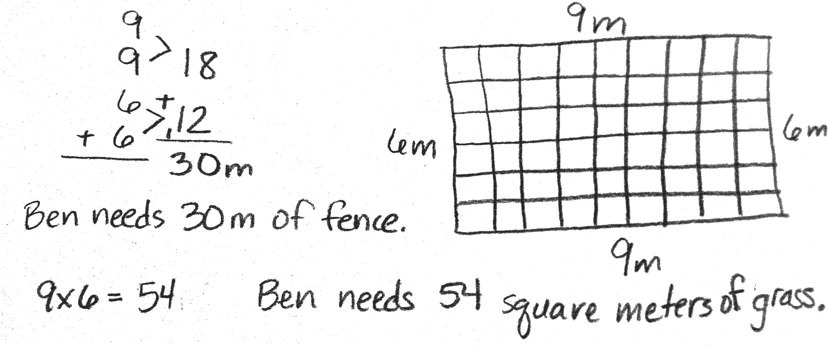

Note: As the first lesson of the year, this Application Problem reviews area, perimeter, multiplication, and addition—all important concepts from Grade 3. This problem can be extended after the Concept Development by asking students to find an area 10 times as much as the grass sod or to find a perimeter 10 times as wide and 10 times as long.
Concept Development (35 minutes)
Materials: (T) Place value disks: ones, tens, hundreds, and thousands; unlabeled thousands place value chart (Template) (S) Personal white board, unlabeled thousands place value chart (Template)
Problem 1: 1 ten is 10 times as much as 1 one.
T: (Have a place value chart ready. Draw or place 1 unit into the ones place.)
MP.3
MP.6
MP.3
MP.3
MP.3
MP.3
MP.3
MP.3
MP.3
MP.3
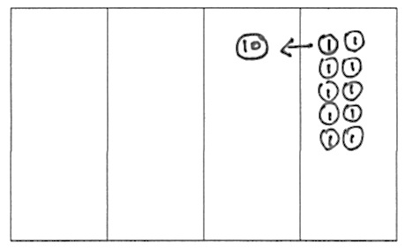
T: How many units do I have?
S: 1.
T: What is the name of this unit?
S: A one.
T: Count the ones with me. (Draw ones as they do so.)
S: 1 one, 2 ones, 3 ones, 4 ones, 5 ones...10 ones.
T: 10 ones. What larger unit can I make?
S: 1 ten.
T: I change 10 ones for 1 ten. We say, “1 ten is 10 times as much as 1 one.” Tell your partner what we say and what that means. Use the model to help you.
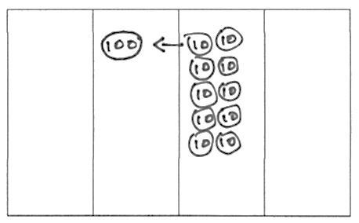
S: 10 ones make 1 ten. 10 times 1 one is 1 ten or 10 ones. We say 1 ten is 10 times as many as 1 one.
Problem 2: One hundred is 10 times as much as 1 ten.
Quickly repeat the process from Problem 1 with 10 copies of 1 ten.
Problem 3: One thousand is 10 times as much as 1 hundred.
Quickly repeat the process from Problem 1 with 10 copies of 1 hundred.
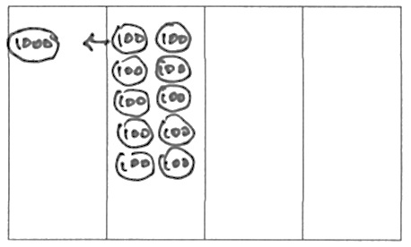
T: Discuss the patterns you have noticed with your partner.
S: 10 ones make 1 ten. 10 tens make 1 hundred.
10 hundreds make 1 thousand. Every time we get 10 we bundle and make a bigger unit. We copy a unit 10 times to make the next larger unit. If we take any of the place value units, the next unit on the left is ten times as many.
T: Let's review, in words, the multiplication pattern that matches our models and 10 times as many.
1 ten = 10 × 1 one (Say, “1 ten is 10 times as much as 1 one.”)
1 hundred = 10 × 1 ten (Say, “1 hundred is 10 times as much as 1 ten.”)
1 thousand = 10 × 1 hundred (Say, “1 thousand is 10 times as much as 1 hundred.”)

Display the following information for student reference:
Problem 4: Model 10 times as much as on the place value chart with an accompanying equation.
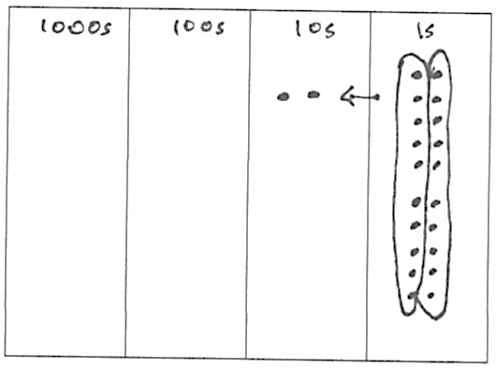
Note: Place value disks are used as models throughout the curriculum and can be represented in two different ways. A disk with a value labeled inside of it, such as in Problem 1, should be drawn or placed on a place value chart with no headings. The value of the disk in its appropriate column indicates the column heading. A place value disk drawn as a dot should be used on place value charts with headings, as in Problem 4. This type of representation is called the chip model. The chip model is a faster way to represent place value disks and is used as students move away from a concrete stage of learning.
(Model 2 tens is 10 times as much as 2 ones on the place value chart and as an equation.)
T: Draw place value disks as dots. Because you are using dots, label your columns with the unit value.
T: Represent 2 ones. Solve to find 10 times as many as 2 ones. Work together.
S: (Work together.)
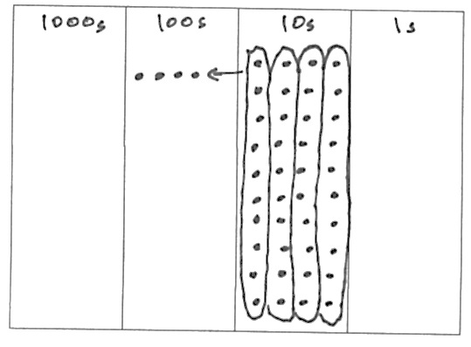
T: 10 times as many as 2 ones is?
S: 20 ones 2 tens.
T: Explain this equation to your partner using your model.
S: 10 × 2 ones = 20 ones = 2 tens
Repeat the process with 10 times as many as 4 tens is 40 tens is 4 hundreds and 10 times as many as 7 hundreds is 70 hundreds is 7 thousands.
10 × 4 tens = 40 tens = 4 hundreds
10 × 7 hundreds = 70 hundreds = 7 thousands
Problem 5: Model as an equation 10 times as much as 9 hundreds is 9 thousands.
T: Write an equation to find the value of 10 times as many as 9 hundreds. (Circulate and assist students as necessary.)
T: Show me your boards. Read your equation.
S: 10 × 9 hundreds = 90 hundreds = 9 thousands..
T: Yes. Discuss whether this is true with your partner. (Write 10 × 9 hundreds = 9 thousands.)
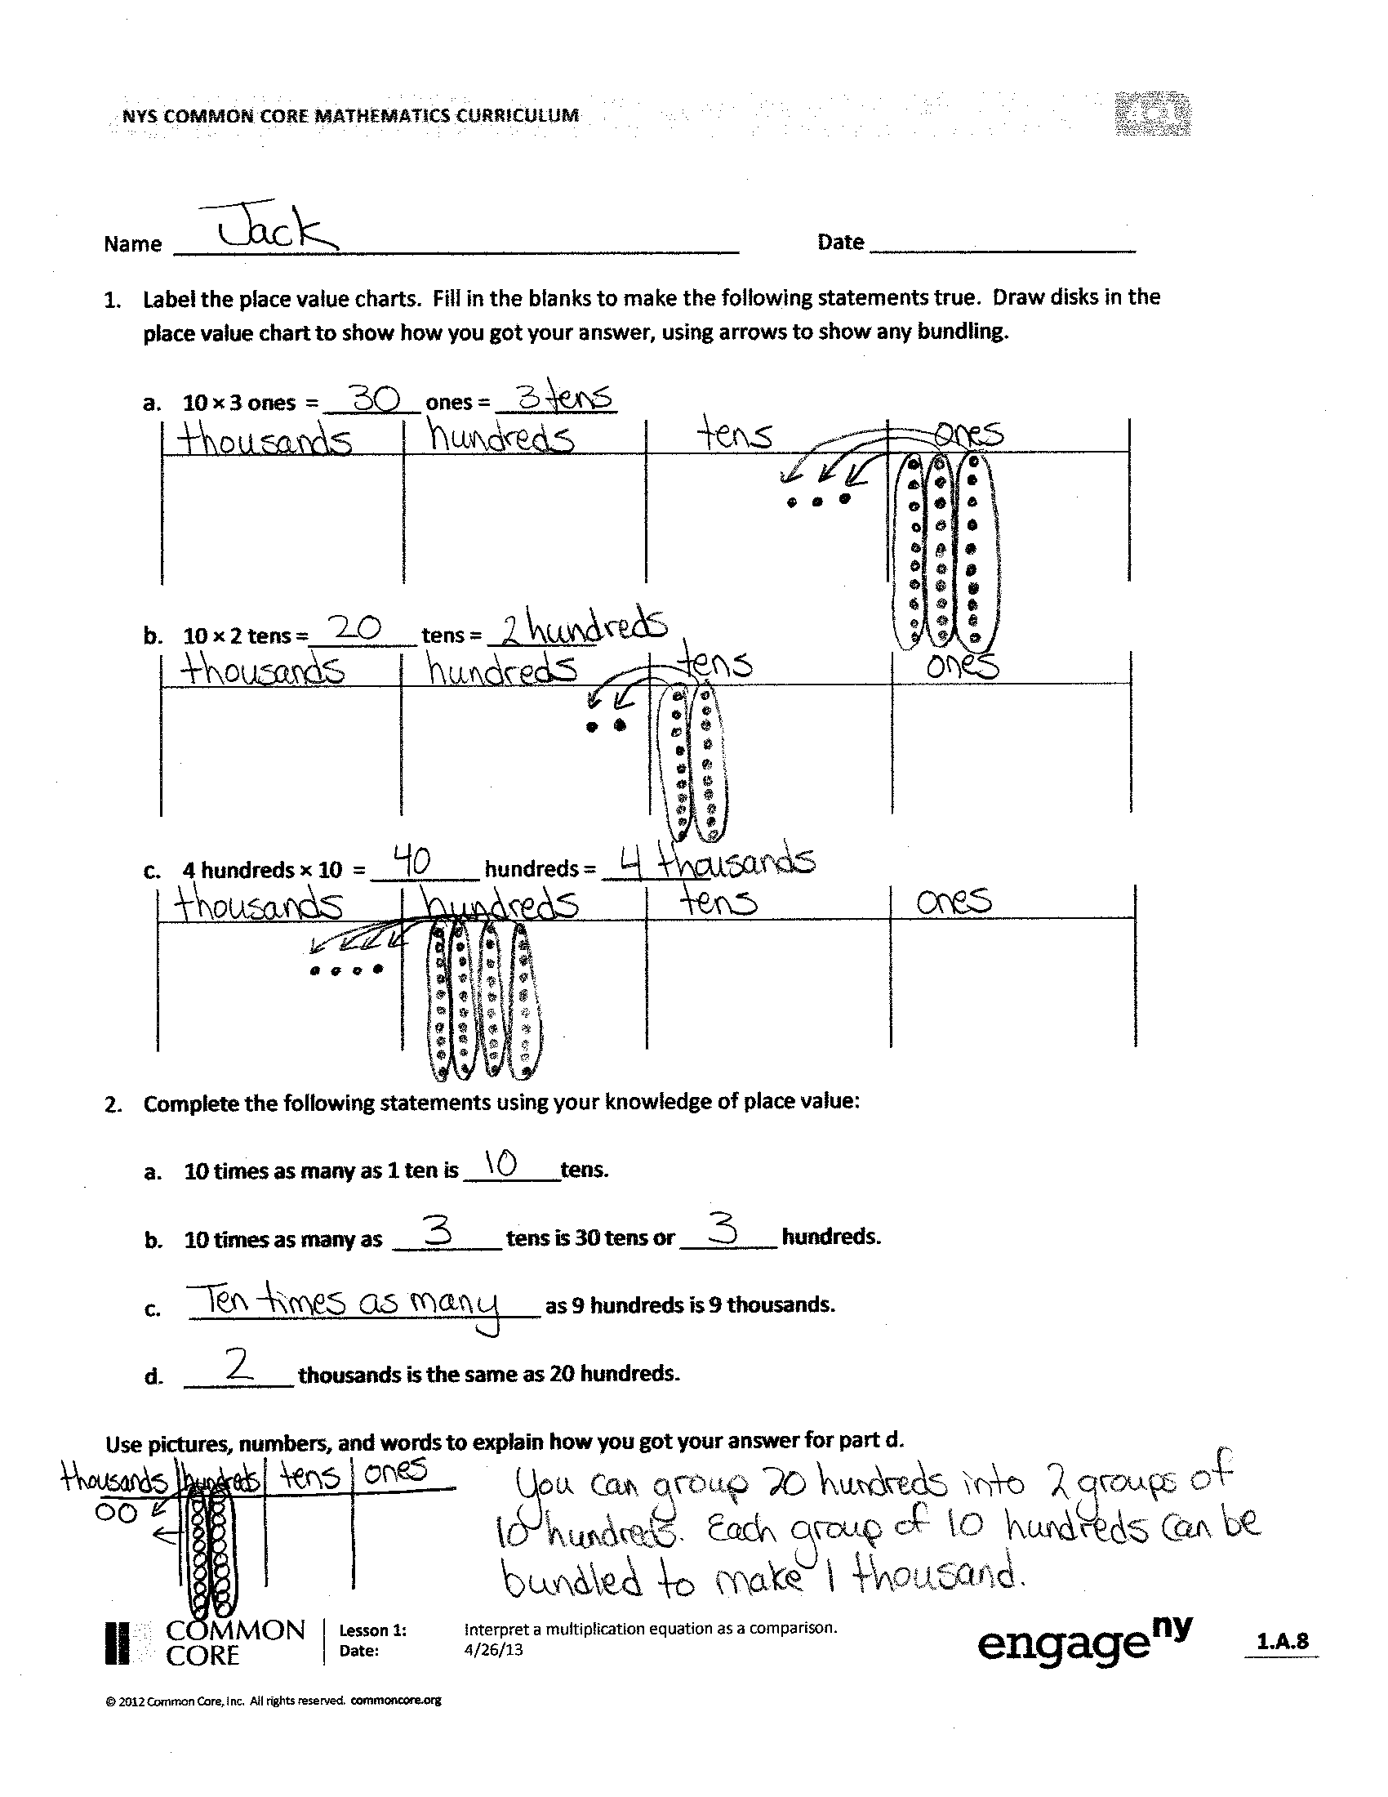
S: Yes it is true because 90 hundreds equals 9 thousands, so this equation just eliminates that extra step. Yes, we know 10 of a smaller unit equals 1 of the next larger unit, so we just avoided writing that step.
Problem Set (10 minutes)
Students should do their personal best to complete the Problem Set within the allotted 10 minutes. Some problems do not specify a method for solving. This is an intentional reduction of scaffolding that invokes MP.5, Use Appropriate Tools Strategically. Students should solve these problems using the RDW approach used for Application Problems.
For some classes, it may be appropriate to modify the assignment by specifying which problems students should work on first. With this option, let the purposeful sequencing of the Problem Set guide your selections so that problems continue to be scaffolded. Balance word problems with other problem types to ensure a range of practice. Consider assigning incomplete problems for homework or at another time during the day.
Challenge quick finishers to write their own 10 times as many statements similar to Problems 2 and 5.

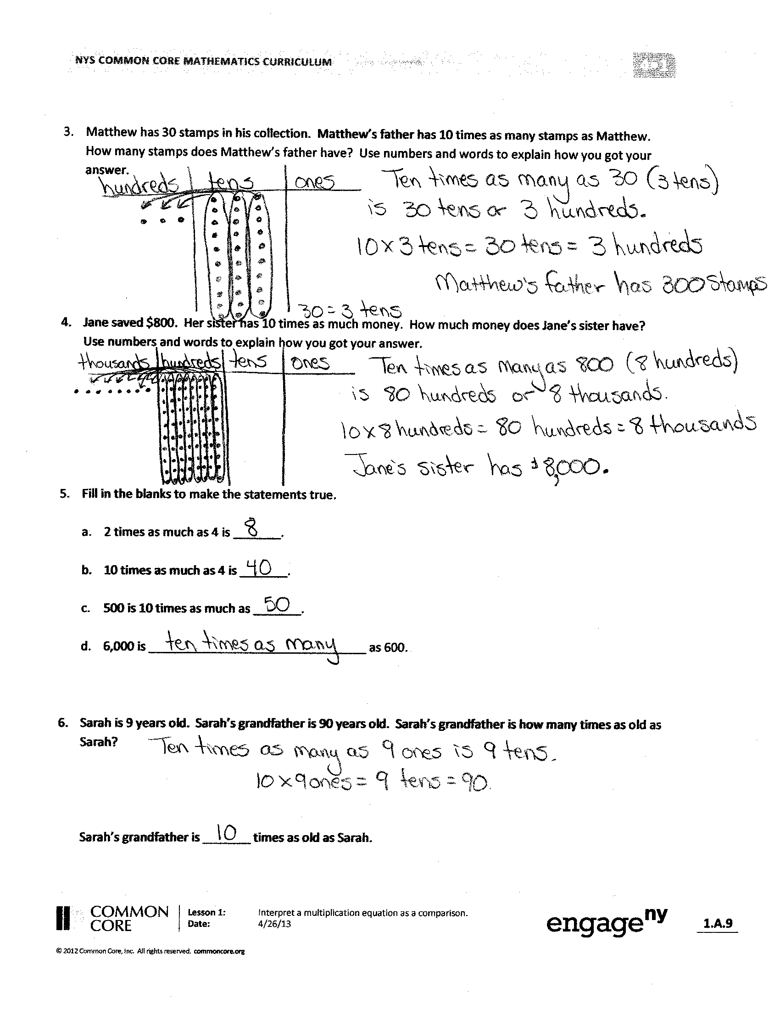
Student Debrief (7 minutes)
Lesson Objective: Interpret a multiplication equation as a comparison.
Invite students to review their solutions for the Problem Set and the totality of the lesson experience. They should check work by comparing answers with a partner before going over answers as a class. Look for misconceptions or misunderstandings that can be addressed in the Debrief. Guide students in a conversation to debrief the Problem Set.
You may choose to use any combination of the questions below to lead the discussion.
- What relationship do you notice between the problem of Matthew’s stamps and Problems 1(a) and 1(b)?
- How did Problem 1(c) help you to solve Problem 4?
- In Problem 5 which solution proved most difficult to find? Why?
- How does the answer about Sarah’s age and her grandfather’s age relate to our lesson’s objective?
- What are some ways you could model 10 times as many? What are the benefits and drawbacks of each way of modeling? (Money, base ten materials, disks, labeled drawings of disks, dots on a labeled place value chart, tape diagram.)
- Take 2 minutes to explain to your partner what we learned about the value of each unit as it moves from right to left on the place value chart.
- Write and complete the following statements:

_____ ten is _____ times as many as _____ one.

_____ hundred is _____ times as many as _____ ten.

_____ thousand is _____ times as many as _____ hundred.
Exit Ticket (3 minutes)
After the Student Debrief, instruct students to complete the Exit Ticket. A review of their work will help you assess the students’ understanding of the concepts that were presented in the lesson today and plan more effectively for future lessons. You may read the questions aloud to the students.

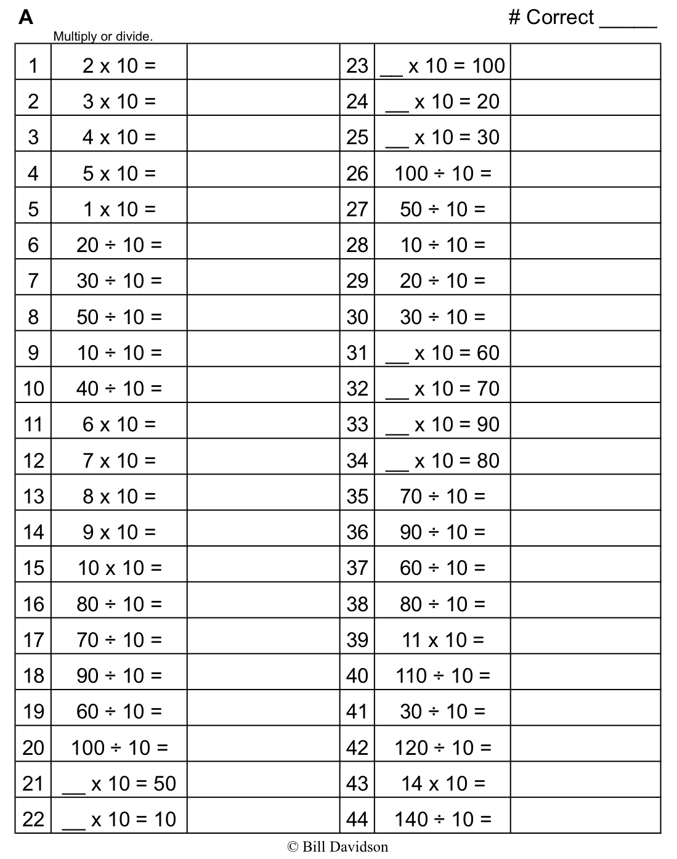
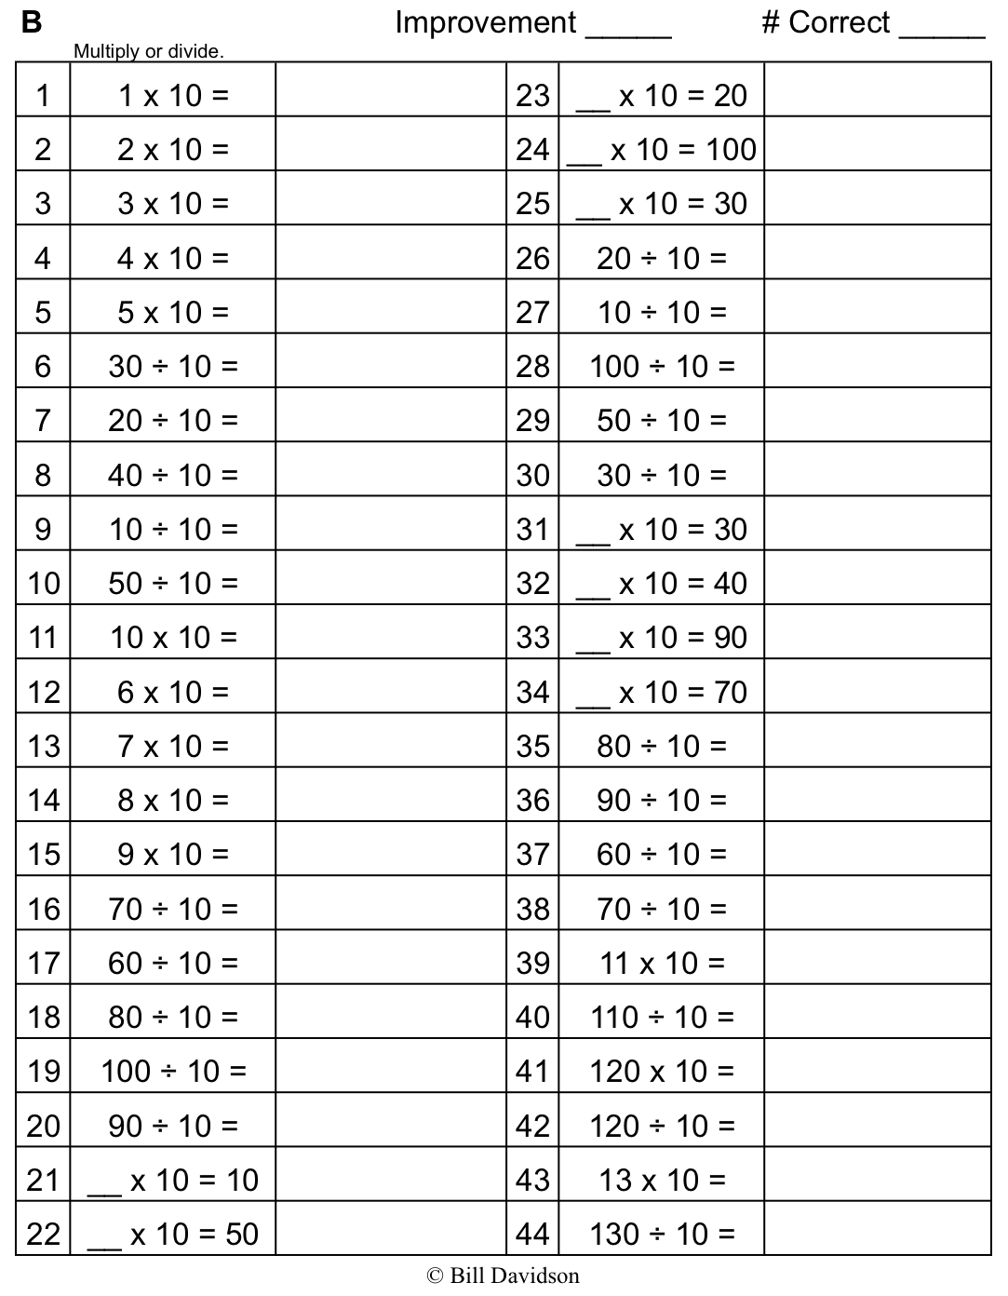
Name Date
- Label the place value charts. Fill in the blanks to make the following equations true. Draw disks in the place value chart to show how you got your answer using arrows to show any bundling.

  - 10 × 3 ones = ________ ones = __________

  - 10 × 2 tens =_________ tens = _________

  - 4 hundreds × 10 = _________ hundreds = _________

- Complete the following statements using your knowledge of place value:

  - 10 times as many as 1 ten is ________tens.

  - 10 times as many as _________ tens is 30 tens or ________ hundreds.

  - _____________________________ as 9 hundreds is 9 thousands.

  - _________ thousands is the same as 20 hundreds.

Use pictures, numbers, or words to explain how you got your answer for Part (d).
- Matthew has 30 stamps in his collection. Matthew’s father has 10 times as many stamps as Matthew. How many stamps does Matthew’s father have? Use numbers or words to explain how you got your answer.

- Jane saved $800. Her sister has 10 times as much money. How much money does Jane’s sister have? Use numbers or words to explain how you got your answer.

- Fill in the blanks to make the statements true.

- 2 times as much as 4 is _______.

- 10 times as much as 4 is _______.

- 500 is 10 times as much as _______.

- 6,000 is ________________________________ as 600.

- Sarah is 9 years old. Sarah’s grandfather is 90 years old. Sarah’s grandfather is how many times as old as Sarah?

Sarah’s grandfather is _______ times as old as Sarah.

Name Date
Use the disks in the place value chart below to complete the following problems.

- Label the place value chart.

- Tell about the movement of the disks in the place value chart by filling in the blanks to make the following equation match the drawing in the place value chart.

_____________ × 10 = ___________________ = ________________

- Write a statement about this place value chart using the words “10 times as many.”

Name Date
- Label the place value charts. Fill in the blanks to make the following equations true. Draw disks in the place value chart to show how you got your answer, using arrows to show any regrouping.

  - 10 × 4 ones = ________ ones = __________

  - 10 × 2 tens =_________ tens = _________

  - 5 hundreds × 10 = _________ hundreds = _________

- Complete the following statements using your knowledge of place value:

  - 10 times as many as 1 hundred is ______ hundreds or ________ thousand.

  - 10 times as many as _________ hundreds is 60 hundreds or ________ thousands.

  - _____________________________ as 8 hundreds is 8 thousands.

  - _________ hundreds is the same as 4 thousands.
Use pictures, numbers, or words to explain how you got your answer for Part (d).
- Katrina has 60 GB of storage on her tablet. Katrina’s father has 10 times as much storage on his computer. How much storage does Katrina’s father have? Use numbers or words to explain how you got your answer.

- Katrina saved $200 to purchase her tablet. Her father spent 10 times as much money to buy his new computer. How much did her father’s computer cost? Use numbers or words to explain how you got your answer.

- Fill in the blanks to make the statements true.

- 4 times as much as 3 is _______.

- 10 times as much as 9 is _______.

- 700 is 10 times as much as _______.

- 8,000 is ________________________________ as 800.

- Tomas’s grandfather is 100 years old. Tomas’s grandfather is 10 times as old as Tomas. How old is Tomas?

unlabeled thousands place value chart

