Lesson 32
Objective: Culminating task—describe measurable attributes of single objects.

Suggested Lesson Structure
 Fluency Practice (8 minutes)
 Concept Development (34 minutes)
 Student Debrief (8 minutes)
Total Time (50 minutes)
Fluency Practice (8 minutes)
- Breaking Apart Dot Cards of 6 K.CC.2 (4 minutes)
- Mystery Attribute K.MD.2 (4 minutes)
Breaking Apart Dot Cards of 6 (4 minutes)
Materials: (S) Dot cards of 6 (Lesson 13 Fluency Template) inserted into personal white board
Note: Students decompose numbers pictorially in this activity and develop part–whole thinking, essential to the work of the next module.
1. Have students touch and count the dots.
2. Partner A circles a group of dots, and then tells how many he circled.
3. Partner B tells how many are not circled and gives a (and…make) statement (e.g., 4 and 2 make 6).
4. Partners erase, switch roles, and continue exploring compositions of 6.
Variation: Give two (and…make) statements when applicable (e.g., 4 and 2 is 6; 2 and 4 is 6), or give two 6 is… statements when applicable (e.g., 6 is 5 and 1; 6 is 1 and 5.)
Mystery Attribute (4 minutes)
Materials: (T) Assorted classroom objects, balance scale
Note: This activity challenges students by presenting multiple attributes, preparing students for the culminating task.
T: (Show students a pencil and crayon side by side, vertically, with endpoints aligned.) Listen carefully, and raise your hand when you know what word is missing: “The pencil is than the crayon.” (If students are unsure at first, offer two options—taller or heavier.) Ready?
S: Taller! Longer!
Repeat with pencil and crayon side by side, horizontally, with endpoints aligned. Repeat with objects on a balance scale. Continue with a variety of objects, having students identify the attribute by indicating taller or shorter, longer or shorter, or heavier or lighter.
Application Problem
Note: In this lesson, the Application Problem has been omitted to allow more time for the culminating task.
Concept Development (34 minutes)
Materials: (T) Wide variety of objects arranged on the table from past lessons such as a piece of clay, a few linking cube sticks, clear containers including a vase and a cup, a string, a paper strip, a set of pennies, an empty clean juice box, a water bottle, and other student favorites (S) Balance scale, bag of two cups of rice, small scoop, and tray for a working surface per pair, comparing attributes recording sheet (Template)
T: You have learned so much about how to compare things! We are going to play a comparing game today. Student A, please come up to the table. Choose an object.
S: I chose the cup.
T: If you wanted to tell someone about the cup, what would you say?
S: It is clear. It is about as high as my finger. It is not heavy! It could hold as much rice as I could hold in my hands!
T: We can talk about the cup in a lot of different ways, can’t we? We can talk about its height, its weight, or its capacity. (Act out each as you use the words.) These are all ways to describe and compare objects.
T: Student B, please come up and choose two objects on the table.
S: (Answers may vary.) I chose the linking cube stick and the vase.
T: What are some things that are different about the stick and the vase?
S: The vase can hold things, but the stick is taller! I think the vase feels heavier, too.
T: Let’s choose one way to compare first. Let’s compare which is heavier. Use the balance scale to see which is heavier. (Allow student to demonstrate.) Which is heavier? Use your math words!
S: The vase is heavier than the cube stick.
T: Yes, the cube stick is lighter than the vase. Let’s show how we would put that on our Recording Sheet. (Demonstrate by drawing a balance and the objects.)
T: Let’s think about your other ideas. Which do you think is taller? How could you find out?
S: We have to line them up first. The stick is taller than the vase!
T: Yes, the vase is shorter than the stick. The stick is taller than the vase. Let’s draw that on our Recording Sheet. (Demonstrate.)
T: What other way could we compare the vase and the cube stick?
S: We could see which holds more. We could find its capacity!
T: Yes, we have been talking about the capacity of things. We were thinking about which object can hold more. What do you think about the vase and the cube stick?
S: The vase could hold some rice, but the cube stick can’t really hold anything.
T: Okay, so I can figure out the capacity of the vase, but is the cube stick meant to hold liquid or objects?
S: No.
T: The cube stick might be able to hold a little bit of liquid or small objects in these dents, but we don’t actually use it for that. So, does it make sense to compare the capacity of these two objects?
S: No!
T: We can compare things in lots of different ways! Our answers will be very different depending on what we choose to compare and how we compare them.
T: You will work with a partner. You will choose a pair of objects and decide in what ways you could compare them. Talk to your partner about which way is the best way to measure. You will use the recording sheet to draw a picture to show which is more. Think about your math words. Is one object longer than the other? Does it hold more than the other? Is it heavier than the other? Test your guesses, and show your work! When you have recorded your work, choose two other objects.
MP.5
Allow ample time for discussion and experimentation. Circulate to ensure isolation of individual attributes and correct comparisons on the recording sheet. Encourage correct math vocabulary.
T: Let's share some of our discoveries! Who would like to share?
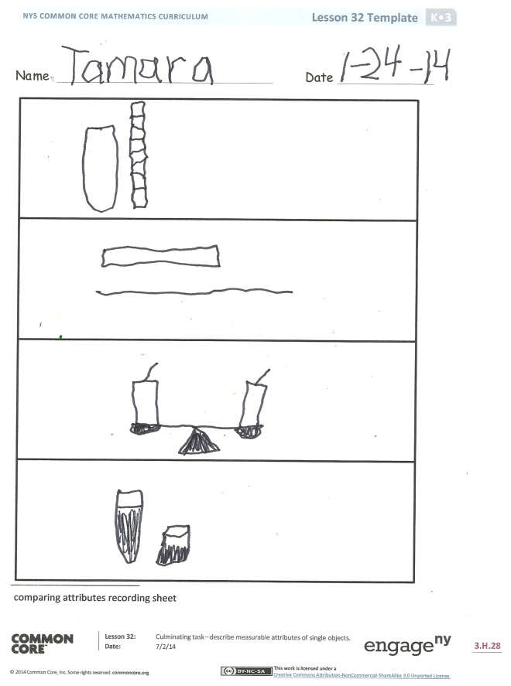
Student Debrief (8 minutes)
Lesson Objective: Culminating task—describe measurable attributes of single objects.
The Student Debrief is intended to invite reflection and active processing of the total lesson experience.
Invite students to review their Recording Sheet. They should compare work with a partner before reviewing it with the class. Look for misconceptions or misunderstandings that can be addressed in the Debrief.
You may choose to use any combination of the questions below to lead the discussion.
- How did you and your partner decide to compare your first set of objects?
- What did you discover?
- How did you draw your discovery on your recording sheet to show your friends?
- Are there any objects that you couldn’t compare in a certain way? Why?
- What new (or significant) math vocabulary did we use today to communicate precisely?

Name Date
The homework is a review of fluency skills from Module 3.

______ and _____ is_____ ______.
Example:
Circle a group of dots. Then, fill in the blanks to make a number sentence.

______ and _____ is ______.

______ and _____ is ______.

______ and _____ is ______.

On the back, make your own 6-dot cards. Circle some dots, and then say, “_____ and _______ is ________.”

______ and _____ is _____._.

Na me Date

comparing attributes recording sheet

