Lesson 31
Objective: Use benchmarks to create and compare rectangles of different lengths to make a city.

Suggested Lesson Structure
 Fluency Practice (12 minutes)
 Application Problem (5 minutes)
 Concept Development (25 minutes)
 Student Debrief (8 minutes)
Total Time (50 minutes)
Fluency Practice (12 minutes)
- Sprint: Rekenrek to 5 K.CC.5 (12 minutes)
Sprint: Rekenrek to 5 (12 minutes)
Materials: (S) 2 copies of the Rekenrek to 5 Sprint
Note: In this activity, students grow more comfortable with the Sprint routine while completing a task that involves relatively simple concepts. This builds confidence and enthusiasm for Sprints.
Follow the instructions for delivering a Sprint in Lesson 25. Use the Rekenrek to 5 Sprint for both rounds. Giving the identical Sprint twice facilitates comparison from Sprint A to Sprint B and allows students to see their growth. (Eventually, students will complete two Sprints that are similar but not exactly the same.) Continue to emphasize the concept of students beating their personal score. Praise students for their hard work and for following directions.

NOTES ON
MULTIPLE MEANS
OF REPRESENTATION:
Model the Application Problem for students working below grade level and English language learners. Help them compare the lengths of their bracelets by modeling what to say: “My bracelet is longer than/shorter than yours because…”
Application Problem (5 minutes)
Materials: (S) Bag of pony beads, 1 foot of elastic string or yarn with a bead tied on one end to prevent the beads from falling off
Using your elastic or your yarn, make a string of beads that is as long as your hand. Turn to your partner to talk about how you decided how long to make your string. Compare your strings.
Are they the same length? Tie the ends of your string together to make a bracelet!
Note: This problem serves as an anticipatory set for the exercise of creating something as long as a chosen benchmark. Circulate during the activity to determine if children need support determining where their hand “ends.”
Concept Development (25 minutes)
Materials: (S) Construction paper, crayons or markers, scissors, tape, 10-sticks
T: Today we are going to make a math city! We will use construction paper for each of you to design a special building for our city. First, plan how tall you want your building to be. Think about comparing the height of your building to something else in the room. What are some of your ideas?
MP.6
S: I’m going to make my building taller than a 10-stick. I want to make a house shorter than my hand. I’m going to make a skyscraper as long as my foot! My building will be just as long as my pencil.
T: Now, you need to think about the shape and color of your building. Turn to your partner and talk about your plan. What type of building do you want it to be?
Allow time for sharing and discussion.
NOTES ON
MULTIPLE MEANS
OF ENGAGEMENT:
Challenge students working above grade level by asking them to think about and explain how comparing their buildings to something else in the room helps the class create the math city. Encourage them to use their math vocabulary in expressing their ideas.
T: You may begin your work. I will be visiting all of you during your work to see how you thought about the height of your building. What are you comparing it to? I will help you write your answer on the back.
Allow time for students to work. Circulate during the work period, and ask students about the height of their buildings. Ask them to show you how they compared the height of their buildings to specific classroom objects. Write their answers on the back.
T: Now we will create our city! Students A and B, please bring your buildings to the front. Whose is shorter?
S: Student A’s.
T: Great! Please find a place on the bulletin board for your buildings. (Help students affix their work to the wall or bulletin board.)
T: Students C and D, please bring up your buildings. Whose is taller?
S: Student C’s.
T: Good! Please find a place in the city for your buildings. (Continue with sets of student work, each time comparing the heights of the buildings and reinforcing taller than and shorter than language.)
T: This is a wonderful city! Take some time to talk about the city with your friends. Which buildings do you think would be taller than your foot? Which ones do you think would be shorter than your hand? Are there any that would be shorter than a crayon? (Allow time for observation and discussion. Encourage students to use benchmarks for their comparison; “Here is my pencil! This building is longer, but this one is shorter than my pencil!”)
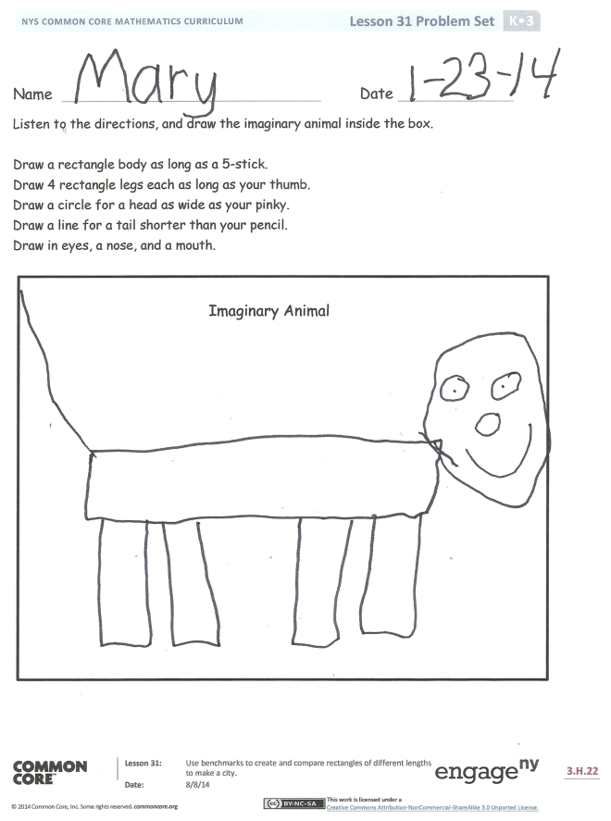
Problem Set (10 minutes)
Materials: (S) 5-stick
Students should do their personal best to complete the Problem Set within the allotted time.
Read the directions below, and have students draw the imaginary animal inside the box.
- Draw a rectangle body as long as a 5-stick.
- Draw 4 rectangle legs each as long as your thumb.
- Draw a circle for a head as wide as your pinky.
- Draw a line for a tail shorter than your pencil.
- Draw in eyes, a nose, and a mouth.
Student Debrief (8 minutes)
Lesson Objective: Use benchmarks to create and compare rectangles of different lengths to make a city.
The Student Debrief is intended to invite reflection and active processing of the total lesson experience.
Invite students to review their solutions for the Problem Set. They should check work by comparing answers with a partner before going over answers as a class. Look for misconceptions or misunderstandings that can be addressed in the Debrief. Guide students in a conversation to debrief the Problem Set and process the lesson.
You may choose to use any combination of the questions below to lead the discussion.
- How did you choose how tall you wanted your building to be?
- How did you choose the object to compare your building to?
- Did you test to see if your guess was right?
- Compare your imaginary animal to a partner’s. Do they look the same? How are they different?
- Why would your drawings be different if you followed the same directions? Were your comparisons different?
- What new (or significant) math vocabulary did we use today to communicate precisely?
- How did the Application Problem connect to today’s lesson?

1 2 3 4 5 | 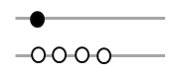  1 2 3 4 5
1 2 3 4 5 | 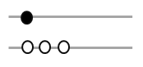  1 2 3 4 5
1 2 3 4 5 | 1 2 3 4 5
1 2 3 4 5 | 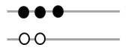  1 2 3 4 5
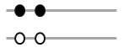  1 2 3 4 5 | 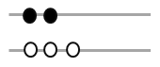  1 2 3 4 5
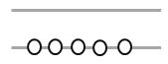  1 2 3 4 5 | 1 2 3 4 5

Name Date
Listen to the directions, and draw the imaginary animal inside the box.

Draw a rectangle body as long as a 5-stick.
Draw 4 rectangle legs each as long as your thumb.
Draw a circle for a head as wide as your pinky.
Draw a line for a tail shorter than your pencil.
Draw in eyes, a nose, and a mouth.
Imaginary Animal

Name Date
Read the following directions to your child to make a castle:
- Draw a rectangle as long as a spoon.
- Draw another rectangle on each side of the rectangle you just made.
- Draw a triangle on top of each rectangle to make towers shorter than your hand.
- Draw 1 rectangle flag pole as long as your pointer finger.
- Draw 1 square flag as long as your pinky.
- Draw a door as long as your thumb.
- Draw 2 hexagon windows each as long as a fingernail.
- Draw a prince or princess in your castle.
Castle

