Lesson 29
Objective: Observe cups of colored water of equal volume poured into a variety of container shapes.

Suggested Lesson Structure
 Fluency Practice (12 minutes)
 Concept Development (25 minutes)
 Application Problem (5 minutes)
 Student Debrief (8 minutes)
Total Time (50 minutes)
Fluency Practice (12 minutes)
- Tower Flip K.OA.3 (5 minutes)
- 5-Group Fill-Up K.OA.4 (4 minutes)
- Full, Not Full, or Empty? K.MD.1 (3 minutes)
Tower Flip (5 minutes)
Materials: (S) 5 linking cubes
Note: At this point in the year, many students have already mastered compositions of 3, 4, and 5. This activity seeks to build on the students’ understanding of comparison to support their work with partner numbers, in the next module.
T: Touch and count your cubes.
S: 1, 2, 3, 4, 5.
T: How many cubes do you have?
S: 5.
T: Set them down on your table like a tower.
T: Take 1 cube off the top of your tower, and place it on the table next to the tower. Do you still have 5 cubes?
S: Yes.
T: How many cubes are on the first tower?
S: 4.
T: On the other tower?
S: 1.
T: We can say 4 and 1 make 5. Echo me, please.
S: 4 and 1 make 5.
NOTES ON
MULTIPLE MEANS
OF ACTION AND EXPRESSION:
Students will understand directions more quickly with a demonstration of how to compose all the combinations of 5 with linking cubes.
Have students state the compositions as towers are built, and list them on the board vertically to help students see the pattern between the partner numbers.
Challenge students working above grade level by having them list the combinations of 5, and state the pattern they observe between the pairs using math language.
T: Good. Take another cube off the top of the first tower, and stick it onto the top of the other tower. Do you still have 5 cubes?
S: Yes.
T: How many cubes are on the first tower?
S: 3.
T: On the other tower?
S: 2.
T: Give me the …and…make… statement.
S: 3 and 2 make 5.
Continue transferring cubes from one tower to the other to work through all of the combinations of 5. Then, reverse the procedure and cycle back through the flipped combinations. Students should progress through the combinations in this order: 5 and 0, 4 and 1, 3 and 2, 2 and 3, 1 and 4, and 0 and 5. Invite students to tell what they noticed about the towers as they did this exercise (one tower got taller while the other got shorter).
5-Group Fill-Up (4 minutes)
Materials: (S) Dice with 6-dot side covered, personal white board
Note: This activity gives students a head start in learning how many more a number needs to make ten, anticipating the work of the next module. This activity also links to the next Fluency Practice and the numerous ways that objects can be considered full.
NOTES ON
MULTIPLE MEANS
OF ENGAGEMENT:
Students may note that one often considers a glass full even if the liquid does not come right up to the rim. Discuss reasons for that (avoiding spills, easier to drink, etc.), and let students develop their own interpretations of full based on context. The Problem Set allows room for further discussion around this topic.

Conduct activity as outlined in Lesson 22.
Full, Not Full, or Empty? (3 minutes)
Materials: (T) 4 real objects filled with various amounts of liquids (e.g., small bottle, mug, vase, and bowl)
Note: A misconception students often have is that a container is full if it has any amount of liquid in it. This activity seeks to clarify the meaning of full in preparation for today’s work with capacity.
T: Look at my water bottle. It is full because the water comes right to the top. I can’t possibly put any more water in here! Repeat after me, “It is full.”
S: It is full.
T: (Drink some of the water.) Now, it is not full. Echo.
S: It is not full.
T: (Show an empty water bottle.) This is my bottle from yesterday. There is no more water in it. Repeat after me, “It is empty.”
S: It is empty.
T: Now, I’ll show you some more things, and I want you to tell me if they are full, not full, or empty. (Show students a mug that is filled to the brim. Alternatively, to reduce spillage, the items could be displayed on a table or in the center of the rug with students seated on the edges of the rug so that they can see. Point to, rather than hold up, the focus object.) Raise your hand when you know what to say. (Wait for all hands to go up, then signal.) Ready?
S: Full!
T: Very good. (Hold up a vase of flowers with a little water in it.) Raise your hand when you know what to say. (Wait for all hands to go up, then signal.) Ready?
S: Not full!
T: Right. (Show students an empty bowl.) Ready?
S: Empty!
Concept Development (25 minutes)
Materials: (T) Clear measuring cup, water, several vials of food coloring, an assortment of clear 1 or 2-cup capacity containers in various shapes (e.g., mug, bowl, small bottle, vase, or beaker) (S) My capacity museum recording sheet (Template), crayons or markers
Note: Save the measuring cup and 1 or 2-cup capacity containers in various shapes for the culminating task in Lesson 32.
T: We are going to create some art today! You will be creating entries for your own Capacity Museum.
T: I have a cup of water. Student A, would you please come put two drops of red food coloring in my water container? (Assist Student A.)
T: Is my cup full?
NOTES ON
MULTIPLE MEANS
OF ACTION AND EXPRESSION:
Point to images of the concepts full, not full, and empty as you speak to scaffold the lesson for English language learners. For student reference, post the visuals on the word wall after introducing them.

MP.7
S: Yes!
T: Watch as I pour the red water into this bowl. (Demonstrate.) Did I change the amount of water in my cup?
S: No!
T: Does it still look the same?
S: No. It looks flatter. The top of the water is wider now! It is not as full.
T: Why do you think it looks different?
S: The bowl is bigger!
T: Yes, the bowl and the cup have different capacities. The bowl holds more water than the cup does. On your sheet, please choose one of the picture frames. Inside it, draw the bowl, and show how the water looks in the bowl.
MP.7
T: I will fill my measuring cup with some new water. Student B, would you please come put two drops of blue food coloring in the cup? (Assist as necessary.)
T: I will carefully pour the blue water into this vase. (Demonstrate.) Did I change the amount of water?
S: No!
T: Does it look the same?
S: No. Now, it looks tall. The water is curved! It is still full, though.
T: The cup and the vase have the same capacity but a different shape! Let’s draw the water in the vase in another one of the frames on your sheet. (Continue the activity with the other colors and containers. Encourage students to notice that, while they had the same amount of water each time, it appeared to be different depending on the capacity and the shape of the container.)
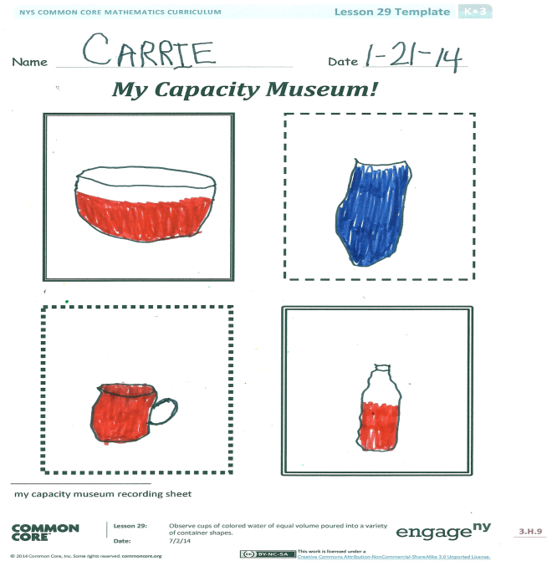
Problem Set
In this lesson, the my capacity museum recording sheet will serve as the Problem Set for the Concept Development.
Application Problem (5 minutes)
Demoss had a very small carton of orange juice. His mom poured it into a very tall glass without spilling any juice. Close your eyes and think about what that might look like. Draw the little carton of juice. Now, draw the juice after she poured it into the big glass. Does Demoss have more or less juice, or does it just look different? Compare your drawings with your partner’s. Are both of your glasses full? Did the glass hold all of the juice?
Note: The objective behind this Application Problem is to stimulate students’ thinking about whether a change in shape necessarily results in a change in another attribute, in this case volume or capacity. Circulate during the discussion to encourage use of language such as more than, less than, and the same as. Note from the drawings which students might need extra support understanding this concept.

Student Debrief (8 minutes)
Lesson Objective: Observe cups of colored water of equal volume poured into a variety of container shapes.
The Student Debrief is intended to invite reflection and active processing of the total lesson experience.
Invite students to review their recording sheets. They should compare answers with a partner before reviewing observations as a class. Look for misconceptions or misunderstandings that can be addressed in the Debrief.
You may choose to use any combination of the questions below to lead the discussion.
- Why did the water look different in each of the containers?
- Did the amount of the water change each time?
- Turn to your partner, and compare your drawings. Do they look the same?
- Which container do you think would hold the most?
- How did you determine if a container was empty, not full, or full?
- How did you know when a container was full?
- How can full be different in certain situations? (For example, with a mug of hot chocolate, you don’t want to fill it too full and spill.)
- When do we need full to mean right to the top?
- What new (or significant) math vocabulary did we use today to communicate precisely?
- How did the Application Problem connect to today’s lesson?

Name Date
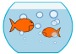
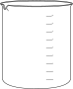
Draw a line from each container to the word that describes the amount of liquid the container is holding.

Full

Not Full

Empty
Name Date
My Capacity Museum!

my capacity museum recording sheet

