Lesson 27
Objective: Strategize to compare two sets.

Suggested Lesson Structure
 Fluency Practice (11 minutes)
 Application Problem (5 minutes)
 Concept Development (26 minutes)
 Student Debrief (8 minutes)
Total Time (50 minutes)
Fluency Practice (11 minutes)
- How Many Are Hiding? K.OA.4 (4 minutes)
- Hidden Numbers K.OA.3 (4 minutes)
- Show Me Taller and Shorter K.MD.1 (3 minutes)
How Many Are Hiding? (4 minutes)
Note: Partners to ten is foundational with respect to development of ten as a unit. Starting early and practicing frequently facilitates automaticity.
T: How many fingers do you have on two hands?
S: 10.
T: Show me 9, piano style, like this. (Demonstrate fingers the Math way, palms down, flat on the table.)
T: How many fingers are hiding?
S: 1.
T: Let that finger come out now. 9 and 1 make…?
S: 10.
T: Now, show me 8.
T: How many fingers are hiding?
S: 2.
T: Let those fingers come out now. 8 and 2 make…?
S: 10.
Work through all of the combinations of 10.

Hidden Numbers (4 minutes)
Materials: (S) Hidden numbers mat (Lesson 3 Fluency Template)
Note: Finding embedded numbers anticipates the work of Module 4 by developing part–whole thinking.
Conduct activity as described in Lesson 3, but this time guide students to find hidden numbers within a group of 6. Look for opportunities to compare sets within the larger group. Encourage students to use the newly acquired vocabulary of more, less, and the same as. Guide students to say, “6 is 4 and 2, but 4 is more than 2.” Or, “6 is 3 and 3. Hey, that’s the same number!”
Show Me Taller and Shorter (3 minutes)
Materials: (T) Ruler, pencil
Note: Recalling this vocabulary prepares students for the Concept Development activities in this lesson.
Conduct activity as described in Lesson 2.
Application Problem (5 minutes)
NOTES ON
MULTIPLE MEANS
OF ACTION AND EXPRESSION:
Extend learning for students working above grade level by challenging them to explain, either orally or in writing, how they knew who had more pattern blocks. Ask them to think of another strategy they can use to determine who has more pattern blocks.

Materials: (S) Pattern blocks, small bucket per pair
Work with a partner. Take one handful of pattern blocks out of the bucket. Let your partner do the same. Compare your handfuls of pattern blocks. Who has more? How do you know? Put the blocks back, and try the game again.
Note: Circulate during this time to observe student strategies for comparing the sets of blocks. Do the students line them up? Do they match them in pairs? Do they count them? Gather information about their existing strategies to guide your discussions in today’s lesson.
NOTES ON
MULTIPLE MEANS
OF ENGAGEMENT:
Ask students to verbalize who has more as they take turns every time they play the game. For example, “I have 8 cubes, and you have 3 cubes; 8 is more than 3.” Or, “I have 4 pennies, and you have 7 pennies; 4 is less than 7.” English language learners will benefit from the practice and can be easily observed as to which students might be confused between more and less.

Concept Development (26 minutes)
Materials: (T) 2 sets of student materials (S) 10-sided die, bag of 10 linking cubes, bag of 10 beans, bag of 10 pennies, bag of 10 counters per pair
T: We are going to do some more comparing activities together, and then you will repeat them with your partner. Watch carefully. Student A, please come up to help.

T: I am going to roll the die and take that many cubes out of the bag. You do the same. (Demonstrate.) What would be a simple way to see who has more?
S: Make towers!
T: (Demonstrate.) Student A, how many cubes are in your tower?
MP.6
S: 6.
T: I have 8. Let’s see whose tower is taller. Which is more, 8 or 6?
S: 8.
T: 8 is more than 6. Use your words.
S: 8 is more than 6.
T: Now, you and your partner try the game. (Allow time for comparison and discussion. Continue to encourage the language of more than and less than.)
T: Put the cubes away, and watch our next game. Student B, please come up to help. Student B and I will each take some pennies out of our bag. (Demonstrate.) How can we see who has more?
S: Line them up!
T: We will make rows of our pennies. (Demonstrate.) Student A, how many pennies do you have?
S: 9.
T: I have 3. Let's make pairs, and then move our pennies. (Demonstrate.) Who has fewer?
S: You do! You only had 3.
T: 3 is less than 9. Use your words.
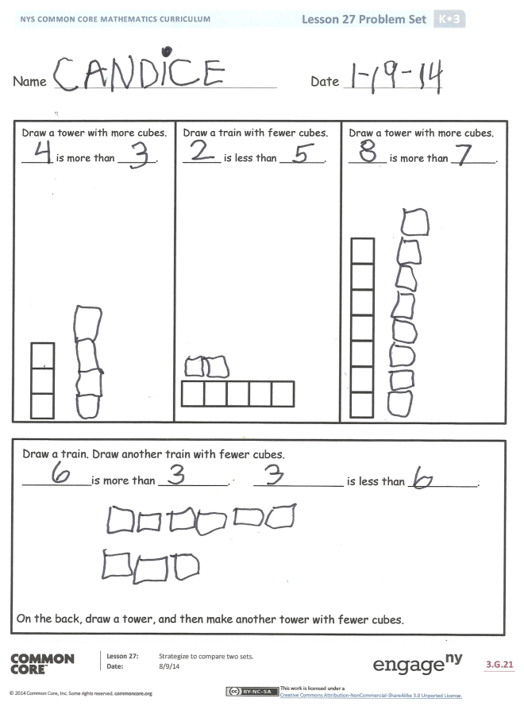
S: 3 is less than 9.
T: Thank you, Student B! You and your partner can play the game now. Line up your pennies each time to find out who has more. (Allow time for comparison and discussion.)
T: Put your pennies away. Take out your bag of beans. Roll the die to find out how many beans will be in your set. Compare your set with your partner’s. Who has more? How do you know? (Circulate during the lesson to observe strategies of comparison. Encourage students to use multiple strategies and to use more than and less than vocabulary in their discussions.)
Problem Set (10 minutes)
Students should do their personal best to complete the Problem Set within the allotted time.

Student Debrief (8 minutes)
Lesson Objective: Strategize to compare two sets.
The Student Debrief is intended to invite reflection and active processing of the total lesson experience.
Invite students to review their solutions for the Problem Set. They should check work by comparing answers with a partner before going over answers as a class. Look for misconceptions or misunderstandings that can be addressed in the Debrief. Guide students in a conversation to debrief the Problem Set and process the lesson.
You may choose to use any combination of the questions below to lead the discussion.
- How did we compare our sets with the linking cubes? What is another way we could have compared them?
- What do you think was the easiest way to find out which bean set had more? Would you do the same thing to find out which set had fewer beans?
- When do you need to count to see which set has more or less?
- When might we compare numbers in our lives?
- What math vocabulary did we use today to communicate precisely?
- How did the Application Problem connect to today’s lesson?

Name Date
Draw a tower with more cubes.
____ is more than _____.
Draw a train with fewer cubes.
____ is less than _____.
Draw a tower with more cubes.
____ is more than ____.

Draw a train. Draw another train with fewer cubes.
_________is more than _________. _________ is less than _________.
Name Date

Draw a tower with fewer cubes.
_____ is more than _____.
_____ is less than ______.

Draw a tower with more cubes.
_____ is more than _____.
_____ is less than ______.

On the back, draw a tower. Draw another tower that has more cubes.
_______ is more than ______.
_______ is less than ______.

Draw a train with more cubes.
_____is more than _____.
_____is less than ______.

