Lesson 26
Objective: Match and count to compare two sets of objects. State which quantity is less.

Suggested Lesson Structure
 Fluency Practice (12 minutes)
 Application Problem (5 minutes)
 Concept Development (25 minutes)
 Student Debrief (8 minutes)
Total Time (50 minutes)
Fluency Practice (12 minutes)
- Matching Fingertips One-to-One K.CC.6 (4 minutes)
- Dot Cards of 6 K.CC.2 (4 minutes)
- Say Ten Push-Ups K.NBT.1 (4 minutes)
Matching Fingertips One-to-One (4 minutes)
Note: This exercise allows students to practice one-to-one matching at the concrete level, preparing them to draw lines to match one-to-one pictorially in this lesson.
Conduct activity as outlined in Lesson 17.
Dot Cards of 6 (4 minutes)
Materials: (T/S) Dot cards of 6 (Lesson 13 Fluency Template)
Note: Reviewing 6, 7, 8, and 9 is essential in anticipating the work of the next module. While compositions of 5 have been well established at this point, numbers 6 through 9 prove challenging.
Conduct activity as outlined in Lesson 13.
Say Ten Push-Ups (4 minutes)
Note: This activity extends students’ understanding of numbers to 10 in anticipation of working with teen numbers. Conduct activity as outlined in Lesson 1. Continue to 20 (2 ten, or 10 and 10).

Application Problem (5 minutes)
NOTES ON
MULTIPLE MEANS
OF ENGAGEMENT:
Support English language learners and students working below grade level by asking questions that scaffold an understanding of the Application Problem. For instance, ask, “How many people are at your table? Draw that many faces.” And then, “How many pencils are at your table? Draw that many pencils.” Finally, ask while pointing from the face to the pencil, “Can you draw a line to connect one face to one pencil?”

Draw how many people are sitting at your table. Draw them in a row or line. Now, draw to show how many pencils are at your table. Draw them in a row or line. Draw lines to match each person to one pencil. Remember, each one gets only one partner! Are there more pencils or people? Show your work to your partner.
Note: Use this exercise to observe which students demonstrate the concept of one-to-one correspondence. This problem will also serve as a review before the less than extension of today’s objective.
Concept Development (25 minutes)
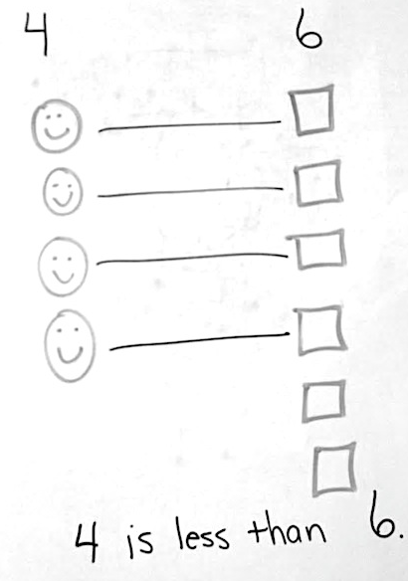
Materials: (T) White board and markers, shapes (Lesson 21 Template 1), cut out and placed in scatter arrangements on the board
8
10
4
7
5

T: In Lesson 25, we talked about how to organize our counting and comparing when we had groups of things. What do you remember?
S: We made lines of things. We counted them. We matched them up to find out which had more.
T: We are going to work on more of this today. Look at the shapes on the board. How can we quickly find out if there are more circles or squares?
S: We can line them up.
T: Yes, we can line them up and match them with partners. What if we put them in towers like your linking cubes? What if we put them in columns? Will that still work?
S: Yes!
T: Let’s try. (Place circles and squares in columns.) Now, what do I need to remember? How do I match them?
S: Each shape gets only one partner!
T: Does it matter which shape is bigger when I am matching?
S: No.
T: I will draw lines between the partners. (Demonstrate.) What did we discover?
NOTES ON
MULTIPLE MEANS
OF ENGAGEMENT:
English language learners will benefit from hearing and seeing sentence starters like “___ is less than ____.” which they can refer to as they do their work. Model the complete sentence, for example, "8 circles is less than 2 triangles," while pointing to the matching visuals.

S: There are more circles! There are leftovers.
T: Count the circles.
S: 1, 2, 3, 4, 5, 6, 7, 8, 9, 10.
T: Now, let’s count the squares.
S: 1, 2, 3, 4, 5, 6, 7, 8.
T: Let’s write the numbers above each column.
T: Compare the numbers!
MP.6
T: Just like we did in the other lesson, let’s question our partner. Today let’s use the word less. Who thinks they have a good question?
S: What is less? Which is less? Which number is less, 10 or 8? Which is less, 8 or 10?
T: Those questions got better and better. Let’s use this one, “Which number is less, 10 or 8?” What will your partner say?
S: 8 is less than 10.
T: Great. Begin your interview.
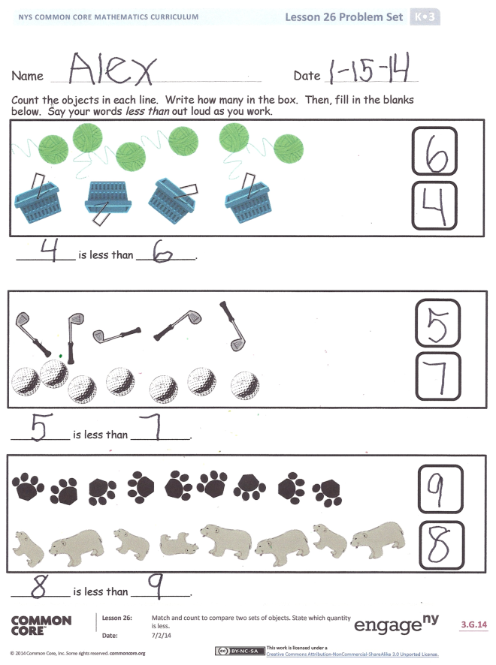
Repeat with several different combinations of shapes, emphasizing the less than language in both the set and number comparisons. Model the one-to-one correspondence carefully. Have the students work with their own drawings when they are ready. They should be able to line things up and match them independently.
T: We will work on this more in our Problem Set.
Problem Set (10 minutes)
Students should do their personal best to complete the Problem Set within the allotted time.
Student Debrief (8 minutes)
Lesson Objective: Match and count to compare two sets of objects. State which quantity is less.
The Student Debrief is intended to invite reflection and active processing of the total lesson experience.
Invite students to review their solutions for the Problem Set. They should check work by comparing answers with a partner before going over answers as a class. Look for misconceptions or misunderstandings that can be addressed in the Debrief. Guide students in a conversation to debrief the Problem Set and process the lesson.
You may choose to use any combination of the questions below to lead the discussion.
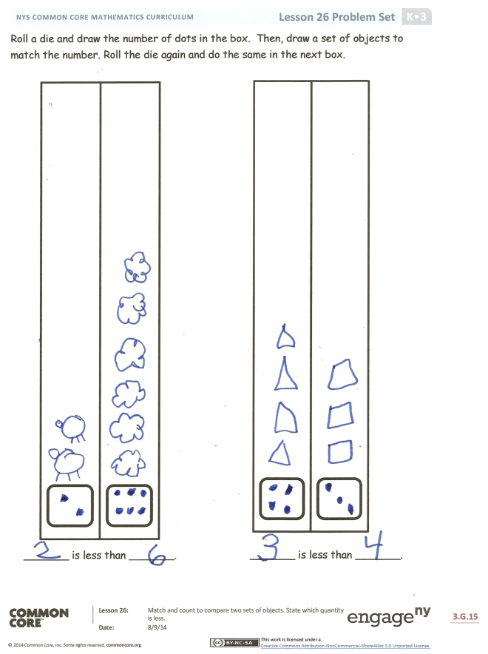
- When we were lining up the shapes on the board to compare the sets, did it matter if we made rows or columns?
- What is the most important thing to remember when lining up shapes? Why does each shape get only one partner?
- What new (or significant) math vocabulary did we use today to communicate precisely?
- How did the Application Problem connect to today’s lesson?

Name Date
- Count the objects in each line. Write how many in the box. Then, fill in the blanks below. Say your words less than out loud as you work.

_________ is less than _________.

_________ is less than _________.

_________ is less than _________.
- Roll a die and draw the number of dots in the box. Then, draw a set of objects to match the number. Roll the die again, and do the same in the next box.

_______ is less than _______. than _________.
_________ is more than _________.

_______ is less than _______. than _________.
_________ is more than _________.

_________ is less than _________. than _________.
_________ is more than _________.

Name Date
Count the objects in each line. Write how many in the box. Then, fill in the blanks below.

_______ is less than _______.

_______ is less than _______.

_______ is less than _______.

