Lesson 25

Objective: Match and count to compare a number of objects. State which quantity is more.

Suggested Lesson Structure

 Fluency Practice (12 minutes)

 Application Problem (3 minutes)

 Concept Development (27 minutes)

 Student Debrief (8 minutes)

**Total Time (50 minutes)**

Fluency Practice (12 minutes)

* Beat Your Score! **K.CC.4b** (12 minutes)

Beat Your Score! (12 minutes)

Materials: (S) 2 copies of *count and circle how many* (Lesson 20 Sprint)

Note: The purpose of this activity is to help students become accustomed to the full Sprint routine while completing a task involving relatively simple concepts (hence the reuse of a Sprint from Lesson 20). This activity builds confidence and enthusiasm for Sprints.

T: It’s time for a Sprint! (Briefly recall previous Sprint preparation activities, and distribute Sprints facedown.) Take out your pencil and one crayon, any color.

T: On your mark, get set, go!

S: (Work.)

T: (Ring the bell or give another signal for students to stop. Although it will not be necessary to time the students in this short practice Sprint, be sure to give the stop signal before students finish so they do not develop the expectation of finishing every time.) Pencils up!

T: Pencils down, crayons up!

T: It’s time to check answers. What do you do if the answer is right?

S: Circle it. (Circling correct answers instead of crossing out wrong ones avoids stigmatization.)

T: What do you say?

S: Yes!

T: We’ll begin with the hearts. Ready? 1.

S: Yes!

Proceed through the checking answers procedure as in Lesson 21.

T: Kindergarteners, do you ever wish you had more time? Another chance to do even better?

S: Yes.

T: Before we try again, let’s get our mind and body ready to work hard with an exercise. Stand up and push in your chairs. Let’s do jumping jacks while counting to 10. Ready?

S: 1, 2, 3, …10. (Count while doing jumping jacks.)

T: Hands on your hips. Twist slowly, counting down from 10. Ready? (While students exercise, distribute the second set of Sprints, which is the same as the first.)

S: 10, 9, 8, …1. (Count while twisting.)

T: Have a seat. Pencils up. Do you remember the number you got the first time?

S: Yes.

T: See if you can beat your own score! Race against yourself! On your mark, get set, go!

Students work on the Sprint for a second time. Perhaps give an additional three to five seconds to help students beat their first score. Give the signal to stop, reiterating that it is okay not to finish. Continue to emphasize that the goal is simply to do better than the first time. Proceed through the checking answers procedure with more enthusiasm than ever. Then, facilitate a comparison of Sprint A to Sprint B. Because students are still developing understanding of the concept of more, it may be necessary to circulate and facilitate the comparison, either visually or numerically.

T: Stand up if you beat your score.

T: You worked so hard, and I am so proud of you! Let’s celebrate (e.g., congratulate each other, give three pats on the back, shake hands, have a parade).

Variation: Allow students to finish, but provide an early finisher activity to do on the back.

Application Problem (3 minutes)

|  |  |
| --- | --- |
|  | NOTES ON  MULTIPLE MEANS  OF REPRESENTATION: |

Model the Application Problem for English language learners. Show what to do by placing a linking cube on top of a penny while speaking the instruction. Model how to tell a partner which set has more, “I have more pennies than linking cubes because two pennies are not covered.”

Materials: (S) Bag of 10 pennies, bag of 8 linking cubes

Note: This Application Problem introduces the comparing of sets of objects in linear configurations, serving as an anticipatory set for the lesson.

Put your pennies in a row. Now, put one linking cube on top of each penny. Are there enough cubes to cover each penny? Talk to your friend about which has more, the set of cubes or the set of pennies?

Concept Development (27 minutes)

Materials: (T) White board and markers, *shapes* (Lesson 21 Template), cut out and placed in scatter arrangements on the board

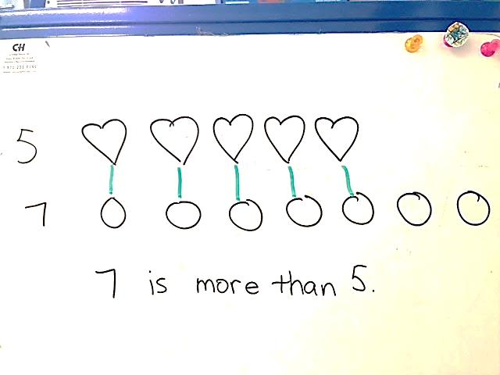

8

10

4

7

5

T: What do you notice on the board today?

S: We have lots of shapes.

T: Do you remember the names of the shapes?

S: There are triangles and hexagons. We have circles. There are some rectangles and special rectangles, too. 🡪 Yeah, the special ones are squares!

T: We’ve been talking lately about sets that have *more than* and *less than*. Today we are going to talk about ways to organize our groups of shapes so that it is easier to tell which has more.

T: Which has more, the circles or triangles?

S: There are more circles than triangles.

T: How did you know so fast?

S: I could just see there were lots more. 🡪 Yeah, I didn’t have to count because there are circles all over the place and just 4 triangles. 🡪 I didn’t count the circles, but I could see there were more than 4.

T: That makes sense, but what about the squares and the hexagons? Right now it is hard for me to guess which has more. It isn’t so easy to just see. Do you have any ideas?

S: (Discuss)

|  |  |
| --- | --- |
|  | NOTES ON  MULTIPLE MEANS  OF REPRESENTATION: |

Scaffold the lesson for students working below grade level and those having trouble grasping the concept of one-to-one correspondence by matching hexagons and squares one at a time. “One hexagon. Let’s count one square. Two hexagons. Two squares.” etc. Once students get the idea, move on to counting one set with more members than the other.

T: Guide the discussion so that students remember how they worked with the coins and cubes in previous lessons.

**MP.2**

S: Let’s line them up!

T: I can move our shapes. I will put the squares in a row, and the hexagons in a row just underneath. (Demonstrate.) Now, what do you notice?

S: The hexagon line is longer. 🡪 The hexagons are bigger. Maybe there are more, but I can’t tell.

T: We can show which set has more. Let’s draw a line between the first hexagon and the first square. 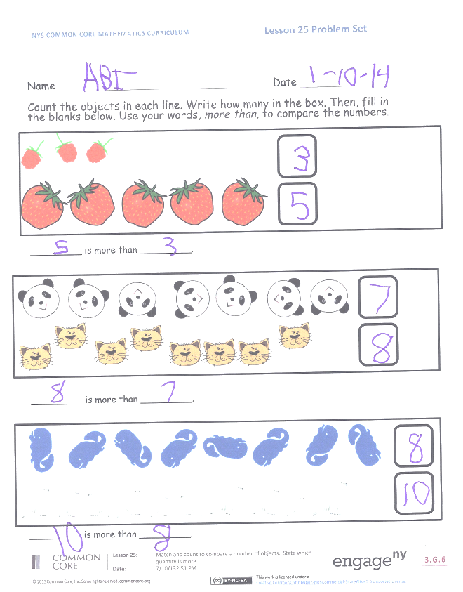(Demonstrate.) Now, let’s match the second hexagon with the second square. (Continue until all hexagons are matched.) Each of our hexagons has a partner in the other set. What do you notice now?

S: There’s a square left over.

T: I wonder if we could count them to find out which has more. Let’s count the hexagons and write that number at the end. 1, 2, 3, 4, 5, 6, 7. Now, let’s count the squares. 1, 2, 3, 4, 5, 6, 7, 8.

**MP.2**

T: Let’s write that number, too. (Write the number.) What do you notice?

T: Look at the numbers at the ends of the lines. There are 8 squares and 7 hexagons. 8 is more than 7. Repeat with me.

S: 8 is more than 7.

T: Here is a question to ask your partner, “Partner, which is more, 8 or 7?” What will your partner say?

S: 8 is more than 7.

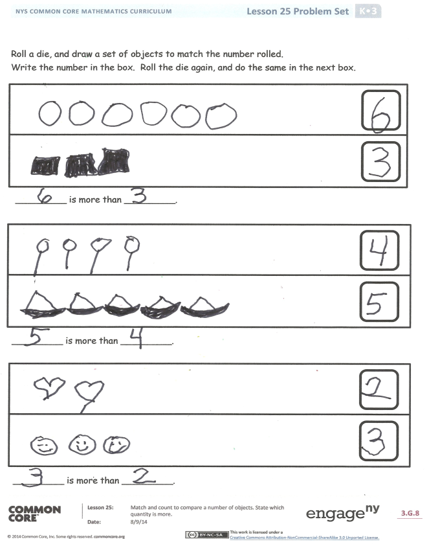T: Take turns, and ask your partner the question.

Repeat activity several times, using various combinations of shapes. Model the linear configuration and one-to-one correspondence each time. Have the students work with their own drawings, representing the shapes as soon as they are ready. They should be able to line things up and match them independently.

Problem Set (10 minutes)

Students should do their personal best to complete the Problem Set within the allotted time.

Student Debrief (8 minutes)

**Lesson Objective:** Match and count to compare a number of objects. State which quantity is more.

The Student Debrief is intended to invite reflection and active processing of the total lesson experience.

Invite students to review their solutions for the Problem Set. They should check work by comparing answers with a partner before going over answers as a class. Look for misconceptions or misunderstandings that can be addressed in the Debrief. Guide students in a conversation to debrief the Problem Set and process the lesson.

You may choose to use any combination of the questions below to lead the discussion.

* How did you organize your shapes to help you know which had more?
* Can you tell by lining up the shapes, which has more? How or how not?
* On the Problem Set, how did you know which set had more? Fewer?
* On the second page of the Problem Set, you compared two numbers. Did anyone roll the same number to compare? What did you do?
* What math vocabulary did we use today to communicate precisely? How did the Application Problem connect to today’s lesson?

Name Date

1. 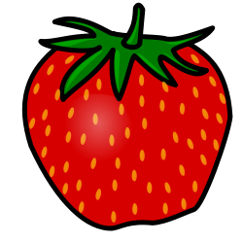Count the objects in each line. Write how many in the box. Then, fill in the blanks below. Use the words *more than* to compare the numbers.

_________ is more than _________.



_________ is more than _________.



_________ is more than _________.

1. Roll a die, and draw a set of objects to match the number rolled. Write the number in the box. Roll the die again, and do the same in the next box. Use the words *more than* to compare the numbers.

_________ is more than _________.

_________ is more than _________.

_________ is more than _________.

Name Date

Count the objects in each line. Write how many in the box. Then, fill in the blanks below.





_________ is more than _________.





_________ is more than _________.





_________ is more than _________.