Grade 8: Module 3B: Unit 1: Lesson 1
Launching the Text: Building Background Knowledge of the Jim Crow South

Long-Term Targets Addressed (Based on NYSP12 ELA CCLS)
I can analyze the connections and distinctions between individuals, ideas, or events in a text. (RI.8.3)
I can analyze how specific dialogue or incidents in a plot propel the action, reveal aspects of a character, or provoke a decision. (RL.8.3)
Supporting Learning Targets | Ongoing Assessment
- I can use items about the civil rights era to build background knowledge about A Mighty Long Way.
- I can analyze how incidents in A Mighty Long Way provoke Carlotta to make certain decisions and shape her story.

Agenda | Teaching Notes
- Opening  - Gallery Walk: Jim Crow South (20 minutes)  - Unpacking Learning Targets (3 minutes)  - Work Time  - Engaging the Reader: Read-aloud (12 minutes)  - Establishing Reading Routines: Reading Homework with Structured Notes (5 minutes)  - Closing and Assessment  - Debrief Learning Targets (5 minutes)  4. Homework  A. Read Chapter 1 and complete the structured notes. | - This lesson launches Module 3B. It begins with a Gallery Walk to build background knowledge of the Jim Crow era of U.S. history and the desegregation of schools following Brown v. Board of Education.  - Gather the Gallery Walk items listed on the document Gallery Walk Items in the supporting materials. Collect the photographs in two stations rather than having each photograph as its own station on the Gallery Walk.  - One of the stations on the Gallery Walk is a listening station for a song, “Ain’t Gonna Let Nobody Turn Me Around.” This song can be found by searching for “Sweet Honey Ain’t Gonna Let Nobody Turn Me Around” on free music or video streaming websites—for example, on YouTube.  - Please bear in mind that YouTube, social media video sites, and other website links may incorporate inappropriate content via comment banks and ads. Although some lessons include these links as the most efficient means to view content in preparation for the lesson, be sure to preview links, and/or use a filter service, such as www.safeshare.tv, for viewing these links in the classroom.  - This topic can be a sensitive one for students. Though the more graphic details remain hidden here, students will read about violent and discriminatory acts against others because of the color of their skin. The central text and other media contain racial, divisive language and slurs. Before teaching this lesson, think about how you might build on your existing class norms and culture to create a space in which students can encounter challenging events and consider the questions of race and racism that this unit raises. Be prepared to directly explain the historical and present-day context and connotations of words and events.  - Carlotta Walls LaNier’s memoir, A Mighty Long Way, is literary nonfiction. Many aspects of this central text will be analyzed using the Reading Information standards. Yet because the book is also a narrative, the Reading Literature standards are, at times, a useful lens. For example, Carlotta is the main character and develops over the course of the text as a person with a unique story and voice.  - This lesson reviews the structured notes routine that was introduced in Module 2. Students will use this note-taking format throughout their study of the book. With each reading assignment, students write the gist of the reading homework, answer a focus question or a few focus questions, and may attend to teacher-selected vocabulary words.

Agenda | Teaching Notes (continued)
- For struggling readers, an optional set of supported structured notes is provided. This supported version of the structured notes provides an actual summary of the reading homework. Note that this full summary is a scaffold for students’ reading. It is different from the “gist” notes that most students (those using the regular structured notes) are asked to write about their reading. The “gist” is simply initial notes of what they think the reading was mostly about; it is not formal summary writing.
- The structured notes, supported structured notes, and Structured Notes Teacher’s Guide are provided at the end of each lesson. Students should keep their structured notes for reference to use in work that comes later in the module. Consider providing the structured notes in a packet or storing them in a folder.
- Review: Gallery Walk protocol (see Appendix).
- In advance:
  - Post Gallery Walk items (see supporting materials).
  - Search for the song “Ain’t Gonna Let Nobody Turn Me Around,” by Sweet Honey on free music or video streaming websites—for example, on YouTube.
  - Carefully review Work Time A and be prepared to address the topic of racism and racist language directly and in a way that will best meet the needs of your particular student population.
- Post: Learning targets; materials for Gallery Walk.

Lesson Vocabulary | Materials
racism, prologue, inference, justice, segregationists (xiii), desegregation (xii), fortitude (xvi), composure | - Gallery Walk items (one of each for display)  - Notice/Wonder note-catcher (one per student)  - Timer (one for the class)  - A Mighty Long Way (book; one per student)  - A Mighty Long Way structured notes, Chapter 1, pages 3–26 (one per student)  - A Mighty Long Way supported structured notes, Chapter 1, pages 3–26 (optional; for students who need extra support)  - A Mighty Long Way Structured Notes Teacher’s Guide, Chapter 1, pages 3–26 (for teacher reference)

Opening | Meeting Students’ Needs
A. Gallery Walk: Jim Crow South (20 minutes)  - Be sure the Gallery Walk items are posted throughout the room (or along the hallway outside the classroom).  - Write the questions for students to focus on as they complete the Gallery Walk:  - “What do you think this module is going to be about?”  - “What time period are we going to be studying?”  - Display and distribute the Notice/Wonder note-catcher and explain the Gallery Walk protocol:  - Tell students that in a moment, they will get to examine several items including photographs, excerpts of text, and excerpts of songs on a Gallery Walk. This Gallery Walk will introduce them to the topic they are going to be studying in this module.  - Make it clear to students that some of what they see and read may make them feel uncomfortable. Tell students that it is important that they continue the great work they have done so far this year in being sensitive and kind to one another, and to be careful and thoughtful as they look over the items.  - At each station, they should consider the two questions posted on the board and on their note-catcher and pause to capture specific details that they notice and wonder about relevant to those questions.  - Tell students they will have just 3 minutes at each station, and that they might not get to see all of the items.  - You might need to coach the students about your expectations for safe movement and for quiet voices during this work period. (For example: “As you move from station to station, there is no need to engage in side conversations. I expect ‘zero’ voice levels during this time. Also, please move carefully, taking care not to bump into one another.”)  - Ask them to begin. Set a timer for 15 minutes, and encourage students to move to another station every 3 minutes or so.  - As students complete this activity, circulate to observe and support as needed. You might notice that they are making inferences (e.g., “I think this has something to do with civil rights. These photos seem to be taken in the 1940s or 1950s.”). This is ideal as it provides a basis for the follow-up conversation.  - After the 15 minutes have ended, ask students to return to their seats. | - Students engaged in a similar Gallery Walk in Modules 1 and 2, Unit 1, Lesson 1. They may benefit from participating with assigned partners to control the sharing and thinking they are doing during the Gallery Walk.  - Consider partnering ELL students who speak the same home language when discussion of complex content is required. This can allow students to have more meaningful discussions and clarify points in their native language.

Opening (continued) | Meeting Students’ Needs
- Cold call on several students to share their suggested answers to the questions, and select volunteers to share what they noticed and wondered. Once an inference comes up, probe the students about why they said what they said. (For example: “You said you saw a picture about civil rights. What specifically did you see that made you think this?”)
- Clarify for students that when they use background knowledge to add meaning to a picture or text, they are making inferences.
- Model for students that an inference is taking clues from the text and using your background knowledge to express thinking about a text. For example: “This picture is about race issues in the United States, and I know this because the water fountains are labeled for blacks and whites separately.” Clarify for students that an inference is not an opinion (e.g., “I hate this picture”).
- Tell students that in this module they are going to read about an important time in history: the African American civil rights movement, which happened between 1954 and 1968, which was a time when people in the United States were trying to end racial segregation and discrimination against black Americans.
- Deal quickly and directly with the N-word, by explaining that students may encounter it in the texts they are going to read. Make it clear that although it does appear in the book, this word in not to be used casually, because it is a word associated with hatred and violence. Historically, white Americans used it to highlight the belief that African Americans were inferior. Some discussion may ensue about other uses of this word, but guide students to understand that the word is not to be used unless in specific reference to a text that includes it. Tell students that according to the dictionary, the definition of racism is commonly “prejudice against someone of a different race based on the irrational belief that one’s own race is superior.”
B. Unpacking Learning Targets (3 minutes)
- Invite a student to read aloud the first learning target:
  - “I can use items about the civil rights era to build background knowledge about A Mighty Long Way.”
- Invite a different student to read aloud the second learning target:
  - “I can analyze how incidents in A Mighty Long Way provoke Carlotta to make certain decisions and shape her story.”
- Explain that in this lesson, students are going to be introduced to a text for the module called A Mighty Long Way.

Work Time | Meeting Students’ Needs
A. Engaging the Reader: Read-aloud (12 minutes)  - Distribute the central text, A Mighty Long Way by Carlotta Walls LaNier with Lisa Frazier Page.  - Read aloud the title of the book and invite students to turn to the Prologue.  - Ask if anyone knows what a prologue of a book is. Be sure students understand that it is an introductory section before the book begins.  - Invite students to follow along in their heads as you read the Prologue aloud.  - At times, pause to check for comprehension by inviting students to turn and talk to a student nearby. Invite them to retell, question, and/or comment on the story. Provide 1 minute for each turn and talk.  - Ask students:  - “Carlotta begins the Prologue stating, ‘All week, I managed to keep my composure.’ What does composure mean? “  - Listen for students to identify that composure means being calm and in control.  - Ask:  - “What do we know about Carlotta Walls LaNier from the Prologue?”  - Invite students to turn and talk to answer this question by returning to the text to find the details and information that answer the question.  - Cold call on student pairs, and listen for students to share that Carlotta was a teenager during desegregation and was the first black, female graduate of Central High School in Little Rock, Arkansas. She survived scare tactics from segregationists, or those who wanted to keep whites and blacks separate, and left Little Rock just after graduation. She is older now, is still friends with the other “Little Rock Nine,” and has a family.  - Inform students that the battle over the desegregation of schools was between integrationists and segregationists. Students need to understand that schools before the 1950s were separate for black citizens and white citizens—they were segregated. In the mid-1950s, a movement began to integrate the schools—to desegregate them. The white citizens who fought this desegregation movement were called segregationists. Not all white citizens in the South were segregationists; in fact, many were not.  - To encourage students to consider Carlotta as a unique individual telling her own story of the events of 1957, ask them:  - “What values did Carlotta possess that shaped her story?” | - Pairing students for comprehension discussions during the reading will provide a supportive structure for reading and understanding a complex text.  - Posting learning targets allows students to reference them throughout the lesson to check their understanding. The learning targets also provide a reminder to students and teachers about the intended learning behind a given lesson or activity.

Work Time (continued) | Meeting Students’ Needs
- Listen for students to refer to page xv of the Prologue in which Carlotta lists the following features of herself and her world in 1957: dedication, perseverance, confidence, hard working, determination, and fortitude (having courage in the face of difficulties).
- Ask students:
  - “What do all of these photographs have in common?”
- Invite students to turn and talk about this question. During their conversations, encourage them to practice using the sentence starters (located on the bottom portion of the note-catcher).
- While students discuss, circulate and probe to encourage them to move beyond the literal of what they see in the photographs to what they infer about the people in the photographs.
- Cold call on student pairs to share their thinking.
Share with students that many of the photographs feature the reality of segregation of races, protests over desegregation, and efforts toward desegregation of U.S. public schools in the 1950s.
B. Establishing Reading Routines: Reading Homework with Structured Notes (5 minutes)
- Distribute the A Mighty Long Way structured notes, Chapter 1, pages 3–26 to students and orient them to the expectations of this work while reading A Mighty Long Way.
- Explain to students that they will have reading homework every night.
- Share with students that the structured notes should be familiar to them. They will write the gist of what they read for homework and answer a focus question or a set of questions. They might be asked to define some vocabulary words.

Closing and Assessment | Meeting Students’ Needs
A. Debrief Learning Targets (5 minutes)  - Cold call on a student to read aloud the first learning target:  - “I can use items about the civil rights era to build background knowledge about A Mighty Long Way.”  - Invite students to turn and talk about what they know, what they wonder, and what they infer about the historical setting of A Mighty Long Way based on the Gallery Walk items.  - Cold call on a different student to read aloud the second learning target:  - “I can analyze how incidents in A Mighty Long Way provoke Carlotta to make certain decisions and shape her story.”  - Ask students to turn and talk:  - “What is one detail or inference you can state about Carlotta as a character based on the incidents we have read about today?” | - Allowing students to turn and talk allows them some time to process and synthesize their thinking.
Homework | Meeting Students’ Needs
- Read Chapter 1, pages 3–26, and complete the structured notes. | - Provide struggling learners with the supported structured notes for additional scaffolding as they read the memoir.

Grade 8: Module 3B: Unit 1: Lesson 1
Supporting Materials

Type of Media | Source | Title
Photograph | http://commons.wikimedia.org/wiki/File:Little_Rock_Nine_protest.jpg  Library of Congress, Prints & Photographs Division, U.S. News & World Report Magazine Collection, LC-DIG-ppmsca-03120 | Little Rock Nine Protest, 1959
Photograph | http://commons.wikimedia.org/wiki/File:Arkansas_Desegregation_Little_Rock_Sept_1957.jpg  US Army http://creativecommons.org/licenses/by-sa/2.0/ | Arkansas Desegregation, Little Rock, 1957
Photograph | http://www.newrochelletalk.com/node/1399  Library of Congress, Prints & Photographs Division, FSA/OWI Collection, LC-DIG-fsa-8a26761 | Separate but equal water fountains
Photograph | http://life.time.com/history/little-rock-nine-1957-photos/#16  George Silk—Time & Life Pictures/Getty Image | Brave hearts
Photograph | http://life.time.com/history/little-rock-nine-1957-photos/#14  Ed Clark—Time & Life Pictures/Getty Images | Segregationist protest
Photograph | http://life.time.com/history/little-rock-nine-1957-photos/#10  Ed Clark—Time & Life Pictures/Getty Images | Jeering/bullying
Photograph | http://life.time.com/history/little-rock-nine-1957-photos/#11  George Silk—Time & Life Pictures/Getty Image | Federal troops with Little Rock Nine
Photograph | http://life.time.com/history/little-rock-nine-1957-photos/#20  Stan Wayman—Time & Life Pictures/Getty ImagesMrs | AK National Guard blocking Little Rock Nine
Photograph | http://life.time.com/history/little-rock-nine-1957-photos/#23  Francis Miller—Time & Life Pictures/Getty Image | At Daisy Bates’ house
Gallery Walk Items

Gallery Walk Items
Type of Media | Source | Title and Text
Photograph | http://en.wikipedia.org/wiki/File:Burning-cross2.jpg  Library of Congress. Public Domain | Ku Klux Klan
Photograph | http://simple.wikipedia.org/wiki/File:Little_Rock_integration_protest.jpg  Library of Congress, Prints & Photographs Division, ppmsca.03090 | Little Rock Segregation Protest
Photograph | http://en.wikipedia.org/wiki/File:1943_Colored_Waiting_Room_Sign.jpg  Library of Congress. Public Domain | Colored Waiting Room Sign
Song Excerpt | Unit 1, Lesson 11 | Lyrics of Stanza 2 of “Lift Every Voice and Sing”  Stony the road we trod,  Bitter the chastening rod,  Felt in the days when hope unborn had died;  Yet with a steady beat,  Have not our weary feet  Come to the place for which our fathers sighed?  We have come over a way that with tears has been watered,  We have come, treading our path through the blood of the slaughtered,  Out from the gloomy past,  Till now we stand at last  Where the white gleam of our bright star is cast.
Audio and Lyrics | Unit 1, Lesson 10 | Audio and lyrics to “Ain’t Gonna Let Nobody Turn Me Around”

Type of Media | Source | Title and Text
Text Excerpt | A Mighty Long Way | Text Excerpt from A Mighty Long Way  “There must have been hundreds of people—white mothers with faces contorted in anger, white fathers pumping their fists in the air and shouting, white teenagers and children waving Confederate flags and mimicking their parents. Just who were these people? Were they the women who turned up their noses and murmured nasty words at Mother and me on the city bus? Were they the white customers I saw from time to time with Big Daddy at the meatpacking houses downtown? Were they my white neighbors? The scene felt surreal. With everyone screaming and jeering at once, their words sounded muddled…”
Text Excerpt | “Jim Crow Laws.” National Park Service. U.S. Department of the Interior, 14 Feb. 2014. Web. 27 Feb. 2014  (From Unit 1, Lesson 9) | Jim Crow Laws  Separate schools shall be maintained for the children of the white and colored races. Mississippi

Gallery Walk Items

Type of Media | Source | Title and Text
Text Excerpt | Plessy v. Ferguson, 163 U. S. 537 (1896)  (From Unit 1, Lesson 5) | Plessy v. Ferguson: The Court’s Decision  “The object of the amendment was undoubtedly to enforce the absolute equality of the two races before the law, but, in the nature of things, it could not have been intended to abolish distinctions based upon color, or to enforce social, as distinguished from political, equality, or a commingling of the two races upon terms unsatisfactory to either. Laws permitting, and even requiring, their separation in places where they are liable to be brought into contact do not necessarily imply the inferiority of either race to the other, and have been generally, if not universally, recognized as within the competency of the state legislatures in the exercise of their police power. The most common instance of this is connected with the establishment of separate schools for white and colored children, which has been held to be a valid exercise of the legislative power even by courts of States where the political rights of the colored race have been longest and most earnestly enforced.”

Gallery Walk Items

Gallery Walk Items

“We hold these truths to be self-evident, that all men are created equal, that they are endowed by their Creator with certain unalienable Rights, that among these are Life, Liberty and the pursuit of Happiness. — That to secure these rights, Governments are instituted among Men, deriving their just powers from the consent of the governed.”
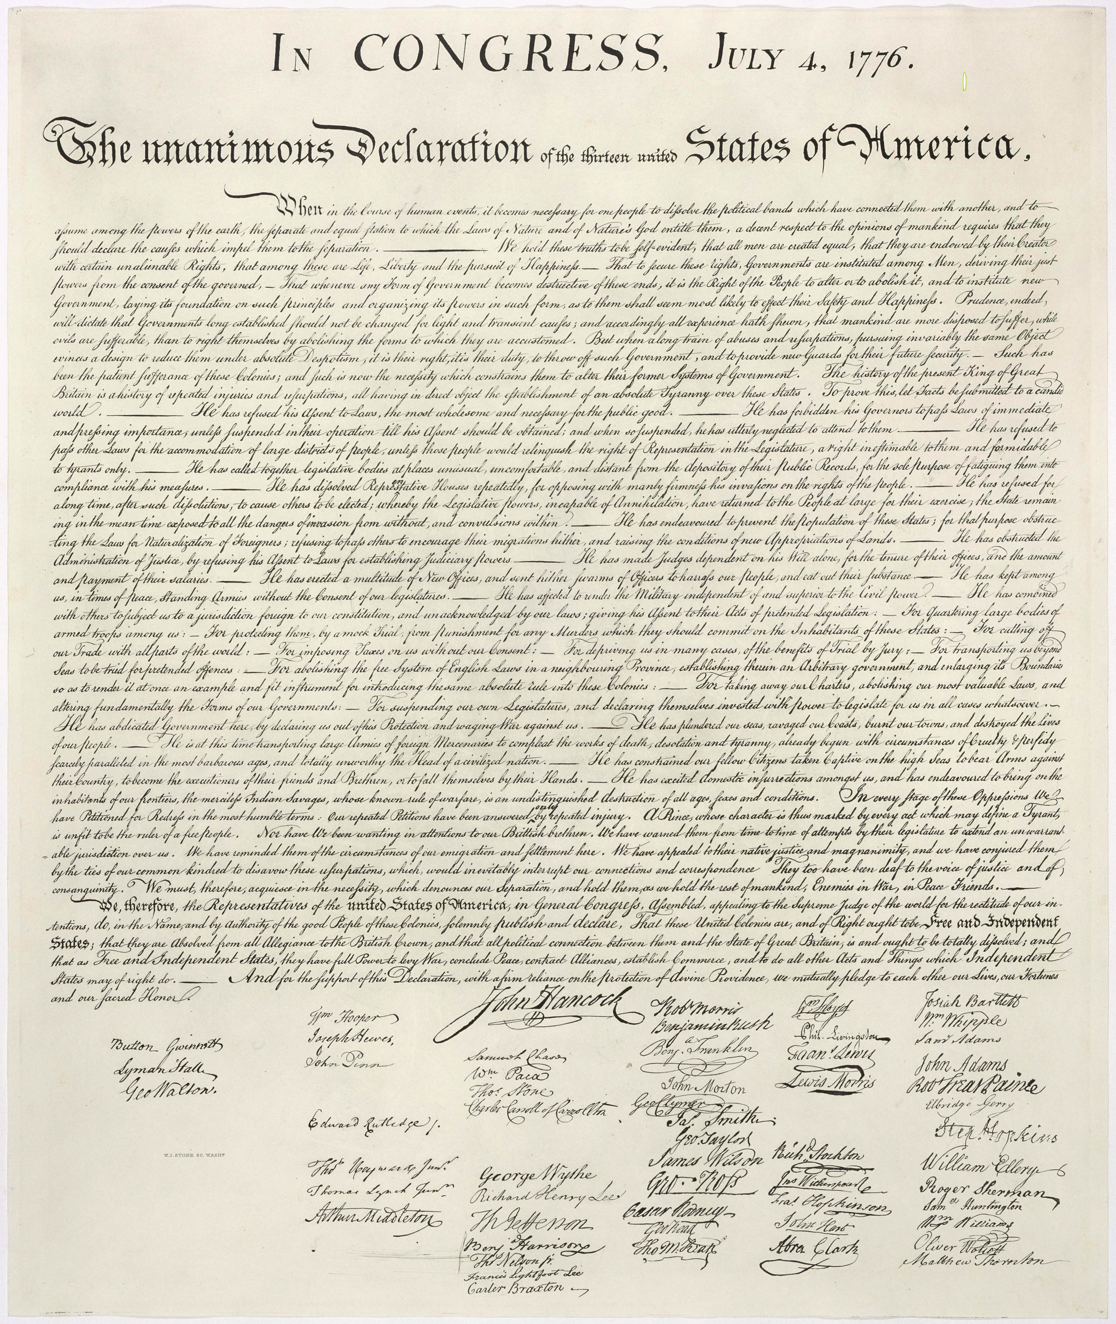

The Declaration of Independence
Notice/Wonder Note-catcher

Name:
Date:

What do you think this module is going to be about?
What time period are we going to be studying?

Notice | Wonder
Partner Discussion Sentence Starters
I hear that you said …

I’m still wondering …

Now that I know that, I think …

What you said about … raised a question for me. (Ask question.)

A Mighty Long Way Structured Notes, Chapter 1, Pages 3–26

Name:
Date:

What is the gist of what you read?

Use this space to keep track of the members of Carlotta’s family and how they are connected to her when you read pages 4–11.

A Mighty Long Way Structured Notes, Chapter 1, Pages 3–26

On page 17, Carlotta tells of an incident on the bus she and her mom were riding. She states that one of the central lessons of her childhood was to “be patient with ignorance and never, ever, bring ourselves down to their level.” They referred to ignorant people. How did her mother model this lesson in the bus incident? Use evidence from the text to support your answer.

Although she was only eight years old when she visited New York City, from what you have read how did her three-month-long visit affect Carlotta? Use evidence from the text to support your ideas.

A Mighty Long Way Supported Structured Notes, Chapter 1, Pages 3–26

Name:
Date:

Summary of Chapter 1, pages 1–26
This first chapter of the book orients the reader to Carlotta’s world in Little Rock during her childhood. In her life, her family roots and connections take a central role in her development as a person. She attributes a lot of her character to the influence of extended and immediate family members. She grew up feeling safe and connected to a family and a community. In her family, she feels like she belongs. In contrast, she feels opposition from the white world. The summer after she attends third grade, Carlotta visits New York City and she recognizes the differences between her life in her black community and the larger, white community in Little Rock.

Use this space to keep track of the members of Carlotta’s family and how they are connected to her when you read pages 4–11.

A Mighty Long Way Supported Structured Notes, Chapter 1, Pages 3–26

On page 17, Carlotta tells of an incident on the bus she and her mom were riding. She states that one of the central lessons of her childhood was to “be patient with ignorance and never, ever, bring ourselves down to their level.” They referred to ignorant people. How did her mother model this lesson in the bus incident? Use evidence from the text to support your answer.

Although she was only eight years old when she visited New York City, from what you have read how did her three-month-long visit affect Carlotta? Use evidence from the text to support your ideas.

A Mighty Long Way Structured Notes Teacher’s Guide, Chapter 1, Pages 3–26
(For Teacher Reference)

Summary of Chapter 1, pages 1–26

This first chapter of the book orients the reader to Carlotta’s world in Little Rock during her childhood. In her life, her family roots and connections take a central role in her development as a person. She attributes a lot of her character to the influence of extended and immediate family members. She grew up feeling safe and connected to a family and a community. In her family, she feels like she belongs. In contrast, she feels opposition from the white world. The summer after she attends third grade, Carlotta visits New York City and she recognizes the differences between her life in her black community and the larger, white community in Little Rock.

Use this space to keep track of the members of Carlotta’s family and how they are connected to her when you read pages 4–11.

Hiram Holloway = maternal great-great-grandfather
Papa Holloway (Aaron) = maternal great-grandfather, raised Juanita, married to Mary (d.) and Dora Holmes was his girlfriend
Maude = Papa’s sister in Cleveland
Big Daddy (Porter Walls) = paternal grandfather
Grandpa Cullins (Med) = maternal grandfather, married to Beatrice (d.) but had Juanita (mom) with Erma Holloway (who left Little Rock) when separated from his wife
Richard Walls = paternal great-great-grandfather (free person of color before the Civil War)
Coatney Walls = paternal great-grandfather
Big Daddy = paternal grandfather, married to Henrietta (d.), children were Cartelyou (dad), Juanita, Margaret

A Mighty Long Way Structured Notes Teacher’s Guide, Chapter 1, Pages 3–26
(For Teacher Reference)

On page 17, Carlotta tells of an incident on the bus she and her mom were riding. She states that one of the central lessons of her childhood was to “be patient with ignorance and never, ever, bring ourselves down to their level.” They referred to ignorant people. How did her mother model this lesson in the bus incident? Use evidence from the text to support your answer.

She didn’t respond to it. She was quiet and used it as a lesson for Carlotta. She said, “At first, Mother said nothing, as if she didn’t even hear it. Then, ever so discreetly, she pulled me closer to her and whispered: “Carlotta, we must be patient with ignorance.…”

Although she was only eight years old when she visited New York City, from what you have read how did her three-month-long visit affect Carlotta? Use evidence from the text to support your ideas.

Students may suggest many ideas here, but here is an example:

Her trip to New York City makes Carlotta realize that things are not the same everywhere and in some places she can live more freely. In New York she could ride anywhere on the bus, did not have to use a separate bathroom or water fountain from others, and could even play on the same playground as white kids. She said, “My parents had ingrained in me all of my life that people of all races were equal in the eyes of God. Here, in New York, I was getting a glimpse of this life through His divine lens.” She also said, “Here in this brand-new world, an ordinary friendship between a little black girl and a little white boy could exist, free of the boundaries that defined such relationships back home.” She finishes that part of the book by explaining, “I’d tasted the sweetness of freedom and seen more than my eight-year-old mind could fully understand. But everything that the Jim Crow South had tried to make me believe about my people and my place in life had been flipped upside down. Suddenly, the world had opened wider.”

