Grade 5: Module 3B: Unit 2: Lesson 6
Research Skills, Part 1: Natural Resource Development and How it Modifies the Physical Environment

Long-Term Targets Addressed (Based on NYSP12 ELA CCLS)
I can quote accurately from a text when explaining what the text says explicitly and when drawing inferences. (RI.5.1)
I can explain important relationships between people, events, and ideas in a historical, scientific, or technical text using specific details in the text. (RI.5.3)
I can integrate information from several texts on the same topic in order to write or speak about the subject knowledgeably. (RI.5.9)
I can conduct short research projects that use several sources to build knowledge about multiple aspects of a topic. (W.5.7)
I can gather relevant information from print and digital sources, summarize information in notes and finished work, and provide a list of sources. (W.5.8)
Supporting Learning Targets | Ongoing Assessment
- I can build knowledge about how Canada’s resources meet people’s needs and wants and how resource industries modify the environment, by using several types of sources to conduct research.  - I can explain how Canada’s resources meet people’s needs and wants and how resource industries modify the environment, by quoting accurately from sources.  - I can synthesize my research by paraphrasing information from a variety of texts and providing a list of sources. | - “A Limited Supply” resource web (from homework)  - Research notes

Agenda | Teaching Notes
- Opening  - Engaging the Reader: “A Limited Supply” Resource Web (5 minutes)  - Work Time  - Research Mini Lesson: Finding Answers in an Excerpt of Text (15 minutes)  - Research Mini Lesson: Finding Answers on a Graph (15 minutes)  - Research Mini Lesson: Finding Answers in Images (20 minutes)  - Closing and Assessment  - Synthesizing Information (5 minutes)  - Homework  - Use the resources you have analyzed and interpreted in the lesson to complete your resource web.  - Read your independent reading book for at least 15–20 minutes. | - In this lesson, students learn how to research to answer the guiding questions through a series of mini lessons that focus on collecting information from a variety of media types: a text, a graph, and an image. In the next lesson, they will be given three new resources to research in order to answer the questions more independently.  - A new question is introduced that students research to answer: “How do natural resource industries modify the physical environment?” Responses to this question are added to the resources already listed on the Canada’s Natural Resources anchor chart, which students have been adding to throughout the unit.  - Students reread “A Limited Supply,” the same text that that was used in Lesson 5 for the mid-unit assessment. This approach has two advantages: 1) The text is a valuable resource for helping students to answer the new question introduced in this lesson about how natural resource industries modify the physical environment; and 2) the focus of this lesson is on the research process and research skills, so using a text students are already familiar with will enable them to focus on the skills and process to effectively research rather than the content of a new text.  - Because the environmental modifications that occur due to resource extraction are often portrayed as negative, it is important to educate students regarding the efforts made by resource industries to implement reclamation projects in areas that have been significantly altered because of industrial activity. Therefore, during Work Time C, students view a series of images that are meant to help them understand not only how these industries can transform areas in harmful ways, but also how companies work to restore excavation sites to conditions similar to what they were like before industrial development.  - In advance:  - Prepare the Research Skills and Processes anchor chart (see supporting materials).  - Review the Popcorn Read protocol (see Appendix).  - Post: Learning targets.

Lesson Vocabulary | Materials
paraphrase; modify, pressures on the land, reclamation | - Canada’s Natural Resources anchor chart (begun in Lesson 1)  - Canada’s Natural Resources anchor chart (completed, for teacher reference; see Unit 2 Overview)  - Dictionary (one per group)  - “A Limited Supply” (from Lesson 5; see Teaching Notes)  - Research note-catcher (one per student and one for display)  - Research note-catcher, Part 1 (suggested answers, for teacher reference)  - Quote/Paraphrase anchor chart (from Module 2; also used in Unit 1, Lesson 3 of this module )  - Research Skills and Processes anchor chart (new; teacher-created)  - Research Skills and Processes anchor chart (for teacher reference)  - “Freshwater Quality by Land Use in Canada, 2007–2009” (one per student and one for display)  - “The Canadian Oil Boom” (one per student and one for display)  - Reclamation images (one per student and one for display)  - Homework: Modifying the Physical Environment resource web (one per student)

Opening | Meeting Students’ Needs
A. Engaging the Reader: “A Limited Supply” Resource Web (5 minutes)  - Remind students that for homework they were to reread “A Limited Supply” and fill out a resource web for the text.  - Invite students to briefly share their resource webs with their group, and to make any additions or revisions based on what they see and hear from others.  - Refocus students whole group. Invite volunteers to share their responses aloud. Add appropriate student suggestions to the Canada’s Natural Resources anchor chart. Refer to Canada’s Natural Resources anchor chart (completed, for teacher reference) for how the anchor chart should look. | - Provide sentence frames to allow all students access to the discussion: “The resource _____ is used to make products like _____, which meet people’s needs and wants because ____.”

Work Time | Meeting Students’ Needs
A. Research Mini Lesson: Finding Answers in an Excerpt of Text (15 minutes)  - Focus students on the learning targets. Invite them to read the targets with you:  - “I can build knowledge about how Canada’s resources meet people’s needs and wants and how resource industries modify the environment, by using several sources to conduct research.”  - “I can explain how Canada’s resources meet people’s needs and wants and how resource industries modify the environment, by quoting accurately from sources.”  - “I can synthesize my research by paraphrasing information from a variety of texts and providing a list of sources.”  - Invite students to discuss in groups:  - “What does paraphrase mean?”  - Select students to share their responses. Listen for them to explain that to paraphrase means to say something in your own words.  - Tell students they are going to be looking at different research resources to try to answer the guiding questions of the unit.  - Remind students of the guiding questions they were focused on in the first half of the unit:  - “How are Canada’s available resources used to meet people’s needs and wants today?”  - “How can I integrate information from a variety of texts and media to build knowledge about a topic?”  - Introduce the new question: “How do natural resource industries modify the physical environment?”  - Invite students to refer to the information they have collected so far on the Canada’s Natural Resources anchor chart. Ask students to discuss in groups:  - “What are some of the natural resource industries in Canada?”  - Select volunteers to share their responses. Listen for students to explain that minerals and mineral commodities, oil and gas, and forestry are some of the natural resource industries they have read about in Canada.  - Invite a student to look up the word modify in a dictionary and to share the definition with the whole group. Ask students to discuss in groups:  - “So if ‘modify’ means change, what does ‘modify the physical environment’ mean?”  - Cold call students to share their responses. Listen for and guide students to understand that to modify the physical environment means to change or affect things that are part of our physical surroundings, or natural environment, such as water, air, and land. | - Learning targets are a research-based strategy that helps all students, especially challenged learners.  - Posting learning targets allows students to reference them throughout the lesson to check their understanding. The learning targets also provide a reminder to students and teachers about the intended learning behind a given lesson or activity.

Work Time (continued) | Meeting Students’ Needs
- Make it clear to students that when they research, they will continue to think about how natural resources in Canada meet people’s needs and wants, as well as the new question of how resource industries modify the physical environment.
- Display and distribute the Research note-catcher. Point out that there is one research chart for each question. Invite students to read the headings in each of the columns on the charts with you.
- Tell students that their first research resource will be a text that they have already looked at. Explain that they are using a text they have read already because: 1) The text contains answers to the new question, and 2) this will help them focus on research skills, rather than trying to figure out what a new text means.
- Invite students to take out the text, “A Limited Supply.”
- Tell students they are going to work in groups to reread the text to answer the first question on their note-catcher: “How are Canada’s natural resources used to meet people’s needs and wants today?” Remind students that they already answered this question in their homework and on the anchor chart, so this will be good practice for them in filling out the Research note-catcher with content they are familiar with.
- Invite students to fill out the first part of the note-catcher to answer the first question in groups.
- Circulate to see how students are doing—notice any issues that can be used as teaching points with the whole group.
- Refocus the group. Invite volunteers to share what they have recorded on their note-catcher. Refer to the Research note-catcher, Part 1 (suggested answers, for teacher reference) to guide students toward what they should have recorded on their note-catchers.
- Emphasize that to paraphrase means to use your own words to write a brief version of a quote from the text in no more than a couple of sentences (refer students to the Quote/Paraphrase anchor chart as needed). Use student examples and the suggested answers for teacher reference to model this.
- Ask students to discuss in groups:
  - “What process did you follow to do this?”
  - “What did you do first? Why?”
  - “What next? Why?”
- Cold call students to share their responses. Record a process on a new Research Skills and Processes anchor chart. See Research Skills and Processes anchor chart (for teacher reference) for guidance.

Work Time (continued) | Meeting Students’ Needs
- Focus students on the second question on the Research note-catcher and invite students to follow the process recorded on the Research Skills and Processes anchor chart to answer: “How do natural resource industries modify the physical environment?”
- Refocus the group. Invite volunteers to share what they have recorded on their note-catcher. Refer to the Research note-catcher, Part 1 (suggested answers, for teacher reference) to guide students in what they should have recorded.
- Invite students to suggest any modifications to the process on the Research Skills and Processes anchor chart.
B. Research Mini Lesson: Finding Answers on a Graph (15 minutes)  - Tell students that the next resource they will use to research is a graph.  - Display and distribute the graph, “Freshwater Quality by Land Use in Canada, 2007–2009.”  - Ask students to spend a few minutes grappling with the graph in groups. Ask students:  - “What is this graph about? How do you know?”  - Refocus the whole group. Listen for student ideas on what the graph is about. Students may or may not have figured it out at this point. Getting them to recognize the process of extracting information from a graph is more important than the answer.  - Ask:  - “How can you determine what the graph is about? What can you do first?”  - Cold call students to share their responses. Listen for them to explain that they need to read the accompanying text with the graph first, as that probably explains what the graph is about.  - Invite students to read the paragraph explaining the graph silently in their heads as you read it aloud.  - Ask students to discuss in groups:  - “So what do you know about the graph now?”  - Select volunteers to share their responses. Listen for and guide students to understand that the graph is about freshwater quality and how it varies according to how the land is used. Point out the word “pressures” and ask students to discuss in groups:  - “What do you think it means by ‘pressures on the land’?”  - Select volunteers to share their responses. Listen for and guide students to understand that pressures on the land are things that disrupt the land, like the examples given of mining and agriculture. | - Provide sentence starters for students who have difficulty expressing their ideas orally.

Work Time (continued) | Meeting Students’ Needs
- Ask students to discuss in groups:
  - “How can you begin to interpret the data on the graph? What do you need to do first?”
- Cold call students to share their responses. Listen for them to explain that they need to read the labels on the axis of the graph.
- Ask students to read the labels on the axis and discuss in their groups what they mean.
- Select volunteers to share their responses. Listen for them to explain that the horizontal axis is the number of water monitoring stations and the labels on the horizontal axis show the land use. Also listen for students to explain the color-coding.
- Remind students of the two guiding questions on their Research note-catcher. Ask students to discuss in groups:
  - “Water is a natural resource. Does this graph or caption convey any information about how water meets people’s needs and wants?”
- Listen for students to say something like: “The graph does not really contain information that helps to answer the first guiding question.” Explain that not every resource will contain information that helps answer both questions. What is important is for students to understand how to identify relevant information from a variety of media types to build their understanding of each aspect of the topic.
- Ask students to discuss in groups:
  - “Does the graph tell you how natural resource industries modify the physical environment?”
- Invite students to record their ideas on their Research note-catcher.
- Cold call students to share their responses. Listen for and guide students to understand that this graph indicates that natural resource industries such as mining can pollute the water. See Research note-catcher (suggested answers, for teacher reference). Invite students to add to and revise their note-catcher based on the responses of other students.
- Ask students to discuss in groups:
  - “What process did you follow to do this?”
  - “What did you do first? Why?”
  - “What next? Why?”
- Cold call students to share their responses. Add anything new to the Research Skills and Processes anchor chart. See the Research Skills and Processes anchor chart (for teacher reference) for guidance.

Work Time (continued) | Meeting Students’ Needs
C. Research Mini Lesson: Finding Answers in Images (20 minutes)
- Tell students that the next resources they will use to research are photographs with captions.
- Display and distribute the photo titled “The Canadian Oil Boom.”
- Ask students to spend a few minutes grappling with this image in groups. Ask:
  - “What does this image show? How do you know?”
  - “What can you see?”
  - “What information is conveyed through the caption?”
- Refocus the whole group. Listen for students’ initial thinking regarding what the image shows the viewer and what information is conveyed through the caption. Answers will vary, and students may or may not be able to articulate their thinking at this point. It is more important for students to begin to recognize the process for locating information in this type of media than to try to determine a “correct” answer.
- Ask students:
  - “How can we work out what the image shows? What can you do first?”
- Cold call students to share their responses. Listen for them to explain that, as with the graph, they need to read the title and the accompanying caption with the image, as those features probably provide clues about the content of the image.
- Invite students to read the caption silently in their heads as you read it aloud.
- Ask students to discuss in groups:
  - “So what do you notice about the image now?”
- Select volunteers to share their responses. Listen for and guide students to understand that the image shows how oil extraction damages the land.
- Ask students to discuss in groups:
  - “What do you think you are seeing in this photograph?”
- Select volunteers to share their responses. Listen for them to explain that they are looking at an area of land in Canada where oil has been extracted.
- Remind students of the two guiding questions on their Research note-catcher. Ask students to discuss in groups:
  - “Thinking about the caption as well as the image, what do they tell us about how oil meets people’s needs and wants?”
Work Time (continued) | Meeting Students’ Needs
- Invite students to record their ideas on their Research note-catcher.
- Cold call students to share their responses. Listen for and guide students to understand that the oil extracted from the land is worth billions of dollars and therefore probably satisfies the needs and wants of many people or satisfies a very important want or need. See Research note-catcher (suggested answers, for teacher reference). Invite students to add to and revise their note-catcher based on the responses of other students.
- Ask students to discuss in groups:
  - “What does the image tell you about how natural resource industries modify the physical environment?”
- Invite students to record their ideas on their Research note-catcher.
- Cold call students to share their responses. Listen for and guide students to understand that natural resource industries change the landscape and can make it ugly. See Research note-catcher (suggested answers, for teacher reference). Invite students to add to and revise their note-catcher based on the responses of other students.
- Ask students to discuss in groups:
  - “What process did you follow to do this?”
  - “What did you do first? Why?”
  - “What next? Why?”
- Cold call students to share their responses. Add anything new to the Research Skills and Processes anchor chart. See the Research Skills and Processes anchor chart (for teacher reference) for guidance.
- Next, display and distribute the reclamation images of oil sands before and after. Focus students’ attention on the first set of images and underline the word reclamation. Ask students to notice the parts of this word that are familiar, such as “re-claim” (like claim). Then ask them to discuss in groups what this word might mean, based on their knowledge of parts of the word and the two images.
- After 1 or 2 minutes, invite a few students to share their thinking aloud. Listen for:
  - “‘Reclaim’ or ‘reclamation’ probably means to make something look like it did before.”
- Take a moment to explain that reclamation means to return land that has been disturbed to an improved condition. Then focus students once again on the initial images and captions and ask students if these images and captions convey any information about benefits. After 1 minute, listen for students to share out that they do not really show or explain benefits (once again, remind students that not every resource they refer to will provide information about both the benefits to people and modifications to the environment).

Work Time (continued) | Meeting Students’ Needs
- Ask:
  - “Do the first set of images and captions here provide information about how natural resource industries can modify the physical environment?”
- Listen for students to respond that “yes, they do” and explain their thinking aloud. Listen for and guide students to understand that natural resource industries do not always modify the environment in ways that make the landscape look ugly (as they saw in the first image); but after companies complete excavation projects, they can work to modify the environment by trying to return it to as close to its original condition as possible. See Research note-catcher (suggested answers, for teacher reference).
- Ask students to consider than discuss in groups:
  - “What process did you follow?”
  - “What did you do first? Why?”
  - “What next? Why?”
- Cold call students to share their responses. Add anything new to the Research Skills and Processes anchor chart. See the Research Skills and Processes anchor chart (for teacher reference) for guidance.
- Then, ask students to work with group members to examine and read the captions below each additional image and add relevant information to their note-catchers.
- Circulate to provide support as needed.
- After 5 or 6 minutes, invite students to share their thinking with the class. See Research note-catcher (suggested answers, for teacher reference).
- Praise students for their ability to work collaboratively with group members to use a variety of media in order to continue building their knowledge about how resources meet people’s needs and wants as well as the new focus on ways that resource industries can modify the physical environment.

Closing and Assessment | Meeting Students’ Needs
A. Synthesizing Information (5 minutes)  - Ask students to refer to their resources and notes and discuss in groups:  - “How are Canada’s available resources used to meet people’s needs and wants today?”  - After 1 or 2 minutes, ask students to popcorn share their ideas. Listen for: “They provide jobs and money.”  - Ask students to refer to their resources and notes and discuss in groups:  - “How do natural resource industries modify the physical environment?”  - After 1 or 2 minutes, ask students to popcorn share their ideas. Listen for:  - “The industries disrupt wildlife, pollute water, and cut down trees that are slow to regrow.”  - “Reclamation projects make land similar to what it was like before.”  - Distribute Homework: Modifying the Physical Environment resource web. | - To ensure balanced airtime and that a variety of student voices are heard, consider limiting each student to one popcorn share.
Homework | Meeting Students’ Needs
- Use the resources you have analyzed and interpreted in the lesson to complete your resource web.  - Read your independent reading book for at least 15–20 minutes. | - Consider providing a partially completed resource web to students who struggle with reading multiple texts.  - Consider providing an audio version of independent reading texts to support students who struggle reading independently.

Grade 5: Module 3B: Unit 2: Lesson 6
Supporting Materials

Research Note-catcher

Name:
Date:

How are Canada’s available resources used to meet people’s needs and wants today?
Source  (title and author) | Information/Quotes  (copy quotes word for word in quotation marks) | Paraphrase  Explain what this quote means in your own words  (linked to answering the question)
Research Note-catcher

How do natural resource industries modify the physical environment?
Source  (title and author) | Information/Quotes  (copy quotes word for word in quotation marks) | Paraphrase  Explain what this quote means in your own words  (linked to answering the question)
Research Note-catcher, Part 1
(Suggested Answers, for Teacher Reference)

How are Canada’s available resources used to meet people’s needs and wants today?
Source  (title and author) | Information/Quotes  (copy quotes word for word in quotation marks) | Paraphrase  Explain what this quote means in your own words  (linked to answering the question)
Ecokids: “A Limited Supply” | “As resources are being used up in the south, oil and gas, mining, and forestry industries are moving northward. Resource industries bring needed jobs to people in the North…” | Resource industries bring jobs as they move north.
National Geographic: “The Canadian Oil Boom” | “…exploitation of Alberta's oil sands is now a gamble worth billions.” | Oil extraction in Alberta makes a lot of money.

How do natural resource industries modify the physical environment?
Source  (title and author) | Information/Quotes  (copy quotes word for word in quotation marks) | Paraphrase  Explain what this quote means in your own words  (linked to answering the question)
Ecokids: “A Limited Supply” | “As more areas of the north are opened up for resource extraction, more roads are needed for transportation. Roads disturb the land and wildlife habitats and also act as a barrier to migrating animals.” | The roads needed to transport resources disturb wildlife and migrating animals.

Research Note-catcher, Part 1
(Suggested Answers, for Teacher Reference)

How do natural resource industries modify the physical environment?
Source  (title and author) | Information/Quotes  (copy quotes word for word in quotation marks) | Paraphrase  Explain what this quote means in your own words  (linked to answering the question)
Ecokids: “A Limited Supply” | “Pipelines disrupt migrating animals such as the caribou. There is also the possibility for oil and gas extraction in the Arctic Ocean. This would lead to a disruption of the marine environment and the possibility of oil spills.” | Pipelines for oil and gas disrupt migrating animals and could disrupt the oceans with a risk of oil spills.
Ecokids: “A Limited Supply” | “Mining disrupts the land and pollutes the water with lead and mercury.” | Mining disrupts the land and pollutes the water.
Ecokids: “A Limited Supply” | “Trees are cut down to create pulp, paper, and wood products. Once Boreal forests are cut down, it takes a long time for them to regenerate because of the harsh growing conditions.” | Lots of trees have to be cut down, and it takes a long time for them to grow again.
“Freshwater Quality by Land Use in Canada, 2007–2009” | “Over 30 water quality monitoring stations in remote areas tested the freshwater quality as good, compared to only 10 in mining areas.” | Mining pollutes the freshwater in the area.
National Geographic: “The Canadian Oil Boom” | “Once considered too expensive, as well as too damaging to the land …” | Oil extraction in Alberta, Canada is damaging to the land.

Research Note-catcher, Part 1
(Suggested Answers, for Teacher Reference)

How do natural resource industries modify the physical environment?
Source  (title and author) | Information/Quotes  (copy quotes word for word in quotation marks) | Paraphrase  Explain what this quote means in your own words  (linked to answering the question)
Earth Magazine.org: “Reclaiming Alberta’s Oil Sands Mines” | “One of the original mine pits at Syncrude’s Mildred Lake;” “The same area after reclamation;” “An area in the process of being reclaimed.” | After resource industries mine an area they can work to make the land look like it did before mining took place. They try to restore the land as close as possible to its original condition.

Research Skills and Processes Anchor Chart

Text | Graphs/Charts/Images

Research Skills and Processes Anchor Chart
(For Teacher Reference)

Text | Graphs/Charts/Images
1. Read the text for gist.  2. Read the text again, thinking about the question.  3. Underline information that answers the question.  4. Copy the information you have underlined word-for-word with quotation marks.  5. Explain what this quote means in your own words in no more than a couple of sentences. | 1. Read the title.  2. Read any writing that is with it.  3. Read the labels on the axis.  4. Analyze the information with the research question in mind.  5. Then, ask yourself, “What is this graph, chart, or image showing me?”  5. Determine whether any of the information you have interpreted in the writing or the image helps to answer the question.  6. Record the information that answers the question.  7. Write your interpretation of the information in your own words.

Freshwater Quality by Land Use in Canada, 2007–2009

From 2007 to 2009, freshwater quality differed according to how the land was used. Good and excellent freshwater quality was found more often in remote areas where few people lived and the land was undisturbed. In areas with pressures on the land—for example, industries like mining or farming—more water quality monitoring stations found water to be of a lower quality.
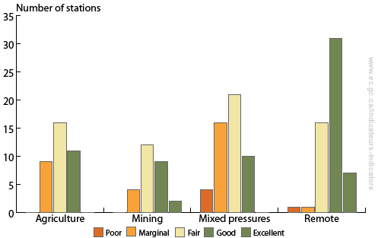

Environment Canada
The Canadian Oil Boom

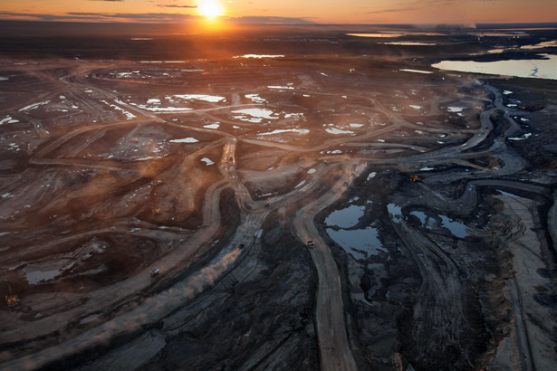
Scraping Bottom
Once considered too expensive, as well as too damaging to the land, exploitation of Alberta’s oil sands is now a gamble worth billions of dollars.

Peter Essick/National Geographic Creative
Reclamation Images

Images from: Earth Magazine.org “Reclaiming Alberta’s Oil Sands Mines”

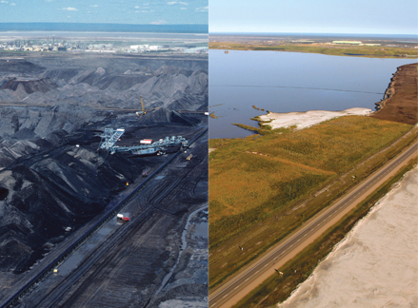

Left: One of the original mine pits at Syncrude’s Mildred Lake oil sands mine in Alberta, Canada
Right: The same area after reclamation

Reclamation Images

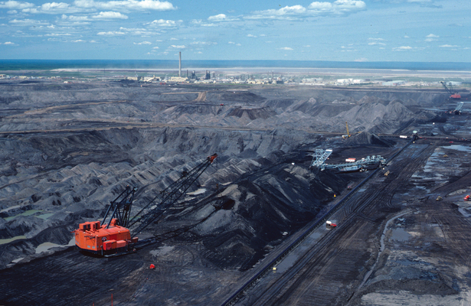

Before: One of the original mine pits at Syncrude’s Mildred Lake oil sands mine

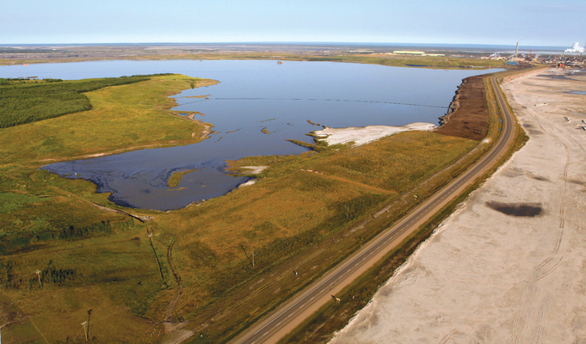

After: Syncrude’s reclaimed Mildred Lake oil sands mine, in Alberta, Canada

Reclamation Images

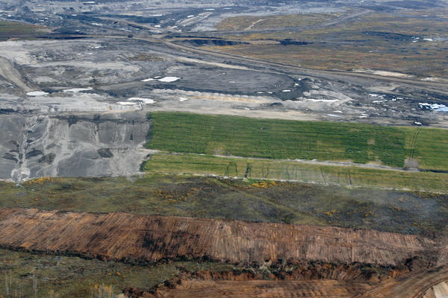

An area in the process of being reclaimed

Photo: Courtesy of Syncrude Canada Ltd.
Caption Credit : Earth Magazine
Homework:
Modifying the Physical Environment Resource Web

Name:
Date:

- Reread the resources and your Research note-catcher to locate information that helps you complete the web.
- Write a short sentence to explain how the natural resource industries modify the physical environment, in the box “How it modifies the physical environment …”

Canada’s Natural Resources

Energy: Oil and Gas
Extraction
Mining: Minerals and
Metals
Mining:
Minerals and Metals

Forestry: Trees

How it modifies the physical environment …
How it modifies the physical environment …
How it modifies the physical environment …

