Lesson 41
Objective: Find and use a pattern to calculate the sum of all fractional parts between 0 and 1. Share and critique peer strategies.

Suggested Lesson Structure
 Fluency Practice (12 minutes)
 Application Problem (4 minutes)
 Concept Development (34 minutes)
 Student Debrief (10 minutes)
Total Time (60 minutes)
Fluency Practice (12 minutes)
- Add and Subtract 4.NBT.4 (4 minutes)
- Multiply Mixed Numbers 4.NF.4 (4 minutes)
- Make a One 4.NF.3 (4 minutes)
Add and Subtract (4 minutes)
Materials: (S) Personal white board
Note: This fluency activity reviews adding and subtracting using the standard algorithm.
T: (Write 643 thousands 857 ones.) On your personal white boards, write this number in standard form.
S: (Write 643,857.)
T: (Write 247 thousands 728 ones.) Add this number to 643,857 using the standard algorithm.
S: (Write 643,857 + 247,728 = 891,585 using the standard algorithm.)
Continue the process for 658,437 + 144,487.
T: (Write 400 thousands.) On your boards, write this number in standard form.
S: (Write 400,000.)
T: (Write 346 thousands 286 ones.) Subtract this number from 400,000 using the standard algorithm.
S: (Write 400,000 – 346,286 = 53,714 using the standard algorithm.)
Continue the process for 609,428 – 297,639.

Multiply Mixed Numbers (4 minutes)
Materials: (S) Personal white board
Note: This fluency activity reviews Lesson 36.
T: Write $\text{5}\frac{\text{3}}{\text{4}}$.
S: (Write $\text{5}\frac{\text{3}}{\text{4}}$.)
T: Break apart $\text{5}\frac{\text{3}}{\text{4}}$ using a number bond.
S: (Break apart $\text{5}\frac{\text{3}}{\text{4}}$ into 5 and $\frac{\text{3}}{\text{4}}$.)
T: (Write 3 × $\text{5}\frac{\text{3}}{\text{4}}$. Beneath it, write __ + .) Fill in the unknown numbers.
S: (Beneath 3 × $\text{5}\frac{\text{3}}{\text{4}}$, write 15 + $\frac{\text{9}}{\text{4}}$.)
T: (Write 15 + $\frac{\text{9}}{\text{4}}$. Beneath it, write 15 + __.) Fill in a mixed number for $\frac{\text{9}}{\text{4}}$.
S: (Beneath 15 + $\frac{\text{9}}{\text{4}}$, write 15 + $\text{2}\frac{\text{1}}{\text{4}}$.)
T: (Write 15 + $\text{2}\frac{\text{1}}{\text{4}}$. Beneath it, write =__.) Write the answer.
S: (Beneath 15 + $\text{2}\frac{\text{1}}{\text{4}}$ , write = $\text{17}\frac{\text{1}}{\text{4}}$.)
T: (Point at 3 × $\text{5}\frac{\text{3}}{\text{4}}$ =__.) Say the multiplication sentence.
S: 3 × $\text{5}\frac{\text{3}}{\text{4}}$ = $\text{17}\frac{\text{1}}{\text{4}}$.
Continue the process for 5 × $\text{2}\frac{\text{7}}{\text{8}}$.
Make a One (4 minutes)
Materials: (S) Personal white board
Note: This fluency activity prepares students for Lesson 41.
T: (Write $\frac{\text{3}}{\text{4}}$.) Say the fraction.
S: 3 fourths.
T: Say the fraction that needs to be added to 3 fourths to make one.
S: 1 fourth.
T: $\frac{\text{2}}{\text{3}}$.
S: $\frac{\text{1}}{\text{3}}$.
T: $\frac{\text{7}}{\text{8}}$.
S: $\frac{\text{1}}{\text{8}}$.
T: (Write $\frac{\text{3}}{\text{8}}$ + = 1.) Complete the number sentence.
S: (Write $\frac{\text{3}}{\text{8}}$ + $\frac{\text{5}}{\text{8}}$ = 1.)
Continue with the following possible sequence: $\frac{\text{7}}{\text{10}}$, $\frac{\text{1}}{\text{6}}$, and $\frac{\text{5}}{\text{12}}$.
Application Problem (4 minutes)
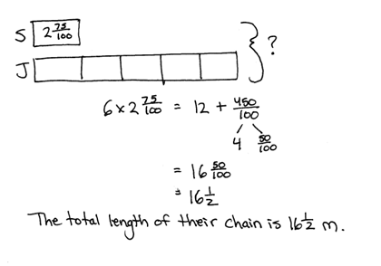
Jackie’s paper chain was 5 times as long as Sammy’s, which measured $\text{2}\frac{\text{75}}{\text{100}}$ meters. What was the total length of both their chains?

Note: This Application Problem anticipates Module 6’s work with decimal numbers.
Concept Development (34 minutes)
Materials: (S) Index cards cut in halves or fourths (20 cards per student)
Problem 1: Explore patterns for sums of fractions.
In groups of four, have students record a set of fractions from 0 to 1 for a given unit on cards.
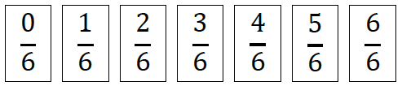
Part 1: Assign each member of the group to make a different set of fraction cards for the following even denominators: fourths, sixths, eighths, and tenths.
- Lay the cards in order from least to greatest.
MP.3
- Solve for the sum of the fractional units $\frac{\text{0}}{\text{n}}$ to $\frac{\text{n}}{\text{n}}$. Express the sum as a mixed number.
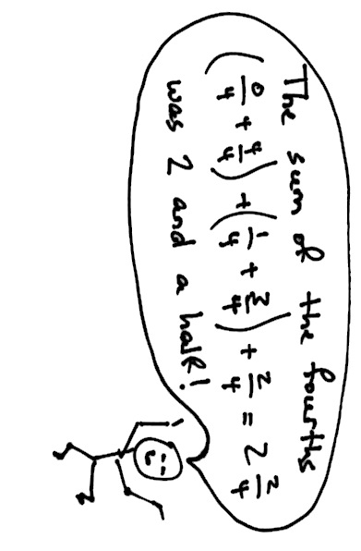
- Invite students to share their ways of finding the sum within their teams.
- Solve for the sum again. This time, group pairs of fractions that equal 1.
MP.3
- Each team looks for patterns within their sums.
Part 2: Assign each member of the group to make a different set of fraction cards for the following odd denominators: thirds, fifths, sevenths, and ninths. Repeat Steps 1–5 from Part 1.
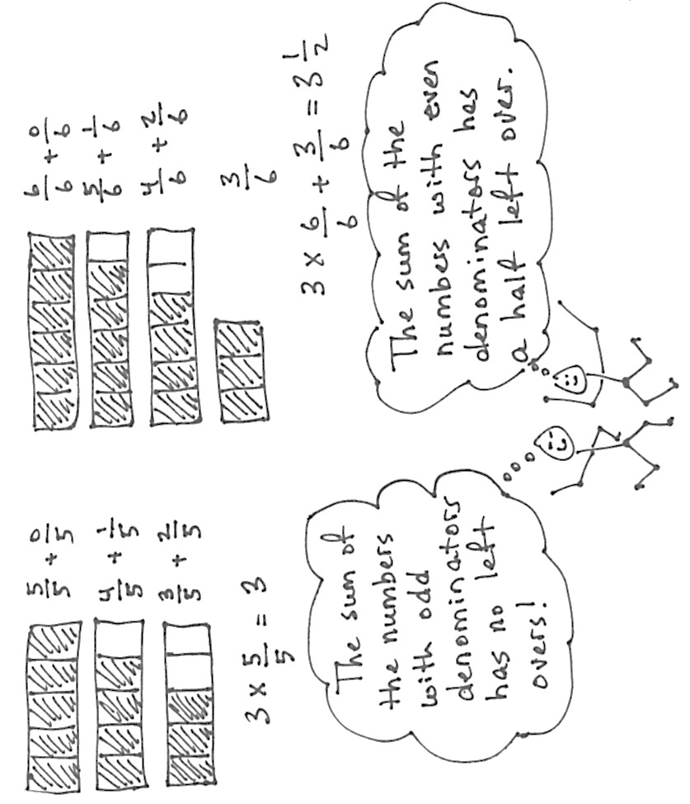
Part 3: Reconvene as a class, having groups compare and contrast the results when adding pairs of numbers with even denominators to adding numbers with odd denominators. Challenge them to clearly state their thinking using words, pictures, or numbers.

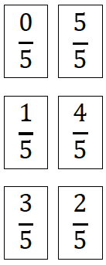
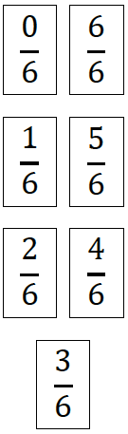

Problem 2: Apply the pattern to find the sum of consecutive fractions with large denominators.
- Each team member chooses at least one large even denominator (above 20) and finds the sum of $\frac{\text{0}}{\text{n}}$ to $\frac{\text{n}}{\text{n}}$.
- Each team member chooses at least one large odd denominator (above 20) and finds the sum of $\frac{\text{0}}{\text{n}}$ to $\frac{\text{n}}{\text{n}}$.
- Team members share results and look for patterns in their sums. Can they describe a way to find the sum of any set of fractions from $\frac{\text{0}}{\text{n}}$ to $\frac{\text{n}}{\text{n}}$?

Problem Set (10 minutes)
Students should do their personal best to complete the Problem Set within the allotted 10 minutes. For some classes, it may be appropriate to modify the assignment by specifying which problems they work on first. Some problems do not specify a method for solving. Students should solve these problems using the RDW approach used for Application Problems.
Student Debrief (10 minutes)

A NOTE ON
MATH HISTORY:
The story goes that, in 1885, when 8 years old, Carl Friedrich Gauss aborted his teacher’s attempt to keep him busy for an hour. The teacher had assigned the class the tedious task of finding the sum of all the whole numbers up to 100. Quick as a wink, Gauss said 5,050 and also explained his solution strategy. He paired one set of numbers from 1 to 100 with another set of the same numbers:
1 2 3 4 5 6 7 8...
100 99 98 97 96 95 94 93…
Each of 100 pairs had a sum of 101. However, that was double the answer, so the product needed to be divided by 2.
(100 x 101) ÷ 2 = $\frac{\text{10,100}}{\text{2}}$ = 5,050

Lesson Objective: Find and use a pattern to calculate the sum of all fractional parts between 0 and 1. Share and critique peer strategies.
The Student Debrief is intended to invite reflection and active processing of the total lesson experience.
Invite students to review their solutions for the Problem Set. They should check work by comparing answers with a partner before going over answers as a class. Look for misconceptions or misunderstandings that can be addressed in the Debrief. Guide students in a conversation to debrief the Problem Set and process the lesson.
Any combination of the questions below may be used to lead the discussion.
- Discuss the difference in the sums between even and odd denominators. Why is this?
- How did the pattern found in Problem 2 work for solving in Problem 4? In what ways did your pattern need revision?
- Is it necessary to test your answer for Problem 6? Why or why not?
- How might you find the sum of all the whole numbers up to 10 using an array?
XOOOOOOOOOO
XXOOOOOOOOO
XXXOOOOOOOO
XXXXOOOOOOO
XXXXXOOOOOO
5 $\text{×}$ 11
- 10
- 9
- 8
- 7
- 6
1 2 3 4 5 6 7 8 9 10
10 9 8 7 6 5 4 3 2 1

$$\frac{\text{10 × 11}}{\text{2}}$$

- Can you find a shortcut to calculate the sum of all the whole numbers from 0 to 50? To 100? Explain how.
(An explanation of one method is found in the Notes in the box above.)
1 2 3 4 5 6 7 8 9 10
50 49 48 47 46 45 44 43 42 41…

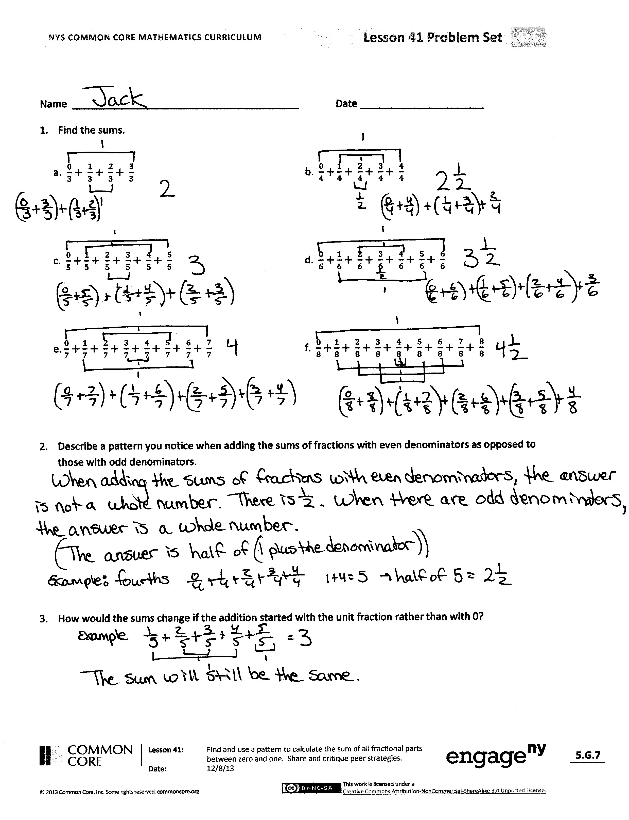
Exit Ticket (3 minutes)
After the Student Debrief, instruct students to complete the Exit Ticket. A review of their work will help with assessing students’ understanding of the concepts that were presented in today’s lesson and planning more effectively for future lessons. The questions may be read aloud to the students.
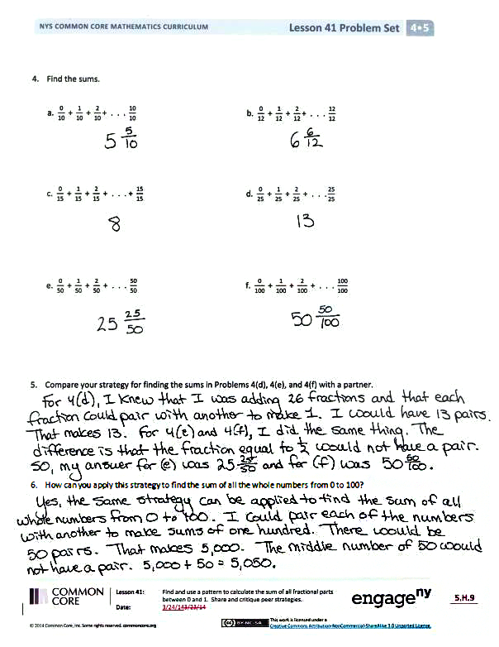
Name Date
- Find the sums.
a. $\frac{\text{0}}{\text{3}} \text{+ }\frac{\text{1}}{\text{3}}\text{+ }\frac{\text{2}}{\text{3}} \text{+ }\frac{\text{3}}{\text{3}}$ | b. $\frac{\text{0}}{\text{4}} \text{+} \frac{\text{1}}{\text{4}} \text{+ }\frac{\text{2}}{\text{4}} \text{+ }\frac{\text{3}}{\text{4}} \text{+ }\frac{\text{4}}{\text{4}}$
c. $\frac{\text{0}}{\text{5}} \text{+} \frac{\text{1}}{\text{5}} \text{+ }\frac{\text{2}}{\text{5}} \text{+ }\frac{\text{3}}{\text{5}} \text{+ }\frac{\text{4}}{\text{5}} \text{+ }\frac{\text{5}}{\text{5}}$ | d. $\frac{\text{0}}{\text{6}} \text{+} \frac{\text{1}}{\text{6}} \text{+ }\frac{\text{2}}{\text{6}} \text{+ }\frac{\text{3}}{\text{6}} \text{+ }\frac{\text{4}}{\text{6}} \text{+ }\frac{\text{5}}{\text{6}} \text{+ }\frac{\text{6}}{\text{6}}$
e. $\frac{\text{0}}{\text{7}} \text{+}\frac{\text{1}}{\text{7}} \text{+ }\frac{\text{2}}{\text{7}} \text{+ }\frac{\text{3}}{\text{7}} \text{+ }\frac{\text{4}}{\text{7}} \text{+ }\frac{\text{5}}{\text{7}} \text{+ }\frac{\text{6}}{\text{7}} \text{+ }\frac{\text{7}}{\text{7}}$ | f. $\frac{\text{0}}{\text{8}} \text{+} \frac{\text{1}}{\text{8}} \text{+ }\frac{\text{2}}{\text{8}} \text{+ }\frac{\text{3}}{\text{8}} \text{+ }\frac{\text{4}}{\text{8}} \text{+ }\frac{\text{5}}{\text{8}} \text{+ }\frac{\text{6}}{\text{8}} \text{+ }\frac{\text{7}}{\text{8}} \text{+ }\frac{\text{8}}{\text{8}}$

- Describe a pattern you notice when adding the sums of fractions with even denominators as opposed to those with odd denominators.

- How would the sums change if the addition started with the unit fraction rather than with 0?

- Find the sums.
a. $\frac{\text{0}}{\text{10}} \text{+} \frac{\text{1}}{\text{10}} \text{+ }\frac{\text{2}}{\text{10}}\text{+ . . . }\frac{\text{10}}{\text{10}}$ | b. $\frac{\text{0}}{\text{12}} \text{+} \frac{\text{1}}{\text{12}} \text{+ }\frac{\text{2}}{\text{12}}\text{+ . . . }\frac{\text{12}}{\text{12}}$
c. $\frac{\text{0}}{\text{15}} \text{+} \frac{\text{1}}{\text{15}}\text{ +} \frac{\text{2}}{\text{15}} \text{+ . . . + }\frac{\text{15}}{\text{15}}$ | d. $\frac{\text{0}}{\text{25}} \text{+} \frac{\text{1}}{\text{25}} \text{+ }\frac{\text{2}}{\text{25}} \text{+ . . .}\frac{\text{25}}{\text{25}}$
e. $\frac{\text{0}}{\text{50}} \text{+} \frac{\text{1}}{\text{50}} \text{+ }\frac{\text{2}}{\text{50}} \text{+ . . . }\frac{\text{50}}{\text{50}}$ | f. $\frac{\text{0}}{\text{100}} \text{+} \frac{\text{1}}{\text{100}} \text{+ }\frac{\text{2}}{\text{100}} \text{+ . . . }\frac{\text{100}}{\text{100}}$

- Compare your strategy for finding the sums in Problems 4(d), 4(e), and 4(f) with a partner.

- How can you apply this strategy to find the sum of all the whole numbers from 0 to 100?

Name Date
Find the sums.
- $\frac{\text{0}}{\text{20}} \text{+} \frac{\text{1}}{\text{20}} \text{+ }\frac{\text{2}}{\text{20}}\text{+ . . . }\frac{\text{20}}{\text{20}}$ | - $\frac{\text{0}}{\text{200}} \text{+} \frac{\text{1}}{\text{200}} \text{+ }\frac{\text{2}}{\text{200}} \text{+ . . . }\frac{\text{200}}{\text{200}}$

Name Date
a. $\frac{\text{0}}{\text{5}} \text{+} \frac{\text{1}}{\text{5}} \text{+ }\frac{\text{2}}{\text{5}} \text{+ }\frac{\text{3}}{\text{5}} \text{+ }\frac{\text{4}}{\text{5}} \text{+ }\frac{\text{5}}{\text{5}}$ | b. $\frac{\text{0}}{\text{6}} \text{+} \frac{\text{1}}{\text{6}} \text{+ }\frac{\text{2}}{\text{6}} \text{+ }\frac{\text{3}}{\text{6}} \text{+ }\frac{\text{4}}{\text{6}} \text{+ }\frac{\text{5}}{\text{6}} \text{+ }\frac{\text{6}}{\text{6}}$
c. $\frac{\text{0}}{\text{7}} \text{+} \frac{\text{1}}{\text{7}} \text{+ }\frac{\text{2}}{\text{7}} \text{+ }\frac{\text{3}}{\text{7}} \text{+ }\frac{\text{4}}{\text{7}} \text{+ }\frac{\text{5}}{\text{7}} \text{+ }\frac{\text{6}}{\text{7}} \text{+ }\frac{\text{7}}{\text{7}}$ | d. $\frac{\text{0}}{\text{8}} \text{+} \frac{\text{1}}{\text{8}} \text{+ }\frac{\text{2}}{\text{8}} \text{+ }\frac{\text{3}}{\text{8}} \text{+ }\frac{\text{4}}{\text{8}} \text{+ }\frac{\text{5}}{\text{8}} \text{+ }\frac{\text{6}}{\text{8}} \text{+ }\frac{\text{7}}{\text{8}} \text{+} \frac{\text{8}}{\text{8}}$
e. $\frac{\text{0}}{\text{9}} \text{+} \frac{\text{1}}{\text{9}} \text{+ }\frac{\text{2}}{\text{9}} \text{+ }\frac{\text{3}}{\text{9}} \text{+ }\frac{\text{4}}{\text{9}} \text{+ }\frac{\text{5}}{\text{9}} \text{+ }\frac{\text{6}}{\text{9}} \text{+ }\frac{\text{7}}{\text{9}} \text{+} \frac{\text{8}}{\text{9}} \text{+} \frac{\text{9}}{\text{9}}$ | f. $\frac{\text{0}}{\text{10}} \text{+} \frac{\text{1}}{\text{10}} \text{+ }\frac{\text{2}}{\text{10}} \text{+ }\frac{\text{3}}{\text{10}} \text{+ }\frac{\text{4}}{\text{10}} \text{+ }\frac{\text{5}}{\text{10}} \text{+ }\frac{\text{6}}{\text{10}} \text{+ }\frac{\text{7}}{\text{10}} \text{+} \frac{\text{8}}{\text{10}}\text{ +} \frac{\text{9}}{\text{10}} \text{+} \frac{\text{10}}{\text{10}}$
- Find the sums.

- Describe a pattern you notice when adding the sums of fractions with even denominators as opposed to those with odd denominators.

- How would the sums change if the addition started with the unit fraction rather than with 0?

- Find the sums.
a. $\frac{\text{0}}{\text{20}} \text{+} \frac{\text{1}}{\text{20}} \text{+ }\frac{\text{2}}{\text{20}}\text{+ . . . }\frac{\text{20}}{\text{20}}$ | b. $\frac{\text{0}}{\text{35}} \text{+} \frac{\text{1}}{\text{35}} \text{+ }\frac{\text{2}}{\text{35}}\text{+ . . . }\frac{\text{35}}{\text{35}}$
c. $\frac{\text{0}}{\text{36}} \text{+} \frac{\text{1}}{\text{36}}\text{ +} \frac{\text{2}}{\text{36}}\text{+ . . . + }\frac{\text{36}}{\text{36}}$ | d. $\frac{\text{0}}{\text{75}} \text{+} \frac{\text{1}}{\text{75}} \text{+ }\frac{\text{2}}{\text{75}}\text{+ . . . }\frac{\text{75}}{\text{75}}$
e. $\frac{\text{0}}{\text{100}} \text{+} \frac{\text{1}}{\text{100}} \text{+ }\frac{\text{2}}{\text{100}}\text{+ . . . }\frac{\text{100}}{\text{100}}$ | f. $\frac{\text{0}}{\text{99}} \text{+} \frac{\text{1}}{\text{99}} \text{+ }\frac{\text{2}}{\text{99}} \text{+ . . . }\frac{\text{99}}{\text{99}}$

- How can you apply this strategy to find the sum of all the whole numbers from 0 to 50? To 99?

