Lesson 40
Objective: Solve word problems involving the multiplication of a whole number and a fraction including those involving line plots.

Suggested Lesson Structure
 Fluency Practice (13 minutes)
 Concept Development (37 minutes)
 Student Debrief (10 minutes)
Total Time (60 minutes)
Fluency Practice (13 minutes)
- Make a One 4.NF.3 (4 minutes)
- Count by Equivalent Fractions 4.NF.1 (5 minutes)
- Multiply Mixed Numbers 4.NF.4 (4 minutes)
Make a One (4 minutes)
Materials: (S) Personal white board
Note: This fluency activity prepares students for Lesson 41.
T: (Write $\frac{\text{2}}{\text{3}}$.) Say the fraction.
S: 2 thirds.
T: Say the fraction needed to complete the next one.
S: 1 third.
T: $\frac{\text{3}}{\text{4}}$.
S: $\frac{1}{4}$.
T: $\frac{\text{3}}{\text{5}}$.
S: $\frac{\text{2}}{\text{5}}$.
T: (Write $\frac{\text{5}}{\text{8}}$ + = 1.) Complete the number sentence.
S: (Write $\frac{\text{3}}{\text{8}}$.)
Continue with the following possible sequence: $\text{1}\frac{\text{9}}{\text{10}}$, $\text{2}\frac{\text{3}}{\text{10}}$ , $\text{3}\frac{\text{7}}{\text{12}}$ , $\text{7}\frac{\text{45}}{\text{50}}\text{, 12}\frac{\text{80}}{\text{100}}\text{,}$and $\text{65}\frac{\text{290}}{\text{400}}$.
Count by Equivalent Fractions (5 minutes)
Note: This fluency activity reviews Lessons 24 and 25. The progression builds in complexity. Work the students up to the highest level of complexity in which they can confidently participate.
T: Count by sevens to 70.
$\frac{\text{0}}{\text{10}}$ $\frac{\text{7}}{\text{10}}$ $\frac{\text{14}}{\text{10}}$ $\frac{\text{21}}{\text{10}}$ $\frac{\text{28}}{\text{10}}$ $\frac{\text{35}}{\text{10}}$ $\frac{\text{42}}{\text{10}}$ $\frac{\text{49}}{\text{10}}$ $\frac{\text{56}}{\text{10}}$ $\frac{\text{63}}{\text{10}}$ $\frac{\text{70}}{\text{10}}$
0 $\frac{\text{7}}{\text{10}}$ $\frac{\text{14}}{\text{10}}$ $\frac{\text{21}}{\text{10}}$ $\frac{\text{28}}{\text{10}}$ $\frac{\text{35}}{\text{10}}$ $\frac{\text{42}}{\text{10}}$ $\frac{\text{49}}{\text{10}}$ $\frac{\text{56}}{\text{10}}$ $\frac{\text{63}}{\text{10}}$ 7
0 $\frac{\text{7}}{\text{10}}$ $\text{1}\frac{\text{4}}{\text{10}}$ $\text{2}\frac{\text{1}}{\text{10}}$ $\text{2}\frac{\text{8}}{\text{10}}$ $\text{3}\frac{\text{5}}{\text{10}}$ $\text{4}\frac{\text{2}}{\text{10}}$ $\text{4}\frac{\text{9}}{\text{10}}$ $\text{5}\frac{\text{6}}{\text{10}}$ $\text{6}\frac{\text{3}}{\text{10}}$ 7

S: 0, 7, 14, 21, 28, 35, 42, 49, 56, 63, 70.
T: Count by 7 tenths to 70 tenths, starting at 0 tenths. (Write as students count.)
S: $\frac{\text{0}}{\text{10}}$, $\frac{\text{7}}{\text{10}}$ , $\frac{\text{14}}{\text{10}}$ , $\frac{\text{21}}{\text{10}}$ , $\frac{\text{28}}{\text{10}}$ , $\frac{\text{35}}{\text{10}}$ , $\frac{\text{42}}{\text{10}}$ , $\frac{\text{49}}{\text{10}}$ , $\frac{\text{56}}{\text{10}}$ , $\frac{\text{63}}{\text{10}}$ , $\frac{\text{70}}{\text{10}}$.
T: Name the fraction that’s equal to a whole number.

NOTES ON
MULTIPLE MEANS
OF REPRESENTATION:
One way to scaffold the Count by Equivalent Fractions fluency activity is to repeat the counting until students reach their comfort level. Keep it fun! Try couple counting with music, rhythm, or motion, such as jumping jacks or hops.

S: 70 tenths.
T: (Point to $\frac{\text{70}}{\text{10}}$.) 70 tenths is how many ones?
S: 7 ones.
T: (Beneath $\frac{\text{70}}{\text{10}}$ , write 7.) Count by 7 tenths again. This time, when you come to the whole number, say the whole number. (Write as students count.)
S: $\text{0}$, $\frac{\text{7}}{\text{10}}$ , $\frac{\text{14}}{\text{10}}$ , $\frac{\text{21}}{\text{10}}$ , $\frac{\text{28}}{\text{10}}$ , $\frac{\text{35}}{\text{10}}$ , $\frac{\text{42}}{\text{10}}$ , $\frac{\text{49}}{\text{10}}$ , $\frac{\text{56}}{\text{10}}$ , $\frac{\text{63}}{\text{10}}$ , 7.
T: (Point to $\frac{\text{14}}{\text{10}}$.) Say $\frac{\text{14}}{\text{10}}$ as a mixed number.
S: $\text{1}\frac{\text{4}}{\text{10}}$.
Continue with the following possible sequence: $\frac{\text{21}}{\text{10}}$ , $\frac{\text{28}}{\text{10}}$ , $\frac{\text{35}}{\text{10}}$ , $\frac{\text{42}}{\text{10}}$ , $\frac{\text{49}}{\text{10}}$ , $\frac{\text{56}}{\text{10}}$ , $\frac{\text{63}}{\text{10}}$.
T: Count by 7 tenths again. This time, convert to whole numbers and mixed numbers. (Write as students count.)
S: 0, $\frac{\text{7}}{\text{10}}$ , $\text{1}\frac{\text{4}}{\text{10}}$, $\text{2}\frac{\text{1}}{\text{10}}$ , $\text{2}\frac{\text{8}}{\text{10}}$ , $\text{3}\frac{\text{5}}{\text{10}}$ , $\text{4}\frac{\text{2}}{\text{10}}$ , $\text{4}\frac{\text{9}}{\text{10}}$ , $\text{5}\frac{\text{6}}{\text{10}}$ , $\text{6}\frac{\text{3}}{\text{10}}$ , 7.
Multiply Mixed Numbers (4 minutes)
Materials: (S) Personal white board
Note: This fluency activity reviews Lesson 36.
T: Break apart $\text{2}\frac{\text{4}}{\text{5}}$ using an addition expression.
S: (Write $\text{2}\frac{\text{4}}{\text{5}}$ as 2 + $\frac{\text{4}}{\text{5}}$.)
T: (Write 3 × $\text{2}\frac{\text{4}}{\text{5}}$. Beneath it, write __ + .) Fill in the unknown numbers.
S: (Write 6 + $\frac{\text{12}}{\text{5}}$.)
T: (Write 6 + $\frac{\text{12}}{\text{5}}$. Beneath it, write 6 + __.) Fill in a mixed number for $\frac{\text{12}}{\text{5}}$.
S: (Write 6 + $\text{2}\frac{\text{2}}{\text{5}}$.)
T: (Write 6 + $\text{2}\frac{\text{2}}{\text{5}}$. Beneath it, write =__.) Write the answer.
S: (Write = $\text{8}\frac{\text{2}}{\text{5}}$.)
T: (Point to 3 × $\text{2}\frac{\text{4}}{\text{5}}$ = __.) Say the multiplication sentence.
S: 3 × $\text{2}\frac{\text{4}}{\text{5}}$ = $\text{8}\frac{\text{2}}{\text{5}}$.
Continue the process for 5 × $\text{3}\frac{\text{5}}{\text{8}}$.
Concept Development (37 minutes)
Materials: (S) Personal white board, Problem Set
Note: Today’s Problem Set, in which students construct and interpret a line plot, will be used during the Concept Development. As students complete each problem, debrief student solutions. The solutions offered below show variety but are not all-inclusive. Encourage students to discuss their math thinking and accept different strategies and solutions that result in the correct answer.
Suggested Delivery of Instruction for Solving Lesson 40’s Word Problems
1. Model the problem.
Have two pairs of students who can successfully model the problem work at the board while the others work independently or in pairs at their seats. Review the following questions before beginning the first problem.
- Can you draw something?
- What can you draw?
- What conclusions can you make from your drawing?
Circulate as students work. Reiterate the questions above. After two minutes, have the two pairs of students share only their labeled diagrams. For about one minute, have the demonstrating students receive and respond to feedback and questions from their peers.

NOTES ON
MULTIPLE MEANS
OF REPRESENTATION:
Consider breaking word problems into steps for students working below grade level. For example, for Problem 1(a), ask, “What is the height of the tallest player? What is the height of the shortest player? What is the difference in the height of the tallest and shortest players?”

2. Calculate to solve and write a statement.
Give students two minutes to finish work on that question, sharing their work and thinking with a peer. All students should then write their equations and statements of the answer.
3. Assess the solution for reasonableness.
Give students one to two minutes to assess and explain the reasonableness of their solution.
Problem 1
Player | Height (in feet)
A | $$\text{6}\frac{\text{1}}{\text{4}}$$
B | $$\text{5}\frac{\text{7}}{\text{8}}$$
C | $$\text{6}\frac{\text{1}}{\text{2}}$$
D | $$\text{6}\frac{\text{1}}{\text{4}}$$
E | $$\text{6}\frac{\text{2}}{\text{8}}$$
F | $$\text{5}\frac{\text{7}}{\text{8}}$$
G | $$\text{6}\frac{\text{1}}{\text{8}}$$
H | $$\text{6}\frac{\text{5}}{\text{8}}$$
I | $$\text{5}\frac{\text{6}}{\text{8}}$$
J | $$\text{6}\frac{\text{1}}{\text{8}}$$
The chart to the right shows the heights, in feet, of some football players. Use the data to create a line plot at the bottom of this page and to answer the questions below.
- What is the difference in the height of the tallest and shortest players?
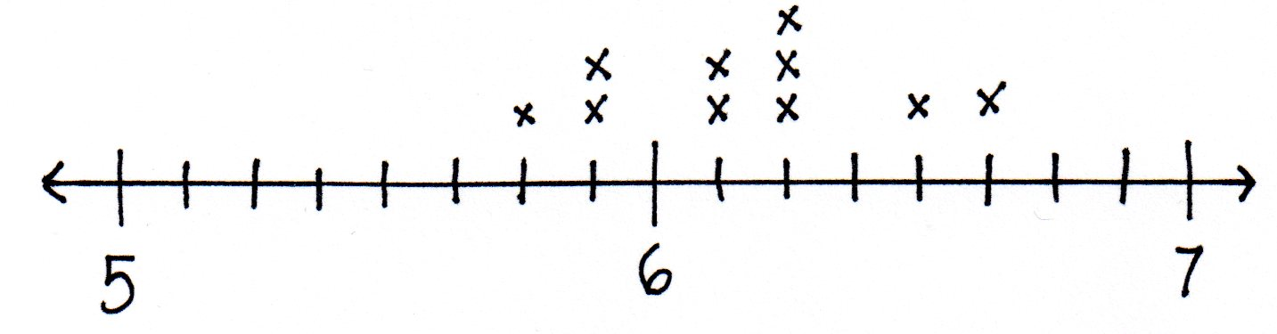
MP.4

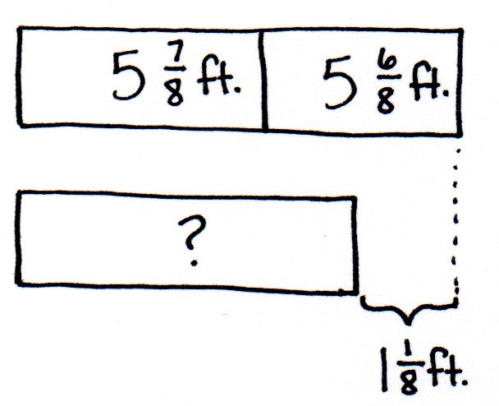
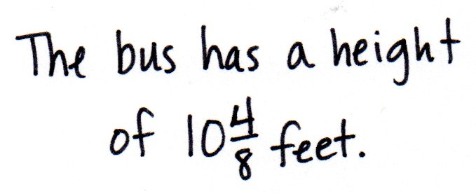
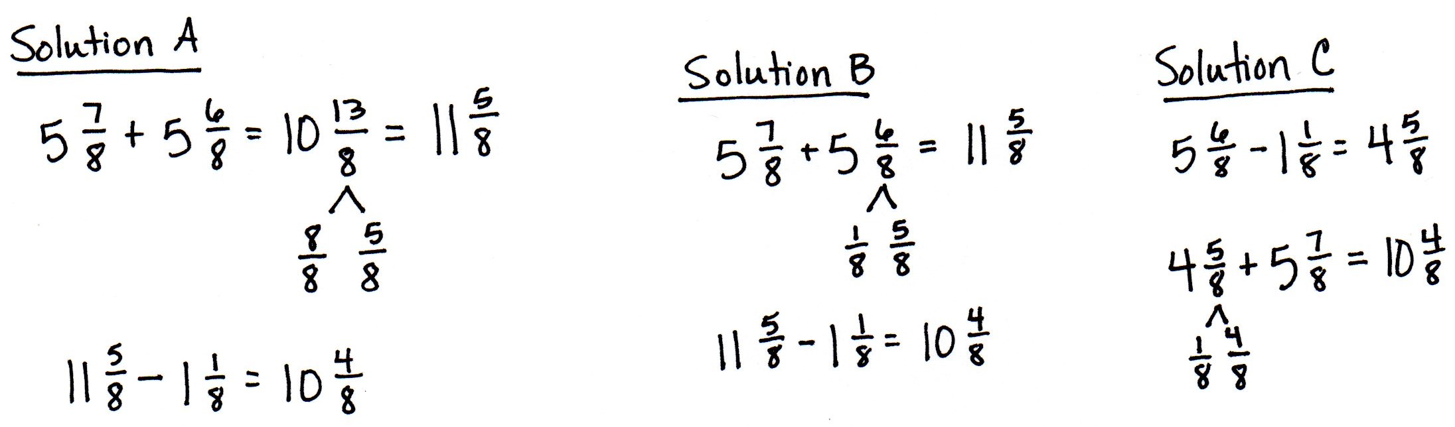
In Solution A, the student subtracts the whole numbers first and then converts to fractions greater than 1 to solve. In Solution B, the student decomposes a whole before solving. In Solution C, the student counts up to find the solution.
Player I and Player B have a combined height that is $\text{1}\frac{\text{1}}{\text{8}}$ feet taller than a school bus. What is the height of a school bus?

MP.4

In Solutions A and B, students find the sum and then convert the fraction greater than 1 to find the height of $\text{11}\frac{\text{5}}{\text{8}}\text{.}$ In the final step, students subtract $\text{1}\frac{\text{1}}{\text{8}}$ to solve for the height of the bus. Solution C subtracts the difference from Player B’s height and adds Player I’s height as a final step.
Problem 2
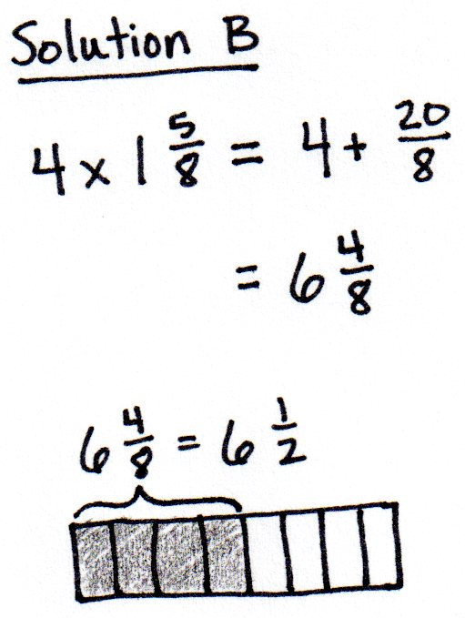
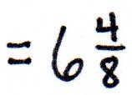
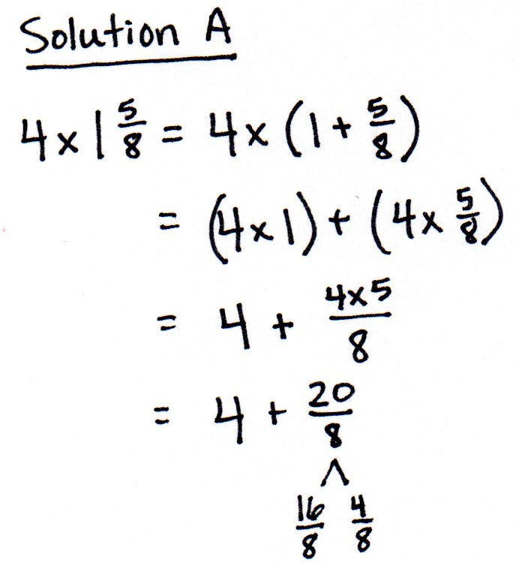
One of the players on the team is now 4 times as tall as he was at birth, when he measured $\text{1}\frac{\text{5}}{\text{8}}$ feet. Who is the player?

In this solution, students use the distributive property to compute the current height of the player. Students then look back at the line plot to determine which player’s height is equivalent to $\text{6}\frac{\text{4}}{\text{8}}$. When using the distributive property, students may complete some of the computations mentally, as shown in Solution B.
Problem 3
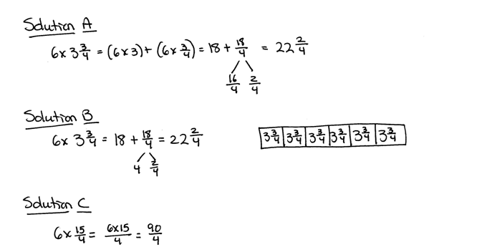
Six of the players on the team weigh over 300 pounds. Doctors recommend that players of this weight drink at least $\text{3}\frac{\text{3}}{\text{4}}$quarts of water each day. At least how much water should be consumed per day by all 6 players?

Students use the distributive property in Solutions A and B. In Solution B, students no longer write out each step. Some of the computations are done mentally. In Solution C, students convert to a fraction greater than 1. Those who do not convert back to a mixed number should be encouraged to use the context of the problem to consider if their answer is in a reasonable form.
Problem 4
Nine of the players on the team weigh about 200 pounds. Doctors recommend that people of this weight each eat about $\text{7}\frac{\text{7}}{\text{10}}$ grams of protein per pound each day. About how many combined grams of protein should these 9 players eat per day?
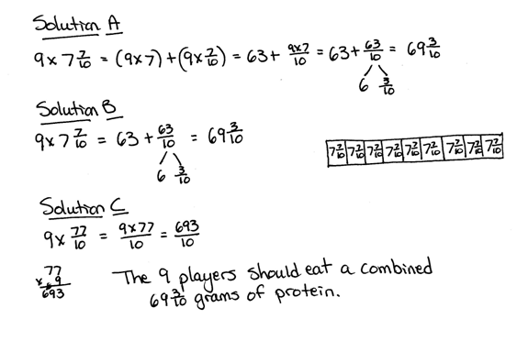

In Solutions A and B, students use the distributive property to solve. Students may choose to solve using Solution C, which is not the most efficient method and does not provide a realistic form of an answer, considering the context. Provide students who are not quick to select the distributive property scaffolds to support their understanding.
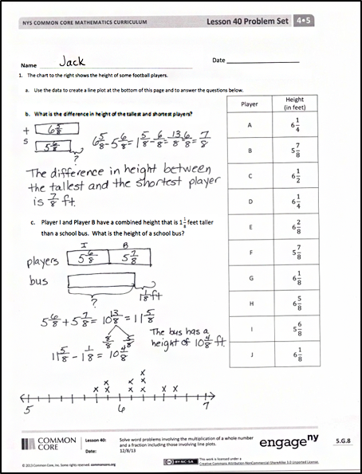
Student Debrief (10 minutes)
Lesson Objective: Solve word problems involving the multiplication of a whole number and a fraction including those involving line plots.
The Student Debrief is intended to invite reflection and active processing of the total lesson experience.
Invite students to review their solutions for the Problem Set. They should check work by comparing answers with a partner before going over answers as a class. Look for misconceptions or misunderstandings that can be addressed in the Debrief. Guide students in a conversation to debrief the Problem Set and process the lesson.
Any combination of the questions below may be used to lead the discussion.
- For Problem 1(a), how was the line plot helpful in finding the height of the tallest and shortest players?
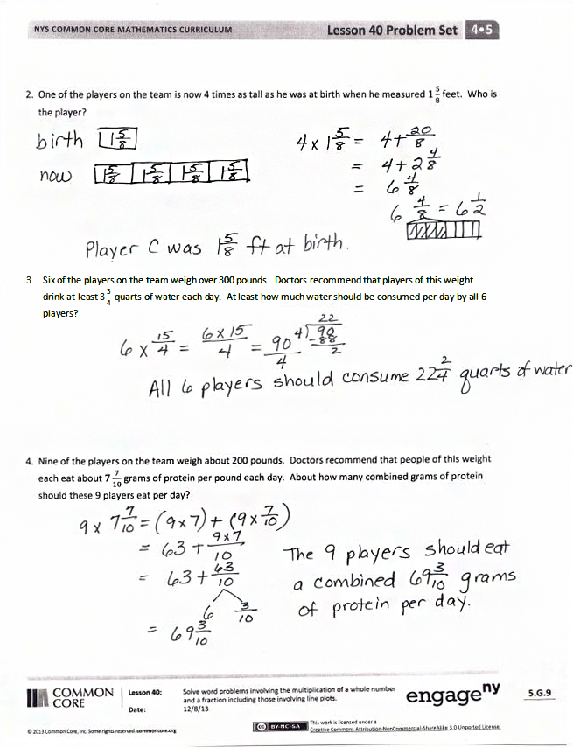
- For Problem 1(b), did you refer back to the line plot or chart to find the information necessary to solve? Explain.
- Did you determine the answers to Problems 2, 3, and 4 using the same math strategy? Explain to a partner how you determined your answers.
- How was the draw step of the RDW approach helpful in solving Problem 2?
- What information can we gather simply by looking at the line plot? Write one statement about the football players based on the information in the line plot.
- What information about the football players is easier to see when the data is represented using a line plot rather than the chart? A chart rather than the line plot?
Exit Ticket (3 minutes)
After the Student Debrief, instruct students to complete the Exit Ticket. A review of their work will help with assessing students’ understanding of the concepts that were presented in today’s lesson and planning more effectively for future lessons. The questions may be read aloud to the students.

Name Date
- The chart to the right shows the height of some football players.
- Use the data to create a line plot at the bottom of this page and to answer the questions below.
Player | Height  (in feet)
A | $$\text{6}\frac{\text{1}}{\text{4}}$$
B | $$\text{5}\frac{\text{7}}{\text{8}}$$
C | $$\text{6}\frac{\text{1}}{\text{2}}$$
D | $$\text{6}\frac{\text{1}}{\text{4}}$$
E | $$\text{6}\frac{\text{2}}{\text{8}}$$
F | $$\text{5}\frac{\text{7}}{\text{8}}$$
G | $$\text{6}\frac{\text{1}}{\text{8}}$$
H | $$\text{6}\frac{\text{5}}{\text{8}}$$
I | $$\text{5}\frac{\text{6}}{\text{8}}$$
J | $$\text{6}\frac{\text{1}}{\text{8}}$$

- What is the difference in height of the tallest and shortest players?

- Player I and Player B have a combined height that is $\text{1}\frac{\text{1}}{\text{8}}$ feet taller than a school bus. What is the height of a school bus?

- One of the players on the team is now 4 times as tall as he was at birth, when he measured $\text{1}\frac{\text{5}}{\text{8}}$ feet.
Who is the player?

- Six of the players on the team weigh over 300 pounds. Doctors recommend that players of this weight drink at least $\text{3}\frac{\text{3}}{\text{4}}$quarts of water each day. At least how much water should be consumed per day by all 6 players?

- Nine of the players on the team weigh about 200 pounds. Doctors recommend that people of this weight each eat about $\text{7}\frac{\text{7}}{\text{10}}$ grams of protein per pound each day. About how many combined grams of protein should these 9 players eat per day?

Name Date
Coach Taylor asked his team to record the distance they ran during practice.
The distances are listed in the table.
Team Members | Distance  (in miles)
Alec | $$\text{1}\frac{\text{3}}{\text{4}}$$
Henry | $$\text{1}\frac{\text{1}}{\text{2}}$$
Charles | $$\text{2}\frac{\text{1}}{\text{8}}$$
Steve | $$\text{1}\frac{\text{3}}{\text{4}}$$
Pitch | $$\text{2}\frac{\text{2}}{\text{4}}$$
Raj | $$\text{1}\frac{\text{6}}{\text{8}}$$
Pam | $$\text{2}\frac{\text{1}}{\text{2}}$$
Tony | $$\text{1}\frac{\text{3}}{\text{8}}$$

- Use the table to locate the incorrect data on the line plot.
Circle any incorrect points.
Mark any missing points.

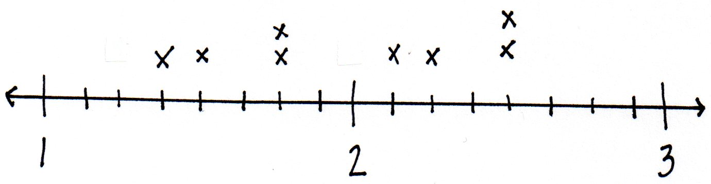

- Of the team members who ran $\text{1}\frac{\text{6}}{\text{8}}$ miles, how many miles did those team members run combined?

Month | Rainfall  (in inches)
January | $\text{2}\frac{\text{2}}{\text{8}}$
February | $\text{1}\frac{\text{3}}{\text{8}}$
March | $\text{2}\frac{\text{3}}{\text{8}}$
April | $\text{2}\frac{\text{5}}{\text{8}}$
May | $\text{4}\frac{\text{1}}{\text{4}}$
June | $\text{2}\frac{\text{1}}{\text{4}}$
July | $\text{3}\frac{\text{7}}{\text{8}}$
August | $\text{3}\frac{\text{1}}{\text{4}}$
September | $\text{1}\frac{\text{5}}{\text{8}}$
October | $\text{3}\frac{\text{2}}{\text{8}}$
November | $\text{1}\frac{\text{3}}{\text{4}}$
December | $\text{1}\frac{\text{5}}{\text{8}}$
Name Date
The chart to the right shows the total monthly rainfall for a city.
- Use the data to create a line plot at the bottom of this page and to answer the following questions.

- What is the difference in rainfall from the wettest and driest months?

- How much more rain fell in May than in April?

- What is the combined rainfall amount for the summer months of June, July, and August?

- How much more rain fell in the summer months than the combined rainfall for the last 4 months of the year?

- In which months did it rain twice as much as it rained in December?

- Each inch of rain can produce ten times that many inches of snow. If all of the rainfall in January was in the form of snow, how many inches of snow fell in January?

