Lesson 39
Objective: Solve multiplicative comparison word problems involving fractions.

Suggested Lesson Structure
 Fluency Practice (12 minutes)
 Concept Development (38 minutes)
 Student Debrief (10 minutes)
Total Time (60 minutes)
Fluency Practice (12 minutes)
- Sprint: Multiply Whole Numbers Times Fractions 4.NF.4 (8 minutes)
- Multiply Mixed Numbers 4.NF.4 (4 minutes)
Sprint: Multiply Whole Numbers Times Fractions (8 minutes)
Materials: (S) Multiply Whole Numbers Times Fractions Sprint
Note: This fluency activity reviews Lesson 35.
Multiply Mixed Numbers (4 minutes)
Materials: (S) Personal white board
Note: This fluency activity reviews Lesson 37.
T: Break apart $\text{3}\frac{\text{3}}{\text{8}}$ using addition.
S: (Write $\text{3}\frac{\text{3}}{\text{8}}$ as 3 + $\frac{\text{3}}{\text{8}}$.)
T: (Write 3 × $\text{3}\frac{\text{3}}{\text{8}}$ = . Beneath it, write __ + $\frac{}{}.$) Fill in the unknown numbers.
S: (Write 9 + $\frac{\text{9}}{\text{8}}$.)
T: (Write 9 + $\frac{\text{9}}{\text{8}}$. Beneath it, write 9 + __.) Record a mixed number for $\frac{\text{9}}{\text{8}}$.
S: (Write 9 + $\text{1}\frac{\text{1}}{\text{8}}$.)
T: (Write 9 + $\text{1}\frac{\text{1}}{\text{8}}$. Beneath it, write =__.) Write the answer.
S: (Write = $\text{10}\frac{\text{1}}{\text{8}}$.)
T: (Point at 3 × $\text{3}\frac{\text{3}}{\text{8}}$ = .) Say the multiplication sentence.
S: 3 × $\text{3}\frac{\text{3}}{\text{8}}$ = $\text{10}\frac{\text{1}}{\text{8}}$.
Continue with the following possible sequence: 6 × $\text{3}\frac{\text{2}}{\text{3}}$ and 4 × $\text{3}\frac{\text{7}}{\text{8}}$.
Concept Development (38 minutes)
Materials: (S) Problem Set
Suggested Delivery of Instruction for Solving Lesson 39 Word Problems
1. Model the problem.
Have two pairs of students who can successfully model the problem work at the board while the others work independently or in pairs at their seats. Review the following questions before beginning the first problem.
- Can you draw something?
- What can you draw?
- What conclusions can you make from your drawing?
Circulate as students work. Reiterate the questions above. After two minutes, have the two pairs of students share only their labeled diagrams. For about one minute, have the demonstrating students receive and respond to feedback and questions from their peers.
2. Calculate to solve and write a statement.
Give students two minutes to finish work on that question, sharing their work and thinking with a peer.
All should then write their equations and statements of the answer.
3. Assess the solution for reasonableness.
Give students one to two minutes to assess and explain the reasonableness of their solution.
Note: Problems 1–4 of the Problem Set will be used during the Concept Development portion of the lesson.

Problem 1: Tameka ran $\text{2}\frac{\text{5}}{\text{8}}$ miles. Her sister ran twice as far. How far did Tameka’s sister run?
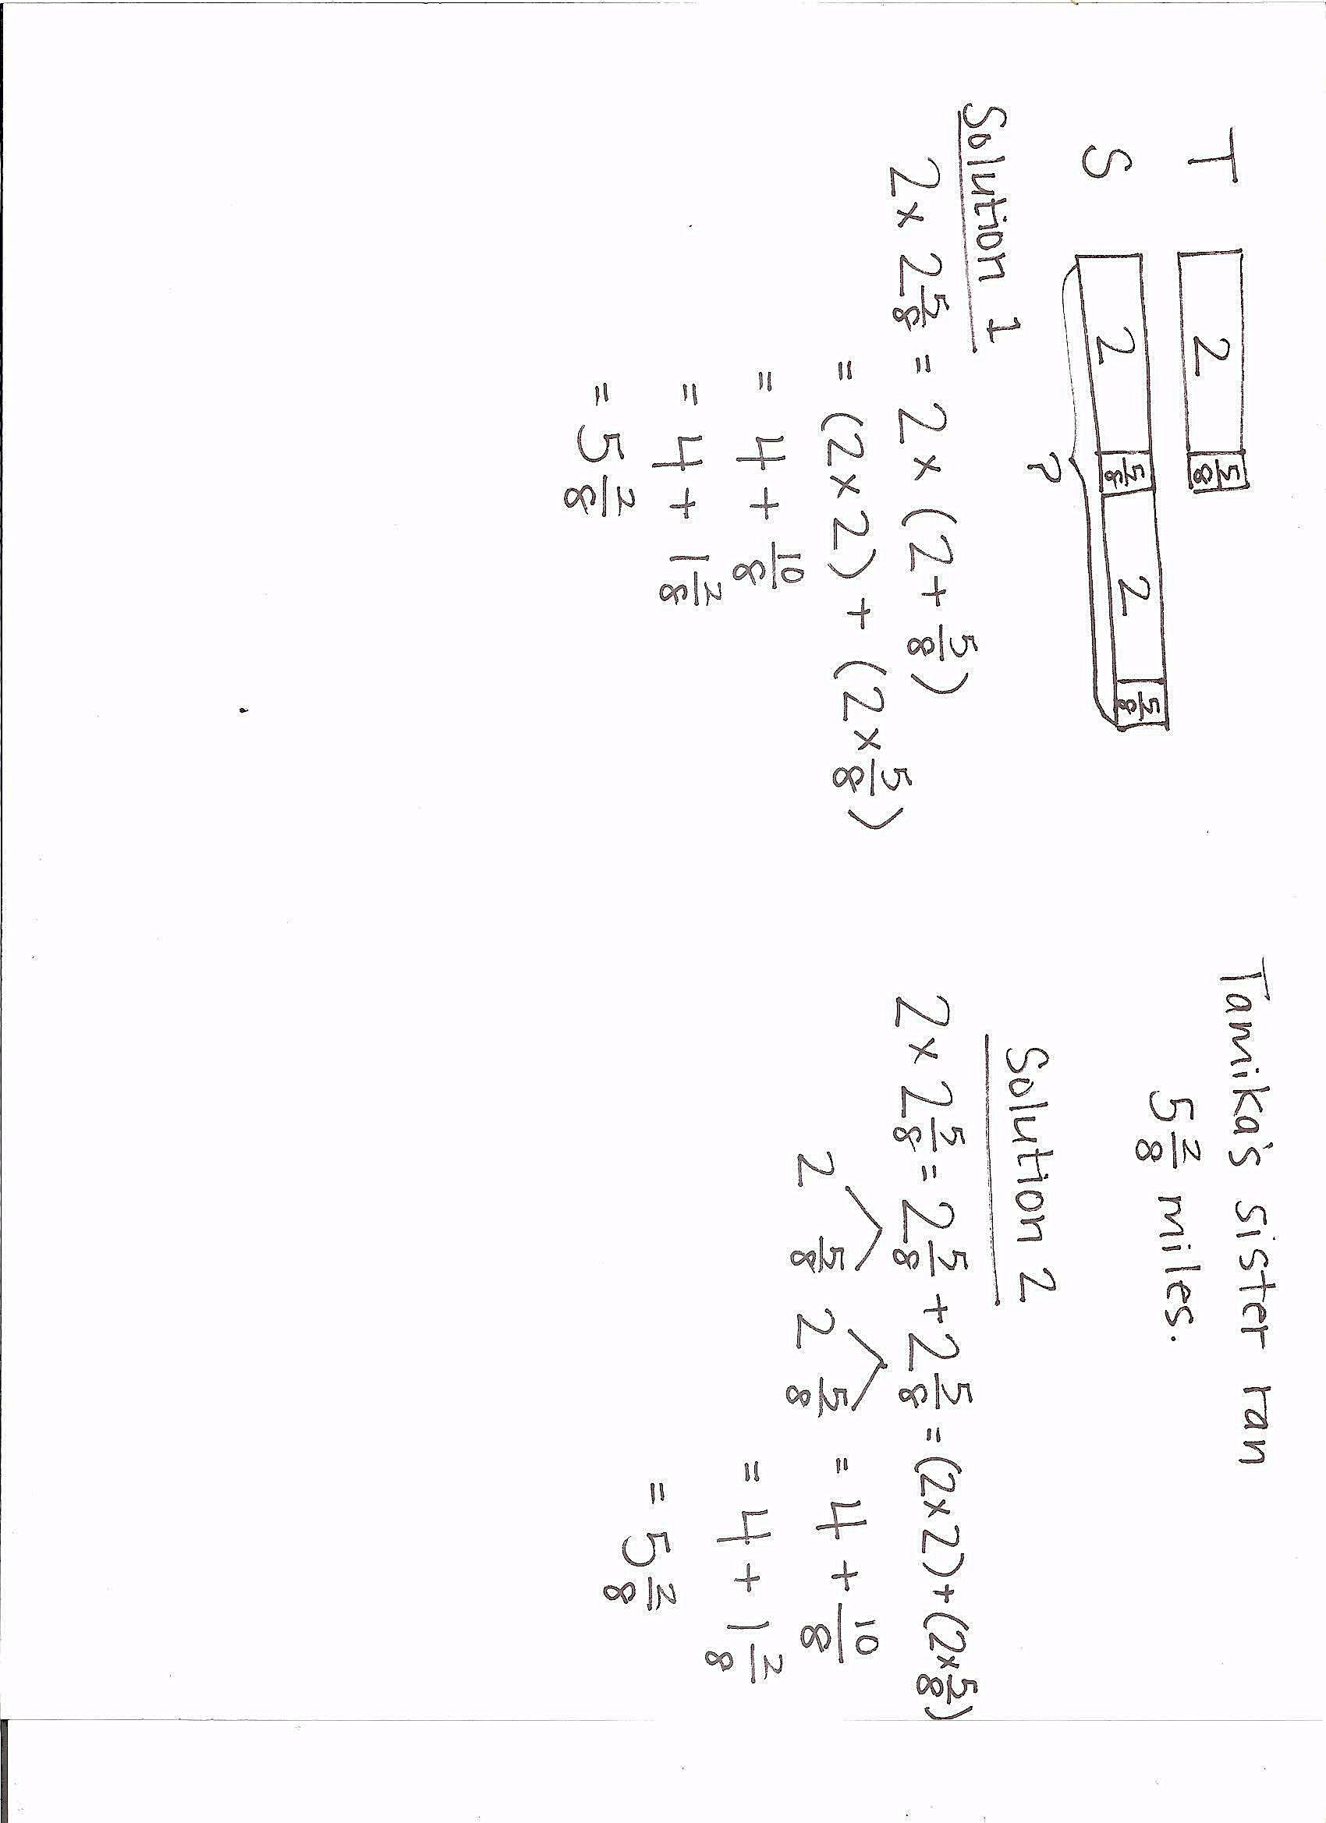

Students may choose to multiply or add to solve this problem. Variations in solution strategies may be used to help students see the distributive property at work.
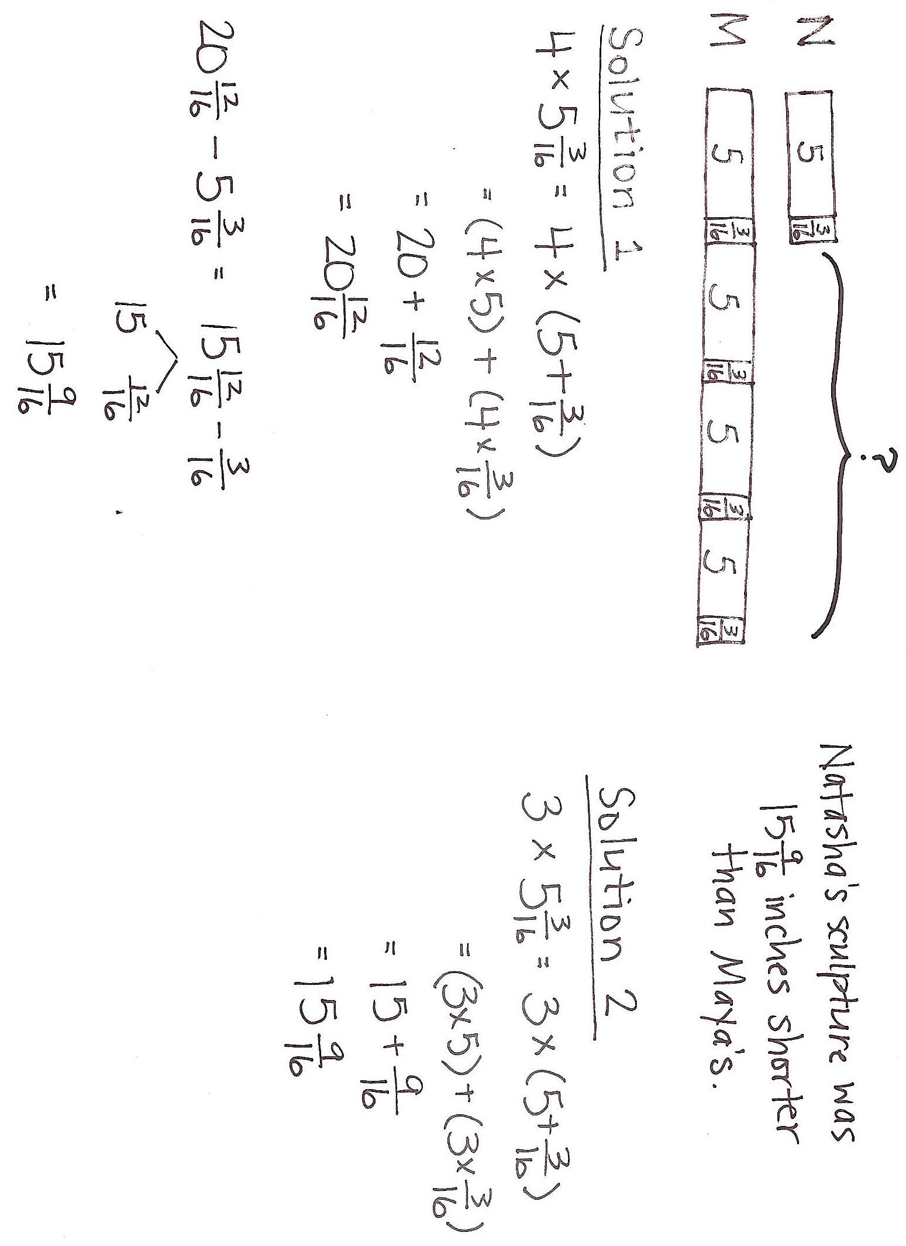
Problem 2: Natasha’s sculpture was $\text{5}\frac{\text{3}}{\text{16}}$ inches tall. Maya’s was 4 times as tall. How much shorter was Natasha’s sculpture than Maya’s?

NOTES ON
MULTIPLE MEANS
OF REPRESENTATION:
Modeling multiplicative comparisons can be tricky. If learners have difficulty representing y times as much, take it one step at a time. Ask, “Draw 1 times as much. (That would be the same.) Now, draw 2 times as much.” Gradually increase the value until the students have modeled, for instance here, 4 times as much.

While some students will solve this problem as a two-step process, as shown in Solution 1, others may recognize that it can be solved as a one-step problem. Because the difference between Natasha’s tape and Maya’s tape is 3 units, students can solve by multiplying 3 and $\text{5}\frac{\text{3}}{\text{16}}$, as shown in Solution 2. Encourage students to reflect on the advantages of Solution 2.
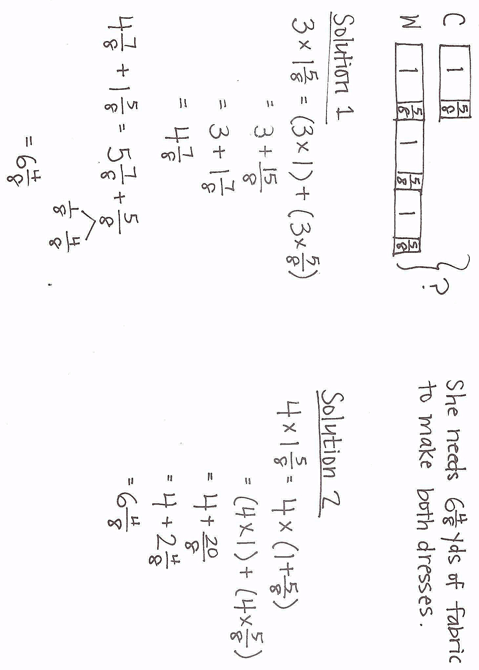
Problem 3: A seamstress needs $\text{1}\frac{\text{5}}{\text{8}}$ yards of fabric to make a child’s dress. She needs 3 times as much fabric to make a woman’s dress. How many yards of fabric does she need for both dresses?

While some students will solve this problem in two steps, as shown in Solution 1, others may recognize that it can be solved as a one-step problem. In Solution 2, the student counts the 4 total units in the double tape diagram and multiplies 4 by $\text{1}\frac{\text{5}}{\text{8}}\text{.}$
Problem 4: A piece of blue yarn is $\text{5}\frac{\text{2}}{\text{3}}$yards long. A piece of pink yarn is 5 times as long as the blue yarn. Bailey tied them together with a knot that used $\frac{\text{1}}{\text{3}}$ yard from each piece of yarn. What is the total length of the yarn tied together?

Solution 1 shows a student’s work in modeling the two pieces of yarn using a double tape diagram. The student multiplies to find the total length of the yarn and then subtracts the $\frac{\text{2}}{\text{3}}$ of a yard that is used in the knot. Solution 2 shows a student’s work; the student recognizes that she needs to subtract $\frac{\text{2}}{\text{3}}$ of a yard at the onset. This student multiplies to identify the length of the pink yarn and then adds on 5, rather than $\text{5}\frac{\text{2}}{\text{3}},$ from the blue yarn. A common error is only subtracting $\frac{\text{1}}{\text{3}}$ yard, instead of $\frac{\text{1}}{\text{3}}$ yard from each piece of yarn.
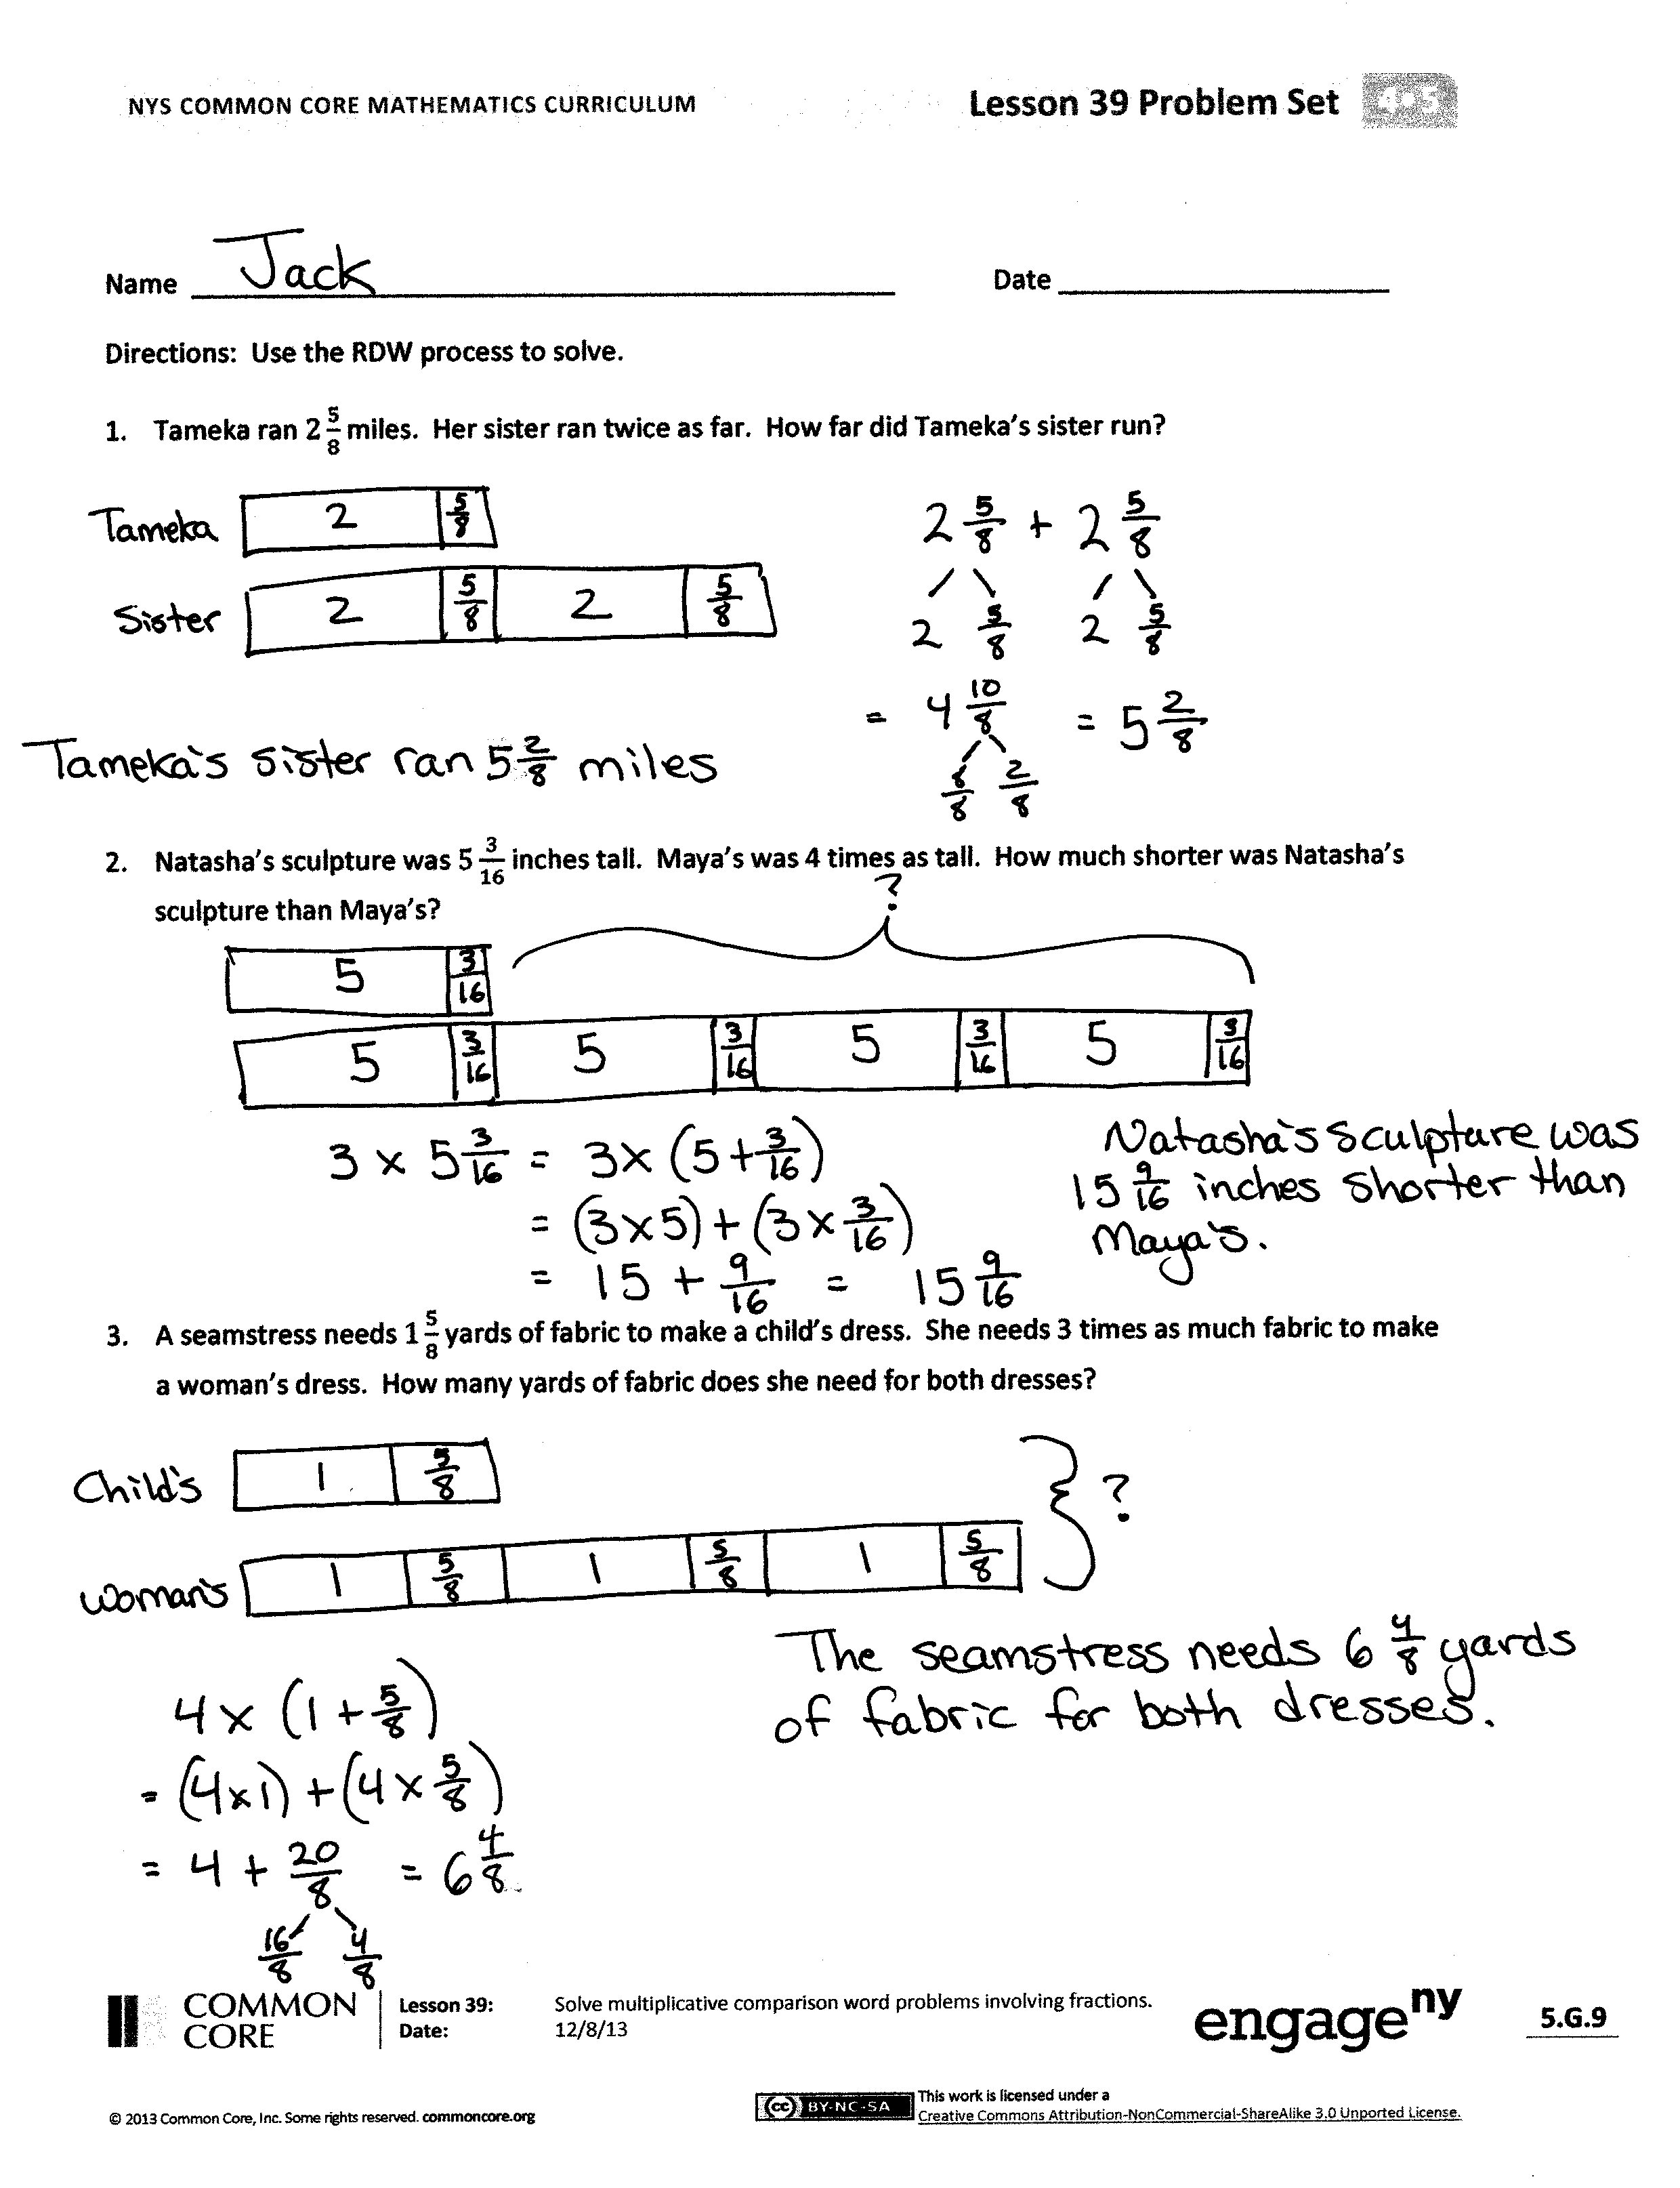
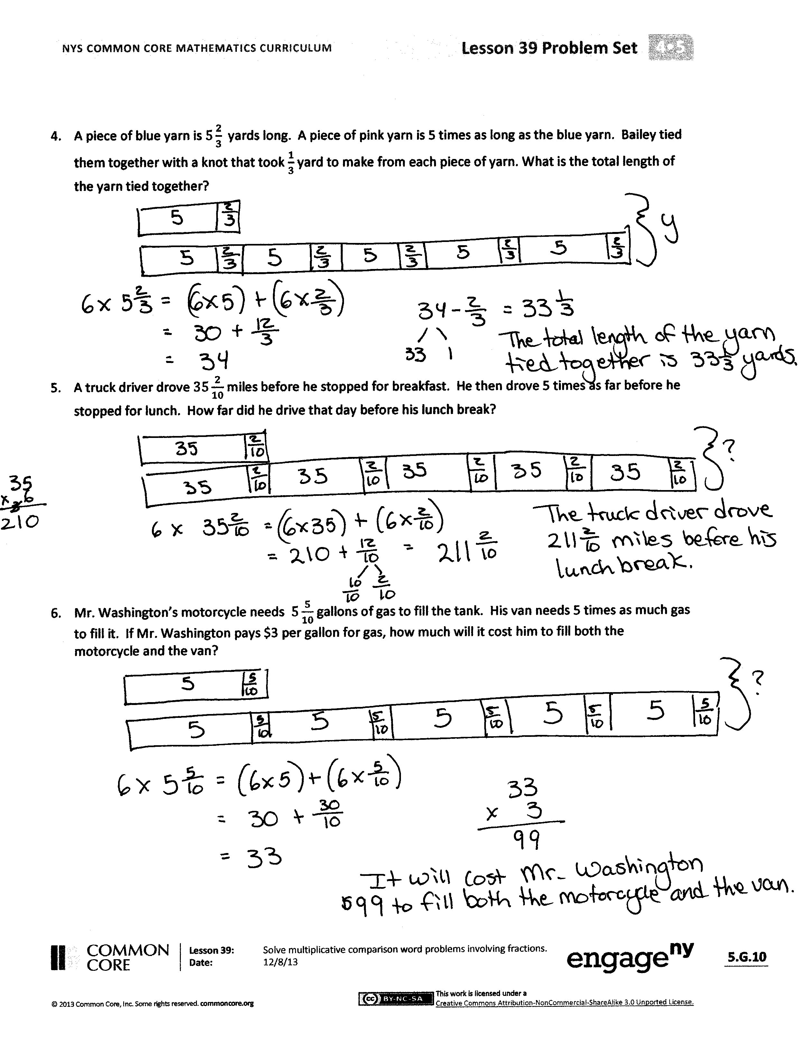
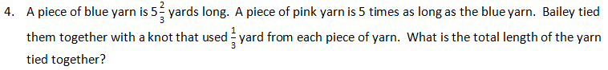
Student Debrief (10 minutes)
Lesson Objective: Solve multiplicative comparison word problems involving fractions.
The Student Debrief is intended to invite reflection and active processing of the total lesson experience.
Any combination of the questions below may be used to lead the discussion.
- What are some advantages to drawing a double tape diagram as the first step to solve comparison word problems?
- As the number of groups or the whole number in the mixed number gets larger, which strategies seem to be more efficient? Explain your thinking.
- When your peers share their drawings, does it help you understand the problem better? How does seeing your peers’ work help you?
- What do you do when you get stuck on a word problem? How do you motivate yourself to persevere?
- When you check for reasonableness, do you look at your number sentences and model? How do you figure out if your answer is reasonable?
- What are some of the words you would use to create a word problem that uses multiplication and comparison?
Exit Ticket (3 minutes)
After the Student Debrief, instruct students to complete the Exit Ticket. A review of their work will help with assessing students’ understanding of the concepts that were presented in today’s lesson and planning more effectively for future lessons. The questions may be read aloud to the students.

Number Correct: _______
A
Multiply Whole Numbers Times Fractions
 | $\frac{\text{ 1 }}{\text{3}} \text{+} \frac{\text{ 1 }}{\text{3}} \text{=}$ |  |  |  | $\frac{\text{ 1 }}{\text{3}} \text{+} \frac{\text{ 1 }}{\text{3}} \text{+} \frac{\text{ 1 }}{\text{3}} \text{+} \frac{\text{ 1 }}{\text{3}} \text{=}$
 | $\text{2 ×} \frac{\text{ 1 }}{\text{ 3 }} \text{=}$ |  |  |  | $\text{4 ×} \frac{\text{ 1 }}{\text{ 3 }} \text{=}$
 | $\frac{\text{ 1 }}{\text{4}} \text{+} \frac{\text{ 1 }}{\text{4}} \text{+} \frac{\text{ 1 }}{\text{4}} \text{=}$ |  |  |  | $\frac{\text{5}}{\text{6}} \text{=}$ | $\text{___ ×} \frac{\text{ 1 }}{\text{ 6 }}$
 | $\text{3 ×} \frac{\text{ 1 }}{\text{ 4 }} \text{=}$ |  |  |  | $\frac{\text{5}}{\text{6}} \text{=}$ | $\text{5 ×} \frac{}{}$
 | $\frac{\text{ 1 }}{\text{5}} \text{+} \frac{\text{ 1 }}{\text{5}} \text{=}$ |  |  |  | $\frac{\text{5}}{\text{8}} \text{=}$ | $\text{5 ×} \frac{}{}$
 | $\text{2 ×} \frac{\text{ 1 }}{\text{ 5 }} \text{=}$ |  |  |  | $\frac{\text{5}}{\text{8}} \text{=}$ | $\text{___ ×} \frac{\text{ 1 }}{\text{ 8 }}$
 | $\frac{\text{ 1 }}{\text{5}} \text{+} \frac{\text{ 1 }}{\text{5}} \text{+} \frac{\text{ 1 }}{\text{5}} \text{=}$ |  |  |  | $\frac{\text{7}}{\text{8}} \text{=}$ | $\text{7 ×} \frac{}{}$
 | $\text{3 ×} \frac{\text{ 1 }}{\text{ 5 }} \text{=}$ |  |  |  | $\frac{\text{7}}{\text{10}} \text{=}$ | $\text{7 ×} \frac{}{}$
 | $\frac{\text{ 1 }}{\text{5}} \text{+} \frac{\text{ 1 }}{\text{5}} \text{+} \frac{\text{ 1 }}{\text{5}} \text{+} \frac{\text{ 1 }}{\text{5}} \text{=}$ |  |  |  | $\frac{\text{7}}{\text{8}} \text{=}$ | $\text{___ ×} \frac{\text{ 1 }}{\text{ 8 }}$
 | $\text{4 ×} \frac{\text{ 1 }}{\text{ 5 }} \text{=}$ |  |  |  | $\frac{\text{7}}{\text{10}} \text{=}$ | $\text{___ ×} \frac{\text{ 1 }}{\text{10 }}$
 | $\frac{\text{ 1 }}{\text{10}} \text{+} \frac{\text{ 1 }}{\text{10}} \text{+} \frac{\text{ 1 }}{\text{10}} \text{=}$ |  |  |  | $\frac{\text{6}}{\text{6}} \text{=}$ | $\text{6 ×} \frac{}{}$
 | $\text{3 ×} \frac{\text{ 1 }}{\text{ 10 }} \text{=}$ |  |  |  | $\text{1 }\text{=}$ | $\text{6 ×} \frac{}{}$
 | $\frac{\text{ 1 }}{\text{8}} \text{+} \frac{\text{ 1 }}{\text{8}} \text{+} \frac{\text{ 1 }}{\text{8}} \text{=}$ |  |  |  | $\frac{\text{8}}{\text{8}} \text{=}$ | $\text{___ ×} \frac{\text{ 1 }}{\text{ 8 }}$
 | $\text{3 ×} \frac{\text{ 1 }}{\text{ 8 }} \text{=}$ |  |  |  | $\text{1 }\text{=}$ | $\text{___ ×} \frac{\text{ 1 }}{\text{ 8 }}$
 | $\frac{\text{ 1 }}{\text{2}} \text{+} \frac{\text{ 1 }}{\text{2}} \text{=}$ |  |  |  | $\text{9 ×} \frac{\text{ 1 }}{\text{ 10 }} \text{=}$
 | $\text{2 ×} \frac{\text{ 1 }}{\text{ 2 }} \text{=}$ |  |  |  | $\text{7 ×} \frac{\text{ 1 }}{\text{ 5 }} \text{=}$
 | $\frac{\text{ 1 }}{\text{3}} \text{+} \frac{\text{ 1 }}{\text{3}} \text{+} \frac{\text{ 1 }}{\text{3}} \text{=}$ |  |  |  | $\text{1 }\text{=}$ | $\text{3 ×} \frac{}{}$
 | $\text{3 ×} \frac{\text{ 1 }}{\text{ 3 }} \text{=}$ |  |  |  | $\text{7 ×} \frac{\text{ 1 }}{\text{ 12 }} \text{=}$
 | $\frac{\text{ 1 }}{\text{4}} \text{+} \frac{\text{ 1 }}{\text{4}} \text{+} \frac{\text{ 1 }}{\text{4}} \text{+} \frac{\text{ 1 }}{\text{4}} \text{=}$ |  |  |  | $\text{1 }\text{=}$ | $\text{___ ×} \frac{\text{ 1 }}{\text{ 5 }}$
 | $\text{4 ×} \frac{\text{ 1 }}{\text{ 4 }} \text{=}$ |  |  |  | $\frac{\text{3}}{\text{5}} \text{=}$ | $$\frac{\text{ 1 }}{\text{5}} \text{+} \frac{\text{ 1 }}{\text{5}}\text{+} \frac{}{}$$
 | $\frac{\text{ 1 }}{\text{2}} \text{+} \frac{\text{ 1 }}{\text{2}} \text{+} \frac{\text{ 1 }}{\text{2}} \text{=}$ |  |  |  | $\text{3 ×} \frac{\text{ 1 }}{\text{ 4 }} \text{=}$ | $$\frac{}{} \text{+} \frac{\text{ 1 }}{\text{4}}\text{+} \frac{\text{ 1 }}{\text{4}}$$
 | $\text{3 ×} \frac{\text{ 1 }}{\text{ 2 }} \text{=}$ |  |  |  | $\text{1 }\text{=}$ | $$\frac{}{}\text{+} \frac{}{}\text{+} \frac{}{}$$
B
[KEY]

Number Correct: _______
Improvement: _______
Multiply Whole Numbers Times Fractions
 | $\frac{\text{ 1 }}{\text{5}} \text{+} \frac{\text{ 1 }}{\text{5}} \text{=}$ |  |  |  | $\frac{\text{ 1 }}{\text{2}} \text{+} \frac{\text{ 1 }}{\text{2}} \text{+} \frac{\text{ 1 }}{\text{2}} \text{=}$
 | $\text{2 ×} \frac{\text{ 1 }}{\text{ 5 }} \text{=}$ |  |  |  | $\text{3 ×} \frac{\text{ 1 }}{\text{ 2 }} \text{=}$
 | $\frac{\text{ 1 }}{\text{3}} \text{+} \frac{\text{ 1 }}{\text{3}} \text{=}$ |  |  |  | $\frac{\text{5}}{\text{6}} \text{=}$ | $\text{___ ×} \frac{\text{ 1 }}{\text{ 6 }}$
 | $\text{2 ×} \frac{\text{ 1 }}{\text{ 3 }} \text{=}$ |  |  |  | $\frac{\text{5}}{\text{6}} \text{=}$ | $\text{5 ×} \frac{}{}$
 | $\frac{\text{ 1 }}{\text{4}} \text{+} \frac{\text{ 1 }}{\text{4}} \text{+} \frac{\text{ 1 }}{\text{4}} \text{=}$ |  |  |  | $\frac{\text{5}}{\text{8}} \text{=}$ | $\text{5 ×} \frac{}{}$
 | $\text{3 ×} \frac{\text{ 1 }}{\text{ 4 }} \text{=}$ |  |  |  | $\frac{\text{5}}{\text{8}} \text{=}$ | $\text{___ ×} \frac{\text{ 1 }}{\text{ 8 }}$
 | $\frac{\text{ 1 }}{\text{5}} \text{+} \frac{\text{ 1 }}{\text{5}} \text{+} \frac{\text{ 1 }}{\text{5}} \text{=}$ |  |  |  | $\frac{\text{7}}{\text{8}} \text{=}$ | $\text{7 ×} \frac{}{}$
 | $\text{3 ×} \frac{\text{ 1 }}{\text{ 5 }} \text{=}$ |  |  |  | $\frac{\text{7}}{\text{10}} \text{=}$ | $\text{7 ×} \frac{}{}$
 | $\frac{\text{ 1 }}{\text{5}} \text{+} \frac{\text{ 1 }}{\text{5}} \text{+} \frac{\text{ 1 }}{\text{5}} \text{+} \frac{\text{ 1 }}{\text{5}} \text{=}$ |  |  |  | $\frac{\text{7}}{\text{8}} \text{=}$ | $\text{___ ×} \frac{\text{ 1 }}{\text{ 8 }}$
 | $\text{4 ×} \frac{\text{ 1 }}{\text{ 5 }} \text{=}$ |  |  |  | $\frac{\text{7}}{\text{10}} \text{=}$ | $\text{___ ×} \frac{\text{ 1 }}{\text{10 }}$
 | $\frac{\text{ 1 }}{\text{8}} \text{+} \frac{\text{ 1 }}{\text{8}} \text{+} \frac{\text{ 1 }}{\text{8}} \text{=}$ |  |  |  | $\frac{\text{8}}{\text{8}} \text{=}$ | $\text{8 ×} \frac{}{}$
 | $\text{3 ×} \frac{\text{ 1 }}{\text{ 8 }} \text{=}$ |  |  |  | $\text{1 }\text{=}$ | $\text{8 ×} \frac{}{}$
 | $\frac{\text{ 1 }}{\text{10}} \text{+} \frac{\text{ 1 }}{\text{10}} \text{+} \frac{\text{ 1 }}{\text{10}} \text{=}$ |  |  |  | $\frac{\text{6}}{\text{6}} \text{=}$ | $\text{___ ×} \frac{\text{ 1 }}{\text{ 6 }}$
 | $\text{3 ×} \frac{\text{ 1 }}{\text{ 10 }} \text{=}$ |  |  |  | $\text{1 }\text{=}$ | $\text{___ ×} \frac{\text{ 1 }}{\text{ 6 }}$
 | $\frac{\text{ 1 }}{\text{3}} \text{+} \frac{\text{ 1 }}{\text{3}} \text{+} \frac{\text{ 1 }}{\text{3}} \text{=}$ |  |  |  | $\text{5 ×} \frac{\text{ 1 }}{\text{ 12 }} \text{=}$
 | $\text{3 ×} \frac{\text{ 1 }}{\text{ 3 }} \text{=}$ |  |  |  | $\text{6 ×} \frac{\text{ 1 }}{\text{ 5 }} \text{=}$
 | $\frac{\text{ 1 }}{\text{4}} \text{+} \frac{\text{ 1 }}{\text{4}} \text{+} \frac{\text{ 1 }}{\text{4}} \text{+} \frac{\text{ 1 }}{\text{4}} \text{=}$ |  |  |  | $\text{1 }\text{=}$ | $\text{4 ×} \frac{}{}$
 | $\text{4 ×} \frac{\text{ 1 }}{\text{ 4 }} \text{=}$ |  |  |  | $\text{9 ×} \frac{\text{ 1 }}{\text{ 10 }} \text{=}$
 | $\frac{\text{ 1 }}{\text{2}} \text{+} \frac{\text{ 1 }}{\text{2}} \text{=}$ |  |  |  | $\text{1 }\text{=}$ | $\text{___ ×} \frac{\text{ 1 }}{\text{ 3 }}$
 | $\text{2 ×} \frac{\text{ 1 }}{\text{ 2 }} \text{=}$ |  |  |  | $\frac{\text{3}}{\text{4}} \text{=}$ | $$\frac{\text{ 1 }}{\text{4}} \text{+} \frac{\text{ 1 }}{\text{4}}\text{+} \frac{}{}$$
 | $\frac{\text{ 1 }}{\text{3}} \text{+} \frac{\text{ 1 }}{\text{3}} \text{+} \frac{\text{ 1 }}{\text{3}} \text{+} \frac{\text{ 1 }}{\text{3}} \text{=}$ |  |  |  | $\text{3 ×} \frac{\text{ 1 }}{\text{ 5 }} \text{=}$ | $$\frac{}{} \text{+} \frac{\text{ 1 }}{\text{5}}\text{+} \frac{\text{ 1 }}{\text{5}}$$
 | $\text{4 ×} \frac{\text{ 1 }}{\text{ 3 }} \text{=}$ |  |  |  | $\text{1 }\text{=}$ | $$\frac{}{}\text{+} \frac{}{}\text{+} \frac{}{}\text{+} \frac{}{}$$

Name Date
Use the RDW process to solve.
- Tameka ran $\text{2}\frac{\text{5}}{\text{8}}$ miles. Her sister ran twice as far. How far did Tameka’s sister run?

- Natasha’s sculpture was $\text{5}\frac{\text{3}}{\text{16}}$ inches tall. Maya’s was 4 times as tall. How much shorter was Natasha’s sculpture than Maya’s?

- A seamstress needs $\text{1}\frac{\text{5}}{\text{8}}$ yards of fabric to make a child’s dress. She needs 3 times as much fabric to make a woman’s dress. How many yards of fabric does she need for both dresses?

- A piece of blue yarn is $\text{5}\frac{\text{2}}{\text{3}}$ yards long. A piece of pink yarn is 5 times as long as the blue yarn. Bailey tied them together with a knot that used $\frac{\text{1}}{\text{3}}$ yard from each piece of yarn. What is the total length of the yarn tied together?

- A truck driver drove $\text{35}\frac{\text{2}}{\text{10}}$ miles before he stopped for breakfast. He then drove 5 times as far before he stopped for lunch. How far did he drive that day before his lunch break?

- Mr. Washington’s motorcycle needs $\text{5}\frac{\text{5}}{\text{10}}$ gallons of gas to fill the tank. His van needs 5 times as much gas to fill it. If Mr. Washington pays $3 per gallon for gas, how much will it cost him to fill both the motorcycle and the van?

Name Date
Use the RDW process to solve.
Jeff has ten packages that he wants to mail. Nine identical packages weigh $\text{2}\frac{\text{7}}{\text{8}}$ pounds each. A tenth package weighs two times as much as one of the other packages. How many pounds do all ten packages weigh?

Name Date
Use the RDW process to solve.
- Ground turkey is sold in packages of $\text{2}\frac{1}{2}$ pounds. Dawn bought eight times as much turkey that is sold in 1 package for her son’s birthday party. How many pounds of ground turkey did Dawn buy?

- Trevor’s stack of books is $\text{7}\frac{\text{7}}{\text{8}}$inches tall. Rick’s stack is 3 times as tall. What is the difference in the heights of their stacks of books?

- It takes $\text{8}\frac{\text{3}}{\text{4}}$ yards of fabric to make one quilt. Gail needs three times as much fabric to make three quilts. She already has two yards of fabric. How many more yards of fabric does Gail need to buy in order to make three quilts?

- Carol made punch. She used $\text{12}\frac{\text{3}}{\text{8}}$ cups of juice and then added three times as much ginger ale. Then, she added 1 cup of lemonade. How many cups of punch did her recipe make?

- Brandon drove $\text{72}\frac{\text{7}}{\text{10}}$ miles on Monday. He drove 3 times as far on Tuesday. How far did he drive in the two days?

- Mrs. Reiser used $\text{9}\frac{\text{8}}{\text{10}}$ gallons of gas this week. Mr. Reiser used five times as much gas as Mrs. Reiser used this week. If Mr. Reiser pays $3 for each gallon of gas, how much did Mr. Reiser pay for gas this week?

