Lesson 38
Objective: Find the product of a whole number and a mixed number using the distributive property.

Suggested Lesson Structure
 Fluency Practice (10 minutes)
 Application Problem (4 minutes)
 Concept Development (36 minutes)
 Student Debrief (10 minutes)
Total Time (60 minutes)
Fluency Practice (10 minutes)
- Multiply Fractions 4.NF.4 (5 minutes)
- Multiply Mixed Numbers 4.NF.4 (5 minutes)
Multiply Fractions (5 minutes)
Materials: (S) Personal white board
Note: This fluency activity reviews Lesson 36.
T: (Write 3 × $\frac{\text{3}}{\text{10}}$ = $\frac{\text{3} \text{×} \text{3}}{\text{10}}$ = $\frac{}{\text{10}}$.) Write the multiplication sentence and product. You can draw a tape diagram or number line to help you.
S: (Write $\frac{\text{3} \text{×} \text{3}}{\text{10}}$ = $\frac{\text{9}}{\text{10}}$.)
Continue with the following possible sequence: 7 × $\frac{\text{2}}{\text{15}}$ and 2 × $\frac{\text{3}}{\text{8}}$.
T: (Write 4 × $\frac{\text{2}}{\text{5}}$ = $\frac{\text{4 × 2}}{\text{5}}$ = $\frac{}{\text{5}}$.) Write the multiplication sentence and product. You can use a tape diagram or number line to help you.
S: (Write $\frac{\text{4 × 2}}{\text{5}}$ = $\frac{\text{8}}{\text{5}}$.)
T: (Write 4 × $\frac{\text{2}}{\text{5}}$ = $\frac{\text{4 × 2}}{\text{5}}$ = $\frac{\text{8}}{\text{5}}$. Beneath it, write $\frac{\text{8}}{\text{5}}$ =__.) Write $\frac{\text{8}}{\text{5}}$ as a mixed number.
S: (Beneath $\frac{\text{8}}{\text{5}}$ , write = $\text{1}\frac{\text{3}}{\text{5}}$.)
Continue with the following possible sequence: 4 × $\frac{\text{3}}{\text{4}}$ , 5 × $\frac{\text{3}}{\text{8}}$ , and 7 × $\frac{\text{2}}{\text{3}}$.
Multiply Mixed Numbers (5 minutes)
Materials: (S) Personal white board
Note: This fluency activity reviews Lesson 37.
T: Break apart $\text{4}\frac{\text{3}}{\text{5}}$ as an addition sentence.
S: (Write 4 + $\frac{\text{3}}{\text{5}}$.)
T: (Write 2 × (4 + $\frac{\text{3}}{\text{5}}$)$.$ Beneath it, write (2 × __) + (2 × ).) Fill in the unknown numbers.
S: (Write (2 × 4) + (2 × $\frac{\text{3}}{\text{5}}$).)
T: (Write (2 × 4) + (2 × $\frac{\text{3}}{\text{5}}$.) Beneath it, write __ + .) Fill in the unknown numbers.
S: (Write 8 + $\frac{\text{6}}{\text{5}}$.)
T: (Write 8 + $\frac{\text{6}}{\text{5}}$. Beneath it, write 8 + __.) Rename $\frac{\text{6}}{\text{5}}$ as a mixed number.
S: (Write 8 + $\text{1}\frac{\text{1}}{\text{5}}$.)
T: (Write 8 + $\text{1}\frac{\text{1}}{\text{5}}$. Beneath it, write = __.) Write the product.
S: (Write = $\text{9}\frac{\text{1}}{\text{5}}$.)
T: (Point to 2 × $\text{4}\frac{\text{3}}{\text{5}}$ .) Say the multiplication sentence.
S: 2 ×$\text{4}\frac{\text{3}}{\text{5}}$ = $\text{9}\frac{\text{1}}{\text{5}}$.
Continue with the following possible sequence: 3 × $\text{2}\frac{\text{2}}{\text{3}}$ and 4 × $\text{2}\frac{\text{3}}{\text{8}}$.
Application Problem (4 minutes)
Eight students are on a relay team. Each runs $\text{1}\frac{\text{3}}{\text{4}}$ kilometers. How many total kilometers does their team run?

Note: This Application Problem reviews Lesson 37, where students used the distributive property to multiply a whole number and a mixed number.
Concept Development (36 minutes)

NOTES ON
MULTIPLE MEANS
OF REPRESENTATION:
Scaffold understanding with visual models. Students working below grade level may benefit from connecting, for example, $\frac{\text{2}}{\text{6}}$is the same as 2 × $\frac{\text{1}}{\text{6}}$ , to a tape diagram or number line.

Materials: (S) Personal white board
Note: This lesson reviews what students learned from
Lesson 37.
Problem 1: Identify the unknown factors.
T: Write 5 × $\text{8}\frac{\text{1}}{\text{5}}$ = (__ × 8) + (__ × $\frac{\text{1}}{\text{5}}$ ). Use the distributive property to fill in the unknown numbers. Turn and discuss your answer with your partner. Draw or write as you explain your thinking.
S: Both parts need to be multiplied by 5. I used a tape diagram to show my partner that there are 5 eights and 5 one-fifths.

NOTES ON
MULTIPLE MEANS
OF ENGAGEMENT:
Give everyone a fair chance to share their work and solutions by providing appropriate scaffolds. Demonstrating students may use translators, interpreters, or sentence frames to present. If the pace of the lesson is a consideration, prepare presenters beforehand.

MP.3
Problem 2: Use and share strategies for using the distributive property to find the product of a whole number and a mixed number.
T: (Write 4 × $\text{9}\frac{\text{3}}{\text{4}}$ = ___.) Solve the problem on your personal white boards.
MP.3
Allow students about one to two minutes to solve.
T: What is 4 × $\text{9}\frac{\text{3}}{\text{4}}?$
S: 39.
T: Share your work with your partner.
MP.3
S: I made a tape diagram showing four units of $\text{9}\frac{\text{3}}{\text{4}}$.
I used the distributive property by writing four groups of 9 and four groups of $\frac{\text{3}}{\text{4}}$. Then, I added those products and got 39. I took a shortcut and wrote 36 + $\frac{\text{12}}{\text{4}}.$
Have students work with a partner to solve the following problems: $\text{5}\frac{\text{6}}{\text{8}}$ × 4, $\text{12}\frac{\text{2}}{\text{6}}$ × 3, and 9 × $\text{7}\frac{\text{5}}{\text{7}}$.

Problem 3: Solve multiplication of a mixed number and a whole number when embedded in word problems.
T: (Write or project, “Robin rides for $\text{3}\frac{\text{1}}{\text{2}}$ miles round-trip to get to and from school. How many miles would Robin ride in 5 days?”) Use the RDW process to solve this story problem.
Circulate and note student work that might be beneficial to share with the class.
S: (Solve on a personal white board.)
T: In 5 days, how many miles would Robin ride to get to school?
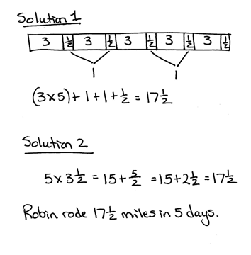
S: $\text{17}\frac{\text{1}}{\text{2}}$ miles.
Invite each selected student to come to the board and share strategies and solutions. Ask the students to share their tape diagrams with the labels and identify all of the referents.
S: I made a tape diagram showing 5 units of $\text{3}\frac{\text{1}}{\text{2}}$. Every time I saw 2 halves, I counted them as 1.
I added (3 × 5) + 1 + 1 + $\frac{\text{1}}{\text{2}}$. (See image at the right.) I multiplied the whole number of miles by 5 and then multiplied the $\frac{\text{1}}{\text{2}}$ mile by 5. I added the products together. That’s the distributive property.
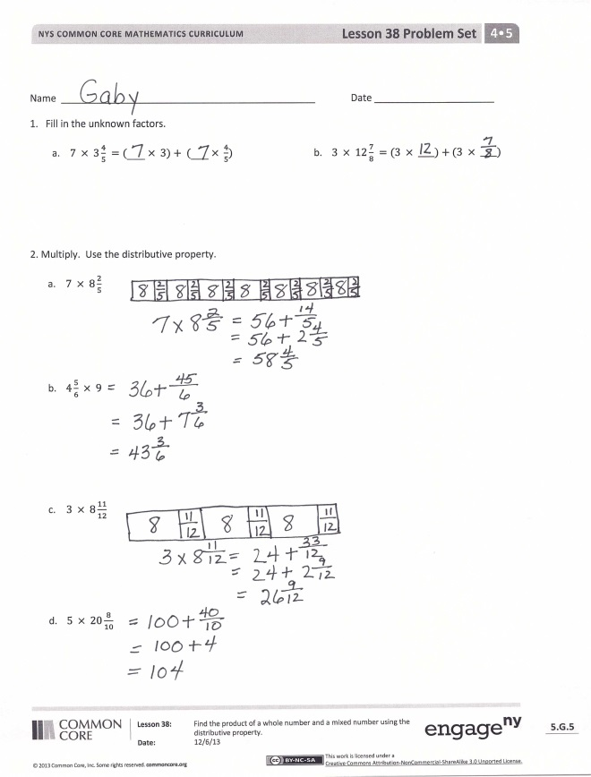
Problem Set (10 minutes)
Students should do their personal best to complete the Problem Set within the allotted 10 minutes. For some classes, it may be appropriate to modify the assignment by specifying which problems they work on first. Some problems do not specify a method for solving. Students should solve these problems using the RDW approach used for Application Problems.
Student Debrief (10 minutes)
Lesson Objective: Find the product of a whole number and a mixed number using the distributive property.
The Student Debrief is intended to invite reflection and active processing of the total lesson experience.

Invite students to review their solutions for the Problem Set. They should check work by comparing answers with a partner before going over answers as a class. Look for misconceptions or misunderstandings that can be addressed in the Debrief. Guide students in a conversation to debrief the Problem Set and process the lesson.
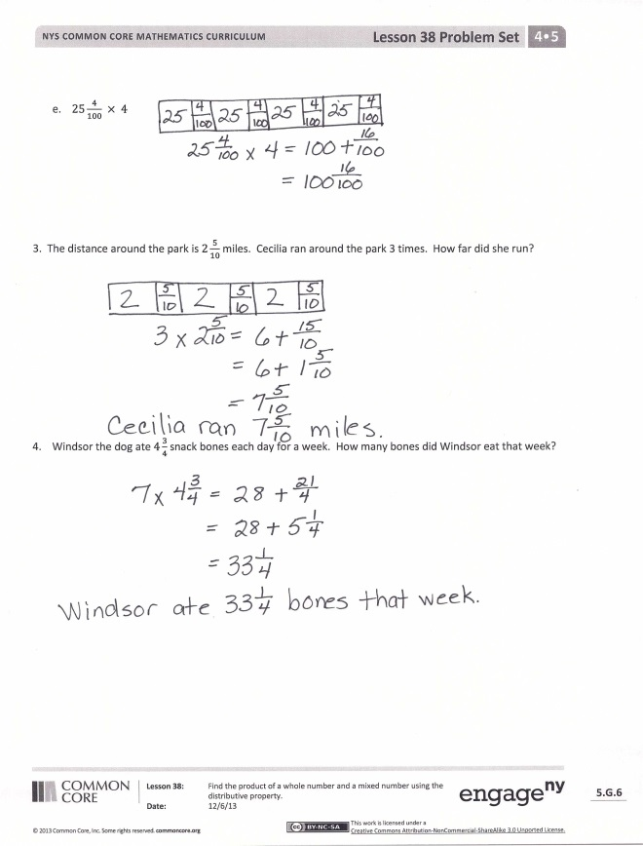
Any combination of the questions below may be used to lead the discussion.
- Explain how you knew what number was unknown from Problem 1.
- What method for solving did you use in
Problem 2? Use a specific example from your Problem Set to explain.
- What did you do to solve the problems when the first factor was a mixed number?
- How did you solve Problem 2(e)? Turn and share with your partner.
- Why is it sometimes useful to see both a tape diagram and the numbers?
- How might you improve your work from today’s Application Problem?
Exit Ticket (3 minutes)
After the Student Debrief, instruct students to complete the Exit Ticket. A review of their work will help with assessing students’ understanding of the concepts that were presented in today’s lesson and planning more effectively for future lessons. The questions may be read aloud to the students.
Name Date
      - Fill in the unknown factors.

- $7 × 3\frac{4}{5} =(_{______} × 3)+ (_{______} × \frac{4}{5})$
- $3 × 12\frac{7}{8} =(3 × ____)+(3 × ____)$

- Multiply. Use the distributive property.
- $7 × 8\frac{2}{5}$

- $4\frac{5}{6} × 9$

- $3 × 8\frac{11}{12}$

- $5 × 20\frac{8}{10}$

- $25\frac{4}{100} × 4$

- The distance around the park is $2\frac{5}{10}$ miles. Cecilia ran around the park 3 times. How far did she run?

- Windsor the dog ate $4\frac{3}{4}$ snack bones each day for a week. How many bones did Windsor eat that week?

Name Date
- Fill in the unknown factors.
$8 × 5\frac{2}{3} =(_{______} × 5)+ (_{______} × \frac{2}{3})$

- Multiply. Use the distributive property.
$6\frac{5}{8} × 7$

Name Date
- Fill in the unknown factors.
- $8 × 4\frac{4}{7} =(_{______} × 4)+ (_{______} × \frac{4}{7})$ b. $9 × 7\frac{7}{10} =(9 × ____)+(9 × ____)$

- Multiply. Use the distributive property.
- $6 × 8\frac{2}{7}$

- $7\frac{3}{4} × 9$

- $9 × 8\frac{7}{9}$

- $25\frac{7}{8} × 3$

- $4 × 20\frac{8}{12}$

- $30\frac{3}{100} × 12$

- Brandon is cutting 9 boards for a woodworking project. Each board is $4\frac{5}{8}$ feet long. What is the total length of the boards?

- Rocky the collie ate $3\frac{1}{4}$ cups of dog food each day for two weeks. How much dog food did Rocky eat in that time?

- At the class party, each student will be given a container that holds $8\frac{5}{8}$ ounces of juice. There are
25 students in the class. If each student’s container is filled, how many ounces of juice does the teacher need to buy?

