Lesson 37
Objective: Find the product of a whole number and a mixed number using the distributive property.

Suggested Lesson Structure
 Fluency Practice (10 minutes)
 Application Problem (5 minutes)
 Concept Development (35 minutes)
 Student Debrief (10 minutes)
Total Time (60 minutes)
Fluency Practice (10 minutes)
- Add and Subtract 4.NBT.4 (4 minutes)
- Multiply Fractions 4.NF.4 (6 minutes)
Add and Subtract (4 minutes)
Materials: (S) Personal white board
Note: This fluency activity reviews adding and subtracting using the standard algorithm.
T: (Write 547 thousands 869 ones.) On your personal white boards, write this number
in standard form.
S: (Write 547,869.)
T: (Write 362 thousands 712 ones.) Add this number to 547,869 using the standard algorithm.
S: (Write 547,869 + 362,712 = 910,581 using the standard algorithm.)
Continue with the following possible sequence: 459,623 + 353,683.
T: (Write 800 thousands.) On your boards, write this number in standard form.
S: (Write 800,000.)
T: (Write 352 thousands 951 ones.) Subtract this number from 800,000 using the standard algorithm.
S: (Write 800,000 – 352,951 = 447,049 using the standard algorithm.)
Continue with the following possible sequence: 805,813 – 368,265.

Multiply Fractions (6 minutes)
Materials: (S) Personal white board
Note: This fluency activity reviews Lesson 36.
T: (Write 2 × $\frac{\text{2}}{\text{5}}$ = $\frac{\text{ × }}{\text{5}}$ = $\frac{}{\text{5}}$.) Write the multiplication sentence, filling in the unknown numbers. You can draw a tape diagram or a number line to help you.
S: (Write 2 × $\frac{\text{2}}{\text{5}}$ = $\frac{\text{2} \text{×} \text{2}}{\text{5}}$ = $\frac{\text{4}}{\text{5}}$.)
Continue the process for 3 × $\frac{\text{3}}{\text{10}}$.
T: (Write 3 × $\frac{\text{3}}{\text{8}}$ = $\frac{\text{ × }}{\text{8}}$ = $\frac{}{\text{8}}$.) Write the multiplication sentence, filling in the unknown number. You can use a tape diagram or a number line to help you.
S: (Write 3 × $\frac{\text{3}}{\text{8}}$ = $\frac{\text{3} \text{×} \text{3}}{\text{8}}$ = $\frac{\text{9}}{\text{8}}$.)
T: Write $\frac{\text{9}}{\text{8}}$ as a mixed number.
S: (Write $\frac{\text{9}}{\text{8}}$ = $\text{1}\frac{\text{1}}{\text{8}}$.)
Continue with the following possible sequence: 4 × $\frac{\text{2}}{\text{3}}$ , 5 × $\frac{\text{3}}{\text{4}}$ , and 5 × $\frac{\text{5}}{\text{12}}$.
Application Problem (5 minutes)
The baker needs $\frac{\text{5}}{\text{8}}$ cup of raisins to make 1 batch of cookies. How many cups of raisins does he need
to make 7 batches of cookies?
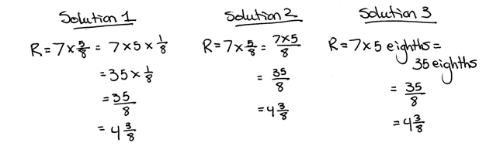

Note: This Application Problem reviews Lessons 35 and 36 of Topic G, where students learned to represent the product of a whole number and a fraction using the associative property. Notice that, although they can be used, parentheses are not modeled in the solutions. Students have already established that parentheses indicate the changed associations. Since the process has been established, parentheses are not necessary and can make notation cumbersome.

Concept Development (35 minutes)

NOTES ON
MULTIPLE MEANS
OF ACTION AND EXPRESSION:
A gentle reminder and grid paper may help learners draw appropriately proportioned, though not meticulously precise, tape diagrams. Generally, the bar for 3 should be longer than the bar for $\frac{\text{1}}{\text{5}}.$
Materials: (S) Personal white board
Problem 1: Draw a tape diagram to show the product of a whole number and a mixed number.
T: With me, draw a tape diagram showing $\text{3}\frac{\text{1}}{\text{5}}$ in two parts, the ones and the fractional part.
S: (Draw.)
T: Point to and say the two parts of your tape diagram.
S: (Point as saying each value.) 3. $\frac{1}{5}$.
T: Draw one more copy of $\text{3}\frac{\text{1}}{\text{5}}$as two parts on the same tape diagram.
S: (Draw.)
T: There are two copies of $\text{3}\frac{\text{1}}{\text{5}}.$ We can record this as
2 × $\text{3}\frac{\text{1}}{\text{5}}$. (Write 2 × $\text{3}\frac{\text{1}}{\text{5}}$ on the board.)
T: What are the 4 parts of your tape diagram?
S: 3, $\frac{\text{1}}{\text{5}}$ , 3, and $\frac{\text{1}}{\text{5}}$. 2 threes and 2 fifths.
T: Make a new tape diagram of two groups of $\text{3}\frac{\text{1}}{\text{5}}$ the same length as your other tape diagram. This time, draw the threes on the left and the fifths on the right.
T: How many threes do we have?
S: 2 threes.
T: How many fifths do we have?
S: 2 fifths.
T: 2 × $\text{3}\frac{\text{1}}{\text{5}}$ is equal to 2 threes and 2 fifths. (Write 2 × $\text{3}\frac{\text{1}}{\text{5}}$ = (2 × 3) + (2 × $\frac{\text{1}}{\text{5}}$ ).)
T: 2 times 3 is…? (Point to the expression.)
S: 6. (Write their response as shown to the right.)
T: 2 times $\frac{\text{1}}{\text{5}}$ is…? (Point to the expression.)
S: $\frac{\text{2}}{\text{5}}$. (Write their response as shown to the right.)
T: The parts are 6 and $\frac{\text{2}}{\text{5}}.$ What is the total?
S: 6 + $\frac{\text{2}}{\text{5}}$ = $\text{6}\frac{\text{2}}{\text{5}}$.

T: Let’s try another one. Make a tape diagram to show four units of $\text{5}\frac{\text{2}}{\text{10}}$. Make another tape diagram to show how the whole numbers and fractional parts can be redistributed. Write a multiplication sentence to represent your groups of $\text{5}\frac{\text{2}}{\text{10}}$ using the format we used to do two groups of 3 and a fifth.
S: (Write 4 × $\text{5}\frac{\text{2}}{\text{10}}.$)
Problem 2: Identify the distributive property to multiply a whole number and a mixed number.
T: Express $\text{5}\frac{\text{2}}{\text{10}}$ as an addition sentence. (Note that this is a continuation of Problem 1.)
S: 5 + $\frac{\text{2}}{\text{10}}.$

NOTES ON
MULTIPLE MEANS
OF REPRESENTATION:
If students are reversing numerators and denominators, try using a color to distinguish them. For example, write the numerator in red. Have students consistently whisper-read fractions as they solve. Continue to use models for meaning-making. Frequently check for understanding, and guide students to offer personalized solutions.

T: (Write 4 × $\text{5}\frac{\text{2}}{\text{10}}$ = 4 × (5 + $\frac{\text{2}}{\text{10}}$).) How many groups of 5 did you draw?
S: Four.
T: How many groups of 2 tenths?
S: Four.
T: There are four groups of 5 and four groups of $\frac{\text{2}}{\text{10}}$. (Write (4 × 5) + (4 × $\frac{\text{2}}{\text{10}}$).) We distribute our multiplication to both parts of our mixed number.
T: 4 × 5 is…?
S: 20.
T: 4 × $\frac{\text{2}}{\text{10}}$ is…?
S: $\frac{\text{8}}{\text{10}}$.
T: (Write = 20 + $\frac{\text{8}}{\text{10}}$.) Our total product is…?

NOTES ON
MULTIPLE MEANS
OF REPRESENTATION:
An additional step to solving 3 × $\text{7}\frac{\text{3}}{\text{4}}$ that may scaffold understanding for students working below grade level is to model the decomposition of $\text{7}\frac{\text{3}}{\text{4}}$ as a number bond, as shown below:

S: 20$\frac{8}{10}$.
T: (Write 3 × $\text{7}\frac{\text{3}}{\text{4}}$.) With your partner, write a number sentence to multiply the whole number by each part. (Pause.) What number sentence did you write?
S: 3 × $\text{7}\frac{\text{3}}{\text{4}}$ = (3 × 7) + (3 × $\frac{\text{3}}{\text{4}}$).
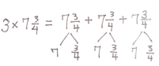
T: Show the products for each part. What are the two products?
S: 21 and $\frac{\text{9}}{\text{4}}$.
T: Rename $\frac{\text{9}}{\text{4}}$ as a mixed number. $\frac{\text{9}}{\text{4}}$ is…?
S: $\text{2}\frac{\text{1}}{\text{4}}$.
T: What is the product of 3 × $\text{7}\frac{\text{3}}{\text{4}}$ ?
S: $\text{23}\frac{\text{1}}{\text{4}}$.
T: You used the distributive property when you broke apart $\text{7}\frac{\text{3}}{\text{4}}$ and multiplied each part by 3.
T: Try another. Solve 5 × $\text{3}\frac{\text{2}}{\text{3}}$. This time, imagine the distributive property in your head. Think out loud if you need to as you solve. Write only as much as you need to.
S: 5 × $\text{3}\frac{\text{2}}{\text{3}}$ = 15 + $\frac{\text{10}}{\text{3}}$ = $\text{18}\frac{\text{1}}{\text{3}}$.
Problem 3: Solve a word problem involving the multiplication of a whole number by a mixed number.
T: In April, Jenny ran in a marathon as part of a relay team. She ran $\text{6}\frac{\text{55}}{\text{100}}$ miles. In September, Jenny ran 4 times as far to complete a marathon on her own. How far did Jenny run in September?
T: Use any strategy we practiced today to solve this problem. Remember to record all of your steps. Be ready to explain your work to your partner.
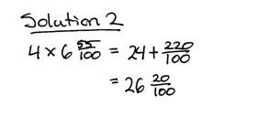
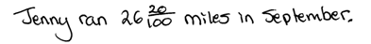
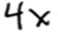

Problem Set (10 minutes)
Students should do their personal best to complete the Problem Set within the allotted 10 minutes. For some classes, it may be appropriate to modify the assignment by specifying which problems they work on first. Some problems do not specify a method for solving. Students should solve these problems using the RDW approach used for Application Problems.
Student Debrief (10 minutes)
Lesson Objective: Find the product of a whole number and a mixed number using the distributive property.
The Student Debrief is intended to invite reflection and active processing of the total lesson experience.
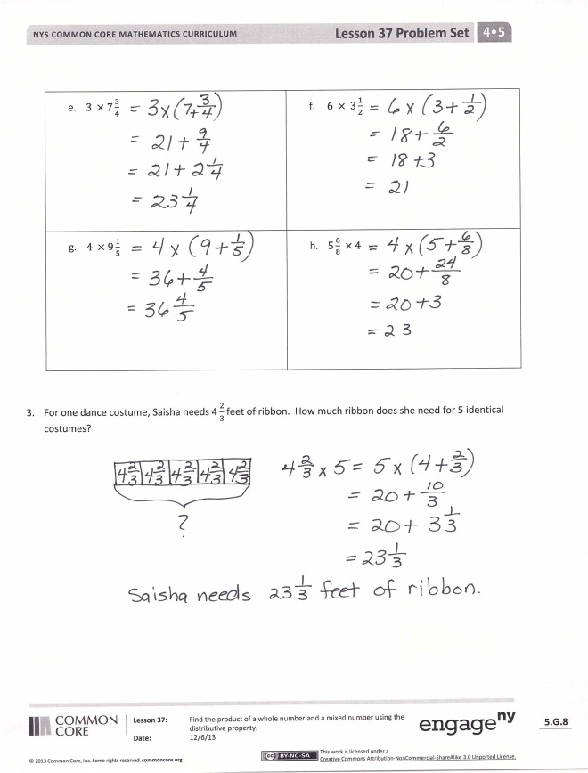
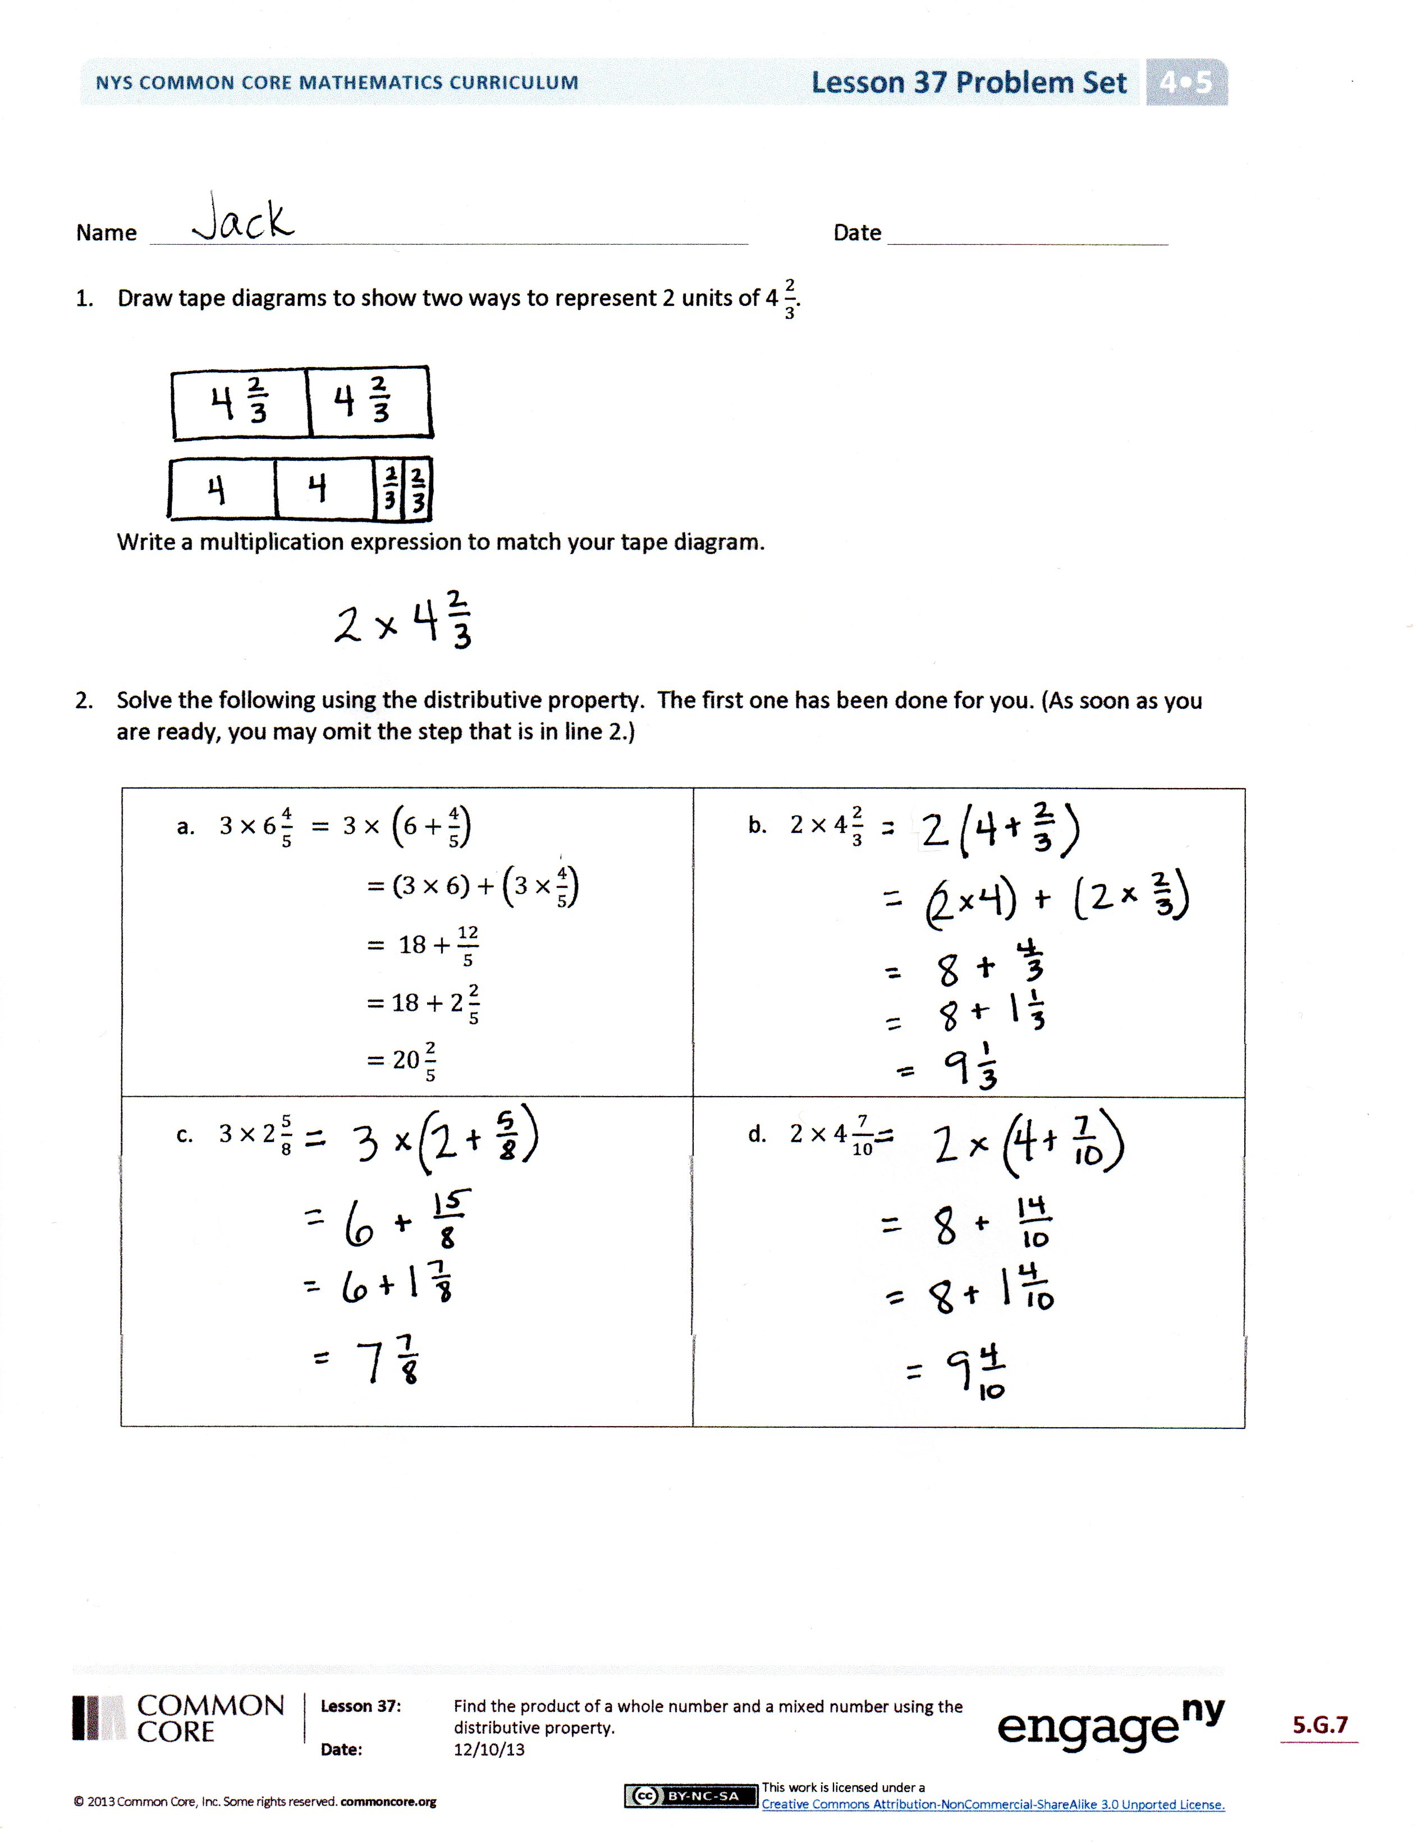
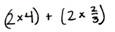
Invite students to review their solutions for the Problem Set. They should check work by comparing answers with a partner before going over answers as a class. Look for misconceptions or misunderstandings that can be addressed in the Debrief. Guide students in a conversation to debrief the Problem Set and process the lesson.
Any combination of the questions below may be used to lead the discussion.
- How could your tape diagram from Problem 1 help you solve Problem 2(b)? Explain your thinking.
- We can use the distributive property to show
3 × 24 as (3 × 2 tens) + (3 × 4 ones). Explain how this relates to solving 3 × $\text{2}\frac{\text{4}}{\text{10}}.$
- Which strategy did you use to solve Problem 3? Why do you prefer this strategy?
- Problem 2(h) shows the expression $\text{5}\frac{\text{6}}{\text{8}}$ × 4 instead of 4 × $\text{5}\frac{\text{6}}{\text{8}}.$ Why are we able to write it either way and still get the same product?
- Look at differences in the solutions for Problem 3 of the Concept Development. In Solution 2, which step was not explicitly written? How did the student move from 4 × $\text{6}\frac{\text{55}}{\text{100}}$ to 24 + $\frac{\text{220}}{\text{100}}$ in one step? Discuss with a partner.
- Were you able to omit the step expressed in
line 2 of Problem 2(a)? Explain.
Exit Ticket (3 minutes)
After the Student Debrief, instruct students to complete the Exit Ticket. A review of their work will help with assessing students’ understanding of the concepts that were presented in today’s lesson and planning more effectively for future lessons. The questions may be read aloud to the students.
Name Date
- Draw tape diagrams to show two ways to represent 2 units of $\text{4}\frac{2}{3}$.

Write a multiplication expression to match each tape diagram.

- Solve the following using the distributive property. The first one has been done for you. (As soon as you are ready, you may omit the step that is in line 2.)

- $3 × 6\frac{4}{5} = 3 × \left(6+\frac{4}{5}\right)$  $=$ $\left(3 × 6\right)+\left(3 ×\frac{4}{5}\right)$  $= 18+\frac{12}{5}$  $=$ $18+2\frac{2}{5}$  $=20\frac{2}{5}$ | - $2 × 4\frac{2}{3}$
- $3 × 2\frac{5}{8}$ | - $2 × 4\frac{7}{10}$
- $3 ×7\frac{3}{4}$ | - $6 × 3\frac{1}{2}$
- $4 ×9\frac{1}{5}$ | - $5\frac{6}{8} ×4$
- For one dance costume, Saisha needs $\text{4}\frac{2}{3}$ feet of ribbon. How much ribbon does she need for 5 identical costumes?

Name Date
Multiply. Write each product as a mixed number.
- $4×5\frac{3}{8}$

- $4\frac{3}{10}×3$

Name Date
- Draw tape diagrams to show two ways to represent 3 units of $\text{5}\frac{\text{1}}{\text{12}}$.

Write a multiplication expression to match each tape diagram.

- Solve the following using the distributive property. The first one has been done for you. (As soon as you are ready, you may omit the step that is in line 2.)

- $3 × 6\frac{4}{5} = 3 × \left(6+\frac{4}{5}\right)$  $=$ $\left(3 × 6\right)+\left(3 ×\frac{4}{5}\right)$  $= 18+\frac{12}{5}$  $=$ $18+2\frac{2}{5}$  $=20\frac{2}{5}$ | - $5 × 4\frac{1}{6}$
- $6 × 2\frac{3}{5}$ | - $2 ×7\frac{3}{10}$
- $8 ×7\frac{1}{4}$ | - $3\frac{3}{8} × 12$

- Sara’s street is $\text{2}\frac{\text{3}}{\text{10}}$ miles long. She ran the length of the street 6 times. How far did she run?

- Kelly’s new puppy weighed $\text{4}\frac{\text{7}}{\text{10}}$ pounds when she brought him home. Now, he weighs six times as much. How much does he weigh now?

