Lesson 36
Objective: Represent the multiplication of n times a/b as (n × a)/b using the associative property and visual models.

Suggested Lesson Structure
 Fluency Practice (10 minutes)
 Application Problem (5 minutes)
 Concept Development (35 minutes)
 Student Debrief (10 minutes)
Total Time (60 minutes)
Fluency Practice (10 minutes)
- Count by Equivalent Fractions 4.NF.1 (5 minutes)
- Multiply Fractions 4.NF.4 (5 minutes)
Count by Equivalent Fractions (5 minutes)
Note: This activity reviews Lessons 24 and 25. The progression builds in complexity. Work the students up to the highest level of complexity in which they can confidently participate.
T: Count by threes to 30, starting at 0.
S: 0, 3, 6, 9, 12, 15, 18, 21, 24, 27, 30.
T: Count by 3 tenths to 30 tenths, starting at 0 tenths. (Write as students count.)

$\frac{\text{0}}{\text{10}}$ $\frac{\text{3}}{\text{10}}$ $\frac{\text{6}}{\text{10}}$ $\frac{\text{9}}{\text{10}}$ $\frac{\text{12}}{\text{10}}$ $\frac{\text{15}}{\text{10}}$ $\frac{\text{18}}{\text{10}}$ $\frac{\text{21}}{\text{10}}$ $\frac{\text{24}}{\text{10}}$ $\frac{\text{27}}{\text{10}}$ $\frac{30}{10}$
0 $\frac{\text{3}}{\text{10}}$ $\frac{\text{6}}{\text{10}}$ $\frac{\text{9}}{\text{10}}$ $\frac{\text{12}}{\text{10}}$ $\frac{\text{15}}{\text{10}}$ $\frac{\text{18}}{\text{10}}$ $\frac{\text{21}}{\text{10}}$ $\frac{\text{24}}{\text{10}}$ $\frac{\text{27}}{\text{10}}$ 3
0 $\frac{\text{3}}{\text{10}}$ $\frac{\text{6}}{\text{10}}$ $\frac{\text{9}}{\text{10}}$ $\text{1}\frac{\text{2}}{\text{10}}$ $\text{1}\frac{\text{5}}{\text{10}}$ $\text{1}\frac{\text{8}}{\text{10}}$ $\text{2}\frac{\text{1}}{\text{10}}$ $\text{2}\frac{\text{4}}{\text{10}}$ $\text{2}\frac{\text{7}}{\text{10}}$ 3

S: $\frac{\text{0}}{\text{10}}$ , $\frac{\text{3}}{\text{10}}$ , $\frac{\text{6}}{\text{10}}$ , $\frac{\text{9}}{\text{10}}$ , $\frac{12}{10}$ , $\frac{\text{15}}{\text{10}}$ , $\frac{\text{18}}{\text{10}}$ , $\frac{\text{21}}{\text{10}}$ , $\frac{\text{24}}{\text{10}}$ , $\frac{\text{27}}{\text{10}}$ , $\frac{\text{30}}{\text{10}}$.
T: Name the fraction that’s equal to a whole number.
S: 30 tenths.
T: (Point to $\frac{\text{30}}{\text{10}}$.) 30 tenths is how many ones?
S: 3 ones.
T: (Beneath $\frac{\text{30}}{\text{10}}$$\frac{20}{10}$, write 3 ones.) Count by 3 tenths again. This time, when you come to the whole number, say the whole number. (Write as students count.)
S: 0, $\frac{\text{3}}{\text{10}}$ , $\frac{\text{6}}{\text{10}}$ , $\frac{\text{9}}{\text{10}}$ , $\frac{\text{12}}{\text{10}}$ , $\frac{\text{15}}{\text{10}}$ , $\frac{\text{18}}{\text{10}}$ , $\frac{\text{21}}{\text{10}}$ , $\frac{\text{24}}{\text{10}}$ , $\frac{\text{27}}{\text{10}}$ , 3.
T: (Point to $\frac{\text{12}}{\text{10}}$$\frac{12}{10}$.) Say $\frac{\text{12}}{\text{10}}$ as a mixed number.
S: $\text{1}\frac{\text{2}}{\text{10}}$.
Continue the process for $\text{1}\frac{\text{5}}{\text{10}}, \text{1}\frac{\text{8}}{\text{10}}$ , $\text{2}\frac{\text{1}}{\text{10}}$ , $\text{2}\frac{\text{4}}{\text{10}}$ , and $\text{2}\frac{\text{7}}{\text{10}}$.
T: Count by 3 tenths again. This time, convert to whole numbers and mixed numbers. (Write as students count.)
S: $\text{0}$, $\frac{\text{3}}{\text{10}}$ , $\frac{\text{6}}{\text{10}}$ , $\frac{\text{9}}{\text{10}}$ , $\text{1}\frac{\text{2}}{\text{10}}$ , $\text{1}\frac{\text{5}}{\text{10}}$ , $\text{1}\frac{\text{8}}{\text{10}}$ , $\text{2}\frac{\text{1}}{\text{10}}$ , $\text{2}\frac{\text{4}}{\text{10}}$ , $\text{2}\frac{\text{7}}{\text{10}}$ , 3.
Multiply Fractions (5 minutes)
Materials: (S) Personal white board
Note: This fluency activity reviews Lesson 35.
T: Draw a number line.
S: (Draw a number line.)
T: (Write 4 × $\frac{\text{2}}{\text{3}}$.) Starting with zero, mark four intervals of $\frac{\text{2}}{\text{3}}$ on the number line.
S: (Mark $\frac{\text{2}}{\text{3}}$ , $\frac{\text{4}}{\text{3}}$ , $\frac{\text{6}}{\text{3}}$ , and $\frac{\text{8}}{\text{3}}$ on the number line.)
T: What’s 4 × $\frac{\text{2}}{\text{3}}?$
S: $\frac{\text{8}}{\text{3}}$.
T: (Write 3 × $\frac{\text{2}}{\text{3}}$.) Complete the number sentence.
S: (Write 3 × $\frac{\text{2}}{\text{3}}$ = $\frac{\text{6}}{\text{3}}$.)
T: (Write 2 × $\frac{\text{2}}{\text{3}}$ .) Complete the number sentence.
S: (Write 2 × $\frac{\text{2}}{\text{3}}$ = $\frac{\text{4}}{\text{3}}$.)
Continue with the following possible sequence: 4 × $\frac{\text{2}}{\text{5}}$ and 5 × $\frac{\text{3}}{\text{4}}$.
Application Problem (5 minutes)
Rhonda exercised for $\frac{\text{5}}{\text{6}}$ hour every day for 5 days. How many total hours did Rhonda exercise?

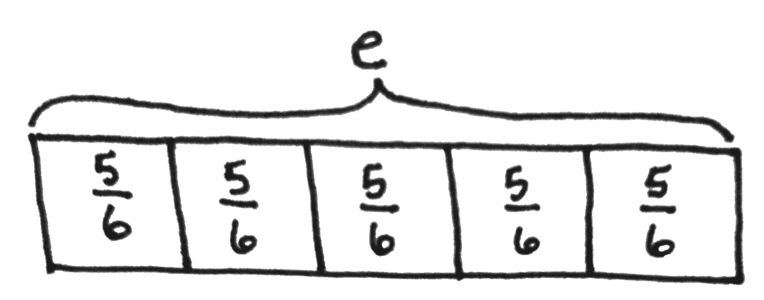
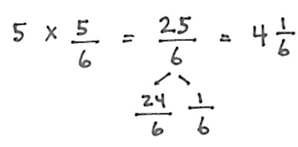
?

NOTES ON
MULTIPLE MEANS
OF ENGAGEMENT:
Adjust the Application Problem to challenge students working above grade level. For example, ask, “How many total hours and minutes did Rhonda exercise?”

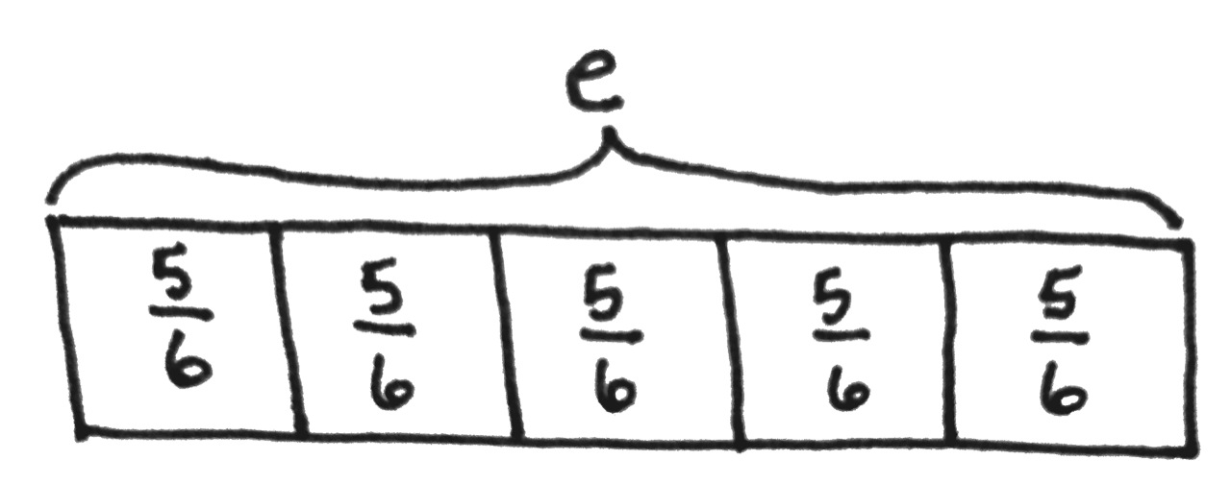

Note: This Application Problem builds on the learning from the previous lesson where students multiplied a whole number by a fraction.
Concept Development (35 minutes)
Materials: (S) Personal white board
Problem 1: Rewrite a repeated addition problem as n times a/b.
T: Look back to the tape diagram we drew for the Application Problem. Say an addition sentence that represents this model.
S: $\frac{\text{5}}{\text{6}}$ + $\frac{\text{5}}{\text{6}}$ + $\frac{\text{5}}{\text{6}}$ + $\frac{\text{5}}{\text{6}}$ + $\frac{\text{5}}{\text{6}}$ = $\frac{\text{25}}{\text{6}}$.
T: Write it as a multiplication expression.
S: 5 × $\frac{\text{5}}{\text{6}}$ = $\frac{\text{25}}{\text{6}}.$
T: Which is more efficient? $\frac{\text{5}}{\text{6}}$ + $\frac{\text{5}}{\text{6}}$ + $\frac{\text{5}}{\text{6}}$ + $\frac{\text{5}}{\text{6}}$ + $\frac{\text{5}}{\text{6}}$ or 5 × $\frac{\text{5}}{\text{6}}$? Discuss with your partner.
MP.2
S: 5 × $\frac{\text{5}}{\text{6}}.$ It doesn’t take as long to write. Multiplication is usually more efficient because making groups is easier than counting by fives, especially if there are a lot of copies.
T: How do we solve 5 × $\frac{\text{5}}{\text{6}}?$
S: We know 5 × $\frac{\text{5}}{\text{6}}$ can be solved like this: $\frac{\text{5 ×} \text{5}}{\text{6}}\text{=}\frac{\text{25}}{\text{6}}$. It’s 5 × 5 sixths, so that is 25 sixths.
Repeat with $\frac{\text{3}}{\text{5}}$ + $\frac{\text{3}}{\text{5}}$ + $\frac{\text{3}}{\text{5}}$ + $\frac{\text{3}}{\text{5}}$ , drawing a tape diagram and solving using multiplication.
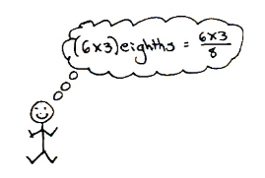
Problem 2: Solve n times a/b as (n × a)/b.
T: (Project 6 × $\frac{\text{3}}{\text{8}}$.) Say this expression in unit form.
S: 6 × 3 eighths.
T: (6 × 3) eighths = $\frac{\text{6 × 3}}{\text{8}}$, yes?
MP.2
S: Yes!
T: Use this way of recording this time.
S: 6 × $\frac{\text{3}}{\text{8}}$ = $\frac{\text{6 × 3}}{\text{8}}$ = $\frac{\text{18}}{\text{8}}.$
T: Rename as a mixed number.
S: $\frac{\text{18}}{\text{8}}$ = $\frac{\text{16}}{\text{8}}$ + $\frac{\text{2}}{\text{8}}$ = $\text{2}\frac{\text{2}}{\text{8}}$.
Repeat with$\frac{\text{3}}{\text{8}}$ × 5 and 9 × $\frac{\text{4}}{\text{5}}$.
Problem 3: Solve a word problem involving the multiplication of fractions.
T: The serving size for cereal is $\frac{\text{2}}{\text{3}}$ cup. Each of 27 students in health class measured out one serving to eat for breakfast. If a box of cereal contained 16 cups, how many boxes of cereal were needed?

NOTES ON
MULTIPLE MEANS
OF ENGAGEMENT:
Empower students working below grade level to solve on-level word problems by using strategies such as the distributive property or decomposition. For example, students who are challenged by 27 × 2 can multiply (20 + 7) × 2 = (20 × 2) + (7 × 2) = 40 + 14, or 9 × (3 × 2).

T: Draw what you know and write an expression to solve.
S: 27 × $\frac{\text{2}}{\text{3}}$ = $\frac{\text{27 × 2}}{\text{3}}$ = $\frac{\text{54}}{\text{3}}$cups.
T: As a mixed number?
S: Hmm. Those numbers are bigger than I am used to converting.
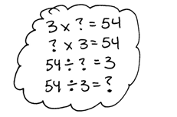
T: We want to know how many groups of $\frac{\text{3}}{\text{3}}$ there are in $\frac{\text{54}}{\text{3}}$. Three times what number is close to or equal to 54? To find that out, I can divide. 54 ÷ 3 = 18. The answer is 18 cups of cereal, so how many boxes are needed?
S: Two boxes because 1 box serves 16 cups, but the class needs 18 cups.
Problem Set (10 minutes)
Students should do their personal best to complete the Problem Set within the allotted 10 minutes. For some classes, it may be appropriate to modify the assignment by specifying which problems they work on first. Some problems do not specify a method for solving. Students should solve these problems using the RDW approach used for Application Problems.
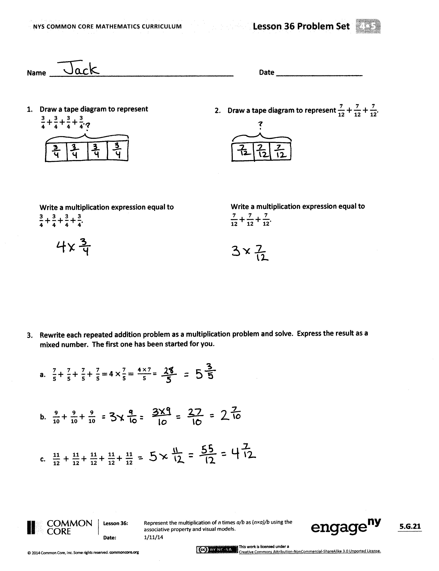
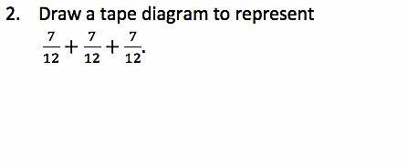
Student Debrief (10 minutes)
Lesson Objective: Represent the multiplication of n times a/b as (n × a)/b using the associative property and visual models.
The Student Debrief is intended to invite reflection and active processing of the total lesson experience.
Invite students to review their solutions for the Problem Set. They should check work by comparing answers with a partner before going over answers as a class. Look for misconceptions or misunderstandings that can be addressed in the Debrief. Guide students in a conversation to debrief the Problem Set and process the lesson.
Any combination of the questions below may be used to lead the discussion.
- Problem 4(d) is a good example of how multiplication is more efficient than repeated addition. Explain.
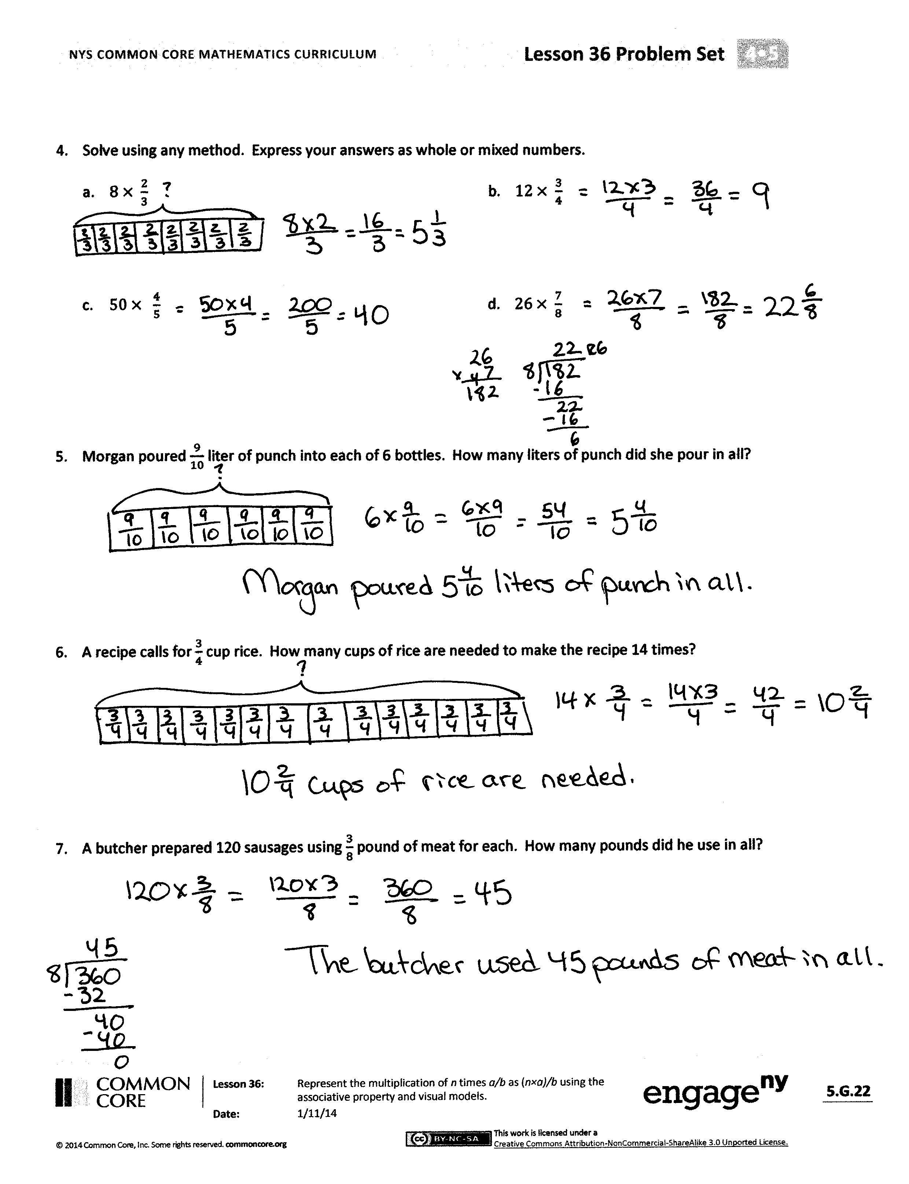
- Explain to your partner the method that you used to solve Problem 4(a–d).
- What was challenging about Problem 4(d)?
- Problem 4(b) results in a fraction greater than 1 with a large numerator. Watch as the fraction is renamed before multiplying. Discuss what you see with your partner. How does this method simplify the work done after the product is found?
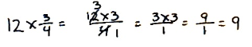

- Try solving Problem 4(c) using a method similar to the one used above. (Note: Simplification is not a requirement in Grade 4 standards.)
Exit Ticket (3 minutes)
After the Student Debrief, instruct students to complete the Exit Ticket. A review of their work will help with assessing students’ understanding of the concepts that were presented in today’s lesson and planning more effectively for future lessons. The questions may be read aloud to the students.
Name Date
1. Draw a tape diagram to represent 2. Draw a tape diagram to represent
$\frac{3}{4}+\frac{3}{4}+\frac{3}{4}+\frac{3}{4}.$ $\frac{7}{12}+\frac{7}{12}+\frac{7}{12}$.

Write a multiplication expression equal to Write a multiplication expression equal to
$\frac{3}{4}+\frac{3}{4}+\frac{3}{4}+\frac{3}{4}$. $\frac{7}{12}+\frac{7}{12}+\frac{7}{12}$

- Rewrite each repeated addition problem as a multiplication problem and solve. Express the result as a mixed number. The first one has been started for you.

- $\frac{7}{5}+ \frac{7}{5}+ \frac{7}{5}+ \frac{7}{5}=$4 $×\frac{7}{5}= \frac{4 × 7}{5}$ =

- $\frac{9}{10}+ \frac{9}{10}+ \frac{9}{10}$

- $\frac{11}{12} + \frac{11}{12}+ \frac{11}{12}+ \frac{11}{12}+ \frac{11}{12}$

- Solve using any method. Express your answers as whole or mixed numbers.

- $8× \frac{2}{3}$
- $12× \frac{3}{4}$

- $50× \frac{4}{5}$
- $26× \frac{7}{8}$

- Morgan poured $\frac{9}{10}$ liter of punch into each of 6 bottles. How many liters of punch did she pour in all?

- A recipe calls for $\frac{3}{4}$ cup rice. How many cups of rice are needed to make the recipe 14 times?

- A butcher prepared 120 sausages using $\frac{3}{8}$ pound of meat for each. How many pounds did he use in all?

Name Date

Solve using any method.

- $7 × \frac{3}{4}$

- $9 × \frac{2}{5}$

- $60 × \frac{5}{8}$

Name Date
- Draw a tape diagram to represent 2. Draw a tape diagram to represent
$\frac{2}{3}+\frac{2}{3}+\frac{2}{3}+\frac{2}{3}$. $\frac{7}{8}+\frac{7}{8}+\frac{7}{8}$.

Write a multiplication expression equal to Write a multiplication expression equal to
$\frac{2}{3}+\frac{2}{3}+\frac{2}{3}+\frac{2}{3}$. $\frac{7}{8}+\frac{7}{8}+\frac{7}{8}$.

- Rewrite each repeated addition problem as a multiplication problem and solve. Express the result as a mixed number. The first one has been completed for you.
  - $\frac{7}{5}+ \frac{7}{5}+ \frac{7}{5}+ \frac{7}{5}=$4 $×\frac{7}{5}= \frac{4 × 7}{5}$ = $\frac{28}{5}$ = $5\frac{3}{5}$
  - $\frac{7}{10}+ \frac{7}{10}+ \frac{7}{10}$
  - $\frac{5}{12} + \frac{5}{12}+ \frac{5}{12}+ \frac{5}{12}+ \frac{5}{12}$ $+ \frac{5}{12}$
  - $\frac{3}{8}+ \frac{3}{8}+ \frac{3}{8}+ \frac{3}{8}+\frac{3}{8} + \frac{3}{8}+ \frac{3}{8}+ \frac{3}{8}+ \frac{3}{8} + \frac{3}{8}+ \frac{3}{8}+ \frac{3}{8}$
- Solve using any method. Express your answers as whole or mixed numbers.
  - $7× \frac{2}{9}$ b. $11×\frac{2}{3}$

- $40× \frac{2}{6}$ d. $24 × \frac{5}{6}$

- $23$ $× \frac{3}{5}$ f. $34 × \frac{2}{8}$

- Coleton is playing with interlocking blocks that are each $\frac{3}{4}$ inch tall. He makes a tower 17 blocks tall. How tall is his tower in inches?

- There were 11 players on Mr. Maiorani’s softball team. They each ate $\frac{3}{8}$ of a pizza. How many pizzas did they eat?

- A bricklayer places 12 bricks along an outside wall of a shed. Each brick is $\frac{3}{4}$ foot long. How many feet long is that wall of the shed?

