Lesson 35
Objective: Represent the multiplication of n times a/b as (n × a)/b using the associative property and visual models.

Suggested Lesson Structure
 Fluency Practice (12 minutes)
 Application Problem (5 minutes)
 Concept Development (33 minutes)
 Student Debrief (10 minutes)
Total Time (60 minutes)
Fluency Practice (12 minutes)
- Add and Subtract 4.NBT.4 (4 minutes)
- Count by Equivalent Fractions 4.NF.1 (4 minutes)
- Add and Subtract Mixed Numbers 4.NF.3 (4 minutes)
Add and Subtract (4 minutes)
Materials: (S) Personal white board
Note: This fluency activity reviews adding and subtracting using the standard algorithm.
T: (Write 676 thousands 696 ones.) On your personal white boards, write this number in standard form.

NOTES ON
MULTIPLE MEANS
OF ACTION AND EXPRESSION:
Some learners may benefit from using grid paper or a place value chart to organize numbers up to 1 million as they add and subtract.
S: (Write 676,696.)
T: (Write 153 thousands 884 ones.) Add this number to 676,696 using the standard algorithm.
S: (Write 676,696 + 153,884 = 830,580 using the standard algorithm.)
Continue the process for 678,717 + 274,867.
T: (Write 300 thousands.) On your boards, write this number in standard form.
S: (Write 300,000.)
T: (Write 134 thousands 759 ones.) Subtract this number from 300,000 using the standard algorithm.
S: (Write 300,000 – 134,759 = 165,241 using the standard algorithm.)
Continue the process for 734,902 – 477,479.
Count by Equivalent Fractions (4 minutes)
Note: This activity reviews Lesson 24. The progression builds in complexity. Work the students up to the highest level of complexity in which they can confidently participate.
T: Count by threes to 15, starting at 0.
S: 0, 3, 6, 9, 12, 15.
T: Count by 3 fifths to 15 fifths, starting at 0 fifths. (Write as students count.)
S: $\frac{\text{0}}{\text{5}}$ , $\frac{\text{3}}{\text{5}}$ , $\frac{\text{6}}{\text{5}}$ , $\frac{\text{9}}{\text{5}}$ , $\frac{\text{12}}{\text{5}}$ , $\frac{\text{15}}{\text{5}}$.
$\frac{\text{0}}{\text{5}}$ $\frac{\text{3}}{\text{5}}$ $\frac{\text{6}}{\text{5}}$ $\frac{\text{9}}{\text{5}}$ $\frac{\text{12}}{\text{5}}$ $\frac{\text{15}}{\text{5}}$
0 $\frac{\text{3}}{\text{5}}$ $\frac{\text{6}}{\text{5}}$ $\frac{\text{9}}{\text{5}}$ $\frac{\text{12}}{\text{5}}$ 3
0 $\frac{\text{3}}{\text{5}}$ $\text{1}\frac{\text{1}}{\text{5}}$ $\text{1}\frac{\text{4}}{\text{5}}$ $\text{2}\frac{\text{2}}{\text{5}}$ 3

T: 1 one is the same as how many fifths?
S: 5 fifths.
T: 2 ones?
S: 10 fifths.
T: 3 ones?
S: 15 fifths.
T: (Beneath $\frac{\text{15}}{\text{5}}$, write 3.) Count by 3 fifths again. This time, when you come to the whole number, say the whole number. (Write as students count.)
S: $\text{0}$, $\frac{\text{3}}{\text{5}}$ , $\frac{\text{6}}{\text{5}}$ , $\frac{\text{9}}{\text{5}}$ , $\frac{\text{12}}{\text{5}}$ , 3.
T: (Point to $\frac{\text{6}}{\text{5}}$.) Say $\frac{\text{6}}{\text{5}}$ as a mixed number.
S: $\text{1}\frac{\text{1}}{\text{5}}$.
Continue the process for $\frac{\text{9}}{\text{5}}$ and $\frac{\text{12}}{\text{5}}$.
T: Count by 3 fifths again. This time, convert to whole numbers and mixed numbers. (Write as students count.)
S: 0, $\frac{\text{3}}{\text{5}}$, $\text{1}\frac{\text{1}}{\text{5}}$ , $\text{1}\frac{\text{4}}{\text{5}}$ , $\text{2}\frac{\text{2}}{\text{5}}$ , 3.
Add and Subtract Mixed Numbers (4 minutes)
Materials: (S) Personal white board
Note: This fluency activity reviews Lesson 31 and Lesson 33. Allow students to solve using any strategy.
T: (Write $\text{5}\frac{\text{5}}{\text{10}}$ + $\text{3}\frac{\text{2}}{\text{10}}$ = .) Decompose the mixed numbers and solve.
S: (Write $\text{5}\frac{\text{5}}{\text{10}}$ + $\text{3}\frac{\text{2}}{\text{10}}$ = $\text{8}\frac{\text{7}}{\text{10}}.$)
Continue with the following possible sequence: $\text{2}\frac{\text{3}}{\text{5}}$ + $\text{2}\frac{\text{2}}{\text{5}}$ , $\text{10}\frac{\text{3}}{\text{5}}$ + $\text{5}\frac{\text{4}}{\text{5}}$ , and $\text{7}\frac{\text{2}}{\text{3}}$ + $\text{3}\frac{\text{2}}{\text{3}}$.
T: (Write $\text{10}\frac{\text{7}}{\text{10}}$ – $\text{5}\frac{\text{4}}{\text{10}}$ = .) Decompose the mixed numbers and solve.
S: (Write $\text{10}\frac{\text{7}}{\text{10}}$ – $\text{5}\frac{\text{4}}{\text{10}}$ = $\text{5}\frac{\text{3}}{\text{10}}.$)
Continue with the following possible sequence: $\text{6}\frac{\text{2}}{\text{3}}$ – $\text{3}\frac{\text{2}}{\text{3}}$ , $\text{6}\frac{\text{1}}{\text{3}}$ – $\text{4}\frac{\text{2}}{\text{3}}$ , $\text{10}\frac{\text{1}}{\text{5}}$ – $\text{4}\frac{\text{3}}{\text{5}}$ , and $\text{6}\frac{\text{3}}{\text{8}}$ – $\text{2}\frac{\text{7}}{\text{8}}$.
Application Problem (5 minutes)

NOTES ON
MULTIPLE MEANS
OF REPRESENTATION:
Modeling the change in the association of the 54 centimeters with the factor of 3 prepares students to interpret fraction multiplication using the associative property, e.g., 3 × 4 fifths = 3 × $\frac{\text{4}}{\text{5}}$ = (3 × 4) fifths = $\frac{\text{3} \text{×} \text{4}}{\text{5}}.$
Students might also benefit from understanding that 3 × 54 cm = 3 × (54 × 1 cm), just as 3 × $\frac{4}{5}$ =
3 × (4 × $\frac{\text{1}}{\text{5}}$).
Since notation can become a barrier for students, be prepared to adjust it when necessary. The Concept Development aims to keep it very simple.

Mary Beth is knitting scarves that are 1 meter long. If she knits 54 centimeters of a scarf each night for 3 nights, how many scarves will she complete? How much more does she need to knit to complete another scarf?
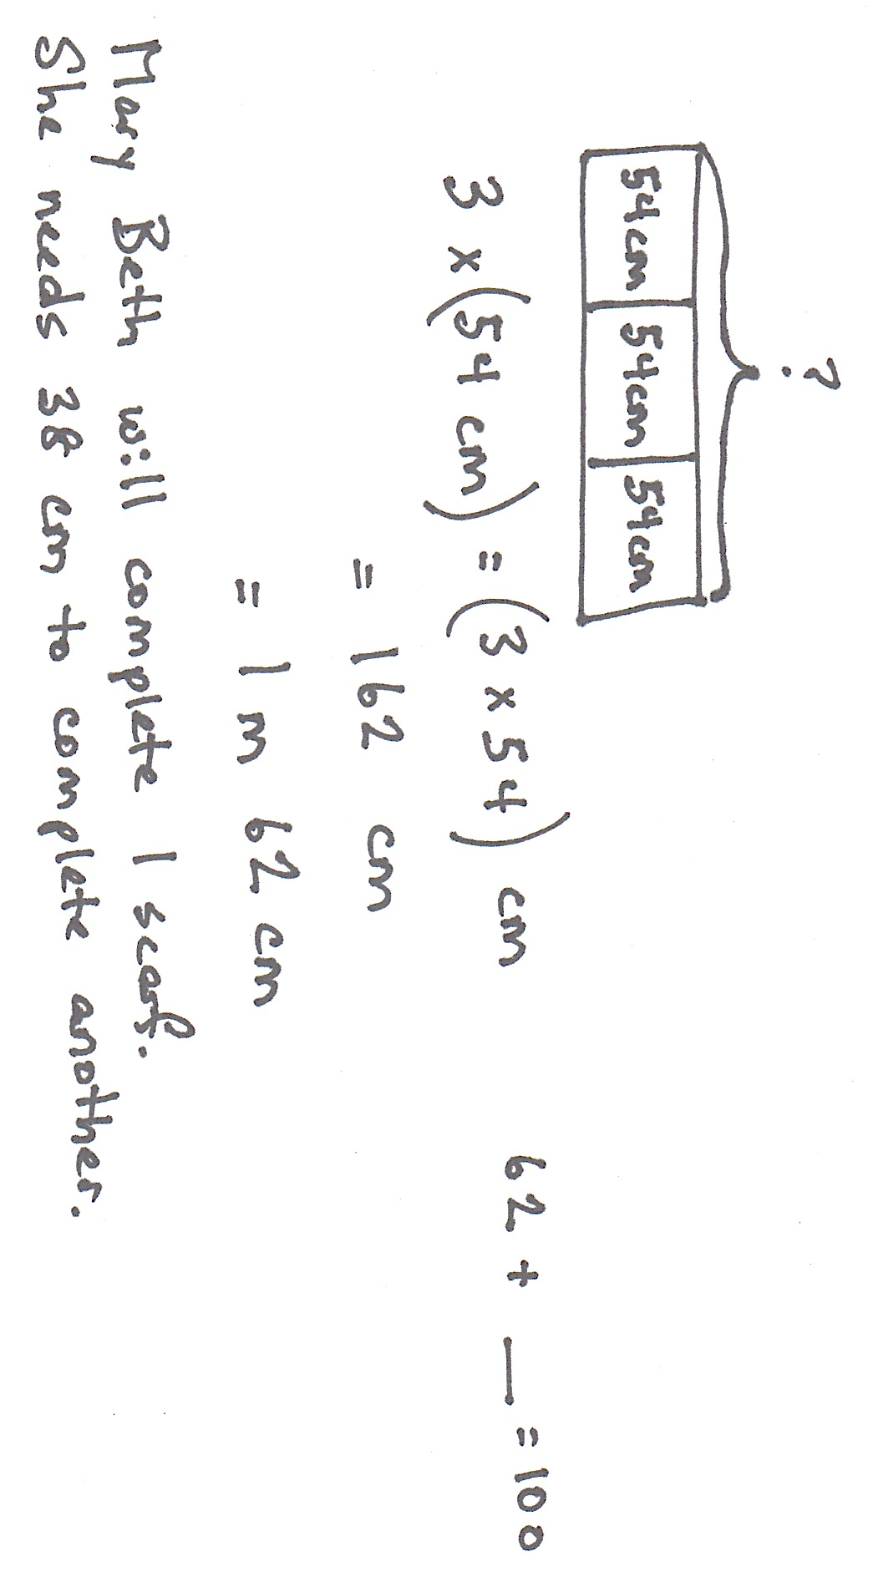

Note: This Application Problem prepares students to think about how a fractional unit behaves like any other unit in a multiplication sentence, e.g., 3 × 4 wheels = 12 wheels, 3 × 54 centimeters = 162 centimeters, and 3 × 4 fifths = 12 fifths or $\frac{\text{3} \text{×} \text{4}}{\text{5}}$.
Concept Development (33 minutes)
Materials: (S) Personal white board
Problem 1: Use the associative property to solve $\text{n}$ × $\frac{a}{b}$ in unit form.
T: Write a multiplication number sentence to show four copies of 3 centimeters.
S: (Write 4 × 3 centimeters = 12 centimeters.)
T: (Write 4 × (3 centimeters).) I put parentheses around 3 centimeters to show that 3 is telling the number of centimeters in one group, but to solve, we moved the parentheses. Show me where you moved them to.
S: (Write (4 × 3) centimeters = 12 centimeters.)
T: Yes, you used the associative property by associating the 3 with the number of groups rather than the unit of centimeters.

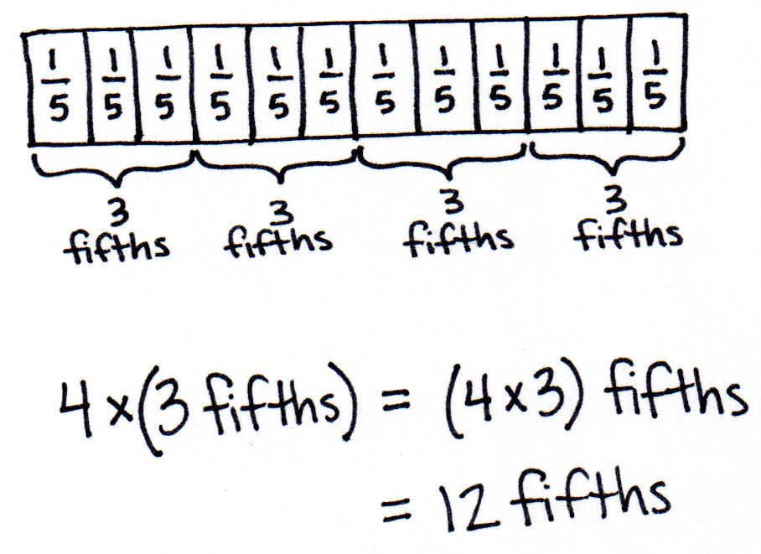
T: Write a multiplication number sentence to show four copies of 3 fifths in unit form.
S: (Write 4 × 3 fifths = 12 fifths.)
T: (Write 4 × (3 fifths) = (4 × 3) fifths.) Is this true?
S: Yes, that’s the associative property.
T: Draw a tape diagram to show four copies of 3 fifths.
S: (Draw a tape diagram.)
Repeat with three copies of 5 sixths and four copies of 3 eighths, associating the factors and drawing a matching tape diagram.
Problem 2: Use the associative property to solve $\text{n}$ × $\frac{\text{a}}{\text{b}}$ numerically.
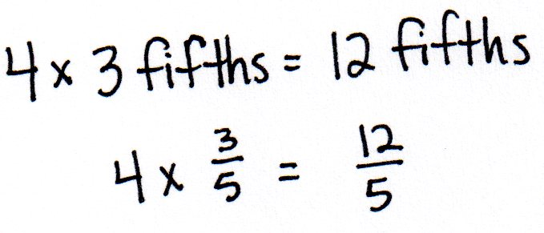
T: (Display 4 × $\frac{\text{3}}{\text{5}}$.) Say this expression.
S: Four times 3 fifths.
T: Write it in unit form.
S: (Write 4 × 3 fifths.) We just did this problem!
T: Compare these number sentences. (See figure at the right). Are these true? Discuss with your partner.

NOTES ON
MULTIPLE MEANS
OF REPRESENTATION:
When using the associative property to solve 4 × $\frac{\text{3}}{\text{5}}$ , some students may proficiently solve mentally, while others may need visual support to solve, including step-by-step guidance. For example, before asking for the value of (4 × 3) × $\frac{\text{1}}{\text{5}}$ , it might be helpful to ask, “What is 12 × $\frac{\text{1}}{\text{5}}$?”

S: Yes, the top was solved in unit form, and the bottom used numbers.
T: (Write 4 × (3 × $\frac{\text{1}}{\text{5}}$) = 4 × 3 fifths.) We can say
4 × (3 × $\frac{\text{1}}{\text{5}}$) = 4 × 3 fifths. On your personal board, move the parentheses to associate the factors of 4 and 3.
S: (Write (4 × 3) × $\frac{\text{1}}{\text{5}}$.)
T: And the value is…?
S: $\frac{\text{12}}{\text{5}}.$
T: (Write 4 × (3 × $\frac{\text{1}}{\text{5}}$) = (4 × 3) × $\frac{\text{1}}{\text{5}}$ = $\frac{\text{12}}{\text{5}}$.)
Is 4 groups of 3 fifths the same as 12 fifths?
S: Yes$.$
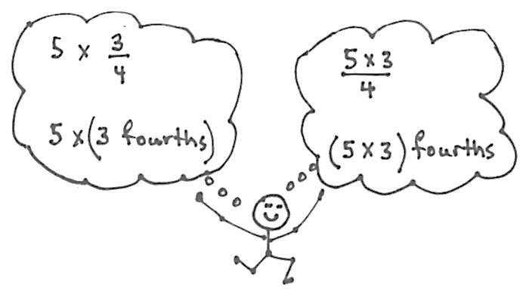
T: (Display 5 × $\frac{\text{3}}{\text{4}}$.) Say this expression.
S: Five times 3 fourths.
T: Keep the unit form in mind as you solve
numerically. Record only as much as you need.
S: 5 × $\frac{\text{3}}{\text{4}}$ = $\frac{\text{15}}{\text{4}}.$
T: Yes, and as I thought of this as 5 times 3 fourths, I wrote down 5 × $\frac{\text{3}}{\text{4}}$ = $\frac{\text{5 × 3}}{\text{4}}$ = $\frac{\text{15}}{\text{4}}$.
Why is my expression true?
S: When you associated the factors, fourths became the unit, and we write the unit fourths as the denominator.
T: Yes. I think of 5 × (3 fourths) as 5 × $\frac{\text{3}}{\text{4}}$ and (5 × 3) fourths as $\frac{\text{5 × 3}}{\text{4}}.$
Both have the same value—12 fourths.
Repeat with 8 × $\frac{\text{2}}{\text{3}}$ and 12 × $\frac{\text{3}}{\text{10}}$.
Problem Set (10 minutes)
Students should do their personal best to complete the Problem Set within the allotted 10 minutes. For some classes, it may be appropriate to modify the assignment by specifying which problems they work on first. Some problems do not specify a method for solving. Students should solve these problems using the RDW approach used for Application Problems.
Student Debrief (10 minutes)
Lesson Objective: Represent the multiplication of n times a/b as (n × a)/b using the associative property and visual models.
The Student Debrief is intended to invite reflection and active processing of the total lesson experience.
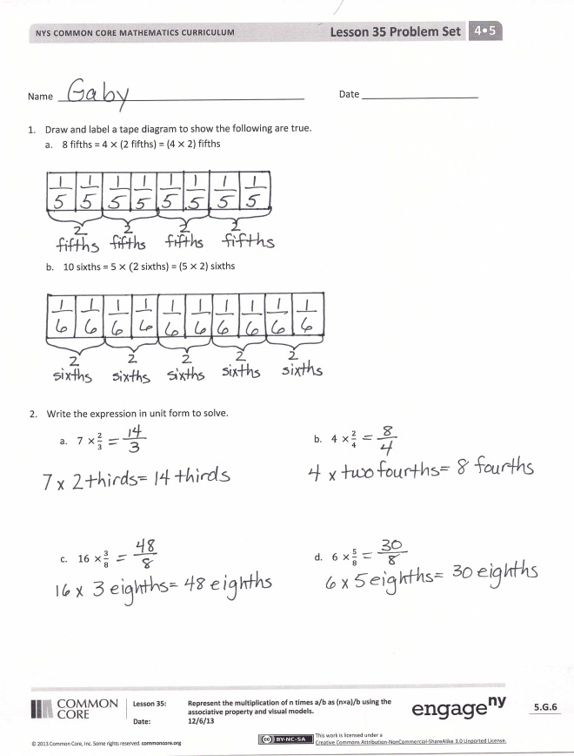
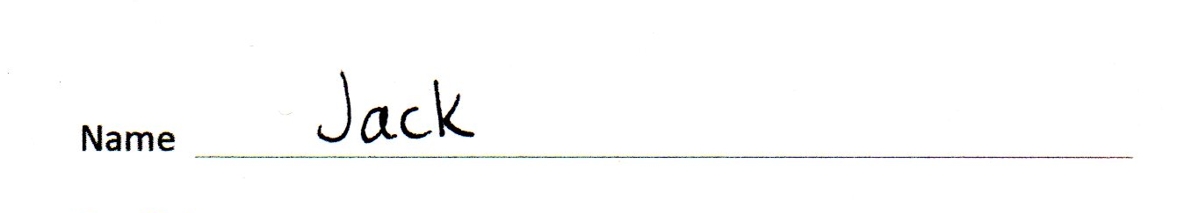
Invite students to review their solutions for the Problem Set. They should check work by comparing answers with a partner before going over answers as a class. Look for misconceptions or misunderstandings that can be addressed in the Debrief. Guide students in a conversation to debrief the Problem Set and process the lesson.
Any combination of the questions below may be used to lead the discussion.
- How do the tape diagrams that you drew in Problems 1(a) and 1(b) help with the understanding that there are different ways to express fractions?
- How did you record your solutions to Problem 3(a–f)?
- Look at your answers for Problem 3(c) and 3(d). Convert each answer to a mixed number. What do you notice? How are the expressions in Problem 3(c) and 3(d) similar?
- How does moving the parentheses change the meaning of the expression? Use the tape diagrams in Problem 1 to help you explain.
- Explain to a partner how you solved Problem 4.
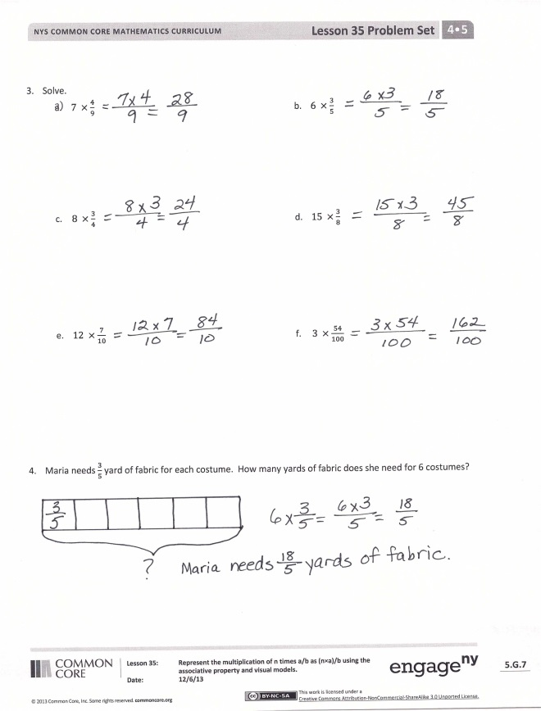
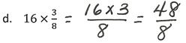
- What significant math vocabulary did we use today to communicate precisely?
- How does the Application Problem relate to today’s Concept Development?
Exit Ticket (3 minutes)
After the Student Debrief, instruct students to complete the Exit Ticket. A review of their work will help with assessing students’ understanding of the concepts that were presented in today’s lesson and planning more effectively for future lessons. The questions may be read aloud to the students.

Name Date
- Draw and label a tape diagram to show the following are true.
- 8 fifths = 4$×$ (2 fifths) = (4$×$ 2) fifths

- 10 sixths = 5 $×$ $(2$sixths) = (5 $×$ 2) sixths

- Write the expression in unit form to solve.

- $7×\frac{2}{3}$

- $4×\frac{2}{4}$

- $16×\frac{3}{8}$
- $6×\frac{5}{8}$

- Solve.

- $7×\frac{4}{9}$
- $6×\frac{3}{5}$

- $8×\frac{3}{4}$
- $16×\frac{3}{8}$

- $12×\frac{7}{10}$
- $3×\frac{54}{100}$

- Maria needs $\frac{3}{5}$ yard of fabric for each costume. How many yards of fabric does she need for 6 costumes?

Name Date
- Solve using unit form.
$\text{5} \text{×}\frac{\text{2}}{\text{3}}$

- Solve.

$11×\frac{5}{6}$

Name Date
- Draw and label a tape diagram to show the following are true.
- 8 thirds = 4 $×$ (2 thirds) = (4 $×$ 2) thirds

- 15 eighths = 3 $×$ $(5$eighths) = (3 $×$ 5) eighths

- Write the expression in unit form to solve.
- 10 $×\frac{2}{5}$ b. 3 $×\frac{5}{6}$

- 9 $×\frac{4}{9}$ d. 7 $×\frac{3}{4}$

- Solve.
- $6×\frac{3}{4}$ b. $7×\frac{5}{8}$

- 13 $× \frac{2}{3}$ d. 18 $×\frac{2}{3}$

- $14×\frac{7}{10}$ f. $7×\frac{14}{100}$

- Mrs. Smith bought some orange juice. Each member of her family drank $\frac{2}{3}$ cup for breakfast. There are five people in her family. How many cups of orange juice did they drink?

