Grade 4: Module 3B: Unit 3: Lesson 3
Reading as Writers: Identifying Characteristics of Broadsides

Long-Term Targets Addressed (Based on NYSP12 ELA CCLS)
I can explain how an author uses reasons and evidence to support particular points in a text. (RI.4.8)
I can write an opinion piece that supports a point of view with reasons and information. (W.4.1)

Supporting Learning Targets | Ongoing Assessment
- I can explain how authors support their opinions with reasons and evidence.  - I can identify the characteristics of a broadside. | - Reading and Analyzing an Opinion Piece graphic organizers (from Lesson 2 classwork and homework)  - What Do You See? graphic organizer  - Participation in creation of Characteristics of Broadsides anchor chart

Agenda | Teaching Notes
- Opening  - Reviewing Learning Targets (5 minutes)  - Work Time  - Reviewing Homework: Sharing the Gist, Opinion, Reasons, and Evidence (20 minutes)  - Discussing Opinion during the American Revolution (10 minutes)  - Exploring Broadsides: Gallery Walk (15 minutes)  - Closing and Assessment  - Debrief/Broadsides Anchor Chart (5 minutes)  - Preparing for the Mid-Unit 3 Assessment (5 minutes)  - Homework  - Review your study guide for the mid-unit assessment. | - In this first half of this lesson, students continue to learn how authors articulate and support their opinions in writing by analyzing the opinion letter they read for Lesson 2 homework, from the perspective of the main character, Robert Barton, from the play Divided Loyalties. They again focus on how the character supports his opinion with reasons and evidence., and continue to define the characteristics of opinion writing through this letter and add to the Exploring Opinions as Readers and Writers anchor chart (begun in Lesson 1).  - In the second half of the lesson, students are introduced to the concept of broadsides through a Gallery Walk to help them understand how broadsides were used to share opinions during the American Revolution. Students co-create a Characteristics of Broadsides anchor chart after examining real broadsides from the time period of the revolution. They will add to and refer to this anchor chart throughout the remainder of this unit as they create their own broadsides.  - As with Lesson 2, adjust the pacing for Work Time B based on how much support your students need.  - In advance:  - Review students’ Reading and Analyzing an Opinion Piece graphic organizers (from Lesson 2 classwork and homework) to determine if any students should be pulled into a small group supported by the teacher during Work Time B.  - If you provided students with a copy of the Exploring Opinions and Reasons anchor chart in Lesson 2, encourage them to add to it (see example for teacher reference).  - Review Gallery Walk protocol (see Appendix).  - Prepare the Gallery Walk of broadsides (see supporting materials) by making one large copy of each broadside to display. Also hang the descriptions and excerpts of each broadside next to them so students do not have to read the entire broadside, but can still get an idea about it during the Gallery Walk.  - Prepare: Characteristics of Broadsides anchor chart (see supporting materials).  - Review Concentric Circles protocol (see Appendix).  - Post: Learning targets.

Lesson Vocabulary | Materials
opinions, reasons, evidence, characteristics, broadsides | - Writing folders (from Lesson 2)  - Document camera  - Reading and Analyzing an Opinion Piece graphic organizer (from Lesson 2; one blank copy for teacher modeling)  - Exploring Opinions as Readers and Writers anchor chart (added to in Lesson 2)  - Exploring Opinions as Readers and Writers anchor chart (for teacher reference; see supporting materials)  - Lesson 1 exit ticket (one for display)  - What Do You See? graphic organizer (one per student)  - Broadsides for the Gallery Walk, #1-8 (printed out on large paper for display)  - Characteristics of Broadsides anchor chart (new; co-created in Closing and Assessment A; see supporting materials)  - Notebook paper

Opening | Meeting Students’ Needs
A. Reviewing Learning Targets (5 minutes)
- Share the learning target: “I can identify the characteristics of a broadside” with students. Tell students that they will learn more about broadsides today.
- Remind students of the learning target: “I can explain how authors support their opinions with reasons and evidence.” Ask them to turn and share with a partner what opinion Robert Barton expressed in the letter they read for homework. Explain that, together, you will look more closely at the opinion, reasons and evidence in Robert Barton’s letter.

Work Time | Meeting Students’ Needs
A. Reviewing Homework: Sharing the Gist, Opinion, Reasons, and Evidence (20 minutes)  - Distribute students’ completed Reading and Analyzing an Opinion Piece graphic organizer for William Barton’s opinion letter (from Lesson 2). Ask students to put this in their writing folder for safekeeping.  - Ask students to get out their copy of Robert Barton’s opinion letter and their Reading and Analyzing an Opinion Piece graphic organizer from last night’s homework.  - Have students share answers to Question 1 from their homework with a partner. Ask them to listen closely to their partner’s answer, as they may be asked to share it with the rest of the class.  - Ask for a few pairs to share their partner’s answer. Listen for the following gist: “This letter is about what Robert Barton thinks about the American Revolution.” Help students if they are struggling to generate this gist statement independently.  - Using a document camera, display your Reading and Analyzing an Opinion Piece graphic organizer (blank copy for teacher modeling). Model for students: Based on the class’ discussion, write a gist statement. Encourage students to add or revise their gist statements if necessary.  - Display Robert Barton’s opinion letter. Zoom in on the first paragraph. Ask partners to share their answers to Question 2 on their graphic organizers and find where in the first paragraph of the text a reader can find this opinion stated.  - Ask a few pairs to share the opinion they recorded and point out where this opinion can be found in the text. Listen for the students to say that Robert’s opinion is that: “They should stay loyal to Great Britain.” They should point out the following sentences in the text: “We are loyal citizens of Great Britain, and will remain so.”  - Prompt students with the following question:  - “How did you determine the author’s opinion?”  - Encourage them to reference the text and Exploring Opinions as Readers and Writers anchor chart for characteristics of opinions. | - Consider adding a think-aloud with more explicit modeling to further support students if they are having trouble getting the gist of this letter.

Work Time (continued) | Meeting Students’ Needs
- Then add Robert Barton’s opinion to Question 2 on your displayed Reading and Analyzing an Opinion Piece graphic organizer. Allow students to once again add to or revise their own graphic organizers (if necessary).
- Ask partners to share their answers to Question 3 on their graphic organizers and point out the reasons/evidence they used in the text.
- Ask a few pairs to share the reasons and evidence they recorded and point out where they found these in the text. Listen for the students to say something like: “You forget that paying those taxes is our duty as subjects of the British crown” and “Great Britain protected us against France in the last war, and British soldiers continue to keep us safe.”
- Let students know they will continue to work on the target: “I can explain how authors support their opinions with reasons and evidence” as they explore some broadsides today.

Work Time (continued) | Meeting Students’ Needs
B. Discussing Opinion during the American Revolution (10 minutes)  - Ask students to turn and talk about the ways people can share their opinion in today’s world. Listen for students to say things like: “Twitter,” “Facebook,” “newspaper editorials,” “blogs,” etc.  - Now invite students to think about how people may have shared their opinion during the American Revolution when all of the things they listed did not yet exist. Give students a few seconds to just think.  - Tell students that in the American colonies, printers had an important job. Their job was to use their printing press to create documents that could be used to educate, advertise, share new, and give someone’s opinion. These documents were often posted in public spaces where people could read them. They often weren’t able to print enough copies for everyone to have their own copy, so they printed fewer and posted them in places where many people could share them. Let students know that they’ll experience something similar to this during today’s Gallery Walk. There may be many students trying to read the same document at the same time, but it is a public document meant for many to read and share, just as the colonists experienced with broadsides printed and posted during the time period of the revolution.  - Display and read aloud the first excerpt from the Lesson 1 exit ticket: “… gloriously fighting in the cause of liberty and country …”  - Remind students that they first read this excerpt on the Lesson 1 exit ticket and discussed it again in Lesson 2.  - Ask students to turn and talk to a neighbor about this author’s opinion of the American Revolution. After a few seconds, invite pairs to share out what they think and how they know. Listen for students to say something like: “This author thinks that the colonies should be free from the King. I know because the quote talks about liberty and it says that fighting is glorious.”  - Display and read aloud the second excerpt from the Lesson 1 exit ticket: “All of the colonies are firm and unshaken in their attachment to the common cause of America, and they are now ready, with their lives and fortunes, to assist us in defeating the cruel enemy.”  - Ask students to turn and talk to a neighbor about this author’s opinion of the American Revolution. After a few seconds, invite pairs to share out what they think and how they know. Listen for students to say something like: “This author also thinks that the colonies should be free from the King. I know because the quote talks about Britain as the ‘cruel enemy,’” or “This author thinks that all the colonies should work together to defeat the King and fight for freedom for America. I know because the quote says that the colonies are ‘firm and unshaken’ and that they are ‘ready.’” | - Determining which sentences or phrases from the text most clearly state the evidence or details used by the author can be difficult for students. If you find students struggling to pull this evidence out of the text, consider explicitly modeling with a think-aloud that allows students to understand the process of selectively choosing evidence or details to underline.  - It is important that students be able to identify reasons and evidence independently so they can explain how it supports the author’s opinion. Students will be asked to do this independently on the mid-unit assessment in Lesson 4. If you have students who are continuing to struggle with this, consider pulling them into a small group or having them work with a partner during this portion of the lesson.

Work Time (continued) | Meeting Students’ Needs
C. Exploring Broadsides: Gallery Walk (15 minutes)
- Tell students that now they will investigate more broadsides on their own. Remind students about the Gallery Walk protocol, emphasizing the importance of silence as others look at and read the documents in the gallery.
- Distribute copies of the What Do You See? graphic organizer. Remind students that they used this graphic organizer during the Gallery Walk in Unit 1 as well. Let students know that they will be focusing on filling in the Document and Observations columns while they are in the gallery today. Cold call one student to tell others what they will write about in each of these columns. Be sure to emphasize that observations are just what they see—not what they think. There will time for reflection after they look.
- As you invite students to silently enter the gallery, let them know that they will see many examples of broadsides for the Gallery Walk so that they can meet the target: “I can identify the characteristics of a broadside.”
- Give students about 5-7 minutes to explore the gallery.
- As students complete their observations, encourage them back to their workspace to fill in the Inferences, Knowledge, and Further Research columns on their own.
- After all students have returned to their workspace, remind them about what to do in each column of the What Do You See? graphic organizer. Give students about 5-7 minutes to complete the graphic organizer.

Closing and Assessment | Meeting Students’ Needs
A. Debrief/Broadsides Anchor Chart (5 minutes)  - Ask students to arrange themselves so they are ready for the Concentric Circles protocol.  - Ask each of the following questions and have students rotate partners for each question:  - “Now that you’ve seen some more broadsides, what do you think broadsides were used for during the American Revolution?”  - “What was one characteristic you saw in most of the broadsides you looked at today?”  - “What was one opinion you saw expressed in the broadsides?”  - Gather students back together to add to the Characteristics of Broadsides anchor chart. Call on students to report what they learned today from the Gallery Walk and from their conversations during Concentric Circles.  - Complete the anchor chart together, listing characteristics of broadsides. | - To further support students in their analysis of opinion pieces, you may want to provide students with their own copy of the texts as well as displaying them on the document camera.
B. Preparing for the Mid-Unit 3 Assessment (5 minutes)  - Tell students that on the upcoming mid-unit assessment, they will demonstrate their progress toward the following learning target:  - “I can explain how authors support their opinions with reasons and evidence.”  - Remind students that they now know what an opinion is, how to identify one in an author’s writing, and how authors support their opinions with reasons and evidence.  - Ask students to make a copy of the Exploring Opinions as Readers and Writers anchor chart on notebook paper to use as a study guide for their homework (see supporting materials for an example of a finished Exploring Opinions as Readers and Writers form).  - Tell them that for their assessment, they will read an opinion piece and identify the opinion as well as the author’s reasons and evidence used to support that opinion. Reassure students that there are no tricks with this assessment. They will be using the same process they have used over the past several days to closely read an opinion piece and answer questions. | - Consider providing a copy of this anchor chart for students as an alternative to copying it.
Homework | Meeting Students’ Needs
- Review your study guide for the mid-unit assessment.

Grade 4: Module 3B: Unit 3: Lesson 3
Supporting Materials

Exploring Opinions as Readers and Writers Anchor Chart
(For Teacher Reference)

Teacher Directions: This anchor chart was added to in Lesson 2. At the start of this lesson (Lesson 3), the chart should contain the following:

Exploring Opinions as Readers and Writers

opinion—what a person thinks about something or someone; this thinking can be based on facts, feelings, experience or a combination of all three

Characteristics of Opinions:
  - A way of thinking about something
  - A belief
  - A judgment; can be debated or argued
  - A differing point of view could be stated

Opinions are supported by:

Reasons: WHY an author has a particular opinion

WITH

Evidence: HOW authors support their reasons with facts or details (based on research and/or observations)
What Do You See? Graphic Organizer

Document | Observations (NOTICE) | Inferences | Knowledge | Further Research (WONDER)
Picture/  text you are looking at/reading. | Describe exactly what you see/read in the picture/text. | Say what you conclude from what you see/read. | Summarize what you know about the situation and time period shown/described. | What questions has the picture/text raised?

Broadsides for the Gallery Walk
#1

In this broadside, the printer used the image of black coffins across the top to show how many men died in the Battle of Lexington and Concord. This broadside was sent throughout the 13 colonies to spread the word about what Patriots saw as the British Regulars’ gruesome attack on the people of Lexington, Massachusetts.

Excerpts used from Lesson 1: “… gloriously fighting in the cause of liberty and country …” or “All of the colonies are firm and unshaken in their attachment to the common cause of America, and they are now ready, with their lives and fortunes, to assist us in defeating the cruel enemy.”

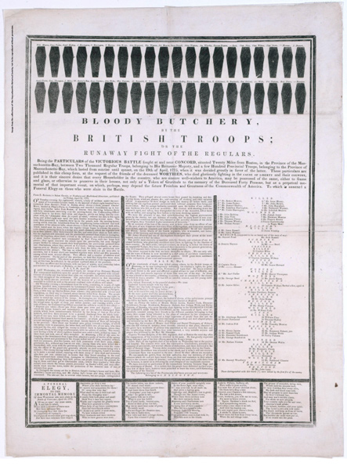
Library of Congress, Rare Book and Special Collections Division

To access the broadside, use the following link:

http://memory.loc.gov/cgi-bin/ampage?collId=rbpe&fileName=rbpe03/rbpe038/0380090a/rbpe0380090a.db&recNum=0&itemLink=r?ammem/AMALL:@field(NUMBER+@band(rbpe+0380090a))&linkText=0

Broadsides for the Gallery Walk
#2

This broadside describes the Battle of Lexington and Concord from the perspective of a British officer who felt the Patriot colonists started the fight.

Excerpts used in Lesson 2: “… this affair has happened through the rashness and imprudence of a few people, who began firing on the troops at Lexington” or “… it was a preconcerted scheme to oppose the King’s troops, whenever there should be a favorable opportunity for it…. They heard many Signal Guns and the ringing of Alarm Bells, which convinced them the Country was rising against them.”

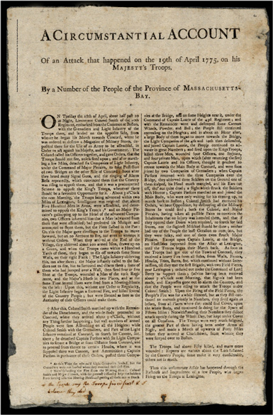
Library of Congress, Rare Book and Special Collections Division

To access the broadside, use the following link:

http://memory.loc.gov/cgi-bin/ampage?collId=rbpe&fileName=rbpe03/rbpe038/03801100/rbpe03801100.db&recNum=0&itemLink=r?ammem/AMALL:@field(NUMBER+@band(rbpe+03801100))&linkText=0
Broadsides for the Gallery Walk
#3

This broadside is a plea for the Congress to officially put together an army to fight the British. The author, a well-known Patriot, is giving his opinion about what the colonists should do—protect themselves and fight for their liberty.

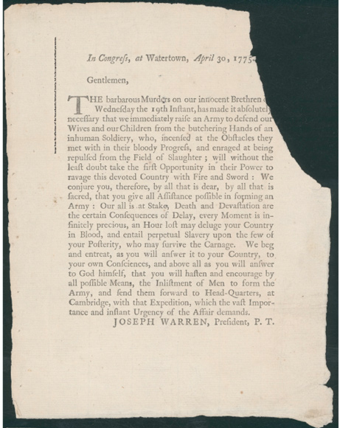
Library of Congress, Rare and Special Book Collection

To access the broadside, use the following link:

http://memory.loc.gov/cgi-bin/ampage?collId=rbpe&fileName=rbpe03/rbpe038/03801200/rbpe03801200.db&recNum=0&itemLink=r?ammem/AMALL:@field(NUMBER+@band(rbpe+03801200))&linkText=0

Broadsides for the Gallery Walk
#4

This broadside is an example of how news was spread during the American Revolution. It tells what happened during the Battle of Lexington and Concord. However, it also shares an opinion. For example, at the end, it says, “The sword is now drawn and God knows when it will be sheathed.”

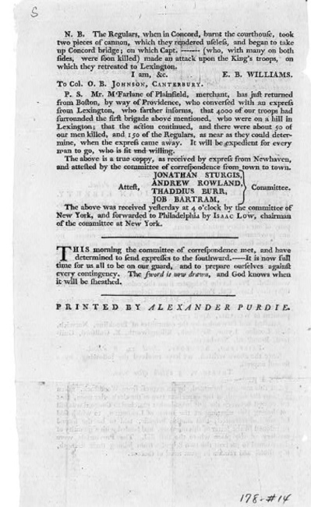
Library of Congress Prints and Photographs Division Washington, D.C, LC-USZ62-44847
To access the broadside, use the following link:

http://www.loc.gov/pictures/resource/cph.3a45071/

Broadsides for the Gallery Walk
#5

This is another broadside giving information about the events of the Battle of Lexington and Concord. The author’s perspective is seen from this quote: “About 1200 of the regular troops (British) are now actually engaged in butchering and destroying our brethren in the most inhuman manner.”

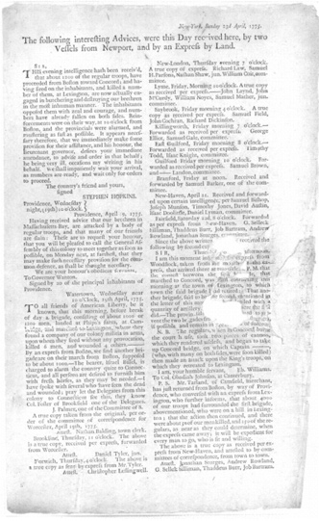
Library of Congress, Rare and Special Book Collection

To access the broadside, use the following link:
http://memory.loc.gov/cgi-bin/ampage?collId=rbpe&fileName=rbpe10/rbpe108/10800500/rbpe10800500.db&recNum=0&itemLink=r?ammem/AMALL:@field(NUMBER+@band(rbpe+10800500))&linkText=0

Broadsides for the Gallery Walk
#6

This broadside shows another way that colonists often shared their opinion about “current” events—in verse, or song. The author’s opinion is clear in these lines: “Our liberty, our life is now invaded, and Freedom’s brightest charms are darkly shaded … Let us with hearts of steel now stand …” We also see an example of how printers used engravings to include an image that may draw people’s attention.

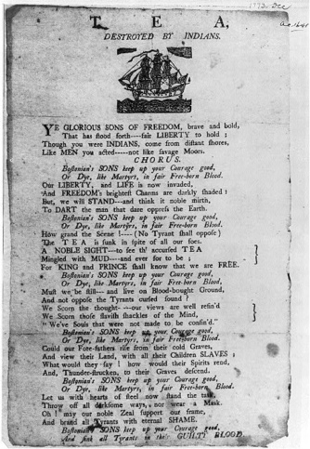
Library of Congress Prints and Photographs Division Washington, D.C, LC-USZ62-53319

To access the broadside, use the following link:
http://www.loc.gov/pictures/resource/cph.3b01290/
Broadsides for the Gallery Walk
#7
This broadside was used as a warning to the Patriots. The Continental (Patriot) army had asked for warm clothes for the soldiers. This broadside tells all who read it that if they are found with linen or wool that may end up with the Patriot soldiers, they will be “treated as a favorer of the Rebels,” or, in other words, a traitor to the King.

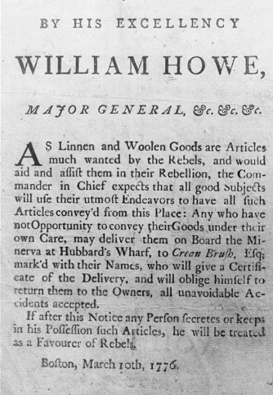
Library of Congress Prints and Photographs Division Washington, D.C, LC-USZ62-53323

To access the broadside, use the following link:
http://www.loc.gov/pictures/resource/cph.3b01294/

Broadsides for the Gallery Walk
#8

This broadside was posted as a list of supplies needed by the Continental (Patriot) Army. It tells people to donate to the soldiers who are fighting for freedom.

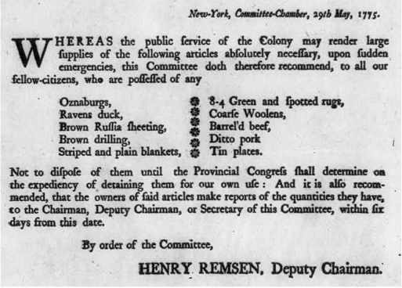
Library of Congress Prints and Photographs Division Washington, D.C LC-USZ62-77711

To access the broadside, use the following link:

http://www.loc.gov/pictures/resource/cph.3b24838/

Characteristics of Broadsides Anchor Chart
(For Teacher Reference)

Teacher Directions: Write the following at the top of a piece of chart paper:

Characteristics of Broadsides

Broadsides are …
… posters announcing news, information, events or proclamations, advertisements, or calls for help or support to a certain cause

Broadsides … (note: the list generated with students during the Closing and Assessment may look something like the following:)

  - Share an opinion on an event or topic
  - Give reasons and evidence to support the opinion
  - Try to convince the reader of something
  - Share details about news or an event
  - Have words in bold, italics, or all capital letters
  - Have large headlines
  - Have the introduction paragraph stand alone
  - Have columns
  - Have dates and location
  - Include “printed by …” or “by …”
  - Start with words like “gentlemen” or “sir”

