Lesson 24

Objective: Reason to identify and make a set that has 1 less.

Suggested Lesson Structure

 Fluency Practice (11 minutes)

 Application Problem (5 minutes)

 Concept Development (26 minutes)

 Student Debrief (8 minutes)

**Total Time (50 minutes)**

Fluency Practice (11 minutes)

* Show Me 1 Less **K.CC.4c** (4 minutes)
* Roll and Say 1 Less **K.CC.4c** (3 minutes)
* Finish My Sentence (1 Less) **K.CC.4c** (4 minutes)

Show Me 1 Less (4 minutes)

Note: Students continue to develop Fluency Practice in terms of describing the pattern of 1 less, preparing them for the current lesson. This activity echoes the previous lesson’s work with 1 more, reinforcing the opposite nature of the concepts.

Conduct activity as described in Lesson 19, but instead, focus exclusively on practicing 1 less. Maintain consistency in the language.

Roll and Say 1 Less (3 minutes)

Note: This is a reiteration of the previous activity. A different representation (dice in this case), develops flexibility and ensures that students do not become too reliant on finger counting.

Conduct activity as described in Lesson 13, but focus exclusively on practicing 1 less. Maintain consistency in the language.

Finish My Sentence (1 Less) (4 minutes)

Note: The previous fluency activities in this lesson build up to this more abstract version in preparation for today’s lesson.

T: Raise your hand, and wait for the signal when you can finish this sentence. 5. 1 less is…? (Wait for all hands to go up, and then signal.)

S: 4.

T: 4. 1 less is…? (Wait for all hands to go up, and then signal.)

S: 3.

Variation: After some whole group practice, have students do this activity with a partner.

Application Problem (5 minutes)

|  |  |
| --- | --- |
|  | NOTES ON  MULTIPLE MEANS  OF ENGAGEMENT: |

Scaffold the Application Problem for students working below grade level by asking questions such as, “How many birds are not vegetarian?” Watch as students draw their birds, count them, and write the number. Ask, “Do you have to draw 9 worms?” Continue questioning until students are successful.

The birds are back! Draw 9 birds. Each of them wants a worm for lunch today except for one—she has become a vegetarian. Draw just enough worms so that each bird who wants one can have one. How many birds did you draw? Write the number. How many worms did you draw? Write the number.

Note: Today’s lesson closely mirrors the previous lesson, but the focus is on *1 less* rather than *1 more*. Having the students draw *just enough* worms *except for one* will provide the anticipatory set for the lesson.

Concept Development (26 minutes)

Materials: (S) 10-sided die, bag of 20 linking cubes, bag of 20 pennies per pair

|  |  |
| --- | --- |
|  | NOTES ON  MULTIPLE MEANS  OF ENGAGEMENT: |

English language learners are often shy about producing language. Practice saying, “6. 1 less than 6 is 5,” with the whole class. Vary the choral response so that the boys try it alone, then the girls, then the left side of the room, then the right, etc. Practicing will help English language learners gain confidence in producing language.

T: We have one last set game to play! Student A, please roll the die. What did you get?

S: 6.

T: I will draw a set of 6. What shape should I draw, Student A?

S: Hexagons!

T: (Draw 6 hexagons on the board.) Now, I need to draw a set of squares that has **1 fewer than** my set of hexagons. Do you remember how we learned to count *1 less* with our linking cube stairs? We will do that again. Count the hexagons with me.

**MP.2**

S: 1, 2, 3, 4, 5, 6.

T: 6. I will write 6 under this set. What is 1 less, or 1 fewer, than 6?

S: 1 less than 6 is 5.

T: 6. 1 less is 5. (Draw 5 squares.) I will write the number 5 under this set. Are the sets the same?

S: No! 6 is 1 more than 5!

Model the exercise one more time, having a different student roll the die. Encourage the use of language such as, “9. 1 less is 8. 8. 1 less is 7.”

T: Now, you will play the game with your partner. One of you will roll the die and make the first set with the cubes, and then the other will make a set of pennies that has 1 fewer than the set of cubes. After you make your sets, count each of them again to make sure that the number of pennies is one less! Next time, you can switch. (Allow students to play several iterations of the game. Circulate to ensure accuracy in terms of counting and matching.)

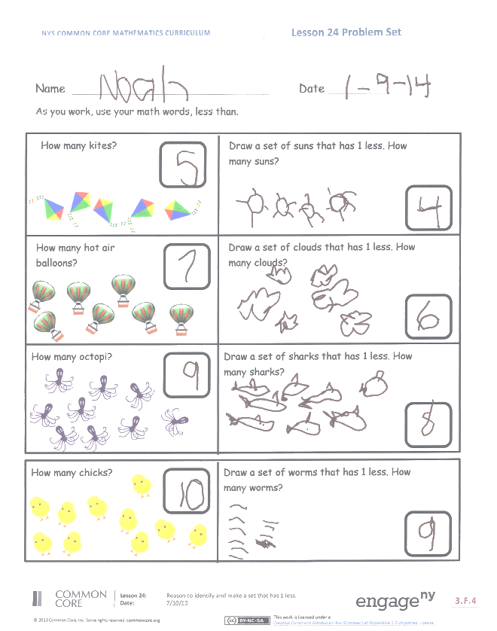Problem Set (10 minutes)

Students should do their personal best to complete the Problem Set within the allotted time.

Student Debrief (8 minutes)

**Lesson Objective:** Reason to identify and make a set that has 1 less.

The Student Debrief is intended to invite reflection and active processing of the total lesson experience.

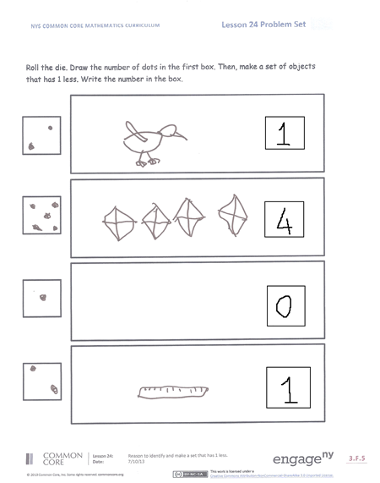Invite students to review their solutions for the Problem Set. They should check work by comparing answers with a partner before going over answers as a class. Look for misconceptions or misunderstandings that can be addressed in the Debrief. Guide students in a conversation to debrief the Problem Set and process the lesson.

You may choose to use any combination of the questions below to lead the discussion.

* When you were playing the game, how did you know how many pennies needed to be in a set?
* If your partner made a set of 5 pennies, how many cubes would you have put in a set?
* What if he had made a set of 9 pennies? How many cubes would you have put in the set?
* On the Problem Set, how did you know how many chicks there were? How did you know how many worms to draw?
* What math vocabulary did we use today to communicate precisely?
* Think about the birds and the worms you drew at the beginning of math today. What could you say about the sets of birds and worms?

Name Date

As you work, use your math words *less than*.



How many chicks?

How many octopi?

How many hot air balloons?



Draw a set of worms that has 1 less. How many worms? 

Draw a set of sharks that has 1 less. How many sharks? 

Draw a set of clouds that has 1 less. How many clouds?

Draw a set of suns that has 1 less. How many suns?

How many kites?

Roll the die. Draw the number of dots in the first box. Then, make a set of objects that has 1 less. Write the number in the box.









Name Date

Count the set of objects, and write how many in the box.

Draw a set of circles that has 1 less, and write how many in the box. As you work, use your math words *less than*.

