Lesson 23
Objective: Reason to identify and make a set that has 1 more.

Suggested Lesson Structure
 Fluency Practice (11 minutes)
 Application Problem (5 minutes)
 Concept Development (26 minutes)
 Student Debrief (8 minutes)
Total Time (50 minutes)
Fluency Practice (11 minutes)
- Show Me 1 More K.CC.4c (4 minutes)
- Roll and Say 1 More K.CC.4c (3 minutes)
- Finish My Sentence (1 More) K.CC.4c (4 minutes)
Show Me 1 More (4 minutes)
Note: Students continue to develop Fluency Practice in terms of describing the pattern of 1 more, preparing them for the current lesson.
Conduct activity as described in Lesson 19, but focus exclusively on practicing 1 more. Maintain consistency in the language.
Roll and Say 1 More (3 minutes)
Note: This is a reiteration of the previous activity. A different representation (dice in this case), develops flexibility and ensures that students do not become too dependent on finger counting.
Conduct activity as described in Lesson 13, but focus exclusively on practicing 1 more. Maintain consistency in the language.
Finish My Sentence (1 More) (4 minutes)
Note: The previous fluency activities in this lesson build up to this more abstract version in preparation for today’s lesson.
T: Raise your hand, and wait for the signal when you can finish this sentence. 3. 1 more is…? (Wait for all hands to go up, and then signal.)
S: 4.
T: 4. 1 more is…? (Wait for all hands to go up, and then signal.)
S: 5.
Variation: After some whole group practice, have students complete this activity with a partner.
Application Problem (5 minutes)
Draw 9 birds. Draw enough worms so that each bird gets one, but also draw 1 extra worm for a snack for later. Use your ruler to match each bird to its worm. How many birds are there? Write the number. How many worms are there? Write the number. Show your picture to a friend.
Note: Creating a set of enough but with an extra one provides the anticipatory set for today’s lesson objective.
Concept Development (26 minutes)

NOTES ON
MULTIPLE MEANS
OF REPRESENTATION:
To help English language learners participate fully in the lesson, point to visuals of triangles, squares, and other shapes on the word wall as shape names are spoken. If visuals are not posted, add them as a reference for students.
Materials: (S) 10-sided die, bag of 20 linking cubes, bag of 20 pennies per pair
T: We are going to play another set game today. Let me show you how we will play. Student A, please roll the die. What number do you see?
S: 4.
T: I will draw a set of 4. What shape should I draw, Student A?
S: Triangles!

NOTES ON
MULTIPLE MEANS
OF ACTION AND EXPRESSION:
Scaffold the lesson for students below grade level by modeling what to do one step at a time. Have one student roll the die. Direct the student’s partner to make a set of cubes equal to the number on the die, counting each one. Then, help students make a set of pennies that has 1 more by counting them one at a time. Ask, “Is there 1 more penny than there are cubes?” and so forth until students are able to continue on their own.
T: (Draw 4 triangles on the board.) Now, I need to draw a set of squares that has 1 more than my set of triangles. How many should I draw? Do you remember how we learned to count 1 more than with our linking cube stairs a long time ago? We will do that again. Count the triangles with me.
MP.2
S: 1, 2, 3, 4.
T: 4. I will write 4 under this set. What is 1 more?
S: 1 more is 5.
T: 4. 1 more is 5. (Draw 5 squares.) I will write the number 5 under this set. Do the sets have the same number?
S: No! 5 is 1 more than 4.
Model exercise one more time, having a different student roll the die. Encourage the use of language such as, “6. 1 more is 7. 7. 1 more is 8.”
T: Now, you will play the game with your partner. One of you will roll the die and make the first set with the cubes, and then the other will make a set of pennies that has 1 more than the set of cubes. After you have made your sets, count each of them again to make sure that the set of pennies has 1 more! The next time, you can switch.
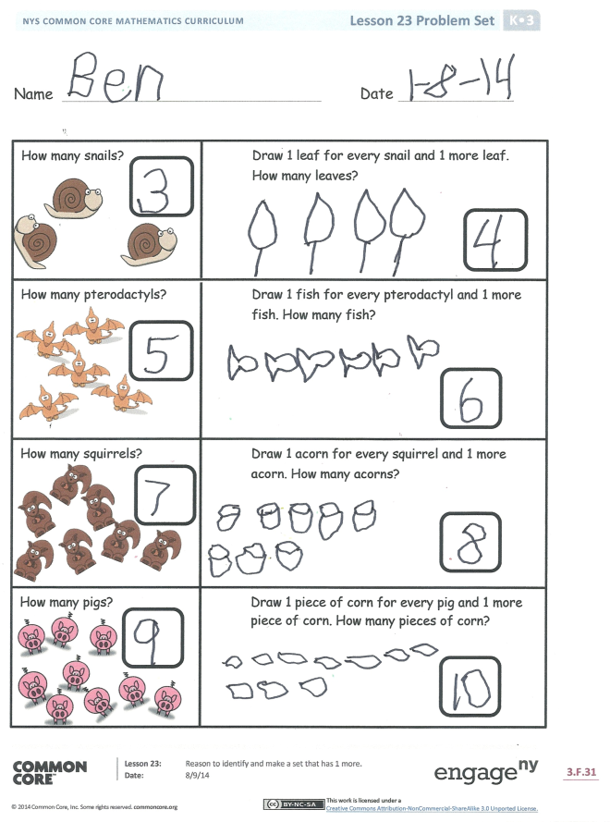
Allow students to play several iterations of the game. Circulate to ensure accuracy in terms of counting and matching.
Problem Set (10 minutes)
Students should do their personal best to complete the Problem Set within the allotted time.
Note: Before students begin the second page of the Problem Set, encourage the students to think about what a set could look like. Do they look just like their friend’s? Do all peanuts, pencils, squirrels, or puppies look identical? Encourage students to draw a set of objects that is diverse. This will allow students to find and discuss embedded numbers.
Student Debrief (8 minutes)
Lesson Objective: Reason to identify and make a set that has 1 more.
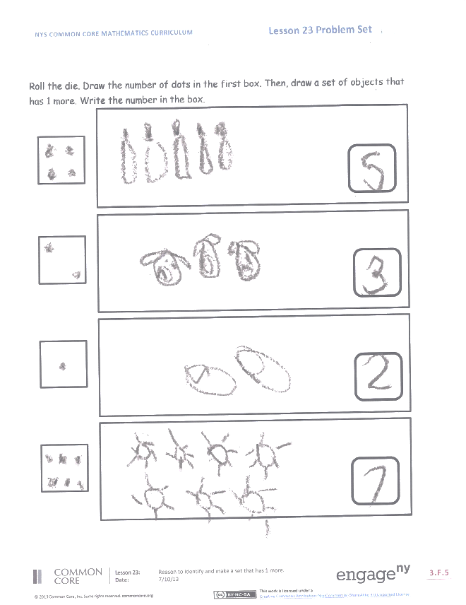
The Student Debrief is intended to invite reflection and active processing of the total lesson experience.
Invite students to review their solutions for the Problem Set. They should check work by comparing answers with a partner before going over answers as a class. Look for misconceptions or misunderstandings that can be addressed in the Debrief. Guide students in a conversation to debrief the Problem Set and process the lesson.
You may choose to use any combination of the questions below to lead the discussion.
- In our activity, how did you know how many cubes you needed to use in your set each time?
- How did you know how many pennies should be in the set each time?
- Think about the birds and the worms you drew at the beginning of math today. What could you say about the sets of birds and worms?
- On the Problem Set, what did you do to make sure you drew a set with 1 more?
- Talk to your partner about the second page of the Problem Set. Pick one box and talk about the number you rolled and how many objects you drew. (Encourage students to talk about hidden partners, if applicable. For example, how many puppies are playing? How many are eating?)
- What math vocabulary did we use today to communicate precisely?
Name Date
How many pterodactyls? Draw 1 fish for every pterodactyl and 1 more fish. How many fish?
How many snails? Draw 1 leaf for every snail and 1 more leaf. How many leaves?
How many squirrels? Draw 1 acorn for every squirrel and 1 more acorn. How many acorns?

How many pigs? Draw 1 piece of corn for every pig and 1 more piece of corn. How many pieces of corn?
Roll the die. Draw the number of dots in the first box. Then, draw a set of objects that has 1 more. Write the number in the box.

Name Date

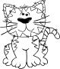

How many elephants?
How many peanuts?
Draw a peanut for every elephant and 1 more peanut.
How many cats?
Draw a ball for every cat and 1 more ball.

How many balls?

