Lesson 22
Objective: Identify and create a set that has the same number of objects.

Suggested Lesson Structure
 Fluency Practice (12 minutes)
 Application Problem (5 minutes)
 Concept Development (25 minutes)
 Student Debrief (8 minutes)
Total Time (50 minutes)
Fluency Practice (12 minutes)
- Make It Equal K.CC.6 (3 minutes)
- Roll and Draw 5-Groups K.OA.3 (5 minutes)
- 5-Group Fill-Up K.OA.4 (4 minutes)
Make It Equal (3 minutes)
Note: Students visually experience comparison, which is a skill foundational to the work of this module.
Conduct as outlined in Lesson 15.
Roll and Draw 5-Groups (5 minutes)
Note: Observe to see which students erase completely and begin each time from one, rather than draw more or erase some to adjust to the new number. By drawing 5-groups, students see numbers as having length in relationship to the five.
Conduct as outlined in Lesson 7. Consider alternating between drawing the 5-groups vertically or horizontally.
5-Group Fill-Up (4 minutes)
Materials: (S) Dice with 6-dot side covered, personal white board
Note: This activity provides students with a head start in terms of learning their partners to ten, thus anticipating the work of the next module.
1. Partner A rolls the dice and draws a corresponding 5-group with Os.
2. Partner B completes the 10 by drawing Xs.
3. Both Partners engage in math talk: “I have 3. You drew 7 more to make 10.”
Application Problem (5 minutes)
Materials: (S) 7 linking cubes, small piece of clay

NOTES ON
MULTIPLE MEANS
OF REPRESENTATION:
Scaffold essential terms for English language learners so that they can follow the Application Problem directions and participate fully in the day’s lesson. To highlight the concept just enough, modeling can be done with two sets of 4 linking cubes. Start with a 4-stick. Match loose linking cubes to the 4-stick one at a time to show not enough until all 4 linking cubes have a partner cube to show just enough.
Pretend your linking cubes are little baskets. Use your clay to make as many balls as there are baskets. Check your work by putting a ball in each basket. Do you have just enough? Score 1 point for every basket you made!
Note: The concrete activity of creating an equal set will serve as an anticipatory set for today’s lesson objective. As you circulate, encourage the students to use the language, “I have the same number of balls as baskets.”
Concept Development (25 minutes)
Materials: (S) 10-sided die (or spinner), bag of 20 linking cubes, and bag of 20 pennies
T: We are going to play Match My Set today! Let me show you how it works. Student A, please roll the die. What number do you see?

NOTES ON
MULTIPLE MEANS
OF ENGAGEMENT:
Model the steps of the game for students who are below grade level. Play the game with a student while explaining the procedure one step at a time.
“You rolled a 4. Watch me make a set of 4 cubes.”
“Now, it’s your turn. Use the pennies to make the same number as my cubes.”
Count out the sets, if necessary, until the student is able to work with a partner.
MP.6
S: 8.
T: I will draw a set of 8 shapes. What shape should I draw, Student A?
S: Circles!
T: (Draw 8 circles on the board.) Now, I will draw as many squares as circles. Then, I’ll have the same number of squares as circles. (Demonstrate.) How should I check my work?
S: You could count them!
T: Good idea. Count the circles with me.
S: 1, 2, 3, 4, 5, 6, 7, 8.
T: I will write the number 8 under this set. Now, let’s count the squares.
S: 1, 2, 3, 4, 5, 6, 7, 8.
T: I will write the number 8 under this set. Do I have the same number of shapes in each set?
S: Yes! They both have 8 shapes!
T: Now, you will play this game with your partner. One of you will roll the die and make the first set with the cubes. Then, the other will make a set of pennies that has the same number of pennies as cubes. When you have made your sets, count each of them to make sure they are the same! The next time, you can switch. (Allow students to play several iterations of the game. Circulate to ensure accuracy in terms of counting and matching.)
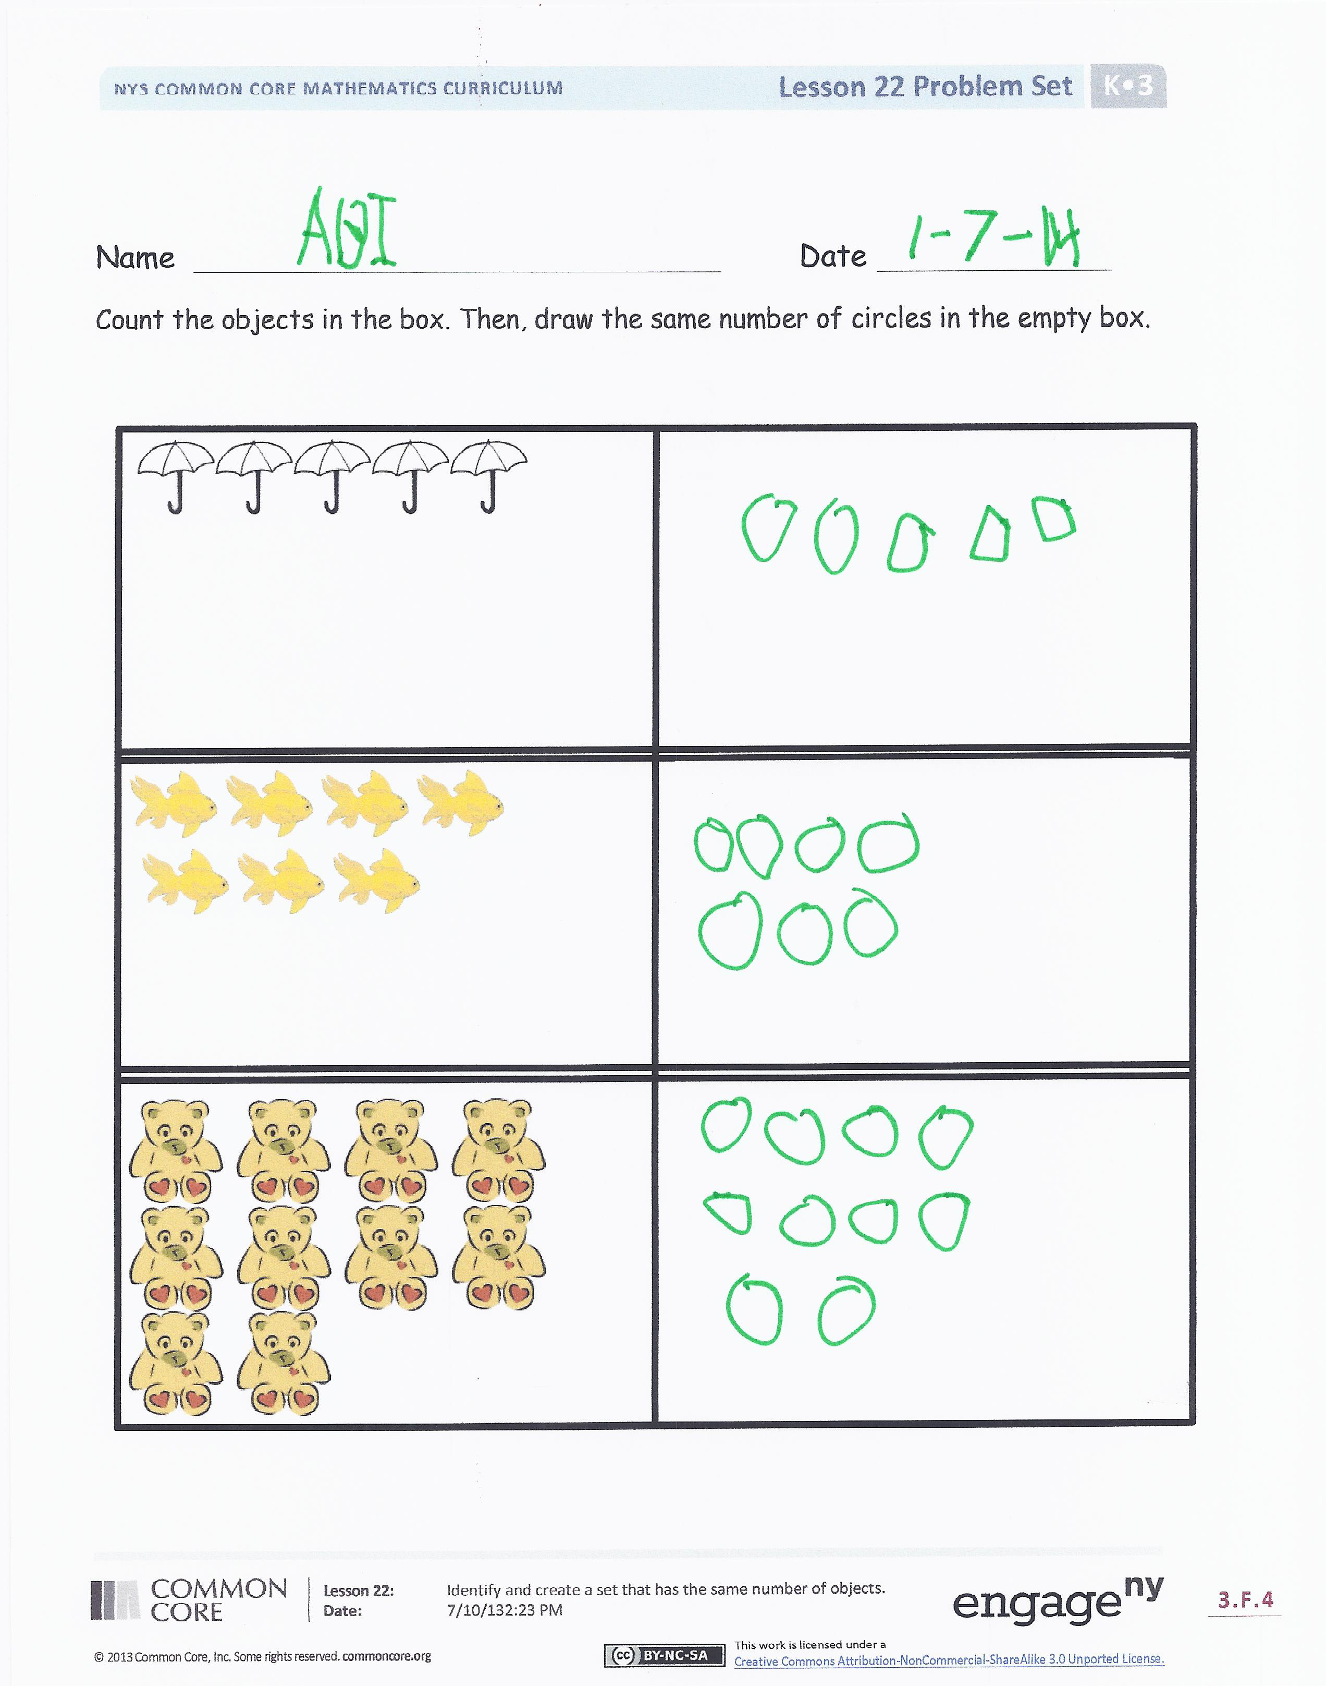
Problem Set (10 minutes)
Students should do their personal best to complete the Problem Set within the allotted time.
Student Debrief (8 minutes)
Lesson Objective: Identify and create a set that has the same number of objects.
The Student Debrief is intended to invite reflection and active processing of the total lesson experience.
Invite students to review their solutions for the Problem Set. They should check work by comparing answers with a partner before going over answers as a class. Look for misconceptions or misunderstandings that can be addressed in the Debrief. Guide students in a conversation to debrief the Problem Set and process the lesson.
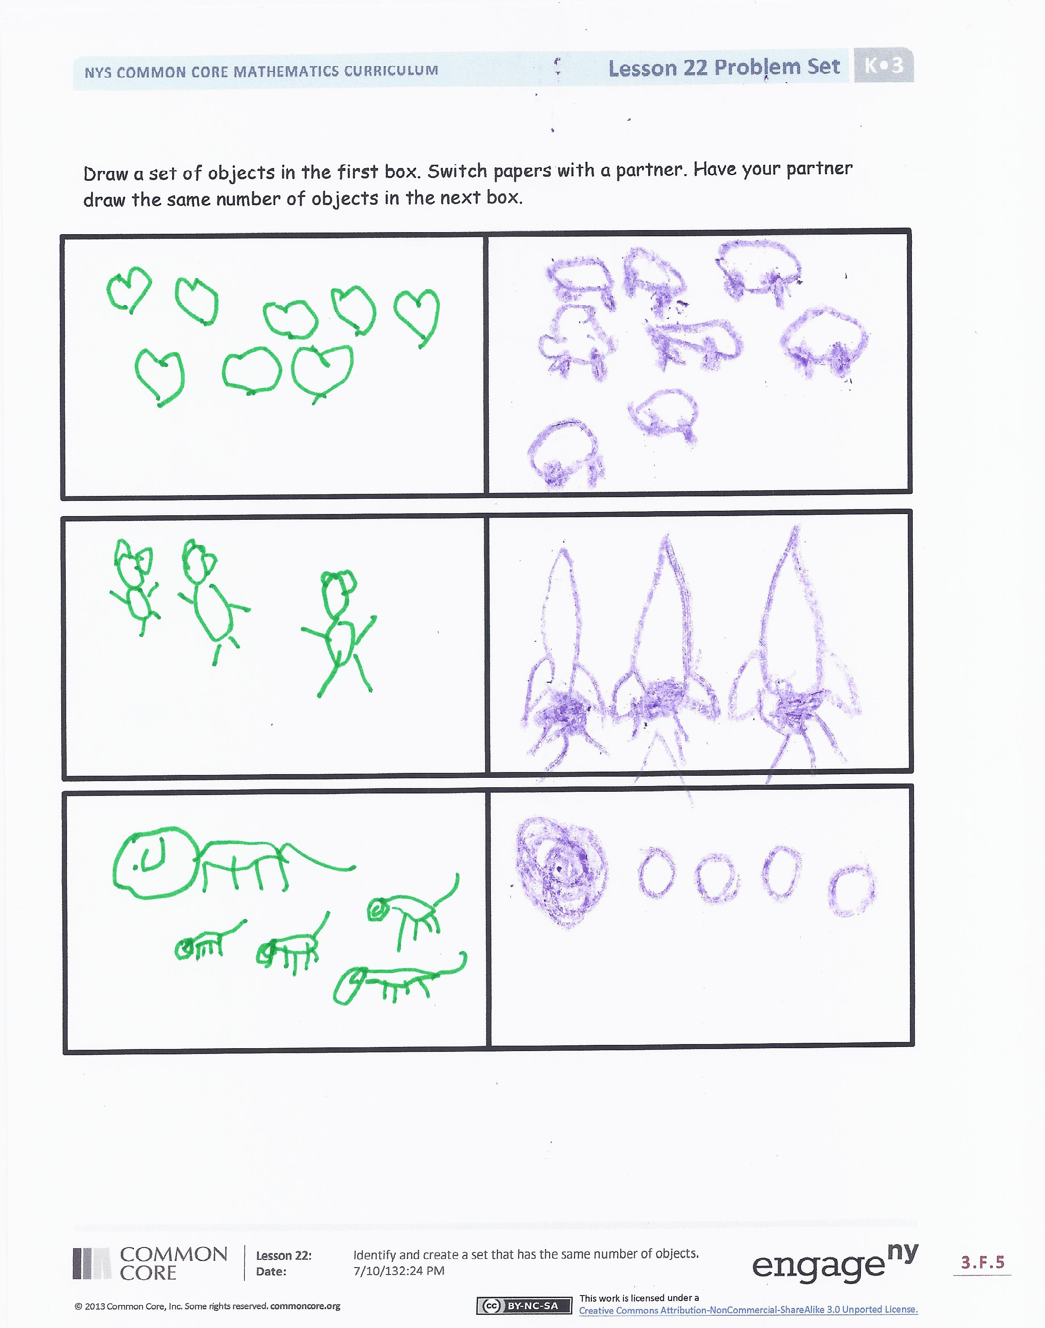
You may choose to use any combination of the questions below to lead the discussion.
- When you were making the sets with your cubes and pennies, how did you check to make sure that the sets had the same number of items?
- What would it mean if you counted 8 in one set and 6 in another?
- What do we have to remember when we are making sets that have the same number of items?
- On the second page of the Problem Set, did your partner draw the correct number of objects to match your set?
- Use the words the same number to tell me something about your hands. Could you make a similar sentence about the same number for any other part of your body?
- What new (or significant) math vocabulary did we use today to communicate precisely?
Name Date
Count the objects in the box. Then, draw the same number of circles in the empty box.

Draw a set of objects in the first box. Switch papers with a partner. Have your partner draw the same number of objects in the next box.

Count the monkeys. In the next box, draw the same number of bananas as monkeys.

On the back of your paper, draw some pencils. Then, draw a crayon for each pencil.

Name Date
Count the birds. In the next box, draw the same number of nests as birds.
Count the houses. In the next box, draw the same number of trees as houses.

