Lesson 21
Objective: Compare sets informally using more, less, and fewer.

Suggested Lesson Structure
 Fluency Practice (13 minutes)
 Application Problem (5 minutes)
 Concept Development (25 minutes)
 Student Debrief (7 minutes)
Total Time (50 minutes)
Fluency Practice (13 minutes)
- My First Sprint K.CC.5 (8 minutes)
- Finger Number Pairs K.CC.4a (5 minutes)
My First Sprint (8 minutes)
Materials: (S) 1 copy of the Count and Circle How Many Sprint (Lesson 20)
Note: This activity allows students to become comfortable with Sprint procedures as they work on this simple task with confidence.
T: Today, you will get to do a math race called a Sprint. (Remind students of the previous day’s activity.) Take out your pencil and one crayon of any color.
T: (Distribute the Sprint papers facedown.) On your mark, get set, go!
T: (Ring the bell or give another signal for students to stop. Although it will not be necessary to time the students in this short practice Sprint, be sure to give the stop signal before students finish so as to not develop the expectation of finishing every time.) Pencils up!
T: Pencils down and crayons up! It’s time to check answers. What do you do if the answer is right?
S: Circle it.
T: What do you say?
S: Yes!
T: We’ll begin with the hearts. Ready? 1.
S: Yes!
T: 2.
S: Yes!

Continue checking the remaining answers. Then, have students count the number correct and write the number at the top. Maintain the celebratory mood. Praise students for learning a new procedure, as well as their strong effort and hard work. Note that only one Sprint is delivered this time. The two-part Sprint will be introduced in a future lesson.
Troubleshooting: If students work across, instead of down, the columns, create a green arrow down the left-hand side and a red arrow along the right-hand side to indicate where to start and stop. If students have difficulty circling the answers quickly, give them a highlighter and allow them to swipe the correct answer.
Finger Number Pairs (5 minutes)
Note: This activity ensures that students do not become overly reliant on counting the Math way and gives them yet another method of breaking apart numbers, essential to the work of the next module.
Conduct as outlined in Lesson 18, but this time, invite students to explain why certain combinations cannot be shown on two hands. A student might say, “I can show 10 as 5 on one hand and 5 on the other, but I can’t show 10 as 6 and 4.” Guide them to use some of their newly acquired vocabulary and be precise with respect to explaining their thoughts.
Application Problem (5 minutes)
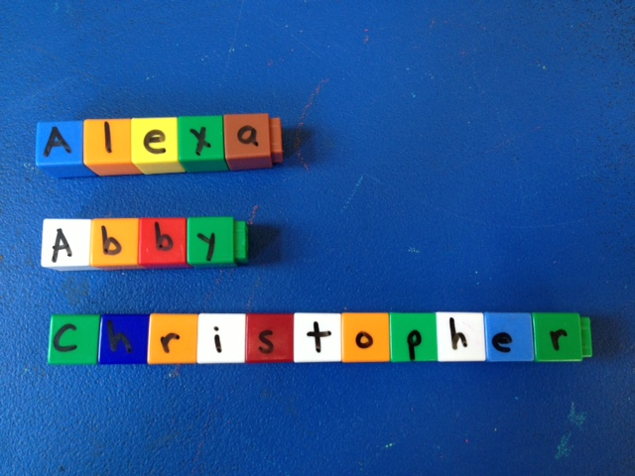
Materials: (S) Linking cubes, dry erase marker
Use your dry erase markers to write the letters of your name on linking cubes. Make a train out of your cubes. Compare your train to at least one friend’s train. Which train is longer? Count the cubes in your trains. Which number is more? Which number is less?
Note: This extension of yesterday’s Application Problem will serve as an introductory informal set comparison for today’s lesson. When comparing a number of discrete objects, use the word fewer. When comparing numbers, use the word less.
Concept Development (25 minutes)

NOTES ON
MULTIPLE MEANS
OF REPRESENTATION:
English language learners will benefit from seeing the names of the shapes as you introduce and discuss them for the lesson. For each set of shapes, include square, circle, triangle, hexagon, and rectangle. Students will be able to focus on how many of each shape is present rather than focusing on trying to produce their names.
Materials: (T) Shapes (Template 1, cut out)
(S) More than, fewer than recording sheet
(Template 2)
9
6
4
6
7

Note: While the importance of definitions is not necessarily stressed in Kindergarten (recognition is intuitive at this stage), a square is still treated as a special type of rectangle. If asked how many rectangles, students might initially respond by saying 7, when, in actuality, there are 16.
T: What do you notice on the board today?
MP.2
S: I see shapes! There are all different kinds.
T: What types of shapes do you see on the board? (Use this as an opportunity to discuss and review the shape types from GK–M2.)
T: Are there more squares or triangles?
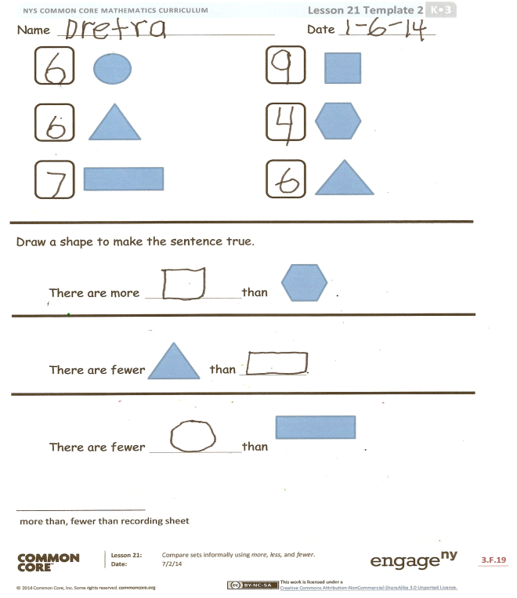
S: There are more squares than triangles.
T: How do you know?
S: The squares look bigger. I counted them. (Discuss relevant strategies.)
T: Are there fewer circles or hexagons? (Continue informally comparing sets of shapes and encourage students to discuss their strategies for finding more or less than.)
T: Which two groups have the same number of shapes?
S: The circles and triangles! There are six circles and six triangles.
T: Let’s compare our sets of shapes on the recording sheet. In each row, count how many of the shapes are on the board. Then, draw a shape that makes each sentence true. (Demonstrate. Pass out recording sheets, and circulate to ensure accuracy in terms of counting and comparison.)
Problem Set (10 minutes)

NOTES ON
MULTIPLE MEANS
FOR ACTION AND EXPRESSION:
Expand the lesson for above grade level students by asking them to arrange the groups of shapes from least to greatest and explain how they knew which set had the least and which set had the most. Ask students to draw more circles so that there are the same numbers of circles as squares, etc.
Students should do their personal best to complete the Problem Set within the allotted time.
Note: Give students step-by-step directions while completing the Problem Set. First, color all of the shapes. Then, count how many of each shape and write the number in the box. Finally, use the first page of the Problem Set to complete the second page.

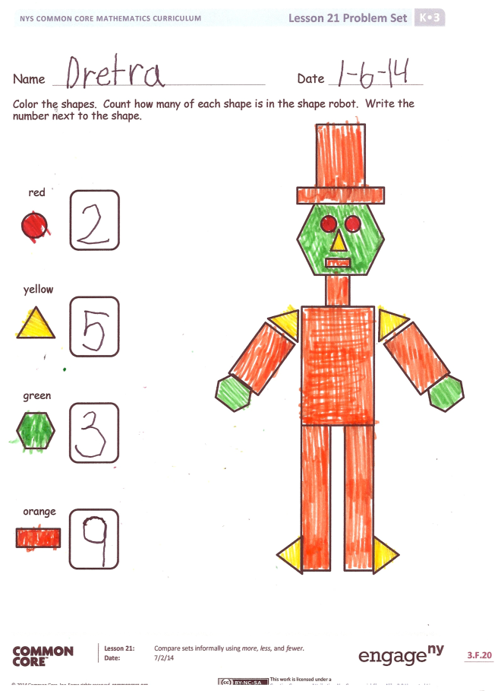
Student Debrief (7 minutes)
Lesson Objective: Compare sets informally using more, less, and fewer.
The Student Debrief is intended to invite reflection and active processing of the total lesson experience.
Invite students to review their solutions for the Problem Set. They should check work by comparing answers with a partner before going over answers as a class. Look for misconceptions or misunderstandings that can be addressed in the Debrief. Guide students in a conversation to debrief the Problem Set and process the lesson.
You may choose to use any combination of the questions below to lead the discussion.
- Were there more circles than hexagons? Were there more squares than triangles?
- Were there fewer hexagons than triangles? Were there fewer rectangles than triangles?
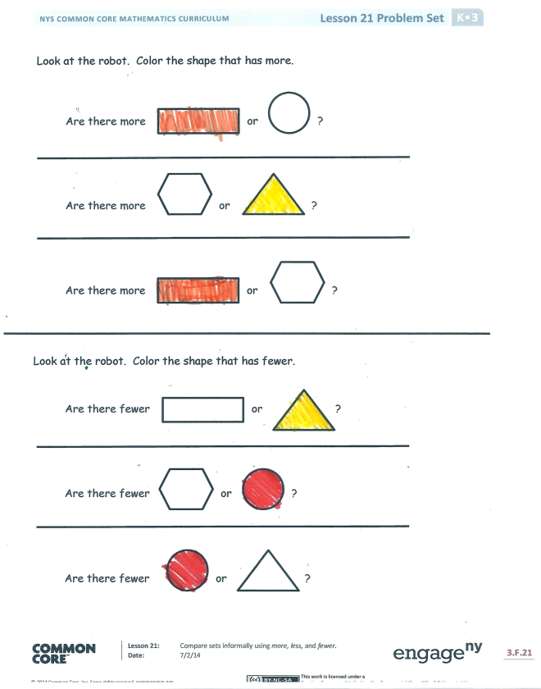
- Which sets of shapes on the board had the same number?
- On the Problem Set, were there more circles than triangles? Were there fewer hexagons than rectangles?
- What new (or significant) math vocabulary did we use today to communicate precisely?

Name Date
Color the shapes. Count how many of each shape is in the shape robot. Write the number next to the shape.

Red
Green
Yellow
Orange
Look at the robot. Color the shape that has more.

Are there more or ?

Are there more or ?

Are there more or ?

Look at the robot. Color the shape that has fewer.

Are there fewer or ?

Are there fewer or ?

Are there fewer or ?
Name Date
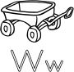
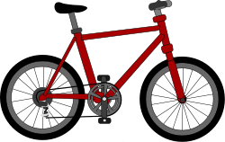
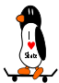
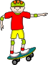
Which has fewer? The or ?
Circle the set that has fewer.
Which has more? The or ?
Circle the set that has more.

On the back of your paper, draw a set of 5 books. Draw some apples. Are there fewer apples or fewer books?
Which has fewer? The or ?
Circle the set that has fewer.

Name Date

Draw a shape to make the sentence true.

There are more than .

There are fewer than .

There are fewer than .

shapes
shapes
more than, fewer than recording sheet

