Grade 4: Module 3B: Unit 1: Lesson 9
Close Reading: Learning about the Declaration of Independence

Long-Term Targets Addressed (Based on NYSP12 ELA CCLS)
I can explain what a text says using specific details from the text. (RI.4.1)
I can make inferences using specific details from the text. (RI.4.1)
I can explain the main points in a historical text, using specific details in the text. (RI.4.3)
I can describe the organizational structure in an informational or persuasive text (chronology, comparison, cause/effect, problem/solution). (RI.4.5)
Supporting Learning Targets | Ongoing Assessment
- I can make inferences based on information from pictures and text “Thomas Jefferson and the Declaration of Independence.”  - I can support my inferences with details and examples from the text “Thomas Jefferson and the Declaration of Independence.”  - I can explain how and why the Declaration of Independence was written.  - I can identify the organizational structure of a section of “Thomas Jefferson and the Declaration of Independence.” | - Close Reading note-catcher: “Thomas Jefferson and the Declaration of Independence” (questions 1-6)

Agenda | Teaching Notes
- Opening  - Reviewing Homework and Adding to Anchor Charts (5 minutes)  - Reviewing Learning Targets (5 minutes)  - Work Time  - Reading for the Gist: “Thomas Jefferson and the Declaration of Independence” (15 minutes)  - Close Reading of “Thomas Jefferson and the Declaration of Independence”: How and Why Was the Declaration of Independence Written? (30 minutes)  - Closing and Assessment  - Share and Debrief (5 minutes)  - Homework  - Reread the introduction and first 3 paragraphs of “A Gifted Writer” from the text “Thomas Jefferson and the Declaration of Independence.”  - Underline or highlight words for the Word Wall. Choose one word and use one of your vocabulary strategies to write a definition for this word. | - To build on their understanding of the American Revolution and the Declaration of Independence, students read part of the first section of the article “Thomas Jefferson and the Declaration of Independence.” The second section of the article is read in Lesson 10. Students closely examine how and why the Declaration of Independence was written and to think about how it impacted other events through answering a series of text-dependent questions on their Close Reading note-catcher. Students continue close reading process in Lesson 10 and again in Lesson 11 for the End of Unit 1 Assessment. Preview Lessons 9-11 to get a sense of the arc of students’ work with this text.  - The close reading process is meant to help students deeply understand a section of the text. They read and reread to deconstruct the meaning of the text, and then reconstruct the meaning using evidence from the text. The teacher uses questioning geared toward a focus question to make the text accessible to students. See the Close Reading Guide for notes on guiding student through the text and answers to the text-dependent questions.  - The close reading process in this lesson is meant to be discussion-based; the teacher can choose to invite students to work independently or in pairs or small groups when thinking about different questions on the Close Reading note-catcher, but the teacher should guide the whole class in a discussion of each section on the note-catcher using the focus question at the top before moving on to the next section. This note-catcher is not meant to be a worksheet that is assigned to students to complete on their own.  - Row 8 of the Close Reading note-catcher asks students to reread Paragraphs 6 and 7 of “A Gifted Writer,” which includes the following quote: “That these United Colonies are, and of right ought to be, free and independent states.” This quote is not read closely in this lesson and is revisited in Unit 2.  - This close read sequence is designed as two lessons; however, depending on the needs of your class, you may choose to split this close reading into three lessons.  - The end goal of Lessons 9 and 10 is for students to be able to answer the focus question on their Close Read note-catchers. Students are given the opportunity to do so in Lesson 10.

Agenda | Teaching Notes (continued)
- In advance:
  - Review: Close Reading Note-catcher so you are familiar with the prompts and can address students’ questions as needed. See supporting materials.
  - Review: Fist to Five in Checking for Understanding techniques (see Appendix).
  - Review: Back-to-Back, Face-to-Face protocol (see Appendix).
  - Post: Learning targets.

Lesson Vocabulary | Materials
declaration, independence; mightier (9), self-evident, delegate (10) | - Be a Patriot anchor chart (begun in Lesson 3)  - Be a Loyalist anchor chart (begun in Lesson 5)  - Close Readers Do These Things anchor chart (begun in Module 1, Unit 1, Lesson 3)  - Close Reading note-catcher: “Thomas Jefferson and the Declaration of Independence” (one per student and one to display)  - Close Reading Guide: “Thomas Jefferson and the Declaration of Independence” (for teacher reference)  - Equity sticks  - “Thomas Jefferson and the Declaration of Independence” (one per student and one to display)  - Sticky notes (five per student)

Opening | Meeting Students’ Needs
A. Reviewing Homework and Adding to Anchor Charts (5 minutes)
- Direct students’ attention to the Be a Patriot and Be a Loyalist anchor charts.
- Ask students to get out their homework from Lesson 8, share their paragraphs with a partner, and discuss any reasons they think can be added to each anchor chart.
- Give students a few minutes to discuss, then call on pairs to offer additional reasons to add to each anchor chart. Listen for and record reasons similar to the following:
  - Be a Loyalist: promised freedom from slavery; receive a gun
  - Be a Patriot: the idea of freedom and liberty; the words “All men are created equal”; fighting in Rhode Island bought freedom
B. Reviewing Learning Targets (5 minutes)  - Focus students’ attention on the posted learning targets and read them aloud:  - “I can make inferences based on information from pictures and text ‘Thomas Jefferson and the Declaration of Independence.’”  - “I can support my inferences with details and examples from the text ‘Thomas Jefferson and the Declaration of Independence.’”  - “I can explain how and why the Declaration of Independence was written.”  - “I can identify the organizational structure of a section of ‘Thomas Jefferson and the Declaration of Independence.’”  - Remind students that they have practiced the second and fourth learning targets in Lesson 7.  - Tell them that today they will think about how someone’s perspective influences his or her opinion of an event. Tell students that they will look closely at the events that happened leading up to the writing of the final version of the Declaration of Independence, thinking about what happened and why.  - Ask students to give a thumbs-up, thumbs-sideways, or thumbs-down to check for understanding of the targets. Clarify as necessary. | - Discussing and clarifying the language of learning targets helps build academic vocabulary.

Work Time | Meeting Students’ Needs
A. Reading for the Gist: “Thomas Jefferson and the Declaration of Independence” (15 minutes)  - Tell students they will expand their understanding of the American Revolution and the Declaration of Independence by reading an article about it over the next two days.  - Display the Close Readers Do These Things anchor chart and remind students that they will be doing all of these things to closely read this text:  - Read small chunks of text slowly and think about the gist.  - Reread each passage one sentence at a time.  - Underline things that you understand or know about.  - Circle or underline words that you do not know.  - Talk with your partners about all of your good ideas.  - State the gist or message of the paragraph in the margin.  - Listen to the questions.  - Go back to the text in order to find answers to questions.  - Talk with your partners about the answers you find.  - Distribute and display the Close Reading note-catcher.  - Tell students that they will be using this note-catcher to help them think and take notes about this article.  - Use equity sticks to call on a student to read the focus question at the top of the Close Reading note-catcher. Remind students that they should keep this question in mind as they work:  - “How and why was the Declaration of Independence written?”  - Distribute “Thomas Jefferson and the Declaration of Independence” and five sticky notes to each student.  - Tell them they will only be reading half of the article in the next two lessons, and reading the second half as part of the End of Unit 1 Assessment in Lesson 11. Explain that they will read the first half of the article twice; first for the gist and a second time to think about what happened leading up to the writing of the final version of the Declaration and why those events happened.  - Use equity sticks to call on a student to read aloud the article’s title and subtitle. | - To provide more support, have students work with their partner to read and write the gist then share out a section at a time.

Work Time | Meeting Students’ Needs
- Invite students to turn and talk:
  - “What does the word declaration mean? What word do you hear in the word declaration?” Listen for responses like: “I hear the word ‘declare’ in the word declaration,” or “I think it means to declare or say something.”
- Use equity sticks to call on several students to share what they discussed with their partners. If necessary, clarify the meaning of declaration as something stated or made known in an official way.
- Repeat with the word independence, clarifying the meaning as being free or not being controlled by anyone.
- Explain to students that the Declaration of Independence was how the Patriots formally told England that they wanted to create their own country.
- Read aloud the first three paragraphs of the article, asking students to follow along as you do so. (“As a boy …” to “‘… has inspired lovers of freedom everywhere.’”)
- Invite students to write a gist statement for those first three paragraphs on one of their sticky notes. If students need more support, ask:
  - “What were these paragraphs mostly about?”
- Tell students to place their sticky notes on the text by these first three paragraphs.
- Invite students to continue reading the next four sections (“A Gifted Writer,” “Expressing the American Mind,” “Hang Together—or Separately,” and “The Test of Time”) in pairs for gist, recording a gist statement for each section on a sticky note.
- As students work, circulate and assist students. If they need support, ask:
  - “What was that section mostly about?”
- Invite students to examine their gist statements for each section and write a new gist statement for the entire article.
- Use equity sticks to call on students to share their gist statements and choose one to fill in the first row of the Close Reading Note-catcher. Listen for responses like: “This article is about the writing of the Declaration of Independence and how Thomas Jefferson was involved with it.”

Work Time (continued) | Meeting Students’ Needs
B. Close Reading of “Thomas Jefferson and the Declaration of Independence”: How and Why Was the Declaration of Independence Written? (30 minutes)  - Remind students that close readers reread the texts they are analyzing paragraph by paragraph, sentence by sentence.  - Explain to them that they will now closely reread pages 8–10 of the Thomas Jefferson article to think carefully about the focus question:  - “How and why was the Declaration of Independence written?”  - Tell students they will be doing this by rereading and discussing with their partner, then sharing their thinking with the class.  - Using the Close Reading Guide, guide students through rereading the text, inviting them to Think-Pair-Share and discuss the prompts as necessary.  - Stop students at the seventh row with the prompt: “Take turns reading the fourth and fifth paragraphs to your partner. Then, working together, use details from the text to answer the questions on the right.” Tell students that they will continue rereading the rest of the section in the next lesson. | - For students needing additional support, consider allowing them to reread the text with high-low partners or in a targeted small group with the teacher.  For students needing additional support and ELLs, consider providing smaller chunks of text for a close read. Teachers can check in on students’ thinking as they speak about their text.

Closing and Assessment | Meeting Students’ Needs
A. Share and Debrief (5 minutes)
- Bring students back together. Invite students to use Fist to Five to show how confident they are in answering the focus question for this article, showing a fist for being completely unsure of how or why the Declaration of Independence was written, or a five, meaning they can share several reasons about how and why the Declaration of Independence was written. Be sure to check in with students showing a fist, one, or two fingers during the close read in Lesson 10.
- Using the Back-to-Back, Face-to-Face protocol, ask:
  - “What was one event leading up to the writing of the Declaration of Independence?”
- Listen for responses like: “The Battles of Lexington and Concord.”
- Ask:
  - “How is this process helping you better understand this text?”
- Listen for responses like: “By rereading, I can think carefully about the meaning of words I don’t know like ‘delegate.’”
- Explain to students that they will continue rereading “Thomas Jefferson and the Declaration of Independence” closely in the next lesson.
Homework | Meeting Students’ Needs
- Reread the introduction and first 3 paragraphs of “A Gifted Writer” from the text “Thomas Jefferson and the Declaration of Independence.”
- Underline or highlight words for the Word Wall. Choose one word and use one of your vocabulary strategies to write a definition for this word.

Grade 4: Module 3B: Unit 1: Lesson 9
Supporting Materials

“Thomas Jefferson and the Declaration of Independence”
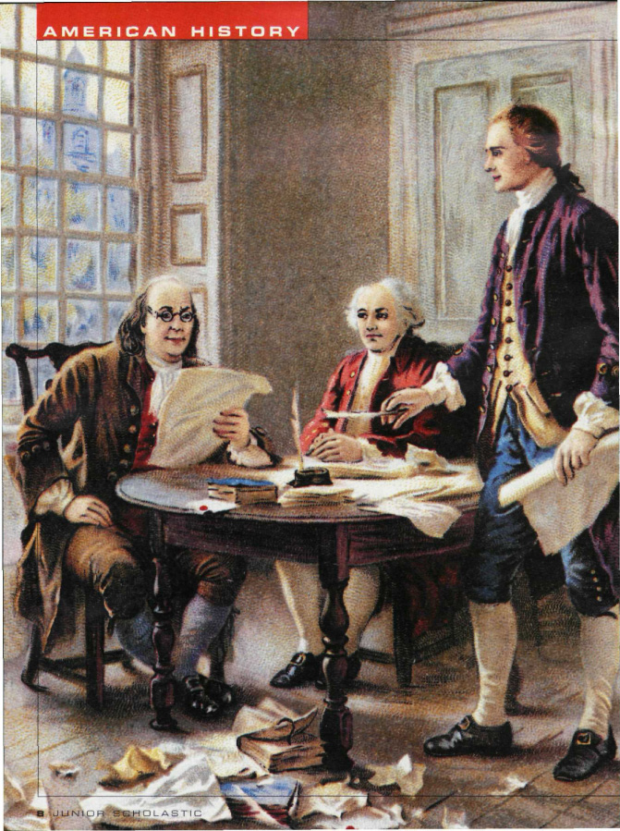

“Thomas Jefferson and the Declaration of Independence”
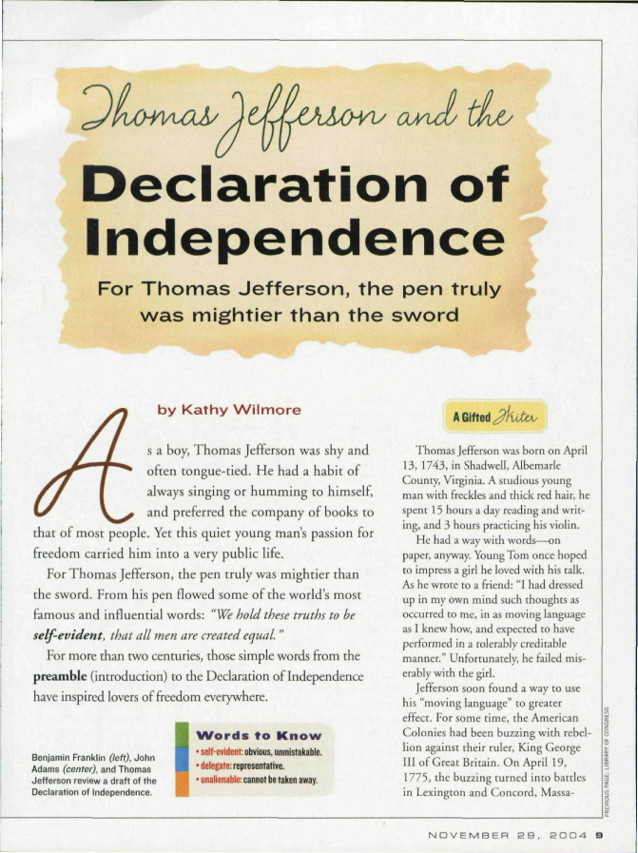

“Thomas Jefferson and the Declaration of Independence”
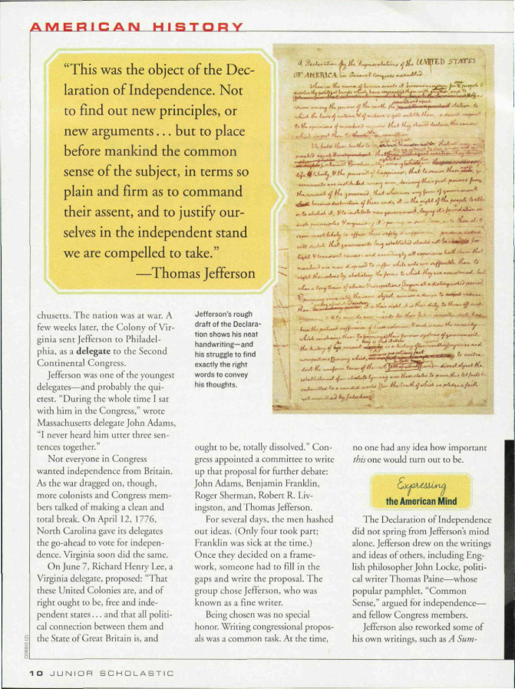

“Thomas Jefferson and the Declaration of Independence”
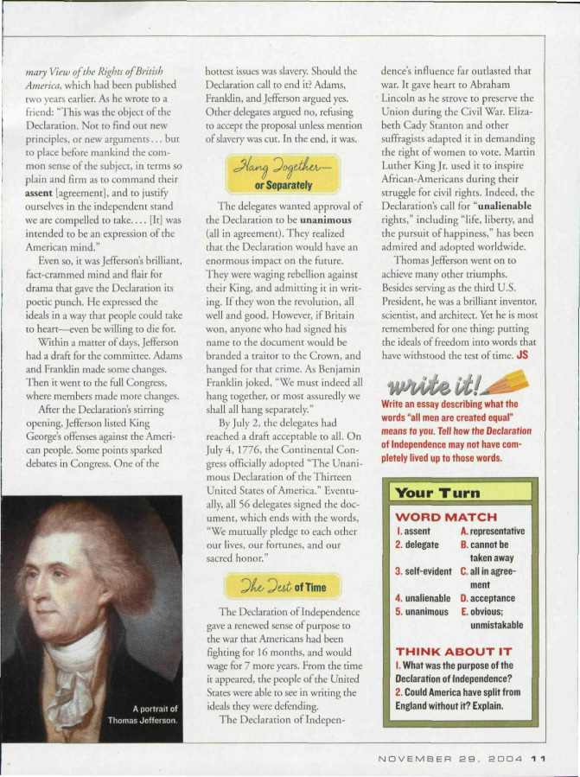

From Junior Scholastic , November 29, 2004. Copyright © 2004 by Scholastic Inc. Reprinted by permission of Scholastic Inc.
Close Reading Note-Catcher:
“Thomas Jefferson and the Declaration of Independence”

Name:
Date:

Focus question: How and why was the Declaration of Independence written?

- What is the gist of this article?
- Examine the picture on page 8 and the caption for it on page 9. Then use details from the text to answer the questions on the right. | Who is in the picture?  What are they reading?  There are many papers on the floor in the foreground of the picture. What might those papers be?  The caption says they were “reviewing a draft of the Declaration of Independence.” Why were there many drafts of the Declaration?

Close Reading Note-Catcher:
“Thomas Jefferson and the Declaration of Independence”

- Now, reread the title, subtitle, and introduction silently. Then use details from the text to answer the questions on the right. | What do you think mightier means? What words in the text make you think so?  The text says, “For Thomas Jefferson, the pen truly was mightier than the sword.” How could a pen be mightier than a sword?
- Reread the last sentence of the second paragraph. Then use details from the text to answer the questions on the right.  “We hold these truths to be self-evident, that all men are created equal.” | Use text features to determine what self-evident means.  What is the main point of this sentence from the Declaration of Independence? What words in the text make you think so?
- Now, reread the first two paragraphs in the section “A Gifted Writer.” Then use details from the text to answer the question on the right. | What words does the author use to describe Thomas Jefferson?

Close Reading Note-Catcher:
“Thomas Jefferson and the Declaration of Independence”

- Take turns reading the third paragraph to your partner. Then, working together, use details from the text to answer the questions on the right. | Use text features to determine what delegate means.  Jefferson was sent to Philadelphia as a delegate to the Second Continental Congress. According to the text, what events led to the Second Continental Congress?  Why was there a Second Continental Congress?  What were the two main events described in these paragraphs?  1.)  2.)
Stop Here. Continue with 7-11 in Lesson 10.
- Take turns reading the fourth and fifth paragraphs to your partner. Then, working together, use details from the text to answer the questions on the right. | The text says, “Not everyone in Congress wanted independence from Britain.” Using what you have learned in this unit, what was the name of the group of people who did not want independence from Britain?  What was the main event described in these paragraphs?

Close Reading Note-Catcher:
“Thomas Jefferson and the Declaration of Independence”

- Now, reread the first two paragraphs in the section “A Gifted Writer.” Then use details from the text to answer the question on the right. | The word dissolved means brought to an end. What did Richard Henry Lee mean when he said, “… that all political connection between them and the State of Great Britain is, and ought to be, totally dissolved.”  What does the word debate mean? What words in the text make you think so?  What were the two main events described in these paragraphs?  1.)  2.)
- Read the seventh paragraph. Then use details from the text to answer the question on the right. | The text says, “At the time, no one had any idea how important this one would turn out to be.” Why did this proposal turn out to be so important?

Close Reading Note-Catcher:
“Thomas Jefferson and the Declaration of Independence”

- Examine the picture and caption on page 9. Then use details from the text to answer the questions on the right. | What is this a picture of?  What inferences can you make about Thomas Jefferson based on this picture and caption?  I infer  because …
TEXT STRUCTURE
- What is the structure of the section “A Gifted Writer”? What words in the text make you think so?

Summarize!

After thinking more closely about this section of the text, summarize what you think the section “A Gifted Writer” is mostly about. Use several specific details from the text in your summary.
Close Reading Guide:
“Thomas Jefferson and the Declaration of Independence”
(Answers, for Teacher Reference)

Focus question: How and why was the Declaration of Independence written?

- What is the gist of this article? | This article is about the writing of the Declaration of Independence and how Thomas Jefferson was involved with it.
- Examine the picture on page 8 and the caption for it on page 9. Then use details from the text to answer the questions on the right. | Who is in the picture?  Benjamin Franklin, John Adams, and Thomas Jefferson  What are they reading?  a draft of the Declaration of Independence  There are many papers on the floor in the foreground of the picture. What might those papers be?  other drafts of the Declaration  The caption says they were “reviewing a draft of the Declaration of Independence.” Why were there many drafts of the Declaration?  they wanted to make sure it was precise and send the message they wanted to the British

Close Reading Note-Catcher:
“Thomas Jefferson and the Declaration of Independence”
(Answers, for Teacher Reference)

- Now, reread the title, subtitle, and introduction silently. Then use details from the text to answer the questions on the right. | What do you think mightier means? What words in the text make you think so?  stronger “famous,” “influential”  The text says, “For Thomas Jefferson, the pen truly was mightier than the sword.” How could a pen be mightier than a sword?  The pen allowed Jefferson to write famous and influential words that were stronger than fighting.
- Reread the last sentence of the second paragraph. Then use details from the text to answer the questions on the right.  “We hold these truths to be self-evident, that all men are created equal.” | Use text features to determine what self-evident means.  obvious, unmistakable  What is the main point of this sentence from the Declaration of Independence? What words in the text make you think so?  “all men are created equal”  “freedom”
- Now, reread the first two paragraphs in the section “A Gifted Writer.” Then use details from the text to answer the question on the right. | What words does the author use to describe Thomas Jefferson?  “studious,” “reading and writing,” “had a way with words”

Close Reading Note-Catcher:
“Thomas Jefferson and the Declaration of Independence”
(Answers, for Teacher Reference)

- Take turns reading the third paragraph to your partner. Then, working together, use details from the text to answer the questions on the right. | Use text features to determine what delegate means.  representative  Jefferson was sent to Philadelphia as a delegate to the Second Continental Congress. According to the text, what events led to the Second Continental Congress?  the Battles of Lexington and Concord  Why was there a Second Continental Congress?  it was a way to gather representatives from the colonies to discuss the war and rebelling against Britain  What were the two main events described in these paragraphs?  1.) The Battles of Lexington and Concord started the war between the colonists and the British.  2.) The colonists sent representatives to Philadelphia for the Second Continental Congress.
Stop Here. Continue with 7-11 in Lesson 10.
- Take turns reading the fourth and fifth paragraphs to your partner. Then, working together, use details from the text to answer the questions on the right. | The text says, “Not everyone in Congress wanted independence from Britain.” Using what you have learned in this unit, what was the name of the group of people who did not want independence from Britain?  Loyalists  What was the main event described in these paragraphs?  North Carolina and Virginia delegates voted for independence

Close Reading Note-Catcher:
“Thomas Jefferson and the Declaration of Independence”
(Answers, for Teacher Reference)

- Now, reread the first two paragraphs in the section “A Gifted Writer.” Then use details from the text to answer the question on the right. | The word dissolved means brought to an end. What did Richard Henry Lee mean when he said, “… that all political connection between them and the State of Great Britain is, and ought to be, totally dissolved.”  any political connections between the colonies and Great Britain should be brought to an end or stopped  What does the word debate mean? What words in the text make you think so?  discuss  “hashed out”  What were the two main events described in these paragraphs?  1.) Richard Henry Lee proposed that the colonies should be free and independent with no political connection to Great Britain.  2.) A group of delegates drafted a proposal based on Lee’s statements.
- Read the seventh paragraph. Then use details from the text to answer the question on the right. | The text says, “At the time, no one had any idea how important this one would turn out to be.” Why did this proposal turn out to be so important?  It turned into the Declaration of Independence.

Close Reading Note-Catcher:
“Thomas Jefferson and the Declaration of Independence”
(Answers, for Teacher Reference)

- Examine the picture and caption on page 9. Then use details from the text to answer the questions on the right. | What is this a picture of?  a draft of the Declaration of Independence  What inferences can you make about Thomas Jefferson based on this picture and caption?  I infer  that Thomas Jefferson wanted to use very precise language in his writing of the Declaration  because …there are so many words and phrases crossed out and revised in the draft.
TEXT STRUCTURE  - What is the structure of the section “A Gifted Writer”? What words in the text make you think so? | chronology—describing a sequence of events or measuring time  “On April 19, 1775,” “a few weeks later,” “On April 12, 1776,” “On June 7,” “For several days”

Summarize!

After thinking more closely about this section of the text, summarize what you think the section “A Gifted Writer” is mostly about. Use several specific details from the text in your summary.

This section was about Thomas Jefferson and how he became involved in writing the Declaration of Independence. He always had a way with words, and was selected to be a delegate at the Second Continental Congress in Philadelphia after the Battles of Lexington and Concord. Here, the colonists discussed the war and rebelling against Britain. Richard Henry Lee proposed that the colonies should be free and independent with no political connection to Great Britain. A group of delegates, including Thomas Jefferson, drafted a proposal based on Lee’s statement. This proposal would become the Declaration of Independence.

