Lesson 20
Objective: Relate more and less to length.

Suggested Lesson Structure
 Fluency Practice (13 minutes)
 Application Problem (5 minutes)
 Concept Development (26 minutes)
 Student Debrief (6 minutes)
Total Time (50 minutes)
Fluency Practice (13 minutes)
- Building up to the Sprint Routine: Observing and Noticing K.CC.5 (8 minutes)
- Building 1 More and 1 Less Trains K.CC.4c (5 minutes)
Building Up to the Sprint Routine: Observing and Noticing (8 minutes)
Materials: (T) Count and Circle How Many Sprint (project for students to view), framed portrait of the teacher at 5─6 years old
Note: Teaching the Sprint routine in stages may be time-consuming, but the investment is worthwhile. Providing students this opportunity to observe and reflect will increase motivation, enthusiasm, and success in this strong fluency exercise. Students complete their first Sprint in Lesson 21.
1. Tell students that they will watch the teacher do a math race called a Sprint as if the teacher were a student back in Kindergarten. Place the portrait on the desk where the teacher will be working to remind students of the role. If possible, have an assistant play the role of the teacher delivering the Sprint.
2. At the start signal, turn the paper over and begin working. Start at the top left corner with the hearts, and continue working down the hearts column. When you get to the bottom of the hearts column, start at the top of the stars column.
3. At the signal, stop and hold your pencil up, just as students have practiced in previous Sprint preparation exercises. Be careful to display a positive demeanor even though the task is not finished. Possibly pretend to wipe away sweat from the brow to emphasize working with intensity, and smile with satisfaction for having made such a strong effort! (Be sure to ask the assistant playing the role of teacher to limit the timeframe, or set a timer, so that the teacher comes very close to completing the Sprint, but does not quite finish.)
4. While reviewing the answers (now projected on the board), students circle correct answers in the air with their fingers, along with the teacher, energetically shouting “Yes!” for each correct answer. The entire class counts the number of correct problems chorally and writes the number in the air as the teacher writes it at the top of the page.
5. Conclude the observation and role play. Then, gather the group at the rug to debrief the process. The following are suggested questions to guide the conversation:
- When did the teacher (playing the role of Kindergarten student) begin working on the problems?
- Which problems did the teacher do first—the hearts or stars? (This question helps students realize that the Sprint is designed to be completed working down the columns, not across the rows.)
- What did the teacher do when the timer sounded (or other stopping signal occurred)?
- How did the teacher react at the end? (Emphasize that the goal is maximum effort and efficiency, not completion. Begin setting expectations for social and emotional behaviors during Sprints.)
Optional: Create a few intentional errors. Let students know to expect this beforehand. Tell them to be ready to explain what went wrong, being careful to avoid having students perceive the teacher as acting foolishly.
Building 1 More and 1 Less Trains (5 minutes)
Note: In this activity, students connect increasing and decreasing length to increasing and decreasing numerical value.
Conduct the activity as described in Lesson 15, but now, have students build and disassemble the cubes horizontally similarly to a train.
Application Problem (5 minutes)

NOTES ON
MULTIPLE MEANS
OF REPRESENTATION:
Model the directions of the Application Problem for English language learners. Show them, one step at a time, what to do, saying, “Start at the box above the star,” while pointing to the star, etc.
Materials: (S) Square path letter trains (Template)

- Write your first name in the top set of boxes, one letter in each box. Start at the box above the star.
- Write your last name in the bottom set of boxes, one letter in each box. Start at the box above the star.
- Which of your trains has more letter passengers? Which passenger train is longer?
- Which of your trains has fewer passengers? Which passenger train is shorter?
- Talk about your trains with your partner. Are your partner’s trains similar to yours?
- Did anyone’s train not have enough room for all of the letter passengers?
Note: The comparison of the lengths of the letter trains serves as the anticipatory set for the concrete work in today’s lesson.
Concept Development (26 minutes)
Materials: (T/S) Bag of 20 linking cubes, 10-sided die
T: I am going to make a stick of 7 linking cubes. Student A, could you please make a stick of 3 linking cubes?
T: Which one of our sticks is longer?
S: Your 7-stick!
T: Yes! (Demonstrate.) The 7-stick is longer than the 3-stick, and the 3-stick is shorter than the 7-stick. How did you know? (Discuss comparison strategies. Did they line them up in their minds? Did they mentally match one-to-one? Did they estimate?) Let’s count the cubes on each side. (Count chorally, and write the numbers on the board.) What do you notice about the numbers 7 and 3? Which is more?
S: 7 is more! 3 is less than 7.
T: 7 is more than 3. 3 is less than 7. How can you be sure?
S: I can see that 7 is longer.
T: You are right! A 7-stick is longer than a 3-stick. (You may wish to match the sets of cubes one-to-one to demonstrate the validity of their argument, showing that there are still some left after pairs have been removed.)
T: Now, I’m going to make a 5-stick. Student C is going to make an 8-stick. Let’s hold our sticks up. Which stick is longer? Which is shorter? Which stick has more? Which has less? How did you know? (Allow time for discussion.)
T: We are going to play a game. Roll the die with your partner. Make a stick using the same number of cubes as the dots that your die shows. Roll the die again and make another stick with that number of cubes. Compare the length of your sticks. Which is longer? Finally, take your sticks apart. Put the sets of cubes on the table and compare them. Which set has more?

NOTES ON
MULTIPLE MEANS
OF ACTION AND EXPRESSION:
Scaffold the activity for struggling students by modeling how to play the game. Play one round with a student or group of students until they are clear about what they need to do. Watch them play one round to ensure that they are on the correct track.
MP.2
T: Count each set of cubes and write the number on a small card. Compare the numbers. Which is more? Which is less? (Circulate during activity to encourage correct mathematical vocabulary and to ensure accuracy of numerical representations.)
T: Roll the die again and make two new sticks to compare! (Repeat as long as time allows.)

Problem Set (10 minutes)
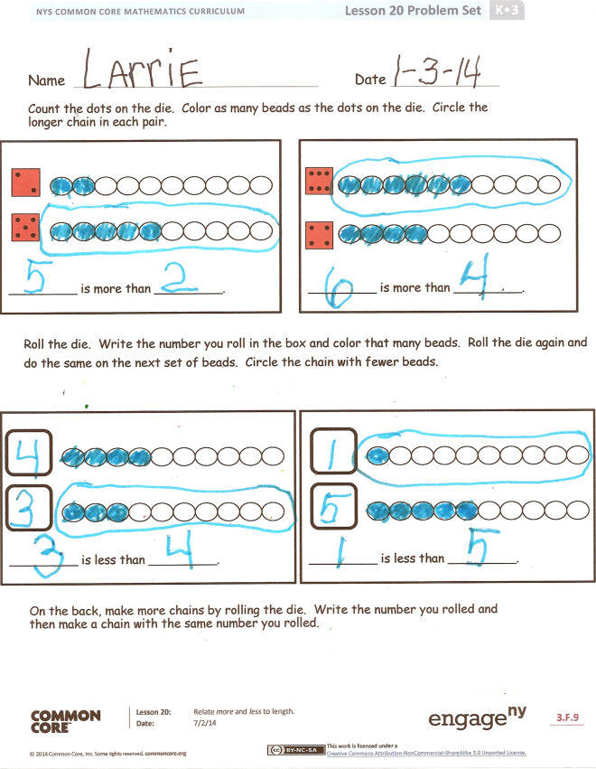
Students should do their personal best to complete the Problem Set within the allotted time.
Student Debrief (6 minutes)
Lesson Objective: Relate more and less to length.
The Student Debrief is intended to invite reflection and active processing of the total lesson experience.
Invite students to review their solutions for the Problem Set. They should check work by comparing answers with a partner before going over answers as a class. Look for misconceptions or misunderstandings that can be addressed in the Debrief. Guide students in a conversation to debrief the Problem Set and process the lesson.
You may choose to use any combination of the questions below to lead the discussion.
- What are some of the ways you could tell which set had more cubes in our activity?
- If one stick has more cubes than another, will it be longer than the other?
- How can you compare the number of cubes in one set to another set? How can you tell which number is more?
- Talk to your partner about the chain you made by rolling the die for your Problem Set. What numbers did you roll? How did you know which had fewer beads?
- For the back of the Problem Set, what numbers did you roll? What did you do to make sure you drew the same number of beads as the number you rolled?
- If one stick has fewer cubes than another, will it be heavier or lighter than the other?
1 2 3 | 1 2 3
1 2 3 | 1 2 3
1 2 3 | 1 2 3
1 2 3 | 1 2 3

Name Date
Count the dots on the die. Color as many beads as the dots on the die. Circle the longer chain in each pair.
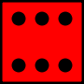
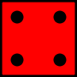

_________ is more than _________.

_________ is more than _________.

Roll the die. Write the number you roll in the box and color that many beads. Roll the die again, and do the same on the next set of beads. Circle the chain with fewer beads.

_________ is less than _________.

_________ is less than _________.
On the back, make more chains by rolling the die. Write the number you rolled, and then make a chain with the same number you rolled.

Name Date
On the first chain, color the first 3 beads blue.
On the next chain, color more than 3 beads red.
How many beads did you color red? Write the number in the box.

OO

_____ red beads is more than 3.
On the first chain, color the first 5 beads green.
On the next chain, color fewer than 5 beads yellow.
How many beads did you color yellow? Write the number in the box.

_____ yellow beads is fewer than 5.
Color 2 beads brown in the first column.
Color more than 2 beads blue in the second column.
How many beads did you color in the second column? Write the number in the box.

_____ blue beads is more than 2.

Color 9 beads red in the first column.
Color fewer than 9 beads green in the second column.
How many beads did you color in the second column? Write the number in the box.

_____ green beads is fewer than 9.

.

Draw a chain with more than 3 beads but fewer than 10 beads.

Draw a chain that has fewer than 10 beads but more than 4 beads.

square path letter trains

