Lesson 19
Objective: Compare using fewer than and the same as.

Suggested Lesson Structure
 Fluency Practice (12 minutes)
 Application Problem (5 minutes)
 Concept Development (25 minutes)
 Student Debrief (8 minutes)
Total Time (50 minutes)
Fluency Practice (12 minutes)
- Dot Cards of 9 K.CC.5, K.CC.2 (4 minutes)
- Building Up to the Sprint Routine: Starting and Stopping at the Signal K.CC.3 (5 minutes)
- Show Me 1 More, 1 Less K.CC.4c (3 minutes)
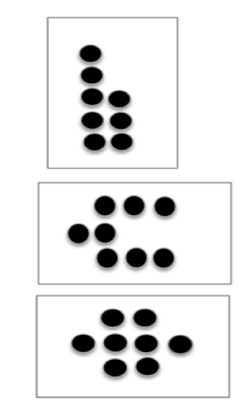
Dot Cards of 9 (4 minutes)
Materials: (T/S) Varied dot cards of 9 (Fluency Template)
T: (Show a card with 9 dots.) How many dots do you count? Wait for the signal to tell me. (Signal.)
S: 9.
T: How can you see them in two parts?
S: (Come forward to the card.) I saw 5 here and 4 here. I saw 3 here and 6 here. I saw 2 here and 7 here.
Repeat with other cards. Pass out the cards for students to work independently.
Building Up to the Sprint Routine: Starting and Stopping at the Signal (5 minutes)
Materials: (S) Lined writing paper
Note: Although the task is simple, this activity conditions students to stop working, even when they have not finished, and develops the self-regulation necessary for participating in math Sprints. Teaching the Sprint routine in stages may be time-consuming, but the investment is worthwhile.
Conduct as described in Lesson 16, but this time, increase the level of difficulty by having students write the numbers counting down from 10 to 0.
Show Me 1 More, 1 Less (3 minutes)
Note: Students develop flexibility with the terms more and less, building upon the previous lesson and preparing for the current lesson.
T: Show me three fingers the Math Way.
S: (Hold up the left pinky, left ring finger, and left middle finger.)
T: Now, show me 1 more.
S: (Hold up the left pinky, left ring finger, left middle finger, and left index finger.)
T: How many fingers are you showing me now?
S: 4.
T: We can say it like this, “3. 1 more is 4.” Echo me, please.
S: 3. 1 more is 4.
T: New number. Show me 5.
S: (Show open left hand.)
T: Now, show me 1 less.
S: (Hold up the left pinky, left ring finger, left middle finger, and left index finger.)
T: How many fingers are you showing me now?
S: 4.
T: We can say it like this, “5. 1 less is 4.” Echo me, please.
S: 5. 1 less is 4.
Continue, and when students are ready, have them provide 1 more and 1 less statements on their own.
Application Problem (5 minutes)

NOTES ON
MULTIPLE MEANS
OF ENGAGEMENT:
For students working below grade level, break the Application Problem down into smaller chunks and ask students to practice the process. Show students what to do. Make a little pancake with the clay and give it to a student while asking, “Is that enough? Did everyone get one? Do we need to make more?” Continue until students are able to complete this problem independently.
Materials: (S) 1 small ball of clay
Use your clay to make six little pretend pancakes. How many people could you serve with your pancakes if you were going to have a tiny pancake party? What if another person joined them? Put your clay back together into a ball. Make new tiny pancakes so there is just enough. Talk about your cooking with your friend.
Note: This problem requires students to recalculate just enough in a change situation, providing an anticipatory set for the discussion of less than and fewer than in today’s lesson.

Concept Development (25 minutes)
Materials: (T) Box of markers (S) Bag of 5 pennies, bag of 10 loose linking cubes
T: (Lay five markers on the table.) I am going to call up six students to be my helpers. (Say to each student, one at a time.) Please take a marker and hold it up.

NOTES ON
MULTIPLE MEANS
OF REPRESENTATION:
Help English language learners by asking them questions that scaffold the concepts of the same as and fewer than. After the sixth student is left without a marker, ask, “Did everyone get a marker? Do we have a marker to give to everyone?” When the student receives a marker, ask, “Are there more students who need a marker? Are there markers left over?”
S: (Sixth student.) I can’t take one. There are none left!
T: Oh, no! There are fewer markers than students! There are not enough markers so that each student can have one. (Hand sixth student a marker.) Now, are there enough?
S: Yes! Everyone has one.
T: Now, the number of markers is the same as the number of students. Each student has one. Please give me your markers and return to your seats.
Repeat exercise several times, each time emphasizing the fewer than and the same as language, until all students have had a chance to participate.
T: You have a bag of pennies and a bag of linking cubes. Please arrange the objects on your desk. What do you notice?
S: We have more cubes. There aren’t as many pennies.
T: How did you know? (Allow students to talk about their comparison strategies. Did they count them? Did they line them up to compare? Discuss all relevant strategies.)
T: You are right! Echo me, “There are fewer pennies than cubes.”
S: There are fewer pennies than cubes.
T: Put one cube back into your bag. Look at the cubes and pennies again. What do you notice?
MP.6
S: There are still more cubes!
T: Echo me, “There are fewer pennies than cubes.” (Repeat until there are five of each object on the desktops.)
T: Look at your objects again. What do you notice?
S: They are just the same!
T: We have the same number of pennies as we do cubes! Echo me, “The number of pennies is the same as the number of cubes.”
S: The number of pennies is the same as the number of cubes.
T: Please put your things away. We will do some more of these in our Problem Set now.

Problem Set (10 minutes)
Students should do their personal best to complete the Problem Set within the allotted time.
Student Debrief (8 minutes)
Lesson Objective: Compare using fewer than and the same as.
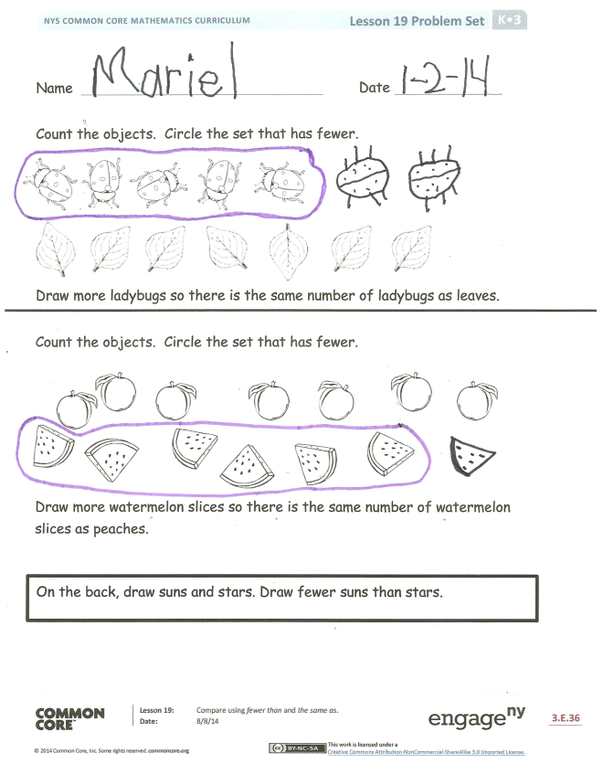
The Student Debrief is intended to invite reflection and active processing of the total lesson experience.
Invite students to review their solutions for the Problem Set. They should check work by comparing answers with a partner before going over answers as a class. Look for misconceptions or misunderstandings that can be addressed in the Debrief. Guide students in a conversation to debrief the Problem Set and process the lesson.
You may choose to use any combination of the questions below to lead the discussion.
- How did you figure out how many pancakes to make when you had an extra guest?
- What strategies did you use to compare the cubes and the pennies on your desk?
- How did you know when there were the same number of cubes as pennies?
- In the Problem Set, how did you know which set had fewer than the other? How did you draw to make the same number of ladybugs as leaves?
- How many suns and stars did you draw on the back of your Problem Set? Were there fewer suns or stars?
- Talk to your neighbor about how your drawings were different. Did your partner have more suns or stars? Did you have more suns or stars? Count all of your suns and stars. How many did you have? Check with your partner. Who had fewer than his or her partner? Did anyone have the same number as his or her partner?
- What important math vocabulary did we use to communicate precisely?

Name Date
Count the objects. Circle the set that has fewer.

Draw more ladybugs so there are the same number of ladybugs as leaves.

Count the objects. Circle the set that has fewer.
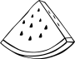

Draw more watermelon slices so there are the same number of watermelon slices as peaches.

On the back, draw suns and stars. Draw fewer suns than stars.

Name Date
Draw another bird so there are the same number of birds as bird cages.

On the back of your paper, draw 5 dogs .
Draw dog houses so there are fewer dog houses than dogs .
Draw bones so there are the same number of bones as dogs .

dot cards of 9
dot cards of 9
dot cards of 9
dot cards of 9
dot cards of 9
dot cards of 9
dot cards of 9
dot cards of 9

