Lesson 18
Objective: Compare using more than and the same as.

Suggested Lesson Structure
 Fluency Practice (12 minutes)
 Application Problem (5 minutes)
 Concept Development (25 minutes)
 Student Debrief (8 minutes)
Total Time (50 minutes)
Fluency Practice (12 minutes)
- Finger Number Pairs K.CC.4a (4 minutes)
- Matching Fingertips One-to-One K.CC.6 (4 minutes)
- Matching Circles and Squares K.CC.6 (4 minutes)
Finger Number Pairs (4 minutes)
Note: This activity ensures that students do not become overly reliant on counting the Math Way and gives them yet another method of breaking apart numbers, which is essential to the next module’s work.
T: You’ve gotten very good at showing fingers the Math way. I want to challenge you to think of other ways to show numbers on your fingers. Here’s a hint: you can use two hands! First, I’ll ask you to show me fingers the Math way. Then, I’ll ask you to show me the number another way. Ready? Show me 2!
S: (Hold up the pinky and ring fingers of the left hand.)
T: Now, show me another way to make 2 using two hands.
S: (Show 1 finger on each hand.)
T: How can we be sure that we’re still showing 2?
S: Count the fingers on both hands.
Continue the process with other numbers. For numbers where more than one combination is possible, have students try each other’s combinations.
Matching Fingertips One-to-One (4 minutes)
Note: This exercise allows students to demonstrate the concepts of enough and same as; it also anticipates drawing lines to match one-to-one for comparison in upcoming lessons.
Conduct the activity as described in Lesson 17, but now, invite students to show fingers in a variety of ways and verify that it is still the same number of fingers.
Matching Circles and Squares (4 minutes)
Materials: (S) Dice, personal white board
Note: Students gain experience with equivalency and practice one-to-one matching in anticipation of comparison.
1. Partner A rolls a die and draws the number of circles that corresponds to the number of dots on the rolled die.
2. Partner B draws that same number of squares.
3. Partner A draws lines to match circles to squares, while both partners say, “One circle, one square, one circle, one square…”
Application Problem (5 minutes)
Draw four little mice. Draw some pieces of cheese so that each mouse can have one. Use a ruler to draw a line between each mouse and its cheese. Are there just enough pieces of cheese? Talk to your partner about how you knew how many pieces of cheese to draw.
Note: Circulate during the activity to check understanding of one-to-one correspondence before today’s lesson.
Concept Development (25 minutes)
Materials: (T) Basket of 3 blocks or small toys, additional blocks (S) Bag of 5 loose red linking cubes, bag of 10 loose blue linking cubes, pair of dice with the 6 dot side covered, 5 additional red linking cubes
T: (Call four students to the front.) Please reach in, one at a time, and take one thing out of my mystery basket.
S: (Last student reaches inside.) I don’t have one!
T: There are not enough. There are more students than blocks. Here is another block for you to hold. Now, we have the same number of blocks as students! Please return to your seats.
T: What happened when I asked them each to take a block?
S: There weren’t enough.
T: Right. I had more students than blocks! I had to find another block to make them the same number. (Put another three blocks in the basket and call a pair of students forward.) One at a time, please take one thing out of my basket. (Show students the remaining block in the basket.) What happened this time?
MP.7
S: There were too many!
T: There were more blocks than students! Student A, would you please come up and take a block out of my basket? (Student takes last block.) Now, we have the same number of blocks as students.

Repeat activity several times until many or all students have had a chance to participate. Model and encourage use of “more ___ than ____ ” and “the same number of ____ as ____ .”
T: Take out your bags of linking cubes. Put the red cubes on one side of your desk and the blue cubes on the other side of your desk. Take a minute to look at the cubes. Tell your partner what you notice. Are the red and blue cube sets the same? (Allow time for discussion. Circulate to notice how the students compare sets. Do they make towers out of the cubes? Do they just line them up and notice what is missing? Do they pair them and see what is left? Do they count them?)
T: What do you notice?
S: There are more blue cubes.
T: Tell me how you knew.
S: I lined them up like this and saw that this line was longer. I made towers out of my cubes, and this tower was higher. I counted five here and ten here. I could just see without counting.
T: Those are interesting strategies! You found ways to know that there were more blue cubes than red cubes. Now, put seven blue cubes back into your bag. What do you notice about the cubes you have left on your desk?
S: Now, there are more red ones!
T: Yes, now there are more red cubes than blue cubes. Can you put enough red cubes away so that there are the same number of red cubes as blue cubes? Show your work to your partner. (Circulate again to ensure understanding of one-to-one correspondence.)
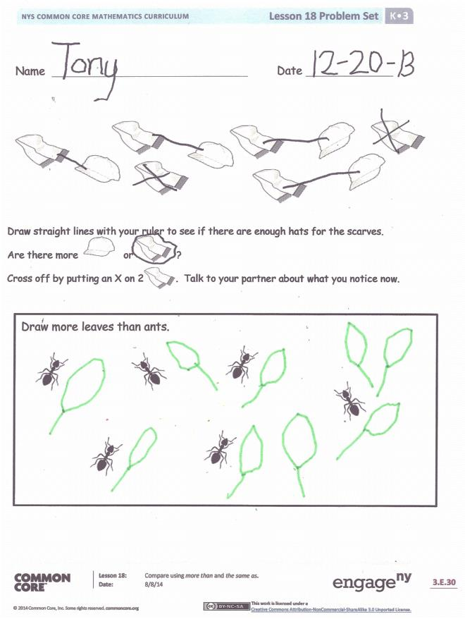
Invite students to play a game. After distributing extra materials (the dice and additional red linking cubes), have one student roll a pair of dice, and then show the same number of red cubes as the number rolled. The partner does the same. Demonstrate how to make a more than or the same as statement based on what happened. Circulate and support students as they practice making precise math statements.
Problem Set (10 minutes)
Students should do their personal best to complete the Problem Set within the allotted time.
Student Debrief (8 minutes)
Lesson Objective: Compare using more than and the same as.
The Student Debrief is intended to invite reflection and active processing of the total lesson experience.
Invite students to review their solutions for the Problem Set. They should check work by comparing answers with a partner before going over answers as a class. Look for misconceptions or misunderstandings that can be addressed in the Debrief. Guide students in a conversation to debrief the Problem Set and process the lesson.
You may choose to use any combination of the questions below to lead the discussion.
- What happened when you first took out the red and blue cubes? How did you know which set had more? Did someone else do it differently?
- In the Problem Set, were there more hats or scarves? How did you know? (Help students use more than and the same number as in their answers.)
- How did you use your ruler to help find which had more?
- What happened when you crossed out the two scarves? (Guide students to practice saying more than and the same as.)
- How many ants were there? You had to draw more leaves than ants. How many leaves did you draw? Check with your partner to see if they drew the same number of leaves. Who had more?
- What new math vocabulary did we use today to communicate precisely?

Name Date
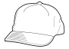
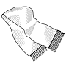

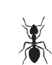
Draw straight lines with your ruler to see if there are enough hats for the scarves.
Are there more or ?
Cross off by putting an X on 2 . Talk to your partner about what you notice now.
Draw more leaves than ants.
Name Date

Draw straight lines with your ruler to see if there is one hoop for each ball.
Are there more or ?
Write the number of .

Write the number of . Write the number of .
Are there the same number of as ? Circle yes or no.

