Lesson 17
Objective: Compare to find if there are enough.

Suggested Lesson Structure
 Fluency Practice (11 minutes)
 Application Problem (8 minutes)
 Concept Development (25 minutes)
 Student Debrief (6 minutes)
Total Time (50 minutes)
Fluency Practice (11 minutes)
- Dot Cards of 8 K.CC.5, K.CC.2 (4 minutes)
- Show Me Bigger and Smaller K.MD.1 (3 minutes)
- Matching Fingertips One-to-One K.CC.6 (4 minutes)
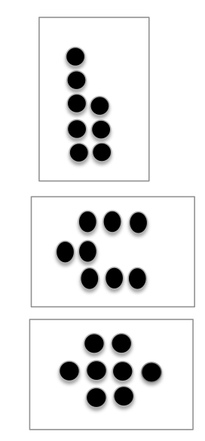
Dot Cards of 8 (4 minutes)
Materials: (T/S) Dot cards of 8 (Fluency Template)
Note: This activity deepens students’ knowledge of embedded numbers and develops part–whole thinking, which is foundational to the work of upcoming modules.
T: (Show a card with 8 dots.) How many dots do you count? Wait for the signal to tell me.
S: 8.
T: How can you see them in two parts?
S: (Point to the card.) I saw 4 here and 4 here. I saw 5 here and 3 here. I saw 6 here and 2 here.
Repeat with other cards. Pass out the cards for students to work independently.
Show Me Bigger and Smaller (3 minutes)
Note: This activity prepares students for the current lesson by making visual and kinesthetic connections to size comparison.
Conduct activity similarly to the Show Me Taller and Shorter activity in Lesson 2, but have students position their hands close together as if holding a tennis ball to indicate smaller and hands farther apart as if holding a basketball to indicate bigger.
Matching Fingertips One-to-One (4 minutes)
Materials: (S) Dice
Note: This exercise relates to the concept of enough and anticipates drawing lines to match one-to-one pictorially in upcoming lessons.
1. Partner A rolls a die and shows as many fingers as dots on the rolled die.
2. Partner B shows the same number of fingers.
3. Both partners touch fingertips, carefully matching one-to-one.
Application Problem (8 minutes)
Materials: (T) Music player; chairs, carpet squares, or pieces of construction paper per student; plus several more chairs than students
It’s time to have a math celebration and play a game of musical chairs (or carpet squares or papers)! During the first round, make sure that there are several more chairs than students. When the students sit and notice the extra chairs, tell them, “There are not enough children to fill the chairs.” Continue playing and remove a chair each round until there are just as many chairs as students. When they sit down, tell them, “There are just enough chairs!” Repeat as time permits.
Note: The physical matching of chairs to students and the introduction of enough will serve as the anticipatory set for the lesson.
Concept Development (25 minutes)
Materials: (S) Paper plate, cup, spoon, and napkin; popcorn (or some other snack); bottle of water

NOTES ON
MULTIPLE MEANS
OF REPRESENTATION:
Scaffold the lesson for English language learners by holding up a plate, spoon, cup, and napkin while explaining what each person in the group needs before handing out the materials to the groups to discover whether they have enough.
Setup: Arrange students into groups of four around tables or on the floor.
T: We are going to have a math popcorn party today! Let’s set our tables. You will each need a plate, a spoon, a cup, and a napkin. Here is a plate for each of you. (Hand each group of students a stack of four plates.) Please pass out the plates. Are there enough?
MP.6
S: Yes.
T: Good! There is one plate for each of you.
T: Here are spoons for you. (Hand each group of 4 students three spoons.) Are there enough spoons?
S: There are not enough!
T: How many more do you need in your group?

NOTES ON
MULTIPLE MEANS
OF REPRESENTATION:
For students who struggle, clarify what the terms just enough and not enough mean after they are introduced. Provide examples of just enough while asking if there are any left over, and provide examples of not enough while asking if everyone received one.
S: We need one more.
T: (Give each group one more spoon.)
T: Now we have one spoon for each child. We have enough spoons.
T: Here are your cups. (Give each group five cups.)
S: There are too many!
T: How many extra cups do you have in your group?
S: One.
MP.6
T: (Take back the extra cups.)
T: Good! Each of you has a cup. We have just enough.
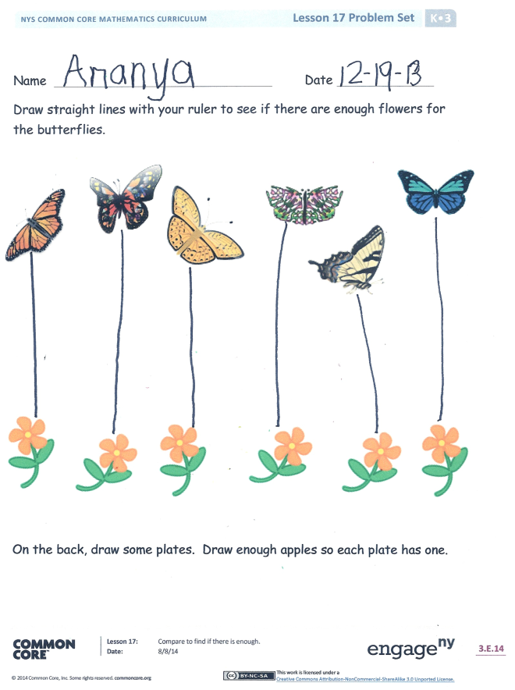
T: Here are some napkins for you. Make sure that you each have one. (Hand each group two napkins.)
S: There are not enough! We need more!
T: Here are extra napkins. Please make sure that each of you has one napkin. When you have enough, please give the rest back to me. Also, here is some popcorn for you to munch on while you do your Problem Set! (Serve the popcorn and water.) I wonder how many cups I can fill with my water bottle? I hope that I have enough!
Have the students count the cups the Say Ten Way as you pour. (Support the students as they count above 20.) Use a scoop to distribute popcorn, and count the number of scoops. Discuss with the class what you should do with the leftovers (the remainder).
Problem Set (10 minutes)
Students should do their personal best to complete the Problem Set within the allotted time.

Student Debrief (6 minutes)
Lesson Objective: Compare to find if there are enough.
The Student Debrief is intended to invite reflection and active processing of the total lesson experience.
Invite students to review their solutions for the Problem Set. They should check work by comparing answers with a partner before going over answers as a class. Look for misconceptions or misunderstandings that can be addressed in the Debrief. Guide students in a conversation to debrief the Problem Set and process the lesson.
You may choose to use any combination of the questions below to lead the discussion.
- When we were playing musical chairs, did we know before we started if there would be enough chairs?
- How could we have found out if there were enough chairs before we started playing?
- When there were not enough spoons, how did you know how many more your group needed?
- When there were too many cups, how did you know how many extra cups your group had?
- In the Problem Set, were there just enough flowers for the butterflies? How did you know?
- How many plates did you draw on the back of your paper? How many apples did you draw? Did you draw enough apples and plates?
- What new (or significant) math vocabulary did we use today to communicate precisely?

Name Date
Draw straight lines with your ruler to see if there are enough flowers for the butterflies.

On the back, draw some plates. Draw enough apples so each plate has one.

Name Date
Draw straight lines with your ruler to see if there are enough shovels for the pails.

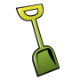

Make sure there is a fork for every plate. Draw straight lines with a ruler from each plate to a fork. If there are not enough forks, draw one.

You have 4 fishes. Draw enough fish bowls so you can put 1 fish in each fish bowl.

dot cards of 8
dot cards of 8
dot cards of 8
dot cards of 8
dot cards of 8
dot cards of 8
dot cards of 8
dot cards of 8
dot cards of 8

