Lesson 16
Objective: Make informal comparison of area.

Suggested Lesson Structure
 Fluency Practice (13 minutes)
 Application Problem (5 minutes)
 Concept Development (25 minutes)
 Student Debrief (7 minutes)
Total Time (50 minutes)
Fluency Practice (13 minutes)
- Groups of Shapes K.G.2 (5 minutes)
- Show Me Bigger and Smaller K.MD.1 (3 minutes)
- Building Up to the Sprint Routine: Starting and Stopping at the Signal K.CC.3 (5 minutes)
Groups of Shapes (5 minutes)
Materials: (T) Shape signs (Fluency Template 1), music (S) Shape cutouts (include exemplars and non-examples) (Fluency Template 2)
Note: This activity prepares students for the current lesson by providing a quick review of shapes.
T: Choose a shape, and then meet me at the rug.
T: Look at your shape. Raise your hand if you know the name of your shape. When I give the signal, whisper the name of your shape to yourself. Ready? (Signal.)
S: (Whisper shape name.)
T: Look around the room. Do you see signs with pictures of shapes?
S: Yes.
T: Do you see your shape?
S: Yes.
T: When I start the music, I want you to calmly walk to the sign that has the same shape as yours.
T: When I point to your group, say the name of your shape. (Point to the group of triangles.)
S: Triangles!
Continue identifying the remaining groups, and then call students back to the rug to trade for a new shape. Circulate to observe which students struggle with this task, and provide support by having them identify the attributes of their shape as compared to the shapes pictured on the signs.
Show Me Bigger and Smaller (3 minutes)
Note: This activity prepares students for the current lesson by making visual and kinesthetic connections to size comparison.
Conduct similarly to the Show Me Taller and Shorter activity in Lesson 2, but have students position their hands close together as if holding a tennis ball to indicate smaller and hands farther apart as if holding a basketball to indicate bigger.
Building Up to the Sprint Routine: Starting and Stopping at the Signal (5 minutes)
Materials: (S) Lined writing paper
Note: Although the task is simple, this activity conditions students to stop working, even when they have not finished; additionally, it develops the self-regulation necessary for participating in Sprints. Teaching the Sprint routine in stages may be time-consuming, but the investment is worthwhile. Students begin their first Sprint in Lesson 21.
T: When I say “go,” we are going to practice writing numbers 1–10 quickly, but carefully, like this. (Demonstrate.) When you hear the bell ring, you must stop and hold up your pencil, even if you are not finished. What do you do when you hear the bell?
S: Stop and hold up my pencil.
T: Good. Remember, it’s okay if you don’t finish. Ready? Go!
S: (Write numbers 1─10.)
T: (Before students reach 10, ring the bell.) Pencils up, up, up!
S: (Hold pencils up.)
T: Wow! You really followed the directions! Let’s practice again. Ready? Go!
Continue several more times, praising students for following directions rather than completing the task.
Application Problem (5 minutes)

NOTES ON
MULTIPLE MEANS
OF ENGAGEMENT:
Support English language learners by providing them with sentence frames such as, “To cover my card, I think I will need linking cubes.” and “To cover my card, I needed linking cubes.” This will make it possible for English language learners to benefit from the Application Problem and discussion with a partner. For non-readers, these frames can be communicated orally.
Materials: (S) Playing card, bag of linking cubes
How many linking cubes would you need to cover up your card? Make a guess! Now, work with your partner to test your guess. What did you discover? How many cubes did you need?
Did your friends use the same number of cubes?
Note: This problem requires students to compare the area of the face of the linking cube to the area of the rectangular card. This will set the stage for today’s lesson. Circulate during the exercise to determine which face of the cube the students choose to use. Observe whether they choose to stack the cubes, as well as whether they arrange them without gaps.
Concept Development (25 minutes)

NOTES ON
MULTIPLE MEANS
OF ACTION AND EXPRESSION:
Students may need to use more beans than previously counted in class. Some students will use this opportunity to showcase their knowledge of counting beyond 20. Other students will benefit from counting beyond 20 with support. Knowing how many more is not the objective in this lesson. Simply knowing that there are more beans than squares is sufficient for an informal comparison.
Materials: (T) 1 set of student materials (S) My square recording sheet (Template), 1 four-inch square of construction paper, 1 four-inch diameter paper circle, 20 one-inch paper or plastic square tiles, 1 small bag of large flat beans, my square recording sheet (Template)
T: Place your square of paper on your desk. What are some things that would fit onto your square?
S: My hand! An apple. A block. Some crayons.
T: Will there be enough room for a circle like this? (Hold up circle.) (Various responses.) Let me give each of you a circle to test your guess.
S: Yes! It fits.
T: Will you have enough room for another circle?
S: No.
T: On your recording sheet, let’s draw what your square looks like now. (Demonstrate.)
T: (Hold up a 1-inch paper square.) Will this fit on your paper? Is there enough space?

NOTES ON
MULTIPLE MEANS
OF ACTION AND EXPRESSION:
Challenge students working above grade level to explain how they were able to cover one square with one circle, 16 small squares, or many beans. Encourage them to use the math words that they know.
S: Yes.
MP.7
T: Do you think 5 of them will fit? (Various responses.) Take out your paper squares, and put 5 of them on the paper. Is there enough space for 1 more?
S: Yes!
T: Put another square on the paper. (Repeat until the square is filled with smaller squares. Notice student strategies as they try to fit more onto their paper.)
T: So, your square held 1 circle. How many small squares did you need to fill your big square?
S: 16.
T: Let’s draw what we did on the recording sheet. (Demonstrate.)
T: I wonder how many beans you would need to cover your square? (Various responses.) Work with your partner to put as many beans as you can on your square without piling them. (Allow time for experimentation and discussion.)
T: What did you notice about using the beans?
S: It was harder! They didn’t fit together like the squares did. I can still see some of the square. It took a lot of them!
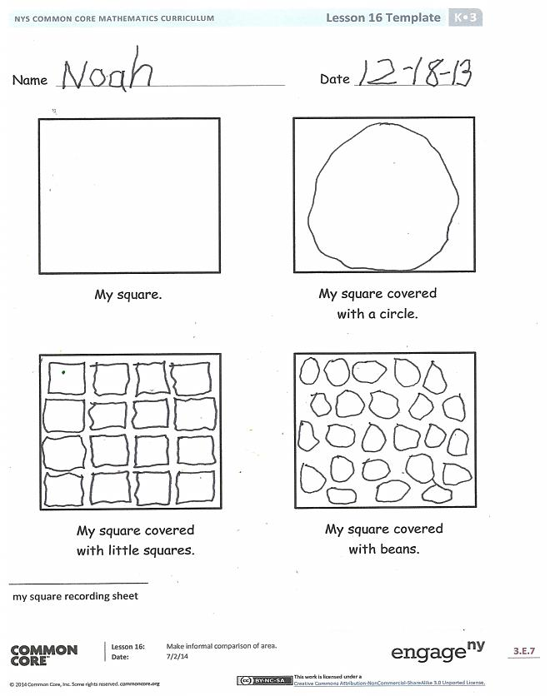
T: Did you use more beans or squares in this activity?
S: More beans! We had to use more because they were smaller.
Problem Set (10 minutes)
Students should do their personal best to complete the Problem Set within the allotted time.
Student Debrief (7 minutes)
Lesson Objective: Make informal comparison of area.
The Student Debrief is intended to invite reflection and active processing of the total lesson experience.
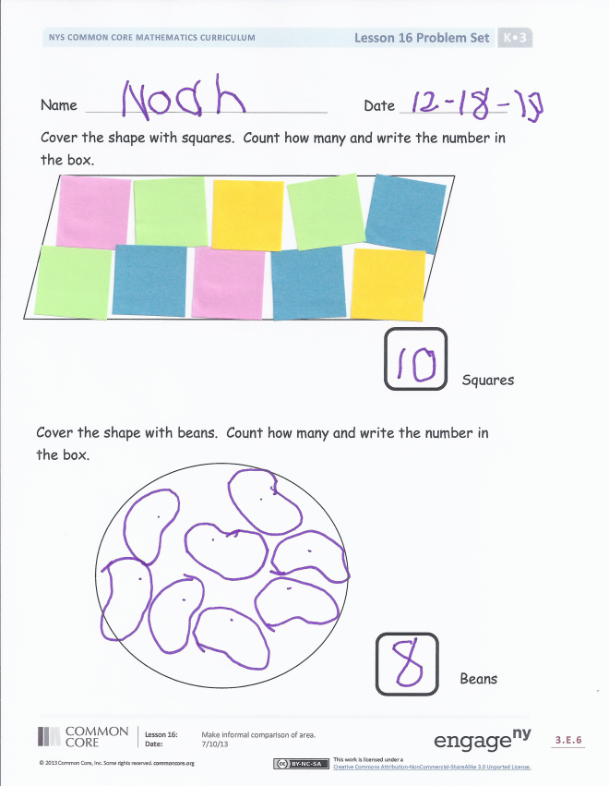
Invite students to review their solutions for the Problem Set. They should check work by comparing answers with a partner before going over answers as a class. Look for misconceptions or misunderstandings that can be addressed in the Debrief. Guide students in a conversation to debrief the Problem Set and process the lesson.
You may choose to use any combination of the questions below to lead the discussion.
- Were you able to cover the square entirely with your little squares or the beans? Why?
- Was that also true on the recording sheet? How were the two different? (Listen for discussion about how differences in sides and angles affected their work. Some students may notice the space between smaller units. Do not worry if they do not notice this because it is a concept they will encounter in Grade 3.)
- What strategies did you use to fit more things onto your paper?
- When you were covering the square, how did you decide that you were done? When you were covering the shapes on the Problem Set, how did you decide that you were done?
- Were you surprised by the number of squares or beans needed to cover some of the shapes?
- What math vocabulary did we use today to communicate precisely?

Name Date
Cover the shape with squares. Count how many, and write the number in the box.

Name Date
Cover the shape with beans. Count how many, and write the number in the box.

Squares

Beans
Trace your hand. Cover the tracing with pennies. Have an adult trace his or her hand. Cover tracing with pennies.* Whose hand is bigger? How do you know that?

*Note: Instead of pennies, you can use pasta, beans, buttons, or another coin. You may want to do this activity twice using different materials to cover the hands. Talk about which materials took more or less to cover and why.

Triangle

Rectangle
Square

Hexagon

Circle

Name Date
My square covered with little squares.
My square covered with beans.
My square covered with a circle.
My square.

shape signs
shape signs
shape signs
shape cutouts
my square recording sheet

