Lesson 15

Objective: Compare using *the same as* with units.

Suggested Lesson Structure

 Fluency Practice (12 minutes)

 Application Problem (5 minutes)

 Concept Development (27 minutes)

 Student Debrief (6 minutes)

**Total Time (50 minutes)**

Fluency Practice (12 minutes)

* Dot Cards of 7 **K.CC.5, K.CC.2** (4 minutes)
* Make It Equal K.CC.6 (3 minutes)
* Building *1 More* and *1 Less* Towers **K.CC.4c** (5 minutes)

Dot Cards of 7 (4 minutes)

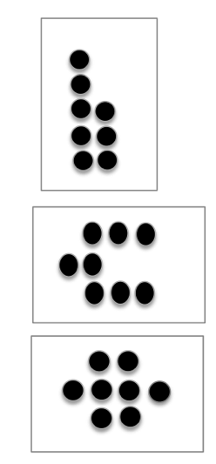

Materials: (T/S) Dot cards of 7 (Fluency Template)

Note: This activity deepens students’ knowledge of embedded numbers and develops part–whole thinking, crucial to the work of the upcoming modules.

T: (Show 7 dots.) How many do you see? (Give students time to count.)

S: 7.

T: How can you see 7 in two parts?

S: (Point to the card.) 5 here and 2 here. 🡪 I see 3 here and 4 here.

Continue with other cards of 7. Distribute the cards to the students for partner sharing time. Have them pass the cards at a signal.

Make It Equal (3 minutes)

Materials: (S) Bag of beans, foam or laminated paper work mat, 2 dice with 6 dot side covered

Note: In this activity, students experience comparison visually, a skill foundational to the work of this module.

1. Teacher introduces the term *equal* as meaning *the same number*.

2. Both partners roll dice and put that many beans on their mat.

3. Partner A makes her beans equal to her partner’s by taking off or putting on more beans.

4. Partner B counts to verify.

5. Switch roles and play again.

Building *1 More* and *1 Less* Towers (5 minutes)

Materials: (S) 10 linking cubes

Note: In this activity, students connect increasing and decreasing height to increasing and decreasing numerical value.

Conduct activity as described in Lesson 13, but now challenge students to stop at a certain number and then change directions so that they state the pattern of *1 more* or *1 less* starting from numbers other than 1 or 10.

T: Build up your tower while saying “1 more.” Stop when you get to 5.

S: 1. 1 more is 2. 2. 1 more is 3. 3. 1 more is 4. 4. 1 more is 5.

T: Stop! Now, take it apart while saying 1 less. Stop when you get to 3.

S: 5. 1 less is 4. 4. 1 less is 3.

T: Stop!

Continue changing directions several more times. It might be helpful to use a stick of cubes that show a color change at 5 to facilitate identifying the number of cubes in the tower.

Application Problem (5 minutes)

|  |  |
| --- | --- |
|  | NOTES ON  MULTIPLE MEANS  OF ENGAGEMENT: |

Extend the thinking of those students working above grade level by asking them to think about what else will fit in their container. Allow them to experiment with materials in the classroom. Ask them to estimate how much of their chosen material will fit into their container, and ask them to explain why they were correct or incorrect.

Materials: (S) Small ball of clay and 10 beans

Use your clay to make a container just large enough to hold your 10 beans. Test to see if the beans fit! Show your work to your partner.

Note: In this exercise, we expand the students’ thinking to consider that volume can be measured in units, in this case by beans. This serves as an anticipatory set for today’s introduction to comparing volume through units.

Concept Development (27 minutes)

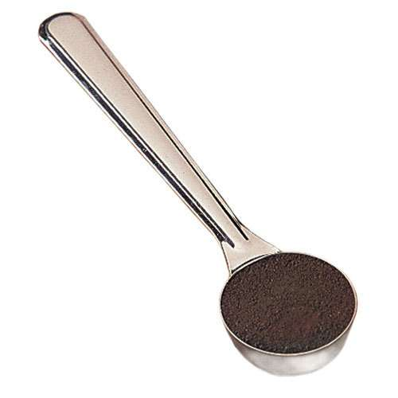Materials: (T) Set of student materials for demonstration, we’ve got the scoop recording sheet (Template) affixed to white board (S) 2 cups of rice, assortment of containers (teacup, small bottle, bowl, glass, small box, measuring cup), small scoop such as a coffee scoop, funnel, and tray per pair or small group; we’ve got the scoop recording sheet (Template)

T: (Hold up the scoop.) I wonder how many of these little scoops of rice it will take to fill my teacup. Does anyone have a guess?

S: (Various responses.)

T: I will put in 1 scoop so you can see how it looks in the cup. Watch how I am careful to level off the scoop before I pour it. It’s not fair using scoops that are only half full! (Model correct measuring technique.) Do you want to change your guess?

S: (Various responses.)

T: Student A, would you please help me finish filling my cup? Let’s count with Student A while he uses the scoop to fill the teacup.

|  |  |
| --- | --- |
|  | NOTES ON  MULTIPLE MEANS  OF ACTION AND EXPRESSION: |

Scaffold the lesson for English language learners by using motions. For example, hold up the scoop when you direct students to count the scoops it takes to fill their containers, and hold up the funnel when you direct students to use the funnel if they need it.

S: 2, 3, 4, 5, …10. Ten scoops!

T: It took 10 scoops to fill the teacup. 10 scoops is the same as 1 teacup of rice! Let me put that on my recording sheet. (Demonstrate.)

**MP.6**

T: (Hold up a smaller container.) How many scoops do you think it will take to fill this? Will it still be 10?

S: That one is smaller. 🡪 It will take 5 scoops. 🡪 I think it will take 7.

T: Student B, would you please come up to help? Count with Student B as he uses the scoop to fill the container.

S: 1, 2, 3, 4, 5, 6. It took 6 scoops. It holds less!

T: This container holds the same amount as 6 scoops. The capacity of this container is the same as 6 scoops. I will record that on my sheet, too. (Demonstrate.)

T: I want you to work with your partner to find out how many scoops each of the containers on your tray holds. Count the scoops and fill each container carefully. Use your funnel if you need to. Each time, remember to fill the scoop up all the way, but make sure it isn’t spilling over. Write your discoveries on your recording sheet. (Allow time for measurement and experimentation.)

T: Put your things back on your tray. Who would like to share something on his/her recording sheet? (Allow time for discussion.)

Problem Set (10 minutes)

In this lesson, the *we’ve got the scoop* recording sheet will serve as the Problem Set for the Concept Development.

Student Debrief (6 minutes)

**Lesson Objective**: Compare using *the same as* with units.

The Student Debrief is intended to invite reflection and active processing of the total lesson experience.

Invite students to review their recording sheets. Students should check work by comparing answers with a partner before going over answers as a class. Look for misconceptions or misunderstandings that can be addressed in the Debrief. Guide students in a conversation to process the lesson.

You may choose to use any combination of the questions below to lead the discussion.

* 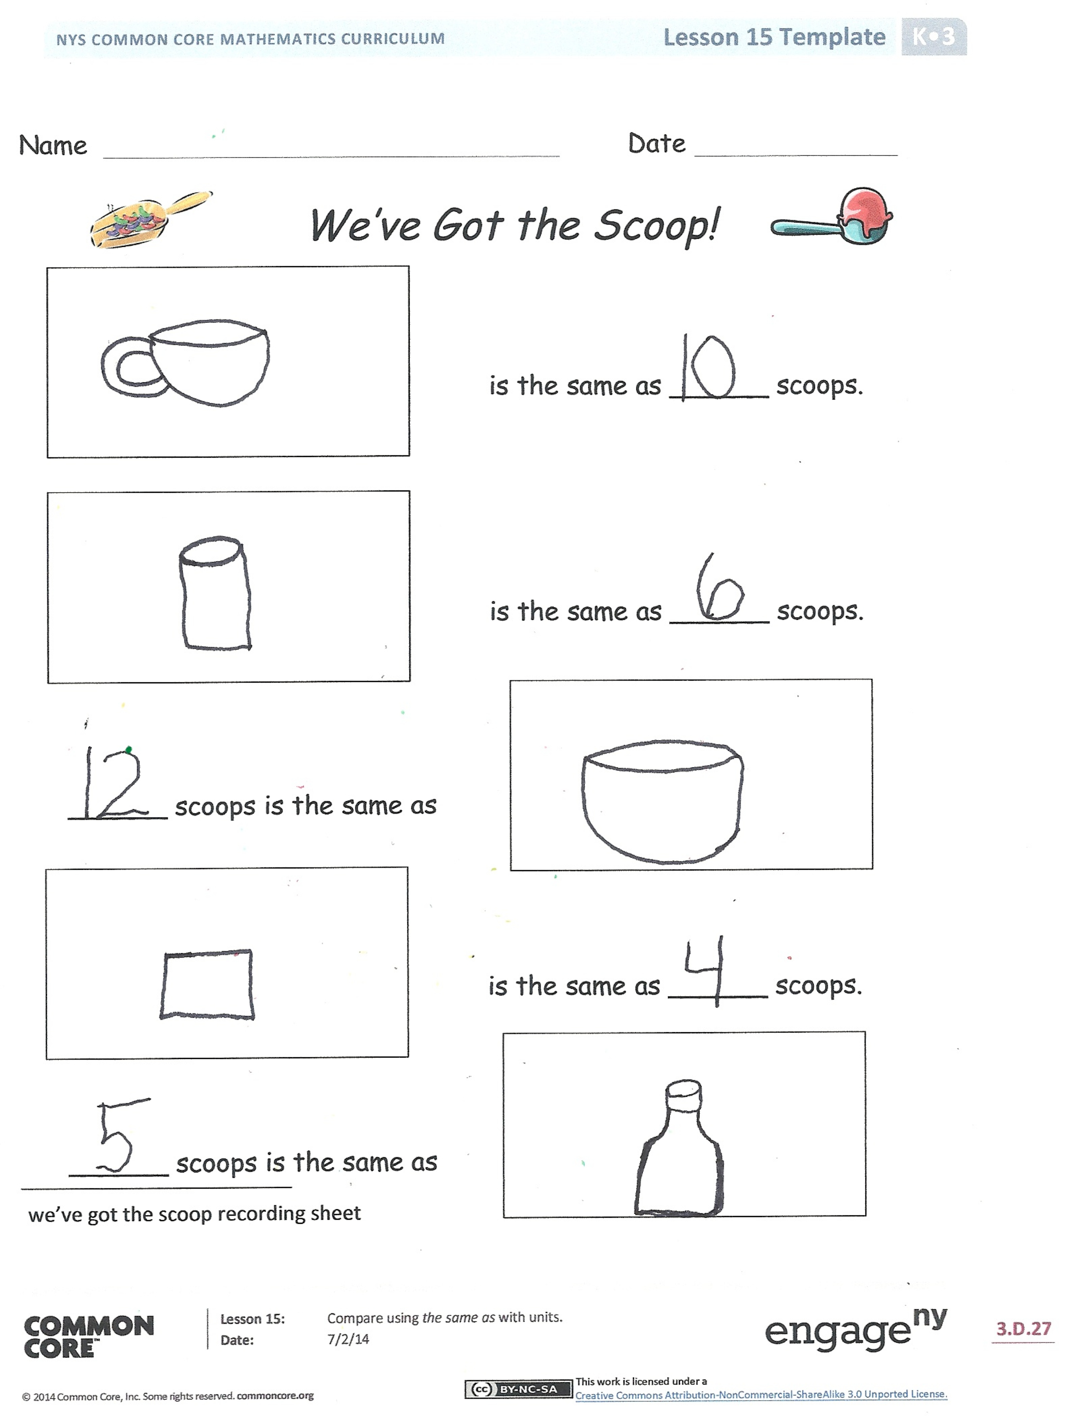Which of your containers held the most scoops?
* Which of your containers held the least number of scoops?
* Which container had the largest capacity? How did you know?
* Which container do you think had the least capacity? How did you know?
* Do you notice any patterns from your work today?
* Did you make any surprising discoveries during your work today?

Name Date

Circle 2 sets within each set of 7. The first one has been done for you.

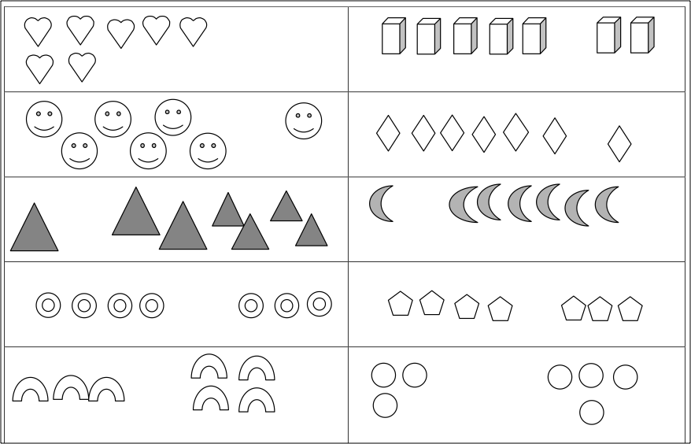

Name Date

[1] **C:\Users\store64\AppData\Local\Microsoft\Windows\Temporary Internet Files\Content.IE5\ZA32B5B8\MC900016745[1].wmfC:\Users\store64\AppData\Local\Microsoft\Windows\Temporary Internet Files\Content.IE5\KBZFFY2J\MC900012948[1].wmf**

*We’ve Got the Scoop!*

is the same as ______ scoops.

is the same as ______ scoops.

______ scoops is the same as

is the same as ______ scoops.

______ scoops is the same as

|  |
| --- |
| [2] |

[3] [4] [5]

[6] [7] [8]

[9]

[10]

1. we’ve got the scoop recording sheet
2. dot cards of 7
3. dot cards of 7
4. dot cards of 7
5. dot cards of 7
6. dot cards of 7
7. dot cards of 7
8. dot cards of 7
9. dot cards of 7
10. dot cards of 7