Lesson 34
Objective: Subtract mixed numbers.

Suggested Lesson Structure
 Fluency Practice (12 minutes)
 Application Problem (5 minutes)
 Concept Development (33 minutes)
 Student Debrief (10 minutes)
Total Time (60 minutes)
Fluency Practice (12 minutes)
- Sprint: Change Mixed Numbers to Fractions 4.NF.4 (9 minutes)
- Subtract Fractions from Whole Numbers 4.NF.3 (3 minutes)
Sprint: Change Mixed Numbers to Fractions (9 minutes)
Materials: (S) Change Mixed Numbers to Fractions Sprint
Note: This fluency activity reviews Lesson 25.
Subtract Fractions from Whole Numbers (3 minutes)
Materials: (S) Personal white board
Note: This fluency activity reviews Lesson 17.
T: (Write 6 – $\frac{\text{4}}{\text{5}}$.) Break apart the whole number and solve.
S: (Write 6 – $\frac{\text{4}}{\text{5}}$ = $\text{5}\frac{\text{1}}{\text{5}}$.)
Continue with the following possible sequence: 7 – $\frac{\text{5}}{\text{9}}$ and 10 – $\frac{\text{5}}{\text{12}}$.

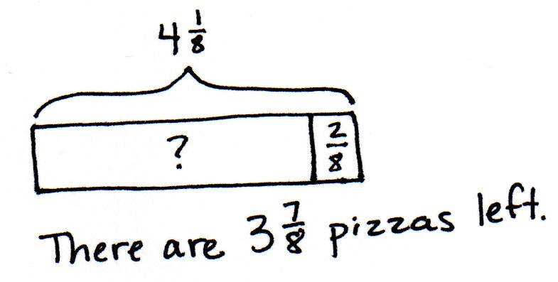
Application Problem (5 minutes)
There were $\text{4}\frac{\text{1}}{\text{8}}$ pizzas. Benny took $\frac{\text{2}}{\text{8}}$ of a pizza. How many pizzas are left?
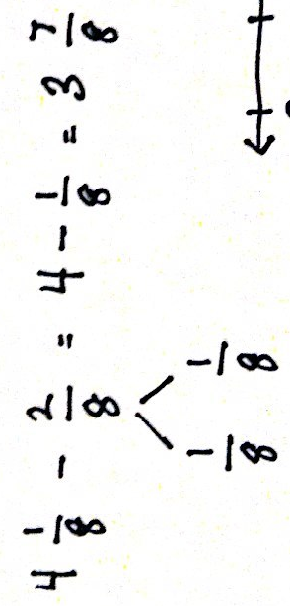
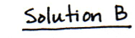
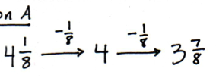
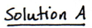

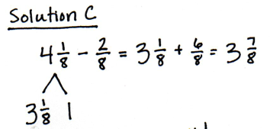
Note: This Application Problem reviews decomposition to subtract from a mixed number. This bridges to subtracting mixed numbers from mixed numbers.

NOTES ON
MULTIPLE MEANS
OF REPRESENTATION:
The strategy presented here involves the decomposition of a higher value unit, the same process used in the standard algorithm when 8 tens 1 one would be renamed as 7 tens 11 ones to subtract 2 tens 8 ones.
This connection is made in the Debrief. Students who struggle with this strategy may benefit from calling out the connection sooner if their understanding of renaming with whole number subtraction has a conceptual foundation.

Concept Development (33 minutes)
Materials: (S) Personal white board
Problem 1: Subtract a fraction from a mixed number by taking out 1 when there are not enough fractional units.
T: (Write $\text{8}\frac{\text{1}}{\text{10}}$ – $\frac{\text{8}}{\text{10}}.$) Do we have enough tenths to subtract 8 tenths?
S: No!
T: Let’s decompose 8 ones 1 tenth by taking out 10 tenths from 8. How many ones and tenths make up the two parts of my number bond?
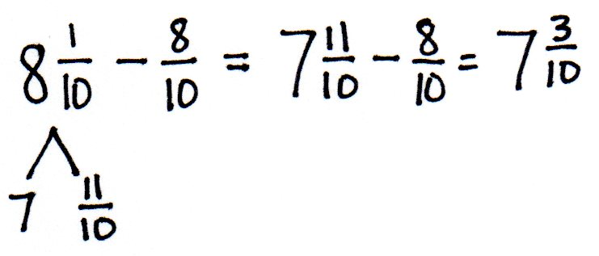
S: 7 ones 11 tenths.
T: (Record a number bond for $\text{8}\frac{\text{1}}{\text{10}}$.) Subtract.
S: $\text{7}\frac{\text{11}}{\text{10}}$ – $\frac{\text{8}}{\text{10}}$ = $\text{7}\frac{\text{3}}{\text{10}}$.
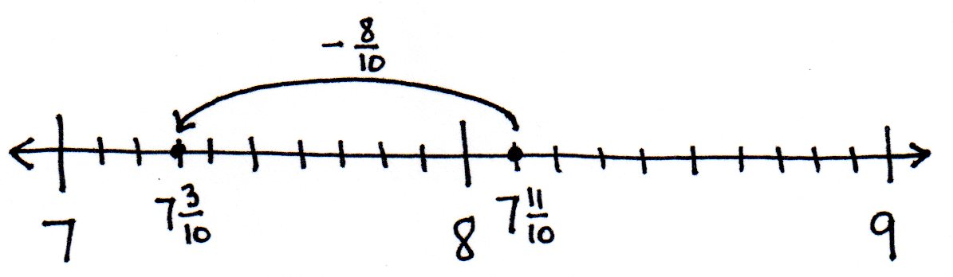
T: Model the subtraction on a number line. Rename $\text{8}\frac{\text{1}}{\text{10}}$ and make one slide of $\frac{\text{8}}{\text{10}}$.
S: (Draw a number line and subtract as shown to the right.)
Let students practice with the following:
$\text{6}\frac{\text{2}}{\text{8}}$– $\frac{\text{7}}{\text{8}} ,$ $\text{5}\frac{\text{1}}{\text{4}}$ – $\frac{\text{3}}{\text{4}}$ , and $\text{4}\frac{\text{2}}{\text{6}}$ – $\frac{\text{5}}{\text{6}}$.
Problem 2: Subtract a mixed number from a mixed number by taking out 1 when there are not enough fractional units.
T: (Write $\text{11}\frac{\text{1}}{\text{5}}$ – $\text{2}\frac{\text{3}}{\text{5}}.$)
T: Subtract the whole numbers. What new subtraction expression remains?
S: $\text{9}\frac{\text{1}}{\text{5}}$ – $\frac{\text{3}}{\text{5}}.$
T: (Write $\text{9}\frac{\text{1}}{\text{5}}$ – $\frac{\text{3}}{\text{5}}$ $.$)
T: Think back to the last problem you solved. What strategy did you use?
S: We renamed the first mixed number, or the total, from which we were subtracting$.$
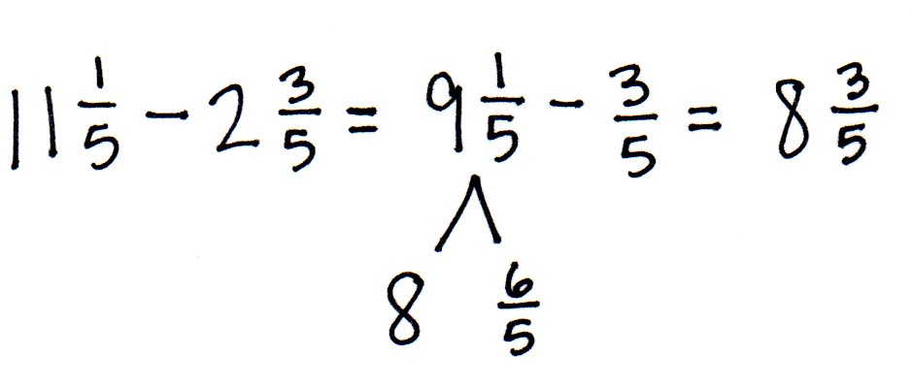
T: Decompose 9 ones 1 fifth by taking out 5 fifths to make 6 fifths. How many ones and fifths are in the total?
S: (Record a number bond for $\text{9}\frac{\text{1}}{\text{5}}$.) 8 ones 6 fifths.
T: (Record a number bond for $\text{9}\frac{\text{1}}{\text{5}}$.) Subtract $\text{8}\frac{\text{6}}{\text{5}}$ – $\frac{\text{3}}{\text{5}}$.
S: $\text{8}\frac{\text{6}}{\text{5}}$ – $\frac{\text{3}}{\text{5}}$ = $\text{8}\frac{\text{3}}{\text{5}}$.
T: Explain to your partner why this is true. Draw a number line to explain your thinking.
S: It’s like regrouping, so we have enough fifths to subtract. We subtract 2 ones first. We can rename $\text{9}\frac{\text{1}}{\text{5}}$ as $\text{8}\frac{\text{6}}{\text{5}}$ and easily subtract $\frac{\text{3}}{\text{5}}$.
Let students practice with the following: $\text{4}\frac{\text{1}}{\text{8}}$ – $\text{1}\frac{\text{7}}{\text{8}}$ and $\text{7}\frac{\text{5}}{\text{12}}$ – $\text{3}\frac{\text{9}}{\text{12}}$. Those who are struggling may need to record more steps to keep track of their thinking, e.g., $\text{4}\frac{\text{1}}{\text{8}}$ – $\text{2}\frac{\text{7}}{\text{8}}$ = $\text{2}\frac{\text{1}}{\text{8}}$ – $\frac{\text{7}}{\text{8}}$ = $\text{1}\frac{\text{9}}{\text{8}}$ – $\frac{\text{7}}{\text{8}}$ = $\text{1}\frac{\text{2}}{\text{8}}$, or to continue modeling with a number line. Have them share their work with a partner, explaining their solution.
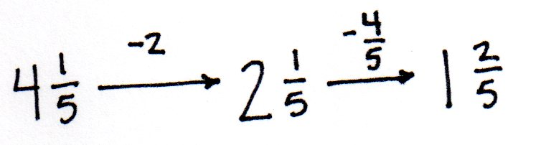
Problem 3: Rename the total to subtract a mixed number from a mixed number when there are not enough fractional units using the arrow way.
T: Solve $\text{4}\frac{\text{1}}{\text{5}}$ – $\text{2}\frac{\text{4}}{\text{5}}$. Tell your partner the first step.
MP.3
S: Subtract the ones.
T: (Record subtracting 2 using the arrow way.) Say the number sentence.
S: $\text{4}\frac{\text{1}}{\text{5}}$ – $\text{2}\frac{\text{4}}{\text{5}}$ = $\text{2}\frac{\text{1}}{\text{5}}$ – $\frac{\text{4}}{\text{5}}$.
T: Tell your partner the next step.
S: Rename $\text{2}\frac{\text{1}}{\text{5}}$ as $\text{1}\frac{\text{6}}{\text{5}}$ and subtract $\frac{\text{4}}{\text{5}}$.
T: (Record subtracting $\frac{\text{4}}{\text{5}}$ using the arrow way.) What is the difference?
S: $\text{1}\frac{\text{2}}{\text{5}}$.
T: Discuss with your partner what you have learned about mixed number subtraction that can help you solve without recording the number bond.
S: The arrow way lets me keep track of the steps in subtracting. I can use counting backward. Subtracting $\frac{\text{1}}{\text{5}}$ gets me to 2, and then I just count back 3 more fifths. I could rename the mixed number as a fraction greater than 1. So, $\text{2}\frac{\text{1}}{\text{5}}$ is the same as $\frac{\text{11}}{\text{5}}$. $\frac{\text{11}}{\text{5}}$ – $\frac{\text{6}}{\text{5}}$ is easy to think of in my head.
MP.3
Let students practice with the following: $\text{9}\frac{\text{3}}{\text{8}}$ – $\text{7}\frac{\text{5}}{\text{8}}$ , $\text{6}\frac{\text{2}}{\text{7}}$ – $\text{3}\frac{\text{6}}{\text{7}}$, and $\text{7}\frac{\text{3}}{\text{10}}$ – $\text{2}\frac{\text{4}}{\text{10}}$. Encourage students to solve mentally, recording only as much as they need to keep track of the problem. Have students share their work with their partner to explain their solution.
Problem Set (10 minutes)
Students should do their personal best to complete the Problem Set within the allotted 10 minutes. For some classes, it may be appropriate to modify the assignment by specifying which problems they work on first. Some problems do not specify a method for solving. Students should solve these problems using the RDW approach used for Application Problems.
Student Debrief (10 minutes)
Lesson Objective: Subtract mixed numbers.
The Student Debrief is intended to invite reflection and active processing of the total lesson experience.
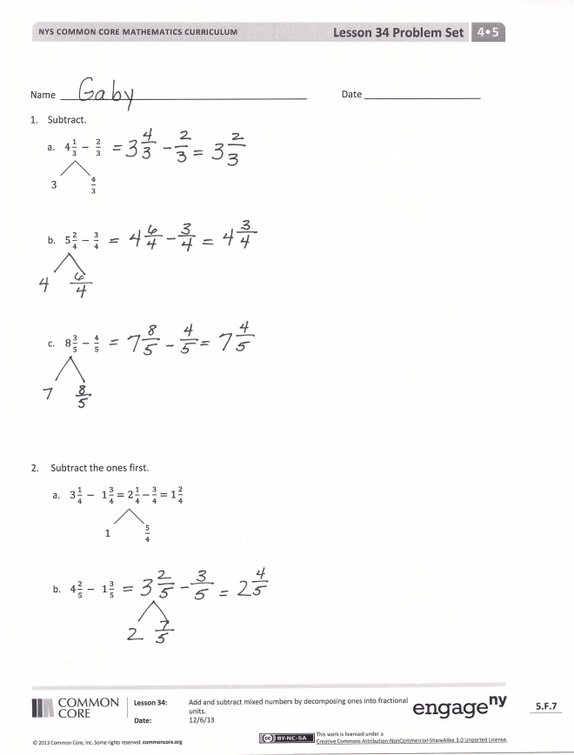
Invite students to review their solutions for the Problem Set. They should check work by comparing answers with a partner before going over answers as a class. Look for misconceptions or misunderstandings that can be addressed in the Debrief. Guide students in a conversation to debrief the Problem Set and process the lesson.
Any combination of the questions below may be used to lead the discussion.
- With your partner, compare and contrast the methods you used for solving Problem 3. Did you find that your partner used a method more efficient than your method? How can you be sure your methods are efficient and effective?
- Solve Problem 2(b) again; this time, do not subtract the ones first. What is more challenging about this method? What could be advantageous about this method?
- How can estimation be used when checking your work for this Problem Set?

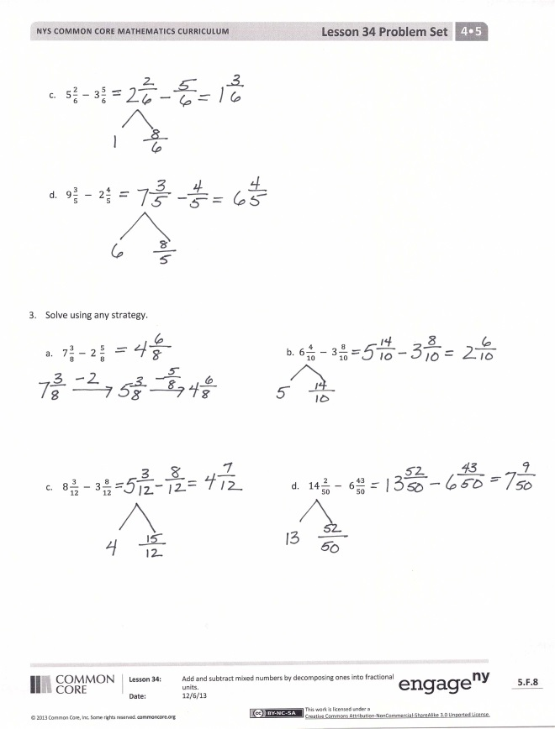
- How is renaming to subtract 3 tens 8 ones from 6 tens 4 ones similar to how you solved for Problem 3(b)? Explain.
- We know 11 – 8 = 13 – 10 = 3. What was added to the total and the part being subtracted? Think about this solution to Problem 3(c). How did this person solve Problem 3(c)?

Exit Ticket (3 minutes)
After the Student Debrief, instruct students to complete the Exit Ticket. A review of their work will help with assessing students’ understanding of the concepts that were presented in today’s lesson and planning more effectively for future lessons. The questions may be read aloud to the students.

Number Correct: _______
A
Change Mixed Numbers to Fractions
 | 4 = 3 + ___ |  |  |  | $\frac{ \text{8} }{\text{4}}\text{ =}$
 | $\frac{\text{ 4 }}{\text{3}} \text{=} \frac{\text{ 3 }}{\text{3}} \text{+} \frac{}{\text{3}}$ |  |  |  | $\frac{}{\text{4}} \text{=} \frac{ \text{8} }{\text{4}} \text{+} \frac{ \text{3} }{\text{4}}$
 | $\frac{\text{ 4 }}{\text{3}} \text{=} \text{1} \text{+} \frac{}{\text{3}}$ |  |  |  | $\frac{\text{11}}{\text{4}} \text{=} \frac{ \text{8} }{\text{4}} \text{+} \frac{}{\text{4}}$
 | $\frac{\text{ 4 }}{\text{3}}\text{ = 1}\frac{}{\text{3}}$ |  |  |  | $\frac{\text{11}}{\text{4}} \text{=} \text{2 +} \frac{}{\text{4}}$
 | 6 = 5 + ___ |  |  |  | $\frac{\text{11}}{\text{4}}\text{ = 2}\frac{}{\text{4}}$
 | $\frac{\text{ 6 }}{\text{5}} \text{=} \frac{\text{ 5 }}{\text{5}} \text{+} \frac{}{\text{5}}$ |  |  |  | $\frac{}{\text{3}} \text{=} \frac{ \text{6} }{\text{3}} \text{+} \frac{ \text{1} }{\text{3}}$
 | $\frac{\text{ 6 }}{\text{5}} \text{=} \text{1} \text{+} \frac{}{\text{5}}$ |  |  |  | $\frac{}{\text{3}} \text{=} \text{2 +} \frac{\text{ 1 }}{\text{3}}$
 | $\frac{\text{ 6 }}{\text{5}}\text{ = 1}\frac{}{\text{5}}$ |  |  |  | $\frac{\text{ 7 }}{\text{3}}\text{ = ___}\frac{\text{ 1 }}{\text{3}}$
 | 5 = ___ + 1 |  |  |  | $\frac{ \text{8 }}{\text{3}}\text{ = ___}\frac{\text{ 2 }}{\text{3}}$
 | $\frac{\text{ 5 }}{\text{4}} \text{=} \frac{}{\text{4}} \text{+} \frac{\text{ 1 }}{\text{4}}$ |  |  |  | $\frac{\text{17}}{\text{5}} \text{=} \frac{}{\text{5}} \text{+} \frac{\text{ 2 }}{\text{5}}$
 | $\frac{\text{ 5 }}{\text{4}} \text{=} \text{1} \text{+} \frac{}{\text{4}}$ |  |  |  | $\frac{\text{17}}{\text{5}} \text{=} \frac{\text{15}}{\text{5}} \text{+} \frac{}{\text{5}}$
 | $\frac{\text{ 5 }}{\text{4}}\text{ = ___}\frac{\text{ 1 }}{\text{4}}$ |  |  |  | $\frac{\text{17}}{\text{5}}\text{ = ___} \text{+} \frac{\text{ 2 }}{\text{5}}$
 | 8 = ___ + 3 |  |  |  | $\frac{\text{17}}{\text{5}}\text{ = ___}\frac{\text{ 2 }}{\text{5}}$
 | $\frac{\text{ 8 }}{\text{5}} \text{=} \frac{}{\text{5}} \text{+} \frac{\text{ 3 }}{\text{5}}$ |  |  |  | $\frac{\text{13}}{\text{6}} \text{=} \frac{\text{12}}{\text{6}} \text{+} \frac{}{\text{6}}$
 | $\frac{\text{ 8 }}{\text{5}} \text{=} \text{1} \text{+} \frac{}{\text{5}}$ |  |  |  | $\frac{\text{13}}{\text{6}}\text{ = ___} \text{+} \frac{\text{ 1 }}{\text{6}}$
 | $\frac{\text{ 8 }}{\text{5}}\text{ = 1}\frac{}{\text{5}}$ |  |  |  | $\frac{\text{13}}{\text{6}}\text{ = 2}\frac{}{\text{6}}$
 | $\frac{\text{ 7 }}{\text{5}}\text{ = 1}\frac{}{\text{5}}$ |  |  |  | $\frac{\text{17}}{\text{6}}\text{ = 2}\frac{}{\text{6}}$
 | $\frac{\text{ 6 }}{\text{5}}\text{ = 1}\frac{}{\text{5}}$ |  |  |  | $\frac{\text{ 9 }}{\text{8}} \text{=} \text{1} \text{+} \frac{}{\text{8}}$
 | $\frac{\text{ 9 }}{\text{5}}\text{ = 1}\frac{}{\text{5}}$ |  |  |  | $\frac{\text{13}}{\text{8}} \text{=} \text{1} \text{+} \frac{}{\text{8}}$
 | $\frac{\text{10}}{\text{5}}\text{ =}$ |  |  |  | $\frac{\text{19}}{\text{10}} \text{=} \text{1} \text{+} \frac{}{\text{10}}$
 | $\frac{}{\text{5}} \text{=} \frac{\text{10}}{\text{5}} \text{+} \frac{\text{ 4 }}{\text{5}}$ |  |  |  | $\frac{\text{19}}{\text{12}} \text{=} \frac{}{\text{12}} \text{+} \frac{\text{ 7 }}{\text{12}}$
 | $\frac{}{\text{5}} \text{=} \text{2 +} \frac{\text{ 4 }}{\text{5}}$ |  |  |  | $\frac{\text{11}}{\text{6}} \text{=} \text{1} \text{+} \frac{}{\text{6}}$
B
[KEY]

Number Correct: _______
Improvement: _______
Change Mixed Numbers to Fractions
 | 5 = 4 + ___ |  |  |  | $\frac{ \text{6} }{\text{3}}\text{ =}$
 | $\frac{\text{ 5 }}{\text{4}} \text{=} \frac{\text{ 4 }}{\text{4}} \text{+} \frac{}{\text{4}}$ |  |  |  | $\frac{}{\text{3}} \text{=} \frac{ \text{6} }{\text{3}} \text{+} \frac{ \text{2} }{\text{3}}$
 | $\frac{\text{ 5 }}{\text{4}} \text{=} \text{1} \text{+} \frac{}{\text{4}}$ |  |  |  | $\frac{\text{ 8 }}{\text{3}} \text{=} \frac{ \text{6} }{\text{3}} \text{+} \frac{}{\text{3}}$
 | $\frac{\text{ 5 }}{\text{4}}\text{ = 1}\frac{}{\text{4}}$ |  |  |  | $\frac{\text{ 8 }}{\text{3}} \text{=} \text{2 +} \frac{}{\text{3}}$
 | 3 = 2 + ___ |  |  |  | $\frac{\text{ 8 }}{\text{3}}\text{ = 2}\frac{}{\text{3}}$
 | $\frac{\text{ 3 }}{\text{2}} \text{=} \frac{\text{ 2 }}{\text{2}} \text{+} \frac{}{\text{2}}$ |  |  |  | $\frac{}{\text{10}} \text{=} \frac{\text{20}}{\text{10}} \text{+} \frac{ \text{1} }{\text{10}}$
 | $\frac{\text{ 3 }}{\text{2}} \text{=} \text{1} \text{+} \frac{}{\text{2}}$ |  |  |  | $\frac{}{\text{10}} \text{=} \text{2 +} \frac{ \text{1} }{\text{10}}$
 | $\frac{\text{ 3 }}{\text{2}}\text{ = 1}\frac{}{\text{2}}$ |  |  |  | $\frac{\text{21}}{\text{10}}\text{ = ___}\frac{ \text{1} }{\text{10}}$
 | 9 = ___ + 1 |  |  |  | $\frac{\text{27}}{\text{10}}\text{ = ___}\frac{ \text{7 }}{\text{10}}$
 | $\frac{\text{ 9 }}{\text{8}} \text{=} \frac{}{\text{8}} \text{+} \frac{\text{ 1 }}{\text{8}}$ |  |  |  | $\frac{\text{13}}{\text{6}} \text{=} \frac{}{\text{6}} \text{+} \frac{\text{ 1 }}{\text{6}}$
 | $\frac{\text{ 9 }}{\text{8}} \text{=} \text{1} \text{+} \frac{}{\text{8}}$ |  |  |  | $\frac{\text{13}}{\text{6}} \text{=} \frac{\text{12}}{\text{6}} \text{+} \frac{}{\text{6}}$
 | $\frac{\text{ 9 }}{\text{8}}\text{ = ___}\frac{\text{ 1 }}{\text{8}}$ |  |  |  | $\frac{\text{13}}{\text{6}}\text{ = ___} \text{+} \frac{\text{ 1 }}{\text{6}}$
 | 9 = ___ + 4 |  |  |  | $\frac{\text{13}}{\text{6}}\text{ = ___}\frac{\text{ 1 }}{\text{6}}$
 | $\frac{\text{ 9 }}{\text{5}} \text{=} \frac{}{\text{5}} \text{+} \frac{\text{ 4 }}{\text{5}}$ |  |  |  | $\frac{\text{17}}{\text{8}} \text{=} \frac{\text{16}}{\text{8}} \text{+} \frac{}{\text{8}}$
 | $\frac{\text{ 9 }}{\text{5}} \text{=} \text{1} \text{+} \frac{}{\text{5}}$ |  |  |  | $\frac{\text{17}}{\text{8}}\text{ = }\frac{}{\text{8}} \text{+} \frac{\text{ 1 }}{\text{8}}$
 | $\frac{\text{ 9 }}{\text{5}}\text{ = 1}\frac{}{\text{5}}$ |  |  |  | $\frac{\text{17}}{\text{8}}\text{ = 2}\frac{}{\text{8}}$
 | $\frac{\text{ 8 }}{\text{5}}\text{ = 1}\frac{}{\text{5}}$ |  |  |  | $\frac{\text{21}}{\text{8}}\text{ = 2}\frac{}{\text{8}}$
 | $\frac{\text{ 7 }}{\text{5}}\text{ = 1}\frac{}{\text{5}}$ |  |  |  | $\frac{\text{ 7 }}{\text{6}} \text{=} \text{1} \text{+} \frac{}{\text{6}}$
 | $\frac{\text{ 6 }}{\text{5}}\text{ = 1}\frac{}{\text{5}}$ |  |  |  | $\frac{\text{11}}{\text{6}} \text{=} \text{1} \text{+} \frac{}{\text{6}}$
 | $\frac{ \text{8} }{\text{4}}\text{ =}$ |  |  |  | $\frac{\text{13}}{\text{5}} \text{=} \text{2} \text{+} \frac{}{\text{5}}$
 | $\frac{}{\text{4}} \text{=} \frac{ \text{8 }}{\text{4}} \text{+} \frac{\text{ 1 }}{\text{4}}$ |  |  |  | $\frac{\text{17}}{\text{12}} \text{=} \frac{}{\text{12}} \text{+} \frac{ \text{5 }}{\text{12}}$
 | $\frac{}{\text{4}} \text{=} \text{2 +} \frac{\text{ 1 }}{\text{4}}$ |  |  |  | $\frac{\text{13}}{\text{8}} \text{=} \text{1} \text{+} \frac{}{\text{8}}$
Name Date
- Subtract.
- $4\frac{1}{3} - \frac{2}{3}$
$3 \frac{4}{3}$

- $5\frac{2}{4} - \frac{3}{4}$

- $8\frac{3}{5} - \frac{4}{5}$

- Subtract the ones first.

- $3\frac{1}{4} -1\frac{3}{4}=2\frac{1}{4}-\frac{3}{4}=1\frac{2}{4}$
$1 \frac{5}{4}$

- $4\frac{2}{5} -1\frac{3}{5}$

- $5\frac{2}{6} -3\frac{5}{6}$

- $9\frac{3}{5} -2\frac{4}{5}$

- Solve using any strategy.

- $7\frac{3}{8} -2 \frac{5}{8}$ b. $6\frac{4}{10} -3\frac{8}{10}$

- $8\frac{3}{12} -3\frac{8}{12}$
- $14\frac{2}{50} -6\frac{43}{50}$

Name Date
Solve.
- $7\frac{1}{6} -2 \frac{4}{6}$

- $12\frac{5}{8} -3\frac{7}{8}$

Name Date
      - Subtract.
- $5\frac{1}{4} - \frac{3}{4}$
$4 \frac{5}{4}$

- $6\frac{3}{8} - \frac{6}{8}$

- $7\frac{4}{6} - \frac{5}{6}$

- Subtract the ones first.
- $4\frac{1}{5} -1\frac{3}{5}=3\frac{1}{5}-\frac{3}{5}=2\frac{3}{5}$
$2 \frac{6}{5}$

- $4\frac{3}{6} -2\frac{5}{6}$

- $8\frac{3}{8} -2\frac{5}{8}$

- $13\frac{3}{10} - 8\frac{7}{10}$

- Solve using any strategy.

- $7\frac{3}{12} -4 \frac{9}{12}$ b. $9\frac{6}{10} -5\frac{8}{10}$

- $17\frac{2}{16} -9 \frac{7}{16}$ d. $12\frac{5}{100} -8\frac{94}{100}$

