Lesson 33
Objective: Subtract a mixed number from a mixed number.

Suggested Lesson Structure
 Fluency Practice (12 minutes)
 Application Problem (5 minutes)
 Concept Development (33 minutes)
 Student Debrief (10 minutes)
Total Time (60 minutes)
Fluency Practice (12 minutes)
- Sprint: Change Mixed Numbers to Fractions 4.NF.4 (9 minutes)
- Subtract Fractions from Whole Numbers 4.NF.3 (3 minutes)
Sprint: Change Mixed Numbers to Fractions (9 minutes)
Materials: (S) Change Mixed Numbers to Fractions Sprint
Note: This fluency activity reviews Lesson 25.
Subtract Fractions from Whole Numbers (3 minutes)
Materials: (S) Personal white board
Note: This fluency activity reviews Lesson 17.
T: (Write 3 – $\frac{\text{2}}{\text{5}}$.) Break apart the whole number and solve.
S: (Write 3 – $\frac{\text{2}}{\text{5}}$ = $\text{2}\frac{\text{3}}{\text{5}}$.)
Continue with the following possible sequence: 5 – $\frac{\text{3}}{\text{4}}$ and 9 – $\frac{\text{7}}{\text{10}}$.

Application Problem (5 minutes)
Jeannie’s pumpkin had a weight of 3 kg 250 g in August and 4 kg 125 g in October. What was the difference in weight from August to October?
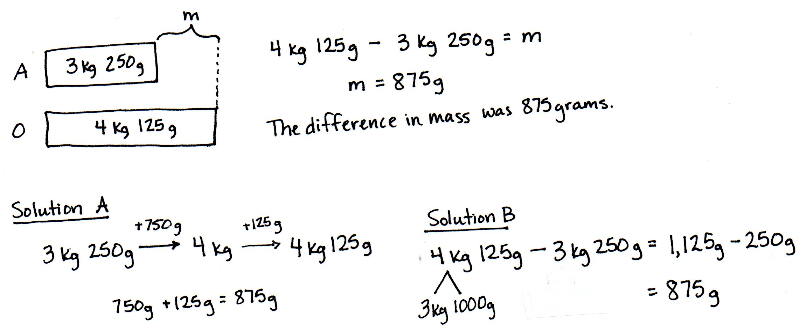

NOTES ON
MULTIPLE MEANS
OF REPRESENTATION:
In Grade 1, students relate subtraction to addition by counting up (1.OA.6), e.g., 12 – 8 is easily solved by counting up from 8 to 12: 8, 9, 10, 11, 12.
As students become more adept at using a unit of 10, they see they can get to the next ten, rather than counting by ones (e.g., 12 – 8 can be solved by thinking), “8 and 2 is 10. 2 more is 12. The unknown part is 4.”
In Grade 2, students apply this strategy to subtract larger numbers (2.NBT.7), e.g., 120 – 80 can be solved by thinking, “80 plus 20 is 100, and 20 more is 120. The unknown part is 40.”
Their use of the ten in Grade 1 has evolved into a place value strategy in Grade 2. Here in Grade 4, it evolves yet again as students use fractional units rather than place value units.

Note: This Application Problem anticipates the subtraction of a mixed number from a mixed number using a measurement context. Solution A shows counting up using the arrow way. Solution B shows subtracting 3 kilograms from 4 kilograms first, and then subtracting 250 grams from the total remaining
1,125 grams.
Concept Development (33 minutes)
Materials: (S) Personal white board
Problem 1: Subtract a mixed number from a mixed number by counting up.
T: (Write $\text{4}\frac{\text{3}}{\text{8}}-\text{2}\frac{\text{5}}{\text{8}}$.) Let’s count up to solve.
T: Draw a number line with endpoints 2 and 5. Label $\text{2}\frac{\text{5}}{\text{8}}.$ What fractional part can we add to get to the next one? $\text{2}\frac{\text{5}}{\text{8}}$ plus what is 3?
S: $\frac{\text{3}}{\text{8}}$.
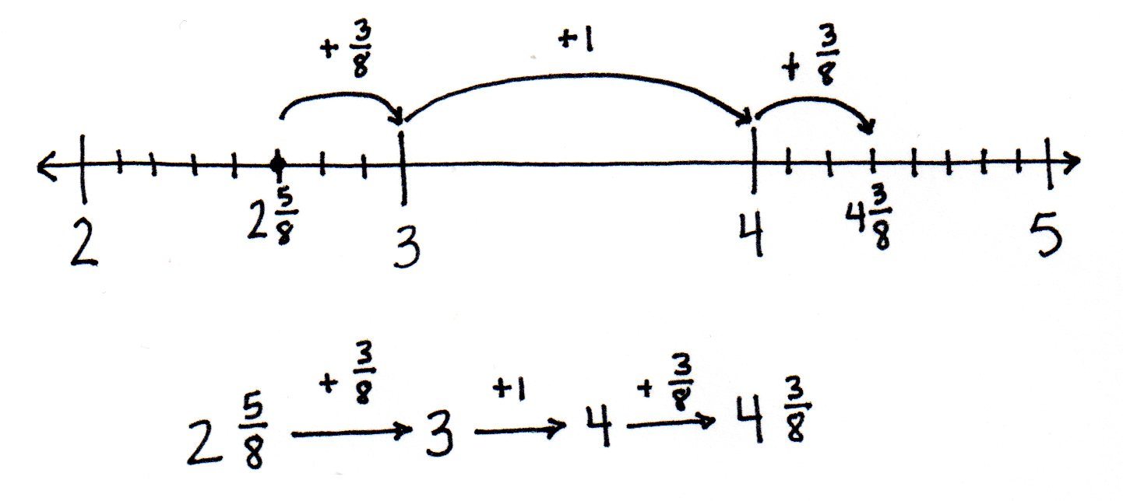
T: Show a slide from $\text{2}\frac{\text{5}}{\text{8}}$ to 3. Next, count up from 3 to the whole number in $\text{4}\frac{\text{3}}{\text{8}}.$
S: (Draw an arrow from 3 to 4.) We added 1.
T: Count up to $\text{4}\frac{\text{3}}{\text{8}}.$
S: (Draw an arrow from 4 to $\text{4}\frac{\text{3}}{\text{8}}.$) We added $\frac{\text{3}}{\text{8}}$ more.
T: What is $\frac{\text{3}}{\text{8}}$ + 1 + $\frac{\text{3}}{\text{8}}$ ?
S: $\frac{\text{3}}{\text{8}}$ + 1 + $\frac{\text{3}}{\text{8}}$ = $\text{1}\frac{\text{6}}{\text{8}}.$
T: Use the arrow way to track our recording.
S: $\text{2}\frac{\text{5}}{\text{8}}$ + $\frac{\text{3}}{\text{8}}$ = 3, 3 + 1 = 4, and 4 + $\frac{\text{3}}{\text{8}}$ = $\text{4}\frac{\text{3}}{\text{8}}$. We counted up $\frac{\text{3}}{\text{8}}$ , 1, and $\frac{\text{3}}{\text{8}}$. That’s $\text{1}\frac{\text{6}}{\text{8}}.$
Let students practice with the following: $\text{2}\frac{\text{5}}{\text{12}}$ – $\text{1}\frac{\text{8}}{\text{12}}$ and $\text{9}\frac{\text{2}}{\text{6}}$ – $\text{3}\frac{\text{5}}{\text{6}}$.
Problem 2: Subtract a mixed number from a mixed number when there are not enough fractional units by first subtracting the whole numbers and then decomposing the subtrahend.
T: (Write $\text{11}\frac{\text{1}}{\text{5}}$ + $\text{2}\frac{\text{3}}{\text{5}}$ .) When we add mixed numbers, we add the like units. We could add the ones first and then the fifths.
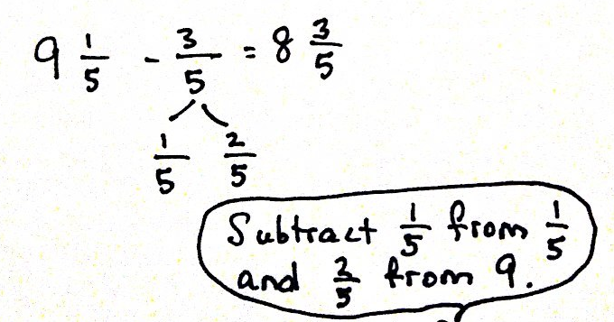
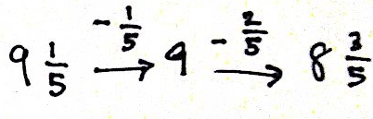
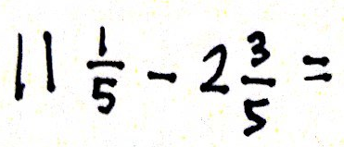
T: (Write $\text{11}\frac{\text{1}}{\text{5}}$ – $\text{2}\frac{\text{3}}{\text{5}}$ .) When we subtract mixed numbers, we can subtract the ones first. What subtraction expression remains?
S: $\text{9}\frac{\text{1}}{\text{5}}$ – $\frac{\text{3}}{\text{5}}$.
T: Just like yesterday, decompose 3 fifths as $\frac{\text{1}}{\text{5}}$ and $\frac{\text{2}}{\text{5}}$ (as pictured to the right).
T: $\text{9}\frac{\text{1}}{\text{5}}$ – $\frac{\text{1}}{\text{5}}$ is…? (Record using the arrow way, as seen to the right.)
S: 9.
T: Count back $\frac{\text{2}}{\text{5}}$ from 9. 9 – $\frac{\text{2}}{\text{5}}$is…? (Record with the second arrow.)
S: $\text{8}\frac{\text{3}}{\text{5}}.$
T: (Write $\text{9}\frac{\text{1}}{\text{5}}$ – $\frac{\text{3}}{\text{5}}$ = 9 – $\frac{\text{2}}{\text{5}}$ = $\text{8}\frac{\text{3}}{\text{5}}$.)
T: Explain to your partner why this is true.
S: It’s like counting back! We subtract a fifth from $\text{9}\frac{\text{1}}{\text{5}}$, and then we subtract $\frac{\text{2}}{\text{5}}$ from 9. First, we renamed $\frac{\text{3}}{\text{5}}$ as $\frac{\text{1}}{\text{5}}$ and $\frac{\text{2}}{\text{5}}$. Then, we subtracted in two steps. It looks like we subtracted $\frac{\text{1}}{\text{5}}$ from both numbers and got 9 – $\frac{\text{2}}{\text{5}}$ , which is just easier.
T: Use a number line to model the steps of counting backward from $\text{11}\frac{\text{1}}{\text{5}}$ to subtract $\text{2}\frac{\text{3}}{\text{5}}$.
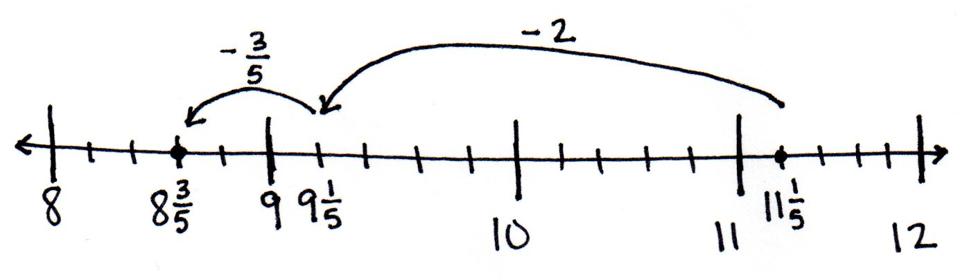
S: (Draw as shown to the right or draw to match the arrow way recording.)
Let students practice with the following:
$\text{4}\frac{\text{1}}{\text{8}}$ – $\text{1}\frac{\text{7}}{\text{8}}$ and $\text{7}\frac{\text{5}}{\text{12}}$ – $\text{3}\frac{\text{9}}{\text{12}}$. Those who struggle with subtracting from a whole number with automaticity can break apart the whole number using Lesson 32’s strategy until gaining mastery, e.g., $\text{4}\frac{\text{1}}{\text{8}}$ – $\text{2}\frac{\text{7}}{\text{8}}$ = $\text{2}\frac{\text{1}}{\text{8}}$ – $\frac{\text{7}}{\text{8}}$ = $\text{1}\frac{\text{9}}{\text{8}}$ – $\frac{\text{7}}{\text{8}}$ = $\text{1}\frac{\text{2}}{\text{8}}$. Have them share their work with a partner, explaining their solution.
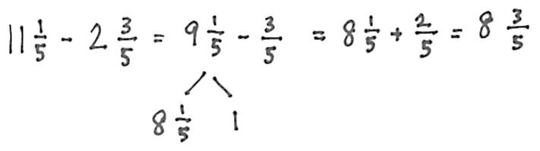
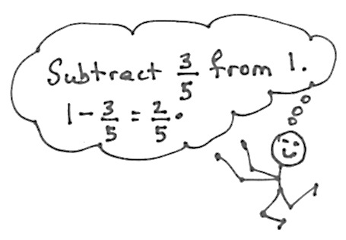
Problem 3: Subtract a mixed number from a mixed number when there are not enough fractional units by decomposing a whole number into fractional parts.
T: (Write $\text{11}\frac{\text{1}}{\text{5}}$ – $\text{2}\frac{\text{3}}{\text{5}}.$) Let’s solve using a different strategy.
T: Subtract the whole numbers.
S: $\text{11}\frac{\text{1}}{\text{5}}$ – $\text{2}\frac{\text{3}}{\text{5}}$ = $\text{9}\frac{\text{1}}{\text{5}}$ – $\frac{\text{3}}{\text{5}}.$
T: Decompose $\text{9}\frac{\text{1}}{\text{5}}$ by taking out one.
S: (Draw a number bond to show $\text{8}\frac{\text{1}}{\text{5}}$ and 1.)
T: 1 – $\frac{\text{3}}{\text{5}}$ is…?
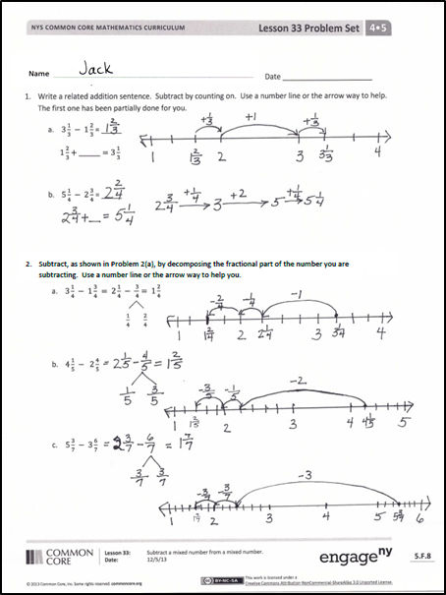
S: $\frac{\text{2}}{\text{5}}.$
T: $\text{8}\frac{\text{1}}{\text{5}}$ + $\frac{\text{2}}{\text{5}}$ is…?
S: $\text{8}\frac{\text{1}}{\text{5}}$ + $\frac{\text{2}}{\text{5}}$ = $\text{8}\frac{\text{3}}{\text{5}}$. That’s the same answer as before. We just found it in a different way.
Let students practice with the following: $\text{4}\frac{\text{1}}{\text{8}}$ – $\text{1}\frac{\text{7}}{\text{8}}$ and
$\text{7}\frac{\text{5}}{\text{12}}$ – $\text{3}\frac{\text{9}}{\text{12}}$. Encourage students to practice this strategy of subtracting from 1, but don’t belabor its use with students. Allow them to use any strategy that makes sense to them and enables them to correctly solve the problem, explaining the steps to their partner. Ask those who finish early to solve using an alternative strategy to strengthen their number sense.
Problem Set (10 minutes)
Students should do their personal best to complete the Problem Set within the allotted 10 minutes. For some classes, it may be appropriate to modify the assignment by specifying which problems they work on first. Some problems do not specify a method for solving. Students should solve these problems using the RDW approach used for Application Problems.
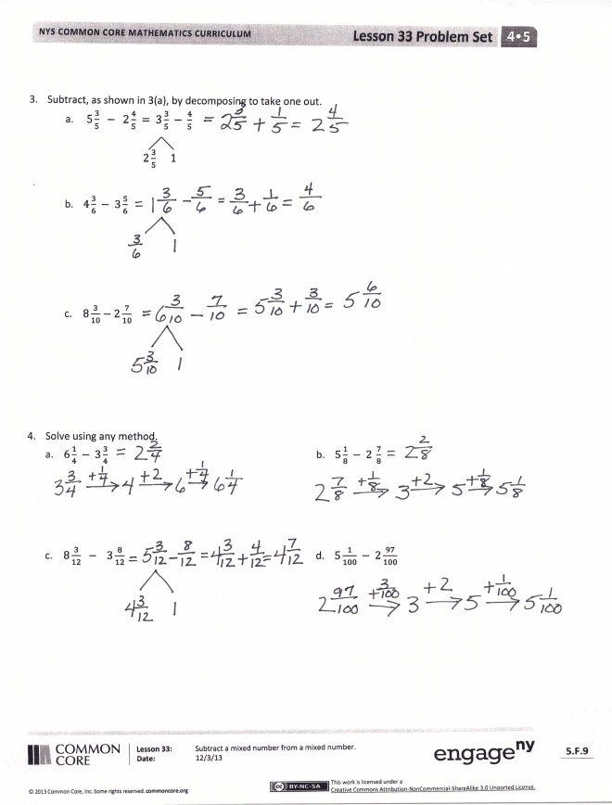
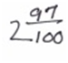
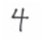
Student Debrief (10 minutes)
Lesson Objective: Subtract a mixed number from a mixed number.
The Student Debrief is intended to invite reflection and active processing of the total lesson experience.
Invite students to review their solutions for the Problem Set. They should check work by comparing answers with a partner before going over answers as a class. Look for misconceptions or misunderstandings that can be addressed in the Debrief. Guide students in a conversation to debrief the Problem Set and process the lesson.
Any combination of the questions below may be used to lead the discussion.
- Can you accurately subtract mixed numbers by subtracting the fraction first, or must you always subtract the whole numbers first? Give an example to explain.
- When subtracting mixed numbers, what is the advantage of subtracting the whole numbers first?
- Which strategy do you prefer to use, decomposing the number we are subtracting as we did in Problem 2 of the Concept Development or taking from 1, as we did in Problem 3? Discuss the advantages of the strategy as you explain your preference.
- Which strategies did you choose to solve Problem 4(a–d) of the Problem Set? Explain how you decided which strategy to use.
- What learning from Lesson 32 was used in this lesson? How can subtracting a mixed number from a mixed number be similar to subtracting a fraction from a mixed number?
- How did our Application Problem relate to today’s lesson?
Exit Ticket (3 minutes)
After the Student Debrief, instruct students to complete the Exit Ticket. A review of their work will help with assessing students’ understanding of the concepts that were presented in today’s lesson and planning more effectively for future lessons. The questions may be read aloud to the students.

Number Correct: _______
A
Change Mixed Numbers to Fractions
 | 2 + 1 = |  |  |  | $\text{1}\frac{\text{ 5 }}{\text{6}} \text{=} \frac{}{\text{6}}$
 | $\frac{\text{ 2 }}{\text{2}} \text{+} \frac{\text{ 1 }}{\text{2}} \text{=} \frac{}{\text{2}}$ |  |  |  | $\text{2 + }\frac{\text{ 1 }}{\text{2}}\text{ = 2}\frac{}{\text{2}}$
 | $\text{1 +} \frac{\text{ 1 }}{\text{2}} \text{=} \frac{}{\text{2}}$ |  |  |  | $\frac{\text{ 4 }}{\text{2}} \text{+} \frac{\text{ 1 }}{\text{2}} \text{=} \frac{}{\text{2}}$
 | $\text{1}\frac{\text{ 1 }}{\text{2}} \text{=} \frac{}{\text{2}}$ |  |  |  | $\text{2 +} \frac{\text{ 1 }}{\text{2}} \text{=} \frac{}{\text{2}}$
 | 4 + 1 = |  |  |  | $\text{2}\frac{\text{ 1 }}{\text{2}} \text{=} \frac{}{\text{2}}$
 | $\frac{\text{ 4 }}{\text{4}} \text{+} \frac{\text{ 1 }}{\text{4}} \text{=} \frac{}{\text{4}}$ |  |  |  | $\text{2 + }\frac{\text{ 1 }}{\text{4}}\text{ = 2}\frac{}{\text{4}}$
 | $\text{1 +} \frac{\text{ 1 }}{\text{4}} \text{=} \frac{}{\text{4}}$ |  |  |  | $\frac{ \text{8 }}{\text{4}} \text{+} \frac{\text{ 1 }}{\text{4}} \text{=} \frac{}{\text{4}}$
 | $\text{1}\frac{\text{ 1 }}{\text{4}} \text{=} \frac{}{\text{4}}$ |  |  |  | $\text{2 +} \frac{\text{ 1 }}{\text{4}} \text{=} \frac{}{\text{4}}$
 | 3 + 1 = |  |  |  | $\text{2}\frac{\text{ 1 }}{\text{4}} \text{=} \frac{}{\text{4}}$
 | $\frac{\text{ 3 }}{\text{3}} \text{+} \frac{\text{ 1 }}{\text{3}} \text{=} \frac{}{\text{3}}$ |  |  |  | $\frac{\text{ 9 }}{\text{3}} \text{+} \frac{\text{ 2 }}{\text{3}} \text{=} \frac{}{\text{3}}$
 | $\text{1 +} \frac{\text{ 1 }}{\text{3}} \text{=} \frac{}{\text{3}}$ |  |  |  | $\text{3 +} \frac{\text{ 2 }}{\text{3}} \text{=} \frac{}{\text{3}}$
 | $\text{1}\frac{\text{ 1 }}{\text{3}} \text{=} \frac{}{\text{3}}$ |  |  |  | $\text{3}\frac{\text{ 2 }}{\text{3}} \text{=} \frac{}{\text{3}}$
 | $\frac{\text{ 5 }}{\text{5}} \text{+} \frac{\text{ 1 }}{\text{5}} \text{=} \frac{}{\text{5}}$ |  |  |  | $\frac{\text{16}}{\text{4}} \text{+} \frac{\text{ 3 }}{\text{4}} \text{=} \frac{}{\text{4}}$
 | $\text{1 +} \frac{\text{ 1 }}{\text{5}} \text{=} \frac{}{\text{5}}$ |  |  |  | $\text{4 +} \frac{\text{ 3 }}{\text{4}} \text{=} \frac{}{\text{4}}$
 | $\text{1}\frac{\text{ 1 }}{\text{5}} \text{=} \frac{}{\text{5}}$ |  |  |  | $\text{4}\frac{\text{ 3 }}{\text{4}} \text{=} \frac{}{\text{4}}$
 | $\text{1}\frac{\text{ 2 }}{\text{5}} \text{=} \frac{}{\text{5}}$ |  |  |  | $\text{3 +} \frac{\text{ 2 }}{\text{5}} \text{=} \frac{}{\text{5}}$
 | $\text{1}\frac{\text{ 4 }}{\text{5}} \text{=} \frac{}{\text{5}}$ |  |  |  | $\text{4 +} \frac{\text{ 1 }}{\text{2}} \text{=} \frac{}{\text{2}}$
 | $\text{1}\frac{\text{ 3 }}{\text{5}} \text{=} \frac{}{\text{5}}$ |  |  |  | $\text{3 +} \frac{\text{ 3 }}{\text{4}} \text{=} \frac{}{\text{4}}$
 | $\frac{\text{ 4 }}{\text{4}} \text{+} \frac{\text{ 3 }}{\text{4}} \text{=} \frac{}{\text{4}}$ |  |  |  | $\text{3 +} \frac{\text{ 1 }}{\text{6}} \text{=} \frac{}{\text{6}}$
 | $\text{1 +} \frac{\text{ 3 }}{\text{4}} \text{=} \frac{}{\text{4}}$ |  |  |  | $\text{3 +} \frac{\text{ 5 }}{\text{8}} \text{=} \frac{}{\text{8}}$
 | $\frac{\text{ 6 }}{\text{6}} \text{+} \frac{\text{ 5 }}{\text{6}} \text{=} \frac{}{\text{6}}$ |  |  |  | $\text{3}\frac{\text{ 4 }}{\text{5}} \text{=} \frac{}{\text{5}}$
 | $\text{1 +} \frac{\text{ 5 }}{\text{6}} \text{=} \frac{}{\text{6}}$ |  |  |  | $\text{4}\frac{\text{ 7 }}{\text{8}} \text{=} \frac{}{\text{8}}$
B
[KEY]

Number Correct: _______
Improvement: _______
Change Mixed Numbers to Fractions
 | 5 + 1 = |  |  |  | $\text{1}\frac{\text{ 7 }}{\text{8}} \text{=} \frac{}{\text{8}}$
 | $\frac{\text{ 5 }}{\text{5}} \text{+} \frac{\text{ 1 }}{\text{5}} \text{=} \frac{}{\text{5}}$ |  |  |  | $\text{2 + }\frac{\text{ 1 }}{\text{2}}\text{ = 2}\frac{}{\text{2}}$
 | $\text{1 +} \frac{\text{ 1 }}{\text{5}} \text{=} \frac{}{\text{5}}$ |  |  |  | $\frac{\text{ 4 }}{\text{2}} \text{+} \frac{\text{ 1 }}{\text{2}} \text{=} \frac{}{\text{2}}$
 | $\text{1}\frac{\text{ 1 }}{\text{5}} \text{=} \frac{}{\text{5}}$ |  |  |  | $\text{2 +} \frac{\text{ 1 }}{\text{2}} \text{=} \frac{}{\text{2}}$
 | 3 + 1 = |  |  |  | $\text{2}\frac{\text{ 1 }}{\text{2}} \text{=} \frac{}{\text{2}}$
 | $\frac{\text{ 3 }}{\text{3}} \text{+} \frac{\text{ 1 }}{\text{3}} \text{=} \frac{}{\text{3}}$ |  |  |  | $\text{2 + }\frac{\text{ 1 }}{\text{3}}\text{ = 2}\frac{}{\text{3}}$
 | $\text{1 +} \frac{\text{ 1 }}{\text{3}} \text{=} \frac{}{\text{3}}$ |  |  |  | $\frac{\text{ 6 }}{\text{3}} \text{+} \frac{\text{ 1 }}{\text{3}} \text{=} \frac{}{\text{3}}$
 | $\text{1}\frac{\text{ 1 }}{\text{3}} \text{=} \frac{}{\text{3}}$ |  |  |  | $\text{2 +} \frac{\text{ 1 }}{\text{3}} \text{=} \frac{}{\text{3}}$
 | 4 + 1 = |  |  |  | $\text{2}\frac{\text{ 1 }}{\text{3}} \text{=} \frac{}{\text{3}}$
 | $\frac{\text{ 4 }}{\text{4}} \text{+} \frac{\text{ 1 }}{\text{4}} \text{=} \frac{}{\text{4}}$ |  |  |  | $\frac{\text{12}}{\text{4}} \text{+} \frac{\text{ 3 }}{\text{4}} \text{=} \frac{}{\text{4}}$
 | $\text{1 +} \frac{\text{ 1 }}{\text{4}} \text{=} \frac{}{\text{4}}$ |  |  |  | $\text{3 +} \frac{\text{ 3 }}{\text{4}} \text{=} \frac{}{\text{4}}$
 | $\text{1}\frac{\text{ 1 }}{\text{4}} \text{=} \frac{}{\text{4}}$ |  |  |  | $\text{3}\frac{\text{ 3 }}{\text{4}} \text{=} \frac{}{\text{4}}$
 | $\frac{\text{10}}{\text{10}} \text{+} \frac{\text{ 1 }}{\text{10}} \text{=} \frac{}{\text{10}}$ |  |  |  | $\frac{\text{12}}{\text{3}} \text{+} \frac{\text{ 2 }}{\text{3}} \text{=} \frac{}{\text{3}}$
 | $\text{1 +} \frac{\text{ 1 }}{\text{10}} \text{=} \frac{}{\text{10}}$ |  |  |  | $\text{4 +} \frac{\text{ 2 }}{\text{3}} \text{=} \frac{}{\text{3}}$
 | $\text{1}\frac{\text{ 1 }}{\text{10}} \text{=} \frac{}{\text{10}}$ |  |  |  | $\text{4}\frac{\text{ 2 }}{\text{3}} \text{=} \frac{}{\text{3}}$
 | $\text{1}\frac{\text{ 2 }}{\text{10}} \text{=} \frac{}{\text{10}}$ |  |  |  | $\text{3 +} \frac{\text{ 3 }}{\text{5}} \text{=} \frac{}{\text{5}}$
 | $\text{1}\frac{\text{ 4 }}{\text{10}} \text{=} \frac{}{\text{10}}$ |  |  |  | $\text{5 +} \frac{\text{ 1 }}{\text{2}} \text{=} \frac{}{\text{2}}$
 | $\text{1}\frac{\text{ 3 }}{\text{10}} \text{=} \frac{}{\text{10}}$ |  |  |  | $\text{3 +} \frac{\text{ 2 }}{\text{3}} \text{=} \frac{}{\text{3}}$
 | $\frac{\text{ 3 }}{\text{3}} \text{+} \frac{\text{ 2 }}{\text{3}} \text{=} \frac{}{\text{3}}$ |  |  |  | $\text{3 +} \frac{\text{ 1 }}{\text{8}} \text{=} \frac{}{\text{8}}$
 | $\text{1 +} \frac{\text{ 2 }}{\text{3}} \text{=} \frac{}{\text{3}}$ |  |  |  | $\text{3 +} \frac{\text{ 1 }}{\text{6}} \text{=} \frac{}{\text{6}}$
 | $\frac{\text{ 8 }}{\text{8}} \text{+} \frac{\text{ 7 }}{\text{8}} \text{=} \frac{}{\text{8}}$ |  |  |  | $\text{3}\frac{\text{ 2 }}{\text{5}} \text{=} \frac{}{\text{5}}$
 | $\text{1 +} \frac{\text{ 7 }}{\text{8}} \text{=} \frac{}{\text{8}}$ |  |  |  | $\text{4}\frac{\text{ 5 }}{\text{6}} \text{=} \frac{}{\text{6}}$

Name Date
- Write a related addition sentence. Subtract by counting on. Use a number line or the arrow way to help. The first one has been partially done for you.

- $3\frac{1}{3} - 1\frac{2}{3}$ = _____
$1\frac{2}{3}+_______=3\frac{1}{3}$

- $5\frac{1}{4} - 2\frac{3}{4}$ = _____

- Subtract, as shown in Problem 2(a), by decomposing the fractional part of the number you are subtracting. Use a number line or the arrow way to help you.
- $3\frac{1}{4} - 1\frac{3}{4} = 2\frac{1}{4} - \frac{ 3}{ 4}= 1\frac{2}{4}$
$\frac{1}{4} \frac{2}{4}$

- $4\frac{1}{5} - 2\frac{4}{5}$

- $5\frac{3}{7} - 3\frac{6}{7}$

- Subtract, as shown in Problem 3(a), by decomposing to take one out.
- $5\frac{3}{5} - 2\frac{4}{5} = 3\frac{3}{5} - \frac{4}{5}$
$2\frac{3}{5} 1$

- $4\frac{3}{6} - 3\frac{5}{6}$

- $8\frac{3}{10}-2\frac{7}{10}$

- Solve using any method.

- $6\frac{1}{4} - 3\frac{3}{4}$
- $5\frac{1}{8} - 2 \frac{7}{8}$

- $8\frac{3}{12} - 3\frac{8}{12}$
- $5\frac{1}{100} - 2\frac{97}{100}$

Name Date
Solve using any strategy.
- $4\frac{2}{3} - 2\frac{1}{3}$

- $12\frac{5}{8} - 8\frac{7}{8}$

Name Date
- Write a related addition sentence. Subtract by counting on. Use a number line or the arrow way to help. The first one has been partially done for you.
- $3\frac{2}{5} - 1\frac{4}{5}$ $= _____$
$1\frac{4}{5}+_______=3\frac{2}{5}$

- $5\frac{3}{8} - 2\frac{5}{8}$

- Subtract, as shown in Problem 2(a) below, by decomposing the fractional part of the number you are subtracting. Use a number line or the arrow way to help you.

- $4\frac{1}{5} - 1\frac{3}{5} = 3\frac{1}{5} - \frac{ 3}{ 5}= 2\frac{3}{5}$
$\frac{1}{5} \frac{2}{5}$

- $4\frac{1}{7} - 2\frac{4}{7}$

- $5\frac{5}{12} - 3\frac{8}{12}$

- Subtract, as shown in 3(a) below, by decomposing to take one out.
- $5\frac{5}{8} - 2\frac{7}{8} = 3\frac{5}{8} - \frac{7}{8} =$
$2\frac{5}{8} 1$

- $4\frac{3}{12} - 3\frac{8}{12}$

- $9\frac{1}{10}-6\frac{9}{10}$

- Solve using any strategy.

- $6\frac{1}{9} - 4\frac{3}{9}$ b. $5\frac{3}{10} - 3 \frac{6}{10}$

- $8\frac{7}{12} - 5\frac{9}{12}$ d. $7\frac{4}{100} - 2\frac{92}{100}$

