Lesson 32
Objective: Subtract a fraction from a mixed number.

Suggested Lesson Structure
 Fluency Practice (12 minutes)
 Application Problem (3 minutes)
 Concept Development (35 minutes)
 Student Debrief (10 minutes)
Total Time (60 minutes)
Fluency Practice (12 minutes)
- Count by Equivalent Fractions 4.NF.1 (5 minutes)
- Change Mixed Numbers to Fractions 4.NF.4 (4 minutes)
- Add Mixed Numbers 4.NF.3 (3 minutes)
Count by Equivalent Fractions (5 minutes)
Note: This activity reviews Lessons 24 and 25. The progression builds in complexity. Work the students up to the highest level of complexity in which they can confidently participate.
T: Count by twos to 18, starting at 0.
$\frac{\text{0}}{\text{6}}$ $\frac{\text{2}}{\text{6}}$ $\frac{\text{4}}{\text{6}}$ $\frac{\text{6}}{\text{6}}$ $\frac{\text{8}}{\text{6}}$ $\frac{\text{10}}{\text{6}}$ $\frac{\text{12}}{\text{6}}$ $\frac{\text{14}}{\text{6}}$ $\frac{\text{16}}{\text{6}}$ $\frac{\text{18}}{\text{6}}$
$\text{0}$ $\frac{\text{2}}{\text{6}}$ $\frac{\text{4}}{\text{6}}$ 1 $\frac{\text{8}}{\text{6}}$ $\frac{\text{10}}{\text{6}}$ 2 $\frac{\text{14}}{\text{6}}$ $\frac{\text{16}}{\text{6}}$ 3
$\text{0}$ $\frac{\text{2}}{\text{6}}$ $\frac{\text{4}}{\text{6}}$ 1 $\text{1}\frac{\text{2}}{\text{6}}$ $\text{1}\frac{\text{4}}{\text{6}}$ 2 $\text{2}\frac{\text{2}}{\text{6}}$ $\text{2}\frac{\text{4}}{\text{6}}$ 3
$\text{0}$ $\frac{\text{1}}{\text{3}}$ $\frac{\text{2}}{\text{3}}$ 1 $\text{1}\frac{\text{1}}{\text{3}}$ $\text{1}\frac{\text{2}}{\text{3}}$ 2 $\text{2}\frac{\text{1}}{\text{3}}$ $\text{2}\frac{\text{2}}{\text{3}}$ 3

S: 0, 2, 4, 6, 8, 10, 12, 14, 16, 18.
T: Count by 2 sixths to 18 sixths, starting at 0 sixths. (Write as students count.)
S: $\frac{\text{0}}{\text{6}}$, $\frac{\text{2}}{\text{6 }}$ , $\frac{\text{4}}{\text{6}}$, $\frac{\text{6}}{\text{6}}$, $\frac{\text{8}}{\text{6 }}$, $\frac{\text{10}}{\text{6}}$, $\frac{\text{12}}{\text{6}}$, $\frac{\text{14}}{\text{6}}$, $\frac{\text{16}}{\text{6}}$, $\frac{\text{18}}{\text{6}}\text{.}$
T: Zero is the same as how many sixths?
S: 0 sixths.
T: (Beneath $\frac{\text{0}}{\text{6}}$ , write 0.) 1 is the same as how many sixths?
S: 6 sixths.
T: (Beneath $\frac{\text{6}}{\text{6}}$, write 1.)
Continue this process for 2 and 3.
T: Count by 2 sixths again. This time, when you come to the whole number, say the whole number. (Write as students count.)
S: $0$, $\frac{\text{2}}{\text{6}}$, $\frac{\text{4}}{\text{6 }}$, 1, $\frac{\text{8}}{\text{6}}$, $\frac{\text{10}}{\text{6}}$, 2, $\frac{\text{14}}{\text{6}}$, $\frac{\text{16}}{\text{6}}$, 3.
T: (Point to $\frac{\text{8}}{\text{6}}$.) Say $\frac{\text{8}}{\text{6}}$ as a mixed number.
S: $\text{1}\frac{\text{2}}{\text{6}}$.
Continue this process for $\frac{\text{10}}{\text{6}}$ , $\frac{\text{14}}{\text{6}}$, and $\frac{\text{16}}{\text{6}}$.
T: Count by 2 sixths again. This time, convert to whole numbers and mixed numbers. (Write as students count.)
S: $\text{0 }$, $\frac{\text{2}}{\text{6}}$, $\frac{\text{4}}{\text{6}}$, 1, $\text{1}\frac{\text{2}}{\text{6}}$, $\text{1}\frac{\text{4}}{\text{6}}$, 2, $\text{2}\frac{\text{2}}{\text{6}}$, $\text{2}\frac{\text{4}}{\text{6}}$, 3.
Possibly extend, having the students rename sixths as thirds.
Change Mixed Numbers to Fractions (4 minutes)
Materials: (S) Personal white board
Note: This fluency activity reviews Lesson 25.
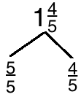
T: (Write $\text{1}\frac{\text{4}}{\text{5}}\text{.}$) Say the mixed number.
S: 1 and 4 fifths.
T: (Draw a number bond with $\text{1}\frac{\text{4}}{\text{5}}$ as the whole. Write $\frac{\text{4}}{\text{5}}$ as the known part. Write $\frac{}{\text{5}}$ as the other part.) Write the unknown part, filling in the numerator.
S: (Write $\frac{\text{5}}{\text{5}}$ as the unknown part.)
T: (Write $\frac{\text{5}}{\text{5}}$ as the unknown part. Write $\text{1}\frac{\text{4}}{\text{5}}$ = $\frac{}{\text{5}}\text{.}$) Fill in the numerator.
S: (Write $\text{1}\frac{\text{4}}{\text{5}}$ = $\frac{\text{9}}{\text{5}}$.)
Continue with the following possible sequence: $\text{2}\frac{\text{1}}{\text{4}}$ and $\text{3}\frac{\text{5}}{\text{6}}$.

Add Mixed Numbers (3 minutes)
Note: This fluency activity reviews Lesson 31.
T: (Write $\text{5}\frac{\text{1}}{\text{3}}$ + $\text{2}\frac{\text{1}}{\text{3}}$.) On your boards, add like units to solve.
S: (Write $\text{5} \text{+}\frac{\text{1}}{\text{3}}$ + $\text{2} \text{+}\frac{\text{1}}{\text{3}}$ = $\text{7}\frac{\text{2}}{\text{3}}\text{.}$)
Continue with the following possible sequence: $\text{4}\frac{\text{3}}{\text{5}}$ + $\text{2}\frac{\text{1}}{\text{5}}$ and $\text{6}\frac{\text{5}}{\text{8}}$ + $\text{2}\frac{\text{3}}{\text{8}}$.
Application Problem (3 minutes)
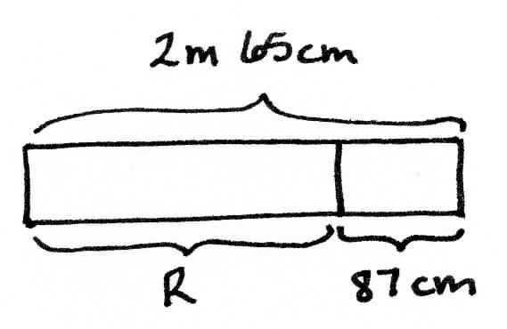
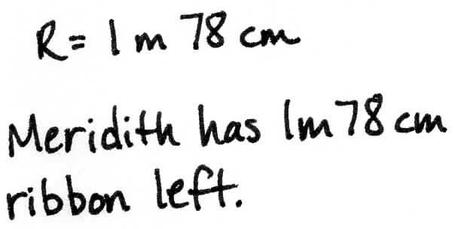
Meredith had 2 m 65 cm of ribbon. She used 87 cm of the ribbon. How much ribbon did she have left?
Note: This Application Problem anticipates the subtraction of a fraction from a mixed number using a measurement context. In Solution A, 87 cm is decomposed as 65 cm and 22 cm to count back to 2 and then to subtract the remaining centimeters. In Solution B, the total is decomposed into smaller units before subtracting. In Solution C, the one is taken out of 2 m 65 cm and 87 centimeters is subtracted from 1. The remaining 13 centimeters is then added to 1 m 65 cm.
Concept Development (35 minutes)
Materials: (S) Personal white board
Problem 1: Subtract a fraction from a mixed number by counting back.
T: 3 oranges 2 apples – 1 apple is…?
S: 3 oranges 1 apple.
T: 3 dogs 2 puppies – 1 puppy is…?
S: 3 dogs 1 puppy.
T: 3 ones 2 fifths – 1 fifth is…?
S: 3 ones 1 fifth.
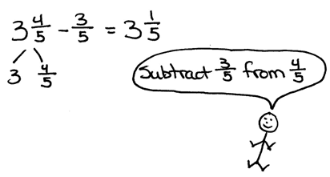
T: (Write $\text{3}\frac{\text{4}}{\text{5}}\text{─}\frac{\text{3}}{\text{5}}$including the number bond as shown.)
T: Do we have enough fifths to subtract 3 fifths$?$
S: Yes!
T: Solve the problem.
S: 3 $\frac{\text{4}}{\text{5}}\text{─}\frac{\text{3}}{\text{5}}\text{=} \text{3}\frac{\text{1}}{\text{5}}\text{.}$
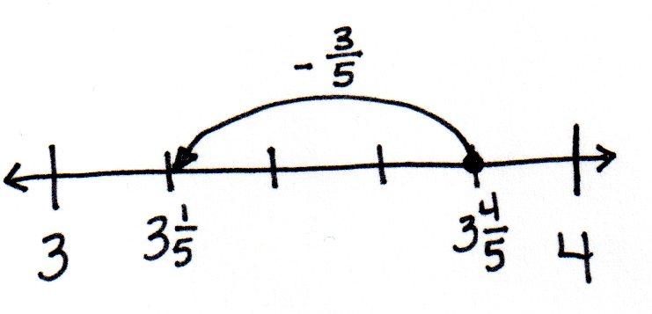
T: Draw a number line to model the subtraction. What will the endpoints of the number line be? How will you partition the whole number?
S: The endpoints will be 3 and 4. We will partition the whole number into fifths.
T: Start at $\text{3}\frac{\text{4}}{\text{5}}\text{.}$ Subtract $\frac{\text{3}}{\text{5}}\text{. }$Say the number sentence again.
S: $\text{3 }\frac{\text{4}}{\text{5}}\text{─}\frac{\text{3}}{\text{5}}\text{=} \text{3}\frac{\text{1}}{\text{5}}\text{. }$
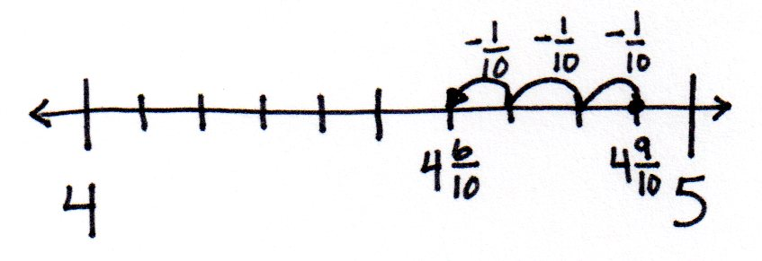
T: Try $\text{4}\frac{\text{9}}{\text{10}}$ – $\frac{\text{3}}{\text{10}}\text{.}$ We can count back by a tenth 3 times from $\text{4}\frac{\text{9}}{\text{10}}$ to find the answer. Draw a number line and use it to explain the difference to your partner.
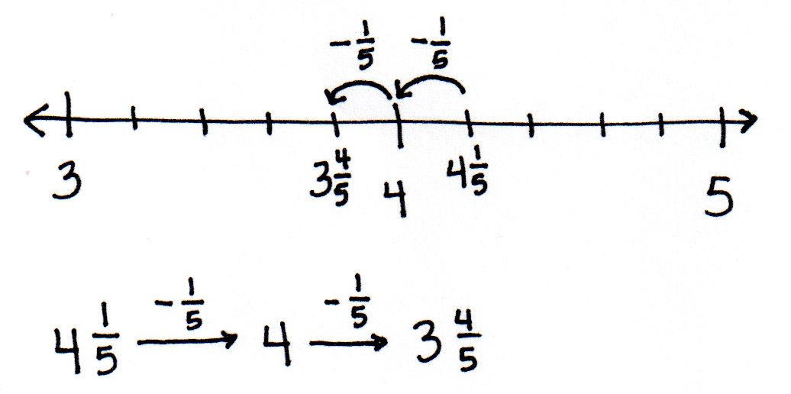
S: $\text{4}\frac{\text{9}}{\text{10}}\text{─}\frac{\text{3}}{\text{10}}\text{=} \text{4}\frac{\text{6}}{\text{10}}\text{.}$
There are 4 ones. 9 tenths – 3 tenths = 6 tenths.
T: Try $\text{4}\frac{\text{1}}{\text{5}}\text{─}\frac{\text{2}}{\text{5}}$. Model with a number line, and try using the arrow way.
S: $\text{4}\frac{\text{1}}{\text{5}}\text{─}\frac{\text{2}}{\text{5}}\text{=} \text{3}\frac{\text{4}}{\text{5}}$. Counting back 1 fifth, we get 4 ones. Counting back 1 more fifth, and we get $\text{3}\frac{\text{4}}{\text{5}}$.
Let students quickly practice with the following: $\text{4}\frac{\text{11}}{\text{12}}\text{─}\frac{\text{3}}{\text{12}}$ and$3\frac{\text{2}}{\text{6}}\text{─}\frac{\text{3}}{\text{6}}$.
Problem 2: Subtract a fraction less than 1 from a whole number by decomposing the subtrahend.
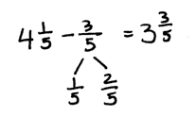
T: (Write $\text{4}\frac{\text{1}}{\text{5}}\text{─}\frac{\text{3}}{\text{5}}$.) Do we have enough fifths to subtract 3 fifths?
S: No!
T: (Show $\frac{\text{3}}{\text{5}}$ decomposed as $\frac{\text{1}}{\text{5}}$ and $\frac{\text{2}}{\text{5}}$ as pictured to the right.)
T: Does $\frac{\text{1}}{\text{5}}$ + $\frac{\text{2}}{\text{5}}$ have the same value as $\frac{\text{3}}{\text{5}}?$ (Point to the parts of the bond.)
MP.4
S: Yes!
T: Now, do we have enough fifths?
S: No. It’s still $\frac{\text{3}}{\text{5}}\text{.}$ We can’t take that from $\frac{\text{1}}{\text{5}}\text{.}$

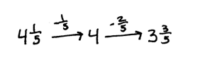
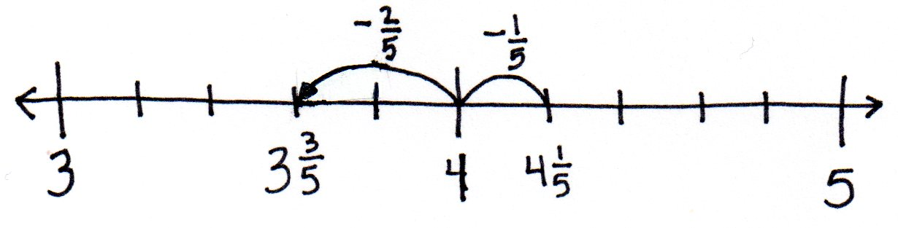
T: Look at the parts. Let’s take away one part at a time.
Draw a number line to model the subtraction.
T: Solve $\text{4}\frac{\text{1}}{\text{5}}\text{─}\frac{\text{1}}{\text{5}}$. Count back 1 fifth on the number line.
S: That’s 4.
T: Now, subtract $\frac{\text{2}}{\text{5}}$ from 4. Talk to your partner.
S: We already know how to do that, $\text{3}\frac{\text{5}}{\text{5}}\text{─}\frac{\text{2}}{\text{5}}\text{=} \text{3}\frac{\text{3}}{\text{5}}\text{.}$ 1 – $\frac{\text{2}}{\text{5}}$ is $\frac{\text{3}}{\text{5}}$ , so 4 – $\frac{\text{2}}{\text{5}}$ is $\text{3}\frac{\text{3}}{\text{5}}\text{.}$
MP.4
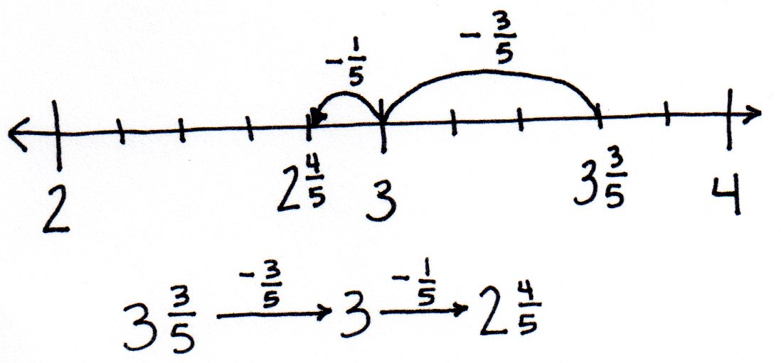
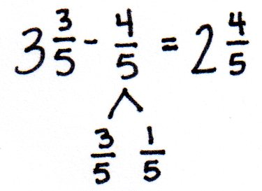
T: We can also use the arrow way. Start with $\text{4}\frac{\text{1}}{\text{5}}\text{ ,}$ count back $\frac{\text{1}}{\text{5}}$ to get to 4, and then count back $\frac{\text{2}}{\text{5}}$ more to get $\text{3}\frac{\text{3}}{\text{5}}\text{.}$ (Shown above to the right.)
T: Write $\text{3}\frac{\text{3}}{\text{5}}\text{─}\frac{\text{4}}{\text{5}}$. First, decompose $\frac{\text{4}}{\text{5}}$ into two parts, count back to 3, and then subtract the other part.
S: I see. We take away one part of $\frac{\text{4}}{\text{5}}$ at a time. $\frac{\text{4}}{\text{5}}\text{=}\frac{\text{3}}{\text{5}}\text{+}\frac{\text{1}}{\text{5}}\text{.}$ $\text{3}\frac{\text{3}}{\text{5}}\text{─}\frac{\text{3}}{\text{5}}\text{=} \text{3.}$ $\text{3}\text{─}\frac{\text{1}}{\text{5}}\text{= 2}\frac{\text{4}}{\text{5}}\text{.}$
T: Model on a number line, and then model using arrows.
Let students practice with the following: $\text{4}\frac{\text{5}}{\text{10}}\text{─}\frac{\text{7}}{\text{10}}\text{, 2}\frac{\text{2}}{\text{12}}\text{─}\frac{\text{7}}{\text{12}}\text{, }$
$\text{3}\frac{\text{7}}{\text{10}}\text{─}\frac{\text{9}}{\text{10}}\text{, 2}\frac{\text{1}}{\text{4}}\text{─}\frac{\text{3}}{\text{4}}$.
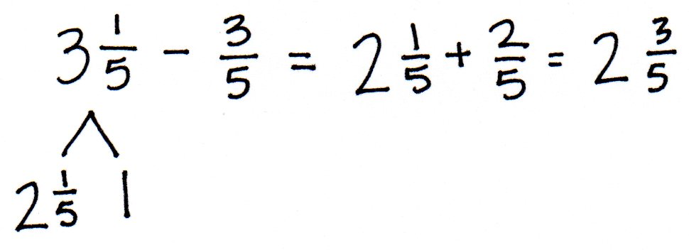
Problem 3: Decompose the total to take out 1 when subtracting a fraction from a mixed number when there are not enough fractional units.
T: (Write $\text{3}\frac{\text{1}}{\text{5}}\text{─}\frac{\text{3}}{\text{5}}$, including the number bond as shown to the right.)
T: Do you have enough fifths to subtract $\frac{\text{3}}{\text{5}}$?
S: No. This is the same problem as before.
T: Let’s try a different strategy to solve. Talk to your partner. Where can we get more fifths?
S: From $\text{3}\frac{\text{1}}{\text{5}}\text{.}$
T: Decompose$\text{ 3}\frac{\text{1}}{\text{5}}$by taking out one. We have $\text{2}\frac{\text{1}}{\text{5}}$ and 1. (Record using a number bond.)
T: Take $\frac{\text{3}}{\text{5}}$ from 1. How many are left?
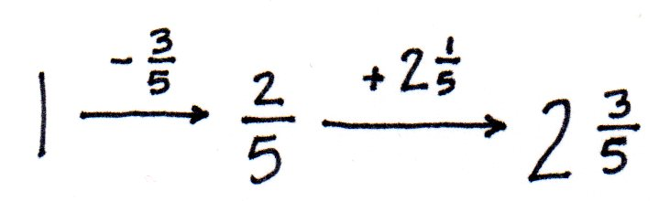
S: $\frac{\text{2}}{\text{5}}\text{.}$
T: We have $\frac{\text{2}}{\text{5}}$ left plus $\text{2}\frac{\text{1}}{\text{5}}$, which is equal to $\text{2}\frac{\text{3}}{\text{5}}\text{. }$ Let’s show this using the arrow way.
Let students practice with the following: $\text{12}\frac{\text{1}}{\text{4}}\text{─}\frac{\text{3}}{\text{4}}$ and $\text{7}\frac{\text{3}}{\text{10}}\text{─}\frac{\text{9}}{\text{10}}$.
Problem Set (10 minutes)

NOTE ON
MULTIPLE MEANS
OF REPRESENTATION:
There are other strategies for subtracting a fraction from a mixed number. Gauge students. Those who quickly show mastery of one strategy can be encouraged to understand and try others.
Those who struggle to master a method might be better off working with the decomposition modeled in Lesson 34 since it most closely resembles regrouping with whole number subtraction.
This connection may well strengthen their understanding of and skill with whole number subtraction, which may also be weak.

Students should do their personal best to complete the Problem Set within the allotted 10 minutes. For some classes, it may be appropriate to modify the assignment by specifying which problems they work on first. Some problems do not specify a method for solving. Students should solve these problems using the RDW approach used for Application Problems.
Student Debrief (10 minutes)
Lesson Objective: Subtract a fraction from a mixed number.
The Student Debrief is intended to invite reflection and active processing of the total lesson experience.
Invite students to review their solutions for the Problem Set. They should check work by comparing answers with a partner before going over answers as a class. Look for misconceptions or misunderstandings that can be addressed in the Debrief. Guide students in a conversation to debrief the Problem Set and process the lesson.
Any combination of the questions below may be used to lead the discussion.
- Use Problems 2(a) and 3(c) to compare the different methods to subtract when there are not enough fractional units.
- How is 7 tens 3 ones – 9 ones like 7 ones 3 tenths – 9 tenths? How is it different?
- Tell your partner the process of subtracting a fraction from a mixed number when regrouping is necessary.
- Here is another way to solve $\text{9}\frac{\text{1}}{\text{5}}\text{─}\frac{\text{3}}{\text{5}}\text{. }$A student wrote this (write$\text{ 9}\frac{\text{1}}{\text{5}}\text{─}\frac{\text{3}}{\text{5}}\text{=} \text{9}\frac{\text{3}}{\text{5}}\text{─}\text{1=} \text{8}\frac{\text{3}}{\text{5}}$). What was he thinking? (See the illustration of the student’s thinking below. Compare this method to whole number compensation such as 153 – 98 = 155 – 100$.$)
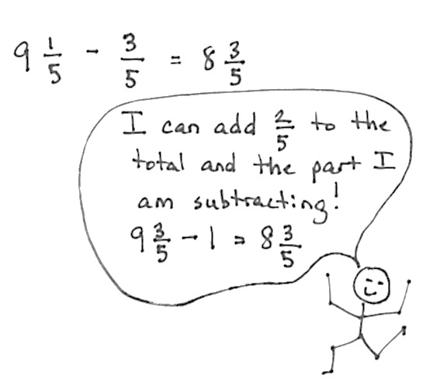

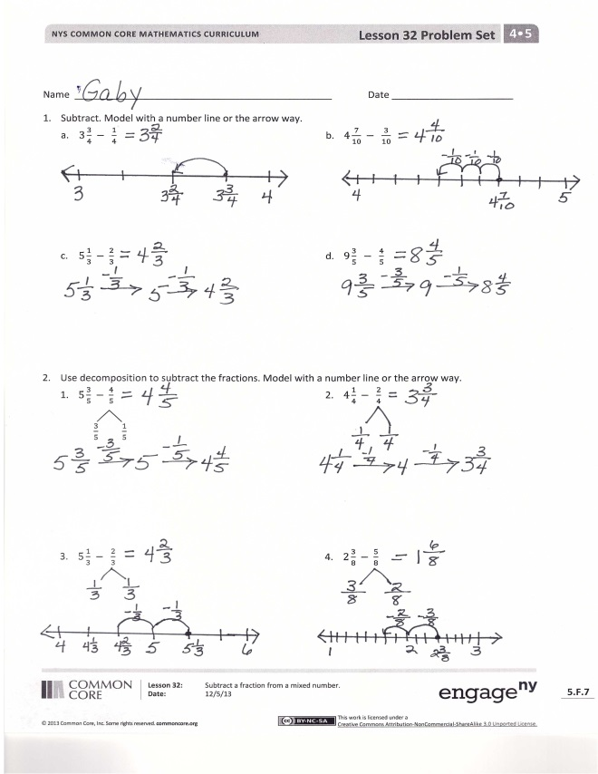
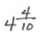
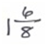
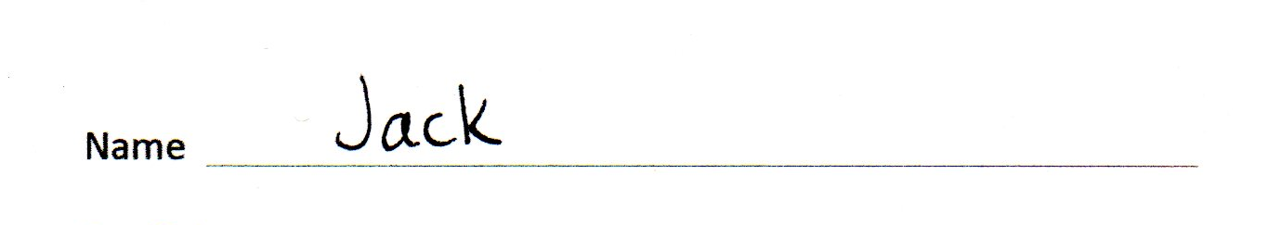
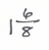
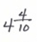
Exit Ticket (3 minutes)
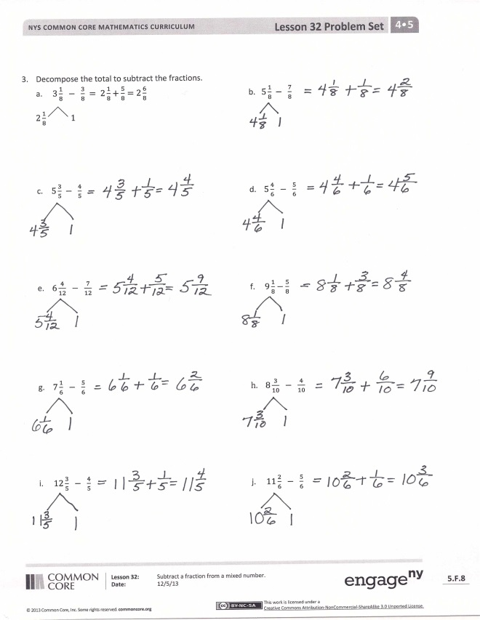
After the Student Debrief, instruct students to complete the Exit Ticket. A review of their work will help with assessing students’ understanding of the concepts that were presented in today’s lesson and planning more effectively for future lessons. The questions may be read aloud to the students.

Name Date
- Subtract. Model with a number line or the arrow way.
- $3\frac{3}{4} - \frac{1}{4}$
- $4\frac{7}{10} - \frac{3}{10}$

- $5\frac{1}{3} - \frac{2}{3}$
- $9\frac{3}{5} - \frac{4}{5}$

- Use decomposition to subtract the fractions. Model with a number line or the arrow way.

- $5\frac{3}{5} - \frac{4}{5}$
- $4\frac{1}{4} - \frac{2}{4}$

$\frac{3}{5} \frac{1}{5}$

- $5\frac{1}{3} - \frac{2}{3}$
- $2\frac{3}{8} - \frac{5}{8}$

- Decompose the total to subtract the fractions.

- $3\frac{1}{8} - \frac{3}{8} = 2\frac{1}{8}+\frac{5}{8}=2\frac{6}{8}$ b. $5\frac{1}{8} - \frac{7}{8}$
$2\frac{1}{8} 1$

- $5\frac{3}{5} - \frac{4}{5}$
- $5\frac{4}{6} - \frac{5}{6}$

- $6\frac{4}{12} - \frac{7}{12}$
- $9\frac{1}{8} - \frac{5}{8}$

- $7\frac{1}{6} - \frac{5}{6}$
- $8\frac{3}{10} - \frac{4}{10}$

- $12\frac{3}{5} - \frac{4}{5}$
- $11\frac{2}{6} - \frac{5}{6}$

Name Date
Solve.
- $10\frac{5}{6} - \frac{4}{6}$

- $8\frac{3}{8} - \frac{6}{8}$

Name Date
- Subtract. Model with a number line or the arrow way.

- $6\frac{3}{5} - \frac{1}{5}$ b. $4\frac{9}{12} - \frac{7}{12}$

- $7\frac{1}{4} - \frac{3}{4}$ d. $8\frac{3}{8} - \frac{5}{8}$

- Use decomposition to subtract the fractions. Model with a number line or the arrow way.
- $2\frac{2}{5} - \frac{4}{5}$ b. $2\frac{1}{3} - \frac{2}{3}$
$\frac{2}{5} \frac{2}{5}$

- $4\frac{1}{6} - \frac{4}{6}$ d. $3\frac{3}{6} - \frac{5}{6}$

- $9\frac{3}{8} - \frac{7}{8}$ f. $7\frac{1}{10}-\frac{6}{10}$

- $10\frac{1}{8} - \frac{5}{8}$ h. $9\frac{4}{12} - \frac{7}{12}$

- $11\frac{3}{5} - \frac{4}{5}$ j. $17\frac{1}{9} - \frac{5}{9}$

- Decompose the total to subtract the fractions.
- $4\frac{1}{8} - \frac{3}{8} =$ 3$\frac{1}{8} + \frac{5}{8} = 3\frac{6}{8}$ b. $5\frac{2}{5} - \frac{3}{5}$

$3\frac{1}{8} 1$

- $7\frac{1}{8} - \frac{3}{8}$ d. $3\frac{3}{9} - \frac{4}{9}$

- $6\frac{3}{10} - \frac{7}{10}$ f. $2\frac{5}{9} - \frac{8}{9}$

