Lesson 31
Objective: Add mixed numbers.

Suggested Lesson Structure
 Fluency Practice (12 minutes)
 Application Problem (5 minutes)
 Concept Development (33 minutes)
 Student Debrief (10 minutes)
Total Time (60 minutes)
Fluency Practice (12 minutes)
- Sprint: Change Fractions to Mixed Numbers 4.NF.4 (8 minutes)
- Compare Fractions 4.NF.2 (4 minutes)
Sprint: Change Fractions to Mixed Numbers (8 minutes)
Materials: (S) Change Fractions to Mixed Numbers Sprint
Note: This fluency activity reviews Lesson 24.

NOTES ON
MULTIPLE MEANS
OF ENGAGEMENT:
Consider preceding the Compare Fractions fluency activity with a counting by fifths, thirds, and fourths activity to increase student confidence and participation.

Compare Fractions (4 minutes)
Materials: (S) Personal white board
Note: This fluency activity reviews Lesson 26.
T: (Write $\frac{\text{26}}{6}$.) How many ones are in 26 sixths?
S: 4 ones.
T: Between what two whole numbers is 26 sixths?
S: 4 and 5.
T: (Write $\frac{\text{26}}{\text{6}}$ __ $\frac{\text{20}}{\text{5}}\text{.}$) Write a greater than or less than sign to compare the fractions.
S: (Write $\frac{\text{26}}{\text{6}}$ > $\frac{\text{20}}{\text{5}}$.)
T: How do you know?
S: $\frac{\text{20}}{\text{5}}$ equals 4. $\frac{\text{26}}{\text{6}}$ is between 4 and 5.
Continue with the following possible sequence: $\frac{\text{31}}{\text{5}}$ __ $\frac{\text{24}}{\text{6}}$ , $\frac{\text{31}}{\text{5}}$ __ $\frac{\text{28}}{\text{4}}$, $\frac{\text{65}}{\text{8}}$ __ $\frac{\text{48}}{\text{6}}$, and $\frac{\text{57}}{8}$ __ $\frac{23}{\text{3}}$.
Application Problem (5 minutes)
Marta has 2 meters 80 centimeters of cotton cloth and 3 meters 87 centimeters of linen cloth. What is the total length of both pieces of cloth?

Note: This Application Problem anticipates the adding of two mixed numbers using a measurement context. Solution A shows a solution whereby the students decomposed 87 centimeters to complete the unit of one meter and added on the remaining centimeters. Solution B shows a solution whereby the student added all of the centimeters and decomposed the sum.
Concept Development (33 minutes)
Materials: (S) Personal white board
Problem 1: Add mixed numbers combining like units.

NOTES ON
MULTIPLE MEANS
OF ENGAGEMENT:
English language learners and others may benefit from explicit instruction and additional practice speaking mixed numbers in unit language. If time is a consideration, prepare students beforehand to increase confidence and participation.

T: Write $\text{2}\frac{\text{1}}{\text{8}}$ + $\text{1}\frac{\text{5}}{\text{8}}$. Let’s find the sum.
T: Say the expression using unit form.
S: 2 ones 1 eighth plus 1 one 5 eighths.
T: What are the units involved in this problem?
S: Ones and eighths.
T: When we add numbers, we add like units. (Point to the mixed numbers and demonstrate.) How many ones are there in all?
MP.2
S: 3 ones.
T: How many eighths are there in all?
S: 6 eighths.
T: 3 ones + 6 eighths is…?
S: $\text{3}\frac{\text{6}}{\text{8}}\text{.}$
T: (Write $\text{2}\frac{\text{3}}{\text{4}}\text{+ 3}\frac{\text{1}}{\text{4}} \text{=} \text{2} \text{+}\frac{\text{3}}{\text{4}} \text{+} \text{3} \text{+}\frac{\text{1}}{\text{4}}\text{.}$ Pause to allow students to analyze.) From our previous work we know $\text{2}\frac{\text{3}}{\text{4}}\text{+ 3}\frac{\text{1}}{\text{4}} \text{=} \text{2} \text{+}\frac{\text{3}}{\text{4}} \text{+} \text{3} \text{+}\frac{\text{1}}{\text{4}}$ , true?
S: Yes!
T: So, we do not have to write all that down.
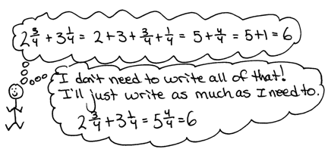
T: The sum of the ones is…?
S: 5 ones.
T: The sum of the fourths is…?
S: 4 fourths.
MP.2
T: (Write.)
$\text{2}\frac{\text{3}}{\text{4}} \text{+} \text{3}\frac{\text{1}}{\text{4}} \text{=} \text{5} \text{+}\frac{\text{4}}{\text{4}}$
$\text{= 6}$.
T: Explain to your partner how we got a sum of 6.
S: Easy. 2 ones and 3 ones is 5. Three fourths and 1 fourth is one. Five and 1 makes 6. We just put the like units together, ones with ones and fourths with fourths. Add the ones. Add the fractions.
Let students practice with the following: $\text{5}\frac{\text{1}}{\text{3}}$ + $\text{6}\frac{\text{2}}{\text{3}}$ and $\text{21}\frac{\text{2}}{\text{5}}$ + $\text{10}\frac{\text{2}}{\text{5}}$. Encourage them to write the solution using the shorter recording method, e.g., $\text{5}\frac{\text{1}}{\text{3}} \text{+} \text{6}\frac{\text{2}}{\text{3}} \text{=} \text{11} \text{+}\frac{\text{3}}{\text{3}} \text{= 12}$ and $\text{21}\frac{\text{2}}{\text{5}}\text{ + 10}\frac{\text{2}}{\text{5}}\text{= 31 +}\frac{\text{4}}{\text{5}}\text{ = 31}\frac{\text{4}}{\text{5}}\text{, }$but if they must decompose each addend as a sum, let them. Encourage them to think in terms of what fractional part will get them to the next whole number.
Problem 2: Add mixed numbers when the sum of the fractional units is greater than 1 by combining like units.
T: (Write $\text{2}\frac{\text{5}}{\text{8}} \text{+} \text{3}\frac{\text{5}}{\text{8}}$.) Right away, we see that the sum of the eighths is greater than 1.
T: The sum of the ones is…?
S: 5.
T: The sum of the eighths is…?
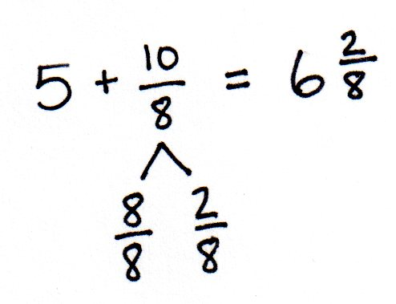
S: 10 eighths.
T: Take out 8 eighths to make one.
S: $\text{1}\frac{\text{2}}{\text{8}}$. $\frac{\text{8}}{\text{8}}$ and $\frac{\text{2}}{\text{8}}$. (Record with a number bond.)
T: (Write the following.)
$$\text{2}\frac{\text{5}}{\text{8}} \text{+} \text{3}\frac{\text{5}}{\text{8}}\text{ = 5} \text{+}\frac{\text{10}}{\text{8}}$$
$\text{ =} \text{5 +}\frac{\text{8}}{\text{8}}\text{ + }\frac{\text{2}}{\text{8}}$
$\text{=} \text{6}\frac{\text{2}}{\text{8}}$
T: Explain to your partner how we got a sum of $\text{6}\frac{\text{2}}{\text{8}}\text{.}$
S: We added like units. We added ones to ones and eighths to eighths. Then, we changed 10 eighths to make 1 and 2 eighths and added $\text{5} \text{+ 1}\frac{\text{2}}{\text{8}}\text{=} \text{6}\frac{\text{2}}{\text{8}}\text{.}$
T: Use a number line to model the addition of like units.
Students may show slides on the number line in different ways depending on their fluency with the addition of like units. Accept representations that are logical and follow the path of the number sentence.
Two samples are shown.
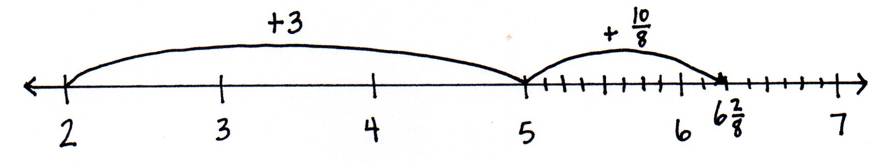
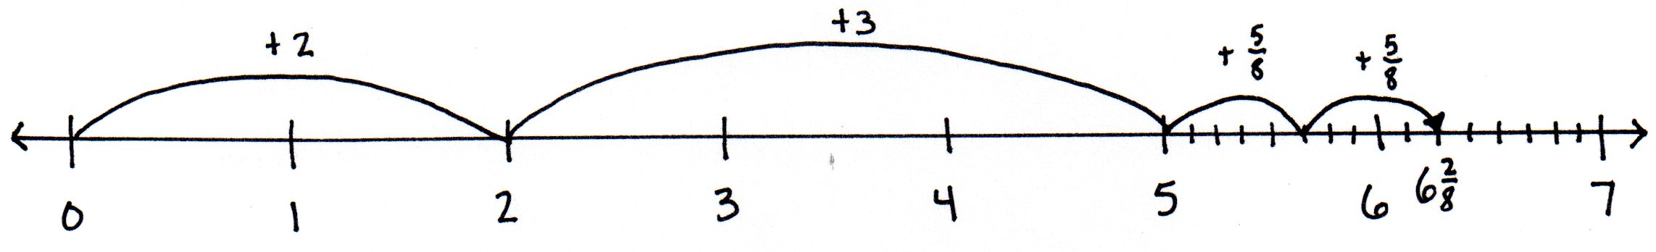

Let students practice with the following: $\text{2}\frac{\text{2}}{\text{5}}\text{ + 2}\frac{\text{4}}{\text{5}}$ and $\text{3}\frac{\text{5}}{\text{12}}\text{+} \text{1}\frac{\text{11}}{\text{12}}\text{.}$ Allow students to work mentally to solve, if they can, without recording the breakdown of steps.
Problem 3: Add mixed numbers when the sum of the fractional units is greater than 1 by making one.
T: (Write $\text{5}\frac{\text{5}}{\text{8}} \text{+} \text{6}\frac{\text{5}}{\text{8}}$.) We can also add the ones first and decompose to make one in the same way we learned to make ten in the first and second grades.
T: 5 and 6 is…?
S: 11.
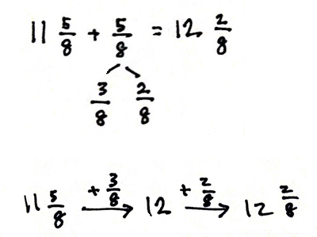
T: (Write 11 $\frac{\text{5}}{\text{8}}\text{ + }\frac{\text{5}}{\text{8}}\text{.}$) How much does 5 eighths need to make one?
S: 3 eighths. (Decompose $\frac{\text{5}}{\text{8}}$ as $\frac{\text{3}}{\text{8}}$ and $\frac{\text{2}}{\text{8}}$ as shown to the right.)
T: We can use the arrow way to show this clearly. Instead of drawing a number line, we can draw arrows to show the sum. $\text{11}\frac{\text{5}}{\text{8}} \text{+} \frac{\text{3}}{\text{8}}$ is…? (Model the arrow way as you speak.)
S: 12. (Record 12 and draw the next arrow.)
T: 12 +$\frac{\text{2}}{\text{8}}$ is…? (Record as modeled to the right.)
S: $\text{12}\frac{\text{2}}{\text{8}}\text{.}$
T: $\text{5}\frac{\text{5}}{\text{8}} \text{+} \text{6}\frac{\text{5}}{\text{8}}\text{ = 11}\frac{\text{5}}{\text{8}} \text{+} \frac{\text{5}}{\text{8}}$
$\text{=} \text{11}\frac{\text{5}}{\text{8}} \text{+} \frac{\text{3}}{\text{8}} \text{+} \frac{\text{2}}{\text{8}}$
$\text{=} \text{12}\frac{\text{2}}{\text{8}}$
Let students practice with $\text{3}\frac{\text{7}}{\text{8}} \text{+} \text{4}\frac{\text{3}}{\text{8}}$ and $\text{9}\frac{\text{11}}{\text{12}} \text{+} \text{10}\frac{\text{5}}{\text{12}}\text{.}$ Again, students may want to add more steps in the recording, e.g., $\text{5}\frac{\text{5}}{\text{8}} \text{+} \text{6}\frac{\text{5}}{\text{8}} \text{=} \text{11}\frac{\text{5}}{\text{8}} \text{+} \frac{\text{5}}{\text{8}} \text{=} \text{11}\frac{\text{8}}{\text{8}} \text{+} \frac{\text{2}}{\text{8}} \text{=} \text{12}\frac{\text{2}}{\text{8}}\text{. }$ Gently encourage them to stop recording the steps they are able to easily complete mentally.
T: (Write $\text{4}\frac{\text{2}}{\text{3}} \text{+} \text{3}\frac{\text{1}}{\text{3}} \text{+} \text{5}\frac{\text{2}}{\text{3}}$. ) The sum of the ones is…?
S: 12.
T: The sum of the thirds is…?
S: 5 thirds.
T: Record your work.
S: $\text{4}\frac{\text{2}}{\text{3}}\text{ + 3}\frac{\text{1}}{\text{3}}\text{ + 5}\frac{\text{2}}{\text{3}}\text{ = 12 +}\frac{\text{5}}{\text{3}}$
$\text{= 13}\frac{\text{2}}{\text{3}}$
Please note that this is not the only way to record this sum. Students might break the problem down into more or fewer steps, use a number bond, or do mental math.
Problem 4: Record the addition of mixed numbers.
T: How much you write down of your calculation is up to you. Some of you may write down each step in a detailed way, while others may do a lot of the work mentally. Write down what you need to so that you can keep track of the problem. At times, I write down more than at other times depending on the problem and even on my mood.
T: (Write $\text{4}\frac{\text{7}}{\text{12}} \text{+} \text{16}\frac{\text{9}}{\text{12}}\text{.)}$ Solve this problem. The goal is to write down only as much as necessary.
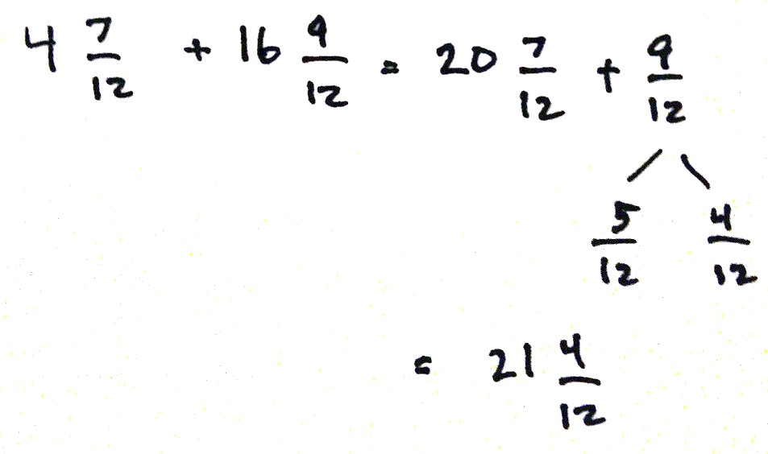
Below are some different recordings that might be seen. Students vary in their ability to do mental math. Be mindful that some students may think they are doing more math by writing as much as possible. Work to bring thoughtfulness to each student’s experience. Be sure to check periodically to make sure that students can explain their thinking.

T: The sum is…?
S: $\text{21}\frac{\text{4}}{\text{12}}$.
T: Share your way of recording with a partner. If you did your work mentally, explain to your partner how you did it. Did you use the same strategies or different strategies? Remember to use the strategy that makes the most sense to you.
Problem Set (10 minutes)
Students should do their personal best to complete the Problem Set within the allotted 10 minutes. For some classes, it may be appropriate to modify the assignment by specifying which problems they work on first. Some problems do not specify a method for solving. Students should solve these problems using the RDW approach used for Application Problems.
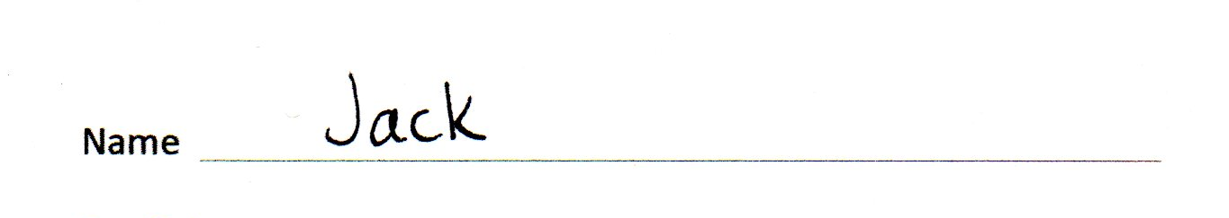
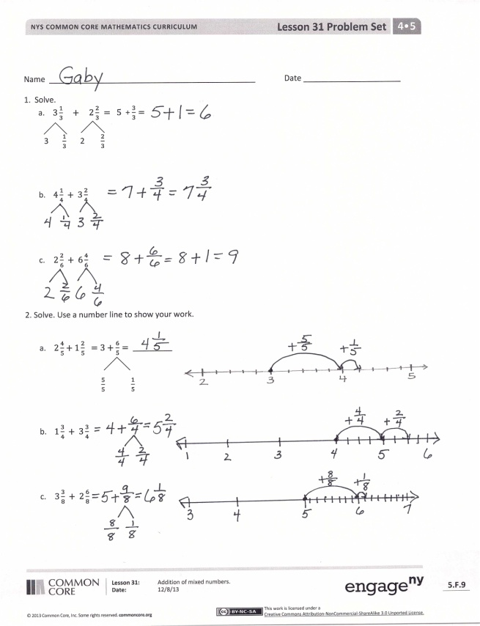
Student Debrief (10 minutes)
Lesson Objective: Add mixed numbers.
The Student Debrief is intended to invite reflection and active processing of the total lesson experience.
Invite students to review their solutions for the Problem Set. They should check work by comparing answers with a partner before going over answers as a class. Look for misconceptions or misunderstandings that can be addressed in the Debrief. Guide students in a conversation to debrief the Problem Set and process the lesson.
Any combination of the questions below may be used to lead the discussion.
- Explain how decomposing mixed numbers helps you find their sum.
- Explain how you solved Problem 1(c).
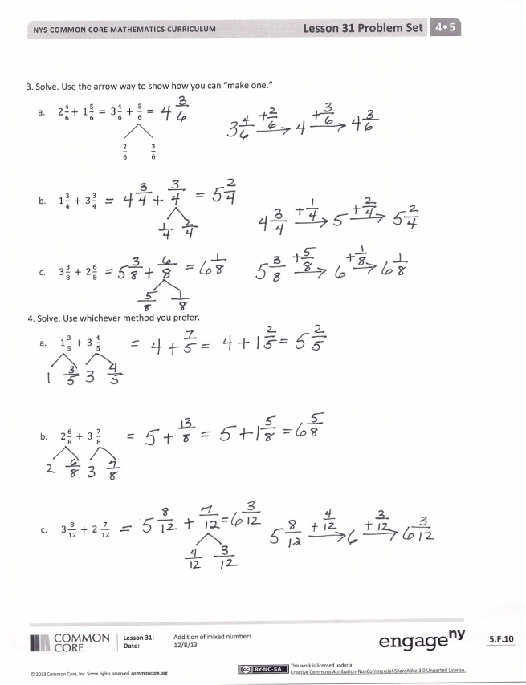
- Explain the methods you chose for solving Problems 4(a), 4(b), and 4(c). Did you use the same methods as your partner?
- How is adding 4 tens 7 ones and 6 tens 9 ones like adding 4 ones 7 twelfths and 6 ones 9 twelfths? How is it different?
- If you were unsure of any answer on this Problem Set, what could you do to see if your answer is reasonable? Would drawing a picture or estimating the sum or difference be helpful?
- How did the Application Problem connect to today’s lesson?
Exit Ticket (3 minutes)
After the Student Debrief, instruct students to complete the Exit Ticket. A review of their work will help with assessing students’ understanding of the concepts that were presented in today’s lesson and planning more effectively for future lessons. The questions may be read aloud to the students.

Number Correct: _______
A
Change Fractions to Mixed Numbers
 | 3 + 1 = |  |  |  | $\text{1}\frac{\text{ 3 }}{\text{8}} \text{=} \frac{}{\text{8}}$
 | $\frac{\text{ 3 }}{\text{3}} \text{+} \frac{\text{ 1 }}{\text{3}} \text{=} \frac{}{\text{3}}$ |  |  |  | $\text{2 + }\frac{\text{ 1 }}{\text{3}}\text{ = 2}\frac{}{\text{3}}$
 | $\text{1 +} \frac{\text{ 1 }}{\text{3}} \text{=} \frac{}{\text{3}}$ |  |  |  | $\frac{\text{ 6 }}{\text{3}} \text{+} \frac{\text{ 1 }}{\text{3}} \text{=} \frac{}{\text{3}}$
 | $\text{1}\frac{\text{ 1 }}{\text{3}} \text{=} \frac{}{\text{3}}$ |  |  |  | $\text{2 +} \frac{\text{ 1 }}{\text{3}} \text{=} \frac{}{\text{3}}$
 | 5 + 1 = |  |  |  | $\text{2}\frac{\text{ 1 }}{\text{3}} \text{=} \frac{}{\text{3}}$
 | $\frac{\text{ 5 }}{\text{5}} \text{+} \frac{\text{ 1 }}{\text{5}} \text{=} \frac{}{\text{5}}$ |  |  |  | $\text{2 + }\frac{\text{ 1 }}{\text{5}}\text{ = 2}\frac{}{\text{5}}$
 | $\text{1 +} \frac{\text{ 1 }}{\text{5}} \text{=} \frac{}{\text{5}}$ |  |  |  | $\frac{\text{10}}{\text{5}} \text{+} \frac{\text{ 1 }}{\text{5}} \text{=} \frac{}{\text{5}}$
 | $\text{1}\frac{\text{ 1 }}{\text{5}} \text{=} \frac{}{\text{5}}$ |  |  |  | $\text{2 +} \frac{\text{ 1 }}{\text{5}} \text{=} \frac{}{\text{5}}$
 | 2 + 1 = |  |  |  | $\text{2}\frac{\text{ 1 }}{\text{5}} \text{=} \frac{}{\text{5}}$
 | $\frac{\text{ 2 }}{\text{2}} \text{+} \frac{\text{ 1 }}{\text{2}} \text{=} \frac{}{\text{2}}$ |  |  |  | $\frac{\text{ 8 }}{\text{4}} \text{+} \frac{\text{ 3 }}{\text{4}} \text{=} \frac{}{\text{4}}$
 | $\text{1 +} \frac{\text{ 1 }}{\text{2}} \text{=} \frac{}{\text{2}}$ |  |  |  | $\text{2 +} \frac{\text{ 3 }}{\text{4}} \text{=} \frac{}{\text{4}}$
 | $\text{1}\frac{\text{ 1 }}{\text{2}} \text{=} \frac{}{\text{2}}$ |  |  |  | $\text{2}\frac{\text{ 3 }}{\text{4}} \text{=} \frac{}{\text{4}}$
 | $\frac{\text{ 4 }}{\text{4}} \text{+} \frac{\text{ 1 }}{\text{4}} \text{=} \frac{}{\text{4}}$ |  |  |  | $\frac{\text{12}}{\text{3}} \text{+} \frac{\text{ 2 }}{\text{3}} \text{=} \frac{}{\text{3}}$
 | $\text{1 +} \frac{\text{ 1 }}{\text{4}} \text{=} \frac{}{\text{4}}$ |  |  |  | $\text{4 +} \frac{\text{ 2 }}{\text{3}} \text{=} \frac{}{\text{3}}$
 | $\text{1}\frac{\text{ 1 }}{\text{4}} \text{=} \frac{}{\text{4}}$ |  |  |  | $\text{4}\frac{\text{ 2 }}{\text{3}} \text{=} \frac{}{\text{3}}$
 | $\text{1}\frac{\text{ 3 }}{\text{4}} \text{=} \frac{}{\text{4}}$ |  |  |  | $\text{3 +} \frac{\text{ 3 }}{\text{5}} \text{=} \frac{}{\text{5}}$
 | $\frac{\text{ 5 }}{\text{5}} \text{+} \frac{\text{ 1 }}{\text{5}} \text{=} \frac{}{\text{5}}$ |  |  |  | $\text{3 +} \frac{\text{ 1 }}{\text{2}} \text{=} \frac{}{\text{2}}$
 | $\text{1 +} \frac{\text{ 1 }}{\text{5}} \text{=} \frac{}{\text{5}}$ |  |  |  | $\text{4 +} \frac{\text{ 3 }}{\text{4}} \text{=} \frac{}{\text{4}}$
 | $\text{1}\frac{\text{ 1 }}{\text{5}} \text{=} \frac{}{\text{5}}$ |  |  |  | $\text{2 +} \frac{\text{ 1 }}{\text{6}} \text{=} \frac{}{\text{6}}$
 | $\text{1}\frac{\text{ 3 }}{\text{5}} \text{=} \frac{}{\text{5}}$ |  |  |  | $\text{2 +} \frac{\text{ 5 }}{\text{8}} \text{=} \frac{}{\text{8}}$
 | $\frac{\text{ 8 }}{\text{8}} \text{+} \frac{\text{ 3 }}{\text{8}} \text{=} \frac{}{\text{8}}$ |  |  |  | $\text{2}\frac{\text{ 4 }}{\text{5}} \text{=} \frac{}{\text{5}}$
 | $\text{1 +} \frac{\text{ 3 }}{\text{8}} \text{=} \frac{}{\text{8}}$ |  |  |  | $\text{3}\frac{\text{ 7 }}{\text{8}} \text{=} \frac{}{\text{8}}$
B
[KEY]

Number Correct: _______
Improvement: _______
Change Fractions to Mixed Numbers
 | 4 + 1 = |  |  |  | $\text{1}\frac{\text{ 5 }}{\text{8}} \text{=} \frac{}{\text{8}}$
 | $\frac{\text{ 4 }}{\text{4}} \text{+} \frac{\text{ 1 }}{\text{4}} \text{=} \frac{}{\text{4}}$ |  |  |  | $\text{2 + }\frac{\text{ 1 }}{\text{2}}\text{ = 2}\frac{}{\text{2}}$
 | $\text{1 +} \frac{\text{ 1 }}{\text{4}} \text{=} \frac{}{\text{4}}$ |  |  |  | $\frac{\text{ 4 }}{\text{2}} \text{+} \frac{\text{ 1 }}{\text{2}} \text{=} \frac{}{\text{2}}$
 | $\text{1}\frac{\text{ 1 }}{\text{4}} \text{=} \frac{}{\text{4}}$ |  |  |  | $\text{2 +} \frac{\text{ 1 }}{\text{2}} \text{=} \frac{}{\text{2}}$
 | 2 + 1 = |  |  |  | $\text{2}\frac{\text{ 1 }}{\text{2}} \text{=} \frac{}{\text{2}}$
 | $\frac{\text{ 2 }}{\text{2}} \text{+} \frac{\text{ 1 }}{\text{2}} \text{=} \frac{}{\text{2}}$ |  |  |  | $\text{2 + }\frac{\text{ 1 }}{\text{4}}\text{ = 2}\frac{}{\text{4}}$
 | $\text{1 +} \frac{\text{ 1 }}{\text{2}} \text{=} \frac{}{\text{2}}$ |  |  |  | $\frac{ \text{8 }}{\text{4}} \text{+} \frac{\text{ 1 }}{\text{4}} \text{=} \frac{}{\text{4}}$
 | $\text{1}\frac{\text{ 1 }}{\text{2}} \text{=} \frac{}{\text{2}}$ |  |  |  | $\text{2 +} \frac{\text{ 1 }}{\text{4}} \text{=} \frac{}{\text{4}}$
 | 5 + 1 = |  |  |  | $\text{2}\frac{\text{ 1 }}{\text{4}} \text{=} \frac{}{\text{4}}$
 | $\frac{\text{ 5 }}{\text{5}} \text{+} \frac{\text{ 1 }}{\text{5}} \text{=} \frac{}{\text{5}}$ |  |  |  | $\frac{\text{ 6 }}{\text{3}} \text{+} \frac{\text{ 2 }}{\text{3}} \text{=} \frac{}{\text{3}}$
 | $\text{1 +} \frac{\text{ 1 }}{\text{5}} \text{=} \frac{}{\text{5}}$ |  |  |  | $\text{2 +} \frac{\text{ 2 }}{\text{3}} \text{=} \frac{}{\text{3}}$
 | $\text{1}\frac{\text{ 1 }}{\text{5}} \text{=} \frac{}{\text{5}}$ |  |  |  | $\text{2}\frac{\text{ 2 }}{\text{3}} \text{=} \frac{}{\text{3}}$
 | $\frac{\text{ 3 }}{\text{3}} \text{+} \frac{\text{ 1 }}{\text{3}} \text{=} \frac{}{\text{3}}$ |  |  |  | $\frac{\text{12}}{\text{4}} \text{+} \frac{\text{ 3 }}{\text{4}} \text{=} \frac{}{\text{4}}$
 | $\text{1 +} \frac{\text{ 1 }}{\text{3}} \text{=} \frac{}{\text{3}}$ |  |  |  | $\text{3 +} \frac{\text{ 3 }}{\text{4}} \text{=} \frac{}{\text{4}}$
 | $\text{1}\frac{\text{ 1 }}{\text{3}} \text{=} \frac{}{\text{3}}$ |  |  |  | $\text{3}\frac{\text{ 3 }}{\text{4}} \text{=} \frac{}{\text{4}}$
 | $\text{1}\frac{\text{ 2 }}{\text{3}} \text{=} \frac{}{\text{3}}$ |  |  |  | $\text{3 +} \frac{\text{ 4 }}{\text{5}} \text{=} \frac{}{\text{5}}$
 | $\frac{\text{10}}{\text{10}} \text{+} \frac{\text{ 1 }}{\text{10}} \text{=} \frac{}{\text{10}}$ |  |  |  | $\text{4 +} \frac{\text{ 1 }}{\text{2}} \text{=} \frac{}{\text{2}}$
 | $\text{1 +} \frac{\text{ 1 }}{\text{10}} \text{=} \frac{}{\text{10}}$ |  |  |  | $\text{4 +} \frac{\text{ 2 }}{\text{3}} \text{=} \frac{}{\text{3}}$
 | $\text{1}\frac{\text{ 1 }}{\text{10}} \text{=} \frac{}{\text{10}}$ |  |  |  | $\text{3 +} \frac{\text{ 1 }}{\text{6}} \text{=} \frac{}{\text{6}}$
 | $\text{1}\frac{\text{ 7 }}{\text{10}} \text{=} \frac{}{\text{10}}$ |  |  |  | $\text{2 +} \frac{\text{ 7 }}{\text{8}} \text{=} \frac{}{\text{8}}$
 | $\frac{\text{ 8 }}{\text{8}} \text{+} \frac{\text{ 5 }}{\text{8}} \text{=} \frac{}{\text{8}}$ |  |  |  | $\text{2}\frac{\text{ 3 }}{\text{5}} \text{=} \frac{}{\text{5}}$
 | $\text{1 +} \frac{\text{ 5 }}{\text{8}} \text{=} \frac{}{\text{8}}$ |  |  |  | $\text{2}\frac{\text{ 7 }}{\text{8}} \text{=} \frac{}{\text{8}}$

Name Date
- Solve.
- $\text{3}\frac{\text{1}}{\text{3}}\text{ + 2}\frac{\text{2}}{\text{3}}\text{ = 5 }$ + $\frac{\text{3}}{\text{3}}\text{= }$
3 $\frac{\text{1}}{\text{3}}$ 2 $\frac{\text{2}}{\text{3}}$

- $\text{4}\frac{\text{1}}{\text{4}}\text{ + 3}\frac{\text{2}}{\text{4}}$

- $\text{2}\frac{\text{2}}{\text{6}}\text{ + 6}\frac{\text{4}}{\text{6}}$

- Solve. Use a number line to show your work.

- $\text{2}\frac{\text{4}}{\text{5}} \text{+} \text{1}\frac{\text{2}}{\text{5}}\text{ =} \text{3} \text{+}\frac{\text{6}}{\text{5}}\text{= ____________}$

$\frac{\text{5}}{\text{5}}$ $\frac{\text{1}}{\text{5}}$

- $\text{1}\frac{\text{3}}{\text{4}}\text{ + 3}\frac{\text{3}}{\text{4}}$

- $\text{3}\frac{\text{3}}{\text{8}}\text{ + 2}\frac{\text{6}}{\text{8}}$

- Solve. Use the arrow way to show how to make one.
  - $\text{2}\frac{\text{4}}{\text{6}} \text{+ 1}\frac{\text{5}}{\text{6}}\text{ = 3}\frac{\text{4}}{\text{6}}\text{ + }\frac{\text{5}}{\text{6}}\text{ = }$

$\frac{\text{2}}{\text{6}}$ $\frac{\text{3}}{\text{6}}$

  - $\text{1}\frac{\text{3}}{\text{4}}\text{ + 3}\frac{\text{3}}{\text{4}}$

  - $\text{3}\frac{\text{3}}{\text{8}}\text{ + 2}\frac{\text{6}}{\text{8}}$

- Solve. Use whichever method you prefer.
- $\text{1}\frac{\text{3}}{\text{5}}\text{ + 3}\frac{\text{4}}{\text{5}}$

- $\text{2}\frac{\text{6}}{\text{8}}\text{ + 3}\frac{\text{7}}{\text{8}}$

- $\text{3}\frac{\text{8}}{\text{12}}\text{ + 2}\frac{\text{7}}{\text{12}}$

Name Date
Solve.
- $\text{2}\frac{\text{3}}{\text{8}}\text{ + 1}\frac{\text{5}}{\text{8}}$

- $\text{3}\frac{\text{4}}{\text{5}}\text{ + 2}\frac{\text{3}}{\text{5}}$

Name Date
  - Solve.
- $\text{2}\frac{\text{1}}{\text{3}}\text{ + 1}\frac{\text{2}}{\text{3}}\text{ = 3 }$ + $\frac{\text{3}}{\text{3}} \text{= }$
2 $\frac{1}{3}$ 1 $\frac{\text{2}}{\text{3}}$

- $\text{2}\frac{\text{2}}{\text{5}}\text{ + 2}\frac{\text{2}}{\text{5}}$

- $\text{3}\frac{\text{3}}{\text{8}}\text{ + 1}\frac{\text{5}}{\text{8}}$

- Solve. Use a number line to show your work.

- $\text{2}\frac{\text{2}}{\text{4}} \text{+ 1}\frac{\text{3}}{\text{4}}\text{ = 3 }$+ $\frac{5}{4}= _______$

$\frac{\text{4}}{\text{4}}$ $\frac{\text{1}}{\text{4}}$

- $\text{3}\frac{\text{4}}{\text{6}}\text{ + 2}\frac{\text{5}}{\text{6}}$

- $\text{1}\frac{\text{9}}{\text{12}}\text{ + 1}\frac{\text{7}}{\text{12}}$
- Solve. Use the arrow way to show how to make one.
  - $\text{2}\frac{\text{3}}{\text{4}} \text{+ 1}\frac{\text{3}}{\text{4}}\text{ = 3}\frac{\text{3}}{\text{4}}$+ $\frac{3}{4}=$
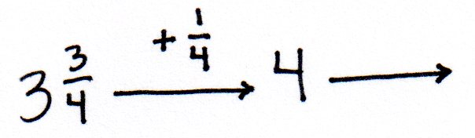

$\frac{\text{1}}{\text{4}}$ $\frac{\text{2}}{\text{4}}$

  - $\text{2}\frac{\text{7}}{\text{8}}\text{ + 3}\frac{\text{4}}{\text{8}}$

  - $\text{1}\frac{\text{7}}{\text{9}}\text{ + 4}\frac{\text{5}}{\text{9}}$

- Solve. Use whichever method you prefer.
- $\text{1}\frac{\text{4}}{\text{5}}\text{ + 1 }\frac{\text{3}}{\text{5}}$

- $\text{3}\frac{\text{8}}{\text{10}}\text{ +} \text{1}\frac{\text{5}}{\text{10}}$

- $\text{2}\frac{\text{5}}{\text{7}}\text{ + 3}\frac{\text{6}}{\text{7}}$

