Lesson 30
Objective: Add a mixed number and a fraction.

Suggested Lesson Structure
 Fluency Practice (12 minutes)
 Application Problem (5 minutes)
 Concept Development (33 minutes)
 Student Debrief (10 minutes)
Total Time (60 minutes)
Fluency Practice (12 minutes)
- Sprint: Change Fractions to Mixed Numbers 4.NF.4 (8 minutes)
- Compare Fractions 4.NF.2 (4 minutes)
Sprint: Change Fractions to Mixed Numbers (8 minutes)
Materials: Change Fractions to Mixed Numbers Sprint
Note: This fluency activity reviews Lesson 24.
Compare Fractions (4 minutes)

NOTES ON
MULTIPLE MEANS
OF ENGAGEMENT:
Consider preceding the Compare Fractions fluency activity with a counting by fifths, thirds, and fourths activity to increase student confidence and participation.

Materials: (S) Personal white board
Note: This fluency activity reviews Lesson 26.
T: (Write $\frac{\text{19}}{\text{5}}$.) How many ones are in 19 fifths?
S: 3 ones.
T: Between what two whole numbers is 19 fifths?
S: 3 and 4.
T: (Write $\frac{\text{19}}{\text{5}}$ __ $\frac{\text{12}}{\text{3}}\text{.}$) Write a greater than or less than sign to compare the fractions.
S: (Write $\frac{\text{19}}{\text{5}}$ < $\frac{\text{12}}{\text{3}}$.)
T: How do you know?
S: $\frac{\text{12}}{\text{3}}$ equals 4. $\frac{\text{19}}{\text{5}}$ is between 3 and 4.
Continue with the following possible sequence: $\frac{\text{25}}{\text{4}}$ __ $\frac{\text{20}}{\text{5}}$, $\frac{\text{25}}{\text{4}}$ __ $\frac{\text{26}}{\text{5}}$, $\frac{\text{26}}{\text{3}}$ __ $\frac{\text{32}}{\text{4}}$, and $\frac{\text{26}}{\text{3}}$ __ $\frac{\text{19}}{\text{2}}$.
Application Problem (5 minutes)
One board measures 2 meters 70 centimeters. Another measures 87 centimeters. What is the total length of the two boards expressed in meters and centimeters?
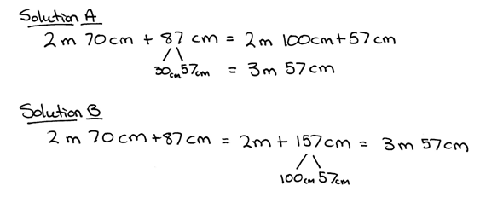
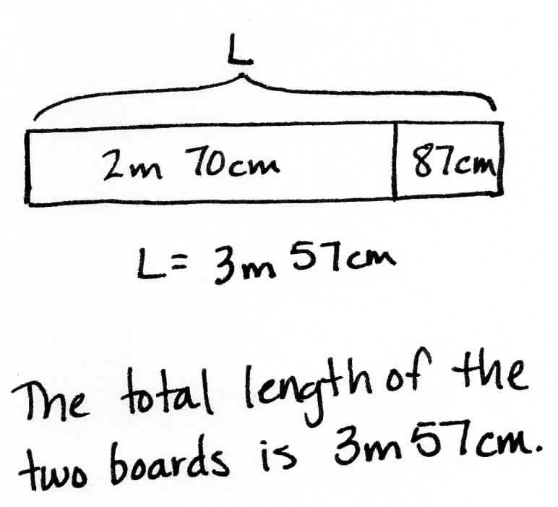
Note: This Application Problem anticipates the addition of a fraction and a mixed number using a measurement context. Solution A shows a solution whereby the students decomposed 87 centimeters to complete the unit of one meter and added on the remaining centimeters. Solution B shows a solution whereby the student added all of the centimeters and decomposed the sum.
Concept Development (33 minutes)

NOTES ON
MULTIPLE MEANS
OF ENGAGEMENT:
English language learners and others may benefit from explicit instruction and additional practice speaking mixed numbers in unit language. If time is a consideration, prepare students beforehand to increase confidence and participation.

Materials: (S) Personal white board
Problem 1: Use unit form and the number line to add a mixed number and a fraction having sums of fractional units less than or equal to 1.
T: Write $\text{2}\frac{\text{3}}{\text{8}}$ + $\frac{\text{3}}{\text{8}}$.
T: Say the expression using unit form.
S: 2 ones 3 eighths + 3 eighths.
T: What are the units involved in this problem?
S: Ones and eighths.
T: When we add numbers, we add like units. (Point to the mixed numbers and demonstrate.) How many ones are there in all?
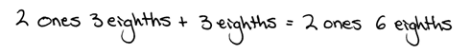

S: 2 ones.
T: How many eighths are there in all?
S: 6 eighths.
T: 2 ones + 6 eighths is…?
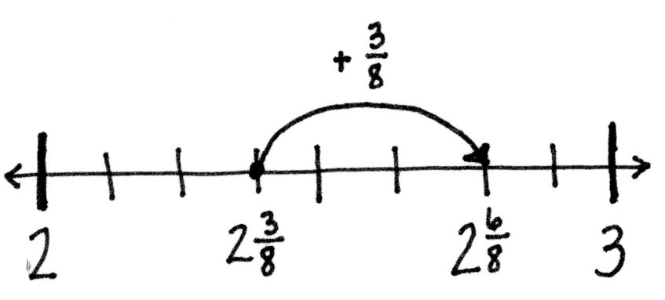
S: $\text{2}\frac{\text{6}}{\text{8}}\text{.}$
T: Show the addition using a number line. Start at $\text{2}\frac{\text{3}}{\text{8}}$, and then add $\frac{\text{3}}{\text{8}}$ more. Notice how the ones stay the same and the fractional units are simply added together since their sum is less than 1.
T: Write $\text{2}\frac{\text{3}}{\text{8}}\text{+}\frac{\text{5}}{\text{8}}\text{.}$ Add like units. How many ones? How many eighths?
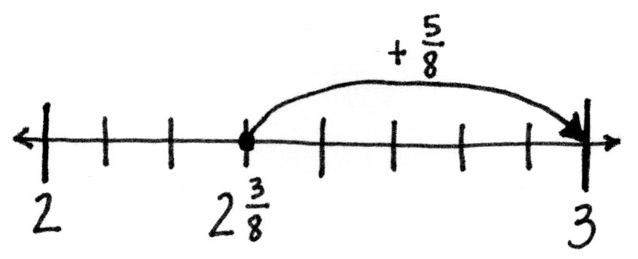
S: 2 ones and 8 eighths.
T: Show the addition using a number line. Start at $\text{2}\frac{\text{3}}{\text{8}}\text{.}$ Add $\frac{\text{5}}{\text{8}}$ more.
S: Hey! When I add $\frac{\text{5}}{\text{8}}$ more, it equals 3.
T: The fractional units have a sum of 1. $\frac{\text{3}}{\text{8}}\text{+}\frac{\text{5}}{\text{8}}\text{=}\frac{\text{8}}{\text{8}}\text{=} \text{1.}$
Problem 2: Complete a unit of one to add a mixed number and a fraction.
T: To add fractional units, sometimes we complete a unit of 1. We look for fractions that have a sum of 1.
If a fraction is equal to 1, what do we know about the numerator and denominator?
NOTES ON
MULTIPLE MEANS
OF REPRESENTATION:
To support English language learners and students working below grade level, couple the request of “How much more to make one?” with a tape diagram such as the following:

S: They are the same number.
T: (Write $\frac{\text{1}}{\text{4}}\text{.}$) How much more to make one?
S: $\frac{\text{3}}{\text{4}}$.
T: Explain.
S: To make a whole number with fourths, four parts are needed. 1 fourth + 3 fourths = 4 fourths.
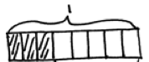
T: Write $\frac{\text{3}}{\text{8}}\text{. }$ What fraction can be added to make one
or a unit of 1?
S: $\frac{\text{5}}{\text{8}}\text{.}$
T: Explain.
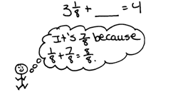
S: I think about 3 + ? = 8. The answer is 5. Since our units are eighths, the answer is 5 eighths.
T: Write $\text{3}\frac{\text{1}}{\text{8}}$. How many more eighths make one?
S: $\frac{\text{7}}{\text{8}}\text{.}$
T: How do you know?
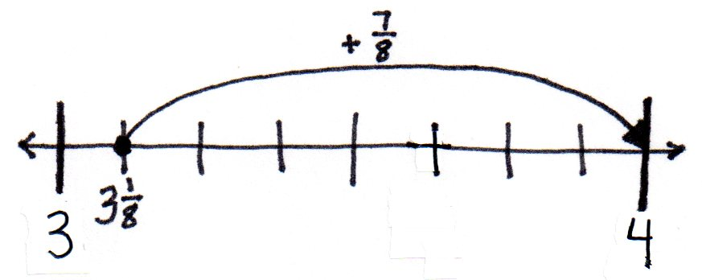
S: $\frac{\text{1}}{\text{8}}\text{+}\frac{\text{7}}{\text{8}}\text{=}\frac{\text{8}}{\text{8}}\text{. }$ 3 + $\frac{\text{8}}{\text{8}}\text{=} \text{4.}$
T: Show this on a number line. Start at $\text{3}\frac{\text{1}}{\text{8}}$ and then add $\frac{\text{7}}{\text{8}}$ more.
Let students practice with the following: $\text{4}\frac{\text{4}}{\text{5}}$ + ____ = 5 and $\text{ 6} \text{=} \text{5}\frac{\text{1}}{\text{8}}\text{+}$_____. Encourage them to solve mentally.
Problem 3: Decompose a sum of a mixed number and a fraction with sums of fractional units greater than 1.
T: (Write $\text{5}\frac{\text{2}}{\text{4}}\text{+}\frac{\text{3}}{\text{4}}$.) Right away, we see that the sum of the fourths is greater than 1.
T: The sum of the ones is…?
S: 5.
T: The sum of the fourths is…?
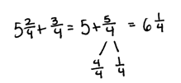
S: 5 fourths.
T: Decompose 5 fourths to make one. Use a number bond.
S: $\frac{\text{5}}{\text{4}}$ = $\frac{\text{4}}{\text{4}}$ + $\frac{\text{1}}{\text{4}}\text{.}$
T: (Write the following.)
$\text{5}\frac{\text{2}}{\text{4}}\text{+}\frac{\text{3}}{\text{4}}\text{ = 5} \text{+}\frac{\text{5}}{\text{4}}\text{ =} \text{5} \text{+}\frac{\text{4}}{\text{4}}\text{+}\frac{\text{1}}{\text{4}}\text{ = 6}\frac{\text{1}}{\text{4}}$.
T: Explain to your partner how we got a sum of $\text{6}\frac{\text{1}}{\text{4}}\text{.}$
S: We added like units. We added ones to ones and fourths to fourths. We changed 5 fourths to make 1 and 1 fourth and added 5 $\text{+ 1}\frac{\text{1}}{\text{4}}\text{.}$ The sum is $\text{6}\frac{\text{1}}{\text{4}}\text{.}$
Let students practice adding like units to find the sum using the following: $\text{7}\frac{\text{2}}{\text{5}}\text{+}\frac{\text{4}}{\text{5}}$ and $\text{3}\frac{\text{5}}{\text{12}}\text{+} \text{1}\frac{\text{11}}{\text{12}}\text{.}$
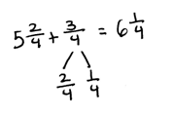
Problem 4: Decompose a fractional addend to make one before finding the sum.
T: (Write $\text{5}\frac{\text{2}}{\text{4}}\text{+}\frac{\text{3}}{\text{4}}$.) We can also decompose to make one in the same way that we did earlier in the lesson.
T: What fractional part added to $\text{5}\frac{\text{2}}{\text{4}}$ makes the next whole number?
S: $\frac{\text{2}}{\text{4}}\text{.}$
T: Decompose $\frac{\text{3}}{\text{4}}$ into parts so that $\frac{\text{2}}{\text{4}}$ is one of the parts.
S: $\frac{\text{3}}{\text{4}}\text{=}\frac{\text{2}}{\text{4}}\text{+}\frac{\text{1}}{\text{4}}\text{.}$
T: Write a number bond to show this. $\text{5}\frac{\text{2}}{\text{4}}\text{+}\frac{\text{2}}{\text{4}}\text{=} \text{6.}$ We add $\frac{\text{1}}{\text{4}}$ to 6 to get $\text{6}\frac{\text{1}}{\text{4}}\text{.}$
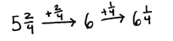
T: We can use the arrow way to show this clearly. Instead of drawing a number line, we can draw arrows to show the sum. $\text{5}\frac{\text{2}}{\text{4}}\text{+}\frac{\text{2}}{\text{4}} \text{=} \text{6 }$and 6 + $\frac{\text{1}}{\text{4}}$ = $\text{6}\frac{\text{1}}{\text{4}}\text{.}$ Notice how we added each part of the number bond to find the total.
Let students practice with the following: $\text{3}\frac{\text{7}}{\text{8}}$ + $\frac{\text{3}}{\text{8}}$ and $\text{9}\frac{\text{11}}{\text{12}}$ + $\frac{\text{5}}{\text{12}}\text{.}$
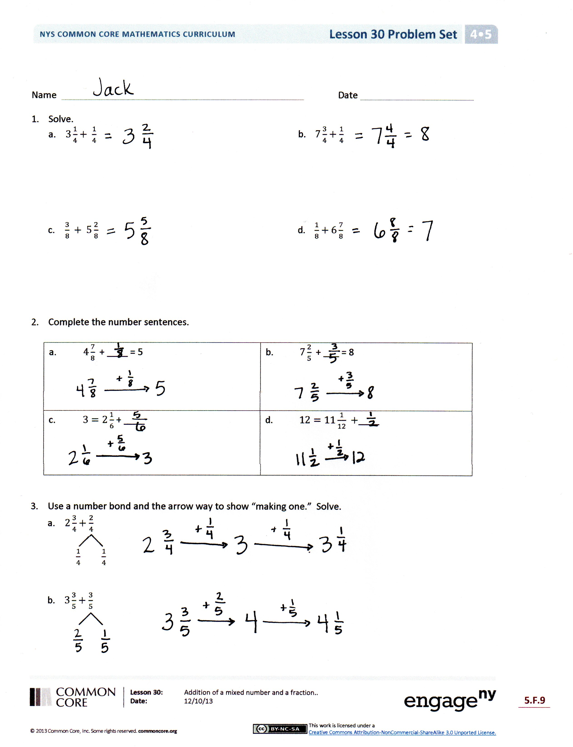
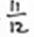
Problem Set (10 minutes)
Students should do their personal best to complete the Problem Set within the allotted 10 minutes. For some classes, it may be appropriate to modify the assignment by specifying which problems they work on first. Some problems do not specify a method for solving. Students should solve these problems using the RDW approach used for Application Problems.
Student Debrief (10 minutes)
Lesson Objective: Add a mixed number and a fraction.
The Student Debrief is intended to invite reflection and active processing of the total lesson experience.
Invite students to review their solutions for the Problem Set. They should check work by comparing answers with a partner before going over answers as a class. Look for misconceptions or misunderstandings that can be addressed in the Debrief. Guide students in a conversation to debrief the Problem Set and process the lesson.
Any combination of the questions below may be used to lead the discussion.
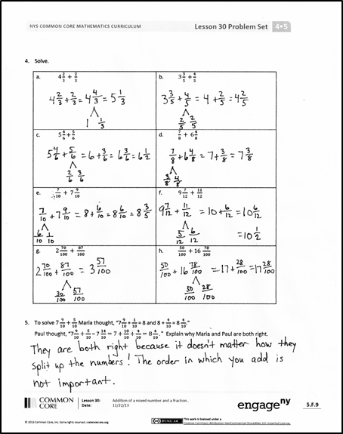
- Explain how decomposing mixed numbers helps you to find their sum.

- Explain how you solved Problem 1(d).
- Explain the challenge in solving Problem 4(d). What strategy did you use?
- If you were unsure of any answer on this Problem Set, what could you do to see if your answer is reasonable? Would drawing a picture or estimating the sum or difference be helpful?
- How does Problem 4(g) relate to the Application Problem?
Exit Ticket (3 minutes)
After the Student Debrief, instruct students to complete the Exit Ticket. A review of their work will help with assessing students’ understanding of the concepts that were presented in today’s lesson and planning more effectively for future lessons. The questions may be read aloud to the students.

Number Correct: _______
A
Change Fractions to Mixed Numbers
 | 3 = 2 + ___ |  |  |  | $\frac{ \text{6} }{\text{3}}\text{ =}$
 | $\frac{\text{ 3 }}{\text{2}} \text{=} \frac{\text{ 2 }}{\text{2}} \text{+} \frac{}{\text{2}}$ |  |  |  | $\frac{}{\text{3}} \text{=} \frac{ \text{6} }{\text{3}} \text{+} \frac{ \text{2} }{\text{3}}$
 | $\frac{\text{ 3 }}{\text{2}} \text{=} \text{1} \text{+} \frac{}{\text{2}}$ |  |  |  | $\frac{\text{ 8 }}{\text{3}} \text{=} \frac{ \text{6} }{\text{3}} \text{+} \frac{}{\text{3}}$
 | $\frac{\text{ 3 }}{\text{2}}\text{ = 1}\frac{}{\text{2}}$ |  |  |  | $\frac{\text{ 8 }}{\text{3}} \text{=} \text{2 +} \frac{}{\text{3}}$
 | 5 = 4 + ___ |  |  |  | $\frac{\text{ 8 }}{\text{3}}\text{ = 2}\frac{}{\text{3}}$
 | $\frac{\text{ 5 }}{\text{4}} \text{=} \frac{\text{ 4 }}{\text{4}} \text{+} \frac{}{\text{4}}$ |  |  |  | $\frac{}{\text{4}} \text{=} \frac{ \text{8} }{\text{4}} \text{+} \frac{ \text{1} }{\text{4}}$
 | $\frac{\text{ 5 }}{\text{4}} \text{=} \text{1} \text{+} \frac{}{\text{4}}$ |  |  |  | $\frac{}{\text{4}} \text{=} \text{2 +} \frac{\text{ 1 }}{\text{4}}$
 | $\frac{\text{ 5 }}{\text{4}}\text{ = 1}\frac{}{\text{4}}$ |  |  |  | $\frac{\text{ 9 }}{\text{4}}\text{ = ___}\frac{\text{ 1 }}{\text{4}}$
 | 4 = ___ + 1 |  |  |  | $\frac{\text{11}}{\text{4}}\text{ = ___}\frac{\text{ 3 }}{\text{4}}$
 | $\frac{\text{ 4 }}{\text{3}} \text{=} \frac{}{\text{3}} \text{+} \frac{\text{ 1 }}{\text{3}}$ |  |  |  | $\frac{\text{ 8 }}{\text{3}} \text{=} \frac{}{\text{3}} \text{+} \frac{\text{ 2 }}{\text{3}}$
 | $\frac{\text{ 4 }}{\text{3}} \text{=} \text{1} \text{+} \frac{}{\text{3}}$ |  |  |  | $\frac{\text{ 8 }}{\text{3}} \text{=} \frac{ \text{6} }{\text{3}} \text{+} \frac{}{\text{3}}$
 | $\frac{\text{ 4 }}{\text{3}}\text{ = ___}\frac{\text{ 1 }}{\text{3}}$ |  |  |  | $\frac{\text{ 8 }}{\text{3}}\text{ = ___} \text{+} \frac{\text{ 2 }}{\text{3}}$
 | 7 = ___ + 2 |  |  |  | $\frac{\text{ 8 }}{\text{3}}\text{ = ___}\frac{\text{ 2 }}{\text{3}}$
 | $\frac{\text{ 7 }}{\text{5}} \text{=} \frac{}{\text{5}} \text{+} \frac{\text{ 2 }}{\text{5}}$ |  |  |  | $\frac{\text{14}}{\text{5}} \text{=} \frac{\text{10}}{\text{5}} \text{+} \frac{}{\text{5}}$
 | $\frac{\text{ 7 }}{\text{5}} \text{=} \text{1} \text{+} \frac{}{\text{5}}$ |  |  |  | $\frac{\text{14}}{\text{5}}\text{ = ___} \text{+} \frac{\text{ 4 }}{\text{5}}$
 | $\frac{\text{ 7 }}{\text{5}}\text{ = 1}\frac{}{\text{5}}$ |  |  |  | $\frac{\text{14}}{\text{5}}\text{ = 2}\frac{}{\text{5}}$
 | $\frac{\text{ 8 }}{\text{5}}\text{ = 1}\frac{}{\text{5}}$ |  |  |  | $\frac{\text{13}}{\text{5}}\text{ = 2}\frac{}{\text{5}}$
 | $\frac{\text{ 9 }}{\text{5}}\text{ = 1}\frac{}{\text{5}}$ |  |  |  | $\frac{\text{ 9 }}{\text{8}} \text{=} \text{1} \text{+} \frac{}{\text{8}}$
 | $\frac{\text{ 6 }}{\text{5}}\text{ = 1}\frac{}{\text{5}}$ |  |  |  | $\frac{\text{15}}{\text{8}} \text{=} \text{1} \text{+} \frac{}{\text{8}}$
 | $\frac{\text{10}}{\text{5}}\text{ =}$ |  |  |  | $\frac{\text{17}}{\text{12}} \text{=} \frac{}{\text{12}} \text{+} \frac{\text{ 5 }}{\text{12}}$
 | $\frac{}{\text{5}} \text{=} \frac{\text{10}}{\text{5}} \text{+} \frac{\text{ 1 }}{\text{5}}$ |  |  |  | $\frac{\text{11}}{\text{8}} \text{=} \text{1} \text{+} \frac{}{\text{8}}$
 | $\frac{}{\text{5}} \text{=} \text{2 +} \frac{\text{ 1 }}{\text{5}}$ |  |  |  | $\frac{\text{17}}{\text{12}} \text{=} \text{1} \text{+} \frac{}{\text{12}}$
B
[KEY]

Number Correct: _______
Improvement: _______
Change Fractions to Mixed Numbers
 | 6 = 5 + ___ |  |  |  | $\frac{ \text{4} }{\text{2}}\text{ =}$
 | $\frac{\text{ 6 }}{\text{5}} \text{=} \frac{\text{ 5 }}{\text{5}} \text{+} \frac{}{\text{5}}$ |  |  |  | $\frac{}{\text{2}} \text{=} \frac{ \text{4} }{\text{2}} \text{+} \frac{ \text{1} }{\text{2}}$
 | $\frac{\text{ 6 }}{\text{5}} \text{=} \text{1} \text{+} \frac{}{\text{5}}$ |  |  |  | $\frac{\text{ 5 }}{\text{2}} \text{=} \frac{ \text{4} }{\text{2}} \text{+} \frac{}{\text{2}}$
 | $\frac{\text{ 6 }}{\text{5}}\text{ = 1}\frac{}{\text{5}}$ |  |  |  | $\frac{\text{ 5 }}{\text{2}} \text{=} \text{2 +} \frac{}{\text{2}}$
 | 4 = 3 + ___ |  |  |  | $\frac{\text{ 5 }}{\text{2}}\text{ = 2}\frac{}{\text{2}}$
 | $\frac{\text{ 4 }}{\text{3}} \text{=} \frac{\text{ 3 }}{\text{3}} \text{+} \frac{}{\text{3}}$ |  |  |  | $\frac{}{\text{5}} \text{=} \frac{\text{10}}{\text{5}} \text{+} \frac{ \text{1} }{\text{5}}$
 | $\frac{\text{ 4 }}{\text{3}} \text{=} \text{1} \text{+} \frac{}{\text{3}}$ |  |  |  | $\frac{}{\text{5}} \text{=} \text{2 +} \frac{ \text{1} }{\text{5}}$
 | $\frac{\text{ 4 }}{\text{3}}\text{ = 1}\frac{}{\text{3}}$ |  |  |  | $\frac{\text{11}}{\text{5}}\text{ = ___}\frac{ \text{1} }{\text{5}}$
 | 5 = ___ + 1 |  |  |  | $\frac{\text{13}}{\text{5}}\text{ = ___}\frac{ \text{3} }{\text{5}}$
 | $\frac{\text{ 5 }}{\text{4}} \text{=} \frac{}{\text{4}} \text{+} \frac{\text{ 1 }}{\text{4}}$ |  |  |  | $\frac{\text{ 5 }}{\text{3}} \text{=} \frac{}{\text{3}} \text{+} \frac{\text{ 1 }}{\text{3}}$
 | $\frac{\text{ 5 }}{\text{4}} \text{=} \text{1} \text{+} \frac{}{\text{4}}$ |  |  |  | $\frac{\text{ 5 }}{\text{2}} \text{=} \frac{ \text{4} }{\text{2}} \text{+} \frac{}{\text{2}}$
 | $\frac{\text{ 5 }}{\text{4}}\text{ = ___}\frac{\text{ 1 }}{\text{4}}$ |  |  |  | $\frac{\text{ 5 }}{\text{2}}\text{ = ___} \text{+} \frac{\text{ 1 }}{\text{2}}$
 | 8 = ___ + 3 |  |  |  | $\frac{\text{ 5 }}{\text{2}}\text{ = ___}\frac{\text{ 1 }}{\text{2}}$
 | $\frac{\text{ 8 }}{\text{5}} \text{=} \frac{}{\text{5}} \text{+} \frac{\text{ 3 }}{\text{5}}$ |  |  |  | $\frac{\text{12}}{\text{5}} \text{=} \frac{\text{10}}{\text{5}} \text{+} \frac{}{\text{5}}$
 | $\frac{\text{ 8 }}{\text{5}} \text{=} \text{1} \text{+} \frac{}{\text{5}}$ |  |  |  | $\frac{\text{12}}{\text{5}}\text{ = ___} \text{+} \frac{\text{ 2 }}{\text{5}}$
 | $\frac{\text{ 8 }}{\text{5}}\text{ = 1}\frac{}{\text{5}}$ |  |  |  | $\frac{\text{12}}{\text{5}}\text{ = 2}\frac{}{\text{5}}$
 | $\frac{\text{ 9 }}{\text{5}}\text{ = 1}\frac{}{\text{5}}$ |  |  |  | $\frac{\text{14}}{\text{5}}\text{ = 2}\frac{}{\text{5}}$
 | $\frac{\text{ 6 }}{\text{5}}\text{ = 1}\frac{}{\text{5}}$ |  |  |  | $\frac{\text{ 9 }}{\text{8}} \text{=} \text{1} \text{+} \frac{}{\text{8}}$
 | $\frac{\text{ 7 }}{\text{5}}\text{ = 1}\frac{}{\text{5}}$ |  |  |  | $\frac{\text{11}}{\text{8}} \text{=} \text{1} \text{+} \frac{}{\text{8}}$
 | $\frac{ \text{6} }{\text{3}}\text{ =}$ |  |  |  | $\frac{\text{19}}{\text{12}} \text{=} \frac{}{\text{12}} \text{+} \frac{\text{ 7 }}{\text{12}}$
 | $\frac{}{\text{3}} \text{=} \frac{ \text{6 }}{\text{3}} \text{+} \frac{\text{ 1 }}{\text{3}}$ |  |  |  | $\frac{\text{15}}{\text{8}} \text{=} \text{1} \text{+} \frac{}{\text{8}}$
 | $\frac{}{\text{3}} \text{=} \text{2 +} \frac{\text{ 1 }}{\text{3}}$ |  |  |  | $\frac{\text{19}}{\text{12}} \text{=} \text{1} \text{+} \frac{}{\text{12}}$

Name Date
- Solve.

- $\text{3}\frac{\text{1}}{\text{4}} \text{+ }\frac{\text{1}}{\text{4}}$
- $\text{7}\frac{\text{3}}{\text{4}} \text{+} \frac{\text{1}}{\text{4}}$

- $\frac{\text{3}}{\text{8}}\text{ + 5}\frac{\text{2}}{\text{8}}$
- $\frac{\text{1}}{\text{8}} \text{+} \text{6}\frac{\text{7}}{\text{8}}$

- $\text{4}\frac{\text{7}}{\text{8}}$+ ____ = 5 | - $\text{7}\frac{\text{2}}{\text{5}}$+ ___ = 8
- $\text{3} \text{=} \text{2}\frac{\text{1}}{\text{6}}$ + ____ | - $\text{12} \text{=} \text{11}\frac{\text{1}}{\text{12}}\text{ +}$____
- Complete the number sentences.

- Use a number bond and the arrow way to show how to make one. Solve.
- $\text{2}\frac{\text{3}}{\text{4}} \text{+} \frac{\text{2}}{\text{4}}$

$\frac{\text{1}}{\text{4}}$ $\frac{\text{1}}{\text{4}}$

- $\text{3}\frac{\text{3}}{\text{5}} \text{+} \frac{\text{3}}{\text{5}}$

- Solve.
- $\text{4}\frac{\text{2}}{\text{3}}\text{ + }\frac{\text{2}}{\text{3}}$ | - $\text{3}\frac{\text{3}}{\text{5}}\text{ +}\frac{\text{4}}{\text{5}}$
- $\text{ 5}\frac{\text{4}}{\text{6}} \text{+} \frac{\text{5}}{\text{6}}$ | - $\frac{\text{7}}{\text{8}}\text{ + 6}\frac{\text{4}}{\text{8}}$
- $\frac{\text{7}}{\text{10}}\text{ + 7}\frac{\text{9}}{\text{10}}$ | - $\text{9}\frac{\text{7}}{\text{12}}\text{ + }\frac{\text{11}}{\text{12}}$
- $\text{2}\frac{\text{70}}{\text{100}}\text{ + }\frac{\text{87}}{\text{100}}$ | - $\frac{\text{50}}{\text{100}}\text{ +} \text{16 }\frac{\text{78}}{\text{100}}$
- To solve $\text{7}\frac{\text{9}}{\text{10}}\text{+}\frac{\text{5}}{\text{10}}$, Maria thought, “7 $\frac{\text{9}}{\text{10}}$ + $\frac{\text{1}}{\text{10}}$ = 8 and 8 + $\frac{\text{4}}{\text{10}}$ = 8 $\frac{\text{4}}{\text{10}}$.”
Paul thought, “7 $\frac{\text{9}}{\text{10}}\text{+}\frac{\text{5}}{\text{10}}$ = 7 $\frac{\text{14}}{\text{10}}\text{=} \text{7} \text{+} \frac{\text{10}}{\text{10}} \text{+} \frac{\text{4}}{\text{10}} \text{=} \text{8}\frac{\text{4}}{\text{10}}\text{."}$ Explain why Maria and Paul are both right.

Name Date
Solve.
- $\text{3}\frac{\text{2}}{\text{5}}\text{ + _____= 4 }$

- $\text{2}\frac{\text{3}}{\text{8}}\text{ + }\frac{\text{7}}{\text{8}}$

Name Date
- Solve.

- $\text{4}\frac{\text{1}}{\text{3}} \text{+ }\frac{\text{1}}{\text{3}}$
- $\text{5}\frac{\text{1}}{\text{4}} \text{+} \frac{\text{2}}{\text{4}}$

- $\frac{\text{2}}{\text{6}}\text{ + 3}\frac{\text{4}}{\text{6}}$
- $\frac{\text{5}}{\text{8}}\text{ +} \text{7}\frac{\text{3}}{\text{8}}$

- Complete the number sentences.
- $\text{3}\frac{\text{5}}{\text{6}}$+ ____ = 4 | - $\text{5}\frac{\text{3}}{\text{7}}$+ ___ = 6
- $\text{5} \text{=} \text{4}\frac{\text{1}}{\text{8}}$ + ____ | - $\text{15} \text{=} \text{14}\frac{\text{4}}{\text{12}}\text{ +}$____

- Draw a number bond and the arrow way to show how to make one. Solve.
- $\text{2}\frac{\text{4}}{\text{5}} \text{+} \frac{\text{2}}{\text{5}}$ b. $\text{3}\frac{\text{2}}{\text{3}} \text{+} \frac{\text{2}}{\text{3}}$ c. $\text{4}\frac{\text{4}}{\text{6}} \text{+} \frac{\text{5}}{\text{6}}$

$\frac{1}{5}$ $\frac{1}{5}$

- Solve.
- $\text{2}\frac{\text{3}}{\text{5}}\text{ + }\frac{\text{3}}{\text{5}}$ | - $\text{3}\frac{\text{6}}{\text{8}}\text{ +} \frac{\text{4}}{\text{8}}$
- $\text{ 5}\frac{\text{4}}{\text{6}} \text{+} \frac{\text{3}}{\text{6}}$ | - $\frac{\text{7}}{\text{10}}\text{+ 6}\frac{\text{6}}{\text{10}}$
- $\frac{\text{5}}{\text{10}} \text{+ 8}\frac{\text{9}}{\text{10}}$ | - $\text{7}\frac{\text{8}}{\text{12}}\text{ + }\frac{\text{11}}{\text{12}}$
- $\text{3}\frac{\text{90}}{\text{100}}\text{ + }\frac{\text{58}}{\text{100}}$ | - $\frac{\text{60}}{\text{100}}\text{ +} \text{14}\frac{\text{79}}{\text{100}}$
- To solve $\text{4}\frac{\text{8}}{\text{10}}\text{+}\frac{\text{3}}{\text{10}}$ , Carmen thought, “$\text{4}\frac{\text{8}}{\text{10}}$ + $\frac{\text{2}}{\text{10}}$ = 5, and 5 + $\frac{\text{1}}{\text{10}}$ = 5 $\frac{\text{1}}{\text{10}}.$”
Benny thought, “$\text{4}\frac{\text{8}}{\text{10}}$ + $\frac{\text{3}}{\text{10}}$ = $\text{4}\frac{\text{11}}{\text{10}}\text{=} \text{4} \text{+} \frac{\text{10}}{\text{10}} \text{+} \frac{\text{1}}{\text{10}} \text{=} \text{5}\frac{\text{1}}{\text{10}}\text{."}$ Explain why Carmen and Benny are both right.

