Lesson 14
Objective: Explore conservation of volume by pouring.

Suggested Lesson Structure
 Fluency Practice (11 minutes)
 Application Problem (5 minutes)
 Concept Development (28 minutes)
 Student Debrief (6 minutes)
Total Time (50 minutes)
Fluency Practice (11 minutes)
- Say Ten Push-Ups K.NBT.1 (3 minutes)
- Hidden Numbers (10 as the Whole) K.OA.3 (5 minutes)
- Double 5-Groups K.CC.2 (3 minutes)
Say Ten Push-Ups (3 minutes)
Conduct activity as outlined in Lesson 1. Continue to 20 (2 ten, or 10 and 10).
Hidden Numbers (10 as the Whole) (5 minutes)
Materials: (S) Hidden numbers (Lesson 3 Fluency Template)
Conduct activity as described in Lesson 3, except students will not need to cross out any of the fish. Guide them to find twos, threes, fours, and fives within the larger group of 10.
Double 5-Groups (3 minutes)
Conduct activity as described in Lesson 10, but now continue to 20 (2 ten, or 10 and 10).
Application Problem (5 minutes)
Materials: (S) Small ball of clay
With your clay, make a bowl big enough to hold a yummy strawberry. Now, make a little vase just the right size for a tiny flower. Which one do you think would have more capacity?
Compare your containers to those of your friend’s. Do they look alike? Do you think hers would have more capacity?
Note: This Application Problem leads students to think about the effect of the shape of a container on its volume or the appearance thereof, serving as an anticipatory set for today’s lesson. Circulate during the exercise to encourage correct use of vocabulary.
Concept Development (28 minutes)
Materials: (T) Set of student materials for demonstration (S) 2 cups of rice, clear containers (if possible) with varying diameters (e.g., a glass, small bowl, small vase with an interesting shape, bottle, mug), tray, funnel, spoon, volume recording sheet (Template)
Note: Save a set of student materials for the culminating task in Lesson 32.
T: In the last lesson, we talked about the capacities of our containers. I wonder what the capacity of this bowl is. How could I find out?
MP.7
S: You could fill it with rice.
T: Tell me when to stop! (Use spoon to fill bowl.) There. Let me draw how the rice looks in this bowl on my recording sheet. (Demonstrate.)
T: Look at this bottle. I wonder if the capacity of the bottle is more or less than the capacity of the bowl. How could we find out?
NOTES ON
MULTIPLE MEANS
OF ACTION AND EXPRESSION:
Encourage students working above grade level to explain their reasoning about capacity. Ask them to explain why they think one container holds more or less rice than another. Have them explain what happens to the rice as it moves from one container to the next. Ask them to write down their reasoning and share it with a friend.
S: Pour the rice into the bottle!
T: Good idea! I will use this funnel so I don’t lose any. (Pour rice into bottle.) What do you notice?
S: The bottle isn’t full! The rice only goes partway up the side!
T: Hmmm. I didn’t spill any. What do you think happened?
S: The bottle is taller, so the rice doesn’t look as big. It must hold more.
T: Yes. The capacity of the bottle is more than the capacity of the bowl. Let me draw how the rice looks in the bottle. (Draw.) What will happen if I pour the rice back into the bowl?
S: It will be full again!
T: Let’s test your guess. (Pour rice back into bowl.) You were right! I’m going to let you experiment with your containers now. Fill your small bowl with the rice, and then notice how that same amount of rice looks in the other containers. On your recording sheet, draw what you see. Pour the rice carefully so that you don’t lose any between containers. If you do, scoop it up from your tray and put it in to make sure that your tests are fair! (Allow ample time for experimentation and discussion.)
T: Who would like to share something they learned during the experiment?
S: The rice looked really tall in this one! This one looks like it could hold a lot more. It almost looked empty!
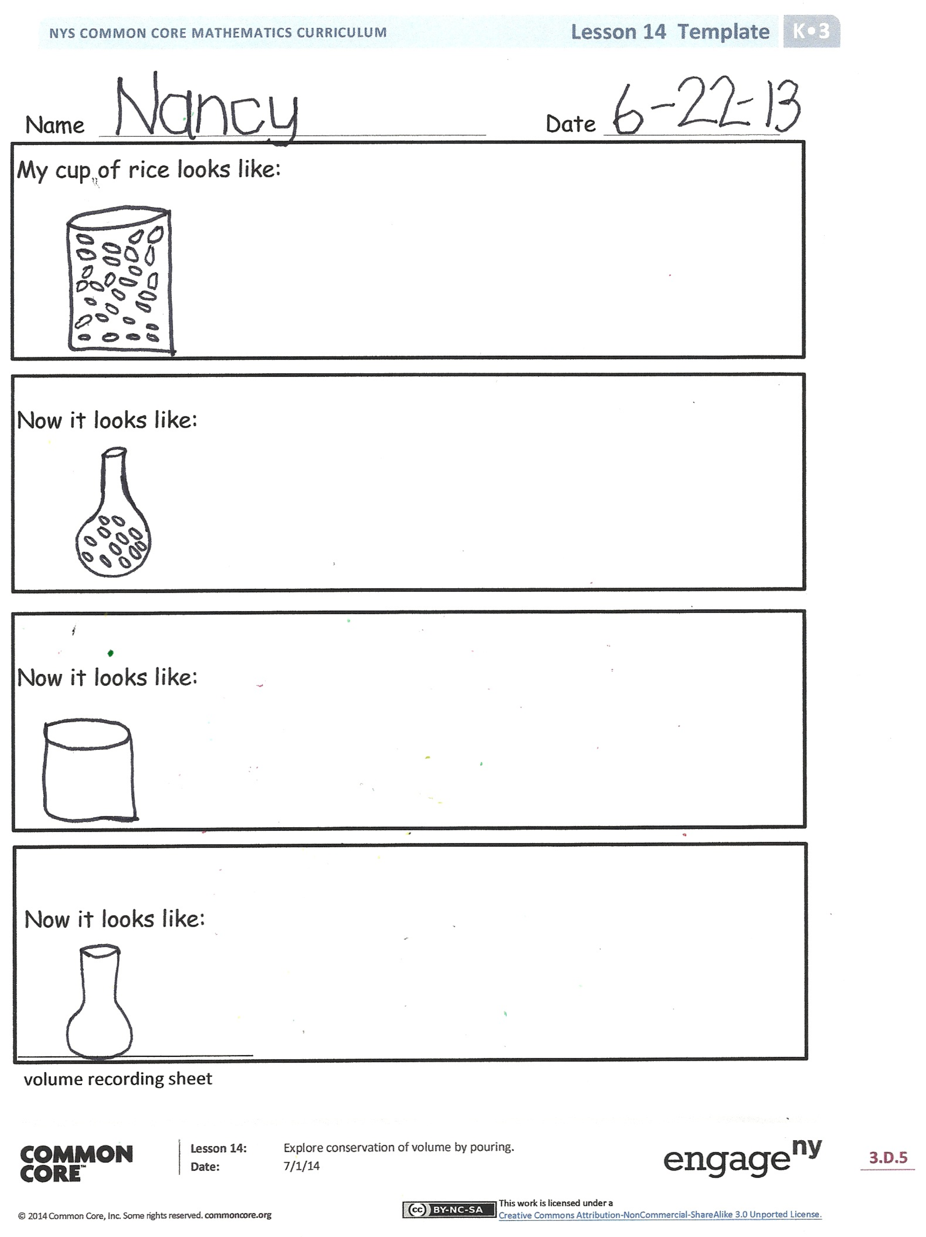
Problem Set (10 minutes)
In this lesson, the volume recording sheet will serve as the Problem Set for the Concept Development.
Student Debrief (6 minutes)
Lesson Objective: Explore conservation of volume by pouring.
The Student Debrief is intended to invite reflection and active processing of the total lesson experience.
Invite students to review their recording sheets. They should check work by comparing answers with a partner before going over answers as a class. Look for misconceptions or misunderstandings that can be addressed in the Student Debrief. Guide students in a conversation to process the lesson.
You may choose to use any combination of the questions below to lead the discussion.
- Look at your Recording Sheet. In which container did it look like you had the most rice?
- In which container did it look like you had the least rice?
- Did the amount of the rice ever change?
- Were the shapes of the containers the same? Describe them to your partner.
- Does the shape of the container make the amount of the rice seem different? Why?
- What math vocabulary did we use today to communicate precisely?
Name Date
Within each rectangle, make one set of 6 objects. The first one has been done for you.
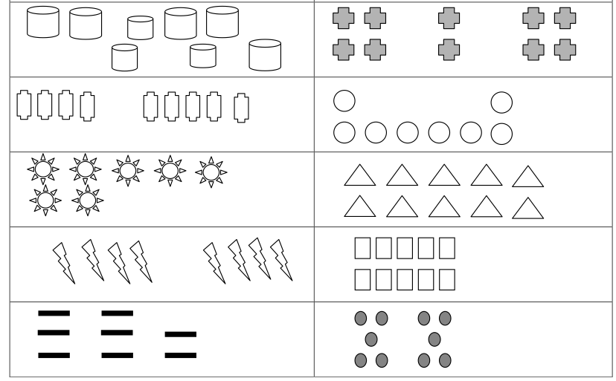

Name Date
My cup of rice looks like:

Now it looks like:

Now it looks like:

Now it looks like:

volume recording sheet

