Lesson 13
Objective: Compare volume using more than, less than, and the same as by pouring.

Suggested Lesson Structure
 Fluency Practice (10 minutes)
 Application Problem (5 minutes)
 Concept Development (29 minutes)
 Student Debrief (6 minutes)
NOTES ON
MULTIPLE MEANS
OF REPRESENTATION:
The dot cards can be adjusted to facilitate the recognition of hidden numbers. Use dots in more than one color or include some dots with only an outline. This can be used as a modification for students with visual discrimination difficulties, especially during partner sharing time.
Total Time (50 minutes)
Fluency Practice (10 minutes)
- Dot Cards of 6 K.CC.2 (3 minutes)
- Building 1 More and 1 Less Towers K.CC.4c (4 minutes)
- Roll and Say 1 More, 1 Less K.CC.4c (3 minutes)
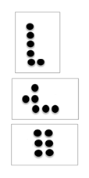
Dot Cards of 6 (3 minutes)
Materials: (T/S) Dot cards of 6 (Fluency Template)
Note: This activity deepens students’ knowledge of embedded numbers and develops part–whole thinking, foundational to the work of the upcoming modules.
T: (Show card.) How many do you see?
S: 6.
T: How did you see them in two parts?
S: (Possible answers are: 5 up and 1 down, 2 down and 4 up, 3 up and 3 down.)
Continue with other cards of 6. Distribute the cards to the students for partner sharing time. Have them pass the card at a signal.
Building 1 More and 1 Less Towers (4 minutes)
Materials: (S) 10 linking cubes
Note: In this activity, students connect increasing length and height to increasing numerical value.
Guide students through the process of building a tower while stating the pattern as 1 more. Maintain consistency in the language: 1. 1 more is 2. 2. 1 more is 3. 3. 1 more is 4. (Continue to 10.)
Disassemble the tower while stating the pattern as 1 less. Again, the language is crucial to students’ conceptual understanding: 10. 1 less is 9. 9. 1 less is 8. 8. 1 less is 7. (Continue to 0.)
Consider having students build the towers vertically as towers but also horizontally as a train of cubes.
Roll and Say 1 More, 1 Less (3 minutes)
Materials: (S) Pair of dice with the 6 dot side covered with a sticker
Note: This exercise prepares students for today’s lesson by moving flexibly between the terms more and less.
Roll the dice and count the dots. Make 1 more and 1 less statements using consistent language. For example, if the student rolls a 4, they would say: 4. 1 more is 5. 4. 1 less is 3.
Application Problem (5 minutes)
NOTES ON
MULTIPLE MEANS
OF REPRESENTATION:
Scaffold the Application Problem for English language learners by emphasizing the critical concept of just enough. Show visuals of what, for a little kitten, would be too much milk (a gallon container), too little (a couple of drops), and just right (a picture of a cat drinking milk out of a regular size container).
Materials: (S) Small ball of clay
With your clay, create a cup that could hold just enough milk for a little kitten to drink. Show your cup to your friend. Do you think your cups would hold the same amount?
Note: Thinking about holding enough will serve as an anticipatory set for the discussion in today’s lesson.
Concept Development (29 minutes)
Materials: (T/S) 2 cups of uncooked rice, several small containers (two with equal capacity: coffee or beverage scoop, ¼ cup measure, teacup, bowl, small drinking cup, small box, tablespoon) and tray per pair or small group; capacity recording sheet (Template)
T: What do you notice on your tray?
S: We have lots of cups. We have a box. We have a spoon. There is a bowl of rice.
T: Watch as I fill my cup with the rice. Tell me when it is full. (Place a medium-sized cup on the tray to prevent any spills. Use the tablespoon to fill it with rice.)
T: How could you tell my cup was full?
S: It was all the way to the top! No more would fit without spilling.
T: It held a lot of rice. One math word for how much something holds is capacity. (Hold up a smaller container.) I wonder if the capacity of this container is more than or less than the capacity of my cup? Do you think it will hold more or less?
MP.2
S: Less!
T: Repeat after me. “I think the capacity of this container is less than the capacity of the cup.”
S: (Repeat.)

A NOTE ON
MULTIPLE MEANS
OF ENGAGEMENT:
Scaffold the lesson for students who struggle by giving them extra practice with capacity using interactive technology such as the game found at
http://www.abc.net.au/countusin
/games/game15.htm.

T: Let’s test your guess. (Pour rice into the smaller cup until it begins to overflow.) What happened?
S: There was too much in the little cup! It spilled! There wasn’t enough room.
T: It was too small. The capacity of the little cup is less than the capacity of the first cup. (Hold up a larger bowl.) Do you think the capacity of this container is more or less than the capacity of my little cup?
MP.2
S: More! It has more capacity.
T: Let’s test your guess. (Pour rice from the small cup into the larger bowl.) What happened?
S: There is a lot of room left. We could put more in.
T: The capacity of the bowl is more than the capacity of the little cup! I’m going to let you test your containers now. Test their capacities by carefully spooning or pouring the rice from one to another. See if you can find the container on your tray that has the biggest capacity and the container with the smallest capacity. Draw them on your recording sheet. (Show students relevant sections on the sheet.) If you spill, just scoop the rice off your tray and put it back. (Allow ample time for experimentation.)
T: Hold up the container on your tray that has the biggest capacity. (Observe whether or not the students exhibit understanding.) How did you know? (Discuss reasonable answers.) Hold up the container with the smallest capacity. How could you tell? (Check for understanding; discuss reasonable answers.)
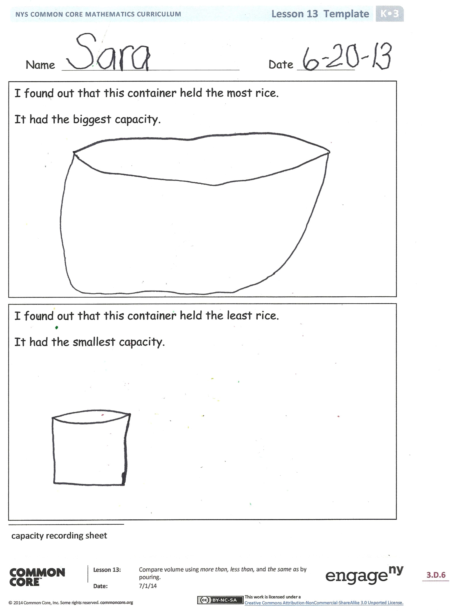
Problem Set (10 minutes)
In this lesson, the capacity recording sheet for the activity will serve as the primary Problem Set for the Concept Development. There is an optional Problem Set, which can be used to ignite discussion by having students consider the capacities of pairs of objects and then wonder if the containers such as the teapot are necessarily completely filled.

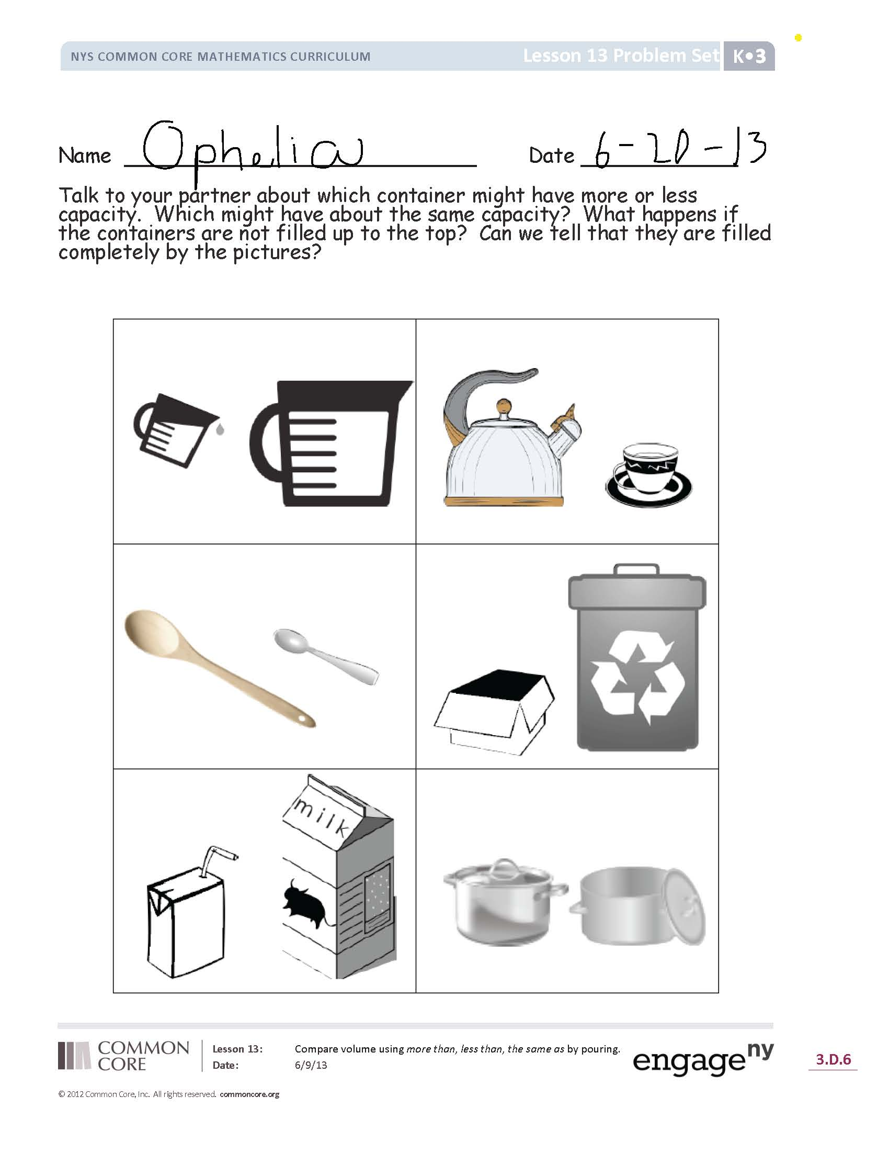
Student Debrief (6 minutes)
Lesson Objective: Compare volume using more than, less than, and the same as by pouring.
The Student Debrief is intended to invite reflection and active processing of the total lesson experience.
Invite students to review their solutions for the Recording Sheet. They should check work by comparing answers with a partner before going over answers as a class. Look for misconceptions or misunderstandings that can be addressed in the Student Debrief. Guide students in a conversation to debrief the Recording Sheet and process the lesson.
You may choose to use any combination of the questions below to lead the discussion.
- How were we comparing today? Were we comparing length, weight, or the number of objects?
- What does the word capacity mean to you?
- Which of your containers had the biggest capacity?
- Which had the smallest capacity?
- Did the shape of the container make a difference in how much it could hold?
- Were you surprised by anything you learned during this activity?

Name Date
Talk to your partner about which container might have more or less capacity. Which might have about the same capacity? What happens if the containers are not filled up to the top? Can we tell that they are filled completely from looking at the pictures?
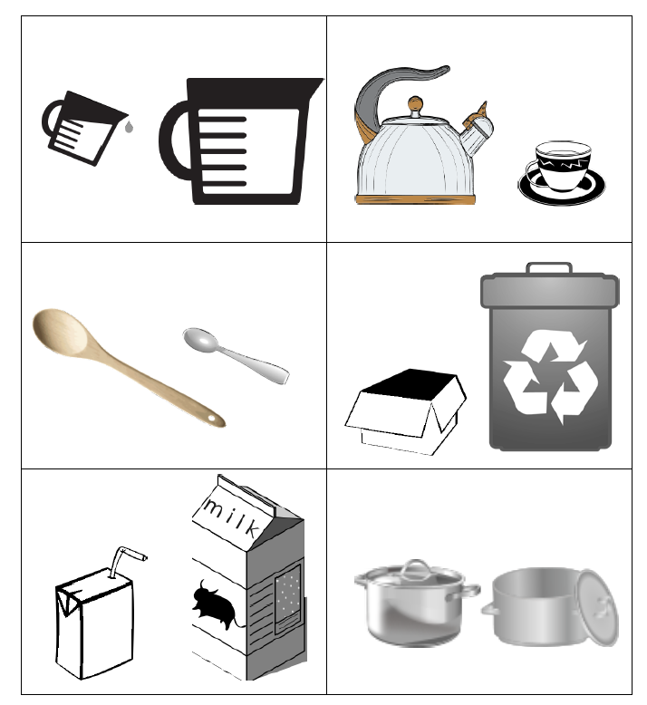

Name Date
In class, we have been working on capacity. Encourage your child to explore with different-sized containers to see which ones have the biggest and smallest capacity. Children can experiment by pouring liquid from one container to another.
All the homework you will see for the next few days will be a review of skills taught from Module 1.
Each rectangle shows 6 objects. Circle 2 different sets within each. The two sets represent the two parts that make up the 6 objects. The first one has been done for you.
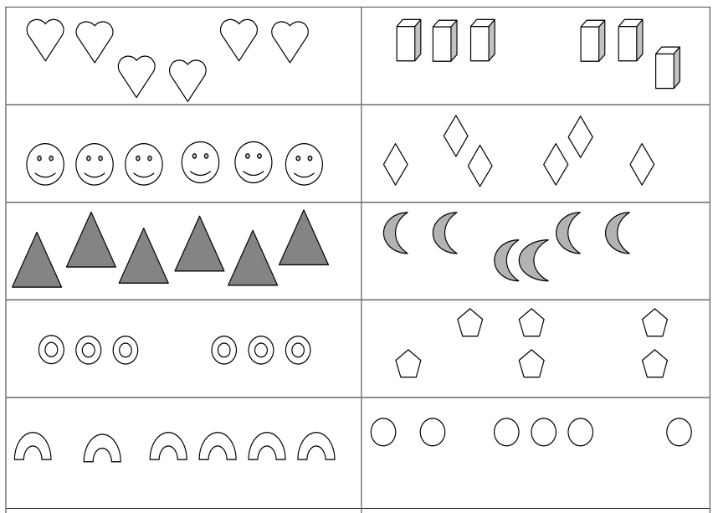

Name Date
I found out that this container held the most rice.
It had the biggest capacity.

I found out that this container held the least rice.
It had the smallest capacity.

capacity recording sheet
dot cards of 6
dot cards of 6
dot cards of 6
dot cards of 6
dot cards of 6
dot cards of 6
dot cards of 6
dot cards of 6
dot cards of 6

