Lesson 28
Objective: Solve word problems with line plots.

Suggested Lesson Structure
 Fluency Practice (12 minutes)
 Concept Development (38 minutes)
 Student Debrief (10 minutes)
Total Time (60 minutes)
Fluency Practice (12 minutes)

NOTES ON
MULTIPLE MEANS
OF REPRESENTATION:
The Change Mixed Numbers to Fractions fluency activity may be a good opportunity for English language learners to practice speaking mixed numbers, particularly if you notice they omit and as they say the whole number and the fraction.

- Change Mixed Numbers to Fractions 4.NF.4 (6 minutes)
- Compare Fractions 4.NF.2 (6 minutes)
Change Mixed Numbers to Fractions (6 minutes)
Materials: (S) Personal white board
Note: This fluency activity reviews Lesson 25.
T: (Write $\text{1}\frac{3}{4}$.) Say the mixed number.
S: 1 and 3 fourths.
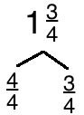
T: (Draw a number bond for $\text{1}\frac{\text{3}}{\text{4}}$. Write $\frac{\text{3}}{\text{4}}$ as a part.) Complete the bond.
S: (Write $\frac{\text{4}}{\text{4}}$ as the unknown part.)
T: (Write $\text{1}\frac{\text{3}}{\text{4}}$ = $\frac{}{\text{4}}$.) Complete the number sentence.
S: (Write $\text{1}\frac{\text{3}}{\text{4}}$ = $\frac{\text{7}}{\text{4}}$.)
Continue the process for the following possible sequence: $\text{1}\frac{\text{4}}{\text{5}}$, $\text{2}\frac{\text{1}}{\text{4}}$, and $\text{4}\frac{\text{5}}{\text{6}}$.
Compare Fractions (6 minutes)
Materials: (S) Personal white board
Note: This fluency activity reviews Lessons 26 and 27.

T: (Project number line with endpoints 1 and 2 and $\text{1}\frac{\text{1}}{\text{2}}$ as the midpoint.) Copy the number line.
S: (Copy number line with endpoints 1 and 2 and $\text{1}\frac{\text{1}}{\text{2}}$ as the midpoint.)
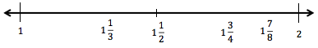

T: (Write $1\frac{1}{3}$ and $\text{1}\frac{\text{3}}{\text{4}}$.) Plot $\text{1}\frac{\text{1}}{\text{3}}$ and $\text{1}\frac{\text{3}}{\text{4}}$ on the number line.
S: (Plot and label $\text{1}\frac{\text{1}}{\text{3}}$ between 1 and $\text{1}\frac{\text{1}}{\text{2}}$ , and$\text{1}\frac{\text{3}}{\text{4}}$ between $\text{1}\frac{\text{1}}{\text{2}}$ and 2.)
T: (Write $\text{1}\frac{\text{1}}{\text{3}}$ ___ $\text{1}\frac{\text{3}}{\text{4}}$.) Write a greater than or less than sign to make the number sentence true.
S: (Write $\text{1}\frac{\text{1}}{\text{3}}$ < $\text{1}\frac{\text{3}}{\text{4}}$.)
T: $\text{1}\frac{\text{3}}{\text{4}}$is the same as 1 and how many eighths?
S: $\text{1}\frac{\text{6}}{\text{8}}$.
T: Plot $\text{1}\frac{\text{7}}{\text{8}}$ on your number line.
S: (Write $\text{1}\frac{\text{7}}{\text{8}}$ between $\text{1}\frac{\text{3}}{\text{4}}$ and 2.$)$
T: (Write $\text{1}\frac{\text{7}}{\text{8}}$ ___ $\text{1}\frac{\text{3}}{\text{4}}$.) Write a greater than or less than sign to make the expression true.
S: (Write $\text{1}\frac{\text{7}}{\text{8}}$ > $\text{1}\frac{\text{3}}{\text{4}}$.)
Continue with the following possible sequence using the same number line: $\text{1}\frac{\text{5}}{\text{12}}$ , $\text{1}\frac{\text{5}}{\text{6}}$ , and $\text{1}\frac{\text{2}}{\text{3}}$.
Continue with the following possible sequence using the following number line: $\text{2}\frac{\text{1}}{\text{4}}$ , $\text{2}\frac{\text{5}}{\text{8}}$ , and $\text{2}\frac{\text{5}}{\text{6}}$.
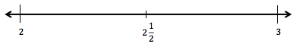

Concept Development (38 minutes)
Materials: (S) Personal white board, Problem Set
Note: Today’s Problem Set will be used throughout the Concept Development. The teacher guides the construction and interpretation of a line plot. As students complete each problem, the teacher might debrief with students about their solutions. Students have had prior exposure to creating and interpreting line plots in Grades 2 and 3.

Problem 1
Student | Distance  (in miles)
Joe | $$\text{2}\frac{\text{1}}{\text{2}}$$
Arianna | $$\text{1}\frac{\text{3}}{\text{4}}$$
Bobbi | $$\text{2}\frac{\text{1}}{\text{8}}$$
Morgan | $$\text{1}\frac{\text{5}}{\text{8}}$$
Jack | $$\text{2}\frac{\text{5}}{\text{8}}$$
Saisha | $$\text{2}\frac{\text{1}}{\text{4}}$$
Tyler | $$\text{2}\frac{\text{2}}{\text{4}}$$
Jenny | $$\frac{\text{5}}{\text{8}}$$
Anson | $$\text{2}\frac{\text{2}}{\text{8}}$$
Chandra | $$\text{2}\frac{\text{4}}{\text{8}}$$
Display table from the Problem Set.
T: This table shows the distance that Ms. Smith’s fourth graders were able to run before stopping for a rest. Tell your partner what you notice about the data.
S: It has the names of students and the distances they ran as a mixed number. Some of the fractions have different denominators. I can see fractions that are equivalent. The distance is measured in miles.
T: Let’s create a line plot to show the information. Discuss with your partner what you might remember about line plots from Grade 3: How does a line plot represent data?
S: It’s like a number line. We don’t put points on the line, but we make marks above the line. Yeah, the Xs go above the line because sometimes there are a lot of Xs at one number. It’s like a bar graph because the tallest column shows the most.
T: Discuss with your partner what the endpoints will be for the number line.
S: The largest fraction is $\text{2}\frac{\text{5}}{\text{8}}$ and the smallest is $\frac{\text{5}}{\text{8}}$, so we could use 0 and 3.
T: To create a number line using a ruler, we need to decide what measurement on the ruler we can use to mark off the distances the students ran. What is the smallest unit of measurement in the chart?
S: 1 eighth mile.
MP.4
T: Let’s see, if I mark off eighth miles from 0 to 3 using an eighth of an inch on a ruler, the increments are very small! Discuss with your partner another length unit that we could use to mark the eighth miles.
S: Let’s use inches. Those are nice and big! There are 24 eighths between 0 and 3. Our paper isn’t 24 inches wide. What if we double the eighth inch to fourth inch marks?
T: Draw a line and make hash marks at every $\frac{\text{1}}{\text{4}}$ inch to represent each eighth mile. Then, label the whole numbers.
S: (Do so.)
T: Now, mark each student’s distance using an X above a point on the number line that shows the distance they ran in miles. Label that point on the number line with the unit eighths. Tell your partner what you notice.
S: One student ran almost 3 miles! Some students ran the same distance. Some distances were measured using different fractional units. I converted fourths and halves to eighths. Most students ran between 2 and 3 miles.

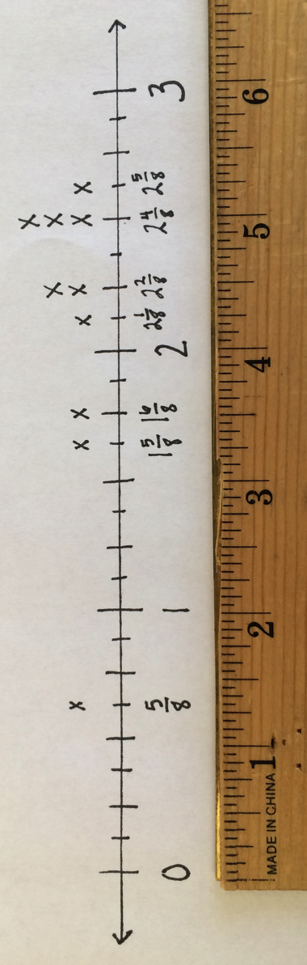

Problem 2
Circulate as students work. When the class is ready, stop the students and debrief Problem 2. If preferred, ask questions such as the following:
T: For Problems 2(a) and 2(b), did you refer to the table or the line plot?
T: For Problem 2(b), make a comparison statement for the distance Jack ran compared to Jenny.

NOTES ON
MULTIPLE MEANS
OF ACTION AND EXPRESSION:
Scaffold the word problems on the Problem Set for students working below grade level with questioning. For example, for Problem 2(d) ask, “What was the longest distance run? The shortest? What is the difference, in miles, between the longest and shortest distance run?”
Additionally, students may benefit from organizing data in a table before solving, for example, Problem 2(b).

T: What strategy did you use for Problem 2(c)? Did you count on the number line or use renaming a fraction to solve?
T: What previous knowledge about subtracting fractions or subtracting mixed units helped you to solve Problem 2(d)?
T: The line plot works just like a number line. I can tell that Arianna ran farther than Morgan. For Problem 2(e), how can you confirm that?
T: For Problem 2(g), comparing eighths and tenths requires a large denominator, like fortieths or eightieths. Using what you know about equivalent fractions to eighths, how could renaming Ms. Smith’s distance to fourths make the comparison to Mr. Reynolds’s distance simpler?
Problem Set (10 minutes)
Students should do their personal best to complete Problem 3 of the Problem Set within the allotted 10 minutes. For some classes, it may be appropriate to modify the assignment by specifying which problems they work on first. Some problems do not specify a method for solving. Students should solve these problems using the RDW approach used for Application Problems.

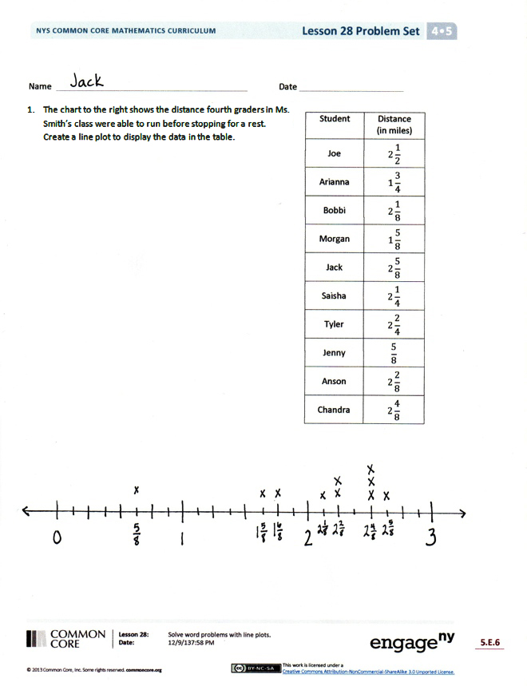
Student Debrief (10 minutes)
Lesson Objective: Solve word problems with line plots.
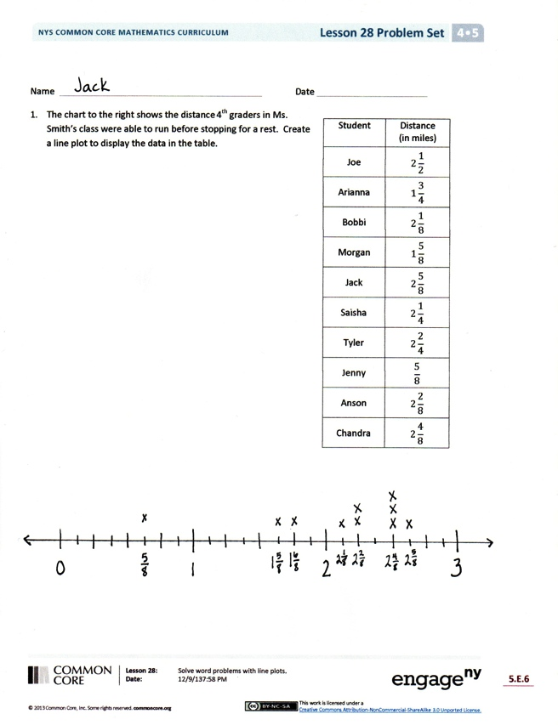
The Student Debrief is intended to invite reflection and active processing of the total lesson experience.
Invite students to review their solutions for the Problem Set. They should check work by comparing answers with a partner before going over answers as a class. Look for misconceptions or misunderstandings that can be addressed in the Debrief. Guide students in a conversation to debrief the Problem Set and process the lesson.
Any combination of the questions below may be used to lead the discussion.
- For Problem 2(g), which strategy did you use to compare the two distances? Would you be able to determine the correct answer if you answered Problem 2(f) incorrectly? Why or why not?
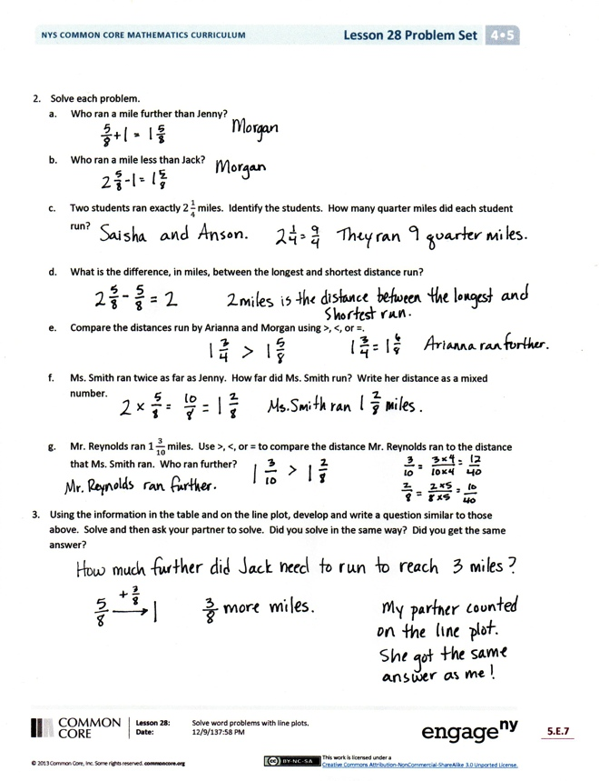
- Let’s share some of the questions that you wrote for Problem 3. Were there similarities in the questions that you and your partner wrote? Were there differences? Explain.
- How is a line plot useful in showing data? By simply looking at the line plot, what can you tell about the distances that the students ran?
- What might be some reasons to use a line plot to display data rather than using a chart or table?
Exit Ticket (3 minutes)
After the Student Debrief, instruct students to complete the Exit Ticket. A review of their work will help with assessing students’ understanding of the concepts that were presented in today’s lesson and planning more effectively for future lessons. The questions may be read aloud to the students.

Name Date
Student | Distance  (in miles)
Joe | $$\text{2}\frac{\text{1}}{\text{2}}$$
Arianna | $$\text{1}\frac{\text{3}}{\text{4}}$$
Bobbi | $$\text{2}\frac{\text{1}}{\text{8}}$$
Morgan | $$\text{1}\frac{\text{5}}{\text{8}}$$
Jack | $$\text{2}\frac{\text{5}}{\text{8}}$$
Saisha | $$\text{2}\frac{\text{1}}{\text{4}}$$
Tyler | $$\text{2}\frac{\text{2}}{\text{4}}$$
Jenny | $$\frac{\text{5}}{\text{8}}$$
Anson | $$\text{2}\frac{\text{2}}{\text{8}}$$
Chandra | $$\text{2}\frac{\text{4}}{\text{8}}$$
- The chart to the right shows the distance fourth graders in Ms. Smith’s class were able to run before stopping for a rest.
Create a line plot to display the data in the table.

- Solve each problem.
- Who ran a mile farther than Jenny?

- Who ran a mile less than Jack?

- Two students ran exactly $\text{2}\frac{\text{1}}{\text{4}}$ miles. Identify the students. How many quarter miles did each student run?

- What is the difference, in miles, between the longest and shortest distance run?

- Compare the distances run by Arianna and Morgan using >, <, or =.

- Ms. Smith ran twice as far as Jenny. How far did Ms. Smith run? Write her distance as a mixed number.

- Mr. Reynolds ran $\text{1}\frac{\text{3}}{\text{10}}$ miles. Use >, <, or = to compare the distance Mr. Reynolds ran to the distance that Ms. Smith ran. Who ran farther?

- Using the information in the table and on the line plot, develop and write a question similar to those above. Solve, and then ask your partner to solve. Did you solve in the same way? Did you get the same answer?

Name Date
Student | Length of time  (in hours)
Robin | $$\frac{\text{1}}{\text{2}}$$
Bill | 1
Katrina | $$\frac{\text{3}}{\text{4}}$$
Kelly | $$\text{1}\frac{\text{3}}{\text{4}}$$
Mary | $$\text{1}\frac{\text{1}}{\text{2}}$$
Gail | $$\text{2}\frac{\text{1}}{\text{4}}$$
Scott | $$\text{1}\frac{\text{3}}{\text{4}}$$
Ben | $$\text{2}\frac{\text{2}}{\text{4}}$$
Mr. O’Neil asked his students to record the length of time they read over the weekend. The times are listed in the table.
  - At the bottom of the page, make a line plot of the data.

  - One of the students read $\frac{\text{3}}{\text{4}}$ hour on Friday, $\frac{\text{3}}{\text{4}}$ hour on Saturday, and $\frac{\text{3}}{\text{4}}$ hour on Sunday. How many hours did that student read over the weekend? Name that student.

Name Date
Students | Length of Shoe  (in inches)
Collin | 8 $\frac{\text{1}}{\text{2}}$
Dickon | 7 $\frac{\text{3}}{\text{4}}$
Ben | 7 $\frac{\text{1}}{\text{2}}$
Martha | 7 $\frac{\text{3}}{\text{4}}$
Lilias | 8
Susan | 8 $\frac{\text{1}}{\text{2}}$
Frances | 7 $\frac{\text{3}}{\text{4}}$
Mary | 8 $\frac{\text{3}}{\text{4}}$
- A group of children measured the lengths of their shoes.
The measurements are shown in the table. Make a line plot to display the data.

- Solve each problem.
a. Who has a shoe length 1 inch longer than Dickon?

- Who has a shoe length 1 inch shorter than Susan?

- How many quarter inches long is Martha’s shoe length?

- What is the difference, in inches, between Lilias’s and Martha’s shoe lengths?

- Compare the shoe length of Ben and Frances using >, <, or =.

- How many students had shoes that measured less than 8 inches?

- How many children measured the length of their shoes?

- Mr. Jones’s shoe length was $\frac{\text{25}}{\text{2}}$ inches. Use >, <, or = to compare the length of Mr. Jones’s shoe to the length of the longest student shoe length. Who had the longer shoe?

- Using the information in the table and on the line plot, write a question you could solve by using the line plot. Solve.

