Lesson 27
Objective: Compare fractions greater than 1 by creating common numerators or denominators.

Suggested Lesson Structure
 Fluency Practice (12 minutes)
 Application Problem (6 minutes)
 Concept Development (32 minutes)
 Student Debrief (10 minutes)
Total Time (60 minutes)
Fluency Practice (12 minutes)
- Add and Subtract Fractions 4.NF.3 (3 minutes)
- Change Fractions to Mixed Numbers 4.NF.4 (4 minutes)
- Change Mixed Numbers to Fractions 4.NF.4 (5 minutes)
Add and Subtract Fractions (3 minutes)
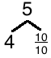
Materials: (S) Personal white board
Note: This fluency activity reviews Lesson 22.
T: (Draw a number bond with a whole of 5. Write 4 as the known part and $\frac{}{\text{10}}$ as the unknown part.) How many tenths are in 1?
S: 10 tenths.
5 – $\frac{\text{3}}{\text{10}}$ = $\text{4} \text{+}\frac{\text{7}}{\text{10}}$
T: (Write $\frac{\text{10}}{\text{10}}$ as the unknown part. Beneath it, write 5 – $\frac{\text{3}}{\text{10}}$ = 4 + $\frac{}{\text{10}}$.)
Write the number sentence.
S: (Write 5 – $\frac{\text{3}}{\text{10}}$ = 4 + $\frac{\text{7}}{\text{10}}$ = $\text{4}\frac{\text{7}}{\text{10}}$.)
Continue with the following possible sequence: 6 – $\frac{\text{5}}{\text{8}}$, 5 – $\frac{\text{3}}{\text{4}}$, and 4 – $\frac{\text{7}}{\text{12}}$.
$\text{4}\frac{\text{7}}{\text{10}}$ + = 5
T: How much does 7 tenths need to be 1?
S: 3 tenths.
T: (Write $\text{4}\frac{\text{7}}{\text{10}}$ + __ = 5.) Write the number sentence, filling in the unknown number.
S: (Write $\text{4}\frac{\text{7}}{\text{10}}$ + $\frac{\text{3}}{\text{10}}$ = 5.)
Continue with the following possible sequence: $\text{5}\frac{\text{3}}{\text{8}}$ + __ = 6, $\text{4}\frac{\text{1}}{\text{4}}$ + __ = 5, and $\text{3}\frac{\text{5}}{\text{12}}$ + __ = 4.
Change Fractions to Mixed Numbers (4 minutes)
Materials: (S) Personal white board
Note: This fluency activity reviews Lesson 24.
T: (Write $\frac{\text{7}}{\text{5}}$.) Say the fraction.
S: 7 fifths.
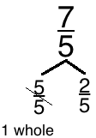
T: (Draw a number bond with a whole of $\frac{\text{7}}{\text{5}}$.) How many fifths are in 1?
S: 5 fifths.
T: (Write $\frac{\text{5}}{\text{5}}$ as the known part.) Write the unknown part.
S: (Write $\frac{\text{2}}{\text{5}}$ as the unknown part.)
T: (Cross out $\frac{\text{5}}{\text{5}}$ and write 1 beneath it.) Write $\frac{\text{7}}{\text{5}}$ as a mixed number.
S: (Write $\frac{\text{7}}{\text{5}}$ = $\text{1}\frac{\text{2}}{\text{5}}$.)
Continue with the following possible sequence: $\frac{\text{9}}{\text{4}}$ and $\frac{\text{11}}{\text{3}}$.
Change Mixed Numbers to Fractions (5 minutes)
Materials: (S) Personal white board
Note: This fluency activity reviews Lesson 25.
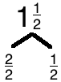
T: (Write $\text{1}\frac{\text{1}}{\text{2}}$.) Say the mixed number.
S: 1 and 1 half.
T: (Draw a number bond with a whole of $\text{1}\frac{\text{1}}{\text{2}}$. Write $\frac{\text{1}}{\text{2}}$ as the known part.)
Write the unknown part.
S: (Write $\frac{\text{2}}{\text{2}}$ as the unknown part.)
T: (Write $\frac{\text{2}}{\text{2}}$ as the unknown part. Write $\text{1}\frac{\text{1}}{\text{2}}$ = $\frac{}{\text{2}}$.) Write $\text{1}\frac{\text{1}}{\text{2}}$as a fraction.
S: (Write $\text{1}\frac{\text{1}}{\text{2}}$ = $\frac{\text{3}}{\text{2}}$.)
Continue with the following possible sequence: $\text{1}\frac{\text{2}}{\text{3}}$ and $\text{2}\frac{\text{1}}{\text{5}}$.
Application Problem (6 minutes)
Jeremy ran 27 laps on a track that was $\frac{\text{1}}{\text{8}}$ mile long. Jimmy ran 15 laps on a track that was $\frac{\text{1}}{\text{4}}$ mile long. Who ran farther?
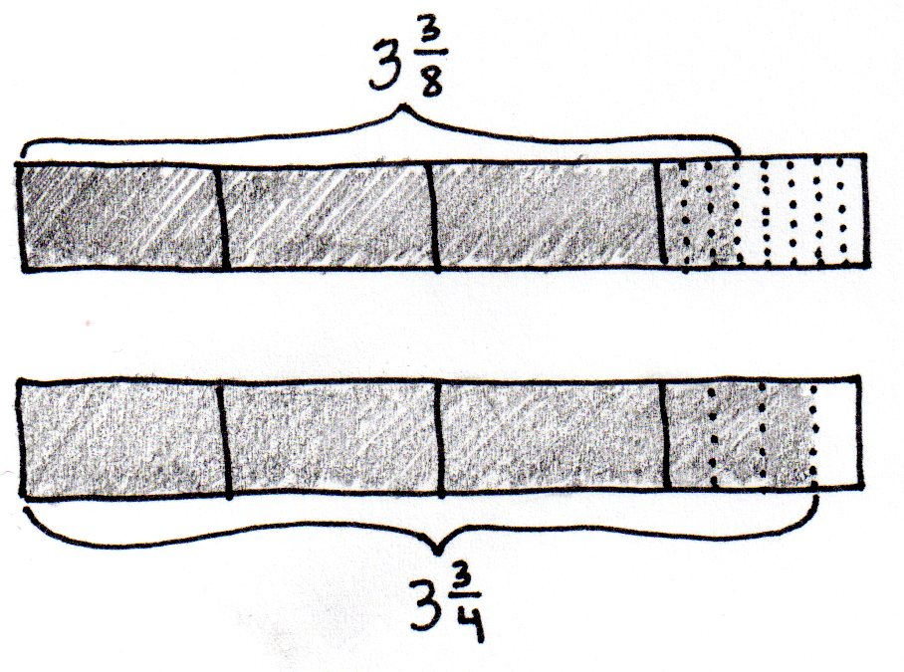
Jimmy ran farther.

NOTES ON
MULTIPLE MEANS
OF REPRESENTATION:
Because precision in modeling is critical when comparing, it may be helpful to provide aligned parallel tape diagram templates of equal length that students can partition.

Note: This Application Problem builds from Lesson 26 where students compared fractions greater than 1 using benchmark fractions. In today’s lesson, students compare fractions by creating common numerators or denominators. The fractions
$\frac{\text{27}}{\text{8}}$ and $\frac{\text{15}}{\text{4}}$, used in the Application Problem, lend themselves to comparison using either benchmark fractions or common numerators or related denominators.
Concept Development (32 minutes)
Materials: (S) Personal white board
Problem 1: Model, using a tape diagram, the comparison of two mixed numbers having related denominators.
T: (Display $\text{3}\frac{\text{3}}{\text{8}}$ and $\text{3}\frac{\text{3}}{\text{4}}$.) Look at the mixed numbers from the Application Problem. You compared fractions by thinking about the size of units. Can you remember another way to compare fractions?
S: We can use common denominators.
T: Yes! Four is a factor of 8. We can convert fourths to eighths by decomposing each fourth to make eighths. Draw a tape diagram to model the comparison of $\frac{\text{3}}{\text{4}}$ and $\frac{\text{3}}{\text{8}}$.
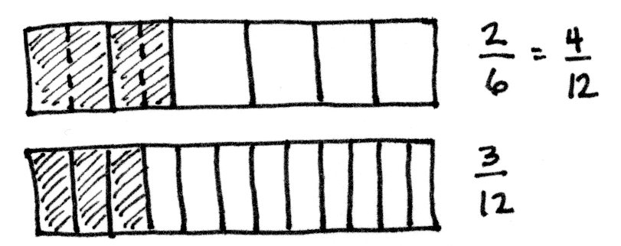
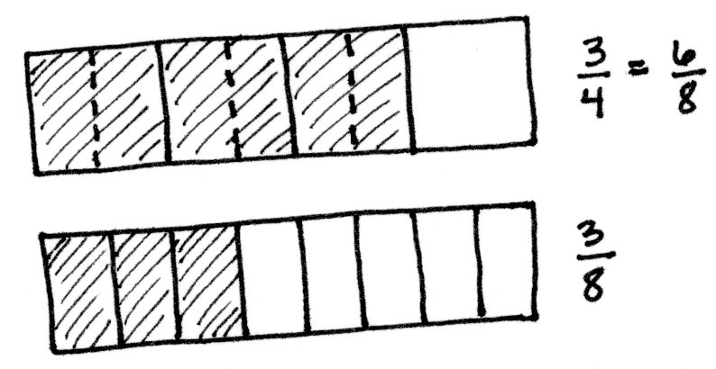
S: (Draw as shown to the right.) $\frac{\text{3}}{\text{4}}\text{=}\frac{\text{6}}{\text{8}}$. $\frac{\text{6}}{\text{8}}\text{>}\frac{\text{3}}{\text{8}}$. So, $\text{3}\frac{\text{3}}{\text{8}}\text{<} \text{3}\frac{\text{3}}{\text{4}}$.
T: With your partner, draw a tape diagram to compare
$\text{2}\frac{\text{2}}{\text{6}}$ and $\text{2}\frac{\text{3}}{\text{12}}$.
S: $\frac{\text{2}}{\text{6}}\text{=}\frac{\text{4}}{\text{12}}$. So, $\text{2}\frac{\text{2}}{\text{6}}\text{>} \text{2}\frac{\text{3}}{\text{12}}$.
Repeat, using a number line to make like units, to compare
$\text{4}\frac{\text{1}}{\text{3}}$ and $\text{4}\frac{\text{2}}{\text{9}}$, then $\text{5}\frac{\text{1}}{\text{4}}$ and $\text{5}\frac{\text{3}}{\text{8}}$.
Problem 2: Compare two fractions with unrelated denominators.
T: Discuss a strategy to use to compare $\text{4}\frac{\text{3}}{\text{4}}$ and $\frac{\text{23}}{\text{5}}$.
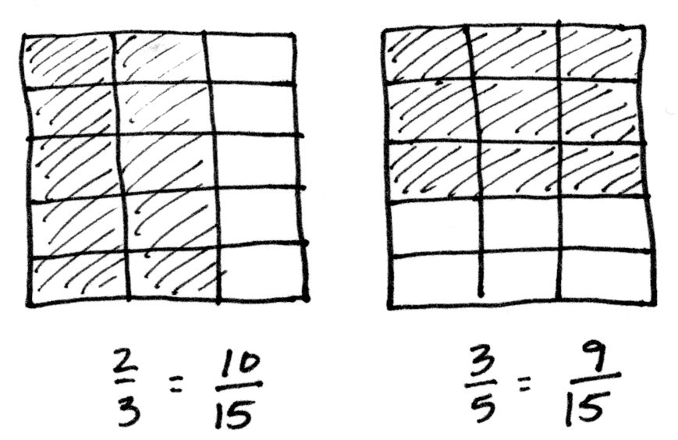
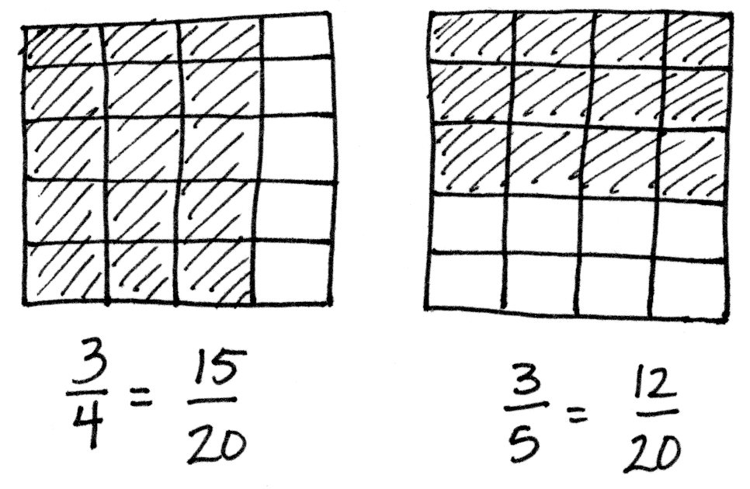
S: We need to convert $\frac{\text{23}}{\text{5}}$ to a mixed number. $\frac{\text{23}}{\text{5}}\text{=} \text{4}\frac{\text{3}}{\text{5}}\text{.}$ Both mixed numbers have the same number of ones, so I can use the denominators to compare because the numerators are the same. Fourths are bigger than fifths, so 3 fourths would be greater than 3 fifths. $\text{4}\frac{\text{3}}{\text{4}}\text{>}\frac{\text{23}}{\text{5}}\text{.}$
T: Yes, that is the same strategy we used in the Application Problem. This time, use the area model to show $\frac{\text{3}}{\text{4}}$ is greater than $\frac{\text{3}}{\text{5}}\text{.}$ Draw two same-sized rectangles representing 1 one. Partition one area into fourths using vertical lines. Partition one area into fifths using horizontal lines. Make like denominators.
MP.4
S: I’ll draw fifths horizontally on the fourths, and fourths vertically on the fifths. We made twentieths!
T: Compare the twentieths to prove$\text{ 4}\frac{\text{3}}{\text{4}}\text{>} \text{4}\frac{\text{3}}{\text{5}}$.
S: $\frac{\text{3}}{\text{4}}\text{=}\frac{\text{15}}{\text{20}}$ and $\frac{\text{3}}{\text{5}}\text{=}\frac{\text{12}}{\text{20}}$. $\frac{\text{15}}{\text{20}}\text{>}\frac{\text{12}}{\text{20}}$. So, $\text{4}\frac{\text{3}}{\text{4}}\text{>} \text{4}\frac{\text{3}}{\text{5}}$.
Repeat, using the area model to make like units, to compare $\text{2}\frac{\text{2}}{\text{3}}$ and $\text{2}\frac{\text{3}}{\text{5}}$.
Problem 3: Compare two fractions.
T: (Display $\text{3}\frac{\text{7}}{\text{10}}$ and $\frac{\text{18}}{\text{5}}$.) Compare by finding like denominators. What is different about this comparison?
S: One number is written as a mixed number and the other as a fraction.
T: Work together with your partner. One of you is Partner A, and the other is Partner B.
T: Partner A, convert $\text{3}\frac{\text{7}}{\text{10}}$ to a fraction, and compare it to 18 fifths. Partner B, convert $\frac{\text{18}}{\text{5}}$ to a mixed number, and compare it to 3 and 7 tenths.
T: Consider using multiplication to solve. Take turns discussing how you solved. Did you both get the same answer?
S: Partner A: $\frac{\text{30}}{\text{10}}\text{= 3.}$ $\frac{\text{30}}{\text{10}}\text{+}\frac{\text{7}}{\text{10}}\text{=}\frac{\text{37}}{\text{10}}$. We have $\frac{\text{37}}{\text{10}}$ and $\frac{\text{18}}{\text{5}}\text{.}$ Fifths and tenths are related denominators. Convert $\frac{\text{18}}{\text{5}}$ to tenths. $\frac{\text{18 × 2}}{\text{5 × 2}}$ = $\frac{\text{36}}{\text{10}}$. $\frac{\text{37}}{\text{10}}\text{>}\frac{\text{36}}{\text{10}}$ . So, $\text{3}\frac{\text{7}}{\text{10}}\text{>}\frac{\text{18}}{\text{5}}\text{.}$
S: Partner B: There are 3 copies of 5 fifths in $\frac{\text{18}}{\text{5}}$. $\frac{\text{15}}{\text{5}}\text{+}\frac{\text{3}}{\text{5}}\text{=}\frac{\text{18}}{\text{5}}$. $\frac{\text{18}}{\text{5}}\text{=} \text{3}\frac{\text{3}}{\text{5}}\text{.}$ Convert the fifths to tenths. $\frac{\text{3 × 2}}{\text{5 × 2}}\text{=}\frac{\text{6}}{\text{10}}$. $\text{3}\frac{\text{3}}{\text{5}}\text{=} \text{3}\frac{\text{6}}{\text{10}}\text{.}$ $\text{3}\frac{\text{7}}{\text{10}}\text{>} \text{3}\frac{\text{6}}{\text{10}}$. So, $\text{3}\frac{\text{7}}{\text{10}}\text{>}\frac{\text{18}}{\text{5}}\text{.}$
S: We both found that $\text{3}\frac{\text{7}}{\text{10}}\text{>}\frac{\text{18}}{\text{5}}\text{.}$ Our answers were the same because we both were converting to equivalent amounts. We just expressed it in a different way.
T: Compare $\text{7}\frac{\text{3}}{\text{5}}$ and $\text{7}\frac{\text{4}}{\text{6}}$.
T: We can make like denominators using multiplication. 30 is a multiple of both 5 and 6. We know that because 5 times 6 is…?
S: 30.
T: Let’s rename each fraction using multiplication to have 30 as the new denominator. (Demonstrate as shown to the right.)
S: $\text{7}\frac{\text{18}}{\text{30}}\text{<} \text{7}\frac{\text{20}}{\text{30}}$, then $\text{7}\frac{\text{3}}{\text{5}}\text{<} \text{7}\frac{\text{4}}{\text{6}}$.
T: Show how we can also make like numerators of 12. (Demonstrate as shown to the right.)
S: $\text{7}\frac{\text{12}}{\text{20}}\text{<} \text{7}\frac{\text{12}}{\text{18}}$ because eighteenths are larger units than twentieths, so $\text{7}\frac{\text{3}}{\text{5}}\text{<} \text{7}\frac{\text{4}}{\text{6}}$.
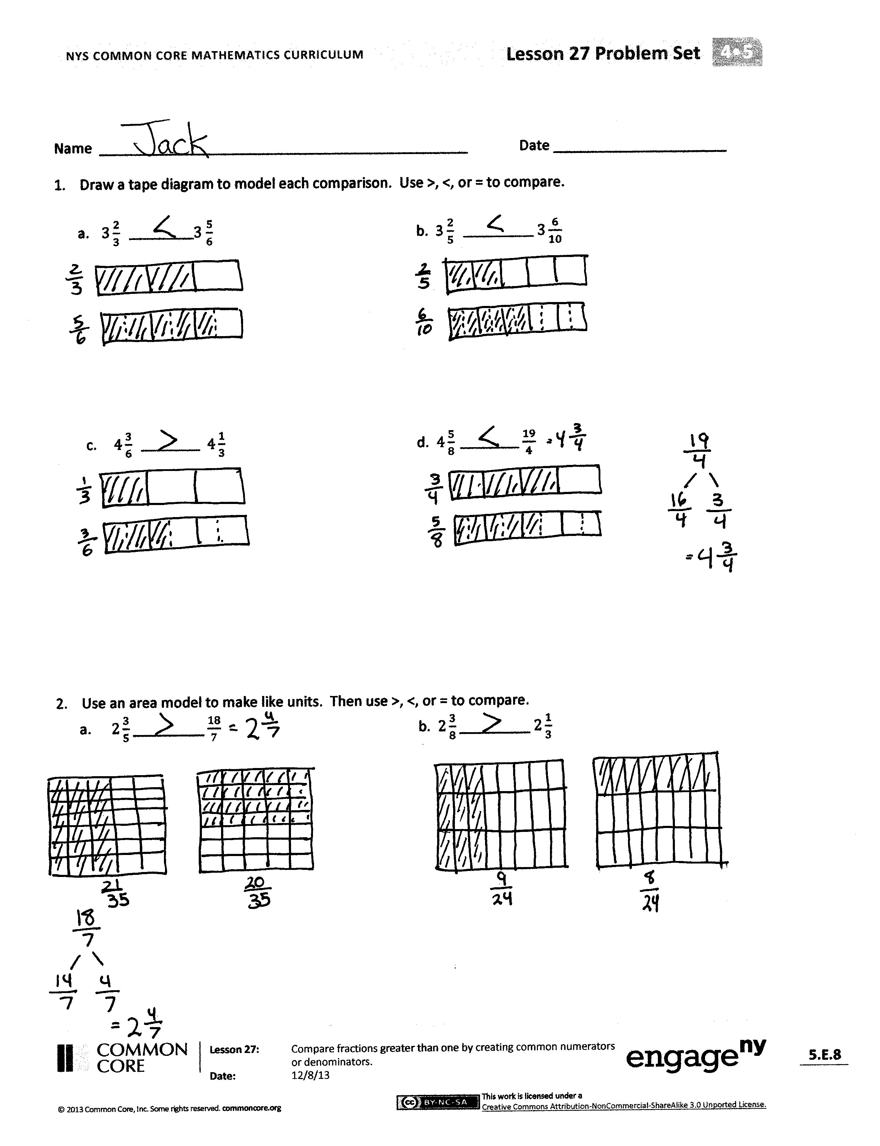
Note: Do not overemphasize the use of like numerators since like denominators is a much bigger idea mathematically that is used when we compare or add and subtract like units.
Other possible examples could include $\text{4}\frac{\text{2}}{\text{3}}\text{, 4}\frac{\text{7}}{\text{12}}\text{;}$ $\text{4}\frac{\text{3}}{\text{4}}\text{,}\frac{\text{29}}{\text{6}}\text{; }\frac{\text{25}}{\text{9}}\text{, }\frac{\text{14}}{\text{5}}\text{.}$
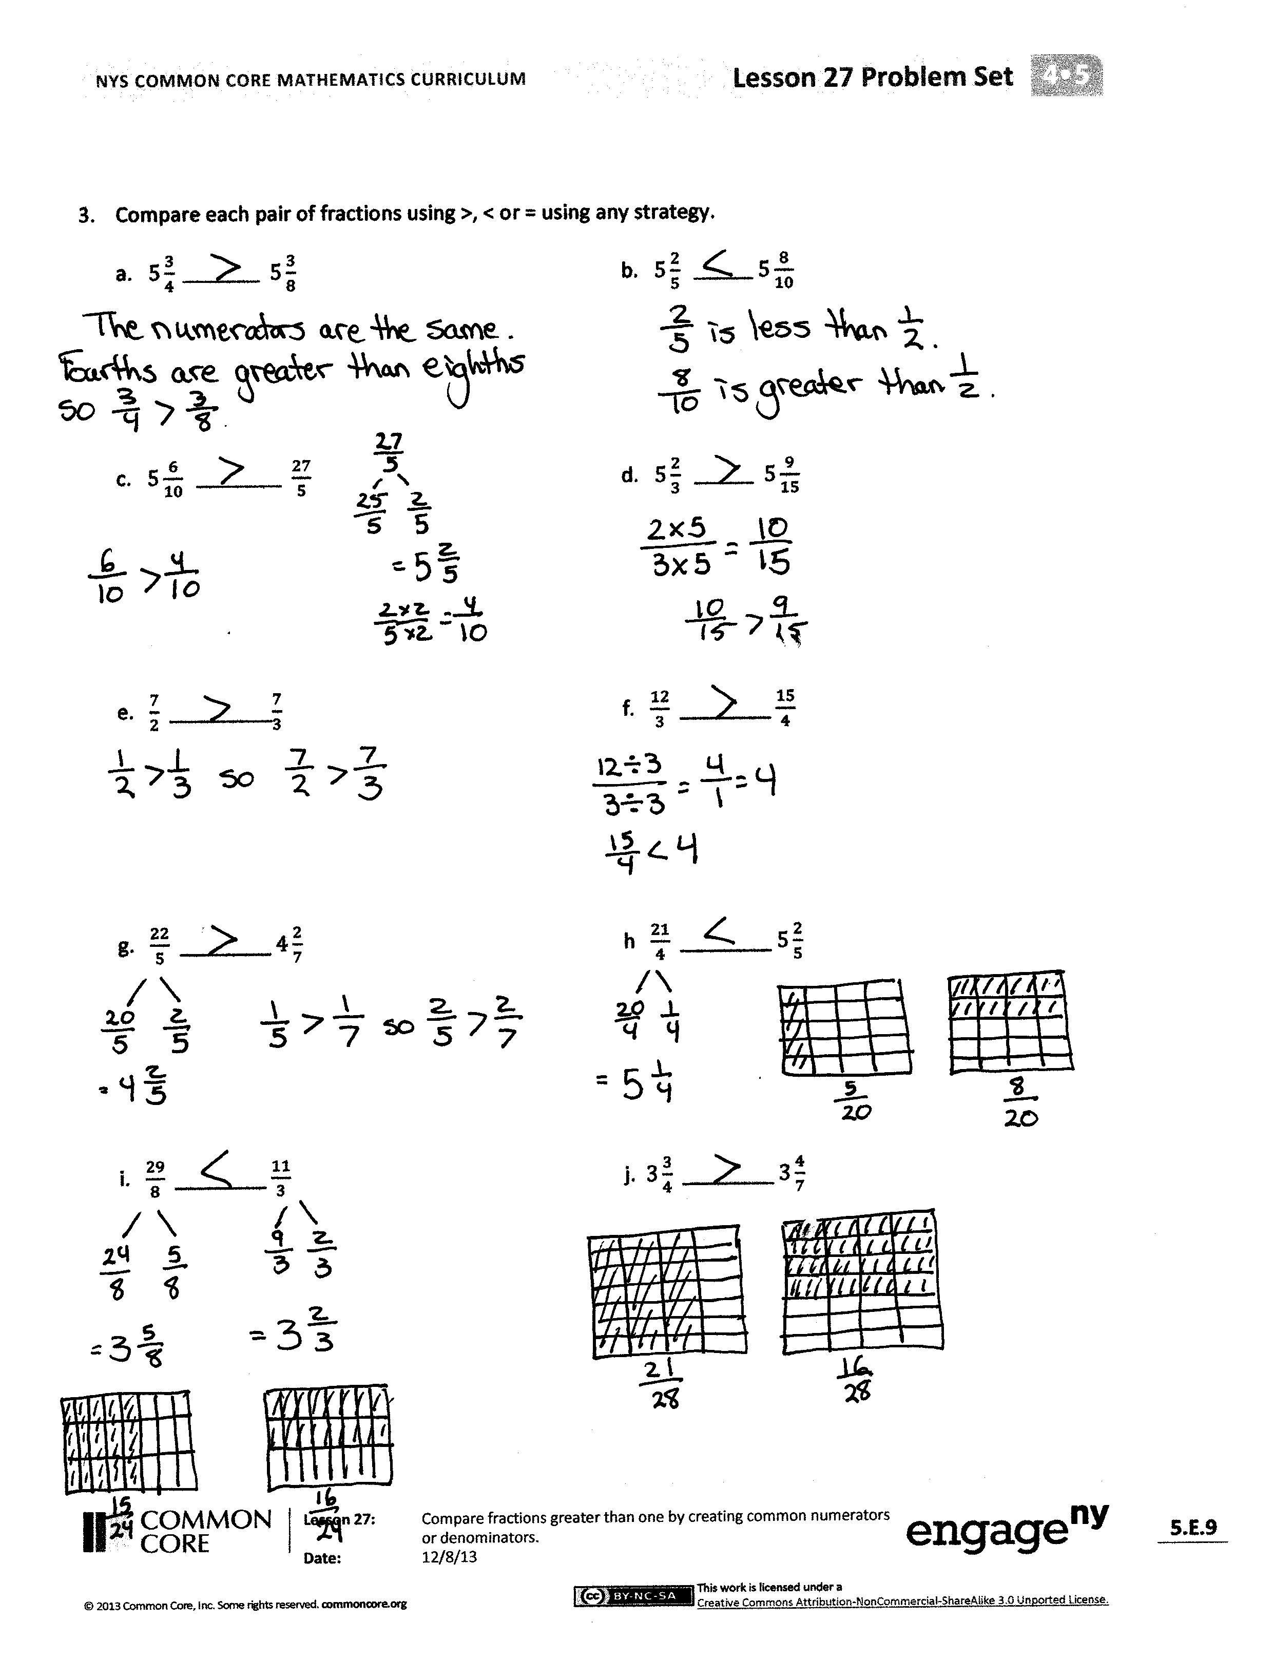
Problem Set (10 minutes)
Students should do their personal best to complete the Problem Set within the allotted 10 minutes. For some classes, it may be appropriate to modify the assignment by specifying which problems they work on first. Some problems do not specify a method for solving. Students should solve these problems using the RDW approach used for Application Problems.
Student Debrief (10 minutes)
Lesson Objective: Compare fractions greater than 1 by creating common numerators or denominators.
The Student Debrief is intended to invite reflection and active processing of the total lesson experience.
Invite students to review their solutions for the Problem Set. They should check work by comparing answers with a partner before going over answers as a class. Look for misconceptions or misunderstandings that can be addressed in the Debrief. Guide students in a conversation to debrief the Problem Set and process the lesson.
Any combination of the questions below may be used to lead the discussion.

NOTES ON
MULTIPLE MEANS
OF ACTION AND EXPRESSION:
The number line may also be used to compare fractions with related denominators. Decompose the unit just as practiced in Topic C. The number line comparison allows students to consider the entire number they are comparing and not just the fractional parts. Show how the number line can be partitioned just like the tape diagram by aligning them on top of each other.
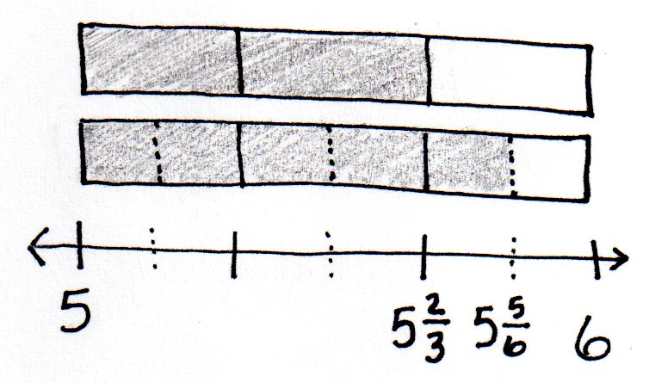

- How did the tape diagram help to solve Problems 1(a) and 1(b)? Why is it important to make sure the whole for both tape diagrams is the same size?
- Who converted to a mixed number or a fraction greater than 1 before finding like units for Problem 3(c)? Was it easier to compare mixed numbers or fractions greater than 1 for this particular problem? (Note: Finding mixed numbers first, one could use a benchmark fraction of 1 half to compare $\frac{6}{10}$ to $\frac{2}{5}$ without needing to find like units.) Is it more efficient to compare fractions greater than 1 or mixed numbers?
- In Problem 3(e), the added complexity was that the denominators were not related, as in the previous problems. What strategy did you use to solve? Did you solve by finding like numerators or by drawing an area model to find like denominators?
- Were there any problems in Problem 3 that you could compare without renaming or without drawing a model? How were you able to mentally compare them?
- How did having to compare a mixed number to a fraction add to the complexity of Problem 2(a)?
- How did the Application Problem connect to today’s lesson?
Exit Ticket (3 minutes)
After the Student Debrief, instruct students to complete the Exit Ticket. A review of their work will help with assessing students’ understanding of the concepts that were presented in today’s lesson and planning more effectively for future lessons. The questions may be read aloud to the students.

Name Date
- Draw a tape diagram to model each comparison. Use >, <, or = to compare.
  - $3\frac{2}{3} __________$ 3$\frac{5}{6}$ b. 3$\frac{2}{5} ____________$ $3\frac{6}{10}$

- $4\frac{3}{6} __________$ $4\frac{1}{3}$ d. $4\frac{5}{8} __________$ $\frac{19}{4}$

- Use an area model to make like units. Then, use >, <, or = to compare.
  - $2\frac{3}{5}$ _________ $\frac{18}{7}$ b. $2\frac{3}{8}$ _________ $2\frac{1}{3}$

- Compare each pair of fractions using >, <, or = using any strategy.
a. $5\frac{3}{4} _________$ $5\frac{3}{8}$ | b. $5\frac{2}{5} _________$ $5\frac{8}{10}$
c. $5\frac{6}{10} __________$ $\frac{27}{5}$ | d. $5\frac{2}{3} ________$ $5\frac{9}{15}$
e. $\frac{7}{2}$ ________ $\frac{7}{3}$ | f. $\frac{12}{3}$ ________ $\frac{15}{4}$
g. $\frac{22}{5}$ ________ $4\frac{2}{7}$ | h $\frac{21}{4}$ ________ $5\frac{2}{5}$
i. $\frac{29}{8}$ ________ $\frac{11}{3}$ | j. $3\frac{3}{4}$ ________ $3\frac{4}{7}$

Name Date
Compare each pair of fractions using >, <, or = using any strategy.
- $4\frac{3}{8} _________$ $4\frac{1}{4}$

- $3\frac{4}{5} _______$ $3\frac{9}{10}$

- $2\frac{1}{3} __________$ 2 $\frac{2}{5}$

- $10\frac{2}{5} _______$ $10\frac{3}{4}$

Name Date
- Draw a tape diagram to model each comparison. Use >, <, or = to compare.
  - $2\frac{3}{4} ___________2$ $\frac{7}{8}$ b. 1$0\frac{2}{6} ____________$ $10\frac{1}{3}$

- 5$\frac{3}{8} __________$ 5 $\frac{1}{4}$ d. $2\frac{5}{9} __________$ $\frac{21}{3}$

- Use an area model to make like units. Then, use >, <, or = to compare.
  - $2\frac{4}{5}$ _________ $\frac{11}{4}$ b. $2\frac{3}{5}$ _________ $2\frac{2}{3}$
- Compare each pair of fractions using >, <, or = using any strategy.
a. $6\frac{1}{2} _________$ $6\frac{3}{8}$ | b. $7\frac{5}{6} ________$ $7\frac{11}{12}$
c. $3\frac{6}{10} __________$ $3\frac{2}{5}$ | d. $2\frac{2}{5} _________$ $2\frac{8}{15}$
e. $\frac{10}{3}$ _________$\frac{10}{4}$ | f. $\frac{12}{4}$ ________ $\frac{10}{3}$
g. $\frac{38}{9}$ ________ $4\frac{2}{12}$ | h. $\frac{23}{4}$ ________ $5\frac{2}{3}$
i. $\frac{30}{8}$ ________ $3\frac{7}{12}$ | j. $10\frac{3}{4}$ ________ $10\frac{4}{6}$

